
EVENT STRATEGIC PLANNING FOR Winter Wonderland Party at The Great Victoria Hotel
Shahd Omer (2130010) International meeting management for the hotel industry BMIH 6007 lecturer: Chris Wilkin / Wordcount: 2739

November 8, 2024
University of wales trinity saint daivid
Swansea

Executive Summary

This report represents a deep strategic and operational framework for the Great Victoria Winter Wonderland: a season-specific event at Bradford's Great Victoria Hotel. This is specially designed to provide a unique winter experience. This focuses on targeting a cross-section of many demographics. This event will establish it as the prime winter destination in Bradford (Visitbradford.com, 2024).

A situational analysis was made by using the EMBOK framework to perceive factors that could impact the success of the event by taking into consideration all influences of a political, economic, social, technological, environmental, and competitive nature.

It pinpoints not only growth in economic constraint and regional competitors but also a SWOT analysis that identifies strengths such as its prime location and multifaceted nature of attractions while touting operational costs and dependency on good weather as certain weaknesses (Kenton, 2024). Some of the key recommendations would include diversification into market offerings through VIP packages, sustainability initiatives, and digital engagement through augmented reality. The operational plan discusses logistics, vendor coordination, and safety, while it also aims to maximise visitor satisfaction for revenue and make the event a highlight for Bradford. Concluding recommendations are focused on the strategy of long-term viability with a community impact (Mair, and Smith, 2021).

Table of contents:
Executive summary 1
- Introduction 3
- Overview of the Great Victoria Winter Wonderland Event 4
- Key Logistics and Organisational Requirements ………………………………..4
  - Load-in Timings …………………………………………………………..…4
  - Guest Arrival and Flow Management……………………………………...5
  - On-site communication……………………………………………...………5
  - Amenities and Waste Management ………………………………...……..5
  - VIP, Artists, and Media Accommodations…………………………….……5
- Event Cycle ……………………………………………………………………….……..6
- Applying the EMBOK Framework ……………………………………….……………7
  - Administration………………………………………………….…………….7
  - Design ………………………………………………………..………………8
  - Marketing………………………………………………………………….….9
  - Operations……………………………………………………………….…...9
  - Risk Management ………………………………………………………….10
- Maximising Stakeholder Value ..………………………………….………………….11
- Strategic option for success……………………………………………………….….11
- Revenue Diversification ………………………………………………………………11
- Strategy Evaluation and Choice …………………………………………………….12
- Industry trends/Issues/Impacts……………………………………………………….13
- Conclusion……………………………………………………………………………...15
- Recommendations…………………………………………………………………….16
- References …………………………………………………………………………….17
- Appendix 1 PESTLE Analysis…………………………………………………….…..21
- Appendix 2 SOAR and SWOT analyses…………………………………………….22

- Introduction
The Great Victoria Winter Wonderland is an open event, large-scale, designed to allow the celebration of the festive season by providing an experience of a winter wonderland phenomenon to the local community in Bradford. It will be held at the prestigious Great Victoria Hotel with the inclusion of traditional Christmas fun-ice skating, a festive market, and family-friendly attractions like Santa's Grotto to attract a wide audience including local families, students at the university, corporate groups, and tourists. The hotel stands at the centre of everything, steeped in history, and easy to travel to and from using all of Bradford's transport systems, therefore making it a perfect venue to host this seasonal event (McCullough, 2020).
This is because there is extremely high demand for festive or family events, especially during the holiday period. The Great Victoria Winter Wonderland thus provides that unique and rare opportunity to bring together this community while attending to the local businesses in terms of artisan market stalls, and social, and cultural engagement. Bradford is one of the culturally diverse metropolitan cities in West Yorkshire and hence could provide the ideal backdrop to such an event to attract both locals and tourists. This report considers PESTLE, SOAR, and a SWOT.

- Overview of the Great Victoria Winter Wonderland Event
The event is Organised by the Great Victoria Hotel in Bradford, this event is a pure variety for families. This will include an option of ice skating, Santa's Grotto, and a Christmas market replete with music and delicious food stalls (Robertson, 2024). The planned objective is to attract 1,000 visitors with a satisfaction rating of 90% (socialtables, 2017). Having an attractive location would appeal to locals and tourists equally. It is then composed of the generation of ideas, planning, implementation, and review, which run parallel to smart marketing, crowd management, and safety (Interim guidance, n.d.).

- Key Logistics and Organisational Requirements
  - Load-in Timings
Setups for the event will be staged over several days to avoid delays and bottlenecks, first focusing on the larger installations such as the ice rink and structural components. This will be followed by setups from other vendors and catering, each scheduled at specific times to avoid conflict and ensure that all goes up on time and without incident (Robertson, 2024).
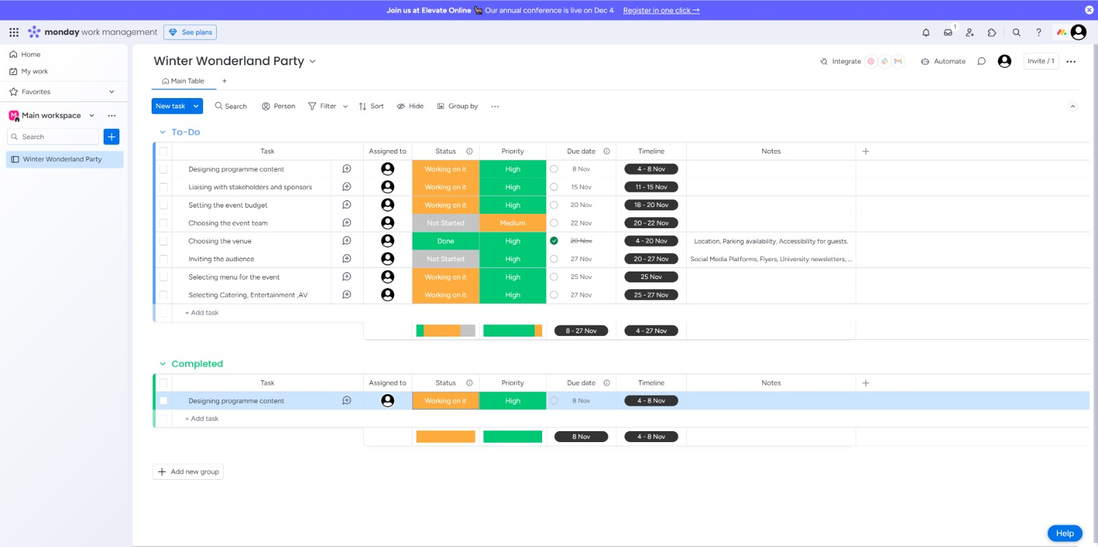
(Page.link, 2024).

  - Guest Arrival and Flow Management
Managing guest arrivals, especially during peak times, will reduce congestion at entry points. Staggered ticketing and designated entry lines for pre-booked walk-ins, and VIPs will streamline the process. Strategic venue layout and crowd control measures, including clear signage and one-way systems, will facilitate smooth movement, especially in high-traffic areas like the ice rink or Santa’s (GrottoAsif, and Bindhu, 2023).

  - On-Site Communication
Effective communication is paramount, with every staff member having two-way radios and a central control room overseeing everything. Naturally, there would be predefined protocols for emergencies ranging from medical issues to lost children that would guarantee immediate and coordinated responses (McCullough, 2020).

  - Amenities and Waste Management
Amenities such as restrooms, food stalls, and first-aid stations will be situated within easy reach for the convenience of the guests. Waste management will be ensured through clearly labelled receptacles, scheduled cleaning, and respond-to-needs teams to keep the grounds free of refuse and an unpleasant environment throughout (Pereira, et. Al, 2021).

  - VIP, Artists, and Media Accommodations
There will be special entrances and places for seating with VIPs. The artists will have special backstage facilities. Press zones, fast Wi-Fi access, and places for interview operations will be easy to handle for media representatives and thus give good experiences along with other key stakeholders (Robertson, 2024).

- Event Cycle:
Major phases of the event cycle for Great Victoria Winter Wonderland include the conceptual, planning, implementation, and evaluation stages of the event. The event concept is to be developed during the conceptual phase, defining the target audience, students, tourists, and corporate clients-make sure it is culturally relevant and has broad appeal. Once the concept has been defined, planning considers logistical issues, budgeting, and marketing strategies in a balancing act between expensive elements such as the ice rink and local sponsorships. Implementation streamlines staff and resources to provide a seamless experience, while interactive elements like AR encourage smooth crowd flow and engagement (GrottoAsif, and Bindhu, 2023). Feedback on visitor satisfaction and financial and operational efficiencies is collected for evaluation purposes to lay the platform for future improvements. The nature of this cycle ensures that the event meets but simultaneously evolves to be sustainable to guarantee long-term success (Holacon, 2024).

- Applying the EMBOK Framework (embok.org, n.d.)
  - Administration
Winter Wonderland aims to draw in 1,000 visitors during its opening weekend and position the Great Victoria Hotel as the go-to spot for celebrations in Bradford. To achieve a 90% satisfaction rate, the plan relies on strategic partnerships, efficient logistics, and community involvement (Thomas, and Stephens, 2022). Collaborating with local vendors enhances the visitor experience and fosters community support, which is crucial for building a beloved local tradition (BBC, 2024).

Financial Management:
The financial plan for the event must strike a balance between delivering a memorable experience and ensuring economic feasibility. Revenue streams will include ticket sales, VIP packages, vendor fees, sponsorships, and merchandise sales. Major expenditures will focus on venue setup, particularly for the ice arena, as well as lighting, staging, and marketing efforts (Bing.com, 2024). The staffing will comprise both paid employees and volunteers responsible for guest services, security, and crowd management. This will be complemented by a break-even analysis and cost-saving measures, such as obtaining bulk discounts and pursuing targeted sponsorships. It is advisable to allocate a contingency budget of 10 to 15% to address unforeseen expenses. Additionally, conducting a cost-benefit analysis regarding high-cost elements, specifically VIP packages and augmented reality technology, will be beneficial in determining their effectiveness in meeting the needs of premium guests and sponsors (Inés, José, and Eduardo, 2023).

Human Resources:
Effective HR planning is essential, involving trained staff and volunteers to handle security, crowd control, guest services, and vendor coordination. Volunteers can assist with managing entry and guiding crowds, which helps reduce disruptions and keeps costs down (Interim guidance, n.d.).

Legal Requirements:
Since this is a public event, it’s important to secure the necessary permits for crowd control, food safety, and entertainment. Close collaboration with Bradford City Council will ensure that all legal requirements are met, allowing the event to run smoothly without any hiccups (Stevenson, 2020).

  - Design
Winter Wonderland is a fun blend of classic British holiday vibes and modern interactive elements, featuring Santa's Grotto, an ice rink, and festive markets—perfect for Bradford's diverse crowd. With ice machines and twinkling lights, the whole setup creates a magical atmosphere that everyone can enjoy.
When it comes to Guest Experience Design, a smart layout is key to avoiding overcrowding. It makes it easy for visitors to navigate between attractions like the ice rink, food stalls, and performance areas. Seasonal scents, along with music and lights, help craft an immersive winter wonderland that guests will remember (GrottoAsif, and Bindhu, 2023).
Accessibility and inclusion are top priorities too. With ramps, wide pathways, and clear signage, guests with disabilities and families with strollers can move around without hassle. The community values this inclusive approach, making the hotel a welcoming spot for everyone. Also offering engaging experiences, like an AR treasure hunt is key, which encourages families and younger visitors to explore the venue. This not only enhances the guest experience but also creates chances for local businesses to sponsor and boosts both engagement and revenue (Richards, 2012).

  - Marketing
Target Market and Promotion:
The target audience is quite broad, including local families, students, corporate clients, and tourists. Promotions can be tailored by offering social media ads featuring student discounts and VIP packages for corporate groups. Using a multi-channel strategy that includes social media, email marketing, influencer partnerships, and both print and digital ads will effectively boost event awareness. Plus, early bird promotions can encourage people to buy tickets ahead of time (Visitbradford.com, 2024).
Sponsorships and Community Engagement: Partner with local businesses for sponsorship opportunities; their branding could appear on the ice rink or during the AR hunt. This not only generates revenue for the organisation but also involves local businesses in the event. Highlight local artisans and provide discounts for residents to foster community pride and increase local attendance (Eventbrite Blog, 2022).

  - Operations
Logistics and Coordination:
The venue layout will facilitate easy movement and access to key attractions. By coordinating setup times with vendors and scheduling entertainment, preventing overcrowding. Afternoon family activities and evening DJ sets will cater to a diverse audience, ensuring there's something enjoyable for everyone.
Guest Services and Sustainability:
Effective crowd management with clear entry points, visible security, and real-time communication among staff will enhance safety. Using compostable utensils, recycling options, and promoting public transport shows our commitment to sustainability, which resonates with eco-conscious attendees (Holacon, 2024).

  - Risk Management
Risk Factor:
Cardinal involves spotting potential risks like bad weather, crowd-related incidents, and health issues. For example, if heavy snow or rain is expected, you might want to move some activities indoors or set up covered areas for guests. By doing a thorough risk assessment, you can tackle these situations before they become a problem (Bing.com, 2024).

Health and Safety Policies:
With a big crowd expected, strict health and safety measures will be implemented. These include setting up first-aid stations, training staff for emergencies, and providing hand sanitising stations to keep everyone safe. Clear signs for emergency exit and crowd control barriers will also help prevent accidents.

Insurance and Liability:
It's important to have comprehensive insurance to cover any liabilities that might come from event delays or cancellations. This way, the hotel minimises its risk and is protected against potential losses. Plus, making sure that vendors and performers have their insurance helps reduce liability issues.

Crisis Communication:
A solid plan needs to be in place for emergencies. Setting up a control room and equipping staff with two-way radios will ensure quick and coordinated responses. If an accident happens, for instance, the onsite medical teams can be called right away, while a dedicated team handles communication with guests (Eventbrite Blog, 2022).

- Maximising Stakeholder Value
To maximise value for stakeholders, revenue can be increased through ticket sales, VIP packages, and sponsorships. The event should build the hotel's brand through integrated branding and promotion via social media while engaging with the community through partnerships with local performers and offering discounted tickets. Strategic partnerships can be developed with suppliers, sponsors, and corporate clients by offering co-branded promotions and sponsorship benefits (Bing.com, 2024).

- Strategic Options for Success
Other key strategies will be to extend the target market to include corporate clients, university students, and young professionals, as well as families. Something different will be offered that no other Christmas market has a snow machine or an ice sculpture competition, for example in key cities like Leeds or Manchester. The festival will also be 'green' by ensuring that all the sellers are simply ecologically friendly/recyclable material companies, thereby appealing to that demographic and offering good PR.

- Revenue Diversification
The event should thus diversify its streams of revenue, just to be sure from a financial point of view, by not relying on ticket sales alone. Vendors who would sell everything from hot cocoa to commemorative ornaments, special VIP experiences complete with heated tents exclusive food options, and merchandise sales would also be nice. Sponsorships for high-profile attractions, like a branded ice rink, would also bring in a lot of money by reducing upfront costs and increasing profitability.

- Strategy Evaluation and Choice
IEDS chooses the optimal event strategy based on feasibility, ROI considerations, and goal-resource alignment through cost, risk, and impact or market fit. SWOT analysis supports the evaluation of the viability of every alternative to make data-informed decisions that are strategically aligned (Kenton, 2024).

Feasibility of Implementation:
Amenities such as snow machines, ice sculptures, and VIP experiences all are a plus, adding to the cost. These need to be balanced against likely visitor numbers to ensure sufficient 'throughput' to justify the associated costs. Corporate VIP opportunities risk excluding families, but sustainable development measures are initially costly and can add value longer-term to brand equity and audience fit (Mair, and Smith, 2021).

Market Alignment:
The strategic plans should reach different market segments; for instance, discounted rates for students are considered one of the vital demographics in Bradford. To make it different from other similar events, unique attractions will be added such as an ice sculpture with a snow machine, which is not normally present in events like Leeds Christmas Market.

Revenue Potential:
Strategies need to focus on boosting revenue, like hosting corporate VIP nights and offering premium packages that include VIP access and pricier tickets. Key sponsorships, such as an ice rink, can provide the upfront cash needed for a solid pricing plan. This approach will appeal to budget-conscious visitors looking for the basics, as well as those wanting a more luxurious experience, helping to attract a wide range of audiences and maximise profits.

- industry Trends/Issues/Impacts
Integrating interactive technology into the event is a smart move to boost guest engagement and set the event apart from competitors. By incorporating AR, digital ticketing, and event apps, this classic winter market can become a more immersive experience that appeals to tech enthusiasts, families, and young adults alike (Huet. Al, 2021). Adding AR to things like a scavenger hunt can motivate guests to explore the venue. Imagine attendees using their smartphones to find hidden winter-themed items. This not only encourages movement throughout the space but also supports local vendors through potential sponsorships.

With digital ticketing, guests can scan QR codes for quick, contactless entry, which helps cut down on crowding and administrative costs while streamlining operations. This is especially important in today’s health-conscious environment, as seen during COVID-19, allowing visitors to enjoy attractions without delays. Event Apps: A dedicated app providing real-time updates, personalised itineraries, and exclusive deals can significantly enhance the guest experience and increase the likelihood of return visits.

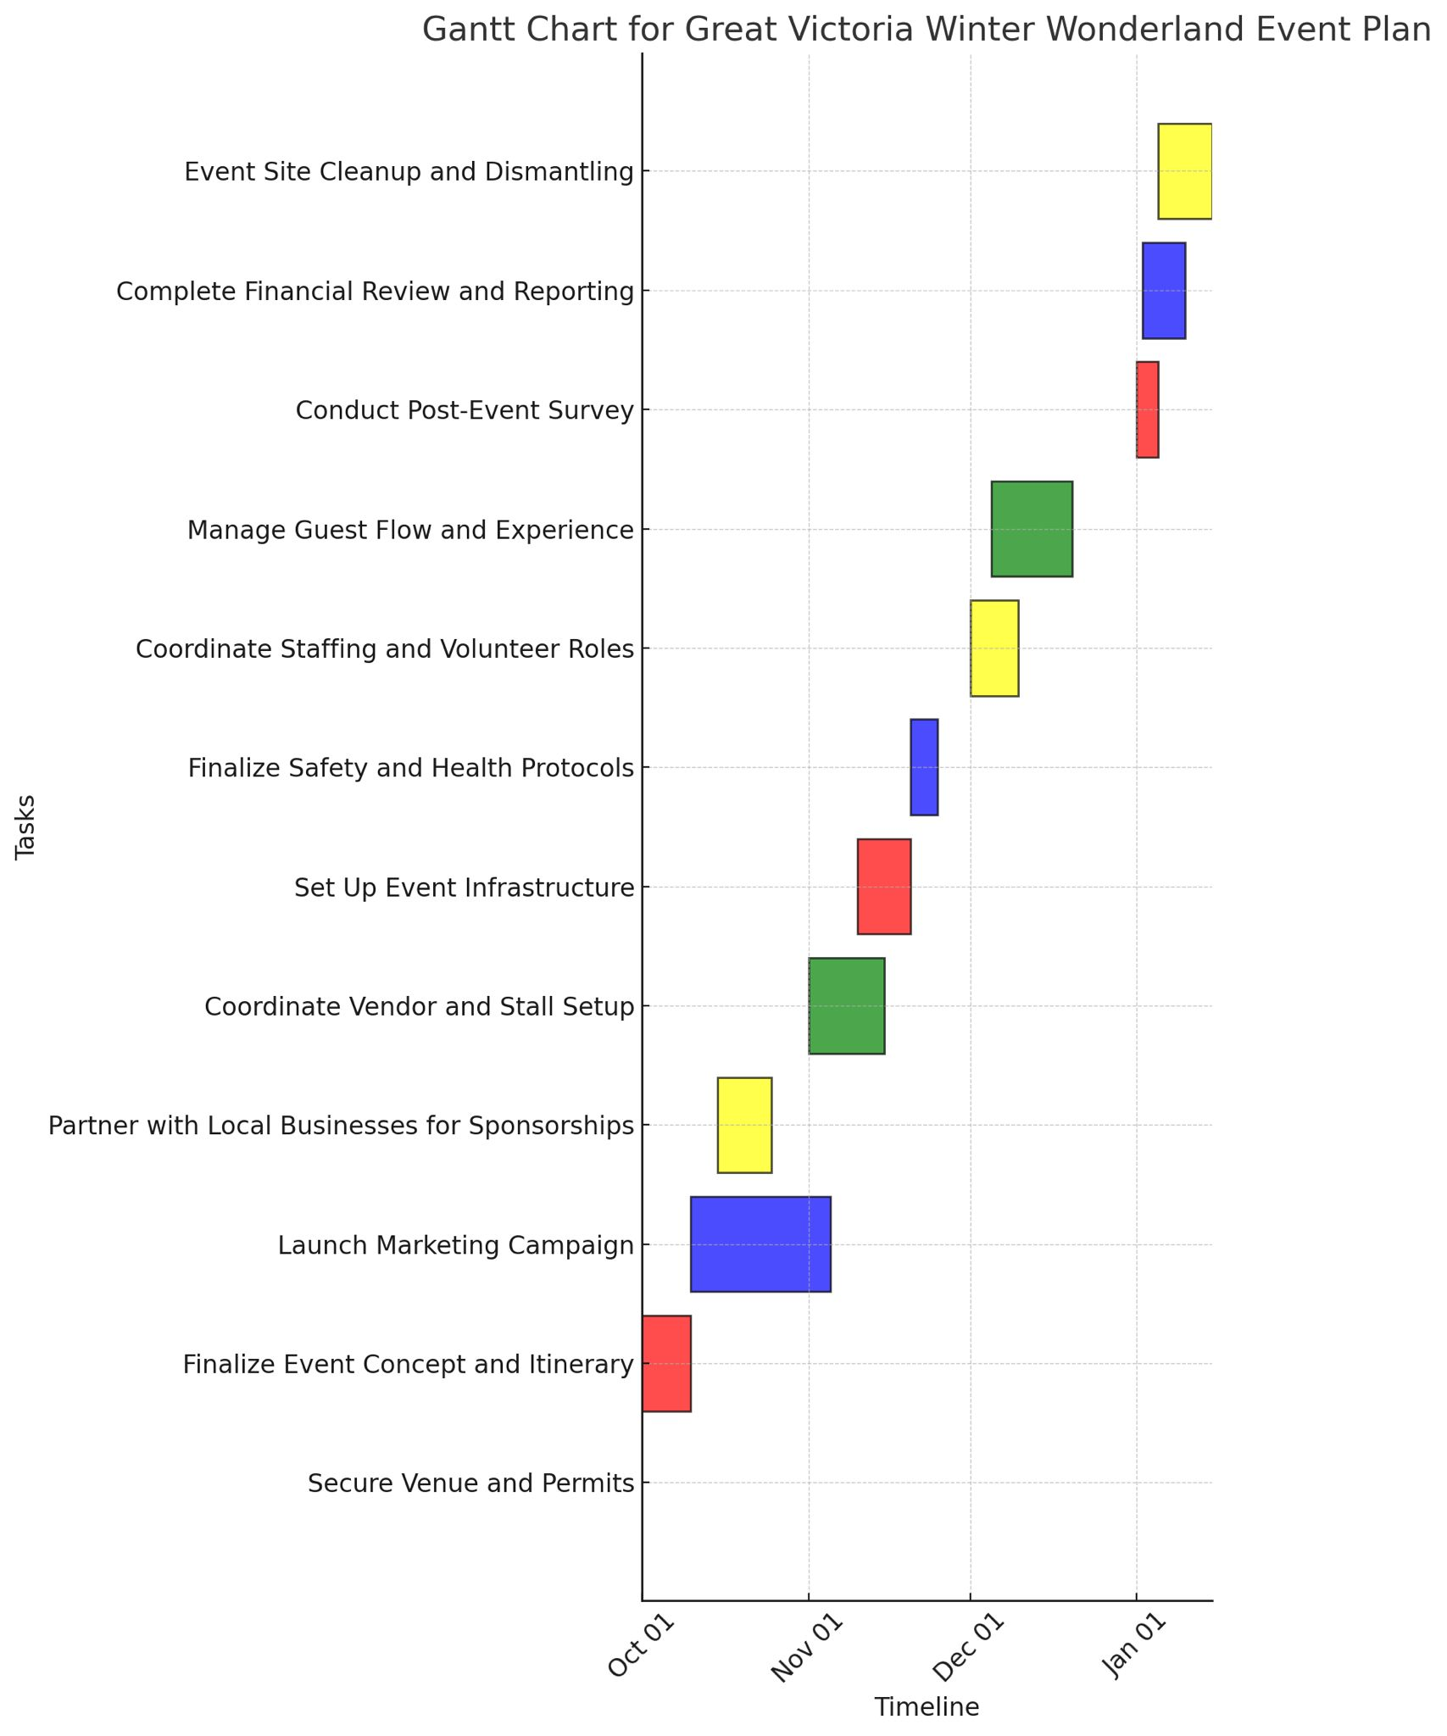

The venue must be booked, and all permits acquired by October 15, 2024. Finalising the attractions will need to be completed by October 30. The marketing team commences marketing campaigns on November 1st. Sponsorships must be in place by November 15th to indicate early bird ticket sales. The vendor setup and infrastructure testing will be completed by December 5, while health and safety protocols will be completed by 1st December. All staffing and volunteer coordination, ticketing, and security finalise on 3 December (Page. link, 2024).

- Conclusion
It would be a great seasonal experience for Bradford, driving positive economic and social impacts, and thus forming an immersive seasonal experience. This event could effectively be placed in the strategic planning and situational analyses of the event, with sure possibilities of attracting diverse sets of audiences, boosting the profile of the Great Victoria Hotel, and encouraging local businesses (Interim guidance, n.d.).

The focus of this report is on understanding various internal and external factors-economic, technological, social, and competitive forces important for enhancing this event's success. Indeed, the event team can use strengths like the prime location and diversified entertainment to minimise risks while enhancements are being made and maximise their event (Huet. Al, 2021). The Great Victoria will be able to become an effective flagship seasonal event that enriches Bradford culturally and economically and ensures long-lasting success in a competitive market.

- Recommendations:

- Augmented Reality Treasure Hunt, whereby using a smartphone families and children, can obtain winter-themed treasures within the venue. This shall enhance interaction with their current attractions and vendors while providing sponsorship opportunities for local businesses to underwrite named locations within the hunt (Interim guidance, n.d.).

- Green Foodie Zone will provide locally sourced, plant-based menus and compostable packaging to appeal to the eco-conscious attendees. This would involve partnerships with local organic suppliers that cater to modern consumer trends and contribute to positive media coverage to enhance the reputation of the event as sustainable and forward-thinking (Mair, and Smith, 2021).

- References:

- . Asif, N. and Bindhu D (2023). Crowd Management -Navigating Challenges and Implementing Best Practices in Crowd Management. [online] ResearchGate. Available at: https://www.researchgate.net/publication/376076772_Crowd_Management_-Navigating_Challenges_and_Implementing_Best_Practices_in_Crowd_Management.
(Accessed: 2nd November 2024).
- Bing.com. (2024). Events Management - Search Videos. [online] Available at: https://www.bing.com/videos/riverview/relatedvideo?q=Events+Management&mid=3C293F75A47675FCEA173C293F75A47675FCEA17&FORM=VIRE
(Accessed: 3^{ed} November 2024).
- Bing.com. (2024). Experiential Marketing in Seasonal Events: Enhancing Visitor Experience. - Search Videos. [online] Available at: https://www.bing.com/videos/riverview/relatedvideo?q=Experiential+Marketing+in+Seasonal+Events%3a+Enhancing+Visitor+Experience.&mid=D2BD624EE799E0052A5CD2BD624EE799E0052A5C&FORM=VIRE
(Accessed: 5th November 2024).
- Bing.com. (2024). Benefits of Social Media in Event Marketing: The Case of Winter Wonderland. - Search Videos. [online] Available at: https://www.bing.com/videos/riverview/relatedvideo?&q=Benefits+of+Social+Media+in+Event+Marketing%3a+The+Case+of+Winter+Wonderland.&qpvt=Benefits+of+Social+Media+in+Event+Marketing%3a+The+Case+of+Winter+Wonderland.&mid=6C9696F4D43AD2D962AE6C9696F4D43AD2D962AE&&FORM=VRDGAR
(Accessed: 5th November 2024).

- embok.org. (n.d.). EMBOK - Event Management Body of Knowledge - EMBOK Model. [online] Available at: https://embok.org/index.php/embok-model.
(Accessed: 1st November 2024).
- Eventbrite Blog. (2022). 6 Steps To Attract Festive Event Sponsors. [online] Available at: https://www.eventbrite.co.uk/blog/attract-festive-event-sponsors-ds00/?msockid=38518469414e602a1fc4965e454e66b4
(Accessed: 5th November 2024).
- Holacon Event Management (2024). Sustainability in Events: A Guide to Eco-Friendly Planning | Holacon Event Management. [online] Holacon Event Management Software. Available at: https://holacon.com/blog/detail/sustainability-in-events-a-guide-to-eco-friendly-planning.
(Accessed: 31st October 2024).
- Hu, R., Wang, C., Zhang, T., Nguyen, T., Shapoval, V. and Zhai, L. (2021). Applying augmented reality (AR) technologies in theatrical performances in theme parks: A transcendent experience perspective. Tourism Management Perspectives, [online] 40, p.100889. Available at: https://doi.org/10.1016/j.tmp.2021.100889.
(Accessed: 30th October 2024).
- Inés Sustacha, José Baños-Pino and Eduardo Del Valle (2023). The role of technology in enhancing the tourism experience in smart destinations: A meta-analysis. Journal of Destination Marketing and Management, [online] 30, pp.100817–100817. Available at: https://doi.org/10.1016/j.jdmm.2023.100817.
(Accessed: 27th October 2024).
- Kenton, W. (2024). How to Perform a SWOT Analysis. [online] Investopedia. Available at: https://www.investopedia.com/terms/s/swot.asp.
(Accessed: 31st October 2024).

- Key planning recommendations for mass gatherings in the context of COVID-19 Interim guidance. (n.d.). Available at: https://iris.who.int/bitstream/handle/10665/348018/WHO-2019-nCoV-POE-mass-gathering-2021.1-eng.pdf?sequence=1.
(Accessed: 2nd November 2024).
- Mair, J. and Smith, A. (2021). Events and sustainability: why making events more sustainable is not enough. Journal of Sustainable Tourism, 29(11-12), pp.1–17. Available at: https://doi.org/10.1080/09669582.2021.1942480.
(Accessed: 30th October 2024).
- McCullough, L. (2020). Corporate Event Management Best Practices: 2020 Guide. [online] Bizzabo. Available at: https://www.bizzabo.com/blog/corporate-event-management-guide.
(Accessed: 6th November 2024).
- Pereira, L., Jerónimo, C., Sempiterno, M., Lopes da Costa, R., Dias, Á. and António, N. (2021). Events and Festivals Contribution for Local Sustainability. Sustainability, [online] 13(3), p.1520. Available at: https://doi.org/10.3390/su13031520.
(Accessed: 31st October 2024).
- Page.link. (2024). Welcome to monday.com | a new way of working. [online] Available at: https://mondaycom.page.link/s9xaQYn9vXFhzZev8.
(Accessed: 27th October 2024).
- Robertson, E. (2024). WINTER WONDERLAND PARTIES - What’s On & Offers: The Great Victoria Hotel Bradford. [online] The Great Victoria Hotel Bradford. Available at: https://www.victoriabradford.co.uk/offers/winter-wonderland-parties/.
(Accessed: 28th October 2024).

- Richards, G. (2012). Eventful Cities. Routledge. Available at: https://doi.org/10.4324/9780080940960.
(Accessed: 28th October 2024).
- socialtables (2017). Define Event Goals and Objectives That Make an Impact. [online] Social Tables. Available at: https://www.socialtables.com/blog/event-planning/defining-event-goals/.
(Accessed: 4th November 2024).
- Stategy aims to attract more major events to Sheffield. (2024). BBC News. [online] 24 Oct. Available at: https://www.bbc.co.uk/news/articles/ckgd5eqkw8eo.
(Accessed: 28th October 2024).
- Stevenson, N. (2020). The contribution of community events to social sustainability in local neighborhoods. Journal of Sustainable Tourism, 29(11-12), pp.1–16. Available at: https://doi.org/10.1080/09669582.2020.1808664.
(Accessed: 5th November 2024).
- Thomas, K. and Stephens, S. (2022). (PDF) Understanding the Management Theory in Event Management. [online] ResearchGate. Available at: https://www.researchgate.net/publication/351229536_Understanding_the_Management_Theory_in_Event_Management.
(Accessed: 5th November 2024).
- Visitbradford.com. (2024). What’s On - Bradford. [online] Available at: https://www.visitbradford.com/whats-on
(Accessed: 3^{ed} November 2024).

- Appendix 1:
PESTLE Analysis
Political | Events on cultural activity may be supported in licensing and permits, funds, and promotion by local governments.
Economic | spending of consumers during holiday seasons in these quite sensitive economic periods will affect attendance and sales. Prices should hit a mark that can accommodate the largest number of people, taking into consideration the economic status.
Sociocultural: | Christmas has a cultural value in the UK; hence, Bradford, being multicultural, needs to see an event organised in an inclusive fashion that reflects diversified traditions.
Technological: | The amount of digital marketing and online ticketing necessary to reach the target audience and facilitate operations with features such as contactless entry via QR codes (Huet. Al, 2021).
Legal: | Compliance with local licensing laws, food safety, and contracts with vendors to avoid legal problems and maintain the event's reputation.
Environmental: | Environmental Practices, including reducing waste and renewable energy; will make the event more attractive to attendees concerned about the environment, plus lessen harm to the planet caused by the event.

- Appendix 2:
SOAR and SWOT analyses
The advantages of this event are underscored by its prime location at the Hotel in Bradford, which possesses significant historical charm. The venue's accessibility through public transportation links is likely to enhance attendance rates considerably. Scheduled during the Christmas season, the event is inherently relevant, appealing to families and tourists seeking festive experiences such as ice skating and visits to Santa's Grotto. Additionally, these activities cater to various demographic groups, creating multiple revenue streams and increasing overall visitor satisfaction (Kenton, 2024). Furthermore, the involvement of experienced event management guarantees that logistics and safety protocols are effectively implemented, ensuring a reliable and enjoyable experience for all guests (Bing.com, 2024).

Other opportunities include market development to capture corporate customers, university students, and young professionals by offering special VIP treats and student concessions. Composting packaging and buying from local business owners also appeal to eco-friendly visitors along with possible sponsors. The inclusion of innovative elements in this festival, such as an AR-based treasure hunt, would enhance the experience of the guests and the visibility of the sponsor brands. Partnering with local businesses for food and other accessories also enhances community involvement while cutting down the operational expenses at the same time.

Its weaknesses include that the event will rely on good weather; bad conditions may send attendance down and cancellations up. High operating costs, particularly for ice rinks and lighting, feature financial exposures if numbers fall below expectations. Inadequate on-site parking may cause guest inconvenience and degraded experiences. Reliance upon sponsorships may bring funding constraints that lead to fewer attractions or reduced operational activities.
Competition from better-established winter events in Leeds York, and Manchester, is also a threat. In this respect, each of these would need to have something unique or be reasonably competitive in their pricing to be attractive. Economic downturns could also reduce attendance as households cut out non-essential spending.

Ambitions revolve around positioning the event as Bradford's number one winter attraction, securing stakeholders through community partnerships and accessible activities, and providing an uplift in the brand reputation of the hotel by establishing its position as one of the top events venues. Innovative initiatives, such as AR experiences and eco-measures, align with current trends and demonstrate the receptive approach to continuous improvement by the hotel.

Results:
The results are an uplifted revenue due to diversified streams in ticket sales, VIP packages, and sponsorships; very high satisfaction of visitors about the event reflected in feedback after the event; less environmental impact, considering sustainable practices, and strengthening of community ties that bolsters the hotel's brand and future events.

