


Emerging Network Technologies

Exercise 3

Faculty of Architecture, Computing and Engineering (FACE)
School of Applied Computing
Mount Pleasant Campus
Swansea
SA1 6ED

Module Leader: Dr Carlene Campbell
Simulation of Communication Channels with Modulation

Getting Started
Start Matlab and open a new Simulink model and the Simulink library as usual. Remember to issue the commstartup command to set the appropriate simulation parameters.
Blocks
As with any communications system, there are three fundamental parts: a transmitter, a communication medium, and a receiver. Table 1 equates these three components with the Simulink blocks we will be using.
Transmitter | Bernoulli Binary Generator  (Comm. Sources library) | This block generates a random binary sequence (0s and 1s) for transmission
Communication Medium | AWGN Channel  (Comm. Channels library) | This block is a simulation of a channel affected by additive white Gaussian noise. This is a basic noise model that we can use to mimic random processes that can occur during transmission.
Receiver | Error Rate Calculation  (Comm. Sinks library) | This block calculates the error rate of the channel by comparing the transmitted signal (Tx) and the received signal (Rx).

Additionally, we also need to use a Display block (Simulink > Sinks library) so that we can see the output of the Error Rate Calculation Block.
We will start with a model similar to the one used last week. Construct the model using the above blocks so that it reflects Figure 1.
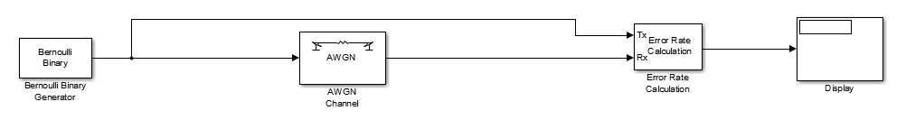
Figure 1 - Initial Model

Configure the block parameters as follows:
AWGN
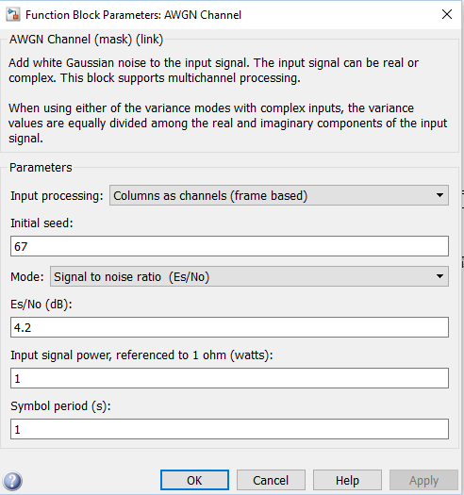
Using the Mode drop down menu, select Signal to noise ration (Es/No).
Set the Es/No value to 4.2

Error Rate Calculation

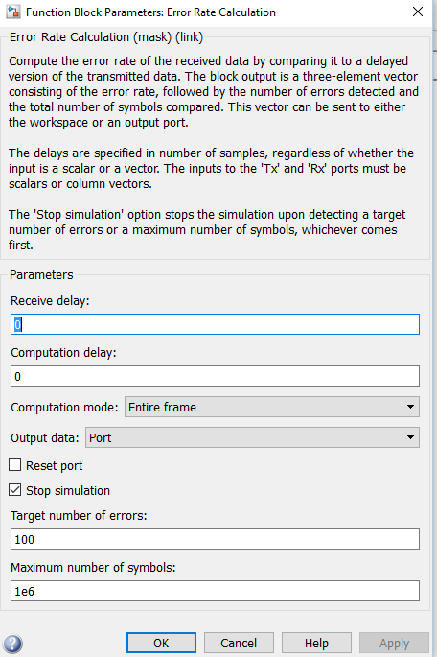
Figure 2 - Error Rate Block Parameters
Using the “Output data” drop-down menu, ensure “Port” is selected.
Make sure the “Stop simulation” checkbox is checked and that the “Target number of errors is set to 100.

This week we will add modulation to the channel, with the objective of comparing the performance of Binary Phase Shift Keying (BPSK), Quadrature Phase-Shift Keying (QPSK), and Quadrature Amplitude Modulation (QAM) modulation techniques.
For this you will require the following blocks:
Modulation Scheme | Required Blocks
BPSK | - BPSK Modulator Baseband  - BPSK Demodulator Baseband  (Comm. Modulation > Digital Baseband > PM)
QPSK | - QPSK Modulator Baseband  - QPSK Demodulator Baseband  (Comm. Modulation > Digital Baseband > PM)
QAM | - Rectangular QAM Modulator Baseband  - Rectangular QAM Demodulator Baseband  (Comm. Modulation > Digital Baseband > AM)

- You are required to save three separate Simulink models, one for each modulation scheme.
- Add the two blocks for the above modulation schemes to each of your simulation models.
Remember that the modulator is on the transmitting side and the demodulator operates on the receiver side; use this knowledge to determine where the blocks should be placed.
Your task for today is to determine which of the three modulation schemes demonstrates the best resilience to channel noise. You should then carry out research on each of the modulation schemes that have been experimented with, and determine if your findings are consistent with the results of the simulations you have run.
Important: Note that the error rate calculation will vary due each time you run a simulation due to the random nature of the AWGN channel, and it is therefore suggested that you simulate each modulation scheme at least five times and calculate an average (mean) error rate. You should also vary the levels of noise affecting the channel to observe the effects.

Questions:
- How would you calculate?
  - Bit Error Rate (BER)
  - Signal to Noise Ratio (SNR)
- Which modulation Scheme is the simplest form of phase shift keying? Why?
- Which modulation scheme is both an analog and a digital modulation scheme?
- Which schemes will suffers signal degradation and error probed on the channels?
  - Will these schemes need an error correction coding so that the interference from adjacent carrier phase in the constellation can be eliminated if not minimized?
  - Name two error correction coding

- These Constellation diagrams are example of which modulation system?

  - Constellation diagram for ________________________________
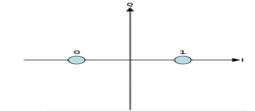

  - Constellation diagram of ______________________________________
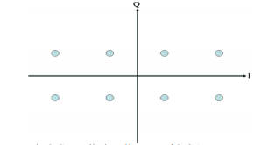

  - Which of these diagrams signal has to transmit extra power? State why.

