

Jack Frampton
2413011

Application of Computer Aided Engineering Processes

University of Wales Trinity Sant David
Computer Aided Engineering ACDB5007

Academic Year: 2025-2026

Supervisor: Andrew Noble

Academic integrity declaration
I declare that:
- the thesis submitted has been written by me alone.
- the thesis submitted has not been previously submitted to this university or any other.
- that all content, including primary and/or secondary data, is true to the best of my knowledge.
- that all quotations and references have been duly acknowledged according to the requirements of academic research.
I understand that to knowingly submit work in violation of the above statement will be considered by examiners as academic misconduct.

Contents
Academic integrity declaration 2
Abstract 5
Introduction 5
Case Study Description and Problem Definition 6
Engineering Context 6
Simplified Test Case Selection 6
Key Performance Metrics 6
Objectives of Case Study 7
Analytical Background and Simplified Solution 7
Purpose of the Analytical Model 7
Preferable Impact Model and Assumptions 8
Limitations of Analytical Solutions 8
Role of the Analytical Solution in CAE Validation 8
CAE Modelling Practice 8
Purpose of Simulated Model 8
Geometry and Model Design 9
Material Modelling 9
Contact Modelling 9
Mech Considerations 10
Mesh Independence Study 10
Purpose of Mesh Independence Study 10
Mesh Refinement 10
Standards used for Mesh Adjustment Evaluation 10
Results of Mesh Refinement 11
Simulated Case Study 11
Comparison of Meshes 19
Influence of Boundary Conditions 19
Importance of Boundary Conditions in CAE 19
Boundary Condition Application 20
Role of Boundary Conditions in CAE Validation 20
Conclusion 20
Bibliography 21

Abstract
The use of Computer Aided Engineering (CAE) tools is extremely important in regard to modern engineering processes. They are widely utilised for research, validation and optimisation of systems/components. In spite of their variety of capabilities, they rely heavily on the user’s capability, mathematical assumptions and numerical settings. This report will investigate the use and limitations of CAE tools through a simplified engineering model. Furthermore, a mesh independence study is conducted to test the credibility of user-inputted values in comparison to a real-world scenario, it will also evaluate the effects of boundary conditions and how it reflects on the result accuracy. The results will show the benefits of modelling complex actual behaviour and also the limitations from numerical simplification and boundaries. It demonstrates that CAE should be used as part of an investigative process instead of a standalone hypothetical solution.

Introduction
CAE tools have become an incredibly important part of modern engineering applications, they provide compelling skills for research, validation and optimisation for engineering designs and suggestions [1]. Advances in strength and mathematical methods have enabled engineers to input increasingly more complex designs and systems, decreasing time-spent and cost in terms of avoiding real-world evaluation.
In contrast of popularity, CAE tools have many limitations. The accuracy of any simulation relies solely on the foundational inputs by the user, boundary conditions and accuracy of data. If data is wrongly inputted or if the wrong conditions are set, this will drastically skew results potentially resulting in flawed design adjustments/decisions.
Furthermore, where feasible, automated solutions should be compared to physical calculations as validation is an extremely important part of using CAE application such as Ansys. Simplified test cases, where solutions can be solved through first principles. Also, the altering of the values of the mesh provides a great insight into how the software calculates the desired, simulated outcome and the extent of which user-defined inputs can change the results.
This report tries to investigate the use, accuracy and limitations of the CAE software, Ansys through a simulated case study exploring the outcomes of tweaking mesh sizes, mesh concentration and mesh boundaries. This will be measured through a mesh independence study by simulating a case study and using this as a benchmark to validate the following meshes. This investigation will show the best practice in terms of utilising CAE software as well as the drawbacks of relying on it.

Case Study Description and Problem Definition

Engineering Context
Penetration and impact simulations containing high strain rates are seen across a range of engineering applications. These simulations are categorised by highly transient loading conditions, strain wave propagation and non-linear material behaviour. Due to cost-effectiveness and practicality, CAE tools are widely used to simulate engineering concepts and theories.
In this investigation, a projectile impacting a metal plate will be used to highlight the impact response. Specifically, a copper bullet and steel 1006 plate will be used to assess these conditions. This simulation is often used to study projectile behaviour when impacting a tough surface [2]. It is commonly used due to the fact that it can test CAE limitations beyond other case studies as it includes velocity of a projectile and also material behaviours such as Young’s modulus and Poisson’s ratio.
The case study is in place to show the use of CAE within an engineering design and analysis, rather than a fixed, flawless practice. It highlights the understanding of how modelling decisions influence outcomes.

Simplified Test Case Selection
A simplified test case is introduced to allow fundamental analysis without introducing unnecessary, complex calculations. This allows identification of key behavioural properties.
The selected test case is a solid projectile impacting a flat, homogeneous metal plate perpendicular to the surface. The plate will show linear elastic and plastic behaviour to show the progression of deformation through both objects. These qualities allow analysis of impact and stress/strain waves, it allows the estimation of the response of impact. For example, contact force and peak tress levels, these will serve as a benchmark for validation.
While this simplified test case does not showcase a real-world ballistic impact, it provides a controlled environment in which the numerical inputs can be assessed and validated.

Key Performance Metrics
The considered performance metrics allow a baseline in which the test case can be analysed and compared. These points of analysis are chosen based on their relevance to the aim of the report – the limit of estimation and how it is calculated.
The main metrics investigated included:
- Peak stress within the armour plate at the point of impact
- Patterns of deformation
- Mech independence and how it affects results
These metrics enable strong points of comparison throughout simulation changes. Discrepancies between analytical and numerical results is used to investigate underlying modelling assumptions within the software and potential sources of inaccuracy.

Objectives of Case Study
The objectives of this simplified case study are as follows:
- Demonstrate the use of CAE tools against high-strain-rate, complex engineering models/scenarios
- Investigate the influence of mesh density and disparity on result accuracy through a mesh independence study
- Assess the reaction of impact response to unique boundary conditions
- Critically evaluate the assumptions and limitations popular in CAE software when simulating high velocity impact tests.
Through the use of these objectives, this report serves as a structured way of reviewing CAE tools in terms of accuracy and validation. These objectives align well with the aims of this report, as it has been used previously to argue separate approaches to the use of CAE tools [2].

Analytical Background and Simplified Solution

Purpose of the Analytical Model
The goal of the analytical model in this section is to provide a simplified result in which the simulated result can be compared. The use of analytical results solved through first principles serve as a benchmark for future analysis from which CAE simulations can be validated. It serves as a secondary “checklist” to establish confidence in theoretical results.
Due to the complexity of a real-world scenario simulated in Ansys, it is broken down to simplified reactions and assumptions. It is not simulated to provide realism but as one step of validation is a long order of validation processes, a comparison of stress in early development stages and impact responses.

Preferable Impact Model and Assumptions
To ensure the case study can be described using equations, using basic mathematical methods, the bullet and armour plate scenario is idealised using assumptions commonly used in impact and wave propagation theory [3]:
- The projectile behaves as a solid, deformable body
- The armour plate is homogenous and linearly elastic and plastic
- Impact occurs at normal incidence
These assumptions simplify the problem so the point of impact can be treated as elastic and plastic waves forming at the point of contact.

Limitations of Analytical Solutions
Analytical equations have clear limitations because they rely on quite extreme simplification of the case study. Effects such as plastic deformation, material damage and failure are not representative of a real-world scenario but is necessary to include mathematical validation. In reality, impact tests involve highly complex contact effects.
In contrast to this, analytical solutions are still extremely useful in CAE scenarios. They assist is defining justifiable ranges of stress, strain and displacement of material while also checking for potential simulation errors.

Role of the Analytical Solution in CAE Validation
The analytical solutions serve as a baseline against which the simulation results can be compared. When the overall trends and theoretical values align, it provides confidence in the numerical calculations. The deviations are evaluated to understand the effects of numerical accuracy, the assumptions and limitations of the CAE software.
Due to this process, the analytical solution creates a crucial part of engineering validation. This proves the importance of first principles when simulating CAE scenarios to achieve reliable and verifiable results.

CAE Modelling Practice

Purpose of Simulated Model
The purpose of the software model is to simulate the simplified bullet/armour plate impact scenario described previously. This model is not aimed to predict real-world ballistic effects but to instead to be used as a comparison using the same simplified assumptions shown in an analytical comparison. This approach allows the accuracy and reliability of CAE tools to be tested.
ANSYS is used as the CAE tool due to its capabilities of simulating short-duration dynamic scenarios and its broad use in engineering processes. The case study is designed to assess how well CAE tools can present simplified physical impact behaviour and to demonstrate the effect of modelling decisions on the simulated outcome.

Geometry and Model Design
The chosen CAE model is a flat armour plate and bullet. The design is heavily simplified to reduce uncertainty when running the simulation and to avoid enabling fictional stress. For example, the top of the bullet is intentionally, severely rounded to avoid having one node on the end. As this would make the bullet infinitely pointy, which this software would not allow.
Through both components, symmetry is used to keep the model easily solvable while still accurate physical impact. This allows the outcome to be evaluated effectively without jeopardising the validity of the evaluation.

Material Modelling
Bothe the projectile and armour plate are modelled as deformable bodies in ANSYS. The materials behave as isotropic, homogeneous solids; the bullet as copper and the armour plate as 1006 steel. They are characterised using Young’s Modulus, Poisson’s Ratio and density. Using these characteristics allow the simulated model to stay aligned with the analytical model by using the same values.
Allowing both components to deform enables a more suitable presentation of stress during impact, while avoiding complex effects such as air resistance, heat transfer, etc. The deformation of the ballistic is crucial to further examine the stress wave formation through the armour plate as the disfigured bullet will produce a larger impact zone which creates a secondary stress wave.
Although limitations are in place which restricts realism, it supports the initial aim of the report which is to assess the accuracy of CAE tools rather than to predict a real-world ballistic scenario.

Contact Modelling
Contact between the bullet and armour plate is specified to allow the transfer of force between the two components. Friction is purposefully left out to remain consistent with the test case simplification.
Contact modelling can be one of the most challenging aspects of simulating scenarios in CAE tools, so a standardised contact force is implied to reduce points of error in validation and to avoid excessive variables in the analysis[4].

Mech Considerations
The bullet and armour plate are divided into a finite element mesh to complete a numerical analysis of the impact. The starting mesh size is inputted based on an engineering judgment to provide an even balance between accuracy and validation capabilities. Since simulated results can change drastically due to change in mesh size, a mesh independence study is conducted.
The simulation uses an explicit solver which is well suited for modelling-short-duration impact scenarios involving stress waves and contact. Explicit solvers calculate the simulated response in extremely small, customisable time increments allowing the visualisation of rapid changes in stress and deformation. This is very practicable for a wide range of engineering processes not limited to OME scenarios [5].

Mesh Independence Study

Purpose of Mesh Independence Study
In Finite Element Analysis (FEA), the accuracy of the simulated outcomes is heavily reliant and influenced by the density of the inputted mesh. If the mesh is too coarse, the software may fail to capture the deformation throughout the impact time. While an excessively fine mesh can increase the computational load and at this point, would be near impossible to validate by hand calculations. “Mesh quality and density values are directly linked with solution accuracy” [6].

Mesh Refinement
A sequence of simulations is calculated using progressively refined meshes on the armour plate. A low-definition mesh is used a control in which other mesh values are compared. Following meshes are then refined further in the region of interest using a sphere of influence to focus the results on the affected area where high stress values and deformation is predicted.
This strategy is used to so that only mesh values are altered between each simulation while all other parameters, such as material properties, boundary conditions, velocity of ballistic and solver settings (explicit) remain unchanged. This allows the evaluation to focus solely on the difference in mesh density and how it affects the results.

Standards used for Mesh Adjustment Evaluation
To assess the effects of mesh convergence, simulated outputs are noted for all mesh configurations. These metrics are chosen based on their relevance to the evaluation; how mesh refinement affects stress and deformation outputs.
These metrics include:
- Deformation of the plate during/postimpact
- Maximum stress on the plate at the point of impact
- Overall deformation patterns and stress waves
These points enable a solid and informational mesh independence study.

Results of Mesh Refinement
The following images show mesh refinement of the simplified case study from which peak stress values can be extracted and a suggested convergence towards a stable mesh is highlighted.

Simulated Case Study
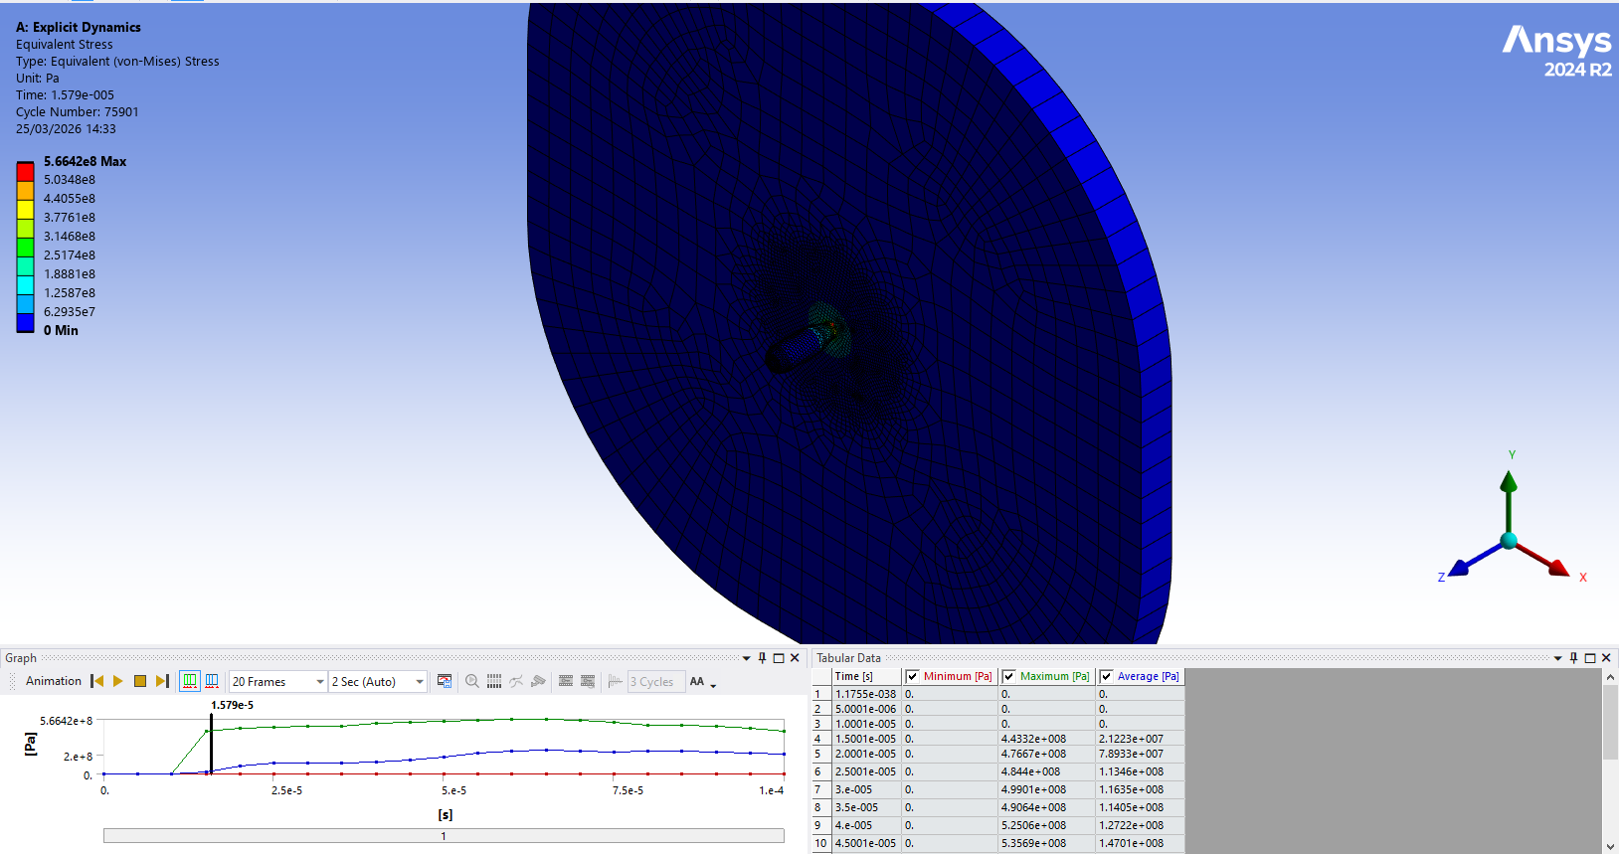

Figure 1 – standard mesh definition with standard sphere of influence at first impact

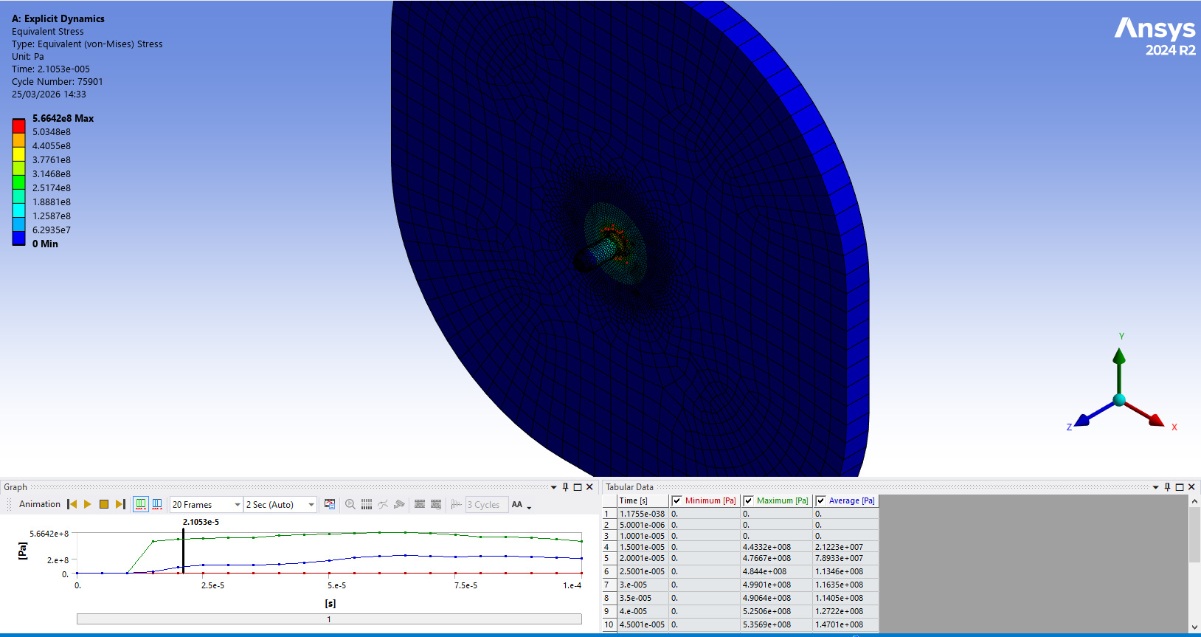

Figure 2 – standard mesh definition with standard sphere of influence, later time interval of impact
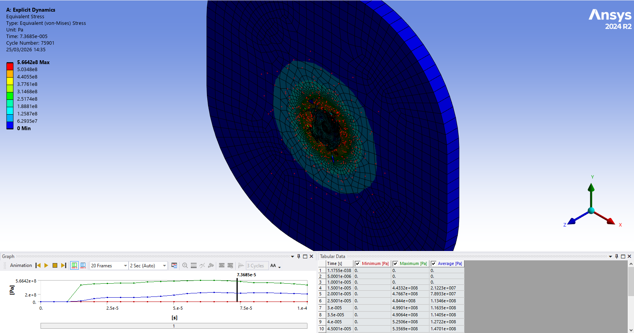
Figure 3 – standard mesh definition with standard sphere of influence, total deformation of bullet
Figures 1 – 3 show a standard mesh with a standard sphere of influence. It shows a reasonable stress propagation wave to which the following mesh refinement changes can be evaluated.
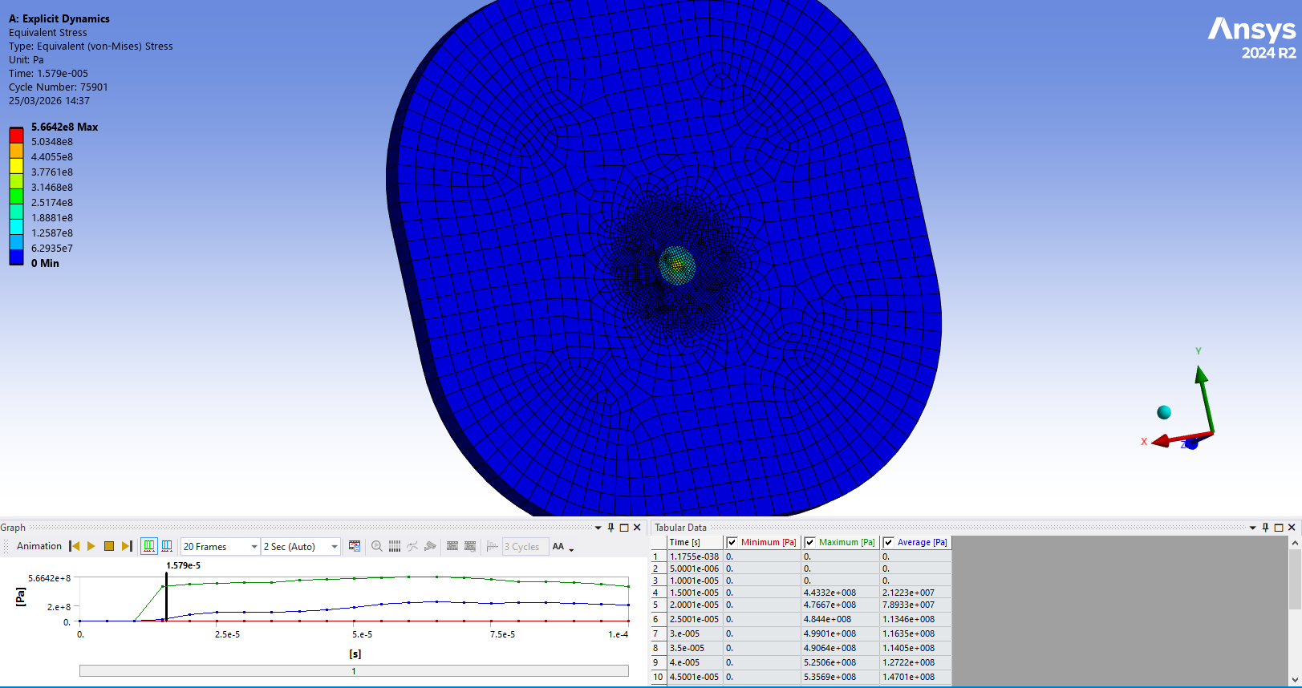
Figure 4 – standard mesh definition, rear of armour plate at first impact
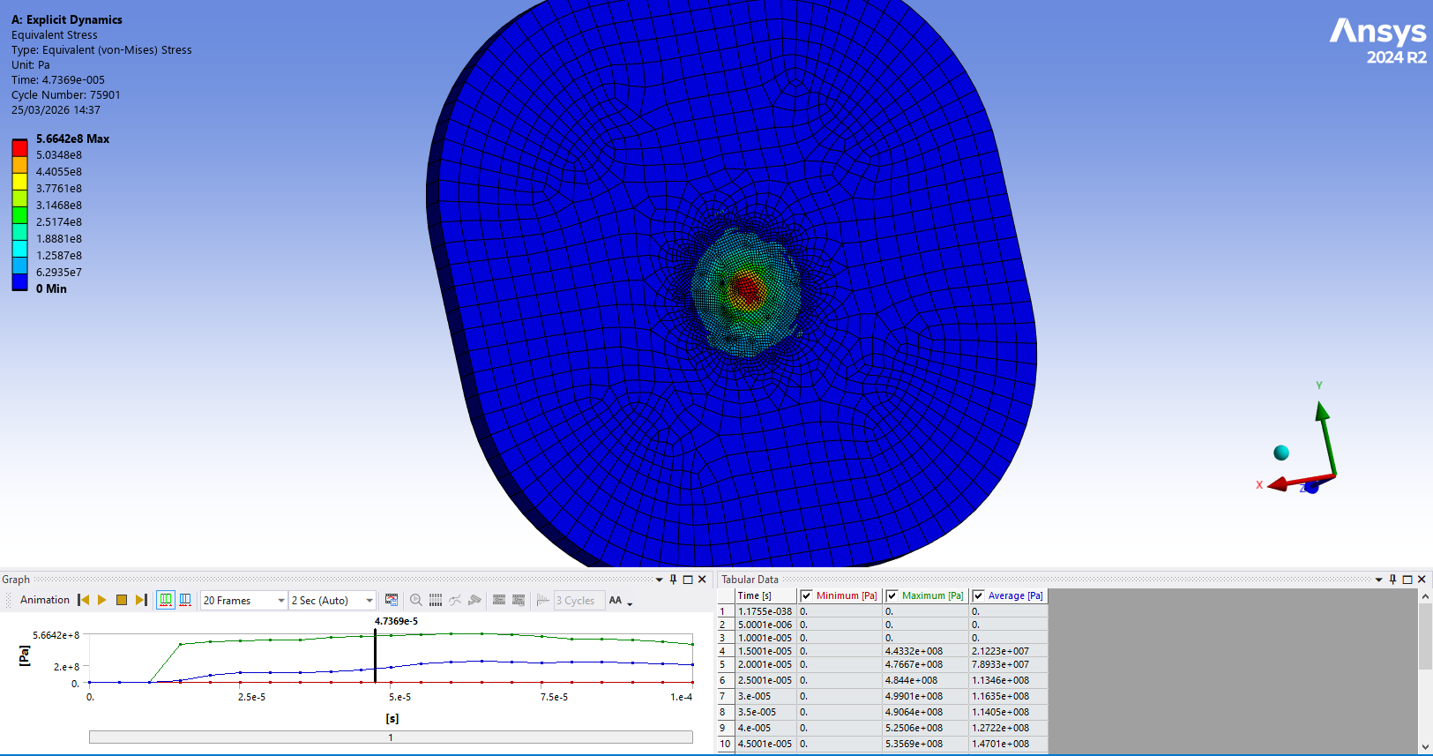
Figure 5 - standard mesh definition, rear of armour plate, later time interval
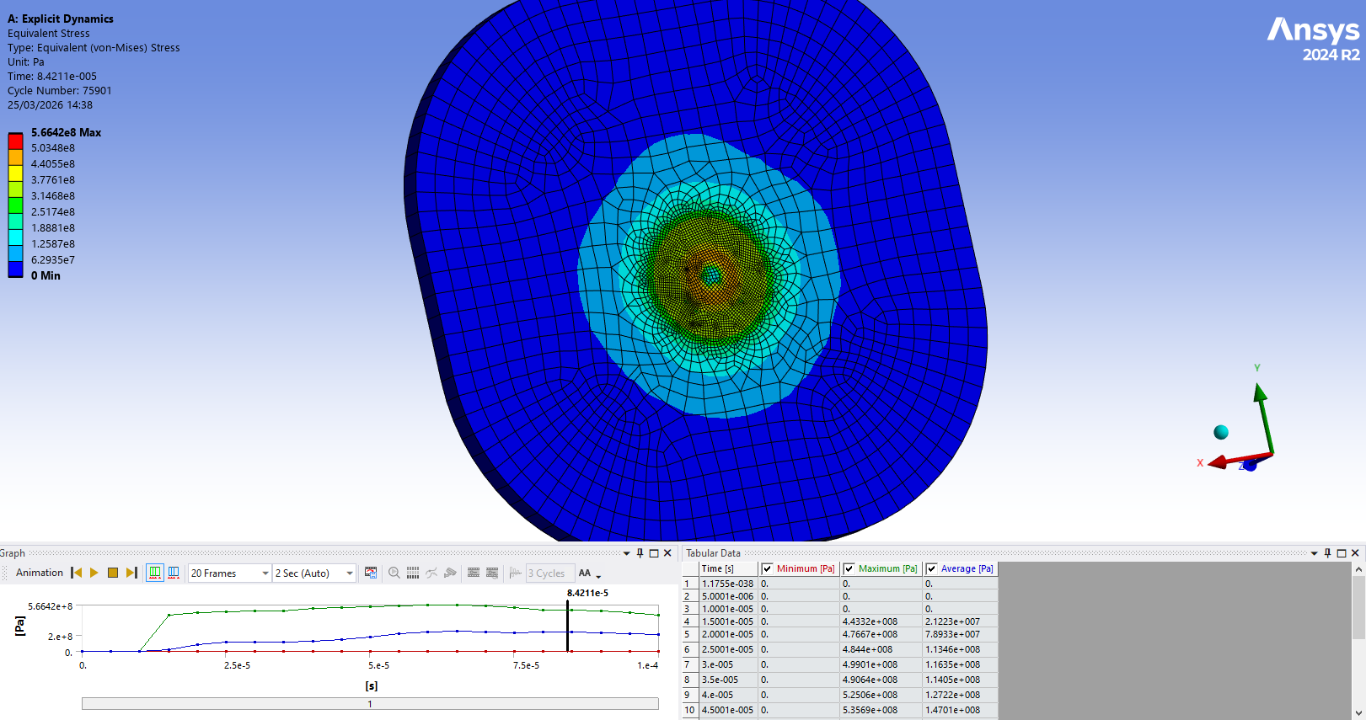
Figure 6 - standard mesh definition, rear of armour plate, during total deformation of bullet
Figures 4 – 6 reveal the rear of the armour plate, highlighting the extent of the stress wave. Due to the standard sphere of influence, the stress wave does not travel far through the material, which does not gauge the full extent of the force affecting the armour plate.

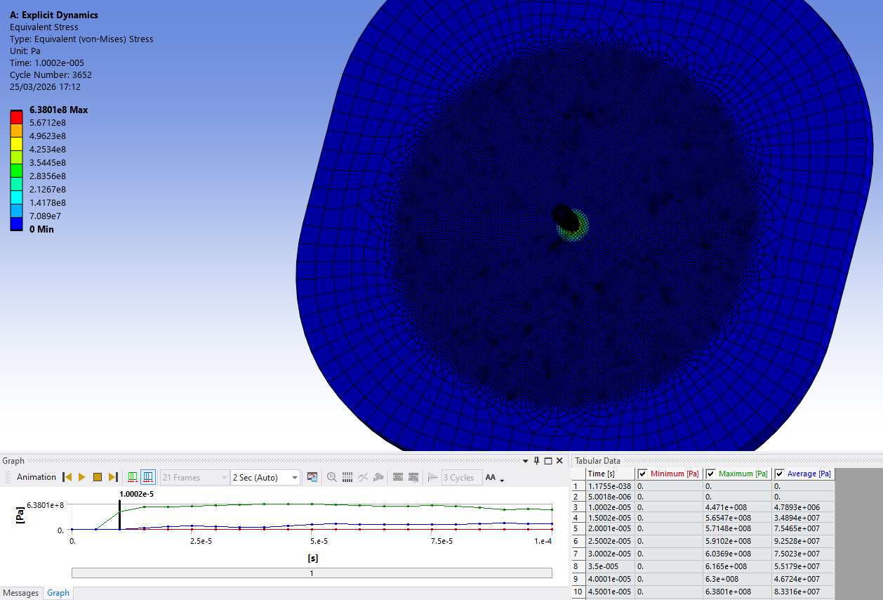
Figure 7 – reduced size mesh and larger sphere of influence, first impact
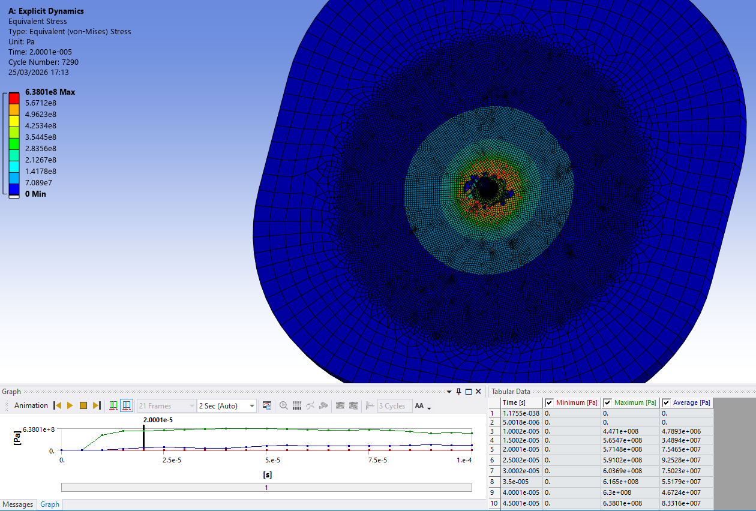
Figure 8 - reduced size mesh and larger sphere of influence, later time interval of impact

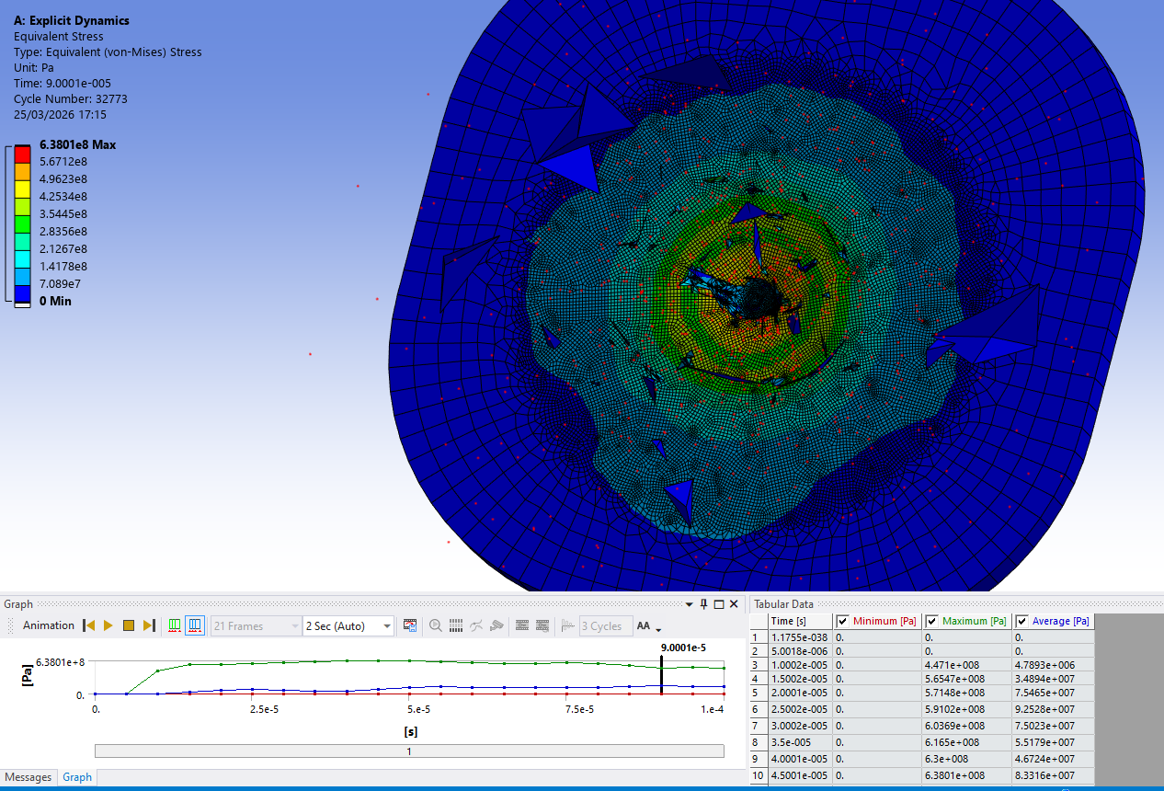
Figure 9 - reduced size mesh and larger sphere of influence, total deformation of bullet
Figure 7 – 9 show a high-definition mesh with a larger sphere of influence, the extended stress wave is much more prevalent in this adjustment. The bullet deformation is also much larger due to the more refined mesh.
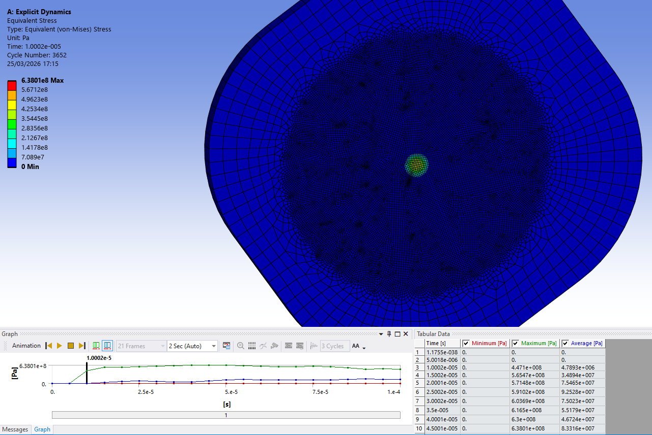
Figure 10 - reduced size mesh and larger sphere of influence at first impact, rear of armour plate

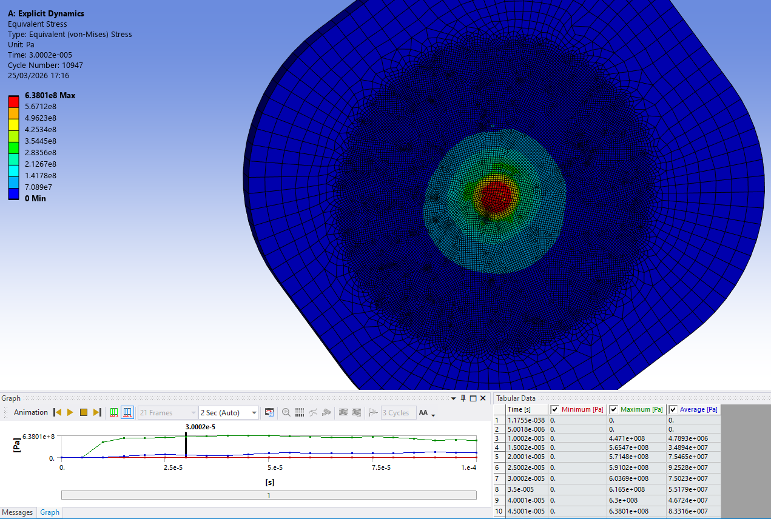
Figure 11 - reduced size mesh and larger sphere of influence at later time interval, rear of armour plate
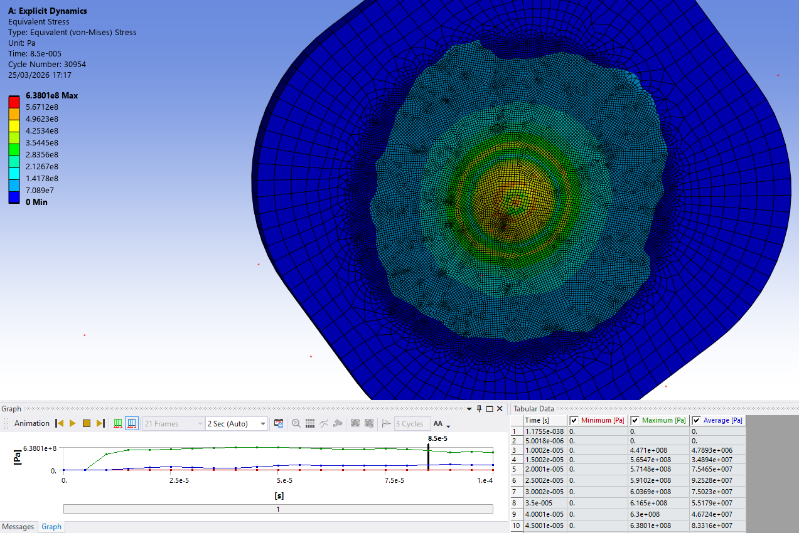
Figure 12 - reduced size mesh and larger sphere of influence at total deformation of bullet, rear of armour plate
Figures 10 – 12 shows the rear of the armour plate at multiple time intervals, this allows a very informative insight into stress values through the material and how forces are transferred between the front and the rear of the plate.
In CAE modelling, a sphere of influence is a region on a software component where the mesh is much more refined compared to other areas on the surface. This is extremely useful in investigating mesh influence and obtaining stress values as a user can avoid simulating areas where stress values are not needed. it is extremely useful for retrieving peak stress levels at the point of impact in this case.
A smaller sphere of influence limits mesh definition to a very localised portion of the impact area. Even though this approach reduces computational time, the stress propagation wave may not be accurately simulated, giving inaccurate results.
A larger sphere of influence increases the area in which the mesh is refined. This permits the stress wave a deformation to extend throughout the material, and lower stress values are highlighted due to the fact that there are more nodes with a lower resistance to these forces.

Comparison of Meshes
Comparing Figures 1 – 3 and Figures 7 – 9, it is clear that the larger sphere of influence shows more wave propagation and material deformation. In Figures 1 – 3, the wave does not reach far within the material which can be very misleading if taken at face value, the stress wave also looks very uniform which, in a physical scenario, is extremely inaccurate.
In Figures 7 – 9, the stress wave becomes more and more distorted as it reaches the edges of the armour plate, this is much more reflective of a real-world scenario due to imperfections in both components. Furthermore, the deformation of the bullet is much more prominent as it comes into contact with many more nodes.

Influence of Boundary Conditions

Importance of Boundary Conditions in CAE
The use of boundary conditions is vital in CAE application. In CAE scenarios, mainly those involving dynamic events, boundary conditions play an extremely important role in predicting stress values, deformation and displacement of the components.
In a real-world scenario, the boundary conditions may not be perfectly calculated or recorded so they are simplified within a CAE tool. For example, in this study, a fixed boundary is applied to the exterior edges of the armour plate, so the deformation only occurs at the point of impact. It is essential in understanding how different boundary conditions affect results. Evaluating these conditions are extremely useful in CAE simulations as they can be altered to assess different properties of a simulation.

Boundary Condition Application
A baseline boundary condition is applied to the armour plate on its exterior edges to prevent it from moving and to focus the deformation on the surface. This constraint was chosen as a similar assumption is made in an analytical model, keeping consistency in calculations.
This method allows the results to be examined in a controlled manner and provides a reference case against which other boundary conditions can be compared.

Role of Boundary Conditions in CAE Validation
This study of the boundaries forms a critical part of the validation aspect of an engineering process. By usin this type of boundary condition, the stress values can be measured at the point of impact without being influenced by the deformation of irrelevant areas.
When combined with an analytical model and a mesh independence study, boundary conditions contribute significantly to the validation of the simplified test case compared to a physical test case. This process of validation is best practice in an engineering process to assess trends and behaviours.

Conclusion
This report has investigated the use of CAE tools to model and predict a bullet and armour plate impact scenario. The primary aim was to show how CAE tools can be applied to physical engineering problems while critically assessing the accuracy, limitations and assumptions prevalent in simulated settings.
A mesh independence study was conducted to demonstrate the effect it has on the outcomes of a CAE simulation, especially where the mesh definition is significant due to the use of a sphere of influence. The study revealed that when adjusting the size of the sphere of influence, the stress wave propagation changes drastically, with the larger sphere of influence being the most informative. The reinforced the importance of mesh definition checks for CAE results.
The report also explained the importance of boundary conditions. The use of boundary conditions allows the user to focus the results primarily on stress values at the point of impact and deformation of the impact area.
Overall, this study demonstrates that CAE tools are highly effective in component analysis when used correctly and appropriately and supported by mathematical validation. This report also highlights that CAE software should not be taken as factual 100% of the time as the software makes many assumptions when solving a simulation but should be used a section of a validation process supported by first principles.

Bibliography

[1] | T. Stolarski, Y. Nakasone and S. Yoshimoto, Engineering Analysis with ANSYS Software, Butterworth-Heinemann, 2018.
[2] | M. Kumar Bhuarya, M. Singh Rajput and A. Gupta, “Finite Element Simulation of Impact on Metal Plate,” Procedia Engineering, vol. 173, pp. 259-263, 2017.
[3] | W. Goldmsith, Impact: The Theory and Physical Behaviour of Colliding Solids, New York: Dover, 2001.
[4] | T. Pore, S. G. Thorat and A. A. Nema, “Review of Contact Modelling in Nonlinear Finite Element Analysis,” Materials Today: Proceedings, vol. 47, pp. 2436-2440, 2021.
[5] | P. Pawar, R. Ballav, Kumar and A, “Finite Element Method Broach Tool Drilling Analysis using Explicit Dynamics ANSYS,” International Journal Manufacturing Technologies, vol. VIII, pp. 54-60, 2016.
[6] | H. Patil and P. V. Jeyakarthikeyan, “Mesh Convergence Study and Estimation of Discretization Error of Hub in Clutch Disc with Integration of ANSYS,” IOP COnference Series: Materials Science and Engineering, vol. 402, p. Article No. 012065, 2018.

