
The impact of Virtual Learning Environment (Moodle) on the learning experience of the students at UWTSD London campus (BMSW4003)
Research Report
Student: Kabirat Aderoju Adegbite 2011967 | 1/6/20 | Lecturer: Koushik Modak

Contents
Introduction 3
Rationale 3
Research Objectives 3
Literature Review/Review of the existing literature 3
Research Methodology 5
Data Collection 5
Qualitative Research Method 5
Quantitative Research Method 5
Primary Data 6
Secondary Data 6
Population, Sample and Sample size 6
Ethics in data collection 6
Results Analysis and Discussion 7
Primary data graph analysis 7
Q1). Pie chart Analysis 7
Q2). Graph analysis. 8
Q3). Pie Charts Analysis. 9
Q4). Pie charts analysis. 10
Q5). Pie chart analysis. 11
Q6). Open ended question analysis. 11
Secondary data analysis 12
Summary of the findings 12
Conclusion 12
Recommendation 12
Appendix 1 (Questionnaire) 13
Appendix 2 (Result) 15
References 16

Introduction
In this assignment I will be doing research about the impact of virtual learning environment (Moodle) on student learning experience at the University of Wales Trinity St David London campus. Virtual learning environment (VLE) is a web-based educational platform used for teaching and learning (eThink, 2020).

Rationale
The purpose for this research is to know how effective virtual learning environment has been for students. In this research I will be using different method of data such as, Quantitative data, qualitative data, primary data and secondary data.

Research Objectives
This research objective will enlighten me on why some student prefer to use VLE and why some find difficulties in understanding what the purpose is. I will compare the different analysis I have found to my own research so that I can get a better outcome. while doing this research I will ensure all opinions are I have received are accurate for mind findings which is finding the impact of VLE on student at UWTSD London campus

Literature Review/Review of the existing literature
I will be reviewing five different articles by looking at existing literature review on the impact of virtual learning environment (VLE). However, this research will focus on the impact of virtual learning environment (Moodle) on the learning experience.
I will analyse different method they have use and what they achieved at the end of the report. This research was about “The influence of virtual leaning environment in students’ performance” (Alves, et al., 2017) This authors “aimed to assess the frequency of students’ access to the virtual learning environment (VLE) approved by the institution, as well as the relation between the frequency of access to the VLE and the students’ performance”. The method which they have used to conduct their research is quantitative data “with descriptive features, involving data obtained from literature rese and from experimental research they done using sample of “6300 undergraduate. The data in which they used was from a VLE and student registration system data that is being used for learning. “The result show that there are positively indicators regarding students’ access to a virtual learning environment and the relation between such access and their performance”. (Alves, et al., 2017)
A research was conducted on “The impact of a virtual learning environment: students’ views”. They did a report on 248 English Sixth Form College students about the impact of using college VLE(Moodle) on learning. they wanted to find out if teaching and learning through VLE has help them develop independent learning and weather it increases students’ motivation to learn. While doing their research they conducted it by using quantitative data such as (Survey Monkey). At the end of this research they concluded that (Moodle) has a positive impact on students learning (Barker & Gossman, 2013).
These authors have researched on “Evaluation of How the Blended use of Virtual Learning Environment (VLE) Can Impact on Learning and Teaching in a Specific Module” the authors done their research using the population at their university. forty-seven student participated in the study. Student questionnaires, Moodle reports and student assessment grade were used to analyse to distinguish what he benefits of online forum is. In this research the authors have used quantitative data questionnaire with closed ended question. Their findings highlighted “the importance of viewing VLE as a communication, collaboration and knowledge-focused medium with the potential of enhancing higher learning skills through the use of interactive online forum activities” (Lyndon & Hale, 2014).
“The Impact of Student Activity in a Virtual Learning Environment on Their Final Mark” by studying the use of a virtual learning environment, many have focused on automatically logged web data in order to distinguish what increases student’s use of virtual learning environment and perhaps it might impact their productive and efficient learning. The research is to examine the activity log used by students while they are logged into their virtual learning environment. The result of this research shows that there are positive links between students’ logs of activities and their final mark (Mogus, et al., 2012)
Many universities use VLE activity as a primary measure for productivity and proxy for engagement with learning, with many studies of how such online engagement is related to student performance. These authors have analysed “The relationship between engagement in Virtual learning environment (VLE) and module grades at Bricks and Mortar University in United kingdom” “they measured VLE activity for students enrolled in 38 different credit-bearing modules and each of the modules ae compulsory component of six degree programmes”. During their analysis they find that high activity on VLE can be associated with high grades, but low activity does not necessarily mean low grades. “Their findings suggest that student engagement with learning at Brick and Mortar University is in general hard to determine by VLE usage alone, due to the majority of other offline leaning activities” that student might be doing (Boulton, et al., 2018).

Research Methodology

Data Collection
Data collection is collecting numerous information from relevant sources to find answer to a research problem, test the theory and evaluate the outcome. There are two categories data collection can be divided into such as: secondary and primary data collection method (Dudovskiy, 2011).
Secondary data collection method can be a data that has already been published in books, newspapers, magazines, journals and many more (Dudovskiy, 2011).
Primary data collection method is split into two: quantitative and qualitative data.

Qualitative Research Method
Qualitative research is a non-numerical data, such as language. Qualitative research can be used to understand how an individual subjectively observes and gives meaning to their social reality. (Mcleod, 2019)
Qualitative research is associated with using words, sounds, feeling, emotions and colours this type of data is then used to understand the person’s situation. (Dudovskiy, 2011)
The methods which are used for qualitative research are interviews, questionnaires with open-ended questions, focus groups and more. (Dudovskiy, 2011)

Quantitative Research Method
Quantitative research involves the process of accurately collecting and analysing numerical data to describe, predict or control variables of interests. (Mcleod, 2019)
Quantitative research method is used for getting opinions, behaviour and other defined variables. This type of research is usually done within large sample so that the results are generalize. (DeFranzo, n.d.)
There are various ways in which quantitative research and analysis can be conducted which includes questionnaires with close ended questions, methods of correlation and regression, mean, mode and median and other. (Dudovskiy, 2011)

Primary Data
Primary data is a publics information that been collected by other people and it is typically inexpensive to get if the foundation of the research is strong. To get this data and ensure that it they are accurate it is better to go where you know you will get a worthy result. (Wolf, 2016)

Secondary Data
Secondary data is a public information that has been collected by others. (Wolf, 2016) Secondary data is a data that has already been collected and researcher who have similar research can compare it to their own. The data which would have been collected is a primary data.

Population, Sample and Sample size
Population is an amount of group that will be used for a research and draw conclusion about. While sample is a specific group used for collecting a data. The size of a sample is usually small than the total size of a population. (Bhandari, 2020)

Ethics in data collection
Ethics in data collection are moral principles which oversee how their work should be carried out by researchers. Researchers must ensure that they comply with laws that are set for them to conduct or that relate to their job.
In my research I have used primary data to collection first-hand information and I used qualitative data by creating a questionnaire with open ended questions this two methods which I have used for my research are combined together to make quantitative data to create my graph. The population I have used are the student at UWTSD London campus and the sample which I have used are specific student within the campus, furthermore within the specific student I conducted my research using a sample size of 20 so that I get an accurate result that will not be time consuming.

Results Analysis and Discussion

Primary data graph analysis

18-24 | 25-35 | 35 and above
6 | 6 | 8

Q1). Pie chart Analysis. 40% of the population are age 35 and above while 60% of population in total are age 18 to 35. The pie chart shows the age group of students a UWTSD London campus that uses virtual learning environment (Moodle). I asked this question in other to know if age could be a reason why some students might be having difficulties in using VLE platform. As a result, this shows we have more younger student using VLE (Moodle) compares to the number of Adult students.

Very easy | Easy | Slightly complicated | Very complicated | I don’t know
5 | 8 | 6 | 1 | 0

Q2). Graph analysis. The graph shows that 40% of population finds it easy and 25% of population find it very easy to use VLE(Moodle). 30% population find using VLE slightly complicated while the rest of 5% population find it very complicated. As a result, it shows how it is only few populations are finding it difficult to use VLE(Moodle) while the rest of the population are finding easy to use.

Extremely effective | Very effective | Moderately effective | Slightly effective | Not all effective
1 | 9 | 9 | 1 | 0

Q3). Pie Charts Analysis. Here I have 45% population who finds VLE (Moodle) very effective and the other 45% finds it moderately effective. 5% of population finds it extremely effective. Some 5% of the population find it slightly effective.
Overall, this result shows that 90% of the population find virtual learning effective as they find it useful.

Extremely effective | Very effective | Moderately effective | Slightly effective | Not all effective
4 | 10 | 3 | 2 | 1

Q4). Pie charts analysis. 50% of the population find it very effective and 20% find it extremely effective that the university has provided with the right resources to learn from home. Some 15% of the population say the university has offering them resources to learn from home is moderately effective whilst 10% say it is slightly effective. 5% of the population find that the VLE resources the university has provided them with is not all effective.
As a result, I feel the university is doing something right because most of the population feel they have enough resources to learn from home.

Extremely effective | Very effective | Moderately effective | Slightly effective | Not all effective
5 | 6 | 3 | 4 | 2

Q5). Pie chart analysis. 30% of the population said they get very effective support from lecturers to help with their virtual learning and 25% said they are extremely effective. Population of 20% get slightly effective support while 15% is moderately supported.10% are not effectively supported by lecturers.

6. Are you likely going to recommend virtual learning to people? (if yes) then why?
Majority of the people who have answered this question said yes, they will recommend virtual learning because it’s a save them time and it is convenient.

Q6). Open ended question analysis. In this section where I have asked an open-ended question majority of the population say they will recommend VLE(Moodle) as it saves them time and it is easy for them to organise and access. Some population even said it is an effective way of learning for them.

Secondary data analysis links to literature review explain secondary
All the result of report I researched about compared to mine were thoroughly explained although some could not come to a proper conclusion of how VLE has had impact on student learning because not all student learns through VLE. Some student has other ways of learning which they have adapted to because that is the only way they can learn while feel VLE is an essential part of their studies.

Summary of the findings
All the article I found about VLE have same result similarity, it turns out that VLE helps students learn efficiently and encourages them to work independently. VLE inspires lots of human interaction via online because there are a lot of in class activities. Although some differ saying actively using VLE is not associated with acquiring higher or lower grades and that is because there are other platform students’ might be using to boost their studies.

Conclusion
overall, the result of all my findings have proven that using VLE(Moodle) influences students’ either positive or negative. In conclusion I think conducting this research has widened my knowledge on VLE and it has encouraged me more on using it as I was previously reluctant about this form of learning.

Recommendation
In the future I will improve my research by ask more specific and relevant questions that has more to do with (Moodle). I will also change the method in which I have used for my research so that I can get more honest result.

Appendix 1 (Questionnaire)
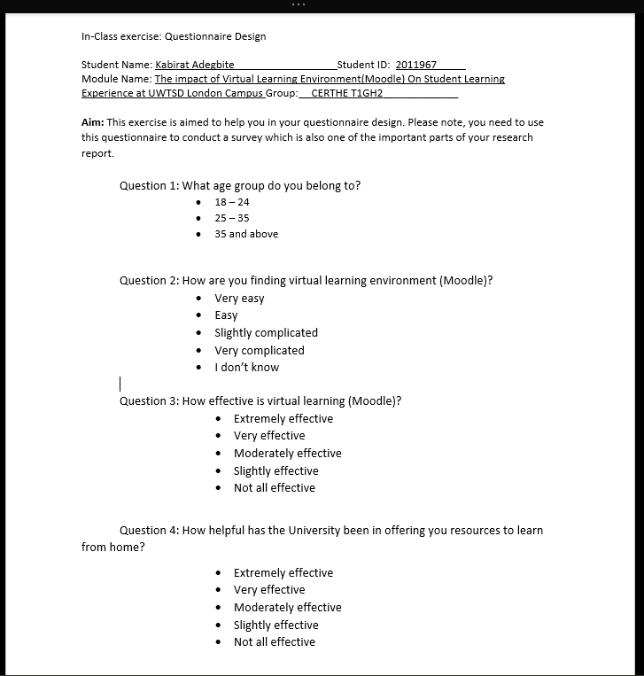

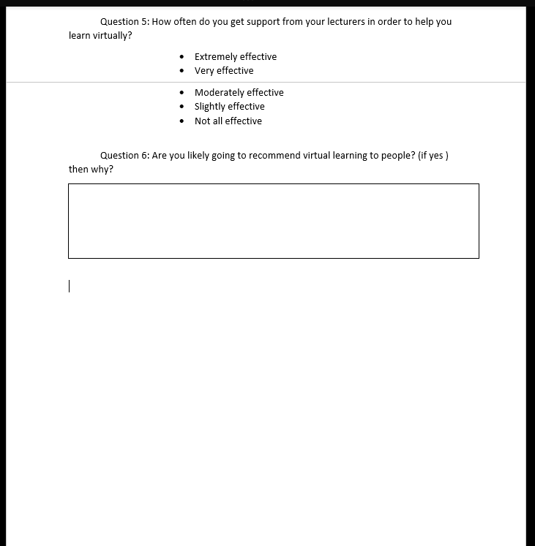

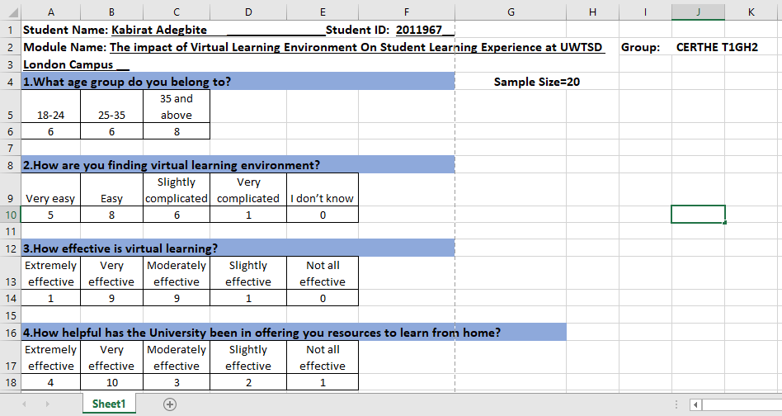
Appendix 2 (Result)
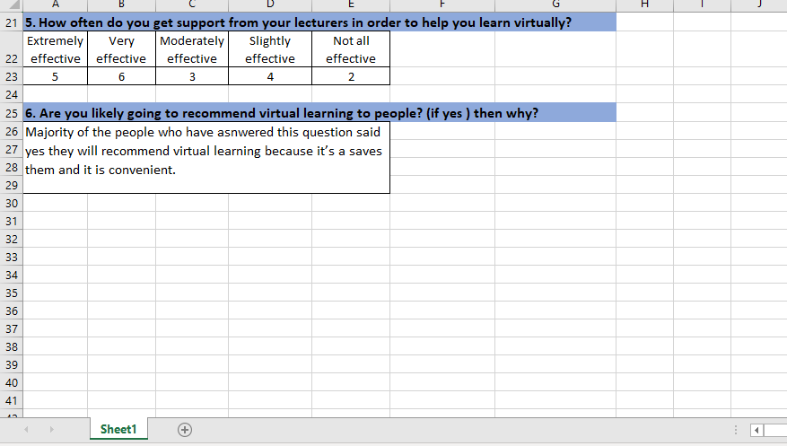

References
Alves, Miranda & Morais, 2017. Research Gate. [Online]
Available at: https://www.researchgate.net/publication/317307245_The_Influence_of_Virtual_Learning_Environments_in_Students'_Performance
[Accessed 30 12 2020].
Barker, J. & Gossman, P., 2013. Teacher Education Network Journal. [Online]
Available at: https://ojs.cumbria.ac.uk/index.php/TEAN/article/view/146/261
[Accessed 30 12 2020].
Bhandari, P., 2020. Scribbr. [Online]
Available at: https://www.scribbr.com/methodology/population-vs-sample/
[Accessed 30 12 2020].
Boulton, Kent & Williams, 2018. Virtual learning environment engagement and learning outcomes at a ‘bricks-and-mortar’ university. [Online]
Available at: https://www-sciencedirect-com.ezproxy.uwtsd.ac.uk/science/article/pii/S036013151830174X
[Accessed 30 12 2020].
DeFranzo, S. E., n.d. Snap Surveys. [Online]
Available at: https://www.snapsurveys.com/blog/qualitative-vs-quantitative-research/
[Accessed 28 12 2020].
Dudovskiy, J., 2011. Business research methodoloy. [Online]
Available at: https://research-methodology.net/research-methods/data-collection/
[Accessed 30 12 2020].
eThink, 2020. Building a Modern Virtual Learning Environment (VLE). [Online]
Available at: https://ethinkeducation.com/blog/building-a-modern-virtual-learning-environment-vle/#:~:text=A%20virtual%20learning%20environment%20(VLE)%20is%20an%20online%20platform%20used,other%20forms%20of%20virtual%20learning.
[Accessed 30 12 2020].
Lyndon, S. & Hale, b., 2014. Evaluation of How the Blended Use of a Virtual Learning Environment (VLE) Can Impact on Learning and Teaching in a Specific Module. [Online]
Available at: https://www.tandfonline.com/doi/pdf/10.11120/elss.2014.00019?needAccess=true
[Accessed 30 12 2020].
Mcleod, S., 2019. Simply Psychology. [Online]
Available at: https://www.simplypsychology.org/qualitative-quantitative.html
[Accessed 27 12 2020].
Mogus, Djurdjevic & suvak, 2012. The impact of student activity in a virtual learning environment on their final mark. [Online]
Available at: https://journals-sagepub-com.ezproxy.uwtsd.ac.uk/doi/full/10.1177/1469787412452985
[Accessed 30 12 2020].
Wolf, A., 2016. Market Research. [Online]
Available at: https://blog.marketresearch.com/not-all-market-research-data-is-equal
[Accessed 30 12 2020].

