

Postgraduate/Distance Learning
Assignment coversheet & feedback form

THIS SHEET MUST BE THE FIRST PAGE OF THE ASSIGNMENT YOU ARE SUBMITTING (DO NOT SEND AS A SEPARATE FILE)

For completion by the student:
Student Name: VADIM ZAVER

Student University Email: 2111154@studend.uwstd.ac.uk
Module code: (HPCA7015)  Module title: Foundations in Cultural Astronomy and Astrology  Word count : 2098 | Student ID number:  2111154 |  |  | Educational support needs:  No
Assignment title: A Critical Comparison of two JSTOR papers

Assignment due date: 04 November 2021
This assignment is for the 1st 2nd 3rd 4th 5th 6th module of the degree
I confirm that this is my original work and that I have adhered to the University policy on plagiarism.
Signed: /vadimzaver/
Email submission:if you are submitting this form via email, please tick this box □
(as a substitute for your signature) to confirm that you agree to the above declaration.
Assignment Mark
1st Marker’s Provisional mark
2nd Marker’s/Moderator’s provisional mark
External Examiner’s mark (if relevant)
Final Mark

NB. All marks are provisional until confirmed by the Final Examination Board.

For completion by Marker 1 :
Comments:

Marker’s signature: |  |  | Date:
For completion by Marker 2/Moderator:

Comments:

Marker’s Signature: |  | Date:
External Examiner’s comments (if relevant)

External Examiner’s Signature: |  | Date:

Introduction
This essay compares and contrasts the ascent of the soul in Head’s Holst - Astrology and Modernism in 'The Planets', and Carrasco’s City as Symbol in Aztec Thought: The Clues from the Codex Mendoza. I am going to argue in this essay, that the work of Head is still actual today, and the work of Carrasco didn’t withstand the test of time. I have changed the essay structure slightly, as I found shortcomings in Carrasco’s arguments and needed space to reflect on these. I am going to disprove 17 academics who in 1977 ‘signed a telegram’, to The Times. I will calculate total Mesoamerican life loss during existence of Aztecs’ empire, based on Harner findings. I will offer a hypothesis which could shed light on origins of Aztecs.
Path to the pinnacle
Raymond Head was born in London, in 1948. He is a composer, music researcher, writer, and a Gustav Holst scholar. He has worked at many different countries around the world, teaching music and learning from different cultures. At some point in his life, Head became ‘disillusioned with the path of contemporary music’, and started his own life long music research. Head published his article on Holst in 1993 in Tempo magazine, which documents the music scene and widely read by composers, musicians and critics. The article is about influence of modernism, theosophy and astrology on Gustav Holst’s work. The article is addressed to a narrow group of musicians interested in history of music. Raymond Head wrote the text in 1993, when in the West there was wide interest in astrology.
The article tells us about poor composer, who had to write music after work, an rely on financial help from friends to survive, produced a number of major works, but all weren’t successful. Desperately looking for a subject for inspiration Holst turns to theosophy and astrology and produces a masterpiece which turned Britain into top musical nation in the world.
Raymond Head examines the influence of theosophy and astrology on creativity of Gustav Holst. Holst was looking for various subjects to inspire his creativity. Turning to astrology led him to achieve the biggest success of his life.
The article is about the creation of a musical masterpiece by Holst, and on top of that gives us the historical and cultural background of the scene.
The main argument of the article is that modernism, along with theosophy is the way for spiritual and intellectual development. After publication of the first edition of The Origin of Species, in 1859 it became clear for many, that the Church is unable to explain or address Darwin’s findings. People started to look for a modern path in philosophy, arts, music and religion.
Theosophy attempted to address issues the Church couldn’t and became popular among people who were intellectuals or looking for spiritual enlightenment. Holst’s stepmother was one of these people. Theosophy ideas are still valid and interesting today for intellectuals. However, these are not widely spread partly for political and religious reasons. Astrology in the UK was illegal – ‘in 1917 the most famous astrologer in Britain - Alan Leo - had been prosecuted’, and died six weeks later.
Main thesis of Raymond Head article is that ‘understanding ... own nature’, is the key to creating outstanding modern work.
In 2014, Head published Gustav Holst: The Planets Suite: New Light on a Famous Work, which despite being much bigger in volume than the article, contained more or less the same facts. This indicates that despite twenty-one-year difference, Head’s research withstood trial by time, and that the first time the research was done so well, that in decades to come not much new were found worth to add to the original research.
Cannibal Kingdom
David Carrasco was born in the US in 1944, and grew up in Mexico City. He is a lecturer, political activist and author of 15 books. He published the article in History of Religions magazine, in 1981. The article is addressed to a narrow group of scholars involved in religious studies, but also a huge group of Spanish speaking people in Mexico and neighbouring countries, which for various reasons started to identify themselves with Aztecs, and needed confirmation that Aztecs were one of the greatest world civilizations. Carrasco is a proponent of the Mexican movement which rejects Spanish colonialism and searches for the new Mexico’s identity in the Aztecs’ past.
The article was written at the height of the argument between the scholars, who claimed that the motive behind human sacrifices was pure cannibalism and scholars who claimed that human sacrifices were pure religious and few, or didn’t exist at all.
Carrasco uses one primary source - Codex Mendoza. The choice of codex is questionable taking into account Carrasco’s opinion on cannibalism and human sacrifices as Spanish lies. There are sixteen codices, created before arrival of Cortes and depicting original Aztecs’ life. Codex Mendoza, is not one of them. It is a sort of Potemkin village, created decades after the fall of the Aztecs’ empire not just to please the emperor, but prove to him that his edict outlawing cannibalism and human sacrifices is working. Florentine codex, for example contains graphical images of cannibalism, see Appendix 1.
Main arguments of the article are that Aztecs were not ‘ragged Indians’, or savages, but an advanced culturally rich, urban civilization. Aztecs were victims of ‘Spanish cunning and aggression’, who had been living in an idyllic world ruthlessly crashed by Spanish invaders who for no reason destroyed rich culture.
Carrasco belongs to the popular in Mexico anti-Spanish faction, which is trying to put a human face on Aztecs, claiming it was one of the great old civilisations. The other faction, which includes Marvin Harris and Michael Harner, claims that the Mexico basin had few sources of protein – neither poultry nor cattle. According to Harris, Aztecs’ ‘victims were eaten’. Harner estimates that ‘250,000 per year’, were sacrificed and eaten. The victims’ meat would sustain 300,000 inhabitants of Tenochtitlan, and the leftovers of the victims were used in the zoos. Spanish accounts of Aztecs cannibalism were dismissed for half a century as racist and colonialist lies, and here is just one Spanish account labelled as a Spanish lie:
I remember that in the plaza where some of their oratories stood, there were piles of human skulls so regularly arranged that one could count them, and I estimated them at more than a hundred thousand. I repeat again there were more than one hundred thousand of them.
There was no evidence of mass cannibalism by Aztecs until 2017, when archaeologists discovered ‘walls built with human skulls’. (see Appendix 2). It took two years to unearth and analyse the finding, so by 2019 the world had clear evidence of Aztecs cannibalism and that Spanish lies were true accounts. It also has become known that the Mexican government hid similar findings in the past.
Finally, there is evidence that Aztecs were cannibals, ate men, ‘pregnant women’, children and used the victims as domesticated animals by keeping them in cages and fattening them up with corn. Harris and his faction were right all along, but were subjected to the cancelling culture, where a publication of Aztec Sacrifices Laid to Hunger, Not Just Religion, was met with a personal attack:
After his [Harner] theory was described in The Times, 17 scholars specializing in Mesoamerican ancient history signed a telegram to The Times dissociating themselves from Dr. Harner's views. “No reputable anthropologist familiar with Aztec culture would subscribe to his views. We regard his statement that scholars have consciously or unconsciously suppressed the facts about Aztec sacrificial practices as ridiculous”.
Discovery of walls build with sculls also confirms Spanish accounts of mass cannibalism which were so far dismissed by ‘reputable anthropologists’, as being racist and deceptive. The dismissal is now looking very much like the Goebbels propaganda, which denied existence of death camps in Nazi Germany. According to Carrasco:
The celebrated march of Hernan Cortes from Villa Rica de la Vera Cruz to the Aztec capital was punctuated by systematic destruction of shrines, temples, and other ceremonial paraphernalia, as well as the attempt to establish Christian symbols and structures in their places.
Yes, after the war Germany had to go through denazification process and so New Spain had to go through de-cannibalization process, where symbols of cannibalism were destroyed. Cannibalism was not acceptable to Spanish in 1519, and it is not acceptable in the civilized world now. The reason that almost nothing was left of ‘shrines, temples, and other ceremonial paraphernalia’, is that so called religious and cultural structures had cannibalistic purpose and literally were flooded with the victims’ blood. Again, according to Carrasco:
‘bitter to the minds of scholars, that of the thousands of pictorial manuscripts extant in Mexico in 1519, showing the histories, cosmologies, and cartographies of the ancient culture, only sixteen remain today’.
There aren’t many Nazi books these days. In fact, reading these is illegal in many countries and for a good reason. No one argues that these books are part of the world heritage. Still the sixteen manuscripts do contain images of cannibalism, see Appendix 1.
In 176 years, the Aztecs’ empire lasted, Aztecs likely sacrificed and ate 44 million Mesoamericans. They also likely ate close to the amount on the battlefields and during ‘Wars of Flowers’, which strikingly remind us The Hunger games, but cannibalistic and on a much grander scale, trimming the population by up to five percent. Wars of Flowers were actually happening during the hunger times, and Aztecs travelled to the wars with huge pots, designed to cook people, see Appendix 1. I must also stress that ‘Aztecs did not normally eat persons of their own polity’. Sufferers of Aztecs cannibalism were Mesoamericans.
The central statement of Carrasco’s article is: ‘we are trying to understand the Aztec empire’. I argue that it is not true. Understanding involves taking into account all available evidence. Carrasco is clearly a judge himself with what evidence is acceptable, and what are lies. With the evidence of Aztecs’ cannibalism unearthed in 2017, scientific value of his article has become negative. The new book Madre Partia asks a question; why 300,000 Mesoamericans made an alliance with Spanish and fought Aztecs? Answer is, because Aztecs were eating Mesoamericans out and the Spanish were liberators.
Finally, I would like to mount my own argument to the discussion. I hope it would shed light on origins of Aztecs as people. Reading about East Asian cultures I noticed that in some of them there is a popular belief that scaring an animal before killing it makes the meat taste better. Another practice found in East Asia is that an animal is put in a suck and beaten with clubs to inflict maximal bruising before death again to make the meat to taste better. There is a variation to the last technique – animal is thrown down from heights to cause bruising. My argument is that Aztecs cannibalistic practices could be not at all religious, but pure culinary. If that is true, it might be possible to pinpoint the origin of Aztecs.
Conclusion
There are stories in this essay, each having a cultural or philosophical meaning.
There is a story of a composer who was climbing to the pinnacle of human spirit and creativity, guided by teachings which were not acceptable and even not legal in the society.
There is a story of a music researcher, who was disappointed with how the music had been developing, and chose his own path, and through meticulous research made a fabulous discovery of the sources of inspiration of the great composer.
There is a story of a author of 15 books on Aztecs, who doesn’t look for truth, but selects facts which suits him, and paints the Aztecs’ history, the way he would like to see it.
There is a story of a tribe, obsessed with eating human flesh, which descended on Mexico from an unknown origin and in 176 years tortured, killed and ate 44 million people.
There is a story of a government which adopted symbols, which at the time seemed beautiful remnants of a great civilization, but turned out to be evil and cannibalistic. Many world leaders received these symbols as a reward for services to humankind. In theosophical terms, the government assassinated the recipients’ karma.
There is also a matter of importance for everyone of whether Aztecs are crazed cannibals or victims of nutritional deficiency. The world population is steadily growing. There are louder and louder calls to outlaw meat production on the planet. Are Aztecs going to have last laugh?

Bibliography
Secondary sources

‘Biography | Raymond Head’ <https://raymondhead.com/biography> [accessed 20 October 2021]
Carrasco, David, ‘City as Symbol in Aztec Thought: The Clues from the Codex Mendoza’, History of Religions, 20.3 (1981), 199–223
Castillo, Bernal Díaz del, The Discovery and Conquest of Mexico, 1517-1521 (Psychology Press, 2004)
Clark, James Cooper, Codex Mendoza: The Mexican Manuscript Known as the Collection of Mendoza and Preserved in the Bodleian Library, Oxford (Waterlow & Sons, Limited, 1938)
Collins, Suzanne, The Hunger Games (Scholastic Inc., 2008)
Darwin, Charles, The Origin of Species (P. F. Collier, 1909)
Fintoni, Monica, Franca Arduini, and Andrea Paoletti, The World of the Aztecs, in the Florentine Codex (Mandragora, 2007)
Harner, Michael, ‘The Ecological Basis for Aztec Sacrifice’, American Ethnologist, 4.1 (1977), 117–35
Harris, Marvin, Cannibals and Kings: The Origins of Cultures (Vintage Books, 1978)
Head, Raymon, Gustav Holst: The Planets Suite: New Light on a Famous Work (Sky Dance Press, 2014)
Head, Raymond, ‘Holst - Astrology and Modernism in “The Planets”’, Tempo, 187, 1993, 15–22
Omodeo, Marcelo Gullo, Madre patria: Desmontando la leyenda negra desde Bartolomé de las Casas hasta el separatismo catalán (Espasa, 2021)
Press, Associated, ‘Mexico Archaeologists Reveal Tale of Cannibalism and Reprisal from Conquest’, The Guardian, 19 January 2021, section World news <https://www.theguardian.com/world/2021/jan/19/mexico-archaeologists-cannibalism-reprisal-conquest-aztec> [accessed 3 November 2021]
Rensberger, Boyce, ‘Aztec Sacrifices Laid to Hunger, Not Just Religion’, The New York Times, 19 February 1977, section Archives <https://www.nytimes.com/1977/02/19/archives/aztec-sacrifices-laid-to-hunger-not-just-religion-above-dr-michael.html> [accessed 2 November 2021]
———, ‘Experts on Aztecs Deny Withholding Cannibalism “Facts”’, The New York Times, 3 March 1977, section Archives <https://www.nytimes.com/1977/03/03/archives/experts-on-aztecs-deny-withholding-cannibalism-facts.html> [accessed 31 October 2021]
The Mexico Daily Post, ‘The Imperial Cannibalism of the Aztecs, an Uncomfortable Truth for Critics of the Conquest’, Mexico Daily Post, 2021 <https://mexicodailypost.com/2021/09/25/the-imperial-cannibalism-of-the-aztecs-an-uncomfortable-truth-for-critics-of-the-conquest/> [accessed 27 October 2021]

Appendix 1

Figure 1 Images of cannibalism in Florentine Codex.

Appendix 2

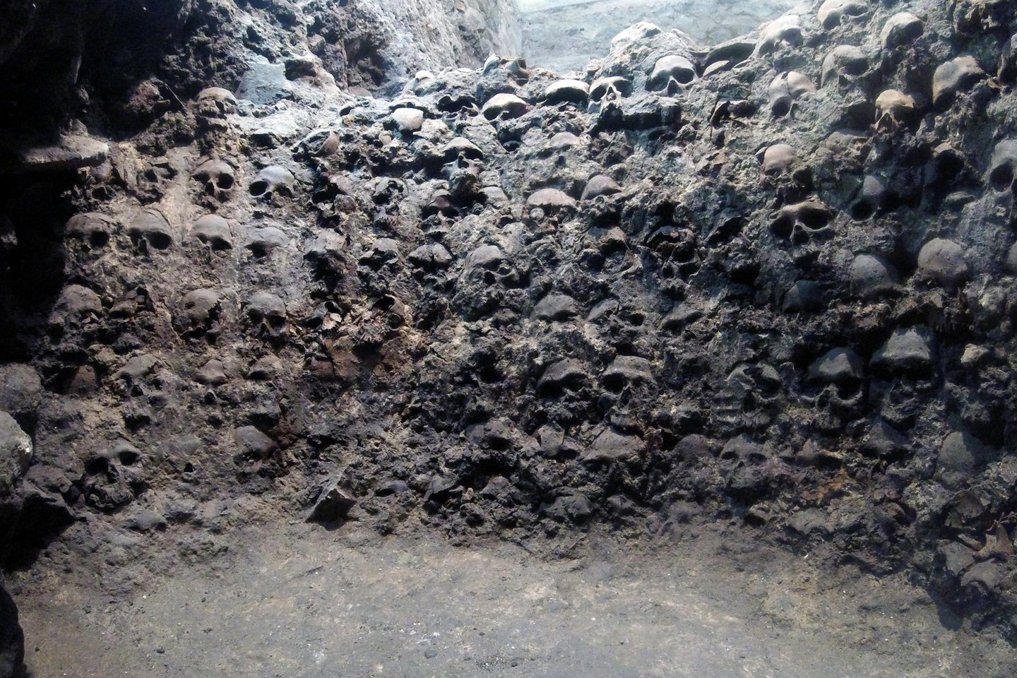
Figure 2 Wall of human skulls.

Raymond Head, ‘Holst - Astrology and Modernism in “The Planets”’, Tempo, 187, 1993, 15–22.
David Carrasco, ‘City as Symbol in Aztec Thought: The Clues from the Codex Mendoza’, History of Religions, 20.3 (1981), 199–223.
Boyce Rensberger, ‘Experts on Aztecs Deny Withholding Cannibalism “Facts”’, The New York Times, 3 March 1977, section Archives <https://www.nytimes.com/1977/03/03/archives/experts-on-aztecs-deny-withholding-cannibalism-facts.html> [accessed 31 October 2021].
‘Biography | Raymond Head’ <https://raymondhead.com/biography> [accessed 20 October 2021].
Charles Darwin, The Origin of Species (P. F. Collier, 1909).
Raymond Head, p. 21.
Raymond Head, p. 22.
Raymon Head, Gustav Holst: The Planets Suite: New Light on a Famous Work (Sky Dance Press, 2014).
James Cooper Clark, Codex Mendoza: The Mexican Manuscript Known as the Collection of Mendoza and Preserved in the Bodleian Library, Oxford (Waterlow & Sons, Limited, 1938).
Clark.
Monica Fintoni, Franca Arduini, and Andrea Paoletti, The World of the Aztecs, in the Florentine Codex (Mandragora, 2007).
Carrasco, p. 199.
Carrasco, p. 202.
Marvin Harris, Cannibals and Kings: The Origins of Cultures (Vintage Books, 1978), p. 122.
Michael Harner, ‘The Ecological Basis for Aztec Sacrifice’, American Ethnologist, 4.1 (1977), 117–35 (p. 119).
Bernal Díaz del Castillo, The Discovery and Conquest of Mexico, 1517-1521 (Psychology Press, 2004), p. 122.
The Mexico Daily Post, ‘The Imperial Cannibalism of the Aztecs, an Uncomfortable Truth for Critics of the Conquest’, Mexico Daily Post, 2021 <https://mexicodailypost.com/2021/09/25/the-imperial-cannibalism-of-the-aztecs-an-uncomfortable-truth-for-critics-of-the-conquest/> [accessed 27 October 2021].
Associated Press, ‘Mexico Archaeologists Reveal Tale of Cannibalism and Reprisal from Conquest’, The Guardian, 19 January 2021, section World news <https://www.theguardian.com/world/2021/jan/19/mexico-archaeologists-cannibalism-reprisal-conquest-aztec> [accessed 3 November 2021].
Boyce Rensberger, ‘Aztec Sacrifices Laid to Hunger, Not Just Religion’, The New York Times, 19 February 1977, section Archives <https://www.nytimes.com/1977/02/19/archives/aztec-sacrifices-laid-to-hunger-not-just-religion-above-dr-michael.html> [accessed 2 November 2021].
Rensberger, ‘Experts on Aztecs Deny Withholding Cannibalism “Facts”’.
Rensberger, ‘Experts on Aztecs Deny Withholding Cannibalism “Facts”’.
Carrasco, p. 204.
Carrasco, p. 203.
Carrasco, p. 203.
Harner, p. 131.
Suzanne Collins, The Hunger Games (Scholastic Inc., 2008).
Harner, p. 131.
Carrasco, p. 222.
Marcelo Gullo Omodeo, Madre patria: Desmontando la leyenda negra desde Bartolomé de las Casas hasta el separatismo catalán (Espasa, 2021).
Fintoni, Arduini, and Paoletti, p. 21.
The Mexico Daily Post.

