ACCA4022 ASSESSMENT 2
Course Name: Certificate of Higher Education Computing Skills for the Workplace.
Module Name: Computer Architecture and Operating Systems.
Module Code: ACCA4022
Student Name: ALPHUS NFORMI NGWANI
Student ID: 2517800
Group: 2
Lecture’s Name: Redhwan Al Amiri
Table of Contents
Introduction: 2
1. Key Functions of general operating systems: 2
-Processor Management (Process Management): 2
-Memory Management: 3
- User Interface (UI): 5
- Security and Access Control: 6
- Networking: 7
- Error Detection and Handling: 7
- Resource Management: 8
2. Use of Windows OS CLI commands: 8
1.Process Management Commands 9
3. Network testing/monitoring commands 12
4.User management Commands: 14
5. Task scheduling Commands 16
3 Use of Linux OS CLI Commands. 17
-Process management CLI Commands. 17
-File and directory management commands 17
-Network testing/monitoring commands; 18
-User management commands. 18
-Task scheduling commands. 19
4 Use of Windows OS scripts: 19
-Conclusion: 21
-References: 22

Introduction:
In this my assessment I will be creating a report about the following topics: key functions of general operating systems, Use of Windows OS CLI Commands, Use of Linux OS CLI commands, Use of Windows OS scripts, and Use of Linux OS scripts.
- Key Functions of general operating systems: General operating systems has the following key functions that revolve around managing computer hardware, software resources, running applications and providing a usable environment.
-Processor Management : It handles running programs (called processes), creates, schedules and terminates processes (running programs), Allocates CPU time(scheduling), deciding which applications get CPU time and for how long. [1]
Tasklist : Displays all current running processes. 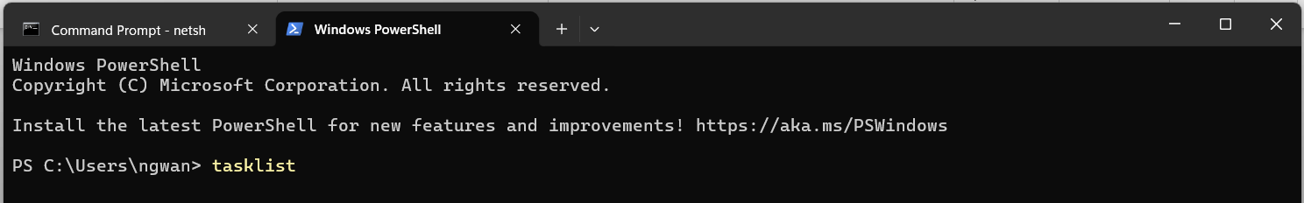
Press enter to run the command and the result will be as below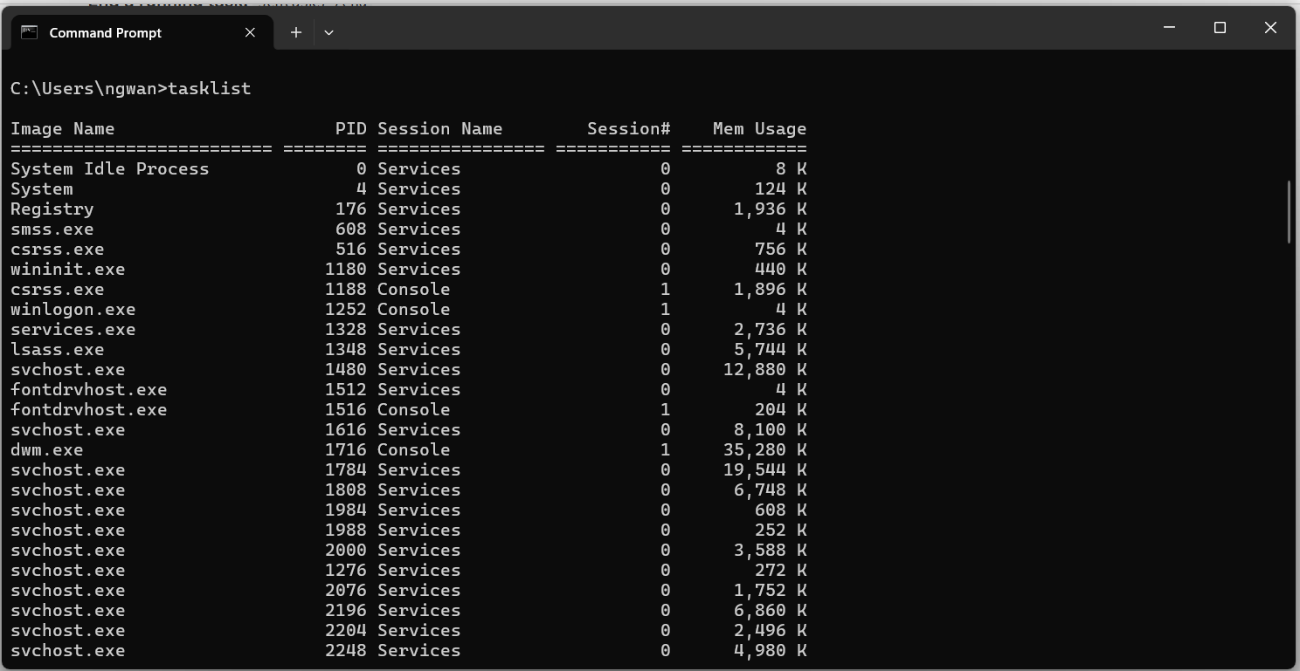
-Memory Management: It controls and manages system's memory (RAM), allocating space to programs when they start deallocating it when they finish to prevent conflicts and ensure stability and also uses techniques like virtual memory to extend available memory. [2]
Taskmgr: Opens the task manager which, which is the most common GUI tool to view and manage memory -intensive applicationgs. 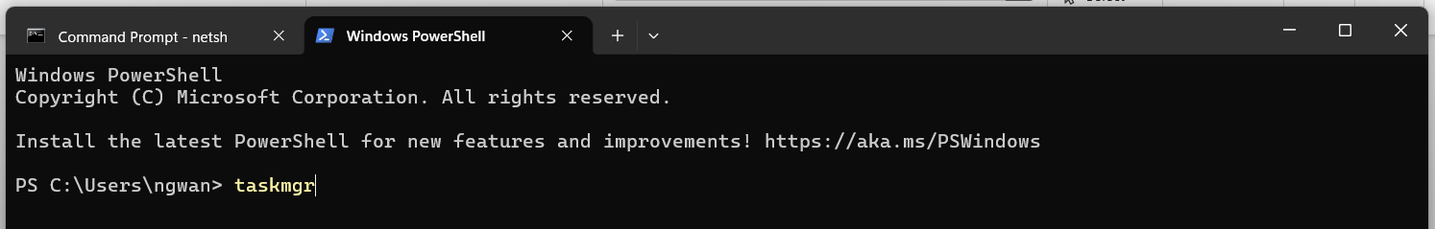
Press enter to run the command and the result will be as below
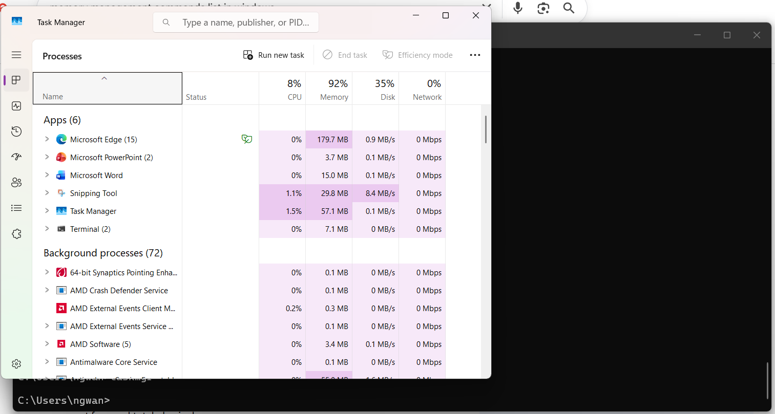
- File Management : The operating system organizes and manages data storage, retrieved, creates, reads, and delete files . It also organised on secondary storage devices(hard drives,SSDs) using directories and folders. It Manages permissions and access control. [3]
Dir: lists files and subdirectories in the current directory. 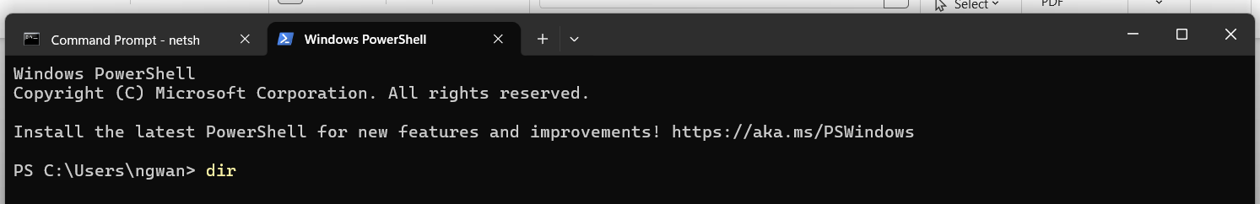
Press enter to run the command and the result will be as below
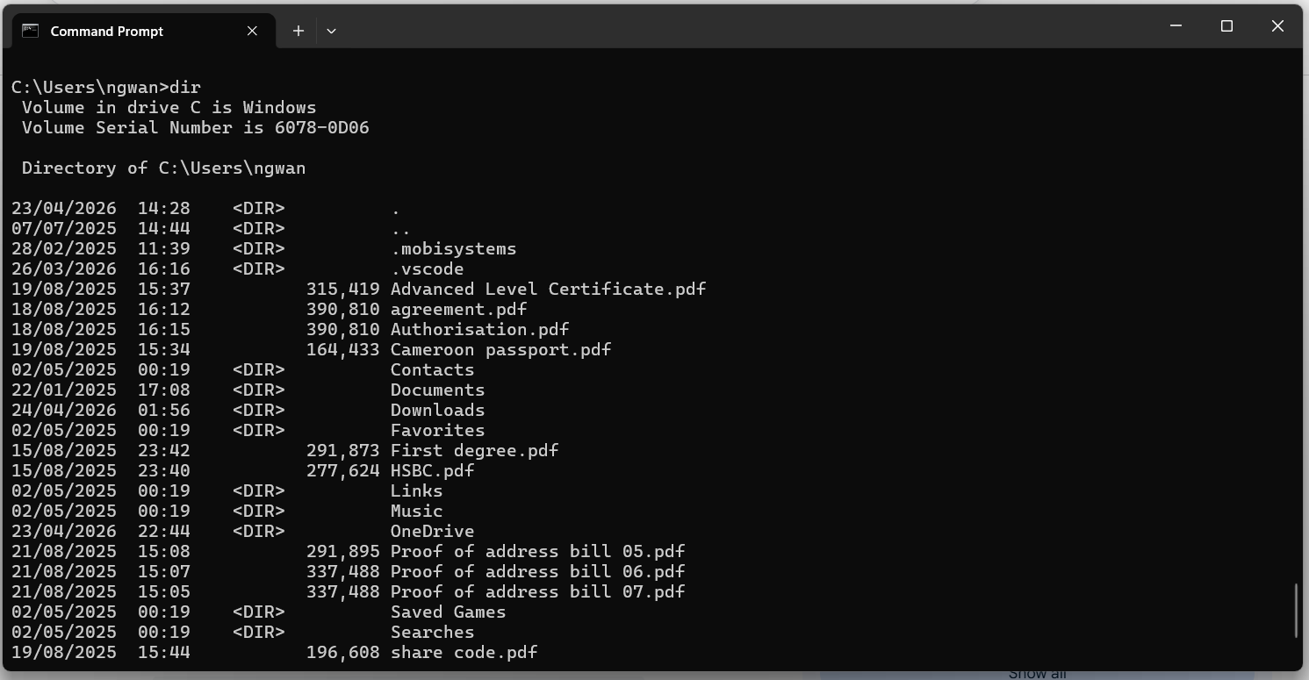
- Hardware and Peripheral Control : Program components by using device drivers to communicate with input and output devices(keyboard,printer,etc), It manages device allocation to applications and handles buffering and caching for efficiency.
Desk.cpl: Display settings. 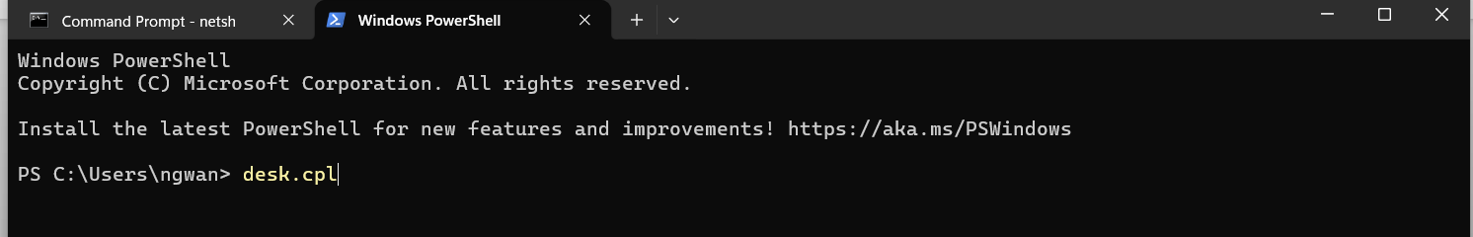
Press enter to run the command and the result will be as below. 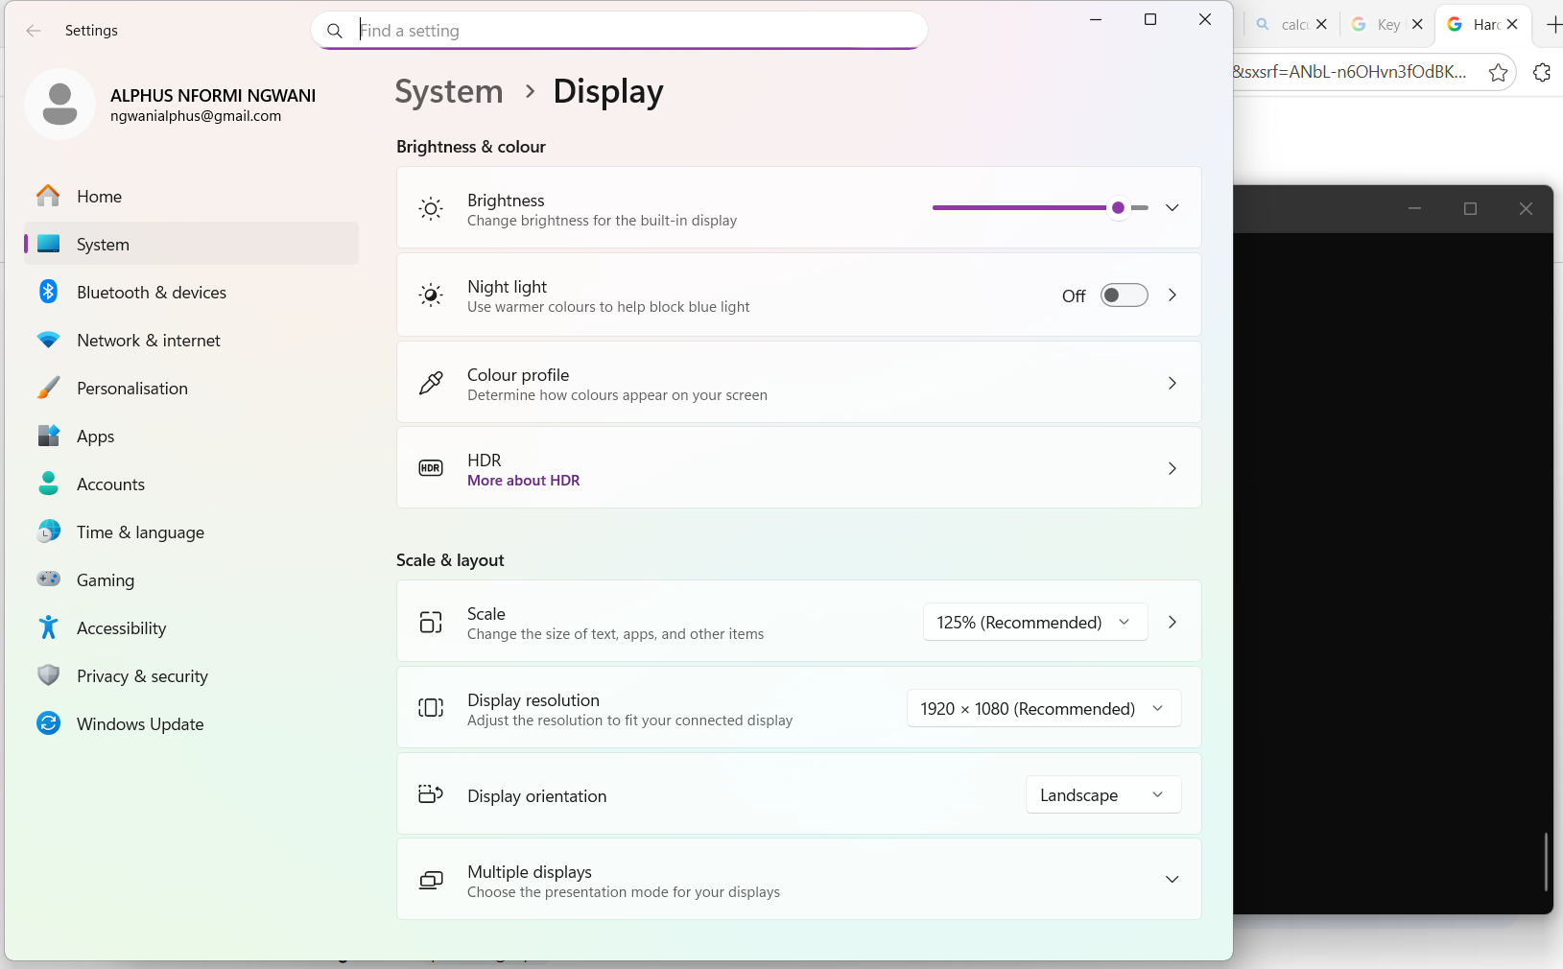
- User Interface (UI): It provides a way for users to interact with the system, typically through Graphical User Interface (GUI) with windows, icons, menus or a Command Line Interface (CLI) for text based commands.
Ipconfig: This is the go-to command for network troubleshooting.
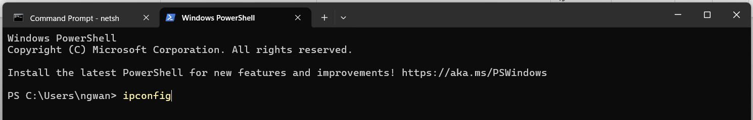
Press enter to run the command and the result is as below.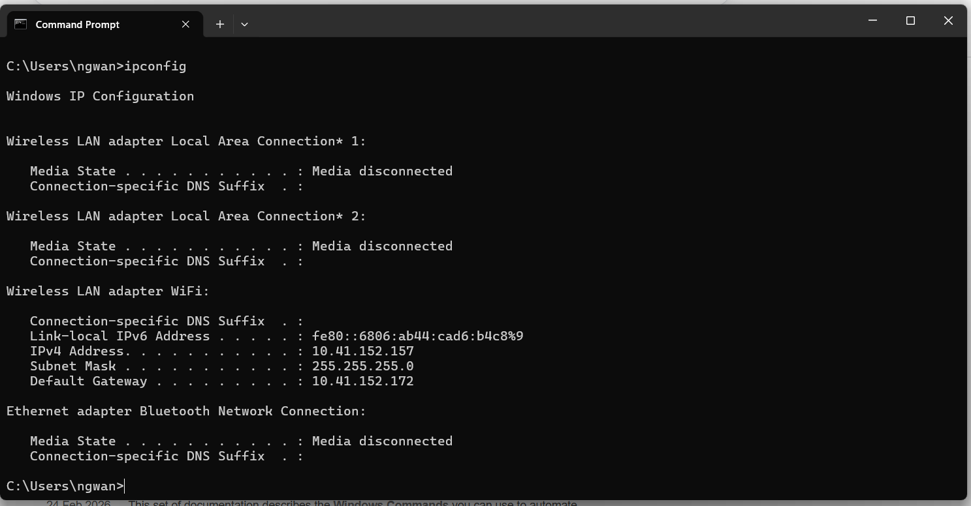
- Security and Access Control: The OS protects the system and user data from unauthorized access through user authentication(login) and file permissions and also data protection and encryption support.
icacls: Displays or modifies Discretionary Access Control Lists (DACLs) on specified files or folders.
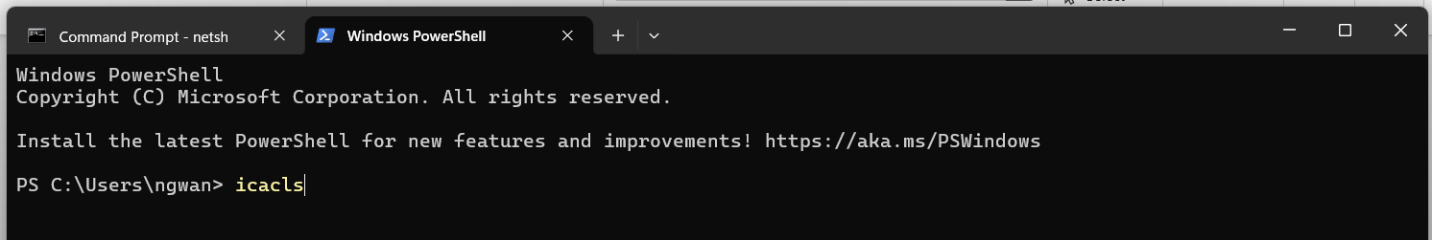
Press enter to run the command and the result is as below.
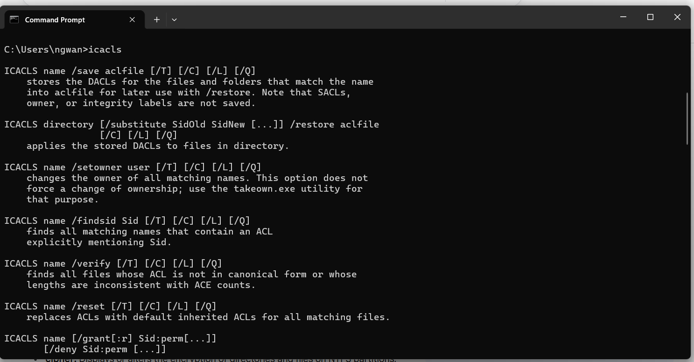
- Networking: It manages network connections by enabling communications between computers with other devices and networks. It supports internet protocols and allows file sharing and remote access.
Nslookup: Networking command.
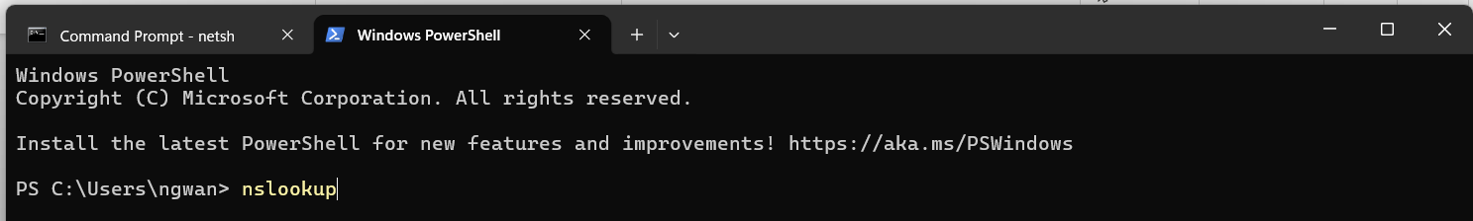
Press enter to run the command and the result is as below.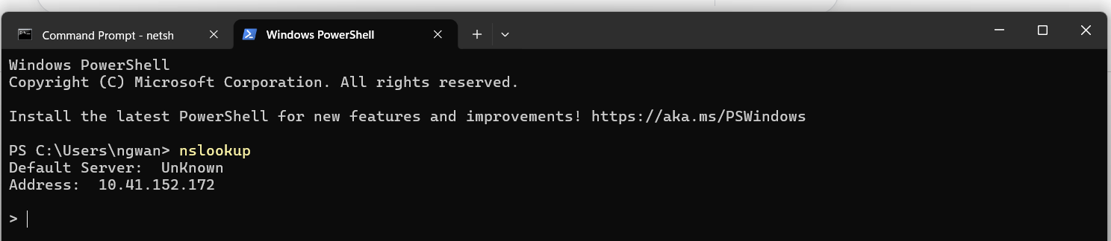

- Error Detection and Handling: It monitors system health, providing error messages and managing system logs to prevent crashes and facilitate debugging and takes corrective actions when possible.
Msconfig: error detection and handling command. 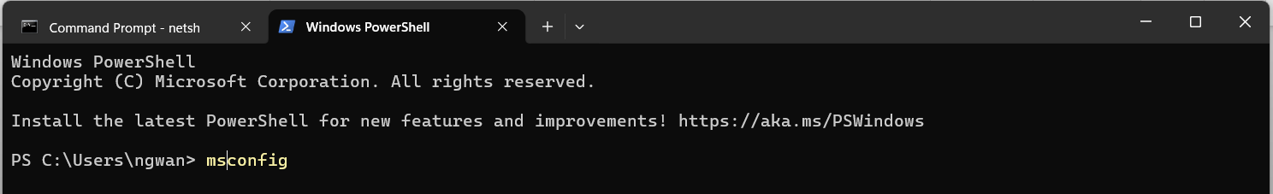
Press enter to run the command and the result is as below
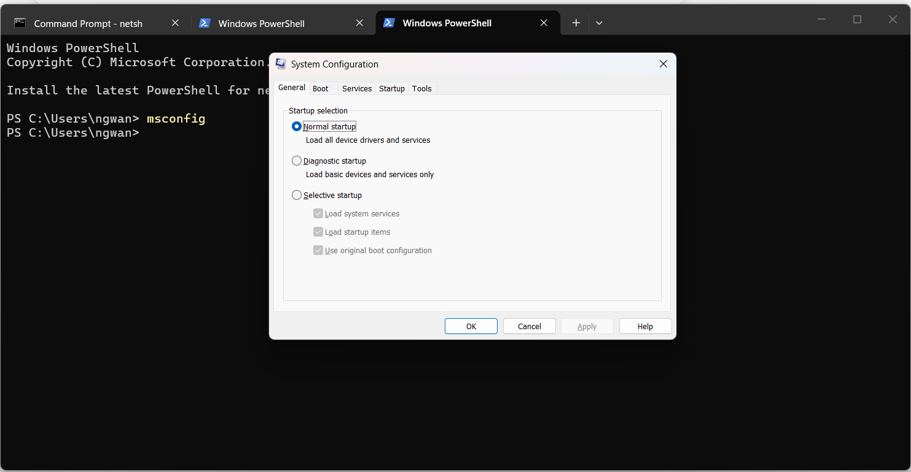
- Resource Management: It tracks the usage of resources by different users or jobs for performance monitroing and auditing and it also prevents conflicts between programs and optimizes overall system performance.
Resmon: resource management command. 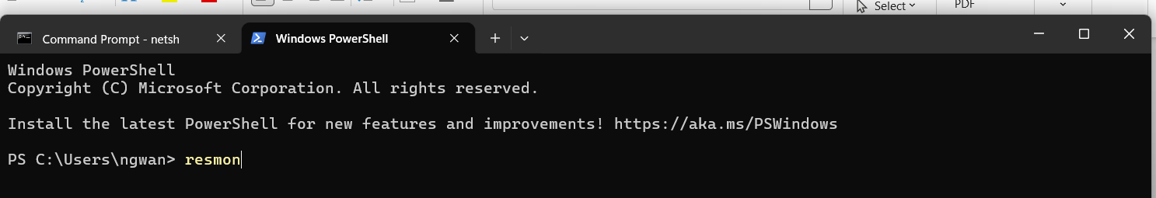
Press enter to run the command and the result is as below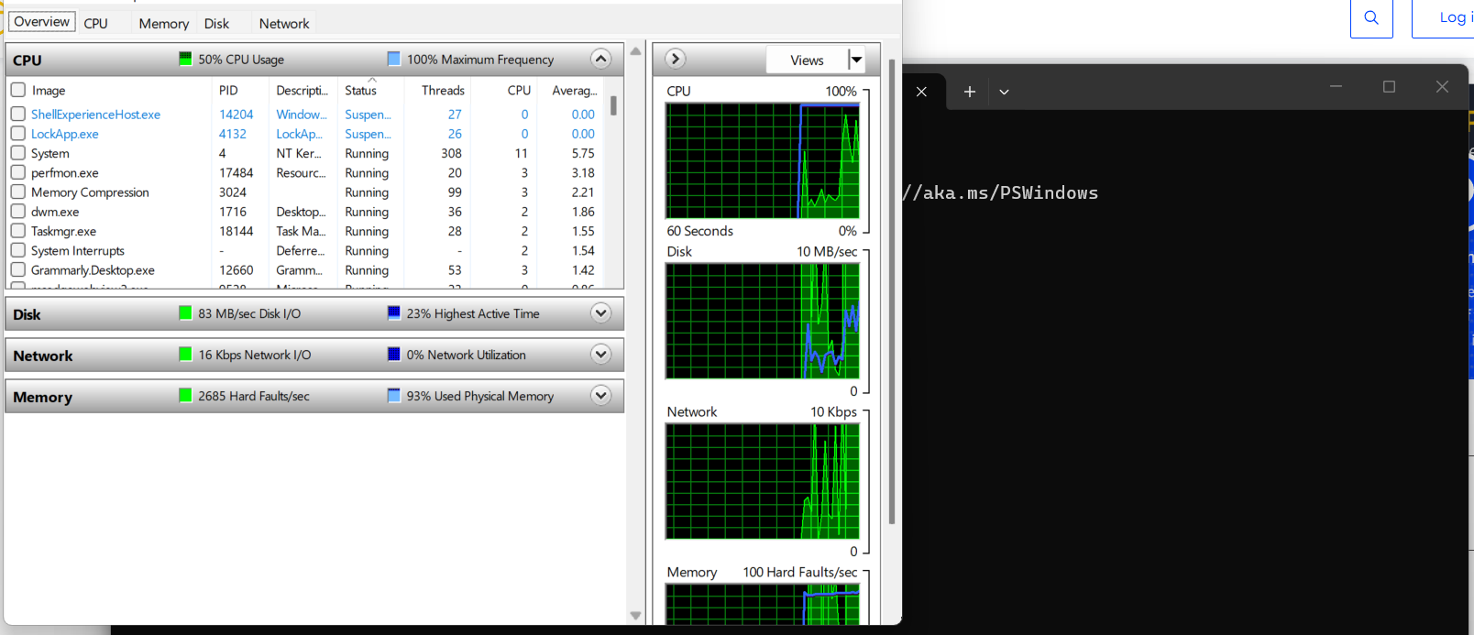

- Use of Windows OS CLI commands: PowerShell directly , providing faster system navigation, advanced troubleshooting, and automation of repetitive tasks. They are essential for managing files, network configurations, and system administration, often exceeding GUI capabilities.
Go to search on your computer and type command prompt and an empty screen is going to show with no graphics for you to put the command you want to use as below 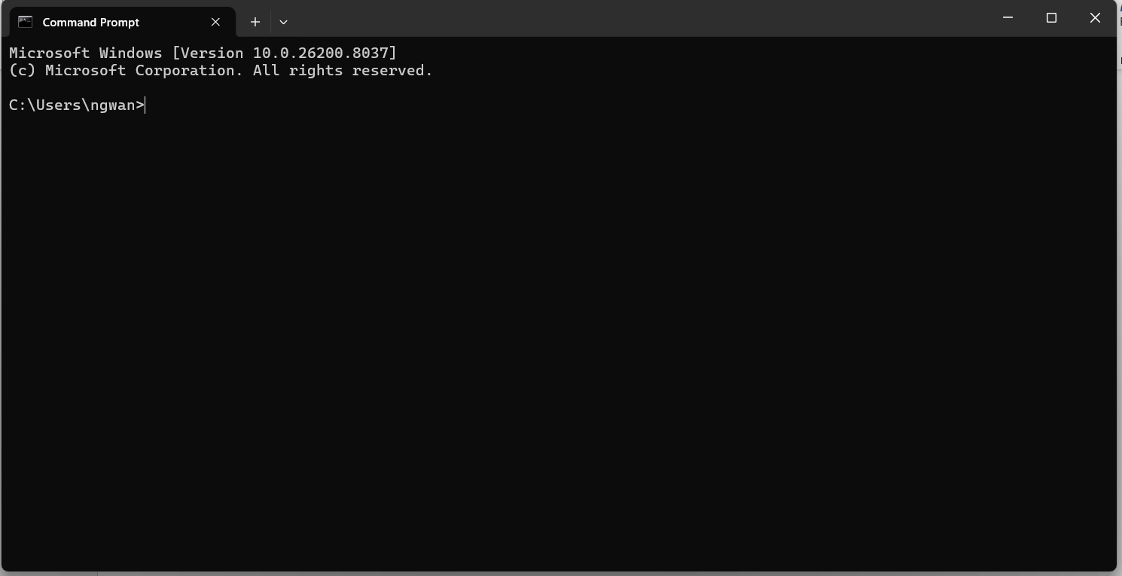

1.Process Management Commands
-Start: Launches a new program or command window
Below is the result when you run the command. 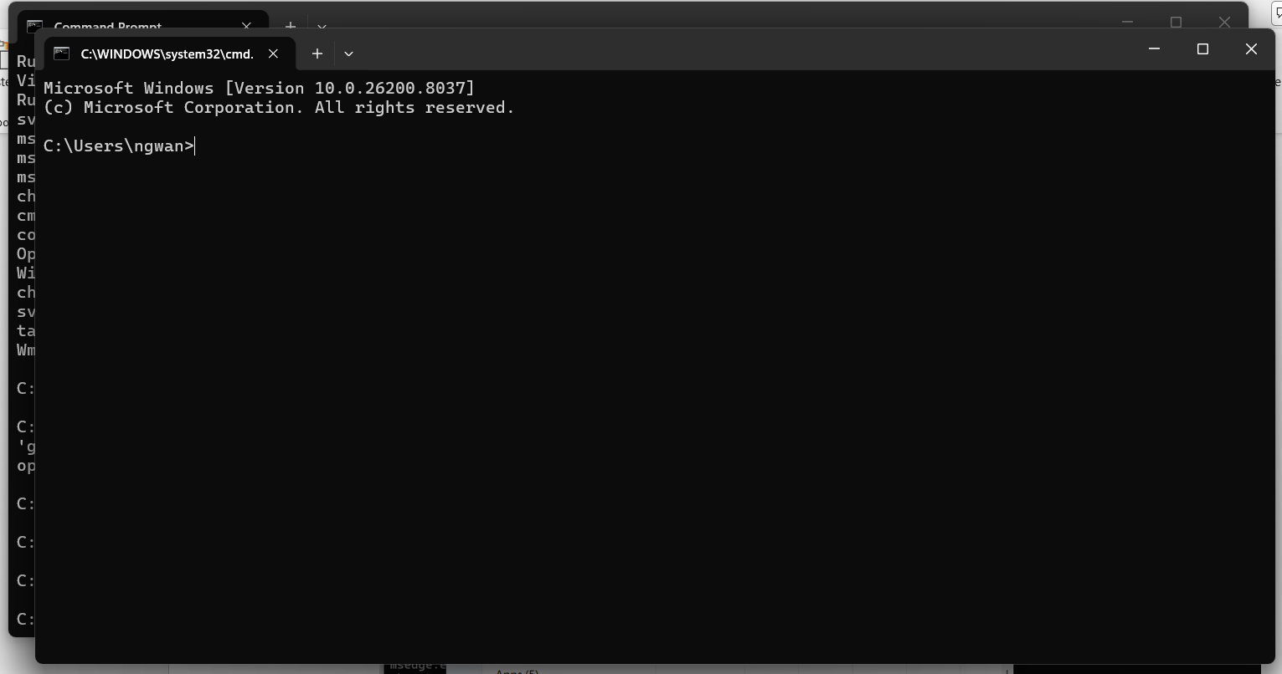
-Taskmgr: Opens the graphical Task Manager. Below is the result when you run the command
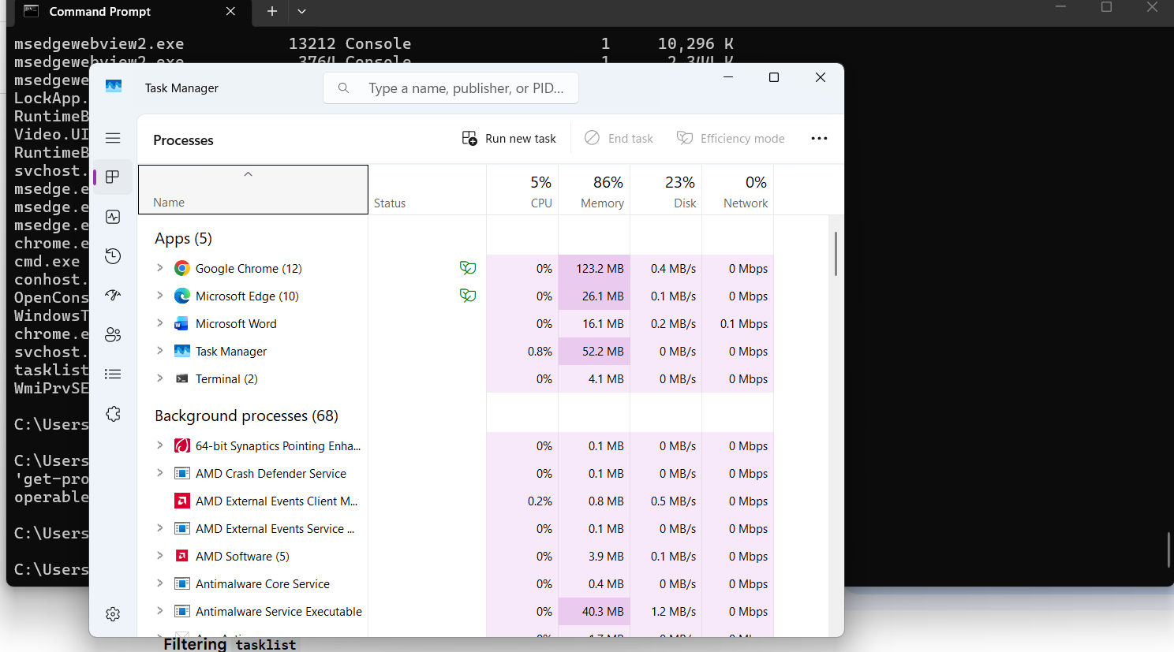
-Services.msc: Opens the services manager to manage background processes.
Below is the results when you run it.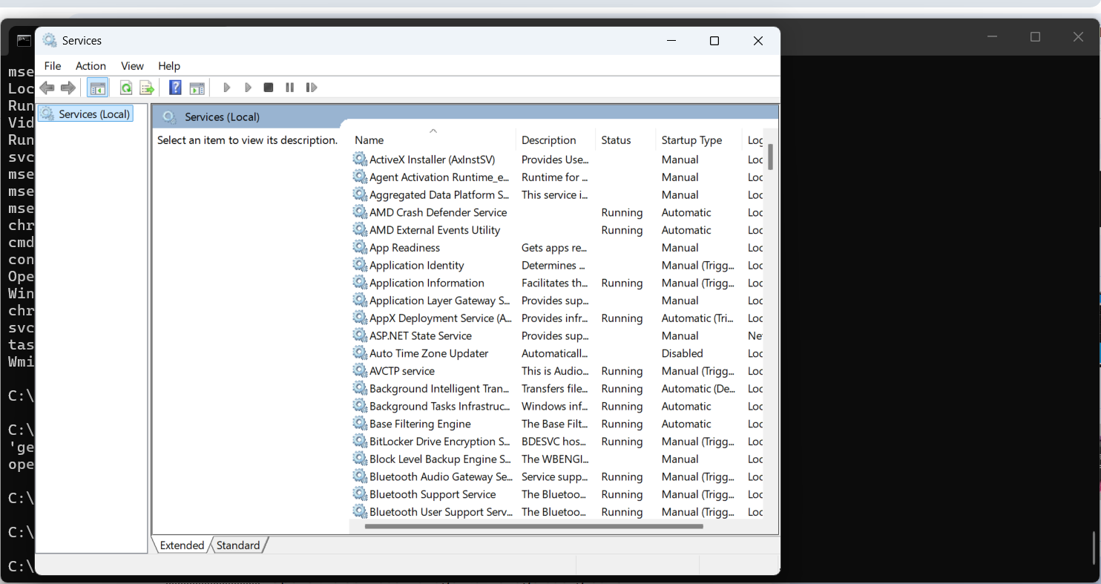 -Systeminfo: Displays detailed configuration information about your computer. 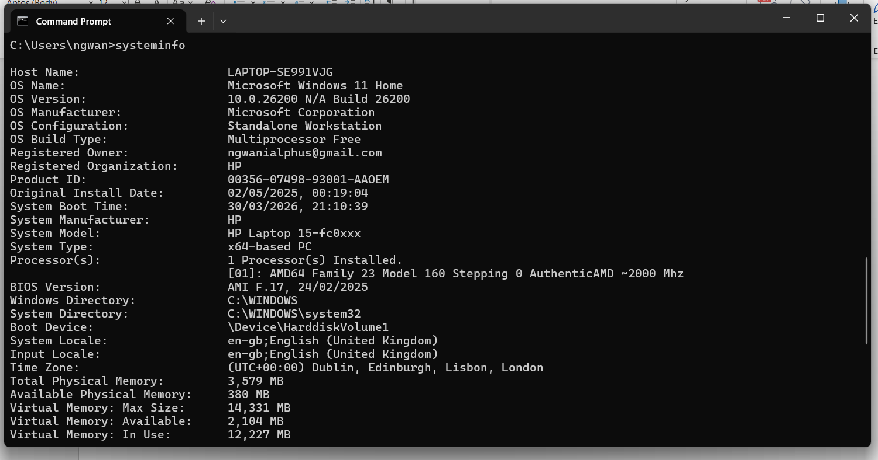-Tasklist: Displays a list of currently running processes. 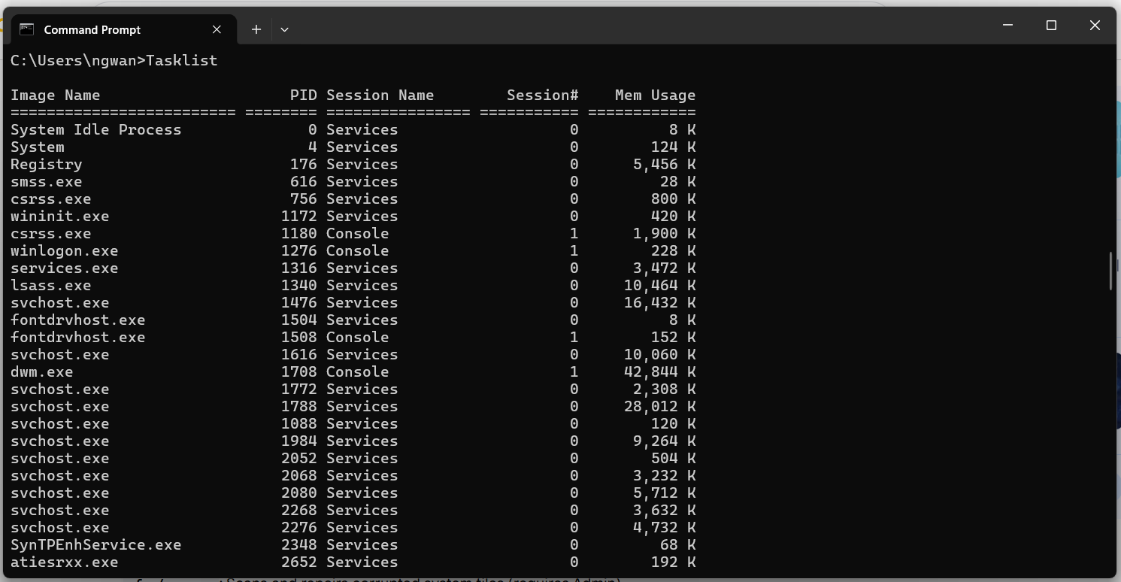2. File and Directory Management commands:
-Robocopy : Robust file copying(better for large file transfer) . 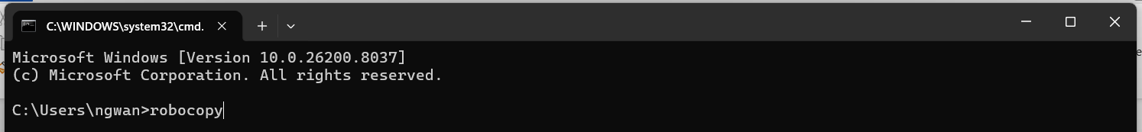The result is as below when you enter the command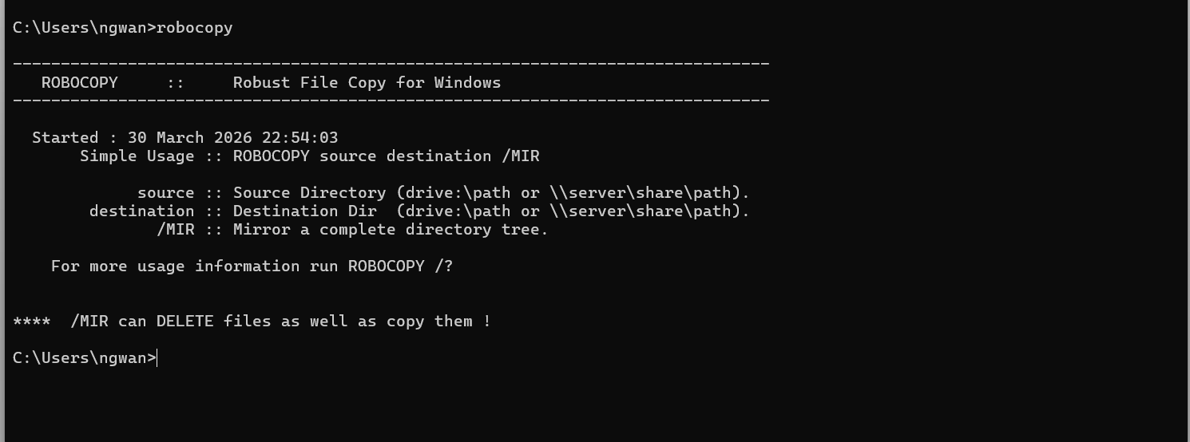
-Attrib: Displays or changes file attributes(Read-only, Hidden, etc) 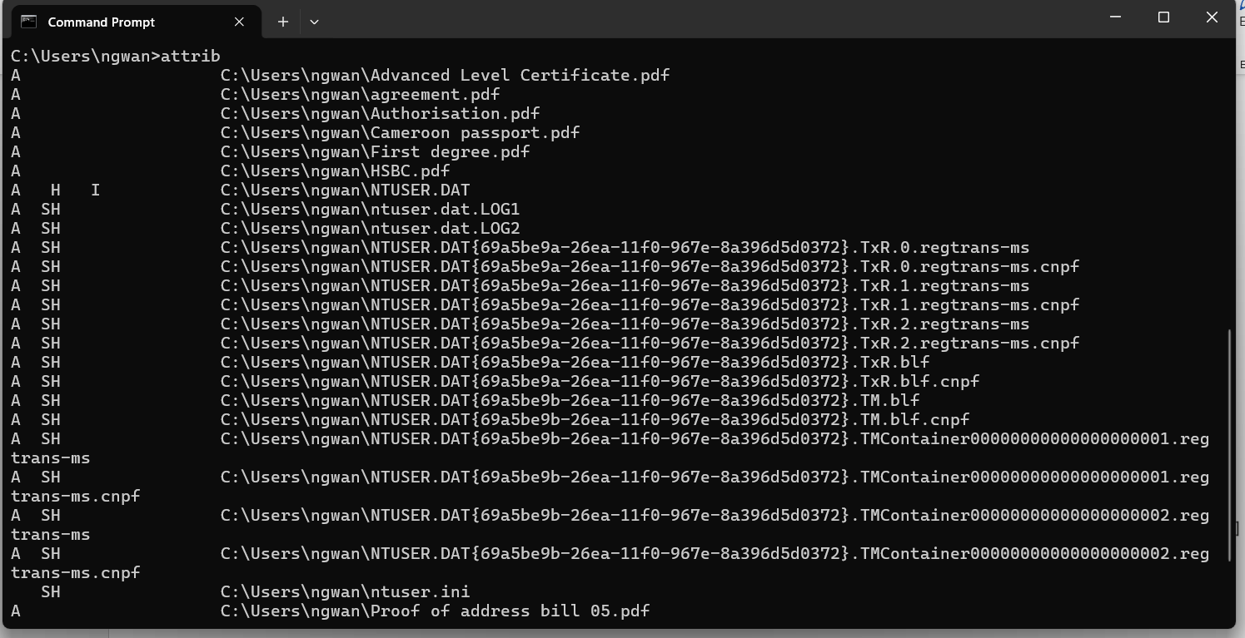

3. Network testing/monitoring commands
-ipconfig: Displays network adapter TCP/IP configuration.
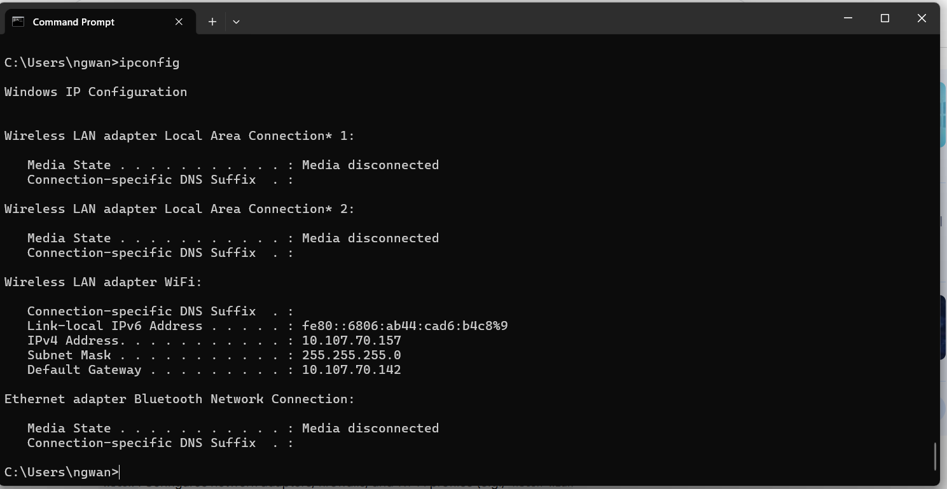
-Ping: Tests connectivity to a network address. 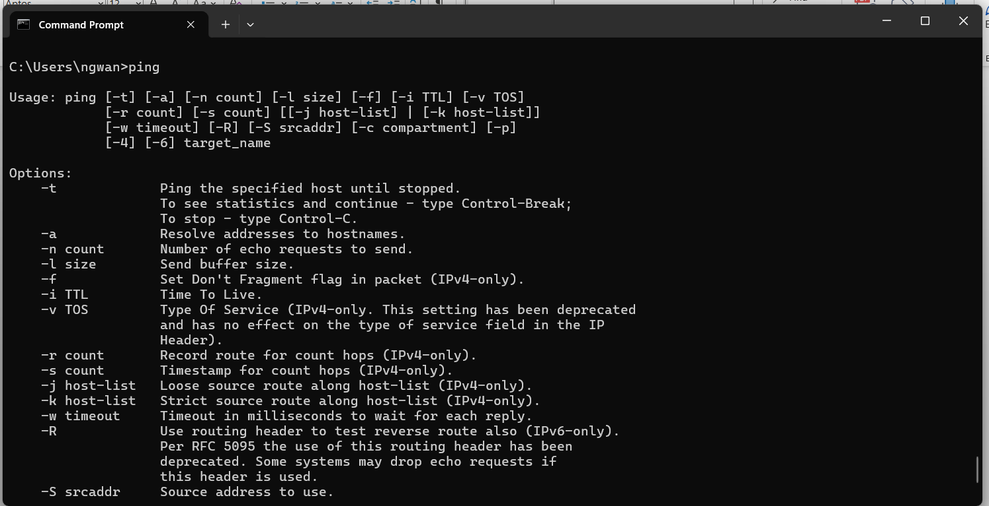
-Tracert: Traces a path packets take to a destination. 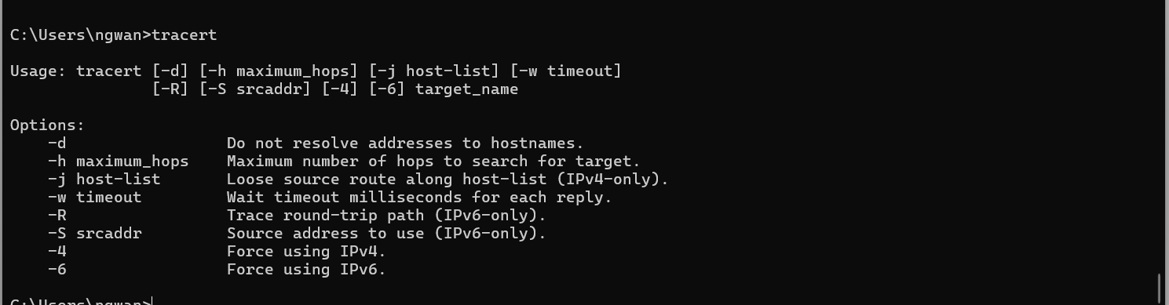
-Netstat: Displays active TCP connections and ports.
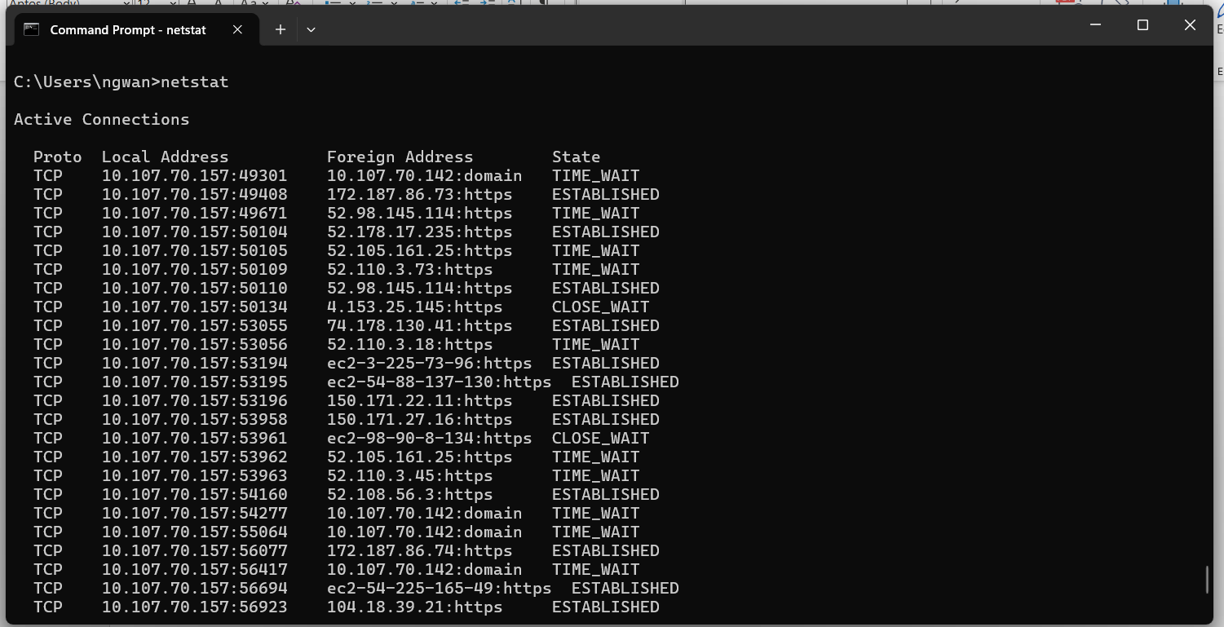-Getmac: Displays the MAC address of network adapters. 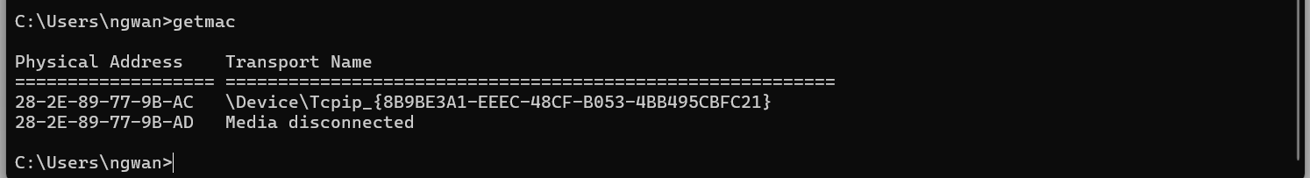

4.User management Commands:
-Net user: List of all users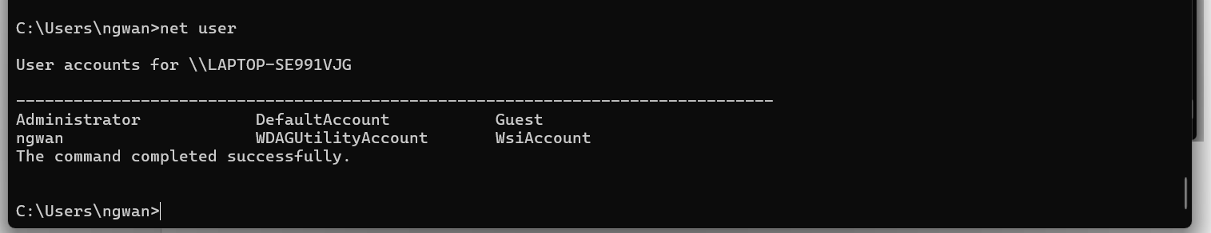-Net localgroup: List of all localgroup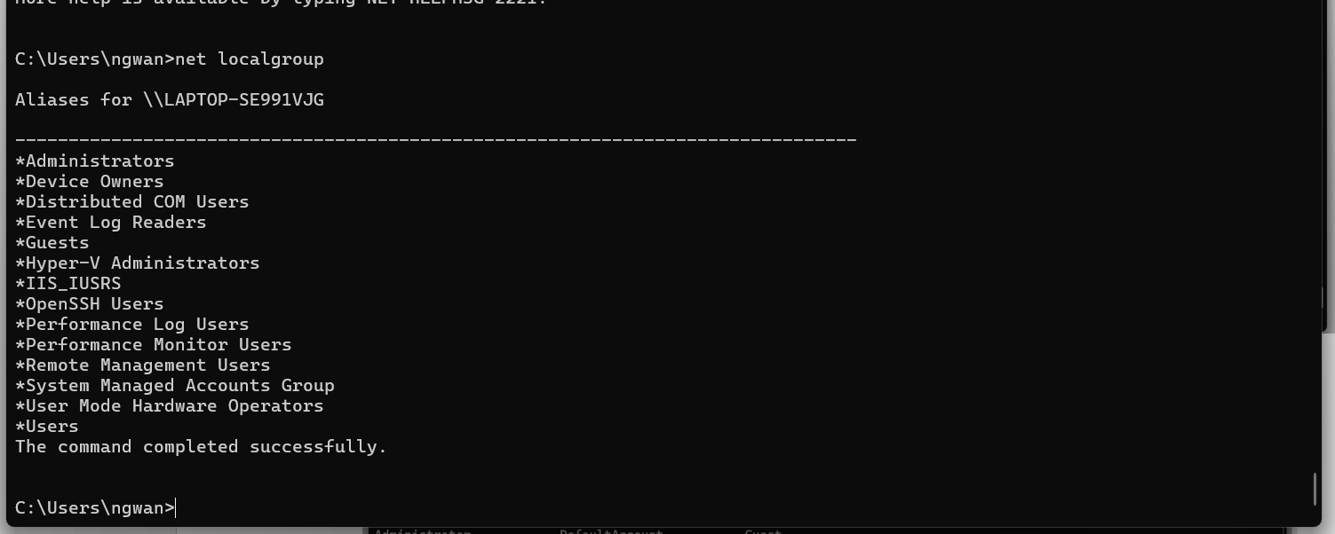-Net plwiz: Advanced user settings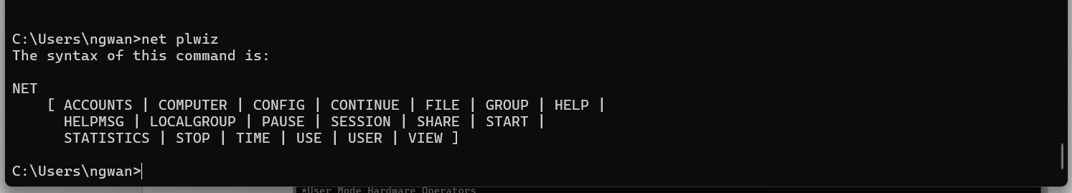-Lusrmgr.msc: Local users and groupswhen you run the command you will have your result as below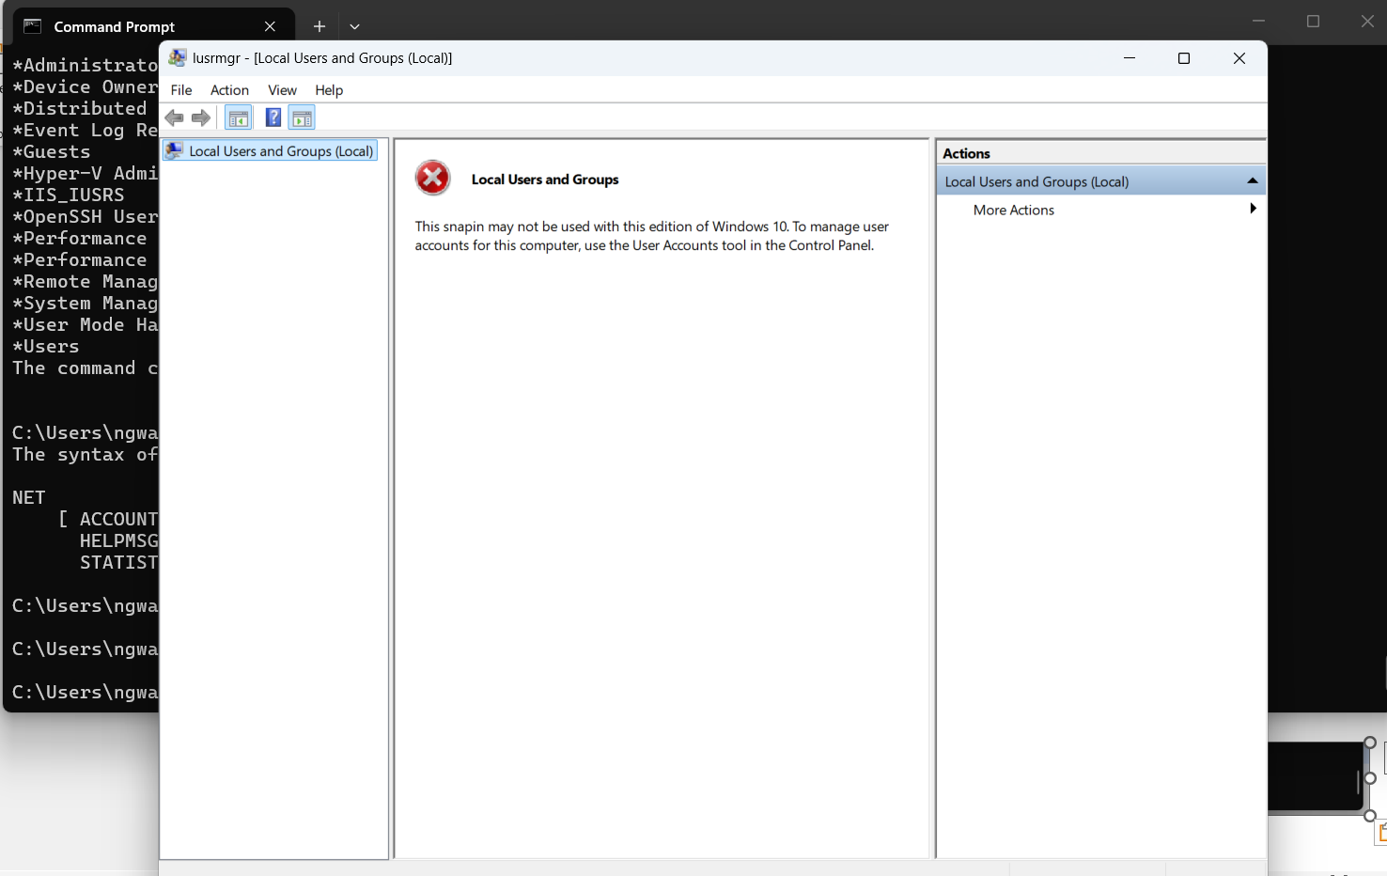

-Label: creates, changes, or deletes the volume level of a disk. 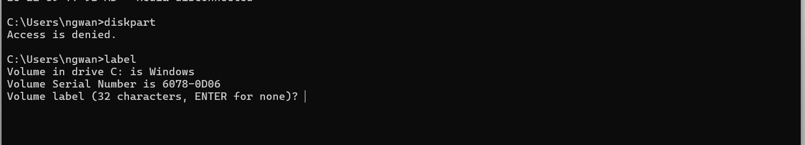

5. Task scheduling Commands
-schtasks /query: Displays all scheduled tasks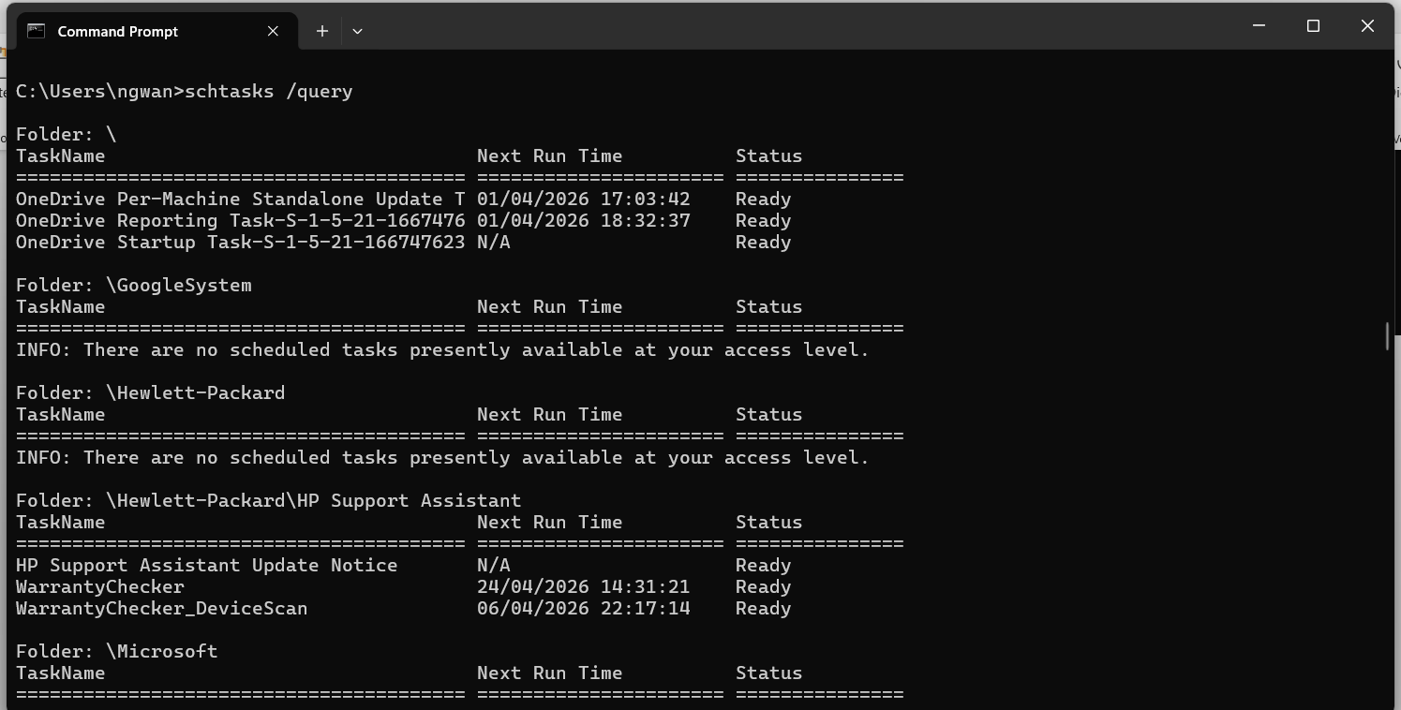-taskschd.msc: Run to open the Task Scheduler graphical interface. when you run the command the result is below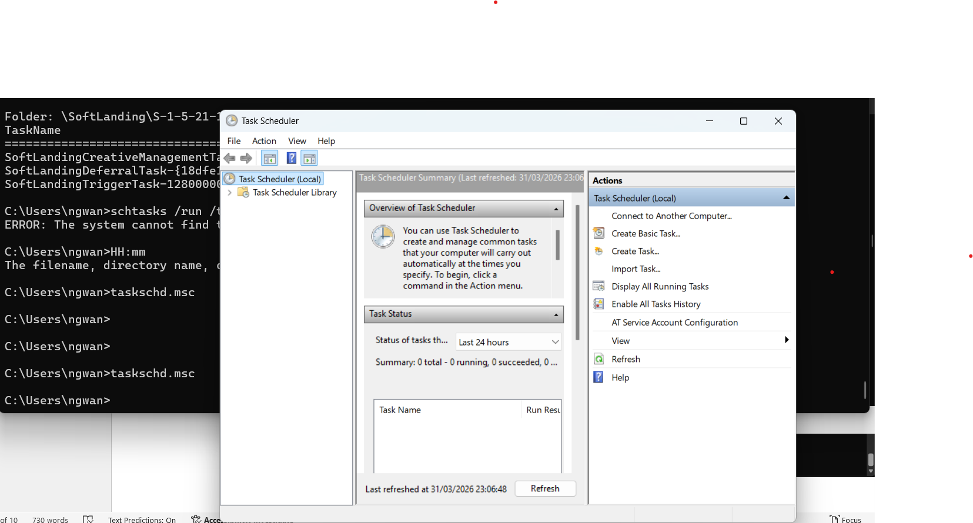

3 Use of Linux OS CLI Commands.

-Process management CLI Commands.
1: bg the bg command is used to resume or stopped job in the background. It allows processes to continue running without blocking out the terminal.
2: fg The fg command brings a background job to the foreground. It allows interaction with the running process.
3: kill The kill command is used to send signals to processes. It is commonly used to terminate unresponsive processes.
4:pmap the pmap commands displays the memory usage of the process. It helps analyze memory consumption. 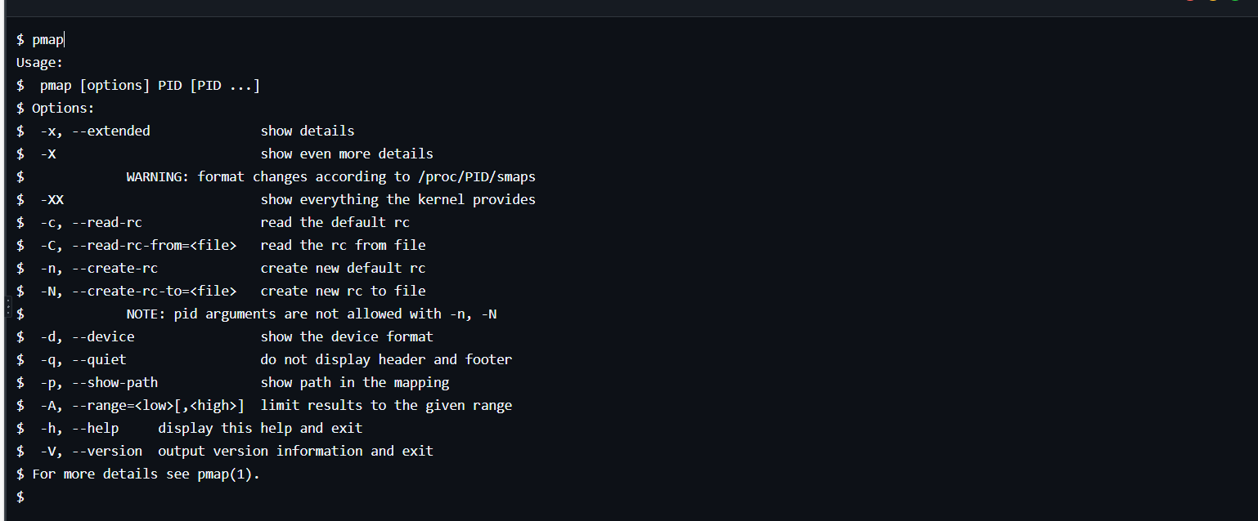

-File and directory management commands
5:mkdir the mkdir command is use to create a new directory.
6: touch the touch command updates the timestamp on existing files.
7: du The du command is use to check directories/files to get in human readable form.

-Network testing/monitoring commands;
8: hostname this command shows the hostname of the current computer system.
9: w this command will shows the information about the users current logged into the system. 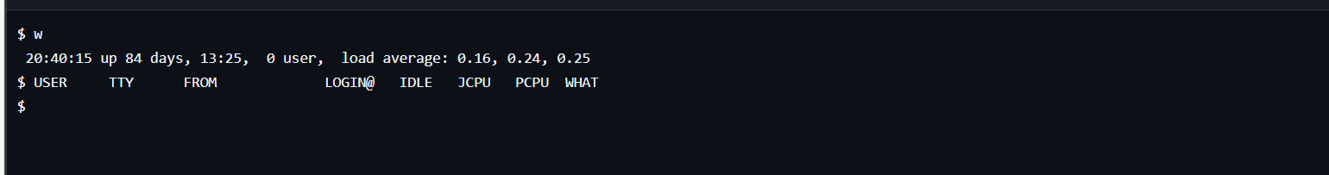

-User management commands.
10: id it is a command for primary group as every linux user is assigned to one primary group.
11:awk this command is use to show the list of all users in linux. 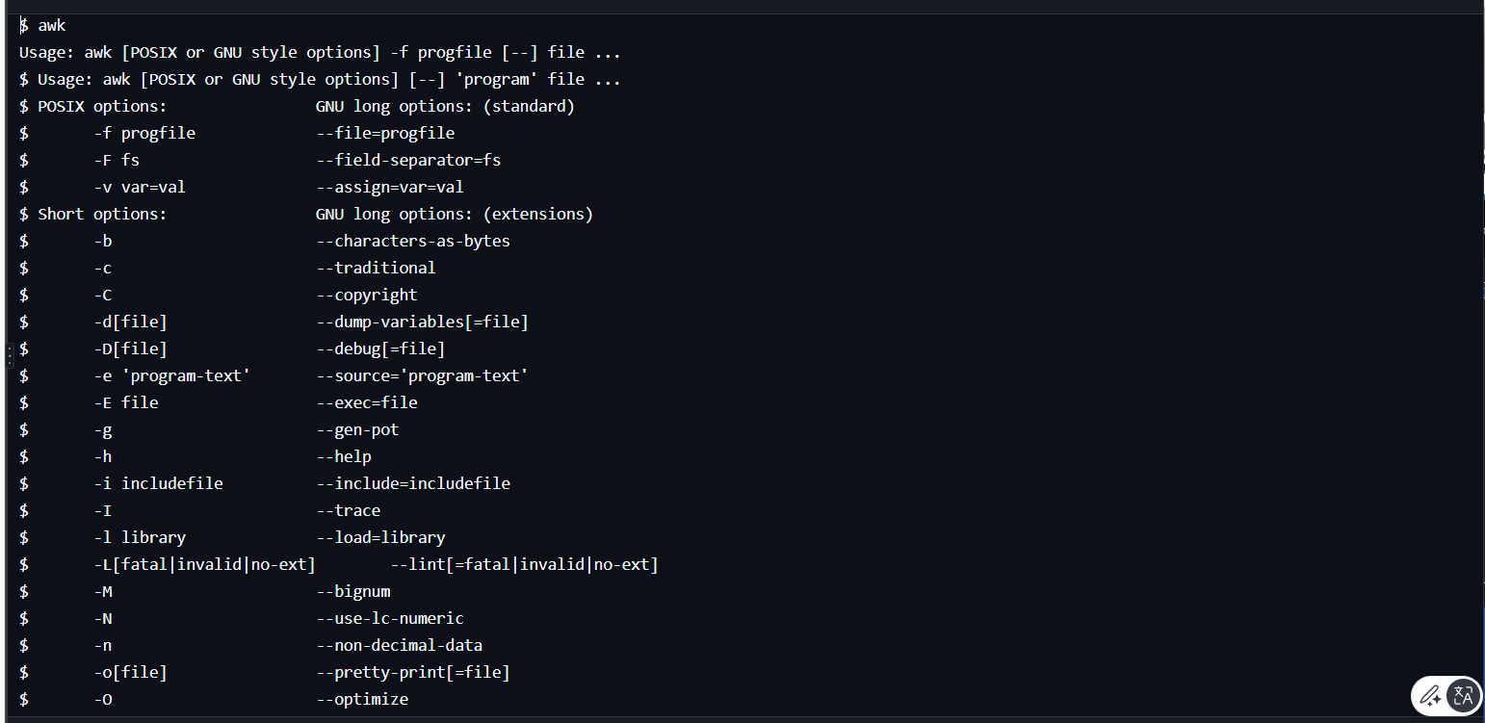

-Task scheduling commands.
12:crontab The crontab command is used to create, edit, and manage cron jobs. It defines scheduled tasks in a file.

4: Use of Windows OS scripts:
You open the notepad in your device then type the various instructions you want you put it in as below also note that you should always start your instructions in the notepad with @echo off and ends it with pause.
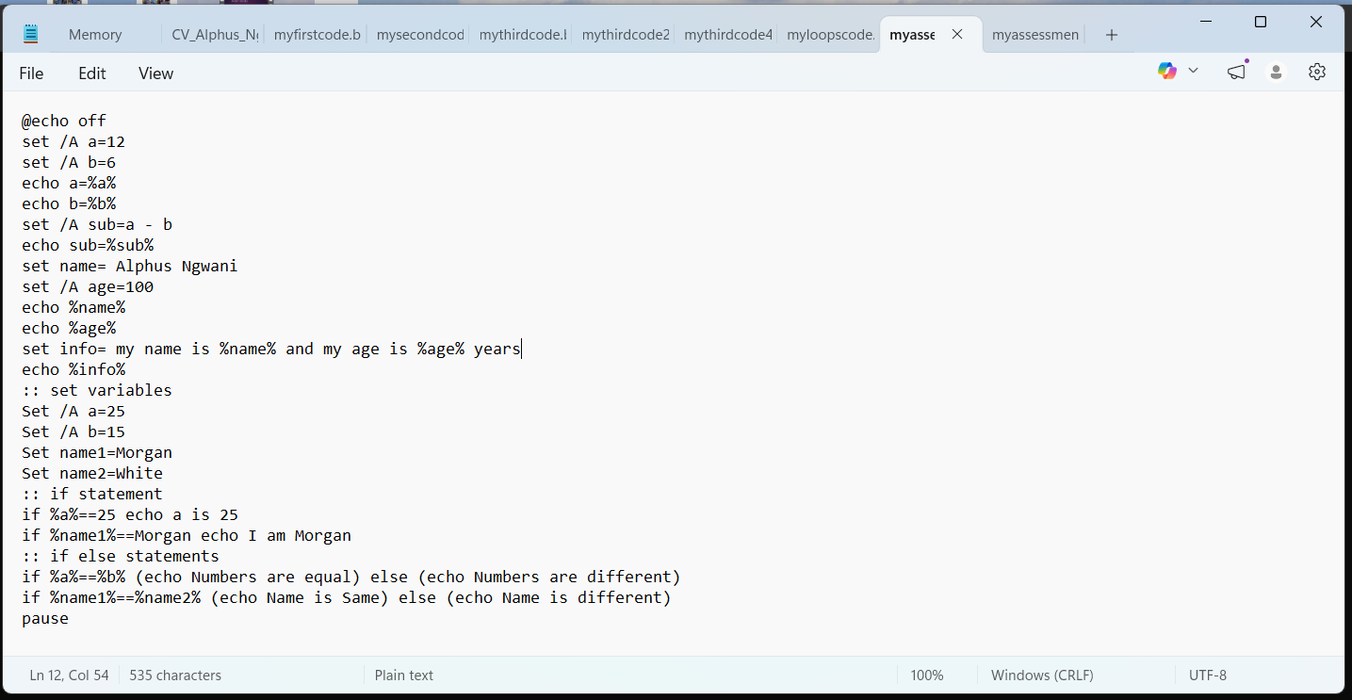
Once all the instructions you required has been entered as above you go to file and select save as and put any name you want to save your file in your device and end it with .bat as below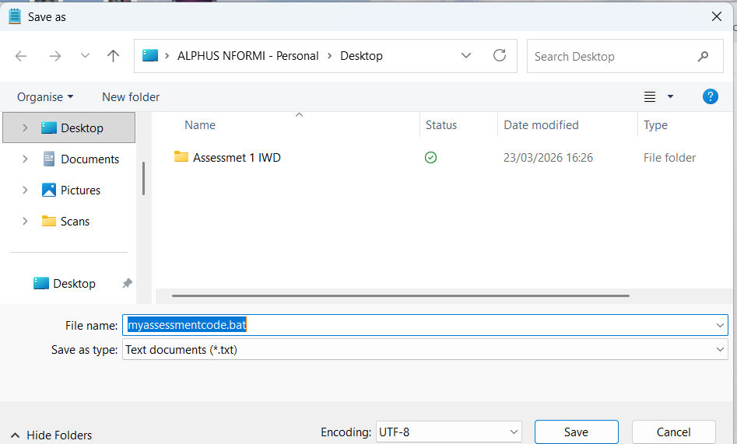Then also select where you want your file to be saved in your device, once you are done you then go to the location in your device where the file stored and double click on the file and then your result will come out clearly in the command window as below. 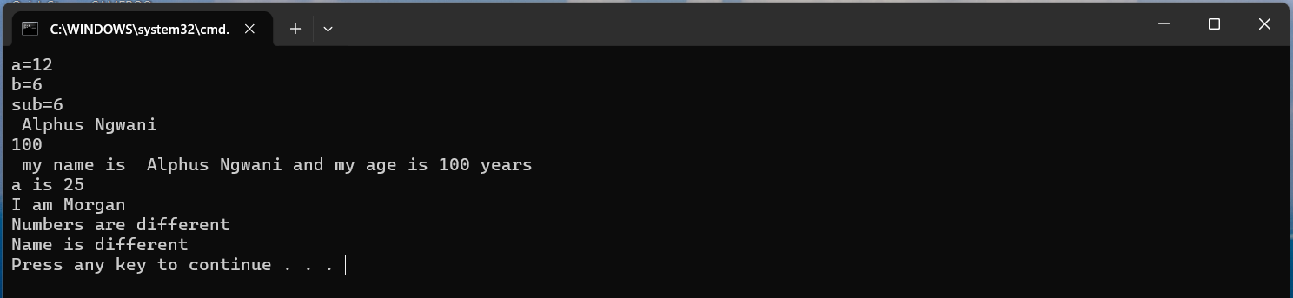Add another tab on the notepad in your device and put in another instructions of what you want the command to give as below. Note that you should always start with @echo off and finish your command with pause. 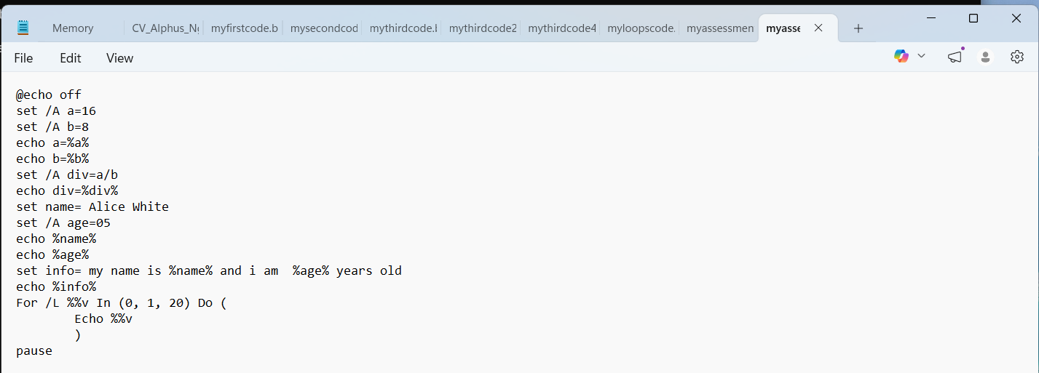
Go to file and select save as and then put the name you want your file to be stored in your device and then .bat and click save as below 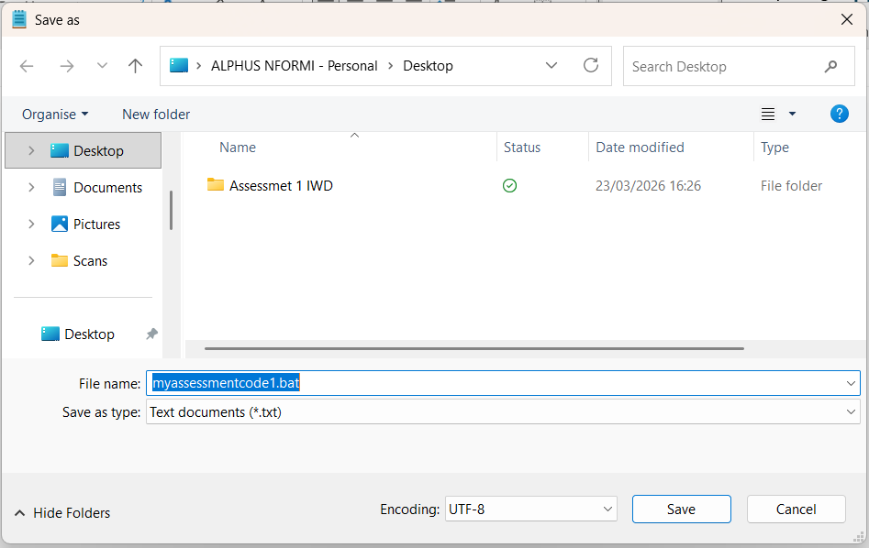Go to the location where your file is stored in your device and double click the file and it is going to open in the command prompt as below displacing all the instructions you wrote . 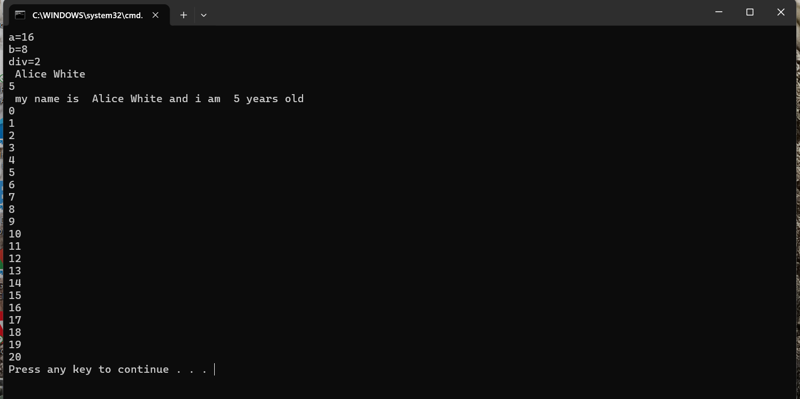

-Conclusion: In this my report I have talked about the key functions of the general operating systems, use of windows OS CLI commands, Use of Linux OS CLI commands, Use of windows Os scripts and Use of Linux OS scripts. All these were very very interesting.

-References:

[1] | Peter B. Galvin, operating system concepts, Hoboken: Wiley, 2018.
[2] | A. Silberschatz, Operating System Concepts, Hoboken: Wiley, 2018.
[3] | G. Gagne, Operating system concepts, Hoboken: Wiley, 2018.

