Digital Skills and Research Methods

Student Name: Nicoleta Anghel
Student ID: 211479
Name Lecturer: Soban Sadiq
Module Name: SH3

Table of Contents
Introduction 3
“Literature review” 4
Methodology justification 5
“Data collection Survey” 7
Analysis 15
Conclusion 18
Recommendations 19
Reference 20

Introduction

The Impact of Virtual Learning Environment acts as a vital aspect in the development of the student's knowledgeable skill. It helps an individual to learn in a flexible time frame. The following research consists of a survey that shows the Importance of a virtual learning environment. The following research also highlights the survey that is conducted on the university students, who were of different age and gender.

“Research aim”

The main aim of this research is to “identify the impact of Virtual Learning Environment” in the “University of Wales Trinity Saint David London Campus”.

“Research objectives”

The main objectives of this research is:
- To examine the importance of “virtual learning environment in the University of Wales Trinity Saint David London Campus” in the lives of the students

- To identify the positive effect of “virtual learning environment in the University of Wales Trinity Saint David London Campus”

- To acknowledge the bad impact of the “virtual learning environment in the University of Wales Trinity Saint David London Campus”
Rationale

The determination of the conducted research is to identify the aspects and the impacts of the “virtual learning environment”. The research also highlight the importance of the “virtual learning environment in the University of Wales Trinity Saint David London Campus”. It also will reflect the negative and positive influence of the “virtual learning environment in the University of Wales Trinity Saint David London Campus”.

“Literature review”

As per Hamutoglu et al., (2018), “the virtual learning environment”, also known as VLE, is a virtual platform that offers teachers and students enhanced experience for learning. Virtual learning environment has become important in the context of education due to the tools and the support given to the institution, students and the teachers. Virtual learning environment helps institutions, teachers and students to improve accessibility and inclusivity, communicate and build relationships, world view expansion, technical skills improvement, immediate learning feedback, comfort and flexibility and help them collaborate and share ideas.

According to Kumar et al (2021), virtual learning is an revolutional education model that changed the way of learning for the students of the current generation. In the virtual learning environment, teachers or the instructors use virtual resources to teach students without gathering everyone in one place or classroom.
Virtual learning environments provide students the freedom to complete assignments and study from any place in the world at any time that fits their schedule. Virtual learning environment also saves money on travel expenses, accommodations, foods and also study materials.

Positive effect of “virtual learning environment”

According to Spruin (2021), the “virtual learning environment” has brought great outcomes in the educational world for both instructor or teacher and students. “Virtual learning environment” has increased the inclusiveness among the shy students without other people watching them like in the classroom.
Learners found that the virtual learning classroom is accessible everywhere and anywhere for their learning. There are no barriers to stop the process of learning for the learners. It seems that it also improves the relationship between the teacher or instructors and the students.

As per the opinion of Kitisuda (2018), the virtual learning environment brings numerous benefits for the instructors and the learners that the traditional classroom fails to provide. Through the virtual learning environment, there are new ways and insights to expand the world view and knowledge of the learners.
It also leads to technical skills improvement like becoming more casual with the use of applications and keyboards. It also brings great comfort and flexibility to all learners and instructors or teachers.

Negative impact of the virtual learning environment

As per Srivastava (2019), although the virtual learning environment has become a revolution in the world of education and has numerous benefits, there are still many negative impacts that it has brought on the society.
The most common one that to be counted should be that virtual learning environment causes social withdrawal and isolation. It also does not provide opportunities for the students and learners to improve communication and social skills. Also the basic and crucial skills such as teamwork, team participation and many more.
According to the opinion of Călin (2018), teachers or the instructors tend to focus less on the practice of the students or learners and more on the theory. Virtual learning environments also lack face to face communication between the learning and teaching party and can also lack pressure and discipline of students or learners. The virtual learning environment increases the computer population and harms the environment indirectly. Virtual learning environment does not provide guarantees or assurance in the virtual education of learners or the students.

Methodology justification

Research Methodology is a key process or technique which provides the ability to select, process, identify, acknowledge, analyze information for a source or topic. It is valuable for the readers to get critical analysis and helps to evaluate a study's complete reliability(Odrekhivskyy et al., 2019),

Primary data collection method is a method through which researchers can collect both quantitative and qualitative datas. They obtained such by surveys, experimentations and observations.
The advantages of primary data collections methods are, data collected is up-to-date and very specific to the problem, data quality is very consequential and relevant to the research objectives, and discovers additional datas and information through the collections (Pereva et al., 2020),
Disadvantages of primary data collection methods form as, the time of data collection it generates an uncertain mess which is how, when and what to collect which is a major disadvantage of primary data collection some of the additional disadvantages of the primary data collection are” it is expensive, “it is time consuming”. In terms of the primary data collection a survey will be done among 20 students from Wales Trinity Saint David London Campus (“Herrador-Alcaide et al., 2019”),

On the other side, secondary data collection is the type of data collected in the past, it is basically a way of collection of data from the used source. Secondary data collections are easy to access and the data are general and not “tailored”. Some of the advantages of the data collections are: it is affordable, which requires no cost to acquire them.
It helps in generating new insights into the “existing primary data”.
Some of the disadvantages of the secondary data are: the collection methods are not reliable, the data may not be authentic. In terms of secondary data collection method, a thematic analysis table will be created which will contain all the applicable books, articles and journals that are associated with the research topic in hand (Phungsuk et al., 2017),

“Data collection Survey”

Q1. “The age of the participants”

“Options” | “No. of Responses received” | “No of total responded” | “Percentage”
17-18 years | 7 | 20 | 35%
19-20 years | 5 | 20 | 25%
21-22 years | 6 | 20 | 30%
22 years and above | 2 | 20 | 10%
Table 1: “The age of the participants”
(Source- learner)

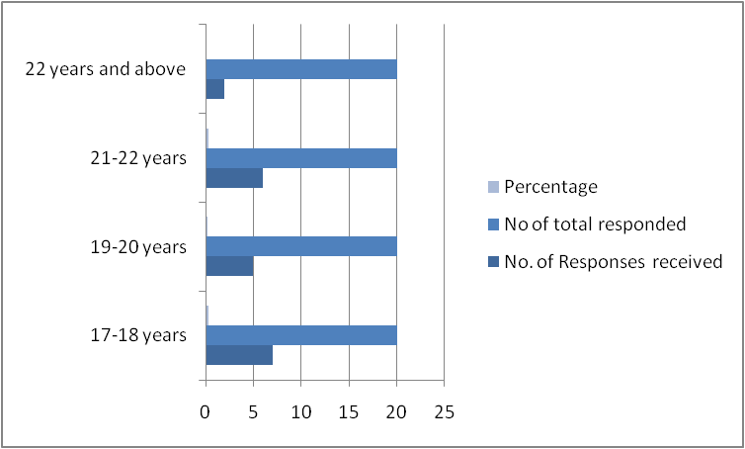

Figure 1: “The age of the participants”
(Source- learner)

Analysis: the above table shows that there are about 35% of the students in the university, that is about 6 out of 20 students who responded to the questions.

Q2. “The gender of the participants”

Options | No. of Responses received | No of total responded | Percentage
Male | 9 | 20 | 45%
Female | 9 | 20 | 45%
Others | 2 | 20 | 10%

Table 2: “The Gender of the participants”
(Source- learner)

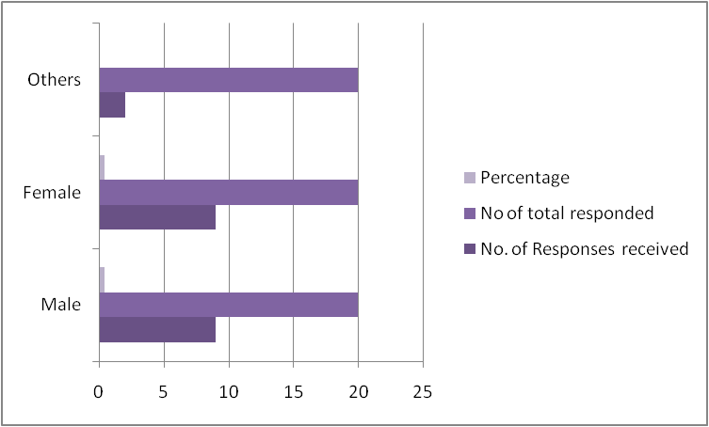
Figure 2: “The Gender of the participants”
(Source- learner)

Analysis: The above table shows the gender of the students in the university. It shows that the university considers both male and females equal In its admission procedures.

Q.3. What is the background of your study?

“Options” | “No. of Responses received” | “No of total responded” | “Percentage”
"MBA Entrepreneurship" | 3 | 20 | 15%
"BSc" | 4 | 20 | 20%
"BA" | 5 | 20 | 25%
"MBA Human Resource Management" | 1 | 20 | 5%
"CertHE Skills for the Workplace (Health & Social Care)" | 2 | 20 | 10%
"BSc (Hons) Cloud Computing" | 3 | 20 | 15%
"MBA Banking and Finance" | 2 | 20 | 10%

Table 3: “The background of the study”
(Source- learner)

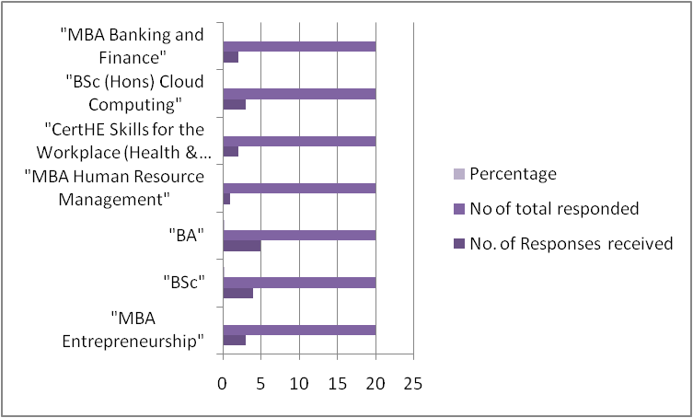
Figure 3: “The background of the study”
(Source- learner)

Analysis: The above table shows the studying background of the student, it is recorded that the maximum number of students participating in the survey is pursuing “Bachelor of arts”.

Q4. How do you like the Virtual Learning Environment?

“Options” | “No. of Responses received” | “No of total responded” | “Percentage”
Excellent | 14 | 20 | 70%
Good | 3 | 20 | 15%
Average | 1 | 20 | 5%
Bad | 2 | 20 | 10%

Table 4: Rating of virtual learning environment by the students
(Source- learner)
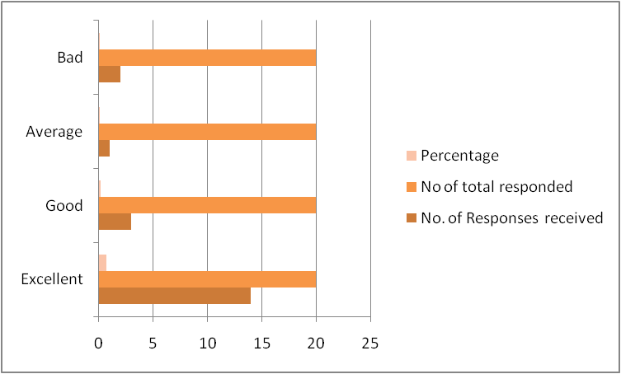

Figure 4: Rating of virtual learning environment by the students
(Source- learner)

Q5. How did the virtual learning environment help you in developing any skill?

“Options” | “No. of Responses received” | “No of total responded” | “Percentage”
"More convenient and flexible" | 6 | 20 | 30%
"Variety of programs and courses" | 4 | 20 | 20%
"Lower total cost" | 8 | 20 | 40%
"More comfortable learning" | 2 | 20 | 10%

Table 5: Virtual learning environment advantages for the students
(Source- learner)
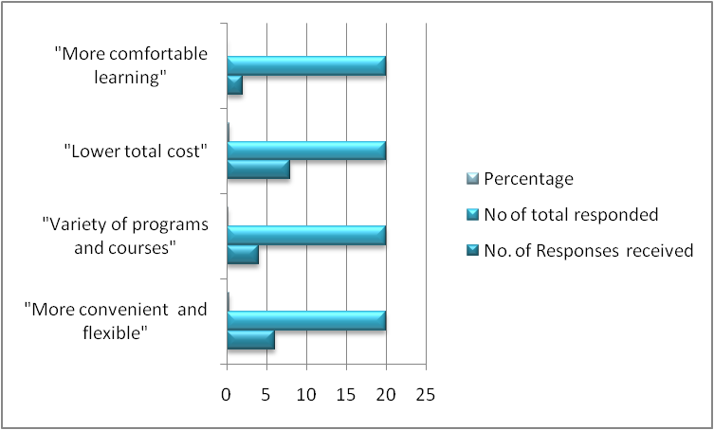

Figure 5: Virtual learning environment advantages for the students
(Source- learner)

Analysis: The above table shows that 40% of the students, 8 out of the 20, responded that the virtual learning environment can help in lowering the cost of learning.

Secondary data collection
Thematic analysis table

Themes | The name of the authors | The years of publication | The name of books/journals/articles
“Importance of virtual learning environment” | - “Hamutoglu, N.B., Gemikonakli, O., Savasci, M. and Gultekin, G.S., “  - “Li, N., Zhang, X. and Limniou, M.” | 2018  2021 | - Development of a scale to appraise virtual learning environment satisfaction.  - A country’s national culture influence virtual learning environment adoption in higher education
“Positive effect of virtual learning environment” | - “Marasco, A., Buonincontri, P., van Niekerk, M., Orlowski, M. and Okumus, F.”  - “Makransky, G., Terkildsen, T.S. and Mayer, R.E” | 2018  2019 | - Exploring the character of next-generation virtual technologies in destination marketing  - Adding immersive virtual reality to a science lab simulation causes more presence but less learning
“Negative impact of the virtual learning environment” | - “Allcoat, D. and von Mühlenen, A.”  - “Alghamdi, A., Karpinski, A.C., Lepp, A. and Barkley, J.” | 2018  2020 | - Effects on performance, emotion and engagement  - Online and face-to-face classroom multitasking and academic performance

Table:6 Thematic analysis table
(Source: learner)

The first theme of the table states the Importance of virtual learning environment, the second theme talks about the Positive effect of virtual learning environment and the third theme talks about the Negative effect of the virtual learning.

Analysis

The first question of the questionnaire shows the age of the participants of the University of “Wales Trinity Saint David London Campus”. The table shows that the age of participants between 17 to 18 years responded 7 questions out of 20 that is about 35% of the total question asked to the student. The second group of students between the age of 19 to 20 years answered 5 questions out of 20 that is about 25% of the total questions,the third group of students between 21 to 22 years of age responded 6 questions out of 20 that is about 30% of the question.
The fourth group of students from 22 years and above answered 2 questions out of 20 that is about 10% of the total question, it was recorded that the maximum of 35% questions were answered by 17 to 18 years of students that were more active than others.
The second question of the questionnaire shows the age of the participants, it is recorded that the university admits an equal number of students in comparison to the gender, the table shows that there are 9 male as well as 9 female that answered the question and other gender numbers were 2 that was only 10% of the student base.
The result shows that the university does not discriminate against any students by their gender. The third questionnaire shows the background of the study by the students. 3 out of 20 students are pursuing “MBA Entrepreneurship” that is about 15% of students in the university.
4 students out of 20 students in the university are pursuing “BSc '' that is about 20% of the total number of the students. 5 out of 20 students, which is about 25% of the students in the university, are pursuing “BA”.1 out of 20 students in the university are pursuing “MBA Human Resource Management” that is about 5% of the student base in the university. 2 out of 20 students that is about 10% of the total student base are pursuing “CertHE Skills for the Workplace (Health & Social Care)".
3 out of 20 students in the university are pursuing “BSc (Hons) cloud computing” that is about 15% of the student base. 2 out of 20 students in the university are pursuing “MBA Banking and Finance” that is about 10% of the student base. The fourth table in the research shows the answers on did the virtual learning environment help the student or not.
14 students of the 20 that is 75% of the student base ranked the virtual learning experience excellent. 3 out 20 people in the university ranked the virtual learning good. 1 out of 20 students that is 5% of the student base ranked the experience average. 2 out of 20 that is 10% of the university student base thinks the experience is bad. The fifth table shows the advantages of a virtual learning environment, the table shows that 40% of the student base, that is 8 out of the 20, thinks that virtual learning can help in lowering the cost of learning.

Importance of virtual learning environment

As per the opinion of Hamutoglu et al., (2018), Importance of virtual learning has influenced the students in Learning new and advanced skills that can help them in easy access of the class and knowledge.

As per the opinion of Li and Limniou, (2021), A student can prosper in learning new things that can help them in an easy way to learn knowledgeable content. It acts as a crucial aspect in the development of the student's skills.

As per the opinion of Marasco et al., (2018), Virtual learning can help prosper of the student prosper in different aspectThere are many positive effects of virtual learning environment. A student can flexibly Take notes of what is taught in the class.

As per the opinion of Makransky et al., (2019), A virtual learning environment can help Increase in technical skills.It does give a flexible working environment according to the students choice. Thus this can help in the students academic performance.

Negative impact of virtual learning environment

According to the opinion of Allcoat and Mühlenen, (2018), Virtual learning environments can be time consuming and the student can lose patience because of server breakdown.

As per the opinion of Alghamdi, (2020), A virtual learning environment can also create a “sense of isolation” that is not good in the academic field of the student.

Conclusion

The following research consists of a survey that shows the Importance of a virtual learning environment. The following research also highlighted the survey that was conducted on the university students, who were of different age and gender. The research also displayed the advantages as well as disadvantages of a virtual learning environment.

Recommendations

- It is recommended that the university can consider enhancing the virtual platform in a more effective way.
- It is recommended that the university can improve the server problem while conducting an online lecture.

- It is also recommended that the university can make the virtual learning more enjoyable by providing the students with different plugin options.

Reference

Alghamdi, A., Karpinski, A.C., Lepp, A. and Barkley, J., 2020. Online and face-to-face classroom multitasking and academic performance: Moderated mediation with self-efficacy for self-regulated learning and gender. Computers in Human Behavior, 102, pp.214-222.
Allcoat, D. and von Mühlenen, A., 2018. Learning in virtual reality: Effects on performance, emotion and engagement. Research in Learning Technology, 26.
Boda, I., Tóth, E., Csont, I. and Nagy, L.T., 2017, September. The use of mythological content in virtual learning environment. In 2017 8th IEEE International Conference on Cognitive Infocommunications (CogInfoCom) (pp. 000307-000314). IEEE.
Călin, R.A., 2018. Virtual reality, augmented reality and mixed reality-trends in pedagogy. Social Sciences and Education Research Review, 5(1), pp.169-179.
Hamutoglu, N.B., Gemikonakli, O., Savasci, M. and Gultekin, G.S., 2018. Development of a scale to evaluate virtual learning environment satisfaction. International Journal of Assessment Tools in Education, 5(2), pp.201-222
Hamutoglu, N.B., Gemikonakli, O., Savasci, M. and Gultekin, G.S., 2018. Development of a scale to evaluate virtual learning environment satisfaction. International Journal of Assessment Tools in Education, 5(2), pp.201-222.
Herrador-Alcaide, T.C., Hernández-Solís, M. and Galván, R.S., 2019. Feelings of satisfaction in mature students of financial accounting in a virtual learning environment: an experience of measurement in higher education. International Journal of Educational Technology in Higher Education, 16(1), pp.1-19.
Kitisuda, P., 2018. An investigation of rhizomatic personal learning environments for autonomous language learners: The case of macrosimulation in a virtual world (Doctoral dissertation, School of Foreign Languages Institute of Social Technology Suranaree University of Technology).
Kumar, S.N., Fred, A.L., Padmanabhan, P., Gulyas, B., Dyson, C., Kani, R.M. and Kumar, H.A., 2021. Multimedia-Based Learning Tools and Its Scope, Applications for Virtual Learning Environment. In Computational Intelligence in Digital Pedagogy (pp. 47-63). Springer, Singapore.
Lacka, E. and Wong, T.C., 2021. Examining the impact of digital technologies on students’ higher education outcomes: the case of the virtual learning environment and social media. Studies in Higher Education, 46(8), pp.1621-1634.
Li, N., Zhang, X. and Limniou, M., 2021. A country’s national culture affects virtual learning environment adoption in higher education: a systematic review (2001–2020). Interactive Learning Environments, pp.1-19.
Makransky, G., Terkildsen, T.S. and Mayer, R.E., 2019. Adding immersive virtual reality to a science lab simulation causes more presence but less learning. Learning and Instruction, 60, pp.225-236.
Marasco, A., Buonincontri, P., van Niekerk, M., Orlowski, M. and Okumus, F., 2018. Exploring the role of next-generation virtual technologies in destination marketing. Journal of Destination Marketing & Management, 9, pp.138-148.
Odrekhivskyy, M., Pasichnyk, V., Rzheuskyi, A., Andrunyk, V., Nazaruk, M., Kunanets, O. and Tabachyshyn, D., 2019. Problems of the Intelligent Virtual Learning Environment Development. In MoMLeT (pp. 359-369).
Pererva, V., Lavrentieva, O., Lakomova, O., Zavalniuk, O. and Tolmachev, S., 2020. The technique of the use of Virtual Learning Environment in the process of organizing the future teachers' terminological work by specialty.
Phungsuk, R., Viriyavejakul, C. and Ratanaolarn, T., 2017. Development of a problem-based learning model via a virtual learning environment. Kasetsart Journal of Social Sciences, 38(3), pp.297-306.
Spruin, E., 2021. Creating a Competitive Advantage in the UK Higher Education Sector through Mirrored Course Delivery: A case example.
Srivastava, P., 2019. Advantages & disadvantages of e-education & e-learning. Journal of Retail Marketing & Distribution Management, 2(3), pp.22-27.
Vaganova, O.I., Smirnova, Z.V., Mukhina, M.V., Kutepov, M.M., Kutepova, L.I. and Chernysheva, T.L., 2017. THE ORGANIZATION OF THE TEST CONTROL OF STUDENTS'KNOWLEDGE IN A VIRTUAL LEARNING ENVIRONMENT MOODLE. Journal of Entrepreneurship Education, 20(3), pp.1-4.



