

Alessandro Calzavacca
Management and Organizational Behavior
M5X01924
Lecturer:
Dr Janet Green

TABLE OF CONTENT

p.3

p.3

p.4

p.6

p.9

p.10

p.11

INTRODUCTION

A TOUCH OF HISTORY

STRUCTURE OF THE COMPANY

LEADERSHIP AND MANAGEMENT ORGANIZATION CHART

CORPORATE CULTURAL RESPONSIBILITY

CONCLUSION

REFERENCES

INTRODUCTION
In this assignment I will compare on three different topics a well-known hospitality company based in Italy, the paragraph is split in two section: an overview and the actual activity of HNH Hospitality. The literature over overview is the result on academic books and documents which from expert of the industry explain how the companies have to work regarding structure, leadership and cultural point of view.

A TUCH OF HISTORY
HNH Hospitality is one of Italy’s leading independent hotel operators in the 4- and 5-star hotel segment. The Group operates fifteen hotels located in northern and central Italy, in major cities such as Trieste, Padua, Verona and Bologna, and tourist destinations such as Jesolo, Venice and Rome.
Passion, quality of service and the constant pursuit of economic efficiency are the driving force behind company’s strategy. (HNH hospitality,2020)
Hotels | Rooms | Cities | International  Hotel Chains | Employees
15 | 1742 | 10 | 03 | 500+

If we retrace the path that has led them here, from the opening of the first hotel in Jesolo in the 1960s, we can understand how HNH Hospitality has been able to establish itself, to grow and reinvent itself, by adapting to the rapid changes in the hotel industry.
Here some important years for the company:
1996
Angelo and Jolanda Boccato
open the first property: the
Hotel Brasilia in Jesolo.
1999
Loris Boccato, current Chairman,
opens the Hotel Tritone in VeniceMestre
and founded the Group.
2013
Best Western CTC Hotel Verona and
Hotel Bellevue & Resort (Jesolo) join
the Group.
2014
Almar Jesolo Resort & Spa, the first 5-star
hotel of the Group opens its doors.
2017
Siparex, a private equity manager,
becomes a shareholder by investing
8.5 million Euros in the Group.
2019
The Hotel Sant’Elena becomes
Hotel Indigo Venice - Sant’Elena.
2019
Grand Hotel Des Arts Verona
joins the Group.
2019
DoubleTree by Hilton
Trieste opens its doors.
2019
Crowne Plaza Padova, Crowne
Plaza Venice East - Quarto d’Altino,
Best Western Hotel Airvenice
join the Group

STRUCTURE OF THE COMPANY
Each hotel needs an organization chart, to precisely define all the positions and responsibilities of the structure, from the receptionist to the hotel manager, from the housekeeping to the chefs and restaurant staff.
Only in this way is it possible to guarantee a studied and tested approach that can make the entire working machine work smoothly.
Regardless of the size of the hotel, it is always necessary to have a program of everyone's activities, objectives and tasks.
The first useful distinction for a concrete approach concerns the type of structure:
- Small hotel (Family run). Management dictated by owners and family members. The key to success will have to leverage its direct contact with the customer, this will serve to develop the relationship, retain it and increase it over time.
- Medium sized hotel (Organized organization). This structure usually has the capacity of up to 150 people, is managed by qualified personnel and must be organized by departments.
- Large hotel (Managerial structure). Generally, it has a capacity of more than 200 places: each department must be delineated and separated. For each there must be a foreman who manages that section and responds only to the management. The staff is highly qualified.
Before exposing the organization chart of a hotel, therefore, we will start with the actual structure of the company, that is, the organization of environments and works.
Hospitality is the mission of the company, by natural vocation and history entrepreneurial. Being a company requires to interpret this role with a spirit of innovation and economic efficiency. Variation of the hotel industry provides for a continuous search for efficiency and an increase constant quality standard of the services they offer to the Guests
The diversification of hotels, not only geographical but also compared to the reference markets, led to the development of four distinct product categories:
- Business Hotels
These facilities offer guests
travel for work personalized services,
appropriate to their needs, without
give up efficiency and comfort
guaranteed by the international chain.
- City Hotels
Promoted according to a logic
multibrand, that is, to tie
the hotel's image to that of
a strong international brand,
guaranteeing high quality standards,
attention to detail and sensitivity
historical and cultural context
where the structure is inserted.
- Resorts
Independently managed,
are characterized by a quality
tailor-made welcome.
- Luxury
Exclusive experience, high level of
services offered, combination of technologies
and well-established knowledge of the world
hospitality with highly
qualified and professional staff.

After a first explanation of the hotels division, I found important to summarize also the different department within the company. Each department has a precise task and reporting to a different management according to the corporate hierarchy which we will have a look in the next paragraph

“It is the little things that make the big things possible. Only close attention to the fine details of any operation makes the operation first class.”
J. Willard Marriott
LEADERSHIP AND MANAGEMENT ORGANISATION CHART
A conversation about managers and management always seems to prompt a conversation about leaders and leadership. Frankly, I am surprised when I read articles comparing management and leadership. I do not understand the comparison. In my mind, they are two completely different things. It is like comparing apples and pianos.
We talk about the word “leader.” The Free Dictionary defines a leader as “one who has influence or power.” Using this definition of leadership tells us a couple of things:
1.Leaders exist at every level of an organization. They may or may not also be managers.
2.If you are a manager, you have some leadership power by virtue of your position.
If we want to cultivate leadership within our organizations, we must recognize that leadership exists in everyone. It is about understanding how an individual’s leadership manifests itself in actions and behaviours. It is about using our leadership ability in the right way and at the right times. Companies need leaders beyond the ones holding a manager job title. And individuals holding a manager job title need to realize that their boss, co-workers, and team members all have leadership ability. This will change the way they view their role.
In the organizations, you may or may not use the terms leader and manager interchangeably. That is, great managers are not great leaders, and vice versa. It is important consider leaders and managers to perform two different roles in the organization. Companies need both of them to be successful.
Here some theoretical opinion I found thanks to my academic research. According to the author about the difference between management and leadership, He says, “I never like to get in an disagreement about leadership and management, for the reason that whenever they are related, management takes second swindle, due to the fact that leadership looks so much more exciting. Yet there are certainly two parts of leadership.”(HR Bartender, 2015)
Blanchard explained the two parts of leadership. “The first is strategic leadership, which involves vision and direction, the second is operational leadership, which involves implementing the vision. The part that entails setting the vision and direction is what people usually associate with leadership. The part that entails implementation, how you accomplish the goals and live according to the vision, is thought of as management. But I really think both are aspects of leadership.”(Blanchard, 1982)
Leadership is a part of management. But it is not the only part of management. Excellent leadership skills are needed at every level of the organization.
HNH Hospitality adopts a business model that follows the center-periphery logic: in the center specialist delegated activities at the headquarters, in the suburbs staff and staff management activities services addressed directly to the guest. Centralized management involves a wide range of functions ranging from direction operational to commercial, from communication to the administration, from finance and management control purchases of products and services, from maintenance management to staff selection and management. In hotels, however, the manager comes asked to focus on quality of the service offered to guests. Thanks to this model organizational, effective synergies of development among the specializations of the top and the operation of the individual structures are able to optimize the quality standards of each hotel, promoting its growth and success.
“Take good care of your employees, and they will take good care of your customers, and the customers will come back.”
J. Willard Marriott
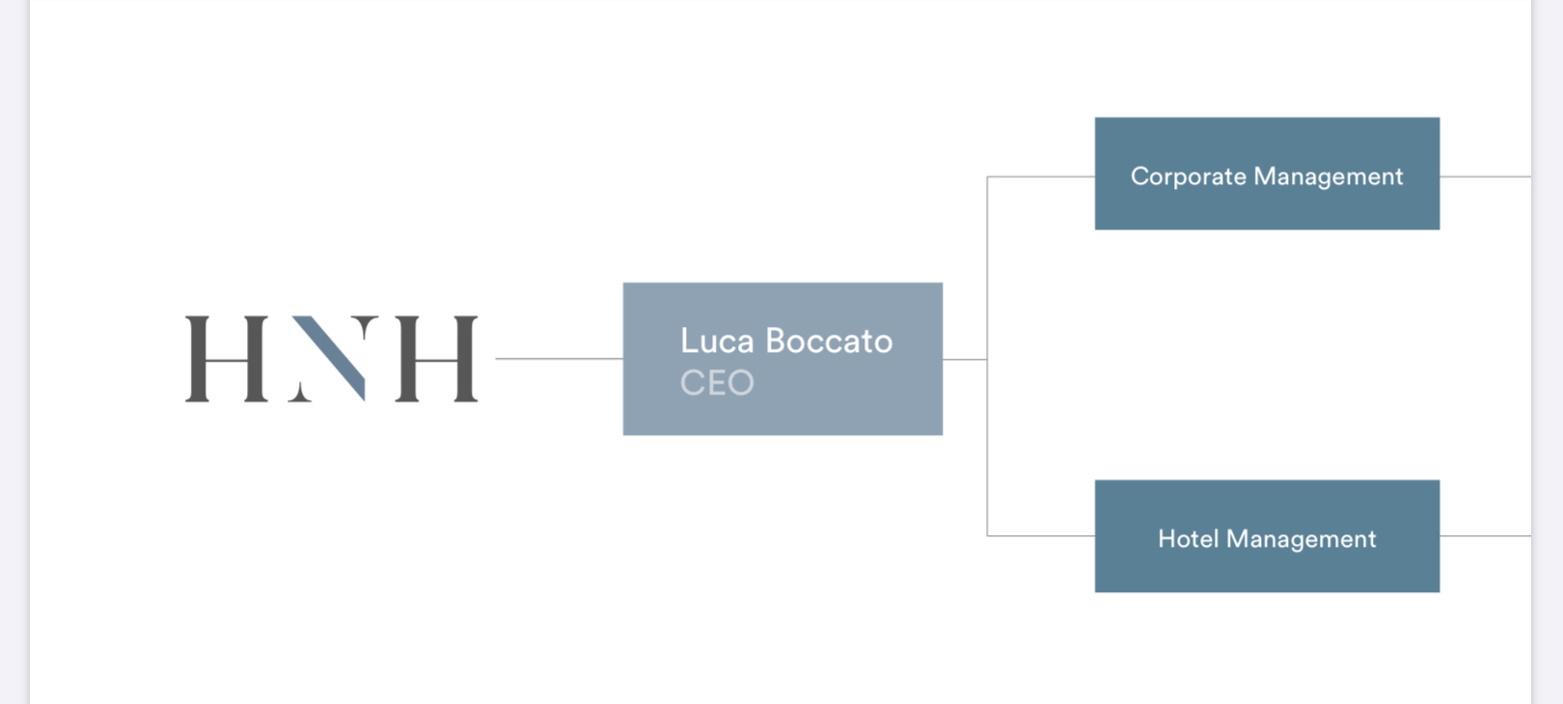
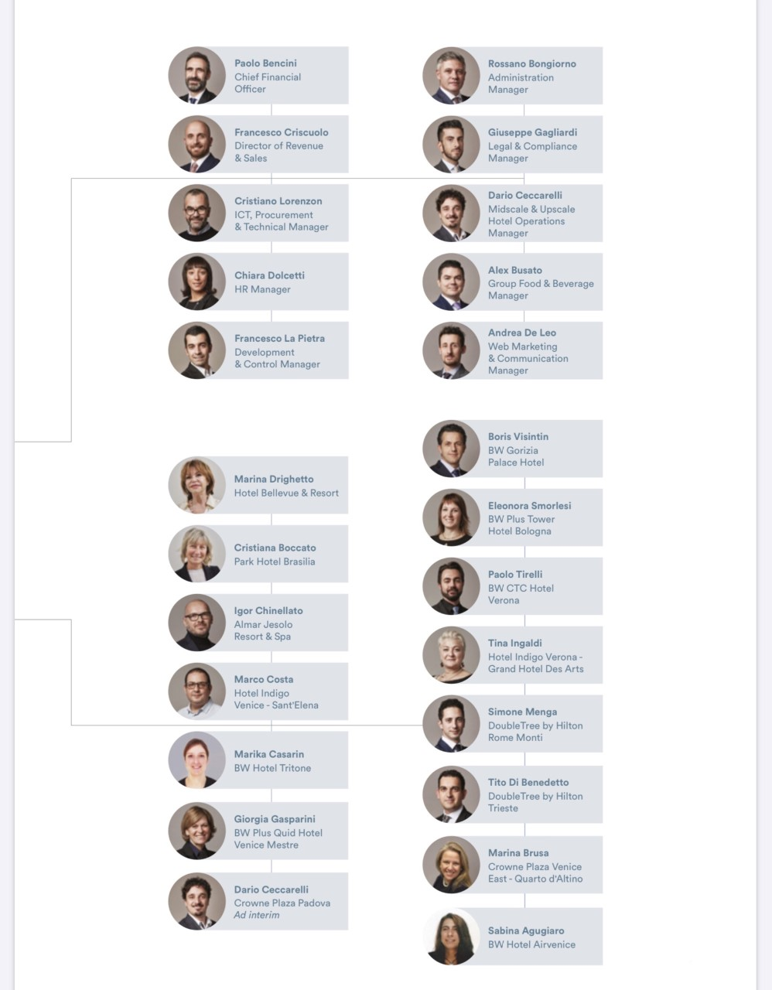

CORPORATE CULTURAL RESPOSABILITY
Cultural, social or environmental, the commitment that a company is taking outside its strict economic interest are the most important as many important authors had highlighted, in the next paragraph I will summarize a large overview on how is important for a company this kind of investments thanks to some academic literature.
The economist Milton Friedman (1970) argued that Corporate Social Responsibility is a distraction from a “a corporation's principal purpose to use its resources and engage in activities that maximize returns to its shareholders, while obeying the laws of the countries within which it works” According to Munilla and Miles (2005), another economist Adam Smith also argued 200 years ago that “the general welfare was better served by people pursuing their enlightened self-interest than by misguided attempts to serve society.” These ideas are contrary to that of Corporate Social Responsibility.
Despite this, McKeon (2006) raises a good point in that virtually all detractors of Corporate Social Responsibility come from the side-lines. “They tend not to be business managers trying to satisfy shareholder expectations. Equally they tend not to represent the community sector. No, the opponents tend to be academics, consultants, members of think tanks and professional opinion writers.”
Another aspect to be aware of is that if companies talk the Corporate Social Responsibility talk, they must walk the walk or they will be found out. For example, Shell has a much-publicized Corporate Social Responsibility policy and was a pioneer in triple bottom line reporting; however a scandal in 2004 over the misreporting of its oil reserves seriously damaged its reputation. (Wikipedia 2007)
The passion that HNH Hospitality puts in operating its business is mirrored in the values used to build a relationship with its guests and its employees day after day. Human connection and the relationship between humans and the environment acquire a fundamental value. The initiatives dedicated to environmental sustainability, the enhancement of human capital and social commitment are the demonstration that "doing business" by pursuing social goals is a possible way to combine the good of the community with that of the company

CONCLUSION
In conclusion we always need to understand that giving the right comparison to elements in regard and theoretical texts we can find out if the company is on the right path. If the employees are feeling comfortable and guests satisfied. HNH has demonstrated with a high organisational behaviour to be on the top of the country in their industry.

"You don’t run harder just to win. You run harder mainly to be able to run faster when you need to."
Luca Boccato

REFERENCES
Blanchard K and Johnson S, 1982. The One Minute Manager. New York: William Morrow.

"Corporate Social Responsibility: The New Strategic Marketing Battleground" by Chris Maloney SMASHWORDS EDITION 2010

Friedman, M. 1970, ‘The Social Responsibility of Business is to Increase its Profits’, The New York Times Magazine, September 13, 1970.

HNH hospitality profile company, March 2020. available at https://www.hnh.it/wp-content/uploads/2020/03/HNH_Company_Profile2020_WebLow.pdf [access 10 July 2020]

“Interview: Dr. Ken Blanchard on Leadership and Management,” HR Bartender (blog), 2015, available at https://www.hrbartender.com/2015/training/interview-drken-blanchard-on-leadership-and-management/ [access 10 July 2020]

Lauby S,2016. Manager Onboarding: 5 Steps for Setting New Leaders Up for Success". published by the Society for Human Resource Management (SHRM).

Marriott J.W. 2020 J. Willard Marriott Quotes, available at https://quoterati.com/authors/j-willard-marriott [access 10 July 2020]

McKeon, S. 2006, ‘Corporate social responsibility makes an impact’, available at <http://www.theage.com.au/news/ [access 10 July 2020]

Munilla, L.S. & Miles, M.P. 2005 ‘The Corporate Social Responsibility Continuum as a Component of Stakeholder Theory.’, Business & Society Review; Winter 2005, Vol. 110 Issue 4, p371-387

Wikipedia 2020, Corporate social responsibility, available at http://en.wikipedia.org/wiki/ Corporate_social_responsibility [access 15 July 2020]

