

Module Code: ECAD6018
Assignment Title: Deepening Practice
ALN – Part 1 Journal: Demonstrate the deep practical and theoretical understanding of the role of the ALNCo.
Student Name: Jodie Everett
Student Number: 2200310
BA Primary Education (QTS)

AI Acknowledgement
I confirm that I have not used any AI tools in the research and creation of this assignment.
I confirm that I have not presented any AI generated materials as my own work.
I confirm that I have copies of my drafts, notes, and other resources I used, which I may be asked to provide in evidence.

Targets from previous module | How I have worked on these? | An example can be seen on…
Target 1 – Proofread assignment with greater care. | Work was proofread by myself and a trusted peer with fine attention to punctuation. I also used the read aloud function on word to ensure consistency and that my work flowed coherently. | This assignment was proofread by myself and a chosen peer. This was highlighted as my main target to ensure that work was being read by a peer as well as myself.
Target 2 – Aim to explain all ideas in consistent depth. | I did my best to ensure that all my points were consistently explored and none were more described to the other. | Whilst this target was hard to achieve due to the limited word count, I made a conscious effor to ensure everything was equally explored and explained for example my description on theorists.
Target 3 – Take care to work on targets before submitting assignment. | I reached out to support systems available at the university to develop my understanding of targets and how I could improve for this assignment. | Literature such as Azorin and Ainscow (2020) was found from collaborating.

The Welsh Government (2024) aims to create a more equal Wales, and as part of this transformation within schools an Additional Learning Needs Co-ordinator (ALNCo) must be appointed (Welsh Government a, 2021). An ALNCo refers to an individual that is designated, in accordance with the additional learning needs (ALN) Act (section 60), by a school that takes responsibility for co-ordinating additional learning provisions for pupils with ALN (Welsh Government b, 2021). Drawing upon shadowing experience within a Welsh primary school, this journal aims to critically examine the core responsibilities of an ALNCo. This journal aims to merge:
- Academic literature
- Observation
- Case studies
- Critical reflection
Concluding with future recommendations linked with the QTS Professional Standards (Welsh Government, 2019).
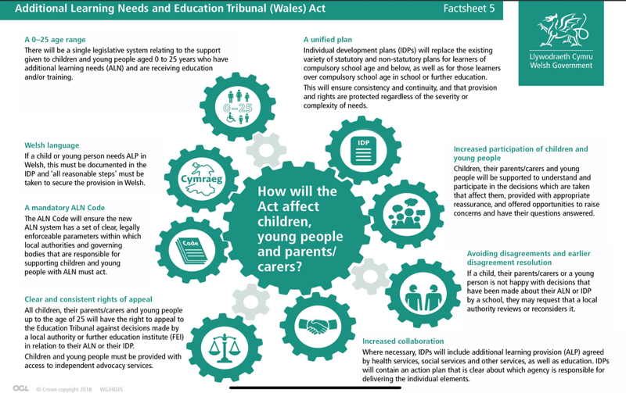
ALN can be defined as a person that has a learning disability or difficulty that requires the facilitation of additional learning resources whether that be non-medical or medical (Welsh Government b, 2021). ALN replaced the special educational needs (SEN) system and the system that supports learning difficulties and/or disabilities (LDD) in Wales to create a more cohesive and inclusive system (Welsh Government, 2022). In alignment with the Welsh Curriculum (2024), the role of an ALNCo and the new ALN system places strong emphasis on inclusivity and equitability ensuring all pupils in Wales receive meaningful education linked to personal needs. The Additional Learning Needs and Education Tribunal (Wales) Act (2018) underpins the new system and outlines responsibilities of the ALNCo being: upholding professional leadership with the delivery of additional provisions for pupils with ALN, maintaining appropriate levels of support and ensuring they are implemented effectively in a holistic manner (Welsh Government a, 2018). It is important to note that whilst this act is in place for 0–25-year-olds it is not accessible in higher education systems such as university. ESTYN (2023) highlighted implications of the act being maintained within schools as it lacks support for children with ALN transitioning to higher education.
(Welsh Government b, 2018).

ALNCo’s Responsibilities and Strategic Role:
Whilst some responsibilities remain optional for an ALNCo, the ALN code for Wales (b,2021) outlines the mandatory roles:
- Ensure pupils with ALN have an Individual Development Plan (IDP), which ensures that their needs are identified and met by the appropriate Additional Learning Provision (ALP). This responsibility corresponds with the United Nations Convention on the Rights of the Child (UNCRC, 1990), particularly Article 12 - the right of the child to be heard – as IDPs actively involve learners in decisions about their own education and development.
- Liaise with outside agencies to provide external support for pupils with ALN if required. For example, the ALNCo may collaborate with social workers inline with the Social Services and Well-being (Wales) Act (Welsh Government, 2014) to support a multi-agency approach.
- ALNCo’s must store and keep all relevant documentations and records of support and IDP’s for pupils with ALN.
- ALNCo’s must advocate for inclusivity and contribute to a whole-school approach to ALN. This supports pupils being protected from discrimination, incoherence with the Equality Act (2010) and the principles set out by UNCRC (1990). Although, whilst these sources provide a fundamental framework, they are becoming increasingly outdated and may no longer reflect the evolving understanding and needs of learners with ALN.
- ALNCo’s must monitor and evaluate the effectiveness of ALP’s put into place.
- The ALNCo must provide support and advice on strategies that teachers can use within their classrooms. Alongside providing staff with training opportunities and supervising support staff to ensure the quality of ALN support being provided.
Due to being placed in a learning resource centre (LRC) I had the ability to interact and shadow the ALNCo for an eight-week period. During this time, I was able to witness the breadth and depth of obligation placed on an ALNCo. As stated above, one of the main responsibilities of an ALNCo is to produce IDPs, which are tailored to meet the specific needs of an individual with ALN (See Appendix 1). I experienced first-hand an ALNCo referencing these plans in order to monitor progression and effectiveness of strategies put into place.
The ALNCo co-ordinated with external stakeholders including families and outside agencies. In relation to parental engagement, I observed the ALNCo set up “cuppa and a chat!” Sessions (See Appendix 2). Here, parents and families were able to come to the school in an informal setting and ask questions, raise concerns and engage with the school's approach to ALN. By fostering positive relationships with parents/guardians, schools can ensure a stronger foundation of support to effectively meet the needs of pupils (McCarthy, 2024). Bronfenbrenner’s Ecological System Theory (1979) reiterates the importance of secure relationships with families, school and outside agencies, supporting the ALNCo’s role in creating collaborative bonds across all systems to meet holistic needs of learners with ALN.
Moreover, the ALNCos collaboration with outside agencies such as specialists was a vital element of the role. I observed the ALNCo arrange and liaise with agencies, such as speech and language therapy, to come into the classroom and offer expertise and support amongst the classroom for non-verbal learners. From this, the specialist supported the pupil by providing a picture-based iPad communication app, enabling the pupil to communicate needs by selecting visual symbols. The ALNCo then welcomed the family of the pupil into school to gain training on the device to enable its use at home.
Additionally, I observed the ALNCo advocate for inclusivity during staff meetings and provided staff with training opportunities to support understanding and knowledge of ALN and ALP implementation. This collaborative approach to ALN supports the overarching goal of creating an inclusive education where all pupils have the ability to thrive (UNESCO, 2009; Fasting & Breilid, 2024; Welsh Government, 2016). The ALNCo also set up and organised meetings such as Person-Centred Reviews (PCRs), ensuring all relevant bodies were present.
Reflection: I understood the importance of the ALNCo when being that bridge between families and external agencies in order to ensure the needs of all pupils were being met.

Limitations and barriers
Despite of the rewarding aspects of the role, it was evident to see the challenges faced when responsibility lied amongst one individual. Murphy, Greenway and Conn (2025) conducted research around the voice of an ALNCo which reiterated the concerns of workload and increase of responsibility for one person. However, National Association of Head Teachers (NAHT, 2022) challenges the view that all responsibilities are placed on the ALNCo, by stating ALNCos are not expected to be directly involved with a pupil's day to day operations, and this responsibility still lies with the class teacher. This is suggestive that with a positive whole-school approach and sharing of responsibilities this barrier is significantly reduced.
Additionally, another challenge faced was an increase in wait time for pupils to gain a diagnosis to be provided with an IDP. The Welsh Government identified an increase in percentages of pupils on the wait list, increasing from 26 weeks up to 3 years (Hardy, 2024). As a result, parents become frustrated, and these frustrations are typically targeted at the ALNCo. Whilst the ALNCo supported families by liaising with external agencies, frustrations remained due to families feeling failed by the system.
Furthermore, inconsistencies in staff knowledge and understanding of ALN and ALPs were identified as a significant barrier for ALNCos. This led to inconsistent implementation of the ALPs provided by the ALNCo across the school, reducing the effectiveness of the strategies. ESTYN (2024) thematic report also identified staffs
misunderstanding of ALPs and asks for clarification from the Government on application in classrooms.
Reflection: Support for pupils with ALN is a collaborative approach, where responsibility goes beyond the ALNCo and includes all stakeholders to ensure a consistent response to meeting the needs of pupils.

Reflecting on the Role of the ALNCo: Theory, Professional standards, and Professional Growth
Gaining experience shadowing the ALNCo offered me insight into the importance of inclusive education in Wales and how an ALNCo role underpins the practical implementation in schools. Vygotsky’s Sociocultural Theory (1978) demonstrates that the more knowledgable other (MKO), referring to the ALNCo in this instance, scaffolds and supports pupils with ALN in the zone of proximal development (ZPD) to access the curriculum purposefully. Building upon this, inclusive education theory (Azorin & Ainscow, 2020) which emphasises the importance of collaboration in order to remove barriers to education. This directly links to an ALNCo and their role of ensuring inclusive provisions are accessible amongst the school.
Through this experience I was able to develop on the following areas of the QTS standards (Welsh Government, 2019):
- Pedagogy (Refinement) – I observed how differentiation was used by the ALNCo to support learners needs effectively. I not only observed but applied this to my own teaching by adapting lessons and support based upon pupil needs. I aim to keep refining this standard by ensuring I differentiate work for pupils in future.
- Collaboration – Observing the ALNCo collaborate with staff, families and external agencies, I was able to apply this when seeking advice and support from colleagues and specialists to better inform my practice. I plan to build on this by actively seeking guidance and help from professionals to better support my knowledge and understanding of ALN.
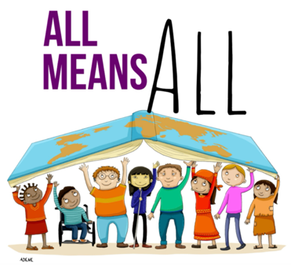
Shadowing an ALNCo allowed me to see that professional development is a continuous process. Picker (2012) highlights that professional learning is a need in education in order to support students to excel. I aim to grow as a teacher and create an inclusive space where all pupils feel welcome and supported.
UNESCO (2022)
Reference list:
Azorín, C. and Ainscow, M. (2020) Guiding schools on their journey towards inclusion. International Journal of Inclusive Education, 24(1), pp.58-76.
Bronfenbrenner, U. (1979) The Ecology of Human Development: Experiments by nature and design. Cambridge, MA: Harvard University Press.
ESTYN (2023) The new additional learning needs system: Progress of schools and local authorities in supporting pupils with additional learning needs. Available at: https://estyn.gov.wales/system/files/2023-09/The%20new%20additional%20learning%20needs%20system_0.pdf [Accessed 29 April 2025].
ESTYN (2024) The additional learning needs system: Progress of schools, settings and local authorities in supporting pupils with additional learning needs. Available at: https://estyn.gov.wales/app/uploads/2024/12/The-additional-learning-needs-system.pdf [Accessed: 1 May 2025].
Equality Act (2010) Available at: https://www.legislation.gov.uk/ukpga/2010/15/contents [Accessed: 29 April 2025].
Fasting, R.B. and Breilid, N., 2024. Cross-professional collaboration to improve inclusive education. Scandinavian Journal of Educational Research, 68(4), pp.661-676.
Hardy, G. (2024) The growing demand for ADHD and autism assessments in Wales. Available at: https://research.senedd.wales/research-articles/the-growing-demand-for-adhd-and-autism-assessments-in-wales/ [Accessed: 1 May 2025].
McCarthy, H., 2024. A story of change: Additional learning needs co-ordinators narratives of additional learning needs transformation in Wales (Doctoral dissertation, Cardiff University).
Murphy, A., Greenway, C. and Conn, C. (2025) Negotiating additional learning needs reform in Wales: The voice of the ALNCo. British Journal of Special Education, 52(1), pp.18-26.
National Association of Head Teachers [NAHT] (2022) What exactly is the Additional Learning Needs and Education Code? Available at: https://www.naht.org.uk/Portals/0/PDF's/Wales/FAQs%20ALNCo%20-%20v2.pdf?ver=2021-06-30-144154-510 [Accessed: 1 May 2025].
Picker, L.S., 2012. The ongoing need for professional learning. Journal of Jewish Education, 78(4), pp.313-315.
UNCRC (1990) The United Nations Convention on the Rights of the Child. Available at: https://www.unicef.org.uk/wp-content/uploads/2016/08/unicef-convention-rights-child-uncrc.pdf [Accessed: 29 April 2025].
United Nations Educational, Scientific and Cultural Organisation [UNESCO] (2009) Policy guidelines on Inclusion in Education. Available at: https://unesdoc.unesco.org/ark:/48223/pf0000177849 [Accessed: 30 April 2025].
United Nations Educational, Scientific and Cultural Organisation [UNESCO] (2022) Open letters from the world’s youth calling for more inclusive schools when they re-open. Available at: https://world-education-blog.org/2020/08/12/open-letter-from-the-worlds-youth-calling-for-more-inclusive-schools-when-they-re-open/ [Accessed: 2 May 2025].
Vygotsky, L. S. (1978) Mind in society: The development of higher psychological processes. Cambridge, MA: Harvard University Press.
Welsh Government (2014) The Social Services and Well-being (Wales) Act 2014. Available at: https://www.legislation.gov.uk/anaw/2014/4/contents [Accessed: 29 April 2025].
Welsh Government (2016) Inclusion and pupil support. Available at: https://www.gov.wales/sites/default/files/publications/2018-05/guidance-inclusion-and-pupil-support_0.pdf [Accessed: 30 April 2025].
Welsh Government a (2018) Additional Learning Needs and Education Tribunal (Wales) Act. Available at: https://www.gov.wales/sites/default/files/publications/2018-04/additional-learning-needs-and-education-tribunal-wales-act-2018-explanatory-memorandum.pdf [Accessed: 28 April 2025].
Welsh Government b (2018) Additional learning needs and education tribunal (Wales) Act - Factsheet 5. Available at: https://www.gov.wales/sites/default/files/publications/2024-03/aln-factsheet-how-will-the-act-affect-children-young-people-and-parents-carers.pdf [Accessed: 28 April 2025].
Welsh Government (2019) Professional standards for teaching and leadership. Available at: https://hwb.gov.wales/api/storage/19bc948b-8a3f-41e0-944a-7bf2cadf7d18/professional-standards-for-teaching-and-leadership-interactive-pdf-for-pc.pdf [Accessed: 28 April 2025].
Welsh Government a (2021) Role of the Additional Learning Needs Co-ordinator. Available at: https://hwb.gov.wales/api/storage/4fda9222-e9e6-4266-b0d5-1f592b3e4d70/role-of-additional-learning-needs-co-ordinator.pdf?preview=true [Accessed: 28 April 2025].
Welsh Government b (2021) The Additional Learning Needs Code for Wales 2021. Available at: https://www.gov.wales/sites/default/files/publications/2025-01/250124-the-additional-learning-needs-code-for-wales-2021.pdf [Accessed: 28 April 2025].
Welsh Government (2022) The additional learning needs transformation programme: frequently asked questions. Available at: https://www.gov.wales/sites/default/files/pdf-versions/2023/9/1/1695036308/additional-learning-needs-transformation-programme-frequently-asked-questions.pdf [Accessed: 28 April 2025].
Welsh Government (2024) Our plan for equality in Wales. Available at: https://www.gov.wales/sites/default/files/consultations/2023-11/our-plan-for-equality-in-wales.pdf [Accessed: 28 April 2025].
Welsh Government (2024) Curriculum for Wales. Available at: https://hwb.gov.wales/curriculum-for-wales/introduction-to-curriculum-for-wales-guidance/ [Accessed: 29 April 2025].

Appendices:
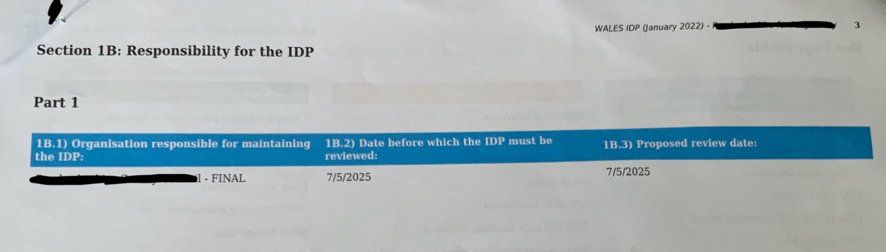
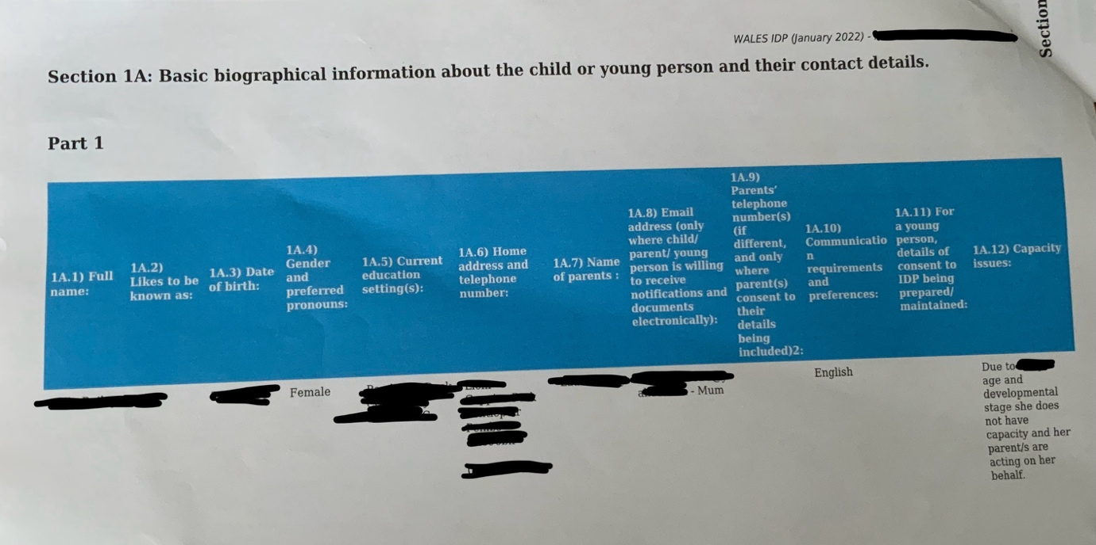
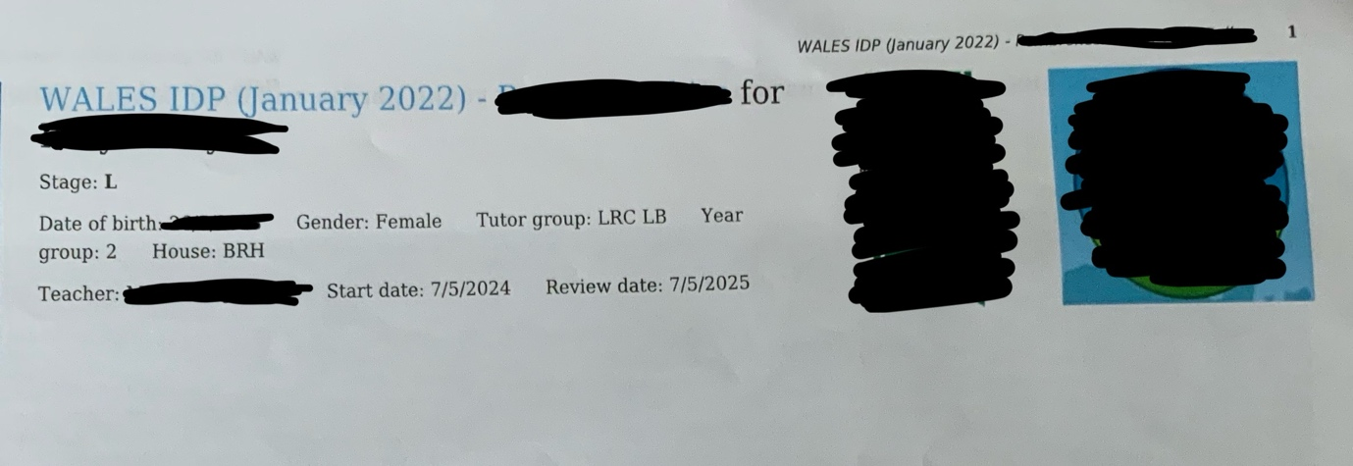
Appendix 1 – Example of an IDP formed by ALNCO

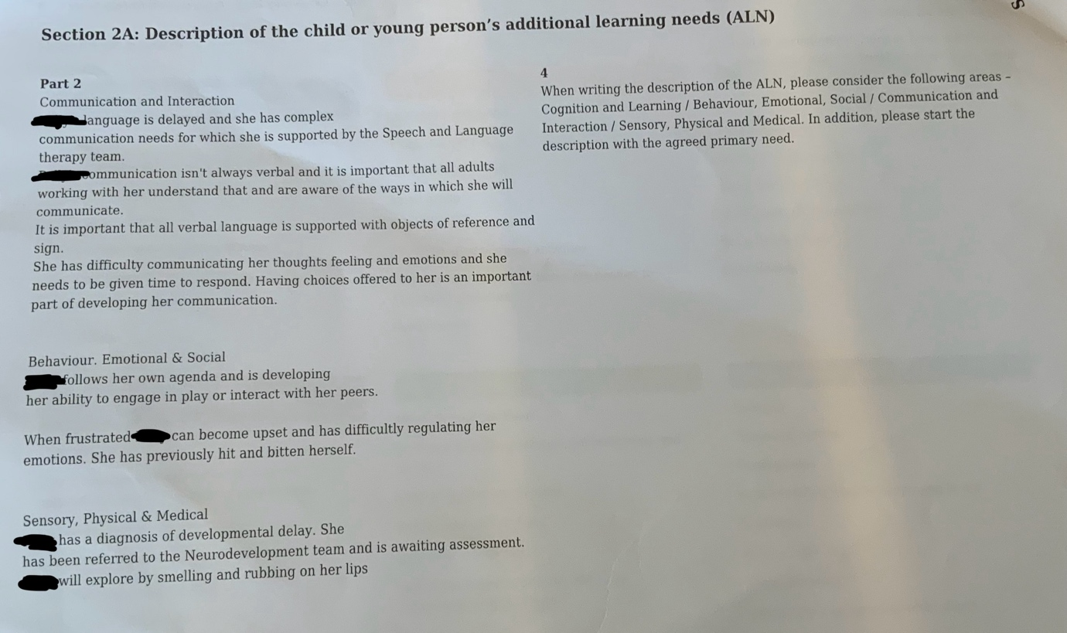
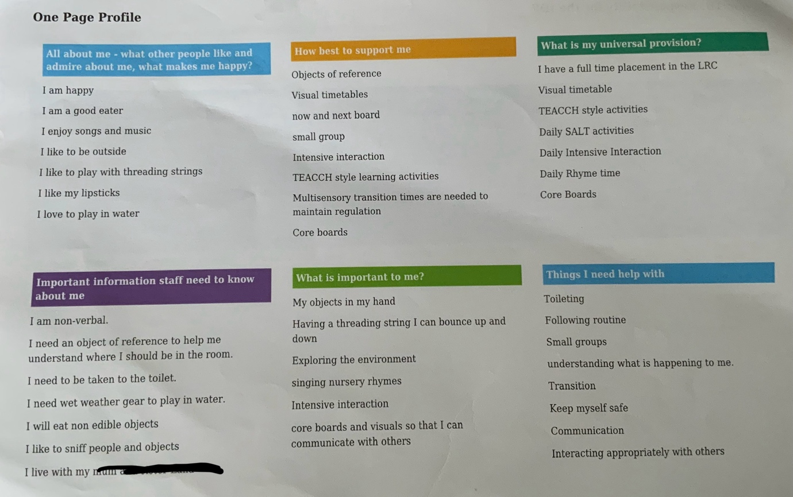

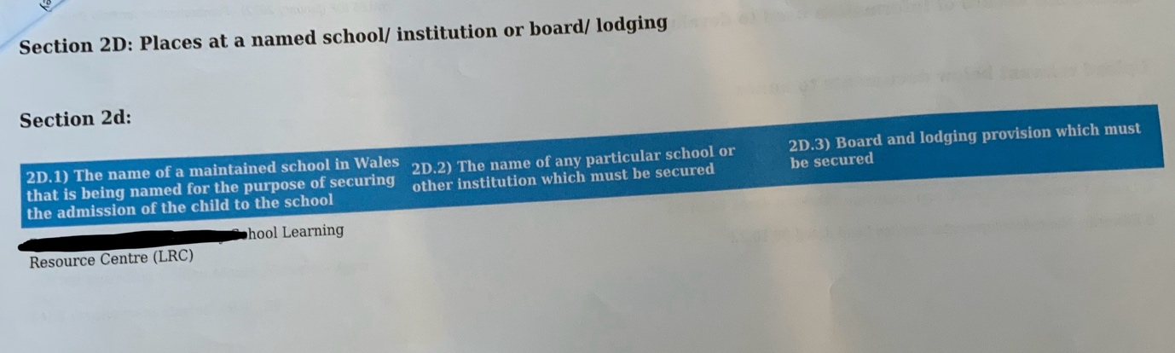
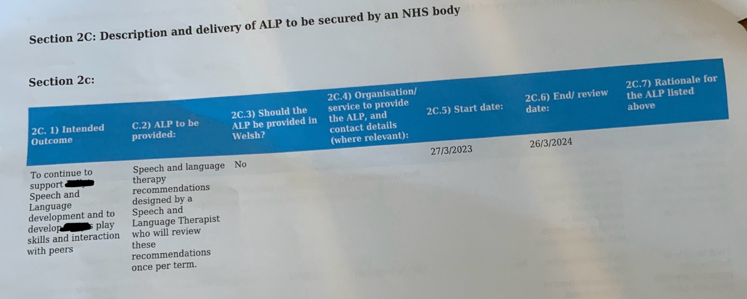
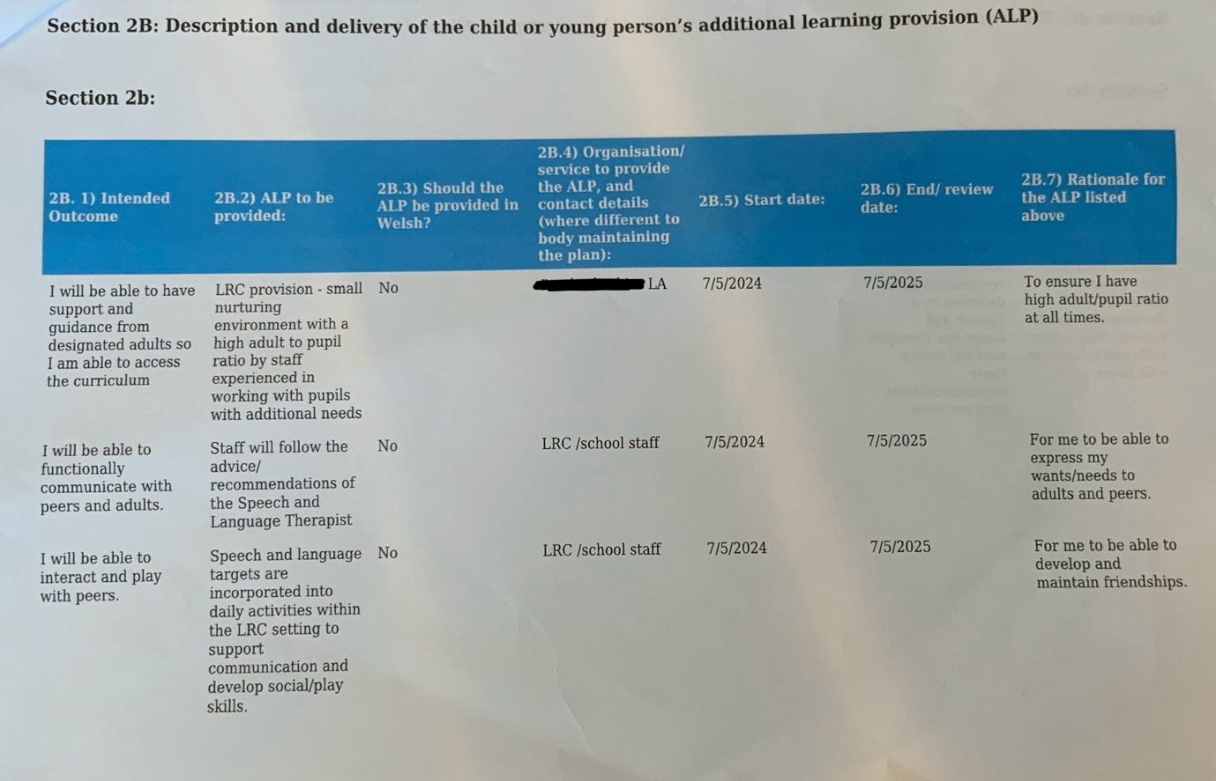

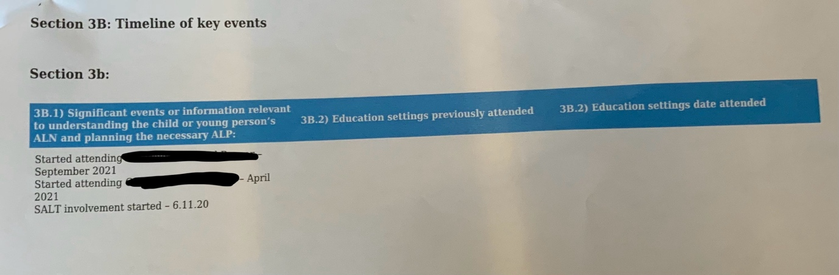
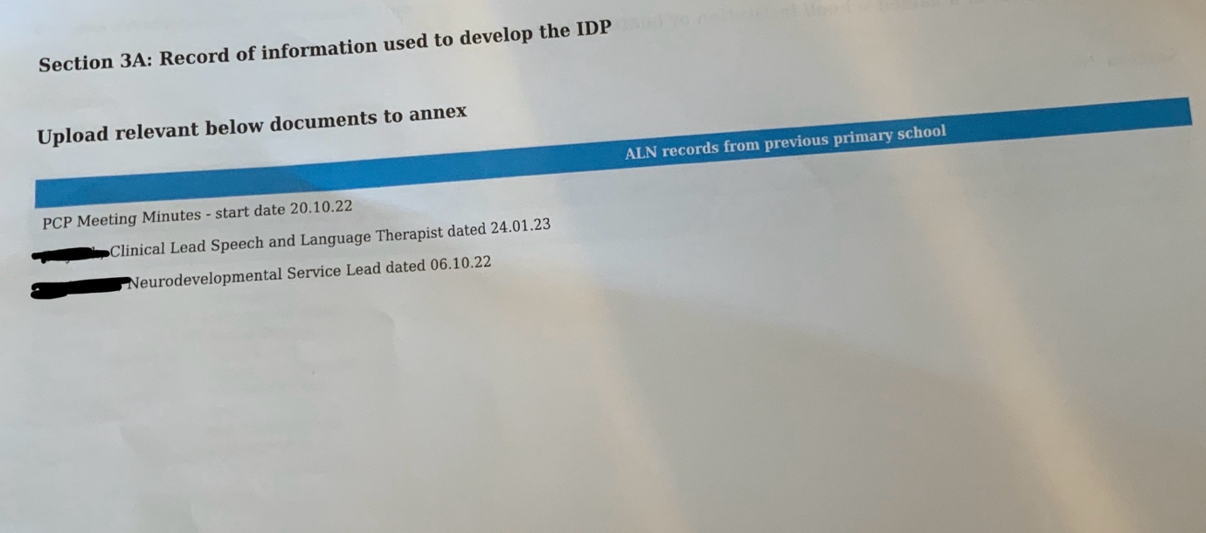


Appendix 2 – “Cuppa and Chat” morning session set up by ALNCo

