

Task 1 – Reading Task Template
Upload your photo of your A3 in-class notes here:
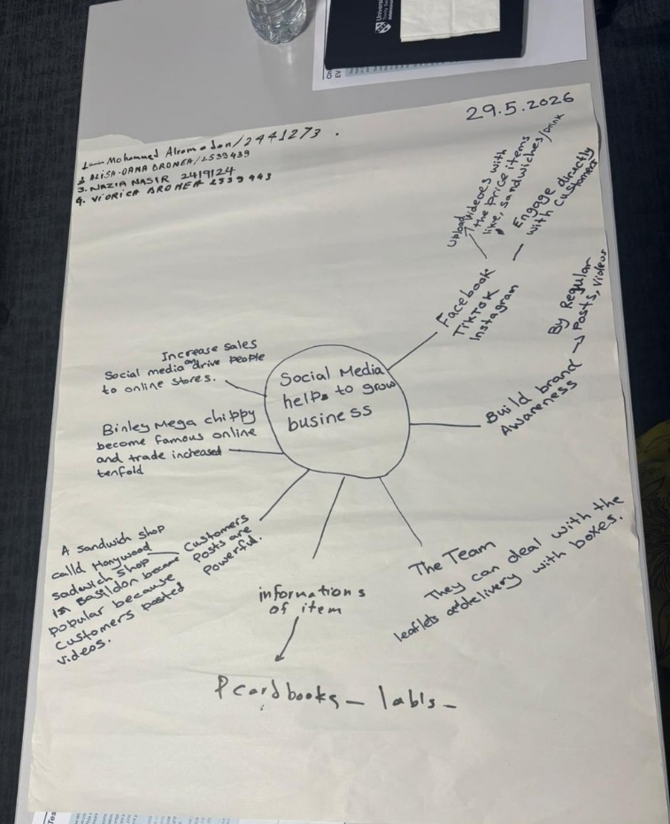

1. Answer these questions using the sentence starters below
a. What is the main idea of the text?
The main idea is that social media can turn online attention into real business success by helping small businesses gain more customers and become more popular.
b. What are two key points?
One key point is that short videos and customer content can make local businesses well-known beyond their usual area.
Another key point is that going viral can improve a business by increasing visibility, sales and customer interest.
c. What part of the text did you find most important? Why?
The most important part is the Honywood Sandwich Shop example, because it shows that posts made by customers can be powerful enough to bring people from far away.
d. Was anything unclear or difficult to understand?
I was not sure about whether all small businesses can benefit from viral social media attention in the same way, because some products may attract more interest than others.
e. How did your group help you understand the text better?
My group helped me by discussing the main idea, checking the evidence from the text and deciding which points were most useful for the mind map.
3. One sentence reflection
Question: What did you find challenging about this task?
The hardest part was separating the main idea from the smaller details because the article mentioned different businesses and examples.

