Securing the Enterprise Network with Check Point GAIA: Part 2 Implementation Report
Table of Contents
1. Introduction 4
1.1 Purpose and Scope 4
1.2 Report Structure 4
2. Enterprise Context and Objectives 4
2.1 Enterprise Network Overview 4
2.2 Threat and risk drivers 5
2.3 Security objectives and boundaries 5
3. Methodology and Evidence 6
3.1 Evidence Capture Approach 6
3.2 Guidance Sources Used 6
3.3 Validation Approach 7
4. Management Architecture Integration 7
4.1 Topology Modification Rationale 7
4.2 SMS deployment (Gaia OS) 7
4.3 SmartConsole Installation and Connection 10
4.4 Gateway Object Creation and SIC 12
4.5 Licensing application and documentation 14
4.6 Management verification 15
5. Firewall policy design and enforcement 16
5.1 Translating Enterprise Policy to Rules 16
5.2 Rulebase design approach 17
5.3 Inbound Traffic Controls 17
5.4 Outbound Traffic Controls 18
5.5 Service-Specific Rules 19
5.6 Testing and Justification 20
6. Additional security enhancements 21
6.1 Selection Criteria 21
6.2 Proposed Enhancements 21
6.3 Implementation Evidence 22
6.4 Residual Risk and Further Hardening 22
7. Verification and Report Quality 23
7.1 Connectivity Validation 23
7.2 Functional Security Validation 23
7.3 Documentation Checklist 24
8. Conclusion 24
8.1 Outcomes versus Objectives 24
9. References 26

1. Introduction

1.1 Purpose and Scope
In this report, Portfolio Part 2 has been outlined, which involves securing the enterprise network with the help of GAIA security appliances that have been installed throughout the organisational buildings in Part 1. The main focus is to record and show the security settings which are put in place. A written technical report with configuration screenshots (which serve as evidence of the controls used and the security posture attained) are the eventual deliverable.

1.2 Report Structure
The report is based on the three requirements. First, it records the implementation of a Check Point Security Management Server, where SmartConsole is applied to monitor, update, and manage policies centrally, in addition to checking the licence status, such as expiry information. Second, it asserts and rationalises an enterprise firewall policy and rule base that limits inbound and outbound traffic that is unauthorised to the requirements of organisational security. Third, it suggests and adopts extra security specifications corresponding to the industry best practices and official Checkpoint guidelines.

2. Enterprise Context and Objectives

2.1 Enterprise Network Overview
The enterprise network that is the focus of the present report is a continuation of the architecture created in Part 1 and is founded on a dual site topology of SWANSEA.ACCA and LONDON.SWANSEA.ACCA. Portfolio Part 2 is concerned with the implementation of GAIA security appliances and their installation without reiterating the implementation procedure that has already been done. Security scope refers to all those elements that are paramount to the safeguarding of the enterprise infrastructure. This includes the management plane on which centralised policy management and administration are conducted, and the security gateway that implements network security policies. Besides this, protection is extended to inter-site traffic that is exchanged between the two sites and protection is also extended to necessary enterprise services that exist within the laboratory topology and which include directory services, name resolution, IP addressing and web based services [1].

2.2 Threat and risk drivers
Part 2 deals with two major security issues, namely, unauthorised inbound as well as outbound traffic over the network, and the operational risk due to the lack of centralised policy management and monitoring. Unmanaged inbound access enhances vulnerability to attacks, exploits and denial-of-service attacks. Equally, lack of outbound traffic control increases the exposure of data exfiltration and command and control messages. These risks pose a direct threat to the confidentiality, integrity, and availability of enterprise resources and hence the basis on which firewall policies and other security measures are adopted [2].

2.3 Security objectives and boundaries
The main targeted goals include centralisation of security policy administration through the use of Security Management Server, enforce firewall policies that limit ingress and egress traffic that is not authorised, and record licence status and expiry of management and gateway entities. Any evidence that can be proven in the laboratory setting in terms of screenshots, logs, and test results is the only evidence that is strictly limited to all findings.
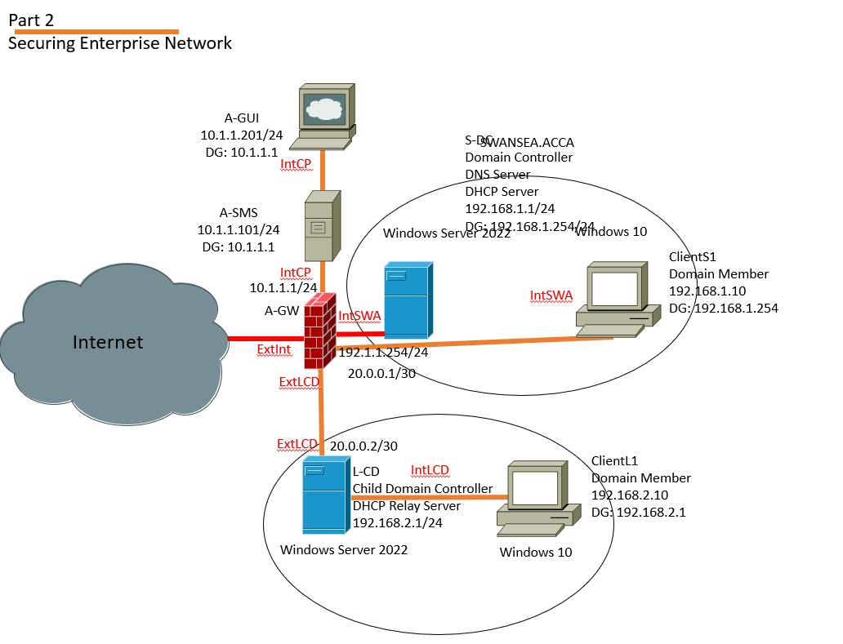
Figure 1: Securing enterprise network with multiple configurations

3. Methodology and Evidence

3.1 Evidence Capture Approach
Every process of practical configuration is accompanied by the screen-shots and summarized in the final report. Timestamps are also presented where the timely completion of each task is important. Any screenshot is ready to be audited, and it contains the name of the application or interface, the part of specific configuration section that was accessed, important parameters and values, and the names of specific objects, the exact place in the rule base, and validation supporting information, including logs or test results. This will help in the fact that all the controls that are implemented can be easily traced, reviewed and verified.
Table 1: Minimum screenshot evidence checklist
Evidence item | Must show | Why it matters
Configuration proof | Screen title, key fields, object names. | Shows control is configured correctly.
Policy enforcement | Rulebase excerpt, installed policy confirmation. | Links policy intent to enforcement.
Validation result | Test output and relevant logs. | Demonstrates expected outcomes.
Timing | Visible timestamp where possible. | Supports traceability of work.

3.2 Guidance Sources Used
The official Check Point documentation is consulted in order to find, choose, and properly apply advanced security functionality that matches the accepted industry best practices. This is especially critical in the areas that Part 2 suggests other security measures other than simple firewall capabilities. The information obtained by credible and authoritative technical sources is used to back up risk measurement and control choice in order to justify security policy decisions. These rationales are structured in the light of the well-known security concepts such as least privilege, defence in depth, and effects on confidentiality, integrity and availability. Sources that are sourced directly and reflected in the adopted configurations are only considered.

3.3 Validation Approach
The validation is done through assurance of successful connectivity between SmartConsole and the Security Management Server, policy is installed correctly on the security gateway, there is established and trusted SIC status, valid licence and expiry information and controlled traffic testing. Traffic tests are used to show permitted and blocked services. Every validation step is accompanied with screenshots and with logs and test results, where needed. The test results are recorded in a table showing the host of source, destination, protocol or service, expected result, actual result and reference to evidence.

4. Management Architecture Integration

4.1 Topology Modification Rationale
Introduction of Security Management Server (SMS) makes it possible to have centrally administered security policies, monitoring and updates, as opposed to decentralised, locally administered gateway configurations [3]. This model will make sure that every enforcement activity on security gateway is controlled under one and that is an authoritative platform. To do this, the same topology as the one used in Part 1 has been increased with the deployment of an A-SMS server that uses Gaia OS. SmartConsole was configured on a special management workstation, A-GUI, to do central administration by connecting to the A-SMS. Management architecture has the following addressing scheme A-SMS at 10.1.1.101/24, A-GUI at 10.1.1.201/24 and the gateway A-GW at 10.1.1.1/24.

4.2 SMS deployment (Gaia OS)
Security Management Server is installed in the form of the central control element that will handle the policy creation, monitoring, and updates on the enterprise security environment. It creates a special plane of management where all services of management are served by SmartConsole whereas the gateway is only the point of enforcement. Administrative access is offered over the Gaia Portal through the use of the SMS management IP and via SmartConsole through the management workstation.
In the First Time Wizard, the device is a Primary Security Management Server with Security Gateway functionality turned off. The main interface (eth0) will be given the default gateway 10.1.1.101/24 and 10.1.1.1. The management hardening policies consist in extension of inactivity and web session timeouts to 720 minutes, a special SmartConsole administrator account (cpadmin), and a limited access of GUI clients to the network 10.1.1.0/24. The successful API readiness checks are used to confirm operational readiness.
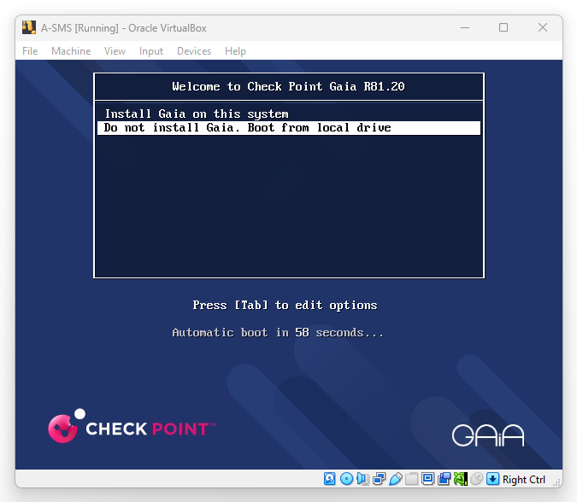
Figure 2: A‑SMS Gaia R81.20 boot menu showing the option to install Gaia on the system
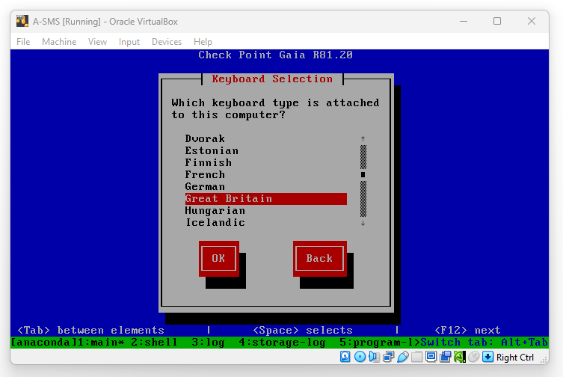
Figure 3: Gaia installer keyboard selection, Great Britain selected for A-SMS
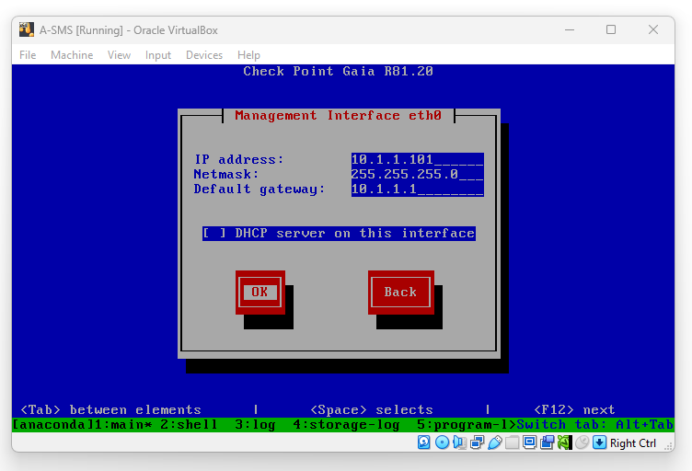
Figure 4: A-SMS management interface configuration showing IP addressing and default gateway settings on eth0
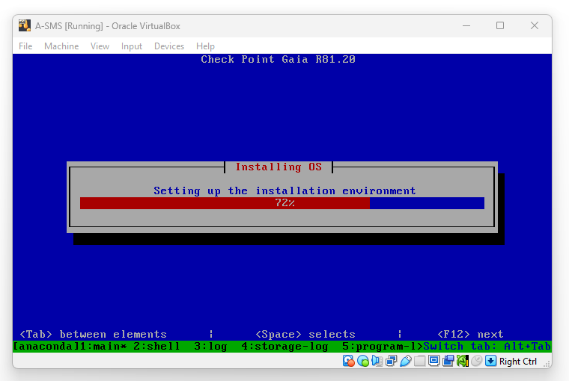
Figure 5: Gaia OS installation progress screen for A‑SMS, confirming OS installation is in progress
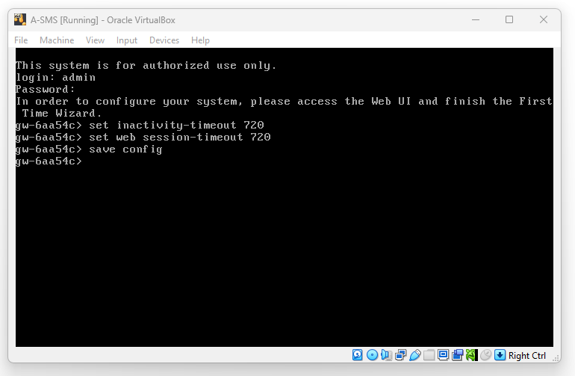
Figure 6: Post-install CLI hardening on A‑SMS showing inactivity and web session timeouts configured and saved.

4.3 SmartConsole Installation and Connection
SmartConsole will be placed on the management workstation (A-UI) in order to give centralised control of the SMS and the overall security infrastructure. The console is booted into A-GUI and is set to reach the SMS at 10.1.1.101 and make sure that all managerial functions are executed in management plane and not in the gateway itself. Access to the administrative area is gained through a dedicated user, cpadmin account created during the process of SMS setup. Additional access control is applied by restricting the permissions of the GUI clients to the hosts in the 10.1.1.0/24 network. The effective integration is proved by the fact that there is an authenticated session on a SmartConsole and the gateway objects and security policies are displayed completely.
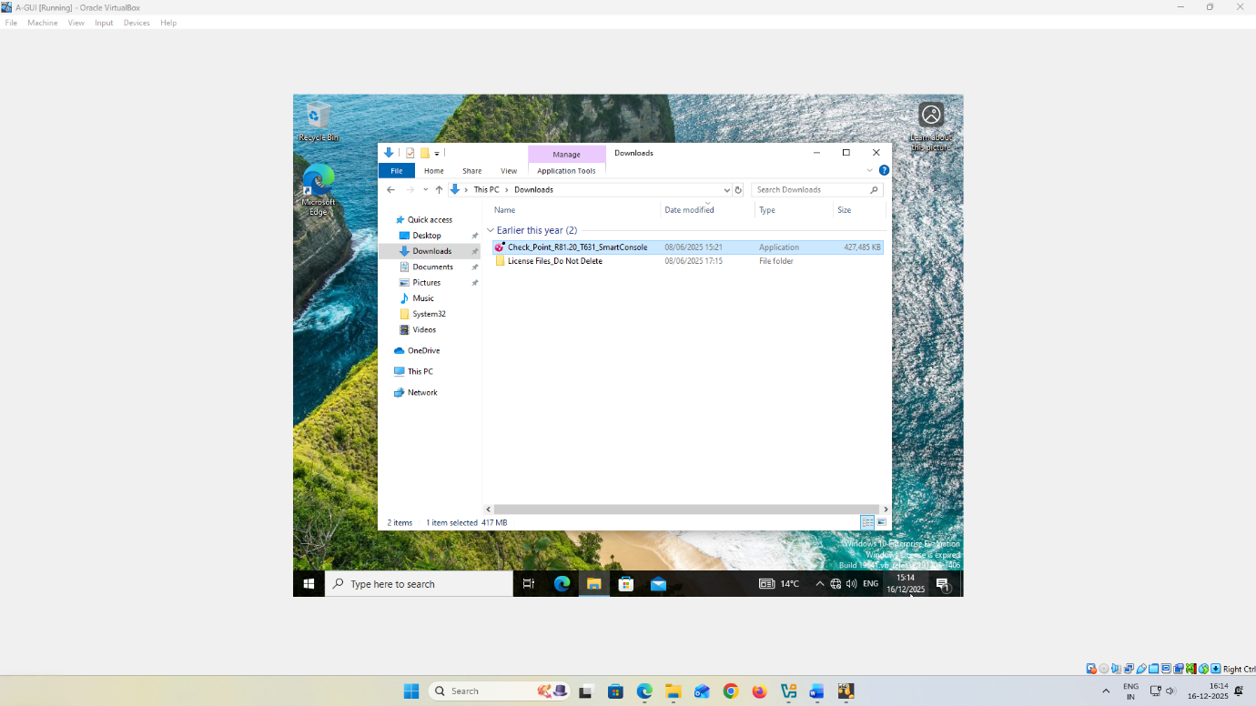
Figure 7: A‑GUI Downloads directory showing the SmartConsole installer (Check_Point_R81.20_T631_SmartConsole.exe) ready for installation

Figure 8: SmartConsole setup display indicating acceptance of the End User License Agreement and the installation destination folder chosen

Figure 9: SmartConsole progress screen on installation, indicates that it is still being installed on A-GUI
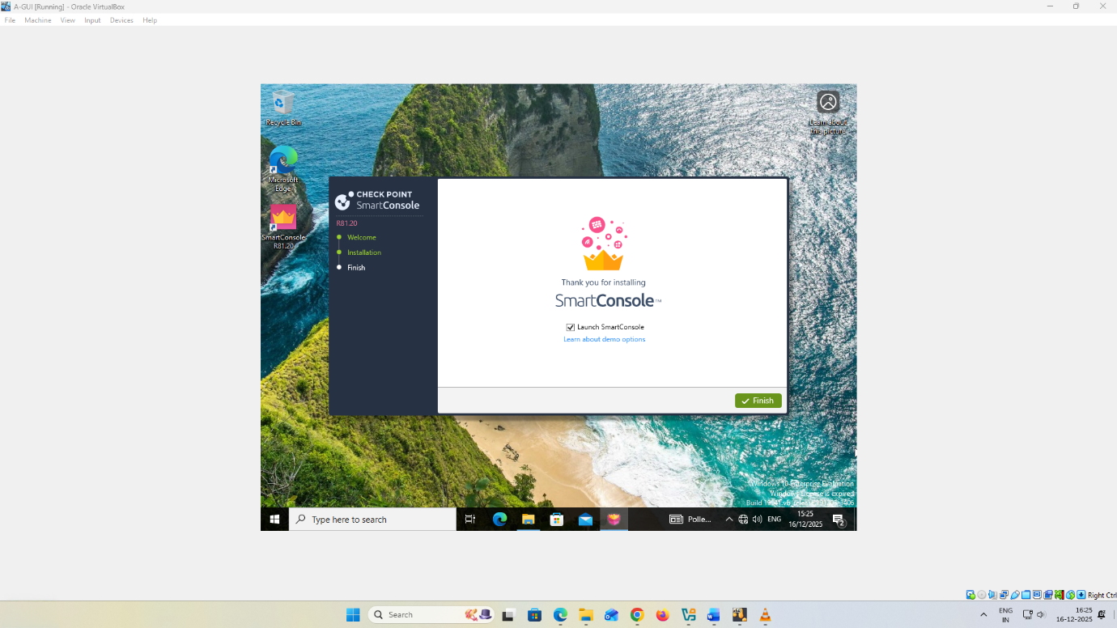
Figure 10: SmartConsole setup display indicating acceptance of the End User License Agreement and the installation destination folder chosen

4.4 Gateway Object Creation and SIC
In SmartConsole, the security gateway is onboarded by creating a gateway object which is a representation of the physical or virtual enforcement device in the management database. The gateway object of A-GW is connected to the management IP address of the 10.1.1.0/24 network to which the gateway belongs using the Gateway Creation Wizard. This association enables the SMS to deploy policies centrally, log collection and management of the gateway.
Secure Internal Communication (SIC) creates a secure, authenticated connection between the SMS and the gateway to ensure that management traffic is not accessed by an unauthorised party. The activation key to initialize SIC, generated on the gateway during the First Time Wizard is input to SmartConsole at the time of creating the gateway objects. The status of communication is checked with the help of the gateway object properties in which a Communicating status means that SIC is established successfully and is saved as evidence.
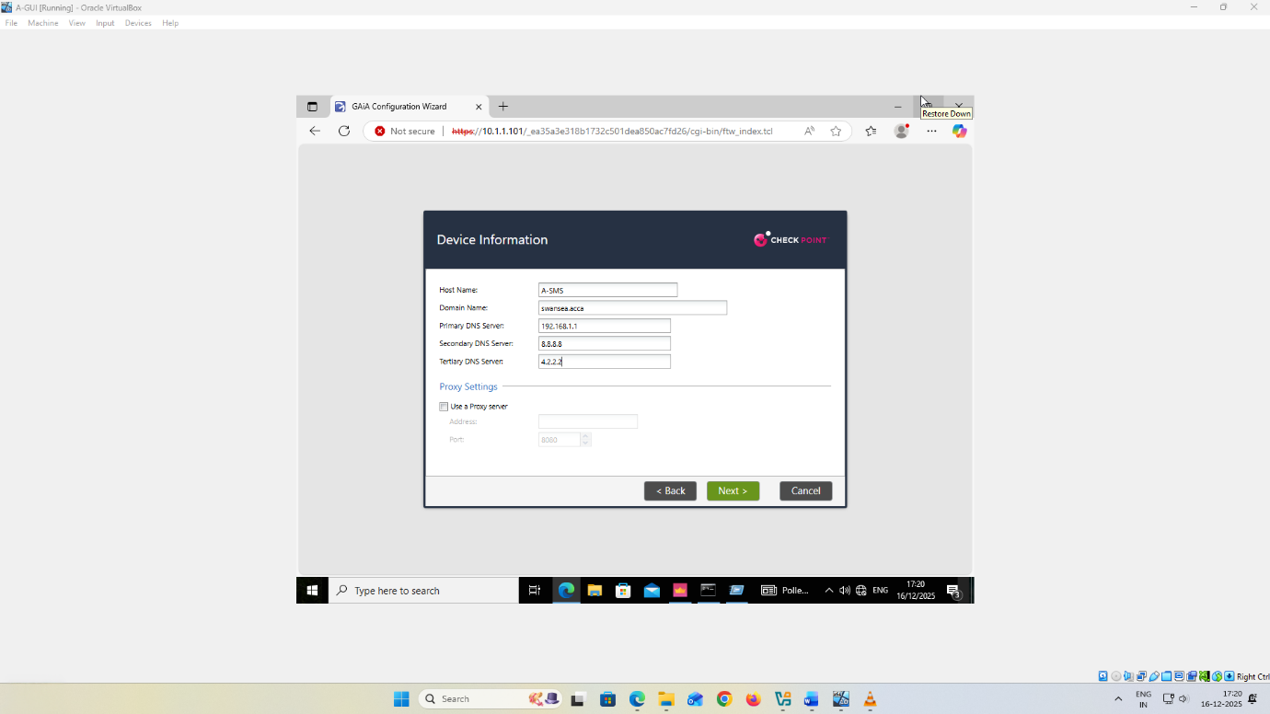
Figure 11: First Time module A-SMS configuration, page - device informationhost name A-SMS, domain swansea.acca, nameservers set to be used.
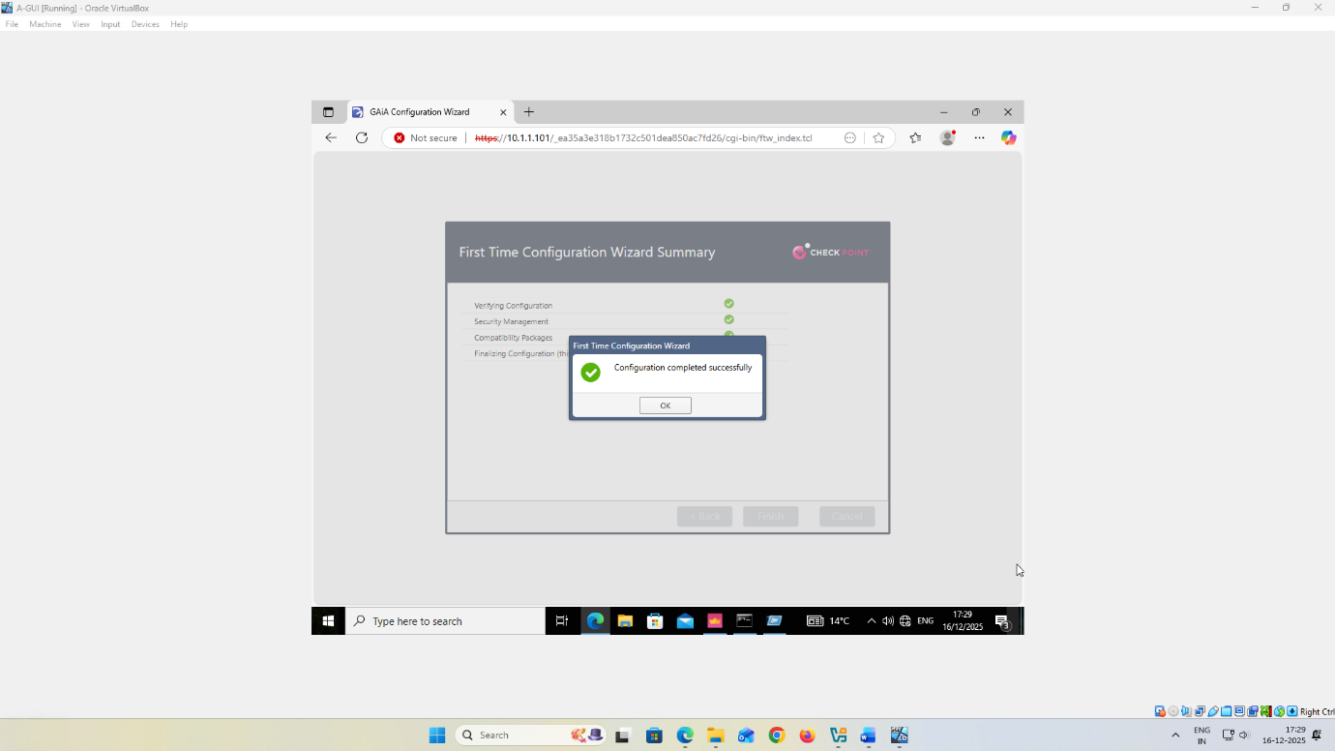
Figure 12: First Time Configuration Wizard summary Inquiries into the success of the configuration of the Security Management Server

4.5 Licensing application and documentation
The Security Management Server and security gateway are both subjected to licensing to confirm that the modules are being used as required and to those who are entitled to receive the necessary software blades and management feature usage. Licensing as a control of governance ensures that there is an approving aspect that policy management and enforcement is authorised and enabled by law [4].
The user handles the licences centrally with SmartConsole by clicking on the Manage Licenses and Packages option launching SmartUpdate. Both the SMS and the gateway licence files are imported into the licence and contracts repository and are attached to the A-SMS and A-GW objects. The screenshots of the contents of the repository, the presence or absence of the licence attachments, and the device-level licence information, including expiration dates, provide evidence. There is a Consolidated License Inventory report that is created on the SmartConsole and are exported as a PDF file to represent auditable records in time-stamped form.
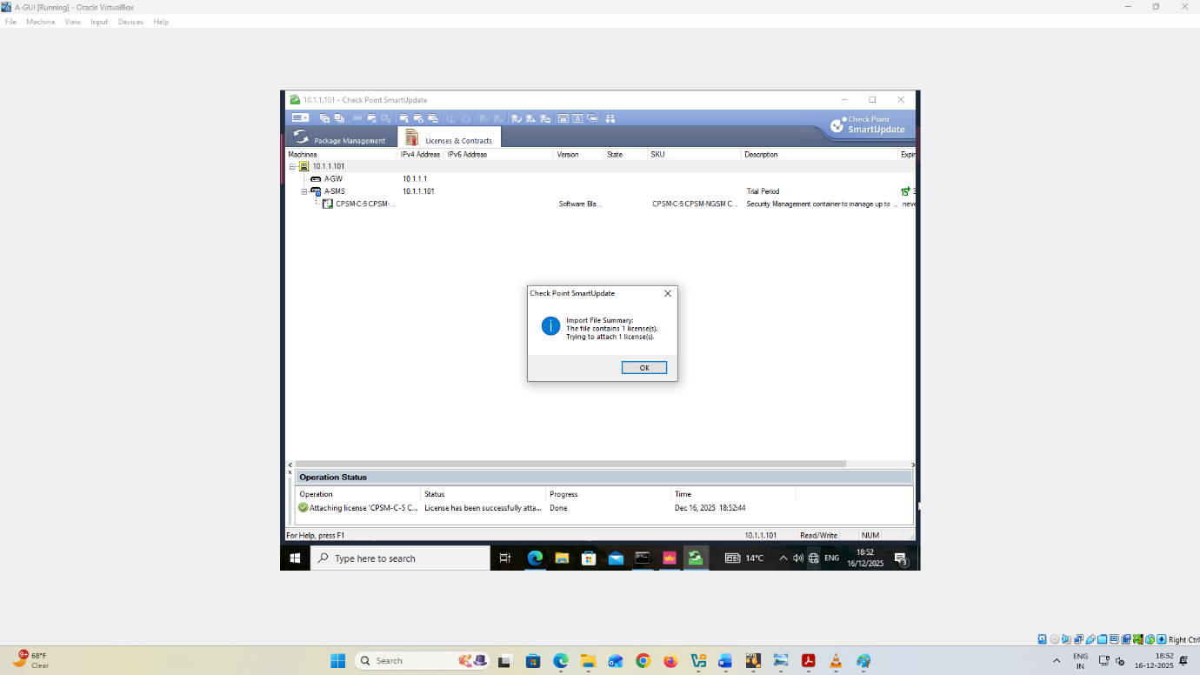
Figure 13: SmartUpdate license import confirmation dialog
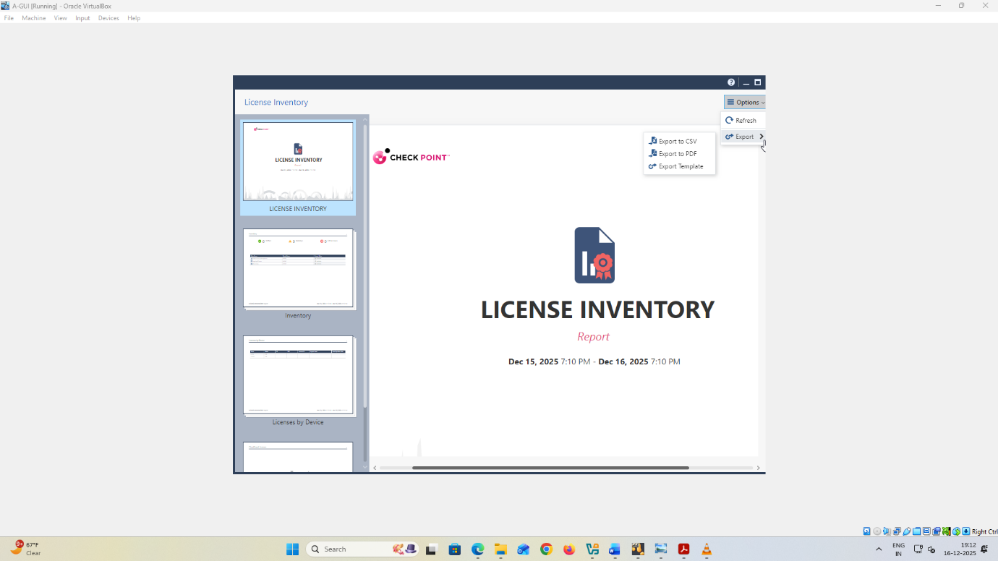
Figure 14: License Inventory report export options

4.6 Management verification
The centralised management functionality is authenticated by making an active SmartConsole session to the SMS, creation and saving the A-GW gateway object and validation of trusted communication via a successful SIC status of “Communicating” [5]. The evidence can be supported with screenshots of the property of the object gateway, the result of SIC tests, and published changes in configuration within SMS database. These findings indicate that the management plane is all active, properly configured and can administer gateways via one and controlled administration console.
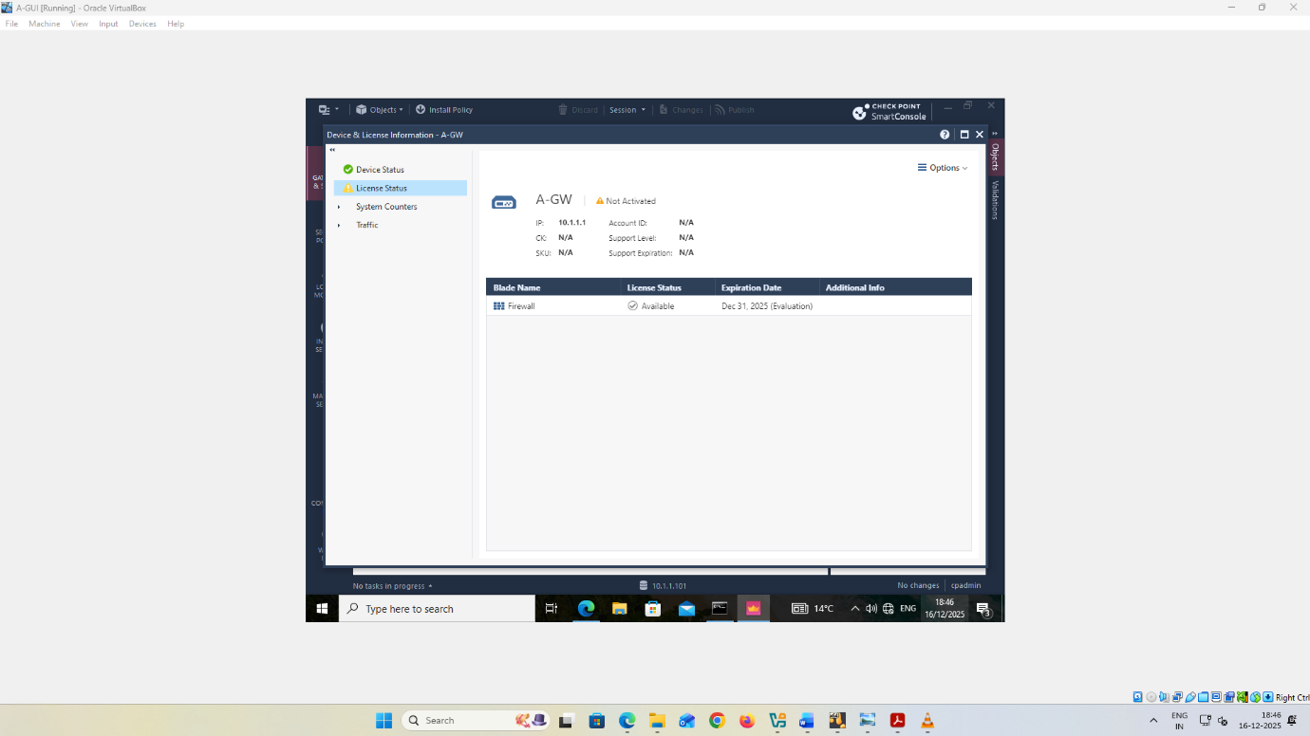
Figure 15: SmartConsole “Device & License Information” for gateway A‑GW showing license status and blade entitlement with the recorded expiration date.

5. Firewall policy design and enforcement

5.1 Translating Enterprise Policy to Rules
One of the enterprise security postures is the default deny policy with least-privilege exceptions. This model fits perfectly well with the Part 2 requirement to limit the unauthorised inbound and outbound traffic and to rationalize firewall rules as official enterprises policy decisions. Using this approach, only services and management communications, which are expressly needed to conduct business operations, are allowed and all other traffic is rejected and monitored to provide protection and auditing.

The organisational security requirements are then mapped to enforceable firewall rules based on traffic to specified security areas, interfaces or network segments, including internal sites, inter-site links, management networks, and externally facing interfaces [6]. These defined segments are the ones to which rules are applied as opposed to general any-to-any relationships. Network objects and groups are used to represent critical assets and include management servers, gateways, and service hosts that exist in the lab topology. This guarantees access decisions to be clear, repeatable and consistent. In the absence of any implementation of an identity source, network location and service definitions are used to determine access control. It only allows the essential business services with the exclusion of unnecessary or high-risk services to support the purpose of preventing the unauthorised inbound and outbound traffic.

5.2 Rulebase design approach
Firewall rulebase is designed based on reusable objects to enhance uniformity in enforcing the rulebase and reduce configuration risk [7]. Key segments and systems, including management networks, internal site subnets and protected servers, are defined using network objects and groups whereas service objects define the precise protocols that are allowed to be used by business. This object-based design prevents repeated definitions of IP, and ad-hoc service definitions and makes it easier to maintain and auditing easier as the intent is represented as meaningful object names and not as raw values.

The rules are ranked based on least-privilege principles and the most specific and high-confidence rules are presented first, then site-to-site traffic, then application-related traffic and then more general, yet still restrictive allowances. At the bottom of the rulebase is a well defined cleanup rule to prevent and log any unmatched traffic, which would give a strong control boundary and assist in troubleshooting. Denied traffic, critical allowed services and externally exposed flows are selectively logged to allow visibility to be practical and efficient evidence to be gathered.

5.3 Inbound Traffic Controls
Inbound traffic policies rely on reduction of exposure by means of clear allow policies. Inbound services should only be permitted when they are business justified and are officially published, and all unsolicited inbound traffic is considered unauthorised. This perfectly fulfills the Part 2 requirement to limit inbound traffic and the firewall policy should be justified as enterprise security control.

Since this is a lab application, only security administration functions are permitted inbound traffic. In particular, the management access is permitted between the network of the management workstations (10.1.1.0/24) and the Security Management Server 10.1.1.101, via SmartConsole and the gaia Portal. These are further reinforced with the established management IP and the explicit GUI client restrictions that restrict the administrative access to the established management network. Secure Internal Communication (SIC) also assures the management between the SMS and the gateway with a known status of Communicating having a known administration status.

Any other incoming traffic is blocked and traced by default, according to the formulated security goals. No extra inbound services may be allowed which are not verified by means of testing and backed up by screenshots, logs, and documented outcomes.
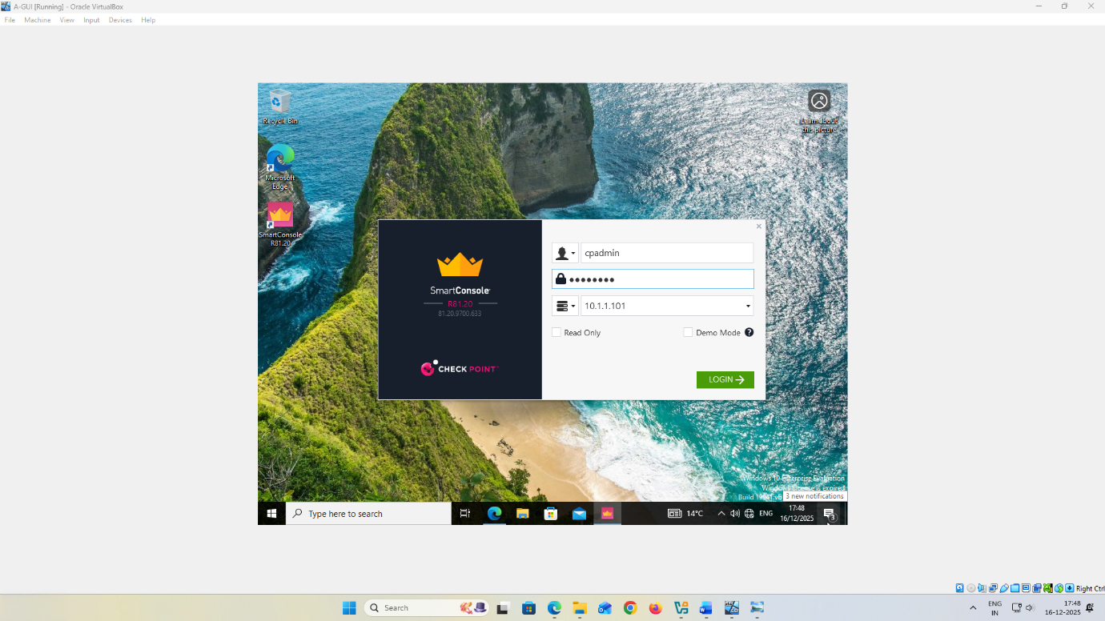
Figure 16: SmartConsole R81.20 connection with Security Management Server at 10.1.1.101 with the cpadmin account writeup log in screen

5.4 Outbound Traffic Controls
Outbound traffic enforcement is based on egress filtering and least-privilege that enables only business-justified connections and blocks and logs all other outbound traffic. This will lower the risk of data leakage and malware command-and-control activity, and directly comply with Part 2 of the requirement to control unauthorised outbound communications.

At this implementation, only the outgoing traffic is permitted to do only the necessary services that are important to the operation of the stable such as DNS queries to configured DNS servers and NTP synchronisation with time1.google.com and time2.google.com [8]. The services are required to facilitate sound management processes, proper logging, and regular administration of security. The services that are not essential or higher risk are defaulted until a justified business need is proven and backed up by testing testaments. All outbound policies are strictly limited by their scope, are explicitly defined in terms of destination and service objects, and are audited by providing screenshots and test outcomes.

5.5 Service-Specific Rules
The firewall policy has service-specific controls that are clearly stated to illustrate allow or deny decisions on protocols like ICMP, FTP, HTTP, Telnet and SSH in accordance with Part 2. Such rules are only used when they are applicable to the laboratory environment and they should have supporting tests, logs, and screen shots. This gives evidence-based decisions of every service and their alignment with enterprise security goals.
Rule goal | Direction | Service | Default action | Business justification if allowed | Expected test evidence
Diagnostic reachability | Inbound and outbound | ICMP | Restrict, allow only for approved diagnostics | Limited troubleshooting, avoid broad host discovery | Ping succeeds only for approved sources, denied attempts logged.
Legacy file transfer | Inbound and outbound | FTP | Block | High risk, cleartext credentials, rarely justified | FTP connection fails, log shows drop, rule hit count increments.
Web access | Inbound and outbound | HTTP | Allow only to published web service or approved destinations | Required business web service or controlled browsing | HTTP succeeds for approved flow, denied elsewhere, logs captured.
Legacy remote admin | Inbound and outbound | Telnet | Block | Cleartext admin protocol, unacceptable enterprise risk | Telnet connection fails, drop logged with source and destination.
Secure administration | Inbound and outbound | SSH | Allow only for defined admin hosts to defined targets | Controlled device administration under least privilege | SSH succeeds only from approved admin host, denied elsewhere, logs and screenshots show result.

5.6 Testing and Justification
The enforcement of firewall is checked with the help of the structured testing matrix which ties every firewall rule with its purpose and result which should be observed. Each test has its evidence which is the section of the rulebase that was used, the value of the traffic and logs or tool outputs, which are all included in the final report. This method proves the fact that unauthorised traffic inbound and outbound is successfully blocked and the legitimate enterprise traffic is allowed.
Effectiveness of a rule is determined by whether observed behaviour reflects the expected results with respect to the sources and destinations of the rule and whether the rule is enforced as recorded in the corresponding logs. Any discrepancies will result in the rule being refined, then the rule is re-tested and new evidence captured until consistent and auditable results are obtained.
Service | Source | Destination | Expected | Observed | Evidence reference
ICMP | Host A | Host B | Allow or block per rule. | Pass or fail. | Screenshot ID, log entry ID.
SSH | Admin host | Gateway or server | Allow only if justified. | Pass only for allowed source. | Rule hit, log, test output.
Telnet | Any | Internal targets | Block. | Fail. | Drop log plus screenshot.
HTTP | Approved host | Approved web | Allow only for defined service. | Pass only for approved flow. | Browser output plus logs.
FTP | Any | Any | Block unless explicitly justified. | Fail. | Connection attempt output plus logs.

6. Additional security enhancements

6.1 Selection Criteria
The security controls are chosen according to established industry best practices and are also aimed at providing a more fortified protection than the minimum protection of basic firewall enforcement, that Part 2 demands. The guidance for Official Check Point is employed to make sure that all the chosen features are compatible with the GAIA-based security architecture and could be carried out in an organized and sustaining form. The top priority is placed on the controls that minimise the probability and the consequences of unauthorised access, malware activity, lateral movement and data leakage. The features that can be deployed completely in the current laboratory topology are only taken into consideration and this provides end-to-end implementation with available management and gateway components. It gives the same emphasis to evidence ability, which implies that the chosen controls should provide verifiable results in the form of configuration screenshots, policy settings, logs, and test outcomes that could be observed. Lastly, operational maintainability is taken into account in order to make sure that configurations are centrally managed, practical to administrators, and not added complexity and tuning overhead over the long term.

6.2 Proposed Enhancements
Part 2, as an incremental addition, provides more security features that augment prevention, detection, and accountability of the same for the same inbound and outbound threats covered by the firewall policy. These improvements consist of the activation of the Intrusion Prevention System (IPS), the anti-malware protection mechanism, and identity-based access control. IPS is chosen to address threats of vulnerabilities exploitation and protocol abuse as well as malicious scanning which can be detected with port-based filtering only. We have anti-malware protection to lessen the chances of malicious code delivery by authorised web access and file transfer, which would otherwise result in compromise or loss of data to the system. Identity-based controls are introduced to deal with the excessive access privileges and to enhance accountability through enforcing access decision-making based on user roles and not on IP addresses only. These improvements in combination with these enhance the overall security positioning by beyond firewall enforcement to more thorough inspection, user-awareness, and threat-prevention.

6.3 Implementation Evidence
Configuration artefacts are given by screenshots of the implementation with timestamps preferably present and these are included in the final report where applicable. Each of the applied enhancements is shown screen-shotted to show that the feature is enabled in the management layer, it is properly set in the relevant policy or profile, and is enforced on the corresponding gateway or policy layer. In the case of identity-based controls, screenshots of identity sources, user account, or user group configuration, as well as their relationship to access control rules are also evidence showing a clear connection between user roles and authorised access.
As part of showing that the enhancements are working and are effective, the items of evidence are successful deployment of the policy to the gateway, logs or security events created during controlled testing, and traffic results that indicate desired behaviour. This involves ensuring that genuine business traffic is allowed with the unauthorised or malicious traffic identified or prevented. Traceability Traceability is ensured by matching observed log entries to the particular rules or profiles that are to be enforced, with screenshots of the applicable rulebase sections.

6.4 Residual Risk and Further Hardening
It is residual risk that exists in those areas where controls cannot be implemented or established with conclusive measures in the laboratory environment in terms of screenshots, logs, and controlled testing. Since this report is within the limits of verifiable evidence, any untested or unobservable controls should be out of scope. Subsequent hardening ought then concentrate on increasing scope of tested-securitys, such as more explicit enforcement of the least privilege, improved logging to aid further inquiry, and the enablement of other Check Point functionality described in Part 2, such as extended anti-malware, less liberal access-by-identity and extended IPS. Every other step would be to be tested and evidenced with the help of documents to be sure of further confidence and auditability.

7. Verification and Report Quality

7.1 Connectivity Validation
The connectivity between Swansea network and the Security Management Server (A-SMS) is confirmed to meet the Part 2 of the requirement of inter-site communication success. It has been proven that Swansea environment can be confidently connected to the plane of management. This consists of screenshots of the gateway interface configuration with A-GW connecting Swansea internal network in 192.168.1.254/24 and the management network in 10.1.1.1/24 and address of A-SMS in 10.1.1.101/24. The connectivity is also confirmed by the reachability tests which are conducted between a Swansea host and management IP A-SMS. The fact that the A-SMS web portal was successfully accessibly opened and the management workstation connected to the SmartConsole through a verified connection proves this. The routing tables, interface settings and the test results are the supporting screenshots, which altogether prove that the management traffic routes are properly configured and running.

7.2 Functional Security Validation
Part 2 is performed through functional security validation, which is conducted using documented traffic tests and associated log entries to prove that authorised services are authorized and unauthorised inbound and outbound traffic is denied, as required by Part 2. The testing is centered on the popular protocols, where the ICMP, FTP, HTTP, Telnet, and SSH are usually given priority so that every decision on allow or deny can be traced to a given firewall rule. Observed traffic behaviour can be related to the corresponding rulebase entries and log entries to ensure proper enforcement measures. In other locations where other security mechanisms are installed, validation can be made by configuration screenshots that indicate features that are active and security events produced during controlled test. These are the IPS alerts, the anti-malware detection logs, and the identity-based access records which show enforcement with regard to user roles or groups. Any and all validation results are rigorously confined to evidence collected in the laboratory setting with screenshots, logs, and controlled test results.

7.3 Documentation Checklist
Each configuration that is implemented is captured as a screenshot, timestamps in all cases are shown and appended as formal evidence in the report to fulfill Part 2 submission requirements. Both the Security Management Server and the Check Point gateway appliances are licensed and licensing evidence is available and easily displays licence status and expiration information as seen via management interfaces and consolidated inventory reports. Behind each notable technical claim in the report there is evidence and brief description of what was set up, why it was selected in the context of Part 2 objectives and how it was ensured to be operating properly based on logs and formal testing. This guarantees the clarity, traceability, and audit preparedness all through the report.

8. Conclusion

8.1 Outcomes versus Objectives
The report compared the results of Portfolio Part 2 with its stated goals that aimed at improving the security of the enterprise network by centralising its management, the enforcement of firewalls and introduction of other security capabilities that were based on GAIA. The initial one, to add a Check Point Security Management Server (SMS) to have centralised administration, was reached successfully, with the implementation of A-SMS and its management with help of SmartConsole provided by A-GUI workstation. The correctness of the central management preparedness was tested with the help of the API readiness tests and the creation of the Secure Internal Communication (SIC) between the SMS and the security gateway, as delivered by the presence of the Communicating status. The importing and the attaching of the valid licences to both the SMS and the gateway was also done by the central repository workflow and the information on the licence status and expiry was recorded to assist in the governance and audit requirements.

The second goal that meant the need to design and implement a reasonable firewall policy to curtail unauthorised inbound and outbound traffic was met by having a centrally administered rulebase on the security gateway. The firewall policy was based on enterprise default-deny and least-privilege model where only business-justified services were allowed and rest of the traffic was blocked and logged. The successful enforcement was confirmed by the installed policies on the gateway, the planned (traffic) tests, and the relevant log records of the services granted and rejected. The correspondence between the anticipated and achieved results was a positive indication that the firewall regulations were operational in enforcing the enterprise security stance and addressing the Part 2 assessment standards.

The third goal was met by suggesting and where practised making further security improvements which goes beyond basic firewalling. These upgrades were intrusion prevention, anti-malware, and access controls which were identity based. They were proven effective in terms of configuration artefacts and observable security events or test results, which signifies a higher level of prevention, detection and accountability of network traffic and user access. All these controls made the security architecture overall more formidable but still in accordance with accepted industry standards and official Check Point recommendations.

This report is deliberately focused on configuring and testing within the laboratory setting and evaluating results which could be completely established as valid through screenshots, logs and controlled experimentation. The security features that were not carried out end to end or could not be demonstrated by captured evidence were not considered to preserve the integrity of assessment. Further enhancement of the environment is necessary in the future, which can be achieved by enhancing the degree of use of the advanced features of Check Point, including more detailed regulation of the IPS and a wider anti-malware policy and implementation of identity-conscious policies. The same should be backed up in terms of repetitive testing, recorded results and documented materials to sustain compliance, functionality, and auditability.

9. References
[1] A. G. Fraser, “A Next Generation Internet Architecture,” Cam.ac.uk, 2023, doi: https://doi.org/10.48456/tr-978
[2] Y. Zhang, “Security Vulnerabilities and Defense Mechanisms in Communication Networks,” Advances in engineering research/Advances in Engineering Research, pp. 646–656, Jan. 2024, doi: https://doi.org/10.2991/978-94-6463-518-8_62
[3] A. Goel and Y. Rahulamathavan, “A Comparative Survey of Centralised and Decentralised Identity Management Systems: Analysing Scalability, Security, and Feasibility,” Future Internet, vol. 17, no. 1, pp. 1–1, Dec. 2024, doi: https://doi.org/10.3390/fi17010001
[4] N. Islam, “A SYSTEMATIC REVIEW OF LEGAL TECHNOLOGY ADOPTION IN CONTRACT MANAGEMENT, DATA GOVERNANCE, AND COMPLIANCE MONITORING,” American Journal of Interdisciplinary Studies, vol. 03, no. 01, pp. 01-30, Mar. 2022, doi: https://doi.org/10.63125/caangg06
[5] U. Verma and D. Bhardwaj, “Centralised and distributed authentication scheme in internet of things: review and outlook,” International Journal of Internet Technology and Secured Transactions, vol. 12, no. 2, p. 127, 2022, doi: https://doi.org/10.1504/ijitst.2022.121418
[6] S. Helapita, “Analysis of Security Attributes and Vulnerabilities in Cisco SD-WAN Networks,” DIVA, 2025. https://www.diva-portal.org/smash/record.jsf?pid=diva2:1949327
[7] G. Haerens , “On the evolvability of the TCP-IP based network firewall rule base. Diss,” University of Antwerp, 2021. https://repository.uantwerpen.be/link/irua/183461
[8] Z. Benomar, F. Longo, G. Merlino, and A. Puliafito, “A Cloud-based and Dynamic DNS approach to enable the Web of Things,” IEEE Transactions on Network Science and Engineering, pp. 1–1, 2021, doi: https://doi.org/10.1109/TNSE.2021.3110003

