

The impact of Virtual Learning Environment Moodle on the learning experience of the students at UWTSD London campus.

Student: Faiza Razak
Student ID: 2020832
Digital skill and research method
BMSW4003_LON
Group 8
Lecturer Koushik Modak

Table of Contents

Abstract 3
1 Introduction 3
1.2 Rationale 3
1.3 Research Objectives 4
2 Literature review 4
3 Methodology 6
Data collection process 6
3.1 Population 6
3.2 Sample size. 7
3.3 Ethics in data collection 7
4Findings and analysts 7
4.1 primary data Analysis 7
4.2 Secondary data analyst 13
4.4 Summary of findings. 14
5 Conclusion 15
6 Referencing 15
7 Appendix 1 16
7.1 Appendix 2 18

Abstract
This report focuses on the virtual learning environment impact of the students learning experience at the University of Wales Trinity St David London campus. It was based on their research questionnaire which investigated whether the use of a VLE has a positive or negative impact on student learning,

1 Introduction

Online learning to be effective and efficient, instructors, organizations and institutions must have comprehensive understanding of the benefits and limitations. This report is based on the impact of virtual learning environment at the UWTSD Moodle platform, to connect students with learning materials and information for students of University of Wales Trinity Saint David its main purpose is to demonstrate the research results, with the questionnaire which was taken to different individuals and also analysed previous articles and data related with the results obtained from the questionnaire using pie and column charts by analysing each of them to demonstrate the positive or negative impact.

1.2 Rationale

According to the virtual learning environment Moodle is a tool used by most students at university in this case the UWTSD London campus it is relevant to keep this tool updated. The best way to do that is by asking its main users the students, reason for conducting this study is to identify the awareness of the students on the use of Moodle and its features.

1.3 Research Objectives
The objective of this report is to identify Moodle as an academic platform which most of students found it easy to use its structure and recommendations.

2 Literature review

According to world economic forum (2020) There is proof that learning online can be more successful in a variety of ways for those who have access to the right technologies. According to some studies, students who study online retain 25-60% more content than those who learn in a classroom retain just 8-10%. This is largely due to students' ability to learn more quickly online; e-learning takes 40-60% less time to learn than traditional learning.
The efficacy of online learning, however, varies by age group. Children, particularly younger ones, need a structured atmosphere, according to the consensus, since they are more easily distracted. To get the most out of online learning, a concerted effort must be made to provide this framework, which must go beyond simply reproducing a physical class/lecture through video capabilities, instead using a variety of collaboration resources and interaction strategies that facilitate "inclusion, personalization, and knowledge."
Dowson Tong, Tencent's Senior Executive Vice President and President of the Cloud and Smart Industries Group, believes so.
According to BYJU's Mrinal Mohit, since studies have shown that children use their senses extensively to learn, making learning enjoyable and successful through the use of technology is critical.
We have observed over time that clever incorporation of games has demonstrated higher engagement and increased motivation towards learning, especially among younger students, causing them to truly fall in love with learning,” he says.

The Moodle e-learning environment, according to Virve Siirak (2008), is a very useful learning tool.
Moodle facilitates learning by increasing students' enthusiasm for activity and participation in the course, thus fostering a learning community. The materials in the Moodle e-learning setting are simple and straightforward. The forums and other programmes available in the Moodle e-learning environment are extremely beneficial to students.
in accordance with. Barker.J and Gossman.P (2013) The Learning Impact of a Virtual Learning Environment: Students’ views
Data shows that using a VLE promotes independent learning by allowing students to learn informally at their own time, location, and speed, giving them more versatility.
The literature review also shows that using a VLE improves students' desire to learn, encourages collaboration, and facilitates interactive learning through the use of forums and chat rooms.
SFC Moodle's use has a positive effect on learning. The use of SFC Moodle aids in the development of self-directed learning.
Students are more motivated to learn when they use a VLE for learning and teaching.
Learning and teaching are enhanced as a result of the use of VLEs, which leads to increased satisfaction, retention, and achievement for a greater and more diverse student body. Tasks on a VLE and the ability to learn at a personal given place, time, and speed enable students to take ownership of their learning, according to this report.
To conclude my literature review with research above is made related to the purpose of this report although Moodle has been a valuable tool as it is easier for students to organise themselves with virtual learning platforms.

3 Methodology

research methodology. this is the philosophy or the Journal principle which will guide your research. (Catherine 2009 p14)
qualitative research explores attitudes behaviour and experiences through such methods as interviews or focus groups. (Catherine 2009 p14)
quantitative research generates statistics through the use of large-scale surveys. Research using methods such as questionnaires or structured interviews. (Catherine 2009 p14)
As I design a questioner with choice based open and closed ended questions, the methodology used in this report includes both qualitative and quantitative data.

Data collection process
All information that we gather ourselves, such as through questionnaire surveys or interviews, is referred to as primary data.
Secondary data is knowledge that we did not gather ourselves but instead obtained from other sources such as books, the Internet, or newspapers.
In this article, I will use both types of data collection: primary data from a questionnaire, and secondary data from my previous and additional literature studies.

3.1 Population
This survey was only conducted among Uwtsd students.

3.2 Sample size.
This study is aimed at students at the uwtsd London campus. A total of 15 students responded to the questionnaire about the effect of Moodle, a virtual learning environment, on students.

3.3 Ethics in data collection
The collection of data and the study strategy should adhere to the highest ethical standards in order to protect individual's privacy. The reason why this is crucial to remember is that I would be using information and data collected based on their opinions and responses to the questionnaire made.

4Findings and analysts

4.1 primary data Analysis

Finding the primary data used in this report I will be analysing in detail all the questions from the questionnaire. Findings include pie and column charts.

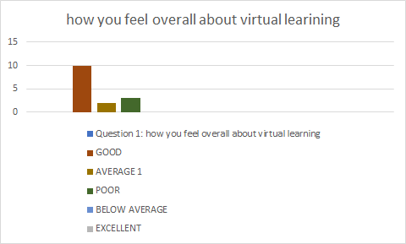
Good | Average | poor | Below average | Excellent
10 | 3 | 2 | 0 | 0

Question number 1 Analysis. On the first graph, we can see that the majority of students enjoy using the virtual learning environment, even though 3 out of 15 students gave average responses and two gave bad responses. Most students like this method, but there are a few who do not. There are improvements that can be made to improve their experience.

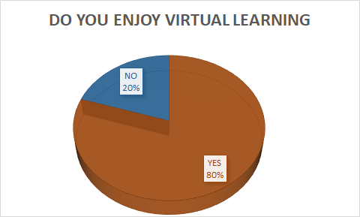
NO | YES
3 | 12

According to the results of the 2nd question, we can see that 80 percent of students reacted positively and enjoy virtual learning, while 20 percent did not.

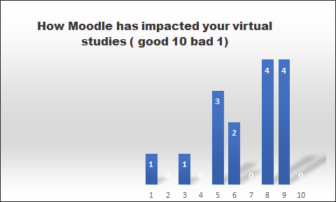

1 | 2 | 3 | 4 | 5 | 6 | 7 | 8 | 9 | 10
1 | 0 | 1 | 0 | 3 | 2 | 0 | 4 | 4 | 0

The results for the question. How has Moodle impacted your virtual study? Ten out of fifteen responded a good impact, three are. in-between and two have given a bad response. Overall, the students have found it to be a positive experience.

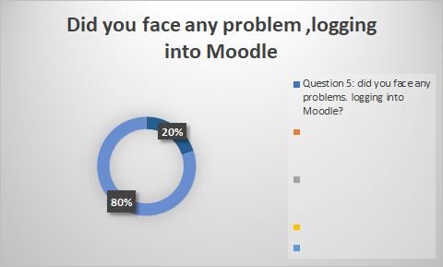
YES | NO
3 | 12
On the 5th chart we can see that most of the students do not face any problem. Although 3 out of 15 have responded by saying they face logging on problems because of Internet connection and technical issues.

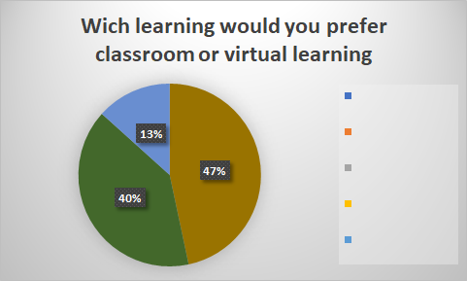
CLASSROOM | VIRTUAL LEARNING | NO NSWER
7 | 6 | 2
As you can see from the graph, 47 percent of students prefer classroom work, 40 percent prefer virtual learning, and 13 percent are undecided. There is not a significant difference between classroom and virtual learning.

Question 8: What benefit/ disadvantage did you find in virtual learning experience explain.
Benefit of virtual learning, most of the students responded by saying they are saving on travelling expenses and is allowing students to learn on their own time, in their own place, and at their own pace, giving them more flexibility.
Disadvantages. connection issues may cause students to miss crucial information, and a lack of contact can contribute to self-isolation.

4.2 Secondary data analyst
secondary data source, the first source was used. world economic forum 2020 studies, The COVID-19 pandemic has changed education forever. This is how.
students who study online retain 25-60% more content than those who learn in a classroom retain just 8-10%. This is due to students' ability to learn more quickly online; e-learning takes 40-60% less time to learn than traditional learning.
Children, particularly younger ones, need a structured atmosphere, according to the consensus, since they are more easily distracted.
According to BYJU's Mrinal Mohit, since studies have shown that children use their senses extensively to learn, making learning enjoyable and successful through the use of technology is critical.
Dowson Tong, Tencent's Senior Executive Vice President and President of the Cloud and Smart Industries Group, believes We have observed over time that clever incorporation of games has demonstrated higher engagement and increased motivation towards learning, especially among younger students, causing them to truly fall in love with learning,” he says.

The second source used in this study was the Moodle e-learning environment, according to Virve Siirak (2008), is an especially useful learning tool. Their study's conclusion is.
Moodle facilitates learning by increasing students' enthusiasm for activity and participation in the course, thus fostering a learning community.
The forums and other programmes available in the Moodle e-learning environment are extremely beneficial to students.

The third source that was used in this research was, Barker.J and Gossman.P (2013) The Learning Impact of a Virtual Learning Environment: Students’ views Data shows that using a VLE promotes independent learning by allowing students to learn informally at their own time, location, and speed, giving them more versatility.
The use of SFC Moodle aids in the development of self-directed learning.
Students are more motivated to learn when they use a VLE for learning and teaching.
SFC Moodle's use has a positive effect on learning.

Learning and teaching are enhanced as a result of the use of VLEs, which leads to increased satisfaction, retention, and achievement for a greater and more diverse student body.

4.4 Summary of findings.
Summary of results from my review of the closed ended and open-ended questions proposed in the questionnaire The overall result was good.
It included open-ended questions like What benefit/disadvantage did you find in your virtual learning experience?
Most students stated that the benefits include saving money on travel costs and allowing students to learn on their own time, in their own place, and at their own speed, allowing them more flexibility. And disadvantages, Connection problems may cause students to miss valuable information, and a lack of interaction can lead to self-isolation.
Question 4 about how Moodle has impacted your virtual studies. 10 out of fifteen people said they had a positive impact, three said they were in the centre, and two said they had a negative impact. Overall, the students thought it was a pleasant experience.
According to the results of the second question, 80 percent of students responded positively to virtual learning and enjoyed it, while 20% do not. The students felt it was a positive experience overall.

5 Conclusion
In conclusion, the effect of the virtual learning environment Moodle in UWTSD has been satisfactory, as it has been an important system that students are familiar with and has easy accessibility.

6 Referencing
Cahterine (2009) Introduction to Research Methods.4th Edition: Publisher Constable & Robinson new york
Virve Siirak (2008) T.Moodle e-learning environment – an effective tool for a development of a learning culture. allinn University of Technology. available at: https://www.icheme.org/media/9718/xx-paper-23.pdf (accessed 2/5/2021)
Barker.J and Gossman.P (2008) Moodle e-learning environment – an effective tool for a development of a learning culture. Teacher Education Network Journal. University of Cumbria Vol 5 (2) pages 19-38 available at: https://core.ac.uk/download/pdf/29422368.pdf
(accessed 29/4/2021)
World economic forum (2020) The COVID-19 pandemic has changed education forever. This is how. available at:
The rise of online learning during the COVID-19 pandemic | World Economic Forum (weforum.org) (Accessed: 27/04/21)

7 Appendix 1

Question 1: how you feel overall about virtual learning

- Poor
- Below Average
- Average
- Good
- Excellent

Question 2: Do you enjoy virtual learning?
- Yes
- N0
Question 3: what do you like to use in Moodle?
- Library
- My TSD
- Hwb
- Service Dessk
- My Moodle

Question 4: how Moodle has impacted your virtual studies.
Bad impact Good Impact
1 | 2 | 3 | 4 | 5 | 6 | 7 | 8 | 9 | 10

Question 5: did you face any problems. logging into Moodle?
- Yes
- NO
Question 6: If yes what type of problems do you face for logging into Moodle, please explain.
Question 7: How helpful is virtual library?
- Not at all helpful
- Slightly helpful
- Moderately helpful
- Very helpful
- Extremely helpful
Question 8: What benefit/ disadvantage did you find in virtual learning experience explain

7.1 Appendix 2

Question 1: how you feel overall about virtual learning
GOOD | 10
AVERAGE | 3
POOR | 2
BELOW AVERAGE | 0
EXCELLENT | 0

Question 2: Do you enjoy virtual learning?
YES | 12
NO | 3

Question 3: what do you like to use in Moodle?
LIBRARY | 1
MY TSD | 2
HWB | 0
SERVICE DESK | 0
MY MOODLE | 12

Question 4: how Moodle has impacted your virtual studies.
BAD IMPACT 1 GOOD IMPACT 10
1 | 2 | 3 | 4 |  | 5 | 6 | 7 |  | 8 |  | 9 | 10
1 | 0 | 1 | 0 |  | 3 | 2 | 0 |  | 4 |  | 4 | 0

Question 5: did you face any problems. logging into Moodle?
YES | 3
NO | 12

Question 6: If yes what type of problems do you face for logging into Moodle, please explain.
very slowly, /technical issue / LOG IN

Question 7: How helpful is virtual library?
NOT AT ALL HELPFUL |  |  | 3
SLIGHTLY HELPFUL |  |  | 0
MODERATELY HELPFUL |  |  | 4
VERY HELPFUL |  |  | 8
EXTREMELY HELPFUL |  |  | 0
Question 8: What benefit/ disadvantage did you find in virtual learning experience explain.
ADVANTAGE |  | Most of the students responded by saying they are saving on travelling expenses and is |  |  | allowing students to learn on their own time, in their own place, and at their own pace, giving them more flexibility.
DISADVANTAGE | connection issues may cause students to miss out on crucial information, and a lack of contact can contribute to self-isolation.

