Management Approaches (Tesco)
Alex Hudson
Contemporary Management Approaches (BMSP4002)
Davina Evans/Anthony Burns
29th November 2017

Contents
Introduction 3
Organisational Functions 3
Approaches to organisation and management 4
Work motivation and satisfaction 7
Perception and communication 9
Organisational nature and context 10
Conclusion 12
References 13

Introduction
For this essay, the selected organisation will be the large well-known company Tesco as this supermarket is one of the largest organisations across the United Kingdom. This essay will also be analysing the organisational functions, the management approaches the company takes, the satisfaction of employees within the company, the different perceptions and the nature of the organisation.

Organisational Functions
The following functions each play their own role for their success:
Sole Trader – This is where the owner and/or entrepreneur must carry out all the functions of the business (they do this by investing their own money and taking all risks) (Roger Lewis, Roger Trevitt, 2000). If the sole trader for Tesco were to employ other people, the organisational structure would be a simple hierarchy with the sole trader taking responsibility for them. What the business would need to do to grow is acquire extra capital, this means either borrowing funds, taking on partners or private shareholders and set up a private limited company (Roger Lewis, Roger Trevitt, 2000).
Partnerships – A lot of partnerships are most likely to have a flat structure. This means that various partners are brought on for increasing extra capital and specialising by function (Roger Lewis, Roger Trevitt, 2000). For Tesco example, this was to enable the business to open their first retail outlet (which took place in Tooting South London).
Private Limited Company – When it comes to private limited companies, this is usually the first big step in the growth of businesses have ambitions to expand. If the business wanted to gain limited liability, they would have to provide proper accounts and keep hold of financial records (Roger Lewis, Roger Trevitt, 2000).

Approaches to organisation and management
The Tesco Board of Directors is comprised of 10 members and there were some changes in the Board during the financial years 2014 and 2015. The appointment of John Allan as Chairman of the Board was one of the changes along with the appointment of a new CEO Dave Lewis and new Chief Financial Officer Alan Stewart (John Dudovskiy, 2016).
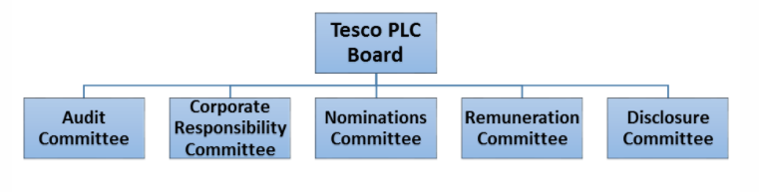

(Figure 1 – Tesco Corporate Governance Structure)
Figure 1 above shows that Tesco governance structure comprises five different committees reporting to the Tesco PLC Board. The Tesco Executive Committee is made up of 11 members and are led by Group Chief Executive Dave Lewis.
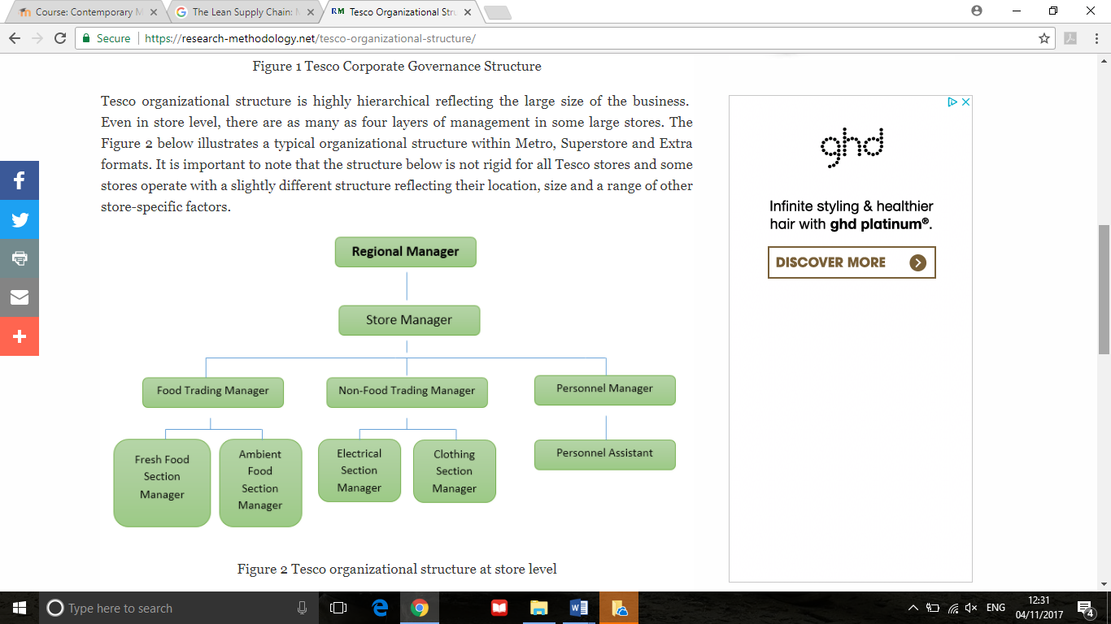

(Figure 2 – Tesco Organisational Structure at store level)
However, figure 2 provides an illustration of a standard organisational structure within a Metro, Superstore and Extra formats. However, the structure above doesn’t apply to all Tesco stores as some stores operate with a slightly different structure which represents their location, size and other store-specific factors. However, it could be arguable that around 3 or 4 management layers within one store might spark unnecessary bureaucracy. This can then lead to negative implications on the flow of information across the layers of management. Increasing the flexibility of operations and in-store changes and acceleration of information flow would need to be considered by the senior level management (John Dudovskiy, 2016).
While looking at the approaches to management of Tesco, the company operates under Scientific Management, this means that the employees must be selected based on their skills and abilities that are related to the job (for Tesco, not much will be required), incentives and wages provided to employees should be based on encouraging them and enhancing their output and there should be attention on eradicating interruptions while planning work (Reddy, 2017). So overall, Tesco takes a Classical approach to management. The advantages and disadvantages will be discussed to look more into Scientific Management:

Advantages
Enhanced production – This management theory is responsible for enhanced production as it focuses on steady improvements in business operations. There is a fruitful cooperation between managers and workers and hence enhanced teamwork is achieved (Reddy, 2017).
Ability to control – The best part of scientific management theorists is that the managers can have a good level of control over production. Employees become specialists in their field as they perform the same tasks repeatedly which makes it easy for the managers to have control over the employees (Reddy, 2017).
Pay system – With the theory piecework pay system is followed, where payment is monitored based in piecework. Here incentive is considered to enhance productivity and provide higher wages for employees. With a higher productivity, there is an increase in wages for employees (Reddy, 2017).
Benefit to customers – With the help of scientific management theory there is triple benefit for consumers. Consumers pay fewer prices and can get best quality products. They are also able to attain better living standards (Reddy, 2017).
Efficiency increased – They follow early working method and control where a management methodology is developed for training, selecting and supervising them in a close manner. Since scientific selection and training methods are followed, it leads to a workforce which is best and where efficiency is enhanced (Reddy, 2017).
Worker instructions – With the assistance of this theory, work is carried out in a systematic manner according to pre-determined plans. Complete guidance and instructions are provided to workers to carry on with work as planned (Reddy, 2017).
Good working conditions – A proper atmosphere for working conditions are developed with scientific management theory. Proper working schedules are followed with ventilation; adequate lighting, rest pauses, with proper safety and other facilities are provided to patients (Reddy, 2017).
Disadvantages
Requires huge capital – The theory requires an investment of huge capital and is considered as a costly system. The establishment of work study, planning department, training of workers and standardisation requires more money (Reddy, 2017).
Management takes control – The management takes complete responsibility related to control and planning of work place activities. Since the managers take up control of the employees, they lack creativity, another reason of this is that since they repeat the same task, their chore is meaningless, monotonous and tedious which reduces employee motivation (Reddy, 2017).
Demotivating approach – With the application of scientific approach of management, the employees are focused on how well they perform their job and their statistics and results are produced along with a time frame. With this result, the employees may feel underestimated and feel alienated which may lead them to absenteeism (Reedy, 2017).
Stress – With managerial decisions, there is strictness and stress for managers as they need to take responsibility for having complete control over the workplace. This way, there is pressure influenced in the workplace for the workers too (Reddy, 2017).

Work motivation and satisfaction
While looking at the work motivation and satisfaction of Tesco, McGregor’s Theory X and Y will be used to analyse the approach. Theory X managers takes the thinking that people dislike work, and only work as it is a necessity for survival. They perceive workers to be lazy people who want to avoid responsibility, lack ambition and would rather be directed instead of using initiative to take roles of responsibility (“Management Leadership Styles: Tesco”, 2017). Usually, these managers believe people want security from their jobs, therefore the managers take a very directive approach to leadership and are very strict and controlling with their subordinates (“Management Leadership Styles: Tesco”, 2017). On the other hand, Theory Y managers take an immensely different view to the theory x style of management. Theory Y managers believe that people see work as a daily occurrence and accept and strive for some responsibility. They believe that if the workers are in the correct conditions, they will put in the effort to work as their own will, helping the organisation achieve the set-out goals while in return be rewarded (“Management Leadership Styles: Tesco”, 2017).
In relation to Tesco, the management takes a theory X approach in running their organisation. This is due to the enormity of the number of subordinates a manager is likely is to be in supervision of, it would be nearly impossible to use the opposite approach (“Management Leadership Styles”, 2017). Furthermore, the tasks needed to be carried out by the workers do not require many skills, an example of this includes shop floor duties such as shelf stacking, checkouts and sales assistants carry out basic duties. As a result, these workers would need constant supervision and direction to ensure continuity and consistency to achieve the firm’s goals. Therefore, for Tesco, a theory X approach to management in their stores is the most effective management style (“Management Leadership Styles: Tesco”, 2017).
An example of what Tesco does to improve employee commitment and satisfaction is by using merit pay, which is extensively used in retailing in general. In the year 2003, Tesco distributed a total of £57 million as merit pay. In Tesco’s model, merit pay is given to employees as shares in proportion to pay. It is usually given to employees that have worked for the company for a least a year. Besides merit pay, there are other ways employee commitments can be strengthened such as different kinds of support and benefits (Sami Finne, Hanna Sivonen, 2008).

Perception and communication
In Tesco, there are different types of communication involved that aims to improve work performance and the progress of the company. Teams within the organisation share monthly communications with all level 3 managers and above to cascade to their teams. It is used to communicate the most important messages relevant to employees and their roles (Our Tesco, 2017). It consists of three sections that include helping employees to do their job, to help them to serve their customers even better and to keep employees informed of news and information happening in their department, office and across the business and to help them celebrate their performance (Our Tesco, 2017). Managers in Tesco are always encouraging employees to approach managers about any issues that affect them and/or the business. They have regular discussions through colleague question time, face to face briefings and publications (Our Tesco, 2017). If employees stereotype themselves or allow others to engage in stereotyping, the workplace is potentially ripe for abuse or mistreatment (Kokemuller, 2017). Employees who act based on stereotypes rather than putting faith in the abilities and efforts of co-workers impede group progress. In a team, stereotyping can prevent an employee from asking support or offering it to a certain employee. So, a man may not ask a woman in his team for help if he believes that she isn’t capable of understanding that tasks because she is female (Kokemuller, 2017). A general issue with stereotyping is that it can cause low morale for the individual or group impacted. Employees who face constant comments, criticisms or other negative results from stereotyping can have their motivation lowered and interest in doing their job (Kokemuller, 2017).

Organisational nature and context
Tesco is a Private Sector organisation which means that it is managed and controlled by private individuals and/or enterprises rather than being owned by the government. Below is a PESTLE Analysis based on Tesco:
Political – Since the retailing company operates worldwide, global political factors greatly influence the performance of Tesco. These include tax rates, acts of legislation and the stability of the country it operates in. As Tesco plays its part in creating employment opportunities, it also in turn, increases the demand for its products and diversifies its workforce (PESTLE Analysis, 2014).
Economic – Economic factors are the main point of concern for Tesco as they are most likely to leverage costs, demand, profits and prices. Therefore, the company should be aware of any changes in taxation or any other factors that could affect the accessibility of finance (PESTLE Analysis, 2014).
Social – Due to a variety of social changes, trends indicate that customers in the UK have moved towards bulk shopping and one-stop shopping. The type of goods and services demanded by consumers is mostly influenced by their beliefs and attitudes which in turn, are influenced by social conditioning. Because customers are becoming more aware of health issues, due to which their approach towards foods is changing constantly, Tesco is adapting to these changes by accommodating the demand for organic products (PESTLE Analysis, 2014).
Technological – The advancements in technology have brought various new opportunities for Tesco. The development of online shopping with home delivery and self-service checkouts have provided convenience and ease for customers (PESTLE Analysis, 2014).
Environmental – Tesco is committed to reducing its carbon footprint by 50% by 2020. They are also minimising the waste produced in their stores by increasing social conscience in customers (PESTLE Analysis, 2014).
Legislative – The performance of Tesco can be impacted by government policies and legislations. For example, the Food Retailing Commission suggested a Code of Practice should be introduced which would ban some current practices, such as changing prices without demanding payments from suppliers. To facilitate these policies, the company provides customer price reductions on the fuel they purchase, in accordance to the amount spent on their grocery stores (PESTLE Analysis, 2014).
Organisational Conflict
When it is unclear who is responsible for what area of a project or task, conflict can occur (Sullivan, 2017). Understanding how personal interests and goals fit within the structure of the organization will alleviate conflict of interests. When an individual’s personal goals are at odds with the goals of the organization, the individual may be tempted to fight for his/her personal goals, creating conflict (Sullivan, 2017). Competition for resources, including money, time and materials will cause teams to undercut each other, leading to conflict between departments or other work groups (Sullivan, 2017). Often the conflict is a result of interpersonal relationships where the parties to the conflict are unable to resolve personal issues with each other, since it can be difficult to set aside personal prejudices when entering the workplace (Sullivan, 2017).

Organisational Stress
Work-related stress can occur when employees feel they are not being compensated fairly or sense a lack of respect from their peers or managers. An over-abundance of rules or a lack of opportunities for advancement can contribute to the creation of stress (Reynolds, 2017). Stress can also bring on counterproductive work behaviours which may include personality changes in employees, disrespect for co-workers or customers and exhibiting extreme anger toward managers (Reynolds, 2017). Tesco can help employees avoid stress and maintain business objectives by providing workers with the means to communicate issues that bother them. Regular performance reviews, options for career development and a sense of autonomy in their jobs enable staff to enjoy their work (Reynolds, 2017).

Conclusion
Overall, Tesco has strong organisational functions that each play their part well enough to help maintain the business. Their flat organisational structure does well to keep information and data flow simple within the company with no complications. The management approach that Tesco operates under shows that Scientific Management keeps the business flowing at a good pace which gives the Classical Approach some benefit. Using McGregor’s Theory X and Y was a good theory to analyse the company, theory x being the better approach for Tesco. With perception and communication, Tesco provide good support for the employees to ensure that they are comfortable and motivated to do their job and to keep them from stereotyping. Lastly, for the organisational nature and context the PESTLE analysis shows that Tesco knows how to deal with each factor, how to handle any conflicts that occur in the workplace and stress that employees come under.

References
Lewis, R., & Trevitt, R. (2002). Business for vocational A level/AVCE. Cheltenham: Nelson Thornes.
Dudovskiy, J. (2016). Tesco Organizational Structure – Research Methodology. Research Methodology.
https://research-methodology.net/tesco-organizational-structure/
Reddy, C. (2017). Advantages & Disadvantages of Scientific Management Theory – WiseStep. WiseStep.
https://content.wisestep.com/advantage-disadvantage-scientific-management-theory/
Management Leadership Styles: Tesco. (2017). UKEssays.
https://www.ukessays.com/essays/management/management-leadership-styles.php
Finne, S., & Sivonen, H. (2008). The retail value chain. London: Kogan Page
Smith, P., Farmer, M., & Yellowley, W. (2013). Organizational Behaviour. Hoboken: Taylor and Francis.
Ike, L. (2016). Management: Principles & Techniques. Xlibris Corporation.
How we communicate together – Our Tesco. (2017). Our Tesco.
https://www.ourtesco.com/how-we-communicate-together-2/
Kokemuller, N. (2017). How Does Stereotyping Affect the Workplace Environment?. Smallbusiness.chron.com.
http://smallbusiness.chron.com/stereotyping-affect-workplace-environment-78286.html

Contributor, P. (2014). PESTLE Analysis for Tesco discusses its Business Environment. PESTLE Analysis.
http://pestleanalysis.com/pestle-analysis-tesco/
Sullivan, J. (2017). Four Types of Conflict in Organizations. Smallbusiness.chron.com.
http://smallbusiness.chron.com/four-types-conflict-organizations-174.html
Reynolds, M. (2017). How Does Employee Stress Affect the Organization?. Smallbusiness.chron.com.
http://smallbusiness.chron.com/employee-stress-affect-organization-64257.html

Appendix
Table 1 – Employee Needs
Social needs | This is where Tesco puts a strong emphasis on team-working and creating a ‘home-from-home’ atmosphere.
Security needs | This is where Tesco offers formal contracts of employment and benefits such as pensions and sickness schemes. Health and safety at work are a priority. Staff are able to join a union for further support.
Physiological needs | This when the company provides regular monthly pay, restaurants and lockers for staff.
(Paul Smith et al. 2013)
Table 2 – How Tesco motivates its employees
Self-actualization | This is where Tesco offers personal development plans, recognition of skills, abilities and talents, and opportunities for career progression. It has a fast track management programme that provides a clear pathway for talented staff.
Self-esteem | This is where Tesco highlights respect for others and praise for those who work hard. The appraisal system is designed to recognise the contribution of individuals and achievements are celebrated.
(Paul Smith, et al. 2013)
As shown above, it is important that Tesco keeps their employees motivated as this will keep them satisfied to work with them. So, all this is proof that Tesco have adopted Maslow’s principles to motivate employees, by considering their needs according to management levels and departments. Associating top management and middle with social, self-esteem and self-actualisation needs, and lower management with physical and safety needs (Luke Ike, 2016).

