ACCA5026 Databases and Application Development
PART A

STUDENT NAME : ADNAN AHMED

ID NUMBER : 2330501

PROFESSOR NAME : Dr Malik Uzair Mehmood

Table of Contents
1. Introduction 4
2. Database Design and Creation 4
2.1 Key Entities: Identification and Justification 4
2.2 Entity Relationship 5
2.3 Entity Relationship Diagram and Explanation 5
2.4 Design Decisions: Normalization 6
3. Implementation Documentation 8
3.1 Table Creation 8
3.2 Constraint Implementation 10
3.2.1 Primary Key constraint 11
3.2.2 Foreign Key Constraint 11
3.2.3 Auto Increment 12
3.2.4 Not Null Constraint 12
3.2.5 Data Types and their Importance 12
3.3 Sample Data Insertion 13
3.3.1 Purpose 13
3.3.2 Data Volume Requirements 13
3.3.3 Validation of Data Inserted 14
3.4 Trigger and stored procedure 14
3.4.1 Trigger procedure 14
3.4.2 Purpose 15
3.4.3 Type of Trigger Used 15
3.4.4 Functionality 16
3.4.5 Stored Procedure 16
3.4.6 Purpose 17
3.4.7 Use and implementation of Place Order. 17
4. Stored Procedure and Transactional Scenario 18
4.1 Insert Product Procedure 18
4.2 Delete Product Procedure 19
4.3 Update Product Procedure 19
4.4 Background on transactions 19
4.5 Transaction design for GreenLeaf 19
4.6 Implementation of Transaction Logic 21
4.7 Stock Validation in the Order Table 21
4.8 COMMIT Operation 22
4.9 ROLLBACK Operation 22
4.10 Demonstration and physical evidence of the transaction 22
5. Performance Tuning Enhancement 23
5.1 Index Implementation 24
5.2 How Indexing Optimizes Performance 24
5.2.1 Benefits 24
5.2.2 Evidence using Prompts 25
6. Conclusion and Reflection 25

Introduction
GreenLeaf Organics is currently experiencing the need to develop a scalable and optimized online store for its products. The main criteria are to enable users or customers to easily browse the products, buy them, and review each product from every certified supplier. It is imperative to have adequate information about such certified suppliers in the online store. Also, the business needs to have a whole set of data to manage customer relationships, suppliers’ concerns, and to keep the business running properly. As such, there is a need for a scalable database in the line of SQL that can help handle an increasing number of customers. Also, a relational database is needed to ensure that accuracy can be maintained across all relevant databases. Furthermore, there is a need to have effective inventory monitoring systems in place, followed by a mechanism to manage supplier relationships. Since it will be an online store, the most important elements are to help customers make an order successfully, from the time they choose a product to making a payment or confirming cash on delivery. Lastly, the database also needs to support user engagement in different ways, such as enabling review and feedback options, enabling link and product sharing options, and enabling easy login, among other things.

Database Design and Creation
A database that supports any online store is critical, mainly because it supports all the live actions taking place in the e-commerce store as consumers interact and use them. Without having the desired data, entities, and relationships established in a defined database, customers cannot effectively use any website or e-commerce store.

2.1 Key Entities: Identification and Justification
The key entities involved in the database creation include the product, suppliers, customers, and orders. Each of these entities shares a distinct relationship. In the case of customers, there can mainly be one to many relationship with the order, which means one customer can order more than one thing at a time. Similarly, there is a distinct relationship between order and product, where a single order can contain multiple products at the same time. In the same way, there is a relationship between suppliers and products where one supplier can supply multiple products, but if there are multiple suppliers, each product needs to be linked with each supplier accordingly.

2.2 Entity Relationship
The relationship is based on the ERD. It primarily shows that the customer makes an order, which become order item, and the same is relevant for review. Similarly, it shows that the product plays a crucial role; however, without a supplier, the product demand cannot be fulfilled. Further, every product has a specific category that is again supplied by a supplier. A specific relationship node has been designed using the ERD. It starts when a customer places an order or multiple orders at a time. It is also true that a customer making an order at a time will contain multiple items, which are identified as order items. Also, every product does not belong to the same category; thus, a category entity relationship is created. Furthermore, the role of suppliers comes into play as soon as the customer places an order. Also, after making a purchase customer puts reviews and feedback on the online store or website, which is again possible only if the purchase or order is successful. Thus, if one analyzes the ERD as shown in Figure 1, the product is linked with multiple entities that include order items, review, product audit, and product category.

2.3 Entity Relationship Diagram and Explanation
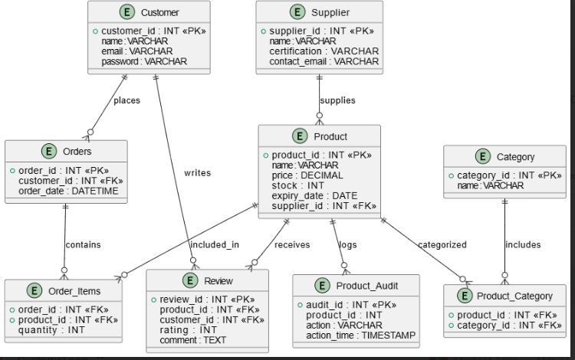
Figure 1: ERD showing the relationship between entities
Figure 1 is an entity relationship diagram that shows the relational existence of each of the entities defined through arrows. There are 9 entities as shown in the figure, and each shares a specific relationship with the others. For example, the customer entity has a relationship with the orders and reviews because a customer ID exists only if they make an order, and the review exists if the customer makes a purchase or order. Similarly, the figure shows the relationship between products and supplies because without supplies, product ID or stock will not exist. The term ‘includes’ and contains’, among others shows the relationship between each entity. For example, the inclusion in the ERD suggests that a category also includes a product category.

2.4 Design Decisions: Normalization
Data normalization is defined as the process or a measure to resolve errors in a database, where errors such as incomplete data and miscalculation of values of attributes [1]. It is key in ensuring a reliable database design that can perform multiple functions successfully. Theoretically speaking, there are three important methods to pursue to handle such data and value-related errors in a given database. They include First, Second, and Third Normal Form.
First Normal Form
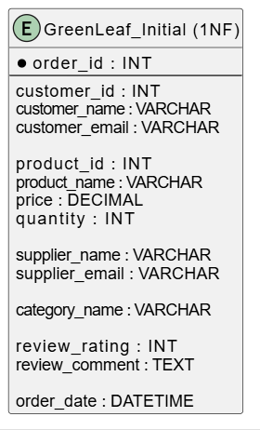
Figure 2: First Normal Form with repeated data
Figure 2 illustrates the first normal form in database normalization, where each of the columns only has a single value or attributes for each of the entities. However, if we consider the table carefully, it has repeated information relating to consumers such as their ID, email address, and name, which needs to be avoided to maintain the integrity of relational data.
Second Normal Form
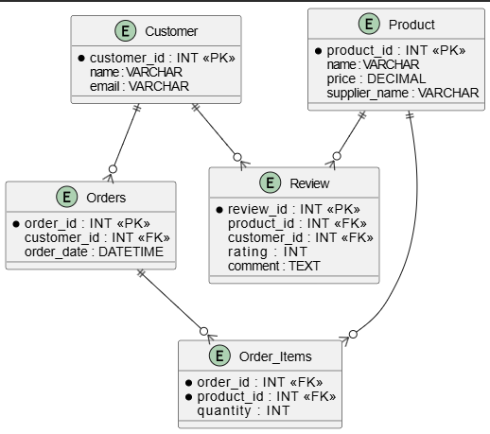
Figure 3: Second Normal Form
Since there are errors in terms of replication of data, it was imperative to use the second normal form. As shown in Figure 3, there were changes implemented to the first table where the focus was on the removal of partial dependencies. The key change implemented was separating data into separate tables, as shown in the figure. For each of the entities, a spate table is created, but the relationship is still maintained using the foreign key, which is indicated by the arrows in the figure.
Third Normal Form
In this case, the overall redundancies and errors are solved where the table does not have any transitive dependencies. Entities are more properly separated than in the second normal form. For example, more entities such as supplier, product category, review, and order items are added as shown in the final ERD in Figure 1 in the above sections.

Implementation Documentation

3.1 Table Creation
The entire table for the GreenLeaf Organics is made using the ERD developed before. It is based on how each of the entities in the database would share a relationship, thereby impacting each other in multiple ways. There are customer, supplier, and product tables that require specific focus, considering the nature of the business and outcomes.
Illustration /Screenshots of Customer Table
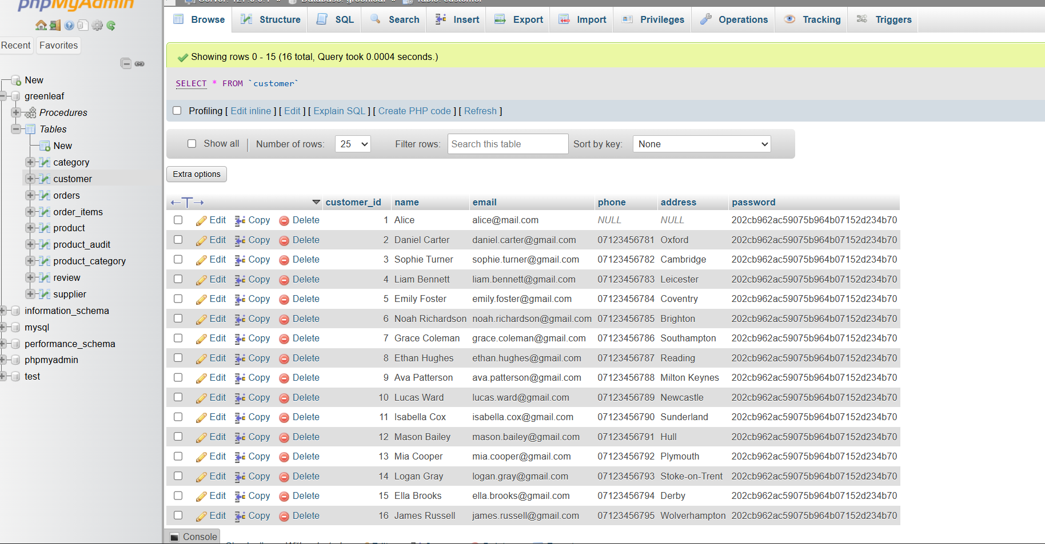
Figure 4: elements that go into the customer table
As shown in Figure 4, the customer table includes mainly a unique ID assigned to each customer, followed by the name, email address, contact details, and address. The table has options to make necessary changes using edit, delete, or copy keys on the left side of the table.

Illustration of Product Table
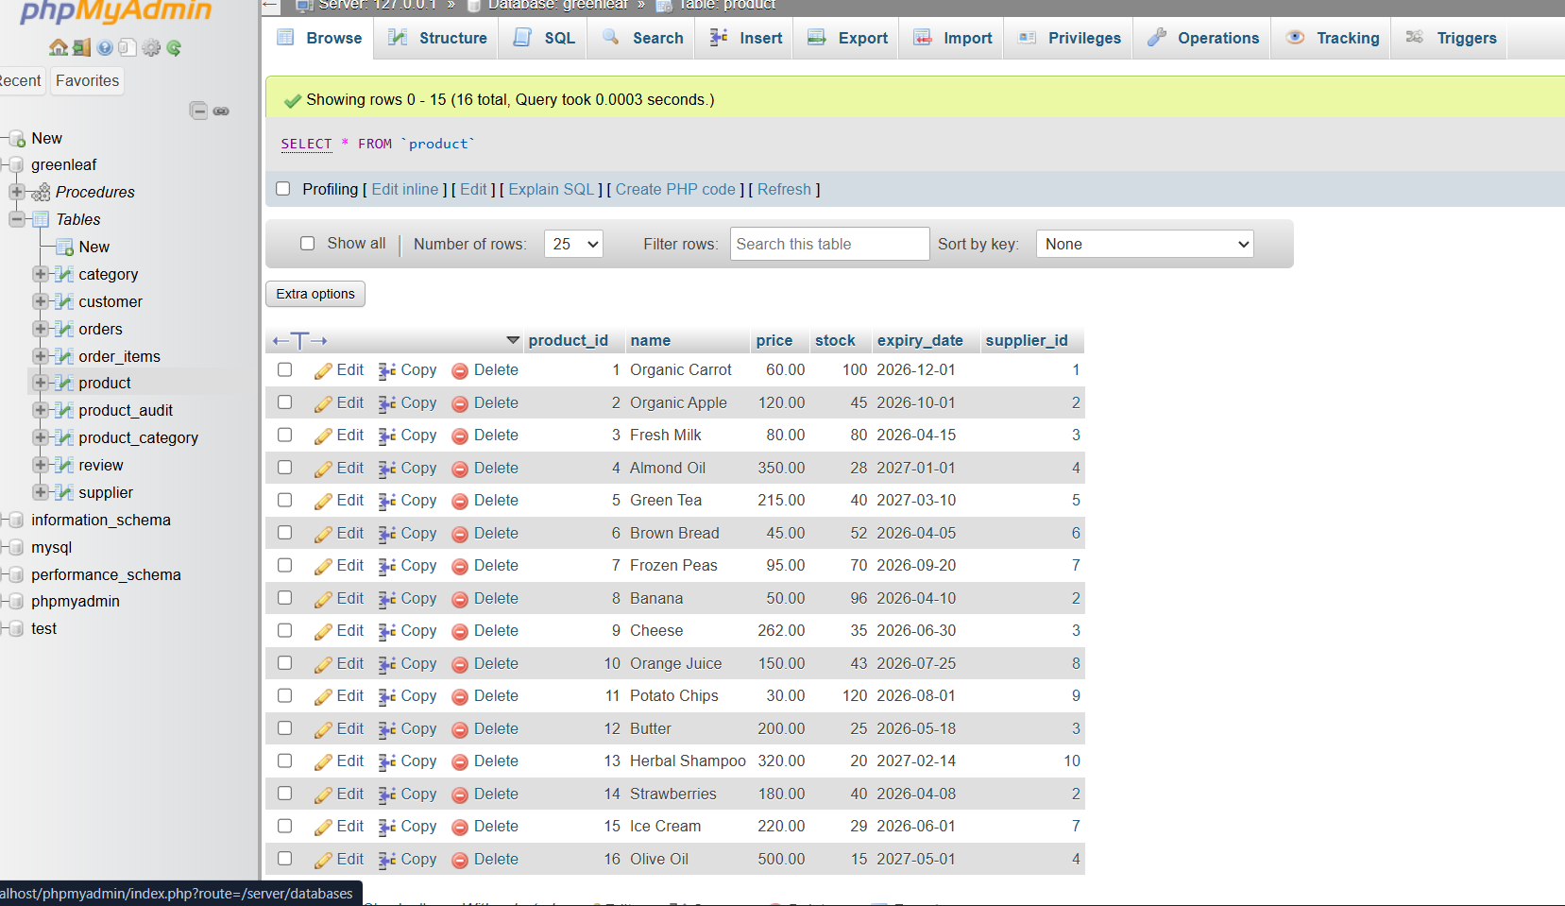Figure 5: product table showing specific products
The product table includes the product's unique ID, different from all other products. It is followed by the name of the product, such as “Organic Carrot’, price of the product, the supplier who specifically supplies those products, and available stock as shown in Figure 5. Since the product comes from a specific supplier, there is a use of a foreign key and references connecting the supplier with a unique Supplier ID.

Illustration/Screenshot of Category Table
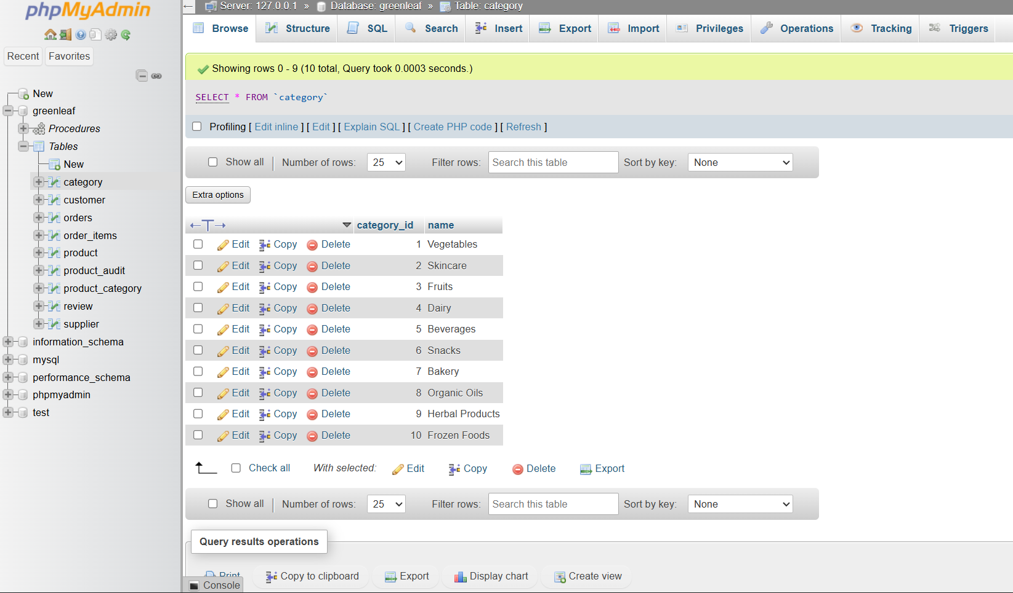
Figure 6: Category Table
The category table is important because it is a more specific categorization of products. If the category means green leafy vegetables, the specific product could include spinach or cabbage. In this case, as shown in Figure 6, the category names are written as ‘Vegetables’ and ‘skincare’, where the products could be the names of more specific vegetables, like cabbage, and skin care products like moisturizer. This entity mainly has a product ID, which is its primary key.

3.2 Constraint Implementation
Through careful reference to the ERD, it can be understood that four major type constraints have been used- primary key, foreign key, auto increment, and Not Null. The primary key is the column denoting ‘Category ID’. Similarly, for a foreign key, it is the column where one data type is related to the other. For example, in the case of organic products, it is the link between the supplier table and the supplier ID, thereby preventing invalid data.

Constraint keys

3.2.1 Primary Key constraint
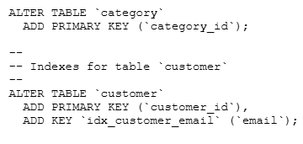
Figure 7: Using primary key in tables- category and customer
A primary key can be defined as an attribute associated with an entity that helps to give a unique identity to the entity [2]. For example, using a customer's name can lead to errors because many customers can have the same names, so instead, if the customer ID or numbers are used, which is also shown in the coding screenshot in Figure 7. The figure is a screenshot from the code where the primary key is defined. For example, in the given figure, the category and Category ID are the primary key.

3.2.2 Foreign Key Constraint
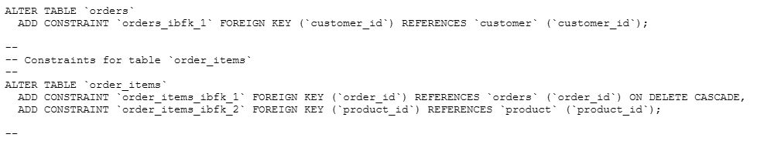
Figure 8: Using a foreign key for tables: orders and order items
A foreign key is defined as a method of linking two or multiple entities, where the same foreign key becomes a primary key for another entity [2]. Considering the foreign key, the figure explains that in the order table, customer ID is linked with the column in the customer table. This is how a constraint in a specific table is created, and this has been done for the GreenLeaf database as well.

3.2.3 Auto Increment
Auto Increment fields are not necessarily considered as a constraint; however, they assign unique values to an attribute or entity when changes are made. It is more appropriately considered as an important attribute of Identity constraints [3] as it assigns a numeric value to define the new identity of an added value or data.

3.2.4 Not Null Constraint
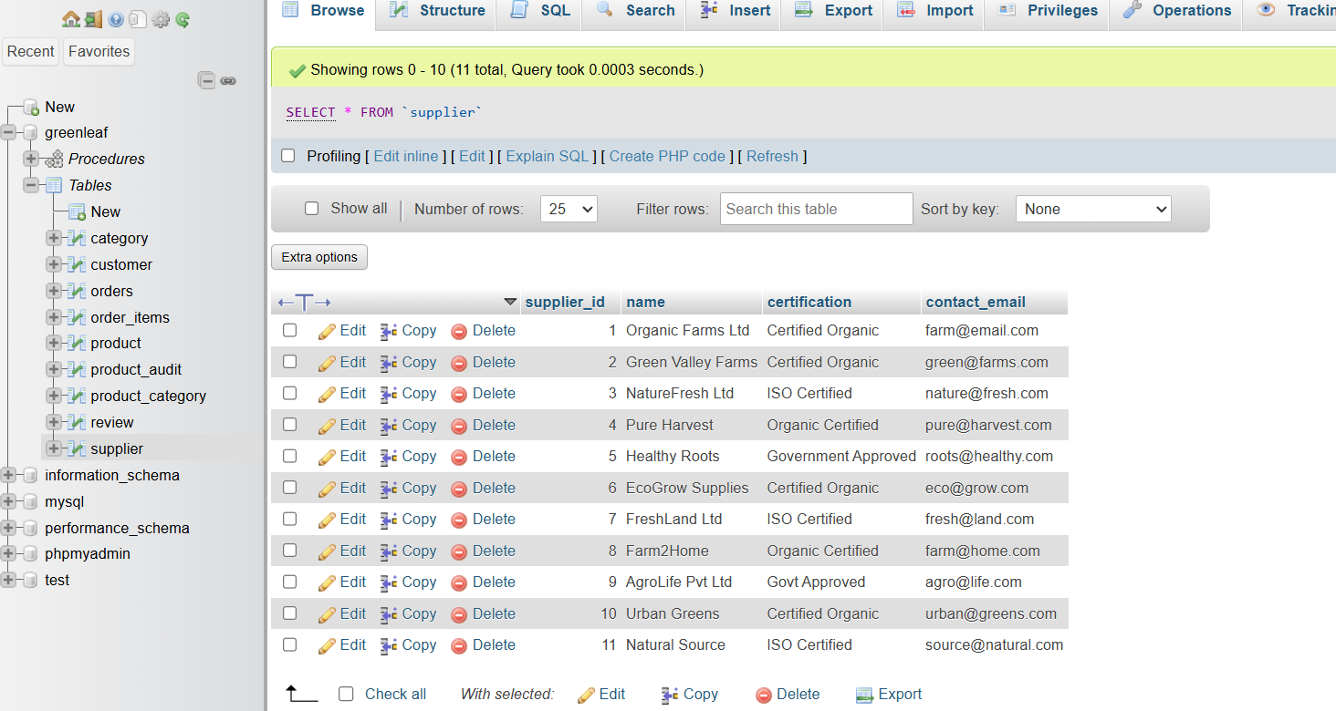
Figure 9: Use of the data ‘certified organic’ as a Not Null key constraint in the Supplier Table
It is an important constraint key that helps in ensuring that the required fields are not left without an attribute or data. It is used mainly during operations like Insert and Update [4], ensuring the existence of a default value attached to an entity or attribute. In Figure 9, the certification attribute in the supplier table has the data defined as ‘certified organic’ because leaving it empty would mean that there is no specific attribute for the supplier’s credibility or reliability.

3.2.5 Data Types and their Importance
In terms of data types, multiple data types are implemented for GreenLeaf’s database in the following manner:
- INT is used as an integer for inserting numeric values.
- VARCHAR is used for any data that requires textual input.
- DECIMAL is used for inserting the value of any product as its price.
- DATE is used for indicating the date when the order is placed, as well as to indicate the expiry date of any product.

3.3 Sample Data Insertion
The use of sample data comes into play once the database and ERD are prepared. Each entity and the tables associated with it are carefully used to use the sample data. For example, in the consumer table, the sample data include the consumer ID, name, address, and contact information, among other things.

3.3.1 Purpose
Sample data insertion plays a crucial role in ensuring that the database operations are successful for each transaction or stage. It also helps to verify the existing relationship between entities. Furthermore, it mainly helps to authenticate the constraints and triggers that will be implemented for each of the tables.

3.3.2 Data Volume Requirements
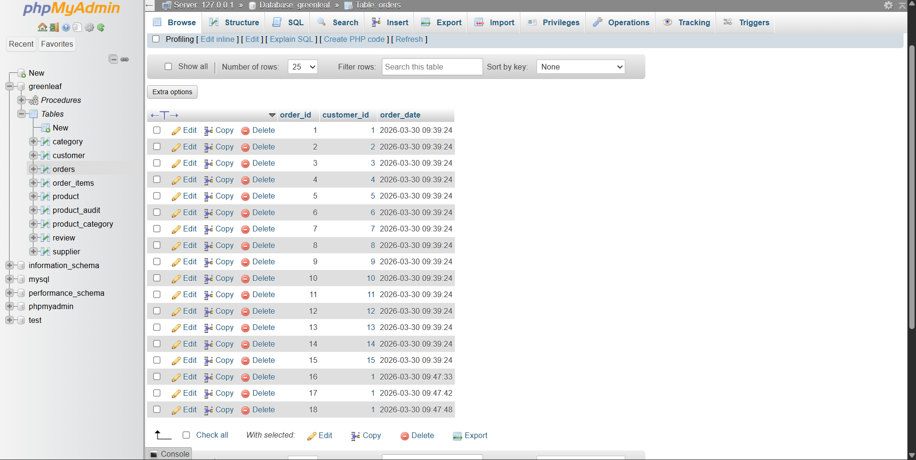
Figure 10: Sample data insertion for the order table
Only a few records have been used, ranging between 10 and 15 for different tables. For example, in Figure 10, there are two records used to show how sample data are inserted for the order table that includes an order ID, the customer ID, and the order date. These are the important elements that have helped in the successful testing and assessment of the database.
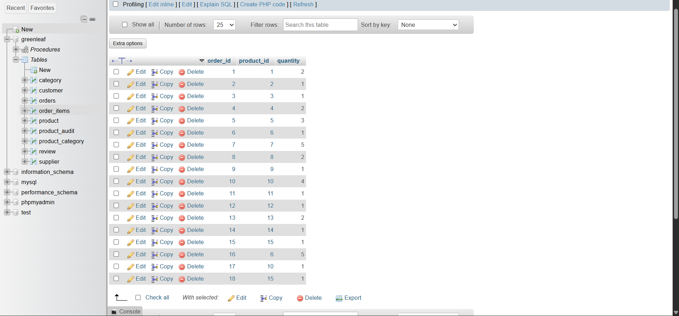Figure 11: Sample data insertion for order item table
Similarly, in the order items table, the records used are only two, with the sample data attributes that include an order ID, product ID, and quantity. Here, the constraints have also been properly implemented, such as those showing the relationship between order ID and the product ID.

3.3.3 Validation of Data Inserted
To ensure that the entered data is successfully updated in the database, the SELECT FROM query has been used. The query helps a user to retrieve all the data inserted using sample data. The query also helped to understand if constraint keys are working properly, as it is directly shown in the table that was prepared.

3.4 Trigger and stored procedure

3.4.1 Trigger procedure
A trigger procedure is used for database creation and management whenever changes are to be made to the database. It mainly uses operations like Insert, Delete, and update [5]. If the trigger is activated, it executes an event that necessarily saves changes; however, a true condition needs to exist.

3.4.2 Purpose
One of the most important purposes of the trigger procedure is to implement and track changes regularly. Through its usage, the users have the option to review historical changes in the database. Since GreenLeaf will run an online store, financial management and tracking will become possible because of such a procedure.

3.4.3 Type of Trigger Used
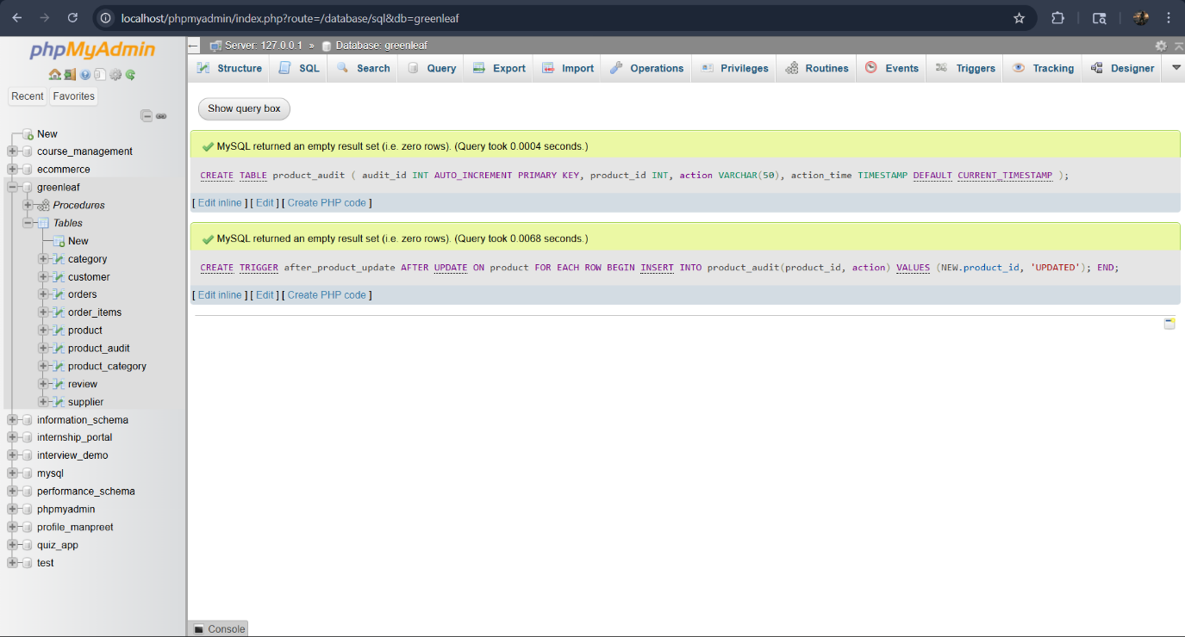
Figure 12: Use of AFTER UPDATE trigger in product table
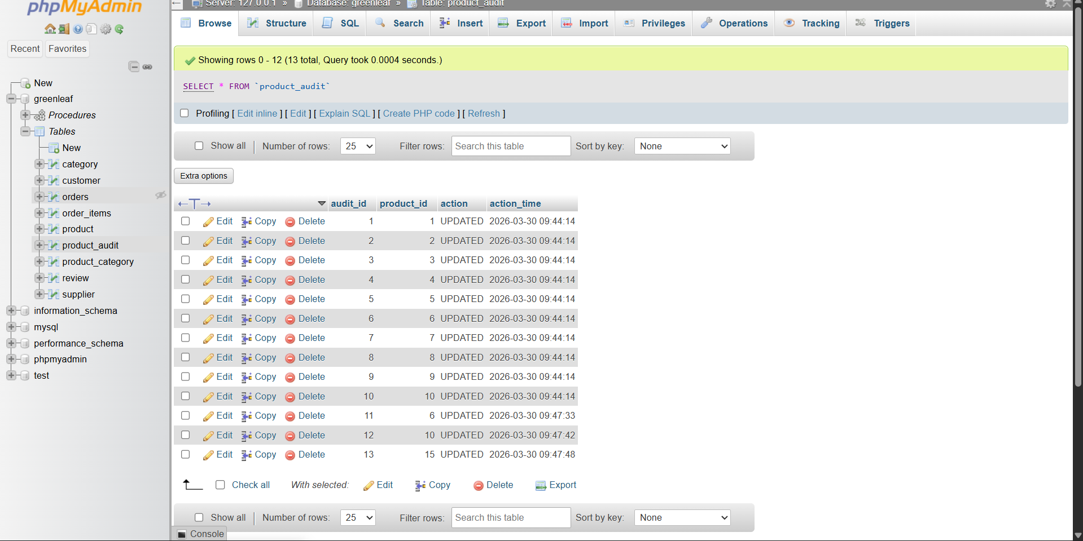
Figure 12: Product_audit table
The focus is on using the after update trigger along with the insert trigger. Figure 12 illustrates the use of the After Update trigger implemented in the product table for each row used in that table. Then, after its execution, it inserts data into another table. This means even if a change is occurring in one part, it is saved to other parts or entirely another table associated with the product.

3.4.4 Functionality
Every time a change is made in the product table and the record gets updated, the trigger operation performs different functions. Firstly, it takes into consideration the previous data or values from the table and helps the system to keep track of the historical data. Then, the new value is acknowledged by the system. Most importantly, specific timing is made available as to when the update was made, thereby helping to ensure accountability.

3.4.5 Stored Procedure
The procedure plays an important role in helping any database recall or remember data that was previously inserted into it [6]. For example, if an Insert action was previously used, the system would now remember the changes made, and that will be shown accordingly.

3.4.6 Purpose
The major purpose of the procedure is to ensure that order placement is correctly handled without the need to perform or write the code again and again. It mainly helps to save time and avoid loss of customers as they begin to make orders using the online store. Further, it also enhances the security of the system as users can only have access to the stored procedure and not the entire table or entity.

3.4.7 Use and implementation of Place Order.
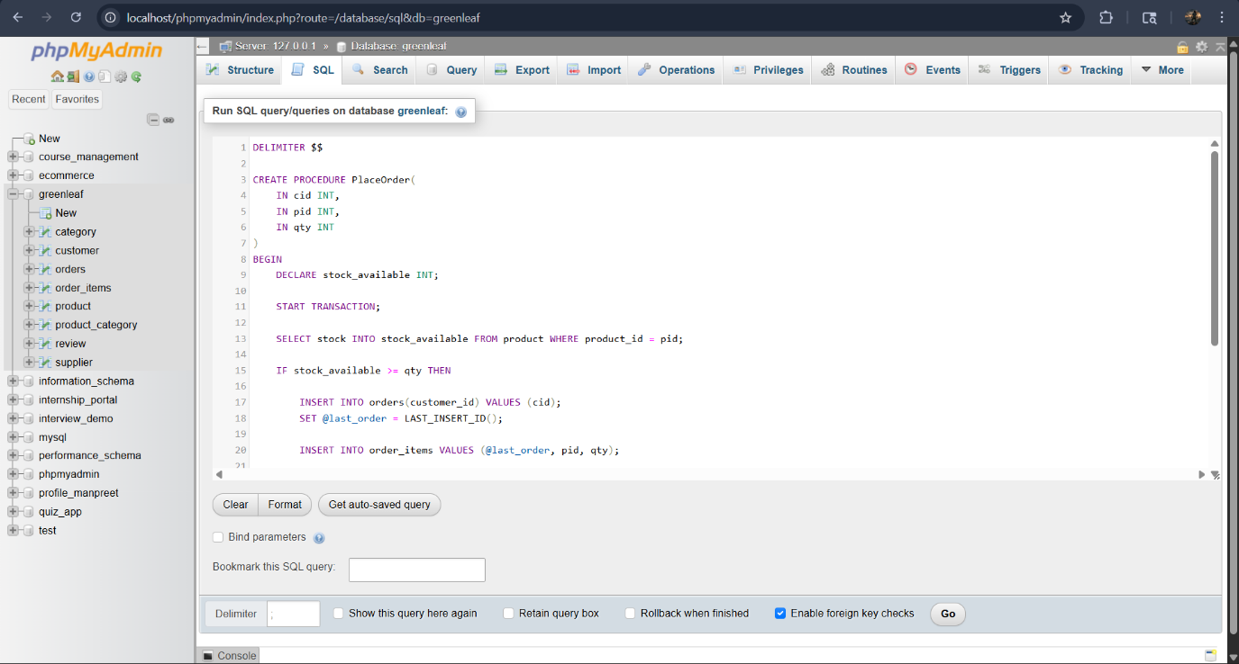
Figure 13: Place Order implementation for stored procedure
The stored procedure used in the database relates to the Place Order attribute, which helps in handling the orders. As illustrated in the figure 13, different components make up the entire place order procedure. They include the customer ID (cid), Product ID (pid), and quantity (qty). Since the role of a stored procedure is also to help check the stocks, this is first done before an order is made. After checking the stocks, the new information is made available in the order table, after which it uses the condition to move further and finally links the product with the order.
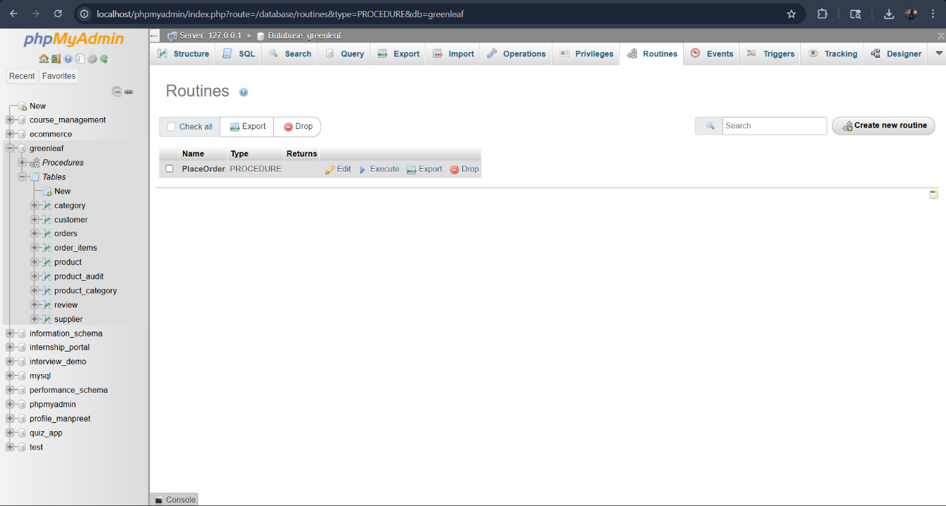
Figure 14: Procedure list
The procedure list is also used, which means that any other procedure for any other tables can be added or deleted based on requirements. As shown in the figure, the whole order procedure is stored, and the users can execute it based on requirements.

Stored Procedure and Transactional Scenario
This is an important part of database creation and implementation, where the users must be able to conduct operations in a single logical unit. This means reducing the time needed for performing operations. This is again based on the stored procedure operations that were previously mentioned and explained.

4.1 Insert Product Procedure
This procedure enables adding a new product to the table every time an order or supplies are made. There are multiple things to consider here that involve using the product or order name, price, and quantity.

4.2 Delete Product Procedure
In this procedure, the removal of a product or order becomes easier. IN this case, the procedure is implemented to remove existing records from other related tables so that data integrity is maintained. Only then is the main table used for the removal of necessary data.

4.3 Update Product Procedure
This procedure is important to consider as day-to-day changes are to be made. This is especially useful for updating price information or stock information in tables, mainly order and order item tables.

4.4 Background on transactions
A transaction in the context of a database is considered any action and its outcomes. For example, if a customer makes an order, the outcome is the delivery of the product against the consideration, which is the price. This is the complete transaction where there are other minute steps that have to take place in the database. There is a theoretical description that is often used to understand what makes any transaction a complete one. The following are the attributes [7] of every succesufl transactions:
- Atomicity: In a database, making changes to a table or data is possible if they are part of a single operation. If an operation is indirectly related to another one, it might get difficult for any data subject to operate logically and successfully.
- Consistency: it ensures that any value of data remains the same throughout so that the transaction become succesufl.
- Isolation: This ensures that if two operations are to take place simultaneously, it has to occur separately to avoid overlapping.
- Durability: it is a property of every transaction where ensuring the maintainability and permanence of changes is important. If using the store procedure, the changes are not saved afterwards, which is termed a failure.

4.5 Transaction design for GreenLeaf
In terms of the business, the use case example is that of the customer placing an order. What usually happens is that when a customer makes an order, it is important to make sure that there is enough stock. The use of stored procedures and the transactional concept ensures that. The operations can exist separately for different attributes like order, review, and supplier, among others.
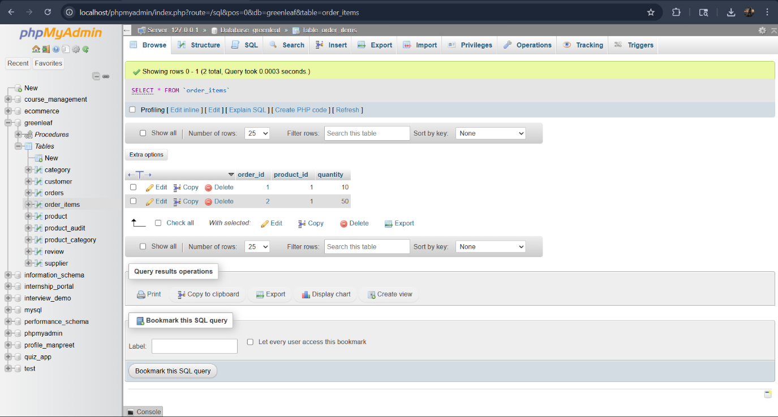
Figure 15: Transactions design
The figure 15 illustrates the use case example for GreenLeaf when an order is made. As shown in the table, the quantity that is available with the store is carefully interpreted, only after which the other part of the transaction gets completed. Once the stocking issue is resolved, the customer can complete the next phase.
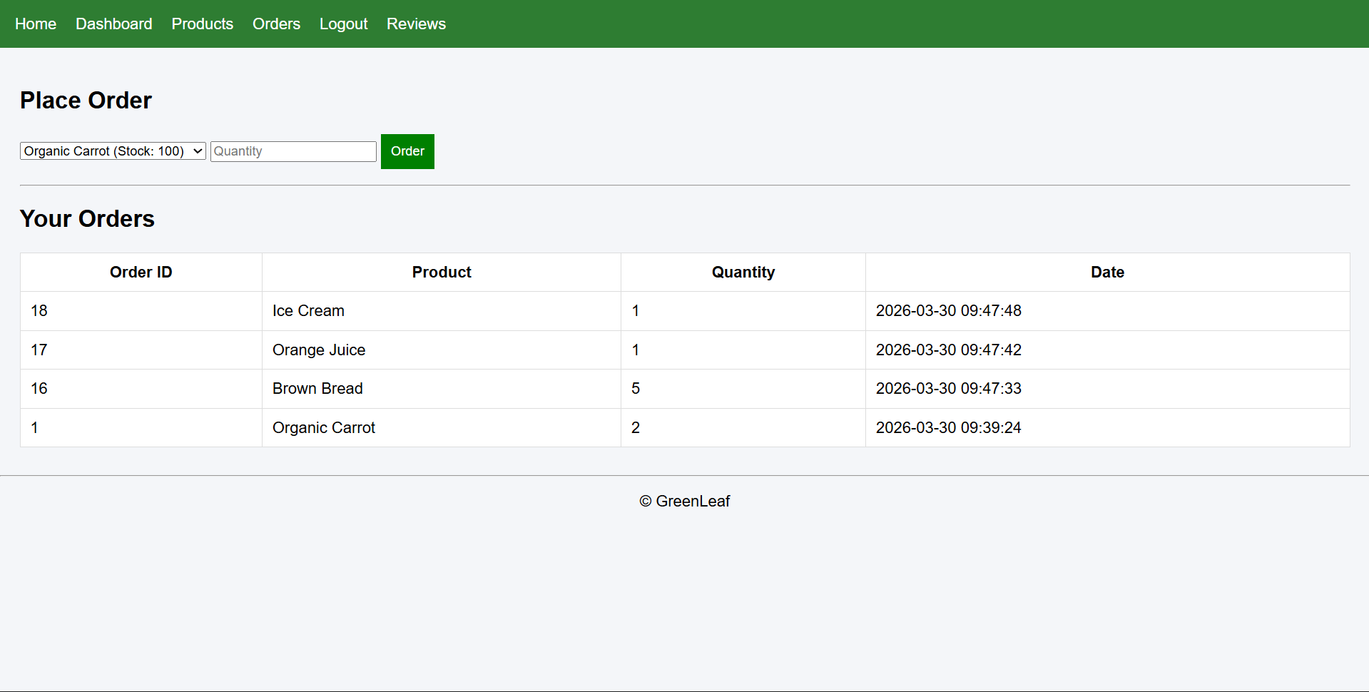
Figure 16: Order fulfilment
The next phase of the transaction for the GreenLeaf customer is shown in the figure 16. It would be suitable to know how the four different orders with different primary keys and quantities are ready and are currently in stock.

4.6 Implementation of Transaction Logic
Every transaction executed within the database is based on the stored procedure; there are different steps to ensure the validity of transactions. The first step in terms of the order table is to ensure and check the availability of stock. It is followed by using a SELECT query, which enables the review of current stocks. It is at this very juncture that the use of COMMIT and ROLLBACK operations comes into the picture.

4.7 Stock Validation in the Order Table
- In this stage, the stock availability or non-availability is carefully determined.
Order Record
- In this stage, a change to the existing record is made.
- For example, if the past stock was 10, the new stock would become 15 or 20.
Order Items
- In this stage, the available stock is entered into order items with a distinct ID for the order as well as for the product, the quantity, and the price.
Update stock
- Finally, in this stage, the entire procedure and transaction are updated, and the order is ready for the user and customers.

4.8 COMMIT Operation
It is used whenever changes have to be permanently saved in the database. Although overlapping is possible, each change made is successful only because of the commit operation. It mainly ensures that the order change is recorded every time. It also ensures that the new stock information is updated in real-time basis.

4.9 ROLLBACK Operation
In this operation, the aim is to avoid creating distorted or faulty transactions. If due to data or value or any stage of a transaction fails, the data service can take the user entirely to the initial page or dashboard. Thus, the major role of the rollback operation is to maintain consistency and data integrity.

4.10 Demonstration and physical evidence of the transaction
There are always two cases when dealing with any transaction- either it becomes entirely succesufl or it fails halfway. Similarly, for the GreenLeaf, two scenarios have been created for its integration in Datasbe.
Figure 17: Successful Transaction
Figure 17 demonstrates the successful transaction where the required quantity of orders is committed.
On the other hand, in a failure scenario, what usually happens is that the requested order quantity becomes more than the available stock. Using the rollback operation, the system helps in determining insufficient stock, and then the entire process is aborted, taking the user back to the initial page.

Performance Tuning Enhancement
Indexing is an important aspect of database creation and management. This is mainly because to make the search query easier and less time-consuming for users. The operation works on the basis of the inputs given or the code written in SQL.

5.1 Index Implementation
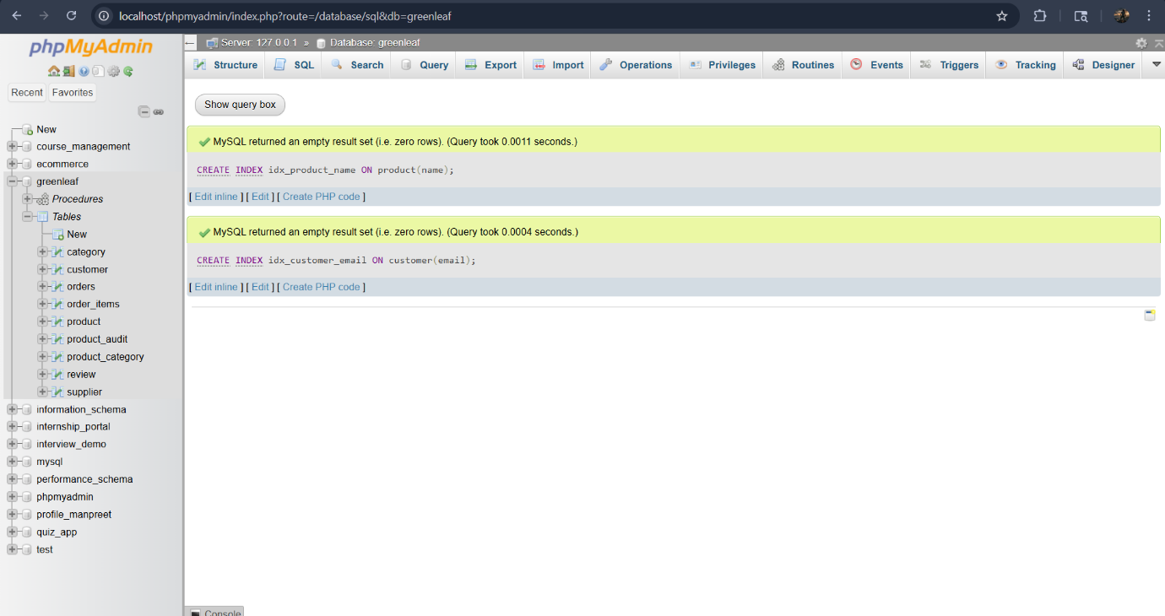
Figure 18: Index Implementation
For the GreenLeaf online store, the indexing was made for the customer email and product name, thus pertaining to the product and customer tables. The rationale for its usage is the commonness of such a query. As shown in the figure 18, the Index statement used is: CREATE INDEX idx_product_name ON Product (Name) and CREATE INDEX idx_customer_email ON Customer (email).

5.2 How Indexing Optimizes Performance
It helps data optimization in different ways. Firstly, it helps the data to conduct a holistic query through scanning. The scanning helps to make the search result visible. Every row and column can be checked thoroughly to ensure the reliability of the indexing measure. Further, it helps in consuming less time for execution even if the data size is bigger.

5.2.1 Benefits
It has multiple benefits, including the faster retrieval of different and complex data from the database. Further, it is beneficial in terms of the time taken for a query to run successfully. Also, it is beneficial in terms of making the query operation scalable.

5.2.2 Evidence using Prompts
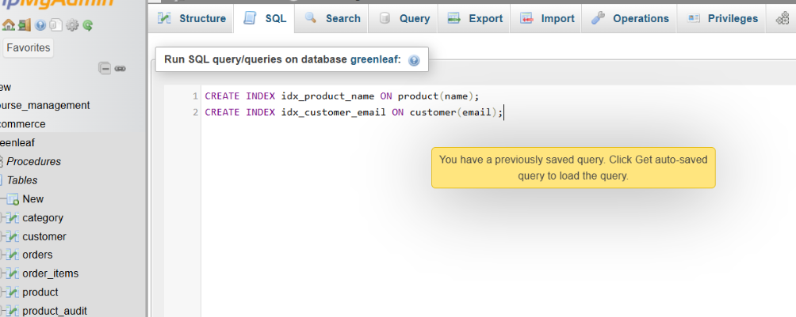
Figure 19: Index Codes
An attempt was made to test the effectiveness of the query using the indexing. There were two columns generated after finalizing the indexes. As illustrated in the figure 19, the first deals with the product name, showing all relevant fields. Similarly, the second one, dealing with customer email, also shows all the relevant fields necessary to run the query.

Conclusion and Reflection
The database design and implementation of GreenLeaf have been successful so far in terms of implementing the tables for different entities, explaining the relationship, and ensuring that data integrity is maintained throughout. The Entity relationship diagram has been the most important basis for explaining the relationship between the entities and maintaining the relevance of the data. There are multiple entities used to ensure that the business process of GreenLeaf is adequately maintained. The use of different procedures and frameworks has been so far succesufl such as the use of samples and stored procedures. Further, to ensure that the changes in the database are carefully managed, the trigger implementation is used; furthermore, the commit and rollback operations are used to ensure that the regular changes in the database can be easily adjusted.
In completing the entire project, the major barrier faced was related to the development of the database using the PHP application. There was a need to alter the data time and again so that effective and reliable data can be used. Further, there were issues in ensuring that the data integrity is maintained for every table. In using the different constraint keys, doubts arose regarding which key to use to determine the relationship between the attributes and tables. It was imperative at one point to consider going through the theoretical background and concepts to make sure that the database and the different elements were used appropriately.

References
[1] Bock, Douglas B. "Entity-relationship modeling and normalization errors." Journal of Database Management (JDM) 8, no. 1 (1996): 4-13. [Online]. Available: https://www.irma-international.org/viewtitle/51172/?isxn=9781466638006 [Accessed: Mar. 29, 2026].
[2] Huawei Technologies Co., Ltd., “Database Development Environment,” in Database Principles and Technologies – Based on Huawei GaussDB. Singapore: Springer, 2022, pp. 189–244. [Online]. Available: https://link.springer.com/chapter/10.1007/978-981-19-3032-4_7. [Accessed: Mar. 29, 2026].
[3] Atlassian, “How to define an auto increment primary key in SQL Server,” Atlassian Data Administration Guide. [Online]. Available: https://www.atlassian.com/data/admin/how-to-define-an-auto-increment-primary-key-in-sql-server. [Accessed: Mar. 29, 2026].
[4] BM, “Using the NOT NULL constraint,” IBM Documentation (Informix Servers 14.10). [Online]. Available: https://www.ibm.com/docs/en/informix-servers/14.10.0?topic=format-using-not-null-constraint. [Accessed: Mar. 29, 2026].
[5] S. Ceri, R. J. Cochrane, and J. Widom, “Practical Applications of Triggers and Constraints: Successes and Lingering Issues,” in Proceedings of the 26th International Conference on Very Large Data Bases (VLDB), Cairo, Egypt, Sept. 2000, pp. 254–262. [Online]. Available: https://www.vldb.org/conf/2000/P254.pdf. [Accessed: Mar. 29, 2026].
[6] N. Hartono and Erfina, “Comparison of Stored Procedures on Relational Database Management System,” Journal of Tech-E, vol. 4, no. 2, pp. 8–15, Mar. 2021. [Online]. Available: https://www.researchgate.net/publication/351676716_Comparison_of_Stored_Procedures_on_Relational_Database_Management_System. [Accessed: Mar. 29, 2026].
[7] IBM, “ACID properties of transactions,” IBM Documentation. [Online]. Available: https://www.ibm.com/docs/en/cics-tx/11.1.0?topic=processing-acid-properties-transactions [Accessed: Mar. 29, 2026].

