

Student name:Sara Panicocolo
Student ID:2322396

Module name: Psychopathological Classifications and Provisions
Module code: (BMHP6029_LON)
Acknowledgement of the use/non-use of AI:

6A02 Autism Spectrum DisorderClassification: Neurodevelopmental disorders (BlockL16A0) (ICD, 2019)  Introduction:  (Predicting autism spectrum disorder,2026)  Autism spectrum disorder (ASD) is a lifelong, developmental condition.  - It affects the way a person communicates  - interacts, and processes information.  - challenges in developing, maintaining, and understanding relationships.  Statistics: (Herts University, 2025)  - 1 in 6 children globally have a neurodevelopmental disorder, which is roughly 15–17 % of children in some populations.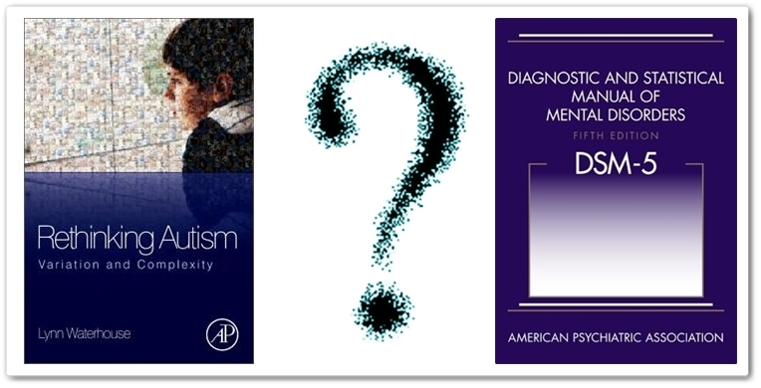  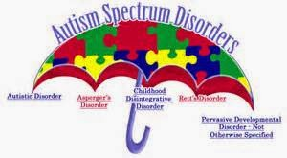 |  | Historical perspectives and treatments (ASD,2015)  - labelled as mentally ill, intellectually disabled, or emotionally disturbed  - misunderstood as lacking empathy or emotions  - Socially isolate  Causes (Translational pediatrics, 2020)  Autism has a strong genetic component  It tends to run in families  Many different genes are involved (not one “autism gene”)  Identical twins are much more likely to both be autistic than non-identical twins  Symptoms (CTD, 2025)  have difficulty starting or maintaining conversations  struggle to understand social cues (facial expressions, tone of voice)  show reduced eye contact or atypical body language  find it hard to form or maintain relationships  prefer being alone or interacting in different ways  strong need for routines and predictability  Diagnosis (HHP, 2023)  - Often in early childhood (around ages 2–4)  - detailed developmental history (from parents/caregivers)  - observation of social communication and behaviour(speech and language therapists)  - Some individuals (especially those with milder traits) are diagnosed in adolescence or adulthood |  | Current Services and Treatments (CDC, 2025)  Applied Behaviour Analysis (ABA)  Early Start Denver Model (ESDM):  Integrates ABA principles for children aged 1–4, focusing on play and social engagement.  Improves communication skills, both verbal and non-verbal.  Focuses on sensory integration therapy for those with sensory sensitivities.  - Neurodiversity  Conclusion: (NIMH, 024)  Autism is a lifelong neurodevelopmental condition  Early identification and continued research are crucial to developing new interventions and reducing disparities in access to services.  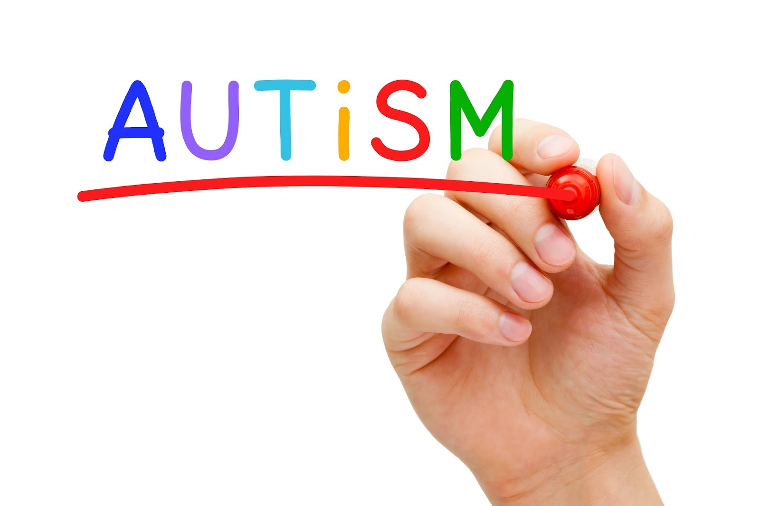
References
Adult Autism Health / Harvard Health Publishing (2023) The Formal Diagnostic Criteria for Autism. Available at: https://www.adult-autism.health.harvard.edu/resources/the-formal-diagnostic-criteria-for-autism
Centers for Disease Control and Prevention (CDC) (2025) Clinical Testing and Diagnosis for Autism Spectrum Disorder. CDC. Available at: https://www.cdc.gov/autism/hcp/diagnosis/index.html
Durand, V.M. (2015) Autism Spectrum Disorder: Diagnosis. In: The SAGE Encyclopedia of Abnormal and Clinical Psychology.
(Discusses diagnostic process and criteria per DSM-5.)
Govindarajan, V., Dutta, A.K., Shaikh, Z.A., Yousef, A., Anjum, M. and Shahab, S. (2026) 'Predicting autism spectrum disorder in children using glowworm optimization with extreme learning machine networks', Brain and Behavior, 16(2), pp. e71225. Available at: https://doi.org/10.1002/brb3.71225.
Herts University (2025) Autism Spectrum Disorder. Available at: https://www.herts.ac.uk/intellectualdisability/conditions-associated-with-intellectual-disability/articles/autism-spectrum-disorders
Hodges, H., Fealko, C. & Soares, N. (2020) ‘Autism spectrum disorder: definition, epidemiology, causes, and clinical evaluation’, Translational Pediatrics, 9(Suppl 1), pp. S55–S65. doi:10.21037/tp.2019.09.09.
National Institute of Mental Health (NIMH) (2024) Autism Spectrum Disorder. NIMH. Available at: https://www.nimh.nih.gov/health/publications/autism-spectrum-disorder
National Academies of Sciences, Engineering, and Medicine (2015) Mental Disorders and Disabilities Among Low-Income Children. Washington, DC: The National Academies Press.
(Discusses ASD as a neurodevelopmental condition with genetic and biological influences.)
World Health Organization (2019) International Statistical Classification of Diseases and Health Problems (ICD) available at:

