Destination Management:
New Forest of England

Name:
Module Title: Sustainable Hospitality and Tourism Management
Module Code: BMIH5006
Lecturer: Dr. Huw Thomas

Contents
Introduction 3
Sustainability of New Forest of England Using Three Pillars 4
Life-Cycle Model of Butler 6
Irridex Model of Droxy 8
Recommendation, and Conclusion 10
References 11

Introduction
Ensuring more attractiveness compared to others is a part and parcel of ensuring the sustainability of the business (Boone et al., 2019). This approach is also common in the business of tourist spots. The New Forests of Southern England is also concerned about the fact. The New Forests of Southern England aim to ensure pleasure for visitors. This forest, which spans more than 71,000 acres, is close to Southampton. The ‘New Forests of Southern England’ saw very little tourist traffic during the COVID-19 pandemic, but this area sees a lot of visitors around the holidays. Before the year 1079, this place was known as a place of punishment for criminal offenses under the ruling of William II. This place was introduced as a forest in Domesday Book in the year 1086. In the twelfth century, this spot was developed as a forest by William II by removing 36 Parishes. This place was a popular source of timber in the year 1968. By New Forest Act, of 1877, this place was taken care of up to the present day. It was turned into a national park in the year 2005.

Sustainability of New Forest of England Using Three Pillars
Sustainability is very important for almost all types of business in the United Kingdom (Sripak et al., 2018). When the current needs are needed to be fulfilled without evaluating the ability of the future generation, it is depicted as sustainable development. For ensuring the development, three pillars named sustainability of economy, sustainability of the environment, and sustainability of society must be ensured in the New Forests of Southern England, which is an area of more than 71,000 acres (Polukhania et al., 2021). This forest is situated near Southampton. The New Forest National Park Authority (NFNPA) takes care of the tourist spot.
The sustainability of the economy is a vital thing for ensuring the consistent performance of the area and using the beauty of the area, the authority (NFNPA) has generated a revenue of 3,000 thousand dollars (2,600 thousand pounds) on average according to Datanyze (Farmer, 2022). The minimum revenue of the area is around 1,000 thousand dollars, and the maximum revenue of the area is 5,000 thousand dollars. Employees are appointed to take care of this spot which is a part of the tourism business. The maximum number of employees in the area is around one hundred, and the minimum number of employees in the area is around half of one hundred. At present, the number of employees in the area is 86, and the average number of employees in the firm is around 75. Most of the other national parks are generating revenue of more than 5,000 thousand dollars on average, and the number of employees for taking care of this spot is also higher in these areas compared to the employees of New Forests of southern England, and to ensure sustainability in economic condition, the appointment of productive employees is an important concern.
Names of Spots | Cairngorms National Park | New Forest National Park | Peak District National Park
Number of Employees | 94 | 86 | 35
Yearly Revenue in Million $ (in 2022) | 19.000 | 3.000 | 12.000
Table 01: Information of Competitors
Source: (Datanyze, 2022)
It will also help the authority to appoint fewer employees, and by doing this, the cost of maintaining the area can be reduced. The popularity of the area must be ensured through conducting marketing heavily, and it will help the authority to generate higher income compared to the previous time. The higher income will help to ensure the development of the area in the future, and the tax rebate through investing in tax-exempted elements can assist in doing this more effectively, and the collection of grants can also be another way to do this (Chemineau, 2016).
Sustainability of the environment is very important to meet the demand of entertainment of people, and the safety of the beauty of the area, and different types of birds, animals, and trees are the signs of beauty here (Asche et al., 2018). The birds of the area can be divided into two types where the first one is the winter birds, and the second one is the woodland birds. Some heathland birds are also available. Different types of reptiles and amphibians are also available in the area which helps to increase the natural beauty of the park, and these include sand lizards, great crested newts, etc. are very popular. Different types of snakes are also found here, and the grass snake is one of the most common snakes in this area. Different types of ponies are also found in the area, and the most popular pony is Shetland Pony. Different types of pigs, donkeys, and cattle are also available here which is a lovely source of different types of meat. Different types of donkeys help to maintain the ecosystem in the park, and the most common dears are roe deer, red deer, sika deer, and muntjac. Other mammals include the Red Squirrel, Grey Squirrel, American Mink, etc. and different types of trees are also available here. To sustain the beauty of the environment, maintenance of the ecosystem is a vital concern that must be conducted through tight monitoring, and ensuring appropriate corrections where necessary. The number of these living beings must be tightly controlled to ensure the proper balance of the ecosystem, and to do this, raising awareness among tourists is a nice attempt to perform. The applications of laws are necessary to do this. Countryside and Rights of Way Act 2000 (CROW Act 2000) is such type of law that assists to maintain the natural beauty of parks in the United Kingdom, and ‘New Forests of Southern England’ is also included under it, and the Global Code of Ethics of the United Nation of the year 1999 for tourism is another such type of law. Tightly maintaining the quality and quantity of air, and water is mandatory to balance the ecosystem, and the necessary personnel is needed to be trained to do this properly (Duic et al., 2015).
The sustainability of society is necessary to maintain the safety of society, and to do it, the ecosystem is needed to be kept healthy which is tightly maintained by the authority of the area (Purvis et al., 2019). The visitors are allowed to visit here which is almost free, and there is the chance to visit near the sea, hills, etc. The people are instructed not to feed animals or touch the animal, and they are also instructed to travel by maintaining a distance of safety from the injurious animal. Here, is the chance of riding using horses and one hundred cars to travel inside the park, and the visitors are also required to arrange some formal safety measures. These formal safety measures include travel insurance, a backpack to avoid thefts, the necessary amount of money, a passport, voice, and a SIM card, which are strictly checked by the officer for entering the traveling spot. Camping in this area is strictly prohibited to reduce the chance of pollution of the venue, and it is important to ensure the safety of the visitors, trees, and animals to maintain the beauty of the area. Also, for keeping the friendly culture of the park, different types of valuable activities are arranged in the area, and the involvement and accessibility of people are ensured on an appropriate and limited scale (Chong et al., 2016). The visitors and employees are instructed properly to maintain the beauty of the area by keeping the places free from garbage, and this intention helps the authority to maintain the sustainability of the beauty of the area. Arranging BBQ is strictly prohibited here.

Life-Cycle Model of Butler
This model is a process of six stages that indicates the development of the tourist spot. During the COVID-19 pandemic, the number of visiting people was very low in the New Forests of Southern England, but this is a place of a lot of crowds during the holidays. The tourist spot is evaluated here to find out the stage where the New Forests of Southern England belongs at present.
The exploration stage is the beginning of the life cycle of a tourist spot where the visitors want to adventure something new (Yun, and Zhang, 2017). Here, the people want to get the feel of the thrilling incident when they reach their respective tourist spots. The New Forests of Southern England are not a very new place for visitors to the United Kingdom at present, and people come frequently to visit the spot. A long time ago, the area was inaugurated as a tourist spot, and now this is a very experienced area full of experienced controllers.
The involvement stage is the stage where some types of publicities are found for the tourist spot but this is very low. Extensive marketing is required to do well in this stage, and some important and related controlling teams like committees, and political teams want to put some advantages for the tourist spot here (Kruczek et al., 2018). This was done previously in the New Forests of Southern England, and the authority of the park was successful in doing this properly. But some marketing attempts are required at present for the survival of the tourist spot which has been done appropriately.
The development stage is the stage where people started to like, and feel the tourist spot a lot (Singh, 2021). Private firms started to invest in tourist spots for maintaining their image in corporate social responsibilities which indirectly help to boost their profit. Around 3 million pounds are donated each year for the development of this spot. In this stage, the number of customers is very high compared to the previous stages which are given in table 02. In the New Forests of Southern England, visitors feel the place is a natural beauty to enjoy which helps the people to forget their monotonous working life. So, the New Forests of Southern England belong to this stage which is a nice thing for the visitors (Butler, 2019).

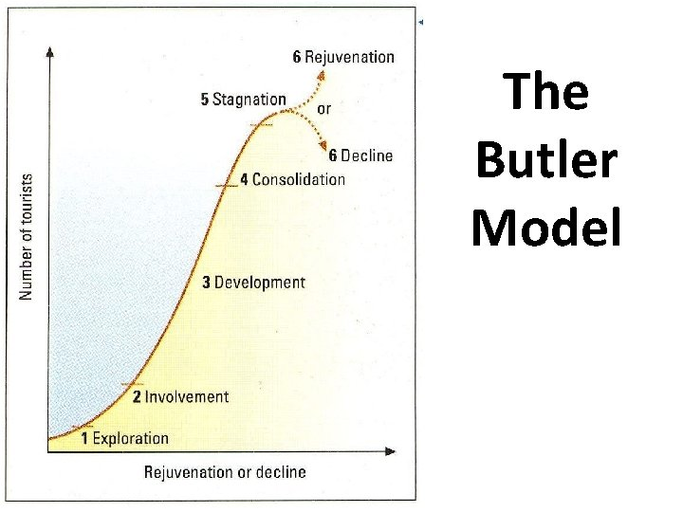
Figure 01: The Life-Cycle Model of Butler
Source: (Piuchan, 2018)
The consolidation stage is the stage where the number of visitors is very high compared to the other stages. Here, some misunderstandings are found among the relevant internal stakeholders. The stagnation stage is the stage where the number of visitors is started to reduce. Here is almost no chance of beautifying the place. Some artificial steps are conducted to retain consumers (Adamiak, 2020). The rejuvenation stage is the stage where the number of visitors is getting very low which was avoided through some innovative ways. This approach helps to avoid the declining stage. The decline stage is the stage where the number of visitors is not enough to ensure profitability (Lundberg, 2015). Here, the good decision is to shut down the tourist spot. New Forests of Southern England is always concerned about these stages, and monitoring of activities in this spot is conducted strictly by the authority.

Irridex Model of Droxy
This model helps to identify the feeling of visitors about their respective tourist spots, and the ‘New Forests of Southern England’ is a lovely place to enjoy for visitors (Yusuf et al., 2021). It is a nice place to enjoy nature visitors, and when people are feeling bored due to their monotonous working life, they want to visit the place to refresh their minds. So, the feeling of the visitors is positive compared to the other types of entertainment, and it is eye-catching.
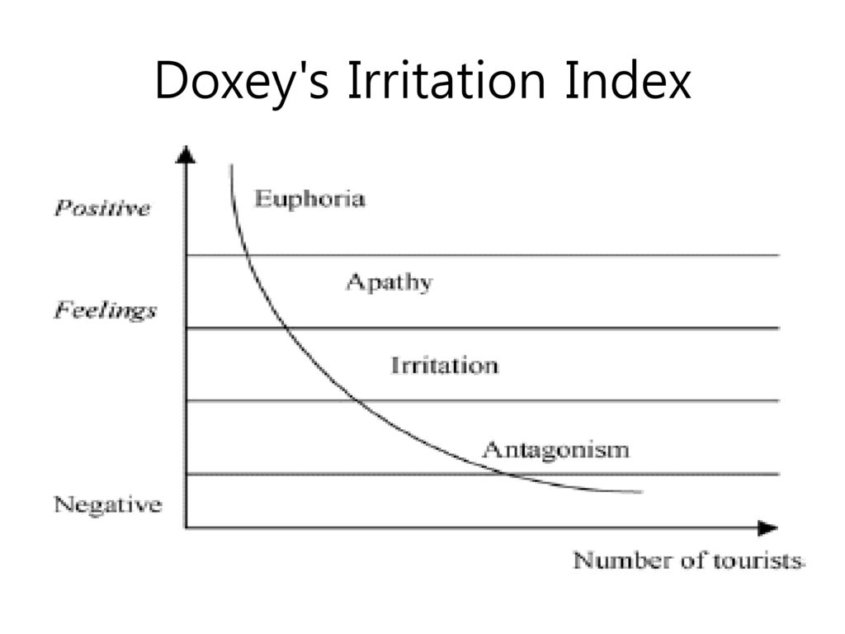
Figure 02: The Irridex Model of Droxy
Source: (KOVJANIC, 2015)
According to the irridex model of Droxy, the ‘New Forests of Southern England’ belongs to the area named ‘euphoria’ where the visitors the area loves to enjoy the beautiful animals, and birds that make the area mind-refreshing, and charming. This spot was very busy at the end of September (Thenewforest, 2019). The number of visitors is increasing at a rate of around 1 percent in this spot for the increase in the population of the United Kingdom.
Year | 2004 | 2009 | 2017
Number of Visitors | 13,550,000 | 14,750,000 | 15,200,000
Table 02: Number of Visitors
Source: (NewForest, 2021)

Recommendation, and Conclusion
The ‘New Forests of Southern England’ is recommended to maintain all of the pillars of ensuring sustainability strictly, and it will help to ensure consistent beauty. Also, the research and development of the spot must be undertaken to find out the appropriate solutions to ensure the beauty of the area consistently, and awareness must be ensured among visitors, and local people to keep the environment clean (Li et al., 2020). The local authorities must ensure the safety of the animals, birds, and trees, and the monitoring of the park must be ensured more strictly to avoid possible illegal activities. It was found that it is nice for visitors that the New Forests of Southern England are still in development. It was also noticed that the "New Forests of Southern England" are part of the region known as "euphoria," where tourists enjoy the area's beautiful birds and animals because they find them to be both charming and refreshing (Devkota et al., 2022).

References
Adamiak, C., 2020. Peer-to-peer accommodation in destination life cycle: the case of Nordic countries. Scandinavian Journal of Hospitality and Tourism, 20(3), pp.212-226.
Asche, F., Garlock, T.M., Anderson, J.L., Bush, S.R., Smith, M.D., Anderson, C.M., Chu, J., Garrett, K.A., Lem, A., Lorenzen, K. and Oglend, A., 2018. Three pillars of sustainability in fisheries. Proceedings of the National Academy of Sciences, 115(44), pp.11221-11225.
Boone, L.E., Kurtz, D.L. and Berston, S., 2019. Contemporary business. John Wiley & Sons.
Butler, R.W., 2019. Overtourism and the tourism area life cycle. Overtourism: Issues, realities and solutions, 1, pp.76-94.
Chemineau, P., 2016. Invited review: Importance of animal health and welfare for the stability of the three pillars of sustainability of livestock systems1. Advances in Animal Biosciences, 7(2), pp.208-214.
Chong, Y.T., Teo, K.M. and Tang, L.C., 2016. A lifecycle-based sustainability indicator framework for waste-to-energy systems and a proposed metric of sustainability. Renewable and Sustainable Energy Reviews, 56, pp.797-809.
Datanyze, 2022. New Forest National Park Authority Company Profile: Management and Employees List, Datanyze. Datanyze. Available at: https://www.datanyze.com/companies/new-forest-national-park-authority/346014432 (Accessed: November 5, 2022).
Devkota, N., Gautam, S., Parajuli, S., Bhandari, U. and Paudel, U.R., 2022. Tourism Entrepreneurial Prospects in Bardiya, Nepal: Challenges and Way-forwards. The Gaze: Journal of Tourism and Hospitality, 13(1), pp.70-92.
Duić, N., Urbaniec, K. and Huisingh, D., 2015. Components and structures of the pillars of sustainability. Journal of Cleaner Production, 88, pp.1-12.
Farmer, J.L., 2022. State Interventions and Interlocal Collaborations Across the Three Pillars of Sustainability. State and Local Government Review, p.0160323X221089664.
KOVJANIC, G., 2015. CHAPTER ONE PERCEPTIONS OF LOCAL RESIDENTS IN ABU DHABI TOWARDS THE DEVELOPMENT. Tourism Development, p.6.
Kruczek, Z., Kruczek, M. and Szromek, A.R., 2018. Possibilities of using the tourism area life cycle model to understand and provide sustainable solution for tourism development in the Antarctic Region. Sustainability, 10(1), p.89.
Li, D., Deng, L. and Cai, Z., 2020. Statistical analysis of tourist flow in tourist spots based on big data platform and DA-HKRVM algorithms. Personal and Ubiquitous Computing, 24(1), pp.87-101.
Lundberg, E., 2015. The level of tourism development and resident attitudes: A comparative case study of coastal destinations. Scandinavian journal of hospitality and tourism, 15(3), pp.266-294.
NewForest, 2021. New study shows nationally important New Forest Wildlife Sites Under pressure, New Forest National Park Authority. New Forest National Park Authority. Available at: https://www.newforestnpa.gov.uk/news/new-study-shows-nationally-important-new-forest-wildlife-sites-under-pressure/ (Accessed: December 3, 2022).
Piuchan, M., 2018. Plog's and Butler's models: A critical review of Psychographic Tourist typology and the Tourist Area Life Cycle. Turizam, 22(3), pp.95-106.
Polukhina, A., Sheresheva, M., Efremova, M., Suranova, O., Agalakova, O. and Antonov-Ovseenko, A., 2021. The concept of sustainable rural tourism development in the face of COVID-19 crisis: Evidence from Russia. Journal of Risk and Financial Management, 14(1), p.38.
Purvis, B., Mao, Y. and Robinson, D., 2019. Three pillars of sustainability: in search of conceptual origins. Sustainability science, 14(3), pp.681-695.
Singh, S., 2021. Time, tourism area ‘life-cycle,’evolution and heritage. Journal of Heritage Tourism, 16(2), pp.218-229.
Skripak, S.J., Cortes, A., Walz, A.R., Parsons, R. and Walton, G., 2018. Fundamentals of business. VT Publishing.
Thenewforest, 2019. Top 10 reasons to visit the new forest from late September onwards, Visit The New Forest. New Forest. Available at: https://www.thenewforest.co.uk/ideas-and-inspiration/blog/read/2019/09/top-10-reasons-to-visit-the-new-forest-from-late-september-onwards-b140 (Accessed: November 5, 2022).
Yun, H.J. and Zhang, X., 2017. Cultural conservation and tourism development in the consolidation stage of the tourism area life cycle model. Tourism Planning & Development, 14(3), pp.353-368.
Yusuf, G., Fahurrahim, F., Putra, I.N.T.D. and Masyhudi, L., 2021. PELATIHAN CITATION DAN REFERENCE BERBASIS APLIKASI DENGAN MENDELEY DAN ENDNOTE BAGI DOSEN DI SEKOLAH TINGGI PARIWISATA MATARAM. Journal Of Responsible Tourism, 1(1), pp.9-18.

