LCBB4016 Global Business Environment
Component 2: Coursework: Essay

Student ID: 2441885
Student Name: Ion Paun

Introduction
Globalisation is defined as the ongoing process where economies, cultures and countries become more interdependent on each other. Gangele and Kumar (2025) stated that globalisation is used in business to maximise profits and promote general welfare with structured economic characteristics. Globalisation is relevant to international business by integrating national markets into a single global economy in relation to expanding the customer base through international sourcing. Rolls-Royce is selected as an international business to evaluate its role and business functions within the global market. Rolls-Royce is a well-renowned manufacturing industry in the UK which is at the forefront of innovation with multi-year transformation to create high-performing and resilient business with profitable growth (Rolls-Royce, 2026). Rolls-Royce plays a crucial global role as a propulsion specialist and premier power with civil aerospace and defence. The purpose of this essay is to evaluate opportunities and challenges within Rolls-Royce in relation to global forces while developing strategic and operational decisions.

Main analysis
Opportunities and challenges
PESTLE analysis helps to determine that economic, social, technological and environmental factors can influence positively on manufacturing firms like Rolls-Royce while developing their business operations. On the other hand, political and legal factors can negatively influence Rolls-Royce while operating supply chain activities due to China-Taiwan wars and Red sea disruptions. In the relevance from PESTLE analysis, Porter’s value network helps to determine key global forces that can give benefits as well as challenges to Rolls-Royce. This network provides informative ideas about Rolls-Royce where manufacturers can get benefits while enhancing their logistic operations. In support activities, technological development with AI, human resource management with internal mobility with employer branding, logistic and automated infrastructure and green procurement processes can bring benefits to Rolls-Royce. Automated and logistic infrastructure can provide benefits to Rolls-Royce in terms of scaling and maintaining consistency in operational standards in the context of worldwide activities.
On the other hand, internal mobility with employer branding can also bring benefits to the human resource department of Rolls-Royce that lead to recruiting more talents to enhance operational efficiency. Advanced AI technologies can give benefits to Rolls-Royce to boost engine efficiency and streamline the overall production processes that lead to improved predictive analytical operations. For instance, AI technologies influence Aston Martin’s global operations through digital twins and data-driven decisions to accelerate car development operations with real-time insights (Aston Martin F1, 2025). Moreover, green procurement processes can guide Rolls-Royce to minimise carbon emission rates and enforce strict environmental standards for logistic partners and raw materials. This innovation can provide benefits for Rolls-Royce to handle sustainable sourcing operations and improve relationships with global suppliers.
Apart from that, the global supply chain process is one of the major global forces for manufacturing firms in the UK that enable them to improve operational efficiency and develop key strategies. In reference to PESTLE analysis, it has been acknowledged that 90% of manufacturing firms in the UK have faced geopolitical tensions while sourcing raw materials or integrating global operational decisions (Roland Berger, 2025). However, in the current situation, due to the rise in geopolitical tensions due to China-Taiwan issues and Red Sea disruptions, suppliers of Rolls-Royce can face challenges while importing raw materials from other countries. This global force can create supply chain disruptions and decline marketing and sales related operations that lead to hinder overall manufacturing services.

Due to this political instability and supply chain disruption, suppliers of Rolls-Royce fail to manage their inbound and outbound logistic operations. These challenges can restrict Rolls-Royce to manage their aerospace services and fail to enable faster as well as cost-effective engine design. Moreover, sometimes. Due to continuous inflation rate fluctuations in the UK, manufacturing teams of Rolls-Royce can affect their strategic decisions of improving manufacturing practices with AI-driven end-to-end analytics that lead to their manufacturing downturn. Thus, informed decisions and strategic changes can guide Rolls-Royce to observe these challenges which are created by these global forces. After this analysis, the manufacturing team can develop strategic plans with AI-driven and automated technologies to achieve global success after executing AI-driven Predictive Analytics.
Impact on the organisation
Porter’s five forces help businesses to measure profit potential, industry attractiveness and competitiveness in the global market. According to Pangarkar and Prabhudesai (2024), Porter’s five forces analysis is often applied to determine underlying rationale and develop key strategies based on missed opportunities to enhance business performance. In the context of Porter’s five forces, it is understood that competitive rivalry is high for Rolls-Royce in terms of integrating AI-driven technologies. In the words of George (2024), AI technologies reshape the landscape of manufacturing operations at the forefront of this transformation. Competitors of Rolls-Royce are Bentley Motors, BAE Systems and Aston Martin in the aerospace division. AI integration can provide positive influence on competitiveness of Rolls-Royce in order to make changes in their manufacturing and designing processes in order to operate their power solutions.
The influence of threat of new entrants is low for Rolls-Royce in the context of market positioning as this manufacturing firm has a strong global presence. This global factor can positively influence marketing and sales based activities for Rolls-Royce as this firm has deep brand loyalty and high-end aerospace markets. In this way, manufacturers can manage their specialised marketing to ensure long-term trust and direct partnership with global aerospace or manufacturing brands.
The impact of bargaining power of buyers is high for Rolls-Royce as the manufacturing team focuses on transforming their designing with Digital and AI-driven technologies. This innovativeness can guide this firm to perform real-time monitoring that leads to improved quality control and reduces machine downtime. In the words of Wang et al. (2024), artificial intelligence promotes technical thresholds within an organisation to enable the adaptation of automation technologies and drive higher performance. This AI innovation and transformation can provide a positive impact on real-time analytical activities and ensure the maximisation of customer values and service margins within Rolls-Royce.
The influence of bargaining power of suppliers is high for Rolls-Royce due to geopolitical tensions that can negatively influence the global sourcing of raw materials. Red Sea disruption and China-Taiwan crisis can lead to supply chain challenges for manufacturers to source required raw materials from global suppliers. Geopolitical tension declined the manufacturing industry growth from 3.2% to 2.6% that hindered the overall supply chain practices (Starks, 2026). This disruption can also negatively impact on global supply chain operations of Rolls-Royce and slow down the overall procurement and manufacturing processes. On the other aspect, the human resource managers of Rolls-Royce can also face talent management challenges while recruiting new suppliers as the demands of new suppliers can be increasing due to this disruption. Thus, Rolls-Royce can fail to execute their manufacturing decisions and fail to improve strategic goals in terms of developing sustainable and quality management processes within their manufacturing settings.
The impact of the threat of substitutes is low for Rolls-Royce due to which manufacturers and suppliers can focus on introducing new manufacturing services with automation technologies. This change management operations can influence positively on the innovativeness of Rolls-Royce while improving their Just-in-Time manufacturing processes in order to secure their global operations. This creative opportunity can guide Rolls-Royce to adopt new supply chain practices and ensure more resilience in their global manufacturing operations that lead to achieve business goals.
Strategic recommendations
From the above essay, it can be recommended that the management of Rolls-Royce can focus on supply chain disruptions and AI-driven competitiveness before adopting any strategic or operational decisions. The management can follow the approaches of Porter’s diamond model during integrating new decisions or strategies to mitigate business challenges. From the first grid of this model, the supply chain manager of Rolls-Royce can integrate automated infrastructure with AI-driven Predictive Analytics, AI-driven monitoring and Digitalised AI technologies. This strategic recommendation can influence Rolls-Royce to improve their quality control and achieve innovativeness in their manufacturing settings.
On the other hand, the higher management of Rolls-Royce can integrate scenario planning based on geopolitical tension to fulfil the suppliers’ demand conditions from the second grid of Porter’s diamond model in manufacturing processes. This scenario planning can guide this firm to be prepared before any geopolitical tensions or supply chain disruptions happen. This initial stage preparation can influence Rolls-Royce to avoid the major impact on supply chain and manufacturing processes. Moreover, the management of Rolls-Royce can also focus on factors condition which is the fourth grid of Porter's diamond model in order to enforce sustainable strategies under the EU’s Corporate Sustainability Reporting Directive (CSRD) guideline.
Conclusion
From the above essay, it has been concluded that global dynamics help international businesses to develop key strategies and reduce global disruptions in relation to supply chain and marketing positions. Rolls-Royce can face difficulties while developing supply chain practices due to geopolitical tensions and slow down their infrastructure development operations. PESTLE and Porter’s value network have been applied to determine global forces that provide benefits and challenges in relation to the supply chain and innovation practices. Porter’s five forces have been applied to determine the influence of global forces on international business strategy in reference to Rolls-Royce. Suitable recommendations have been presented to improve business operations and strategic evaluation of Rolls-Royce to achieve greater success in the global market.

Reference List
Aston Martin F1 (2025), Exploring AI-driven performance with Cognizant. Available at: https://www.astonmartinf1.com/en-GB/news/feature/exploring-ai-driven-performance-with-cognizant [Accessed: 4 August 2026]
Gangele, P. and Kumar, A., (2025). The impact of globalization on business strategies: A systematic review. International Journal of Innovations in Science, Engineering And Management, pp.64-71. DOI: 10.69968/ijisem.2025v4i164-71
George, J., (2024). The Role of Artificial Intelligence and Machine Learning in Reshaping UK Manufacturing Management. JBMI Insight, 1(3), pp.48-58. https://jbmipublisher.org/system/index.php/home/article/download/37/35
Pangarkar, N. and Prabhudesai, R., (2024). Using Porter's Five Forces analysis to drive strategy. Global Business and Organizational Excellence, 43(5), pp.24-34. DOI: 10.1002/joe.22250
Roland Berger (2025), 90% of manufacturers say geopolitical risk is stalling strategic development. Available at: https://www.rolandberger.com/en/Media/90-of-manufacturers-say-geopolitical-risk-is-stalling-strategic-development.html [Accessed: 3 August 2026]
Rolls-Royce (2026), Rolls-Royce: Powering, protecting and connecting the modern world. Available at: https://www.rolls-royce.com/about.aspx#section-about-us [Accessed: 3 August 2026]
Starks, C., (2026), Manufacturing industry growth downgraded to 2.6% amid geopolitical disruptions. Available at: https://interactanalysis.com/manufacturing-industry-growth-downgraded/ [Accessed: 4 August 2026]
Target Integration (2026), Only One in Six UK Businesses Are Using AI. Is Manufacturing Falling Behind?. Available at: https://www.targetintegration.com/en_in/only-one-in-six-uk-businesses-are-using-ai-is-manufacturing-falling-behind/ [Accessed: 3 August 2026]
Trading Economics (2026), United Kingdom GDP Growth Rate. Available at: https://tradingeconomics.com/united-kingdom/gdp-growth [Accessed: 3 August 2026]
Wang, S., Huang, X., Xia, M. and Shi, X., (2024). Does artificial intelligence promote firms’ innovation efficiency: Evidence from the robot application. Journal of the Knowledge Economy, 15(4), pp.16373-16394. https://doi.org/10.1007/s13132-023-01707-w
Worldometers (2026), U.K. Population. Available at: https://www.worldometers.info/world-population/uk-population/ [Accessed: 3 August 2026]

Appendices
Appendix 1: PESTLE analysis
Political | - Due to geopolitical tensions, 90% of manufacturers in the UK were stalling strategic development (Roland Berger, 2025).
Economical | - GDP growth rate has increased by 0.6% from the previous year (Trading Economics, 2026).
Social | - The population rate has increased by 0.55% from the previous year that brings job opportunities for firms (Worldometers, 2026).
Technological | - In the 2026 report, 10.6% of manufacturing firms have adopted AI to advance their practical values in logistics and distribution processes (Target Integration, 2026).
Legal | - Guidelines of Health and Safety at Work etc. Act 1974 positively influences manufacturing firms to avoid workplace hazards.
Environmental | - UK manufacturers must comply with the EU's Corporate Sustainability Reporting Directive (CSRD) to fulfill sustainability demands.

Appendix 2: Porter’s five forces
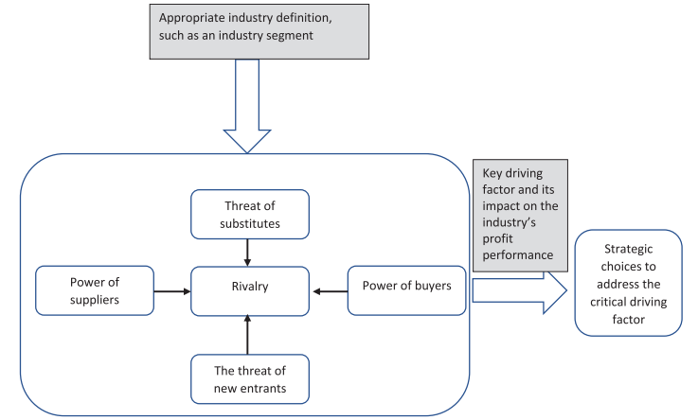
(Source: Pangarkar and Prabhudesai, 2024)

Appendix 3: Geopolitical tension disrupts the manufacturing growth 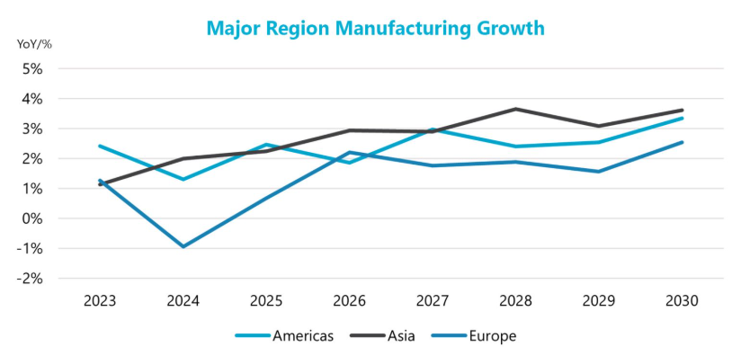
(Source: Starks, 2026)
GAI Declaration
I hereby declare that no GAI tools are involved in the conduction of the research that maintains transparency and authenticity. I followed university guidelines to maintain academic integrity of the research while gathering information from reliable sources effectively. The research follows credible formatting guidelines, grammar checks, and referencing patterns in a balanced manner.

