Jon Morgan (2501590)

Student Name: Jon Morgan
Student Number: 2501590
Course Name: Operating systems
Module Name: Computer Architecture and Operating Systems

Operating Systems

Table of contents:
Table of Contents
Task 1: Different Operating systems used today: 2
Task 2: Research key functions of operating systems: 3
Task 3: Use of CLI commands in a Linux OS: 8
Task 4: Use of windows OS scripts: 14
Task 5: Use of Bash scripts in a Linux OS: 21

Introduction:
Operating systems are an essential piece of software that manager the computer hardware entirely and provide a platform for applications to run. Different operating systems exists such as, Linux, Windows and MacOS, these operating systems are used in personal situations and also for business environments along with server environments too. This report examines the main types of operating systems that are used today, their key functions that they perform, and how command line tools and scripting can be used to automate tasks within Linux and Command Line systems.

Task 1: Different Operating systems used today:

Operating systems today are used to access and functionally control the device in which it is installed. The operating system is essential for the user to be able to control the computer, it essentially acts as a bridge. The Operating systems presence essentially acts as a bridge for the hardware to work on [1].

In global terms, mobile Operating systems are the most widespread Operating systems used. Android OS is the worlds most popular OS which as of 2020, roughly 75% of the worlds mobile device run android [2]. Popular phone brands such as Samsung, Google, Xiaomi, Motorola, and OnePlus all use Android software for their mobile devices. Despite iOS holding roughly 28% of the mobile operating system market, iOS I used by a single phone brand being ‘iPhone’ making iPhone a dominating competitor in the market.

Desktop operating systems are designed for personal computers and providing a simple yet effective interface for everyday activities. The top 3 most used operating systems within computing are Windows, MacOS, and Linux. Windows, released in 1985 was a simple extension of Microsoft’s existing disk operating system and was partly based on licenced concepts that were introduced by Apple Inc [3]. Windows currently holds roughly 70-75% of the desktop operating system market, making it the most widespread operating system being adopted by large number of companies and being present in most educational settings. MacOS and Linux take up smaller amounts of the market due to windows being more versatile. MacOS can only be used on Apple branded computers meaning without the correct brand, it cannot be used. Linux is typically seen as a tool more than a mainstream replacement for windows, as developers who for example use supercomputers typically state that most of the work is done through Linux Operating System (a small minority use Microsoft windows) instead of windows due to its lack of tools and freedom [4].

Task 2: Research key functions of operating systems:

For an operating system to perform reliably, it must carry out essential tasks across different areas like running processes through tools such as Task manager or organising data through the file system. A functional Operating system must work unanimously with these subsystems for the user to have a solid experience when using their personal computer. Examples of OS functions would be: Process management, Memory management, Resource management, a file system management, network management, and also a security management.

Process management:
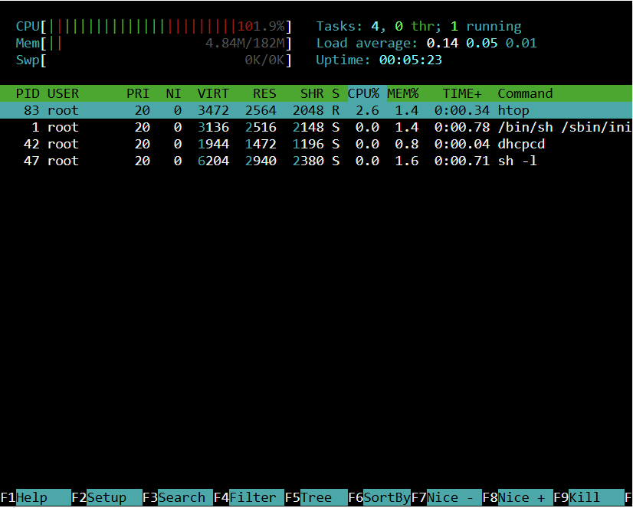

HTOP is clear example of how to view process management which is essential due to its core role within a functioning OS. HTOP provides a clear, real time view of all the running process on a system with information about how much CPU and memory each process is using. It’s colour coded interface and ability to sort, filter and terminate process makes it an easy and practical example of how an OS is able to manage tasks and maintain system stability.

Task manager:
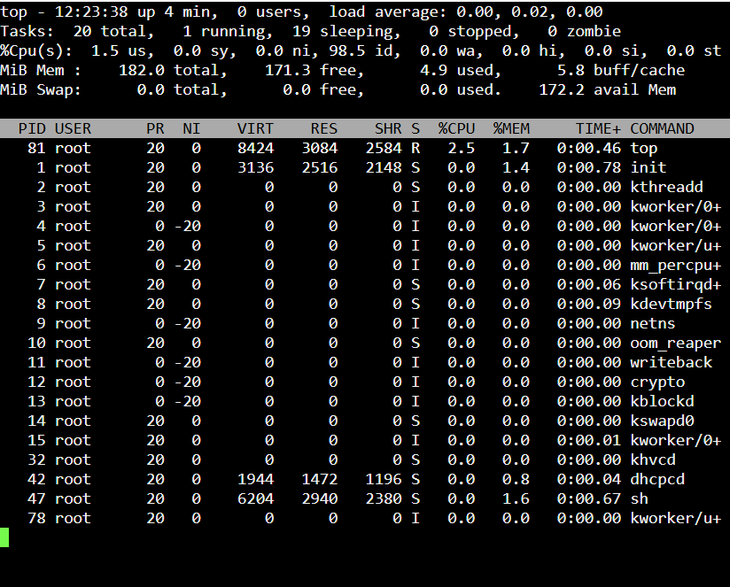

Task manager demonstrates clearly how an operating system can manage its memory usage from active processes and system resources in real time [5]. When viewed in its detailed page, Task manager displays CPU, memory, disk, and network usage for every running application and background process. This allows users to see exactly how the OS allocates resources. The performance graphs highlight how the operating system prioritises tasks, balances workloads, and responds to any issues. Task manager’s ability to enable the user to end any tasks that may be hindering the computer’s ability to run smoothly is what makes it a versatile option for the user. Maintaining control keeps the pressure at a lower level, ensuring the computer works efficiently.

Resource management:
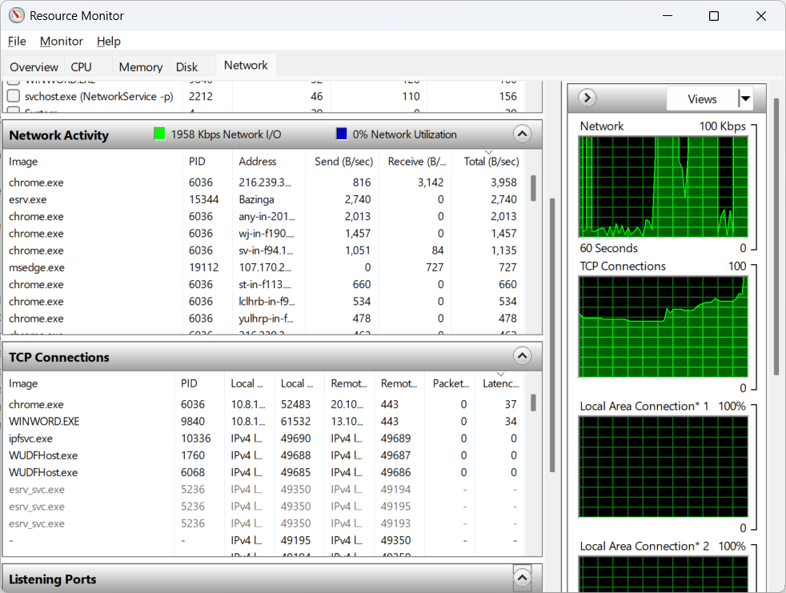
Resource monitor similar to Task manager is a crucial function of an operating system due to its ability to provide detailed views of how resources are allocated and controlled. Unlike Task manager’s broader overview, resource monitor essentially helps the user understand more by breaking down CPU, memory, disk, and network activity at a smaller level. Resource monitor displays real time graphs and statistics that display how the operating system is handling demands, and it maintains overall system performance [6].

File System Management:

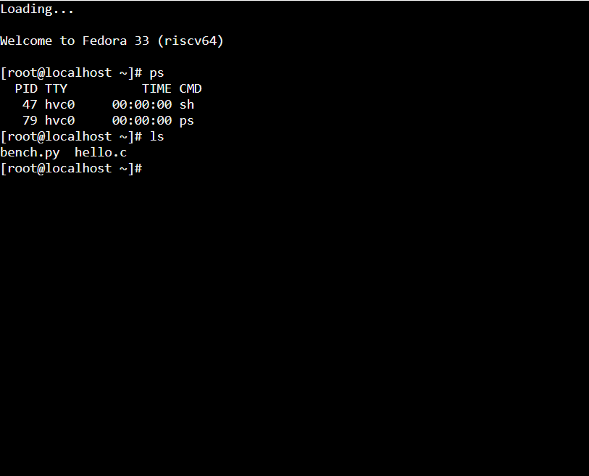

Managing the file system through means such as JSLinux is another fundamental part of an operating system, emulating a full Linux system, allowing users to observe key behaviours such as process management, file system control, and resource monitoring. JSLinux is an excellent example of a file system manager as it includes directories such as /home, /bin, etc. JSLinux also includes real file operations such as, deleting, moving, renaming and editing files using standard linux commands.

Network Management:

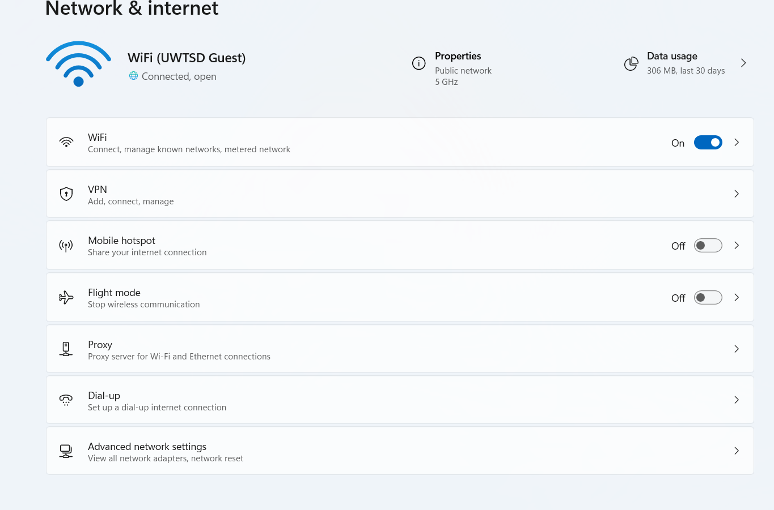

Network management also is a key function of an operating system, ensuring that devices are able to connect to the internet to communicate, and exchange data with other devices whether locally, or online through the internet. The network settings app provides a clear image of how the operating system handles all the information by displaying available networks, connection status, IP configurations, and active protocols. By allowing users to troubleshoot connectivity issues, and view real time activity, the Operating system demonstrates how this section is undeniably important within the system.

Security management:

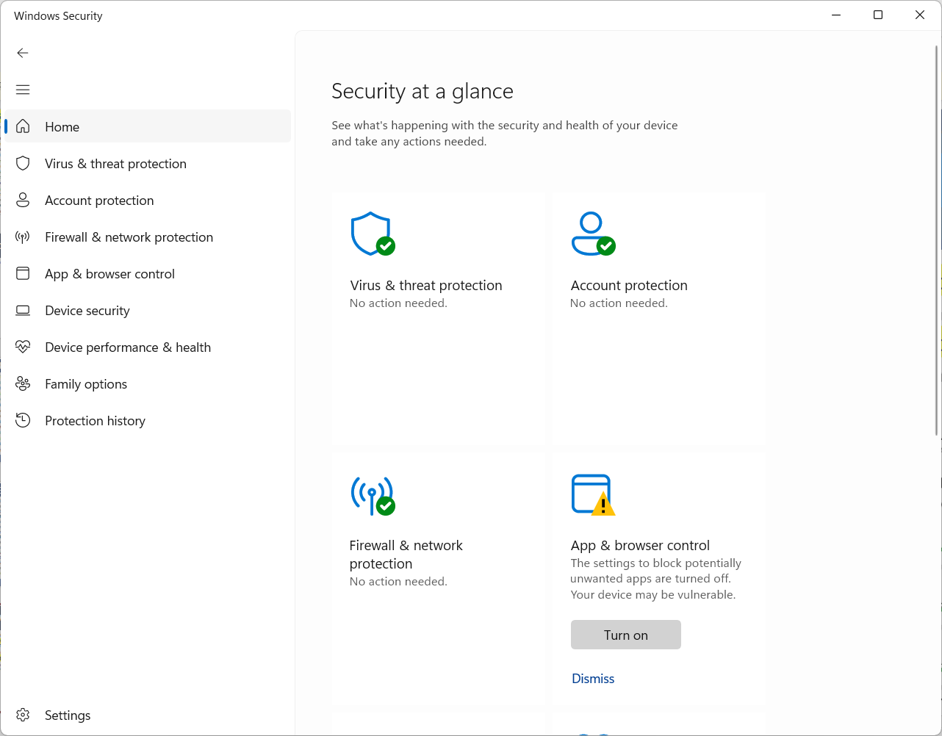
Security is a critical function of an Operating system, ensuring that data, applications, and system resources stay secure and protected from unauthorised access or misuse [7]. Through built in tools such as Windows security and various other system settings, the operating system manages to use features such as antivirus protection, firewalls, and account permissions. These tools work synchronously to help the operating system detect suspicious behaviour, control which applications are allowed to run, and whether they should enforce authentication requirements. The operating system maintains safety on the computer by reinforcing and repeating these examples.

Linux standard subdirectories:

Subdirectories within Linux operating systems are designed to help the system remain organised and predictable. Subdirectories are organised folders under ‘/’ that each serve a specific purpose. For example, some of the most common examples of subdirectories are as follows:
The ‘/bin’ directory, contains core commands needed for basic system operation, (e.g. ls, cp, cat).
‘/sbin’ directory is used for containing system maintenance tools such as networking tools, and file system repair utilities.
‘/home’ is specific to each user. This directory displays their documents, settings, and files.
‘/etc’ holds configuration for the OS and installed services. Etc is strictly for config files.
Finally, ‘/dev’ Represents hardware and virtual devices as files.

Task 3: Use of CLI commands in a Linux OS:

Process management:
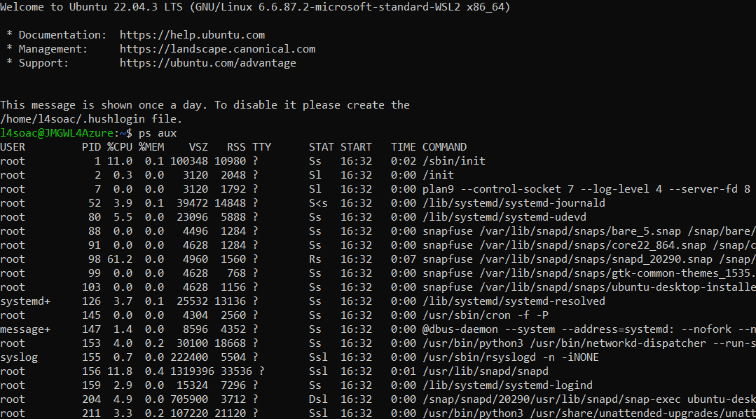
The ‘ps aux’ command lists all running process on a Linux system and shows the user everything in detail. Information such as, process ID, CPU usage, memory usage, and command used to start each process.

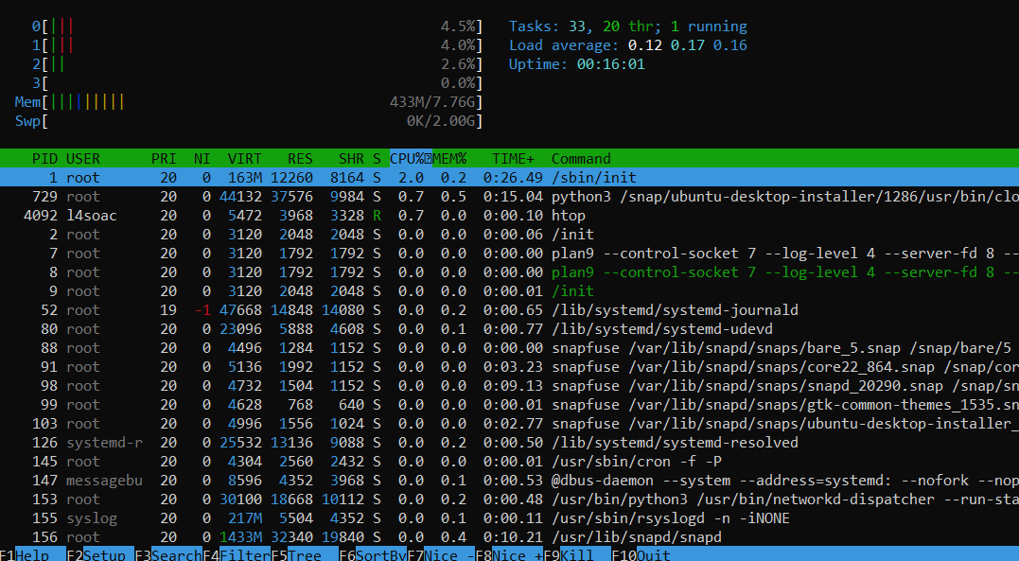

‘htop’ is a system monitoring utility that shows a colour coded live display that demonstrates active processes and areas of the system which are being used. This allows the users to efficiently observe performance and manage different process.

File and directory management:

‘ls -lah’:
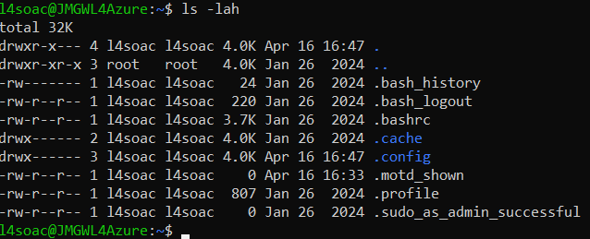

‘ls -lah’ displays the contents of a directory in a detailed format, showing hidden files and presenting file sizes in a readable format to make the information readable for the user. The base command ls is the command that initially lists files and folders, while the following command becomes more specific with its task [8].

‘cp -r’:
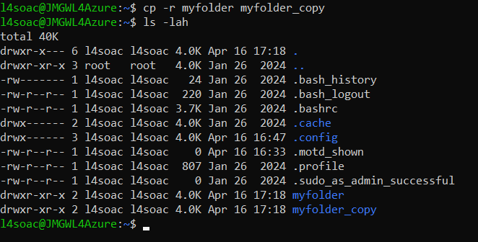
Using ‘cp -r’ the user is able to copy the file ‘my folder’ and all of its contents into a new directory called ‘myfolder_copy’ , preserving the original files whilst also creating a duplicate in a new location.

‘mv -i’:
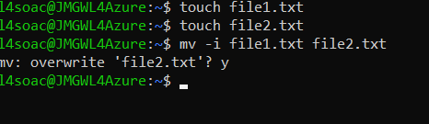
The mv -i command was used to move the contents of a file and then later asks if the user wishes to overwrite the existing file.

‘mkdir’:
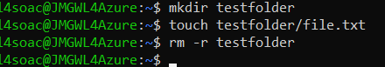
After using ‘mkdir’ and ‘touch’ to create the test folder, the command ‘rm -r’ is used to remove the directory and all files contained within it from the system.

Network testing / monitoring:

‘ping’:
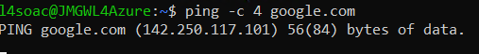
The ‘ping -c 4 <host>’ command sends specifically 4 test packets to a specific host (in this case google), to verify network connectivity and measure the response times. The ping command operates using the internet control message protocol. This is done by sending ICMP echo request messages to a target host (google), and measuring the echo reply to responses to determine a network connectivity and latency [9].
‘curl’:
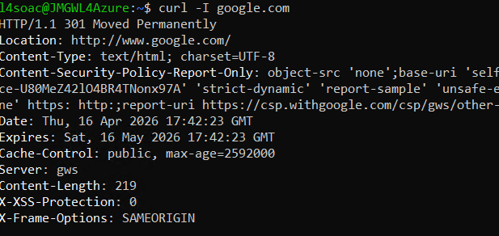
The curl command requested only the response headers from a specific website (google) to check that website’s server status. This is done without downloading the webpage itself.

User management:

‘Sudo useradd’:
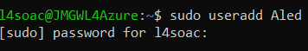
Sudo useradd command creates a new user account on the system using administrative privileges.

‘id’:
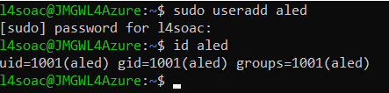
The id <user> command was used to display the user id, group id, and group memberships for the specified user account. The information had to be added to the virtual machine initially through the use of the command ‘sudo useradd <user>’.

Task Scheduling:

‘crontab -e’:
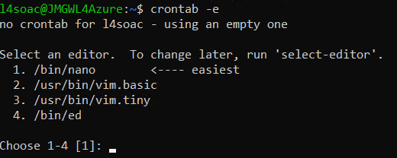
The command ‘crontab -e’ is used to managed scheduled tasks. The command opened the users scheduled task file for editing so automated commands can be added or changed [10]. In the image, the output states there is no crontab set meaning the user could then go forward and create one if they wish.

‘echo’:
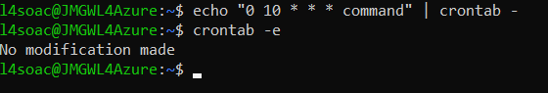

Through the use of the command ‘echo’ the user is able to create a ‘cron job’, the echo command was combined with ‘crontab-e’. Each section of “0 10 * * * command” have different meanings. The order is minute, hour, every day, every month, every weekday, then the final input means to run the specified command. The hour being ‘10’ implies the command will run at 10am.

Task 4: Use of windows OS scripts:

- Variables:
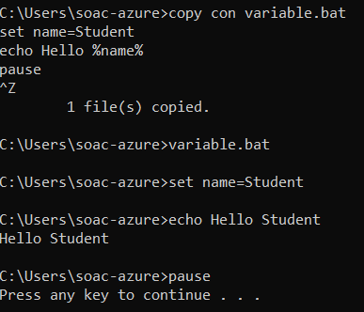

Variables in batch scripting are used to store data that can be accessed later in the script. Variables can contain a number, a character, and a string of characters [11]. They are created using the ‘set’ command which is then followed by the variable name and its value. In this example, ‘name=student’ creates a variable called ‘name’ and stores the word ‘student’. To then display the stored name ‘%name%’ is used which then displays the word to the user.

- User input (/p):
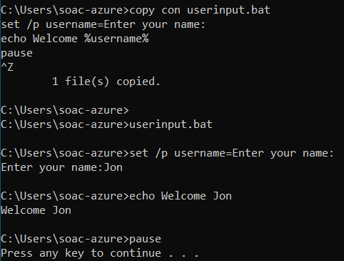

Batch scripting is able to accept user input when using the ‘/p’ switch with the set command. In this example, ‘set /p username=Enter your name’ displays a prompt which asks the user to type a response. The text is then stored inside the variable called ‘username’. This script is considered ‘interactive’ because it can respond to information provided by the user.

- IF statement:
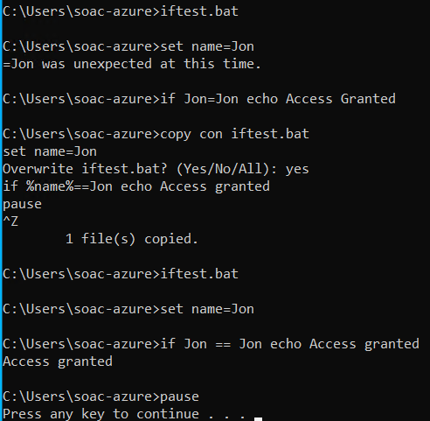

The ‘if’ statement allows a batch script to make decisions based on a condition. It compares one value with another value and then it will perform a command if the condition is true [12]. In this example, ‘if %name%==Jon echo Access granted’ checks whether the value of the username matches that of the input. If the values are the same, the message is displayed.

- Goto Command
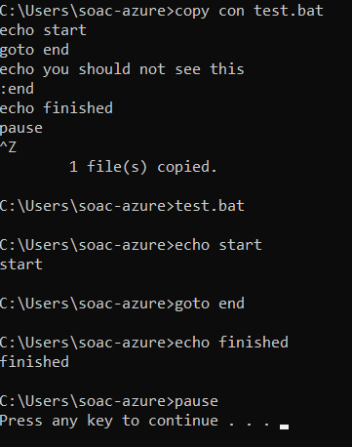

The ‘Goto’ command is used to move the script directly to another section of the file. This section is identified by a colon, followed by text. In this example, when the script reaches ‘end’ the script skips to ‘:end’. This is used to control which parts the script will address.

- FOR loop:
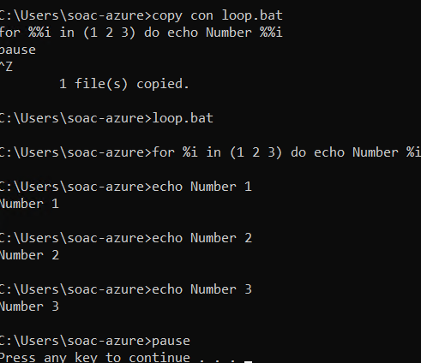

The ‘for loop’ repeats a command multiple times without rewriting the same code. For example, ‘for %%i in (1 2 3) do echo Number %%i’ displays each number in the list one at a time. The variable ‘%%i’ temporarily stores each value during the loop. Loops allow scripts to be more efficient by reducing repetition and allowing the same command to be shown multiple times without the need to be typed out more than once.

- Array:
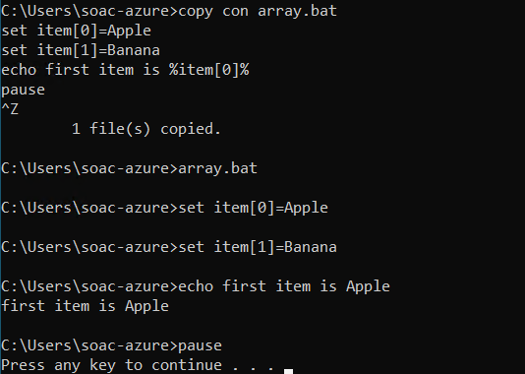
An array in batch scripting can be done through using numbered variable names. In this example, ‘set Item[0]=Apple and set item[1]=banana’ create separate variables that behave similarly to Array elements. Each value can be accessed individually by using its assigned number [13].

- Function:
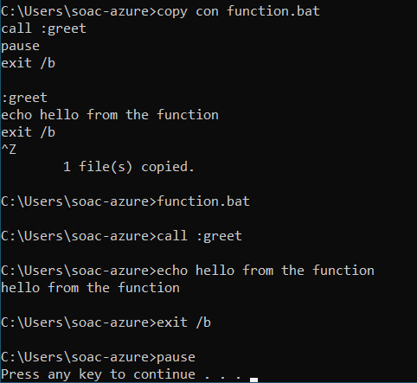

Functions in batch scripting are created using labels and the call command. A label such as ‘:greet’ can mark the start of the function, then later, ‘call :greet’ runs that section of code when needed. The command ‘exit /b’ is then used when the user needs to return to the main script.

Task 5: Use of Bash scripts in a Linux OS:

Variables:
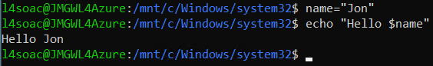

Variables in Bash scripts are used to store information that can then be re-accessed and used at a later point. These make scripts more flexible as values can be changed without needing to rewrite the entire program. In Linux, variables are able to store names, file locations, and also command results.

User input:
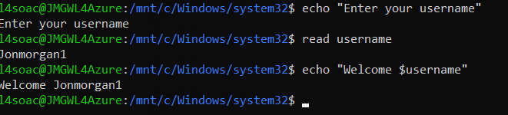
User input allows a bash script to interact with the user running it. The ‘read’ command accepts information typed by the user and stores it inside a variable. This makes the script dynamic due to the output’s ability to change depending on the information that was entered [14].

If Statement:
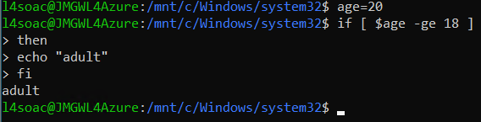
The if statement in batch is used purely to make decision based on different conditions. The if statement checks whether a statement is true before running a command. In Linux scripting, this can be used to verify and compare values.

Loop:
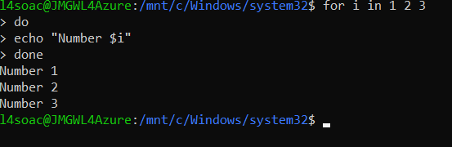
Loops allow a script to repeat commands automatically without the need to type the command out more than once. The for loop is useful for when a command is needed to be executed several times. Loops can also be nested, but each will require its own variable [15]. Loops help with overall efficiency and reduce repeated code.

Array:
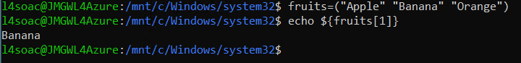
Arrays are able to store multiple values inside one variable. Each item is then stored at a number position called an index (e.g. 0,1,2). Arrays are used when working with lists, and grouped information.

Case statement:
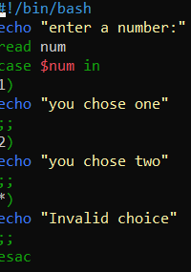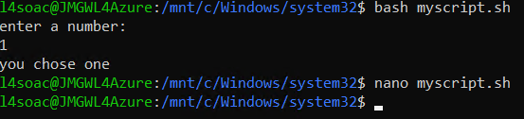

A case statement allows a script to compare one value against several other value . It is commonly used to create menus or multiple choice answers. The case statement is cleaner and more readable than multiple conditions when handling many cases [16]. This makes the script easier to read than using multiple if statements. For this example, ‘nano’ was used to have greater control over the script and create the case statement.

Function:
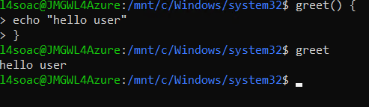
‘Functions’ are reusable blocks of code that perform a specific task, they help organise Bash scripts and are also used to help reduce repetition. Functions within Linux are used to improve readability and make larger scripts easier to maintain.
Conclusion:
In conclusion, operating systems actively perform important roles in managing hardware, software, and user interaction inside the computer. Linux and Windows both provide command-line and scripting tools that allow tasks to be automated efficiently. By understanding this and how operating systems are able to function, users will be able to convenience their lives in many ways through shorter methods of completing tasks through the use of a variety of newfound commands.

Bibliography
[1]
ProQuest, “Sign in to your account,” Proquest.com, 2026. https://www.proquest.com/docview/2326534080?accountid=130472&parentSessionId=Cw6vP9LEZ9zZTCN2Snk6QMY5s1AKHOifoCcXDMpLU%2FQ%3D&pq-origsite=primo&searchKeywords=what%20is%20an%20operating%20system&sourcetype=Magazines (accessed Apr. 14, 2026).
[2]
Britannica, “Android | operating system | Britannica,” Encyclopædia Britannica. 2020. Accessed: Apr. 14, 2026. [Online]. Available: https://www.britannica.com/technology/Android-operating-system
[3]
Britannica, “Microsoft Windows | History, Versions, & Facts | Britannica,” www.britannica.com. https://www.britannica.com/technology/Microsoft-Windows (accessed Apr. 14, 2026).
[4]
A. Van Der Steen, “Overview of recent supercomputers,” 2008. Accessed: Apr. 14, 2026. [Online]. Available: https://www.euroben.nl/reports/overview08.pdf
[5]
GeeksforGeeks, “Functions of Operating System,” GeeksforGeeks, Dec. 11, 2018. https://www.geeksforgeeks.org/operating-systems/functions-of-operating-system/ (accessed Apr. 15, 2026).
[6]
OpenAI, “ChatGPT,” ChatGPT, 2025. https://chatgpt.com/ (accessed Apr. 15, 2026).
[7]
GeeksforGeeks, “Functions of Operating System,” GeeksforGeeks, Dec. 11, 2018. https://www.geeksforgeeks.org/operating-systems/functions-of-operating-system/ (accessed Apr. 15, 2026).
[8]
OpenAI, “ChatGPT,” ChatGPT, 2025. https://chatgpt.com/ (accessed Apr. 20, 2026).
[9]
Internet Engineering Task Force, “rfc792,” datatracker.ietf.org. https://datatracker.ietf.org/doc/html/rfc792 (accessed Apr. 20, 2026).
[10]
introduction to linux, “Scheduling processes,” Tldp.org, 2026. https://tldp.org/LDP/intro-linux/html/sect_04_04.html (accessed Apr. 20, 2026).
[11]
Introduction to linux , “BASH Programming - Introduction HOW-TO: Variables,” tldp.org. https://tldp.org/HOWTO/Bash-Prog-Intro-HOWTO-5.html (accessed Apr. 21, 2026).
[12]
OpenAI, “ChatGPT,” ChatGPT, 2025. https://chatgpt.com/ (accessed Apr. 21, 2026).
[13]
Introduction to Linux, “Arrays,” Tldp.org, 2026. https://tldp.org/LDP/abs/html/arrays.html (accessed Apr. 21, 2026).
[14]
Microsoft Copilot, “Microsoft Copilot,” Microsoft Copilot, 2025. https://copilot.microsoft.com/ (accessed Apr. 22, 2026).
[15]
R. Van der Woude, “Batch files - FOR loops,” Robvanderwoude.com, 2016. https://www.robvanderwoude.com/for.php (accessed Apr. 22, 2026).
[16]
GeeksforGeeks, “Bash Scripting Introduction to Bash and Bash Scripting,” GeeksforGeeks, Apr. 19, 2022. https://www.geeksforgeeks.org/linux-unix/bash-scripting-introduction-to-bash-and-bash-scripting/ (accessed Apr. 22, 2026).
Appendix:

- Tutorial activity: OS Types:
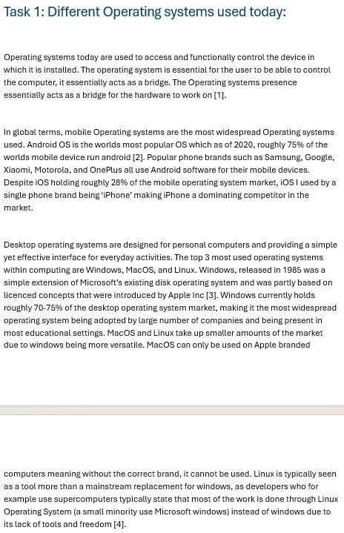

Lecture Activities:

Activity 1:
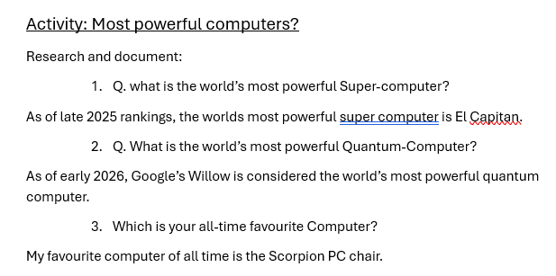

Activity 2:
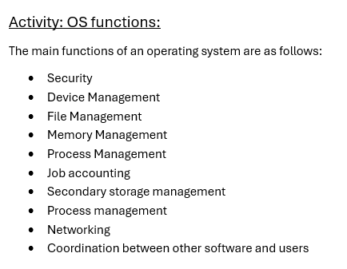

Activity 3:
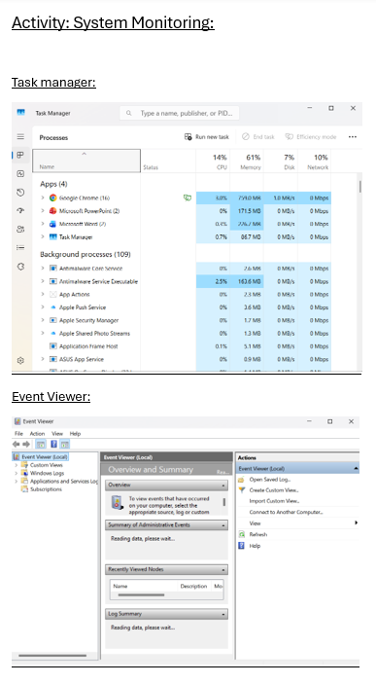

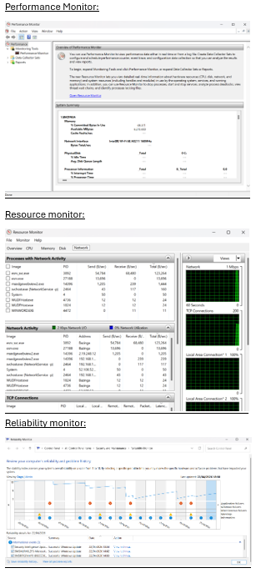

Engagement with online course:

Beginning of course:

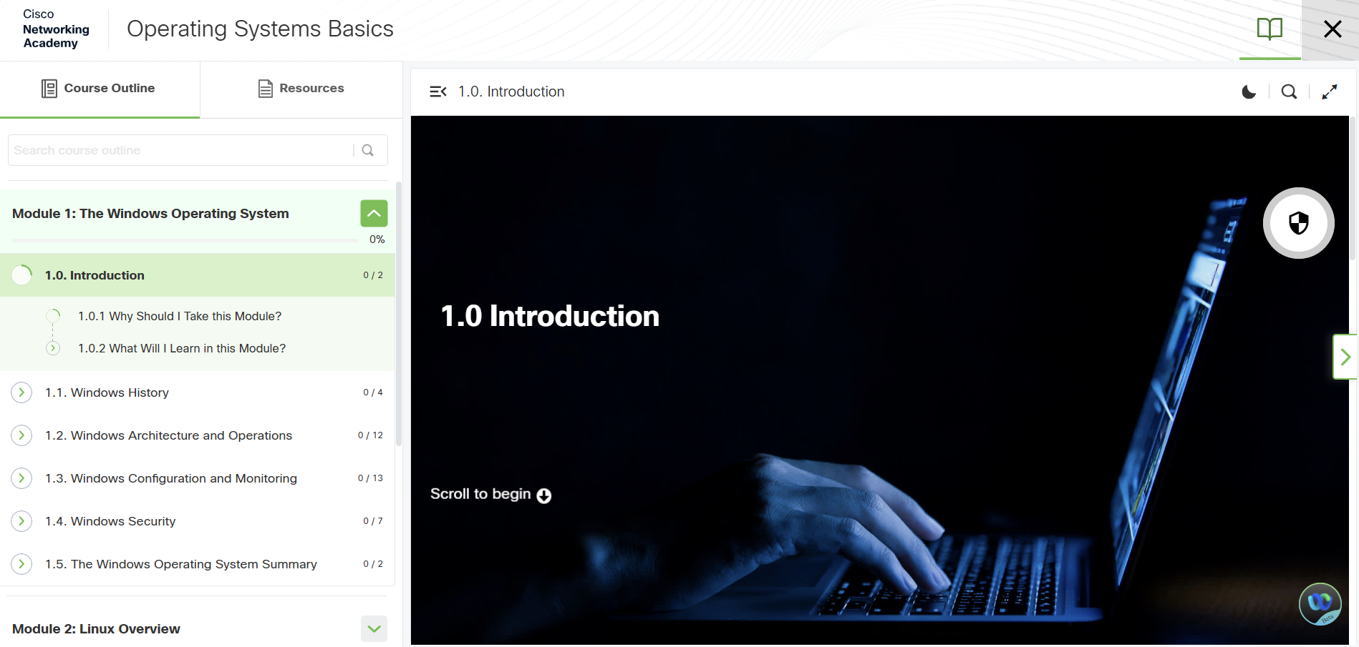

Mid way through Course:
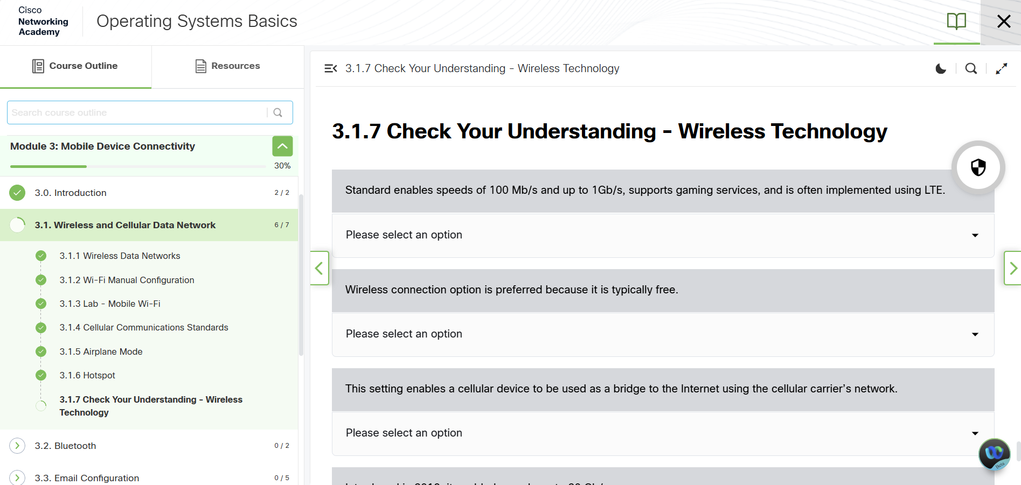

End of course:


