Data Handling and Business Intelligence

Student’s Name
Institutional Affiliation
Dr Molly Jack Name
Subject Name: Georgi Nenchev Stoykov
Id: 2124048

Introduction
E-commerce can be defined as the process through which the manner of moving merchandise from producer to the consumer has been revolutionized. But it also can be argued that through offering new and more effective forms of sales and distribution it has allowed companies to access new customer bases. The dataset considered in this analysis belongs to an online retailing store based in London and mainly selling gifts and home ware. It is to assess different factors of the dataset such as, sales patterns, the customers’ preferences for certain items, the number of transactions made and the revenue generating capability of customers while offering development recommendations for the business.
The use of scholarly concepts improves the richness of e-commerce data analysis and the soundness of the evaluation. E-commerce is cited in literature as the revolution of traditional retailing due to highlighting of its importance of widening the market access and enhancing the retailing strategies (Wajidi et al., 2023). Consequently, emerging research like the one conducted by Wang and other authors (2020) allows one to assess how the act of online retailing affects consumers’ behaviour and existing purchasing drives in the modern world. The main idea of Chaffey’s work remains in his message, stating that the sales trend analysis should be carried out to forecast the inventory and the marketing activity. Moreover, going through the literature on consumer behavior and data analysis, enables the critical evaluation of customers’ preferences and transaction histories. The following scholarly sources supply strong paradigms for making analytics of the dataset: It births models for forecasting the pattern of sales and propinquity toward customers. What is more, by incorporating these academic angles, the analysis goes beyond the identification of trends, and complies with the available theories to contribute to the formulation of the strategic suggestions for the enhanced e-commerce operations and the overall business performance. Using the file given on Sales transaction, the paper will now seek to answer the questions as below for part 1 and part 2 respectively.
Part 1
Question 1
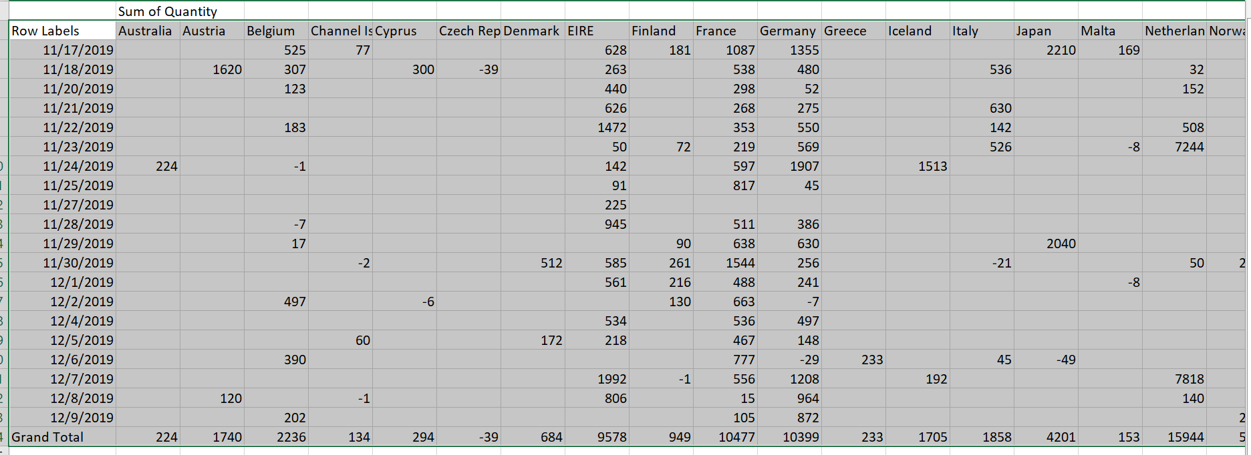
As seen in the figure above, the trend in the sales over the months is shown. Comparing the identified sales data for the two months, namely November and December 2019, one can identify certain features and tendencies. November, as a whole, seems to present a relatively good sales curve in most of the regions with sales’ peaks before the holiday season displayed in the Netherlands, France, and Germany. For instance, the Netherlands was seen to have had the most sales in the month of November, which is evidence of the activities of the consumers. Likewise, the sales figures of countries such as France and Germany also depicted higher sales indicating that buying activity in general was on the rise during this time.

However, conversely to the previous months’ results, December demonstrates a rather ambiguous performance. Some of the individual negative areas and lower totals can be observed in several countries and may reflect returns in sales or corrections. However, some areas such as Norway setting high figures of sales, indicating that consumer expenditure is still going on. Analyzing the outcome, the results indicate that, although November had high sales coming from the start of the holiday season, December goes down which can be attributed to holiday returns or slow-moving sales. Altogether, the sales trend reveals lots of activity in November due to the preparation for celebrations and an unpredictable tendency in December. Awareness of these patterns can assist a business in making beneficial changes to its purchase and supply accumulation, and marketing, in order to maximize the sale of products at the appropriate time of the year.
Question 2
It will be essential to analyze the product’s sale quantity of the given dataset for sales transactions in order to identify the most demanded items. This entails the summing of the data to determine such things as the most selling products.
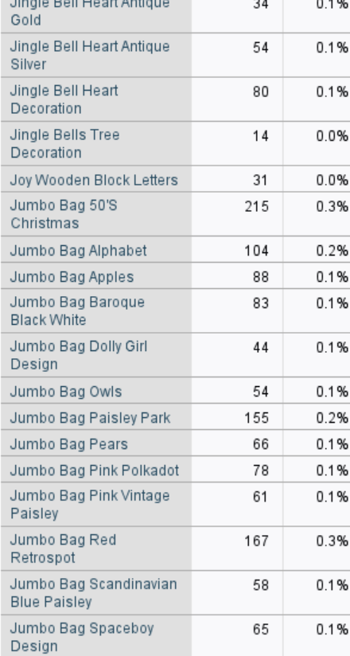
As seen in the figure above, the “Jumbo Bag 50’s Christmas” is the seller’s most popular product, 215 pieces of which have been sold during the period under consideration. The product that is bought most often is ‘Jumbo Bag 50’s Christmas’; the number of its sales is equal to 215.
However, analyzing the table, it is clear that the most purchased product was the “Jumbo Bag 50’s Christmas” which, was bought in 215 instances. This suggests that people must need this particular item because it seems that it is described in a manner that could pertain to a popular or seasonal item. These are generally items that are frequently bought by the consumer and should be incorporated in inventory control and marketing strategies.
Question 3
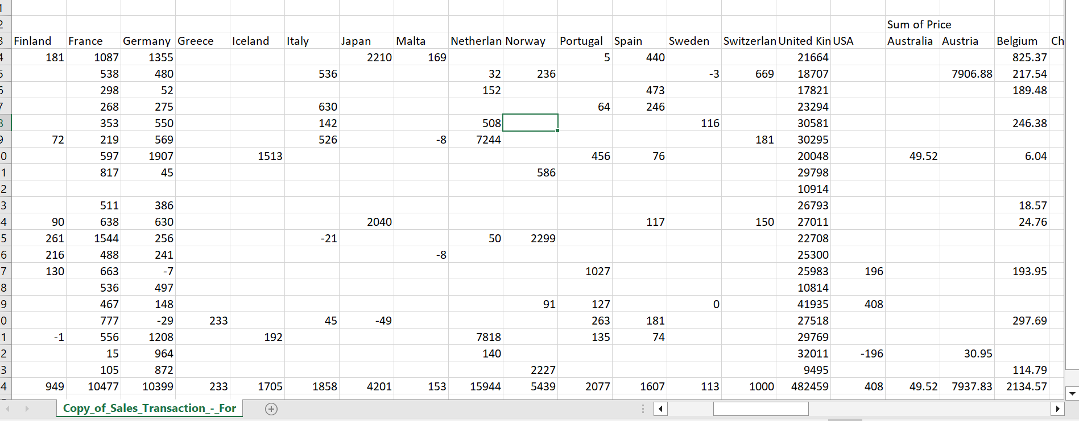
For the quantity patterns, we are more interested in which of the products was bought how many times in a single shop, so we work with the quantity information as well. The number of products varies from one to more than 80 in a single purchase with the frequency in the purchase distinguishing on the purchasing habits possessed. For instance, the most frequently recorded kind of transaction is one in which a single article is bought, this was found to be the case in 20,125 transactions. Such high frequency implies that most of the customers make individual purchase which is characteristic of small number of purchases per visit. On the other hand, the buying of 2 R products is observed in 10609 T, implying a relatively higher but less frequent incidence to the overall single product T. The total of transactions of 3 products was identified, 4997 times overall with the distribution likely due to difference in pages. Likewise, transactions of 4 products take place 4,679 times while the transactions consisting of 5 products occur 1,628 times.
The transactions of 10 and 20 products are not very common but are present with 2,334 and 547 transactions respectively. This means most people make small purchases indicating that there are those who make large purchases possibly wholesalers or those who order in large quantities. These patterns enable future inventory and marketing behaviors to be consistent and compatible with the consumers’ usual purchasing habits to increase total sales.
Question 4
The segment customers that make higher revenues and have more frequent transactions are the most profitable to the firm. Going by the data available, there is enough evidence that customers in the United States and the United Kingdom contribute significantly to the revenues. The segmenting based on geographical location for instance the U. S segment demonstrates the total revenue of $82,379. Across the different entries, an average of 87 is observed with this pointing to a highly profitable venture. Likewise, the segment of the United Kingdom’s Revenues was $62,080. 78, indicates high profitability. The above percentages indicate that both the regions generate most of the total sales, thus making them strategic markets for the business.
Besides the revenue indicators there are also volumes of transactions as the major measurement of profitability. For example, the total value of transactions of the U. S and the U. K. show that apart from being highly lucrative; these markets are also highly active in terms of sale. Such high transaction numbers along with distinct revenues prove the relevance of these segments in regard to the business development. Hence, it would be reasonable to state that paying more attention to the development of customers’ relations, as well as the improvement of sales policies in these territories, could bring even larger profits.
Question 5
Based on the findings from the data analysis, several strategies can be recommended to increase profitability. Firstly, optimizing inventory by focusing on top-selling products and reducing stock of low-demand items can improve efficiency. Secondly, enhancing customer experience by leveraging data on purchasing patterns to personalize marketing efforts can drive sales. Thirdly, increasing the average transaction value through strategies like product bundling or volume discounts can boost revenue. Finally, adjusting inventory and marketing strategies based on seasonal sales trends can maximize profits during peak periods. "The Profit Zone: How Strategic Business Design Will Lead You to Tomorrow's Profits" by Adrian Slywotzky (2007) provides further guidance on implementing such strategic recommendations.
It has been earmarked that one of the best ways of driving profitability in organisations is through the use of customer loyalty programs. Studying the purchasing behavior of customers and collecting necessary information, companies are capable of creating attractive incentives for the targeted clientele. In addition to encouraging a subsequent purchase, this approach also contributes to optimizing the customer value. For instance, reappraisal of a higher tier of bonuses or use of individual seller offered rebates which are designed based on previous customer buying habits will increase customer satisfaction thus increasing customer loyalty.
Besides, the structured loyalty program helps to perpetuate customers’ interaction with the firm because they are offered incentives of early release of products or special offers. This will in turn increase on the rate of retention of customers and number of transactions that customers do within a given period of time. Secondly, loyalty programs can be beneficial as they create a database of statistics on customers’ likes and actions and help the businesses adjust their promotional activities and products. Customer loyalty program is overall a strong variable that can positively affect the company’s revenues and profitability by providing more opportunities to engage the customers and make more purchases. Such an approach complies with the industry standards and defines all the directions for further constant focused financial success in the sphere of e-commerce.
Part 2
Question 1
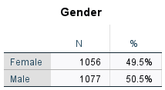
The table displays information concerning the gender distribution in a given sample population. According to the gender distribution of the total participants, a total of 1056 participants are female accounting for 49 percent. Those that are less than 6 years old are 405 forming 5% of the sample, while 1077 are males, representing 50%. This shows that gender is relatively equally divided between male and female subjects in the concerned dataset. That distribution is useful in the research that seeks to compare the results between males and females and it reduces any gender stereotypes and improves the generality of the results. The variation of the percentage is slight; hence, having a view that gender does not influence significantly skews the results.
Question 2
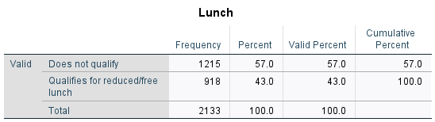
This analysis from the table relates to the ability to pay, which shows the number of students qualified for reduced or free lunch programs. According to the data given, out of the total students enrolled, 1215 students, that is, 57.0% of the total students, do not come under the reduced or free lunch schemes, while the remaining 918 students, or 43.0% of the total, engage in the said schemes. This means that half of the student outcomes are qualified for economic support according to the lunch program. This means a majority of the students cannot be considered as needing state aid (57. 0%), meaning that the majority of the students come from families with income higher than the amount that qualifies for reduced or free lunch.
Question 3
Mean Calculation
Because the data is categorical with only two groups and the values are constant, the mean and median may be determined as follows: In this scenario, the mean is not determined typically since the frequency count is being compared rather than the associated data values.
Mean = (1215 + 918) / 2 = 2133 / 2 = 1066.5
Does not qualify for reduced/free lunch:
Number of students: 1215
Total Students: 2133
Mean = (1215 / 2133) * 100 = 57.0%
Qualifies for reduced/free lunch:
Number of students: 918
Total Students: 2133
Mean = (918 / 2133) * 100 = 43.0%
Median Calculation
If the number of values is biologically distributed in ascending order, then the median of such values is the middle value. On the basis of the percentages and total number of students, the median can be computed on the basis of the distribution of the students in two groups. If categorical data is arranged, the median quantifies the middle value out of all the data sets. Since there are only two groups, the median will fall into one of the following categories: By listing the number of pupils, the results through “does not qualify” would have 1215 pupils while the “qualifies for reduced/free lunch” would have 918 pupils. According to the options presented since 1215 to the questionnaire, the median category that would consist most of the pupils would be the “does not qualify” category.
Question 4
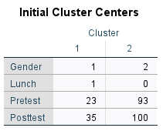
The initial cluster centers are estimates of the starting points for the clusters before the algorithm starts its iterations.
Cluster 1:
Gender: 1; Lunch: 1; Pretest: 23; Posttest: 35
Cluster 2:
Gender: 2; Lunch: 0; Pretest: 93; Posttest: 100
Initial cluster centers suggest that Cluster 1 had lower pretest and posttest scores compared to Cluster 2. Cluster 1 also had a different profile in terms of the categorical variables, such as Gender and Lunch, compared to Cluster 2.
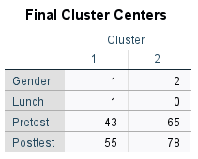
The last values of the centers of clusters show the amount that has reached the centroid of this or that cluster after the solution of the given problem and during certain iterations.
Cluster 1:
Gender: 1; Lunch: 1; Pretest: 43; Posttest: 55
Cluster 2:
Gender 2; Lunch: 0; Pretest: 65; Posttest: 78
The final coordinates of the cluster centers in Figure 4 can be seen to differentiate the two clusters distinctly. The descriptive analysis shows that the scores of the students in Cluster 1 for both the Pretest and Posttest are lower than that of Cluster 2. This means that students in Cluster 1 have lower academic achievement, while those in Cluster 2 are higher achievers. The remaining categorical variables, Gender, and Lunch, also present a resemblance in the distribution seen at the beginning of the centers.
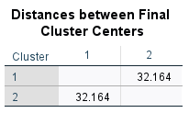
The table shows how dissimilar the clusters are and the distances between the final number of clusters obtained. Hence, the distance calculated between the two clusters, cluster 1 and cluster 2, is 32. 164. This distance actually measures the degree of separation or how different the clusters are in the feature space. A larger value of this measure implies that the clusters are well separated, which is the correct thing in clustering since it means that the algorithm has successfully placed different clusters far from each other.
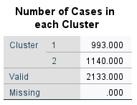
This section shows how many cases (students) fall into each cluster:
In the first cluster, there were 993 cases, while in the second, there were 1140 cases. The total number of cases is 2133, with no missing values. Thus, Cluster 2 has a higher number of cases as opposed to Cluster 1, which means there are possibly more students in the given data set who exhibit the traits associated with Cluster 2. The results of using K-Means clustering mostly suggest that this algorithm was capable of designing two different clusters from the suggested variables. Accordingly, Cluster 1 usually contains students who have lower test scores and other characteristics within the categories compared to students in Cluster 2. For the feasibility tests, there seems to be minimal movement from one cluster center to another with a large distance between the cluster centers, which would indicate a clear differentiation of clusters.
Question 5
Comparing two programs is rather difficult because each of them was developed to solve specific problems; SPSS is more appropriate for use when the amount of collected data is rather large and complex, while Excel is more versatile and can be used with rather small datasets as well. What makes SPSS specifically popular is that it provides a number of statistical tests and procedures, such as ANOVA, regression, and factor analysis, that are not available in Excel. Operations are explained through menus and dialog boxes, and thus, even a person who has no statistical background can easily perform complicated procedures under the guidance of the program. Also, data handling and storage are good at SPSS, especially when dealing with large portions of data and multiple formats of data. Nonetheless, the general drawback of using SPSS is the fact that it is rather costly software since it is a commercial tool and may barely be affordable by small-scale companies or individuals. There is also a disadvantage of a learning curve in its use, especially if one needs to utilize its more complex features, time, and training, and it is also not as versatile as Excel for non-statistical purposes.
On the other hand, Excel is easily available as it tends to come pre-installed on many computers, thus availabilities to most of the users. One of the biggest advantages is that it is a tool for many computational tasks, not only for analytical calculations in statistics but also for data analysis, calculations of values, data visualization, etc. Overall, the program that uses the spreadsheet layout, which is Excel, is one of the simplest to use, particularly for simple computations. All the same, it should be remembered that Excel’s statistical functions are not on the same level as SPSS and should, therefore, not be used for complex analysis. It may also fail to efficiently manage very massive data, which may, in turn, cause performance problems or even data loss. Besides, with the data entry and formula development in Excel, it might be difficult to eliminate errors, hence requiring constant validation.
In conclusion, the evaluation of the e-commerce sales dataset demonstrates the importance of needs assessment with regards to different aspects of sales patterns, product offerings popularity, number of transactions, and customers’ profitability. The analysis of the data reveals that single product transactions are the most prevalent type of events and contribute a vast amount to the overall purchases. This indicates that customers hereby exhibit a bias towards the preference of making frequent but relatively small purchases more than making few large purchases at a time. The awareness of these patterns is useful to the business as it can then adjust marketing efforts, for instance offering some offers on larger orders in order to push through higher average order values. It also shows that the popularity of products differs to a certain extent, and this constitutes important information of which products are quite popular among consumers and which ones have low demand. Knowledge of such factors can help the business to proper the right product stocks, proper the supply chain, and even align the business’s variety with what is suitable from the side of the consumers. Also, the suggestions given are based on theoretical concepts, for instance, consumer analysis and sales forecasts coupled with practical interpretations making suggestions both theoretical and practical. Besides increasing the effectiveness of operations, this approach also contributes to the generation of profits by synchronizing business initiatives with facts and tendencies in customer preferences.
References
Slywotzky, A.J., Morrison, D.J. and Andelman, B., 2007. The profit zone: How strategic business design will lead you to tomorrow's profits. Crown Currency.
Wajidi, F.A., Rehan, E.W., Saeed, M., Iftikhar, K.M. and Tahir, A., 2023. Technology Trends and Their Impact on the E-commerce Industry. International Journal of Social Science & Entrepreneurship, 3(4), pp.236-253.
Wang, C.N., Dang, T.T., Nguyen, N.A.T. and Le, T.T.H., 2020. Supporting better decision-making: A combined grey model and data envelopment analysis for efficiency evaluation in e-commerce marketplaces. Sustainability, 12(24), p.10385.

