

BSc (Hons) Professional Police Practice

LEVEL 5 - 40 Credits

Workbook title: Competency Based Workbook 3 (PCDA)

(SOUTH WALES POLICE, GWENT POLICE AND UWTSD)

Learner name: Patric Rogers

Learner’s University Registration Number: 1922408

FACULTY OF BUSINESS AND MANAGEMENT
PUBLIC SERVICE PROGRAMME

Module title: Professional Police Practice 2 (PCDA) BMPP5000D

Task 1

Relevant areas of the National Policing Curriculum:
Wellbeing and Resilience

Having achieved Independent Patrol Status, reflect on the impact of organisation culture within policing on your wellbeing and resilience (organisation change, retaining personal values in a wider organisational culture).

Consider the risks of conforming to organisational culture.

Illustrate your strategies for maintaining wellbeing and resilience.

1250 words (+/- 10%: include your actual word count at the end of each section)

ANSWER:

In this text, I will consider the difficulties of needing to conform to organisational culture within the police. I will illustrate my strategies for maintaining personal wellbeing and resilience since accomplishing my independent patrol status.
A police officer works under much complexity, scrutiny, and high expectations. There are many more organisational stressors rather than operational stressors which is said to have a ‘detrimental’ impact on officers and their performance while carrying out duties. It is analysed that these stressors are due to the relationship between a law enforcement agency and its officers rather than the officer and the community. These impacts and stressors are said to have an adverse effect impact on family life and unmet personal ambition due to limited opportunities for promotion. It is also stated that police agencies are placing unsustainable demands on their workforce, therefore damaging the officer’s performance (Shane, 2019).
Policing can be described as a stressful, demanding and frequently dangerous profession. Police forces throughout England and Wales are under ‘significant stress’ due to the unprecedented period of reform (Lockey, 2021, p. 2). It was noted by the police federation in England and Wales in 2019 that “79% of officers say they have felt feelings of stress and anxiety within the previous 12 months with 94% of those saying these difficulties were caused or made worse by their job” (Police Federation, 2019).
Other academics have also described policing as ‘running on empty’ (Dijk et al., 2019). On a regular basis I can relate to this idea of ‘running on empty due to the general under-resourced conditions which effects mental health within the workplace. It is well understood that the police organisation, as much as the police role, is a primary stressor for officers and it has been believed for 50 years that there is a difference between stressors from the police work and the police organisation and noted that wellbeing of police officers have not always been a priority for police organisations nor for governments (McDaniel, 2020, p.241-242).
Currently, resources in policing are very low and have been under increasing amount of pressure through recent years (Greater London Authority, 2019). Although government figures show that since 2015, there has been a considerable rise in police funding in England and Wales (Home Office, 2020). However due to unprecedented cutbacks in the years prior to this increase of funding, the governments are still fighting to cover a huge shortfall in policing with the recruitment drive of 20,000 additional officers, however, this is said to be an ambition and difficult target (Institute for Government, 2019). With an increasing demand on the police with such effects of the covid pandemic, since the start of 2020, there has been a dramatic increase of domestic abuse incidents and an increase in mental health calls which already has been highlighted above (HMICFRS, 2021). The annual PEEL report, set out for the end of 2020, highlighted the extreme pressures that officers have faced since the start of the pandemic, highlight that officer’s mental health is at risk from the stresses posed to them in the exercise of their duties. The report also highlights the knock-on effect that this also carries onto the families of officers. However, the report does also highlight that it believes that the job also has one of the highest levels of job satisfaction. No one day is the same as any other and the amount of people that can be helped in the process of doing such job (HMICFRS, 2020). I can confirm the remarks made in this report, which states there have been huge pressures and stresses fought by officers serving through this difficult period, I have also felt them. However, I do feel it is extremely rewarding that you can help others in the process of carrying out your duties.
For me the most relevant issues in conforming to organisational culture within policing are the long and unsocial hours that officers are required to work and the short notice that is organisationally acceptable to be given to officers to have rest days cancelled to cover short falls in staffing levels.
Previously, I did not think this would cause me any issues, however, later I realised this was causing me to become very tired at times and effecting my sleeping patterns drastically.
This is unlike civilian life, whereby, in most employment structures, considerable notice needs to be given for a change of shift or even working a common nine-to-five job whereby it much easier to keep a healthy work-life balance.
Subsequently I realised that I needed to form a healthy routine to help me adjust to the extreme routine that working in the police required to maintain my wellbeing and resilience.
Resilience is described as the quality of being able to adjust to difficult situations, recover quickly from obstacles, adapt to new and different situations, feel they have some sense of control over their environment, and move forward positively in adversity. It is described as a skill and like any skill can be developed and made better with practice (Channel 1 Creative Media, 2020). Ways that you maintain wellbeing and resilience have been described as having mutual support, open and honest communication with colleagues, a shared sense of purpose and connectedness and a clear understanding of how your work contributes to the organisation’s objectives. Ways that the latter can be achieved is to build a supportive, companionate culture where members of the team support and check on one and other, this can be helped by participating in regular social activities with your team and informal catchups (Channel 1 Creative Media, 2020). In my personal life, I have aimed for team cohesion by way of social activities such as going out for meals/drinks and participating in informal social gathering outside work such as physical activity with team members. This has proved to be a great way to relieve stress and build resilience.
According to Silverman and Deuster (2014) Physical fitness and regular exercise allows for resilience by creating positive psychological and physiological benefits, reducing stress reactivity, and helping protect against potentially adverse behavioural and metabolic consequences of stressful events and preventing many chronic diseases. I personally continued to conduct physical activity over the period since I have achieved independent patrol status and have found it to be a very useful tool to fight stress and to build personal resilience. When I am feeling dejected by the experience of a long workday, by participating in physical exercise, I have noticed an improvement in my mood and wellbeing.
It is also suggested that a heathy work life balance is needed to build a higher level of resilience due to modern technology giving you access to your work 24/7 (Channel 1 Creative Media, 2020). Although, it’s also suggested that work life balance is a ‘myth’ but instead, ‘paths and choices in life’ and the balance is in fact, ‘making money but having meaning’. It is also stated that you need to have control in your life, such as taking that choice to go out and do physical fitness, it is also stated you should have the willingness to look at life’s problems as challenges, to always have commitment, and have connectedness, meaning relate to the people that will make you do better and aid you in progression instead of hindering you (Healthy Learning, 2015). Learning and developing from these points has shown me a greater understanding that leading your life isn’t all about going to work and earning money, but instead it’s about having a healthy relationship with the things in life that give you pleasure and meaning such as spending time with family, friends, doing exercise and making the most of your leisure time. All this has aided me in maintaining my wellbeing and resilience.
Word Count: 1,294.

Task 2

Relevant areas of the National Policing Curriculum:
Decision-making and Discretion, Vulnerability and Risk, Public Protection.

You must choose an incident, for example a domestic related incident, and reflect on how you made decisions in complex and unpredictable circumstances using dynamic risk assessment.

Give a brief description of the problem including social and legislative contexts and any relevant cultural, ethnicity and language issues.

Evaluate decisions made during the incident and your use (or otherwise) of the National Decision Model. Explain the rationale behind your decisions and your considerations when recording details of the incident. Consider your ethical approach to the decision. Outline the consequences of your decision making.

1750 words (+/- 10%: include your actual word count at the end of each section)

ANSWER:

For this task, the incident I have chosen to discuss a domestic abuse related incident. Police first became aware of this incident when bank staff contacted police through 101 to report concerns for one of their elderly female clients.
Domestic abuse is any incident or pattern if incidents of controlling, coercive, threatening behaviour, violence, or abuse between those aged 16 or over who are, or have been, intimate partners or family members and can involve but is not limited to psychological, physical, sexual, financial, or emotional abuse (College of Policing, 2015).
The report entailed that they (the bank staff) had frozen the bank account of this elderly female due to suspected fraudulent activity on it. The female (Victim) had visited the bank to try and resolve the issues with her middle-aged son (Perpetrator). When bank staff were with the victim, they requested that they talk to her on her own away from her son. This was due to their suspicions that her son may be fraudulently using her account as there were several transactions on there under his name.
While bank staff were with the victim, she also had a scabbed injury to the forehead which they suspected there may be foul play involved and again her son may be involved. The victim was reportedly confused by the transactions within her account when they explained them to her, and she could not explain why those transactions were there.
Due to all the above, bank staff found it fit to report this to police. As a police officer picking this call up, I now had to conduct welfare checks on the elderly female to work out if there were any offences and to safeguard this victim if need be.
Prior to my colleague and I attending this call, I considered and used the ‘National Decision Model’ to develop a plan on how to deal with the situation as I knew it at hand.
The ‘National Decision Model’ or NDM abbreviated is there to aid police officers in making decisions in a dynamic and ever-changing environment. The NDM is suitable for use in all decision-making tasks and should be used by everyone in policing, it can be used in spontaneous incidents or planned operations, by an individual or team of people and used in both operational and non-operational situations (College of Policing, 2013). This situation is a spontaneous incident, included a team of a colleague and myself and being used operationally.
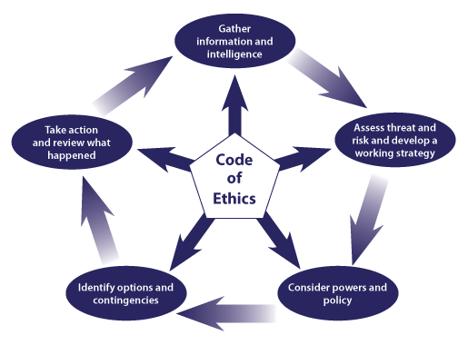
Figure 1: National Decision Model (College of Policing, 2013).
The above figure shows the NDM. There are six key elements with the mnemonic CIAPOAR explaining the key elements. This is as follows:

“ Code of Ethics – Principles and standards of professional behaviour
Information – Gather information and intelligence
Assessment – Assess threat and risk and build a working strategy
Powers and Policy – Consider Powers and Policy
Options – Identify options and contingencies
Action and review – Take action and review what happened “

(College of Policing, 2013)

Prior to attending the call, we gathered information about incident. This part was aided by the original call handler that took all the details. The call handler then linked the correct people to the incident. By doing this, we were able to see any intelligence that we had linked to the respective people. It just so happened, the son who is the possible suspect of the incident had previous with the police for violence and a history of domestic violence. Due to this, my colleague and myself were able to a build a dynamic risk assessment.
In the original call that we received; the reporting person described the elderly female as being frail. Due to the age of the female, being reported as frail and the fact that this is a possible domestic incident, the female would be classed as vulnerable. A vulnerable person is any person over 18 years of age who may need extra help by reason of mental, physical, or learning disability, age or illness and someone who may be unable to take care of themselves or unable to protect themselves against significant harm or exploitation (National Crime Agency, 2016).
Through police intelligence we were able to see prior to attending that both mother and son shared the same address. My colleague and I had to take into consideration how we would have to approach the situation if the son was in the address at the same time. Due to this we decided that we’d have to inform the elderly mother that we need to speak to her independently of her son. This decision was made in respect of the assessment part of the NDM. Also, through this planning, with the intelligence we had on the son, we decided for our initial response of two officers was sufficient and safe.
Upon conducting the welfare check of the female, we were able to establish that the injury on her head was sustained from a fall and no foul play was involved. However, through investigations we were able to see unusual activity on the female’s bank account by looking at her bank statement and found that there were transactions by her son on there, which the female couldn’t explain. The elderly female wanted an investigation into this.
Due to the female wanting an investigation, consideration had to be made to our powers and policies at this time. Due to the current living circumstances and relationship between both, the way that we needed to continue the investigation was to arrest the son for fraud. The legislation which granted me power to conduct this arrest was Section 24(2) of the Police and Criminal Evidence Act 1984 which states that “If a constable has reasonable grounds for suspecting that an offence has been committed, he may arrest without a warrant anyone whom he has reasonable grounds to suspect of being guilty of it” (Police and Criminal Evidence Act 1984).
The legislation which I suspected the son of breaking at this point was Section 2 of the Fraud Act 2006 which states the following:
(1) A person is in breach of this section if he—
(a)dishonestly makes a false representation, and
(b)intends, by making the representation—
(i)to make a gain for himself or another, or
(ii)to cause loss to another or to expose another to a risk of loss.”
(Fraud Act 2006).

Combining these Acts together, this granted me the power to arrest the son for the offence of fraud. Although, prior to making this decision, further consideration had to be taken to Section 24 of PACE 1984. This is the necessity for the arrest. Under part 4 and 5 of the act, it states that a constable should have a necessity for the arrest to be made. The list of the necessities are as follows:
- To prevent the person causing further injury to himself or any other person.
- To prevent the person suffering physical injury.
- To prevent the person causing loss or damage to property.
- To prevent the person committing an offence against public decency.
- To prevent the person causing an unlawful obstruction to the highway.
- To protect a child or vulnerable person.
- To allow a prompt and effective investigation of the offence.
- To prevent the disappearance of that person.
(Police and Criminal Evidence Act 1984).
South Wales Police also holds a policy to which positive action needs to be taken in relation to domestic incidents. It is said that early and prompt positive action needs to be taken to show a clear commitment against tackling violence against woman. (Police and Crime Commissioner, 2019).
Combining all of this, I decided that an arrest would be the most suitable course of action. The son had returned to the property by the point this decision was made and was unaware up to this point why we were there as we had discussed this with his mother only. Due to change of dynamics whereby an arrest will need to be made, I now needed to conduct a new dynamic risk assessment due to the dangers that poses us if the son was to resist an arrest. With the dynamic use of the NDM and reassessment of the threat and risk, further colleagues were requested prior to an arrest being made.
Once the son was informed of his arrest, he remained calm and understanding, due to the non-violent nature of the offence and his calm nature, I could not justify the use of any restraints such as handcuffs. However, under the Section 32 of the Police and Criminal Evidence Act 1984, a constable upon arrest is granted the power to search that person if they have reasonable grounds to believe that person could pose a risk to themselves or others (Police and Criminal Evidence Act 1984). With this power in mind, I conducted a search of the son.
Due to the type of offence, I believed it reasonable at the time to assume electronic banking had been used. This was also done with the use of Section 32 of the Police and Criminal Evidence Act 1983 which give a constable the right to search a person or property where they are arrested or just come from for items which they suspect may relate to an offence (Police and Criminal Evidence Act 1984). This allowed me to seize the sons mobile phone and laptop which was at the address upon his arrest.
Due to extra colleagues being present at this time, I considered and identified the options and contingencies that I had available on how to continue dealing with the situation. Due to continued need to safeguard the elderly female, I requested that the assisting officers conveyed the son to custody so that we could continue to safeguard the female.
A way that we need to gather evidence to allow for an investigation is to gather a Section 9 witness Statement. Section 9 of the Criminal Evidence Act 1967 states that any statement given by a witness and signed by them is admissible in a court to the same extent that oral evidence would be (Criminal Justice Act 1967). The benefits of taking evidence in this form are as follows:
“
- Witnesses can be spared the inconvenience of unnecessary attendance at Court
- Evidence can be presented simply and clearly;
- Trials can be shortened;
- Costs can be saved. “
(CPS, 2018).
Due to the frailness of the victim due to her age and heath related issues, and due to this incident being a domestic related issue. South Wales Police policy states that a Public Protection Notification (PPN) needs to be completed for the incident. It’s described that officers who attend domestic related incidents fill out a PPN which summarises the vulnerabilities of the victim. The notice then gets passed with the public protection unit (PPU) within South Wales Police which uses the information which is provided by the officers to risk assess the situation (HMICFRS, 2015). A PPN is also described as an information sharing document where officers should raise any safeguarding concerns they may have. These notices should be tasked to the PPU by the end of an officer’s tour of duty or within 24 hours of an incident being reported. Once the report is risk assessed by PPU staff, they will decide if necessary, to forward the information to partner agencies for their further information and action (South Wales Police, 2008).
I believe this incident was dealt with effectively and proportionately. One of my main concerns during the incident, however, was arresting the female’s sole carer, however, looking back now, I can see there were little options to sufficiently deal with the incident and safeguard the elderly female. Although through my submission of a PPN, the PPN was subsequently shared with adult services allowing for sufficient safeguarding of the female.
Word Count: 1,782.

Task 3

Relevant areas of the National Policing Curriculum:
Maintaining Professional Standards, Leadership and Team-working

Evaluate theories of team dynamics as a means of developing team cohesion (reasons why some teams cannot function, theories and models relating to team dynamics, ways to improve team cohesion).

Consider why inter-personal conflict can occur within a team and outline what strategies can be adopted to enhance individual and team performance.

Consider how team dynamics within the police service can result in failing to comply with professional standards requirements (Code of Ethics, policies, procedures, protocols or legislation).

1750 words (+/- 10%: include your actual word count at the end of each section)

ANSWER:

Team dynamics is described as a process which is reflected in the behaviour of a team to stick together and remain united in pursuit of the common goal and objectives despite possible difficulties and any setbacks (Oxford Reference, 2021).
I have picked two models of team dynamics and will explain a little about each dynamic model, discuss reasons why some teams cannot function, and discuss ways to improve team cohesion. The two models are Tuckman’s team model and Belbin’s team model.
Tuckman’s team model
Also referred to as the Tuckman’s Stages of Group Development, it’s a theory proposed by psychologist Bruce Tuckman, Last (2019) describes this model as one of the most famous theories of team development, she states that there are five stages that teams may progress through which are: forming, storming, norming, performing, and adjourning.
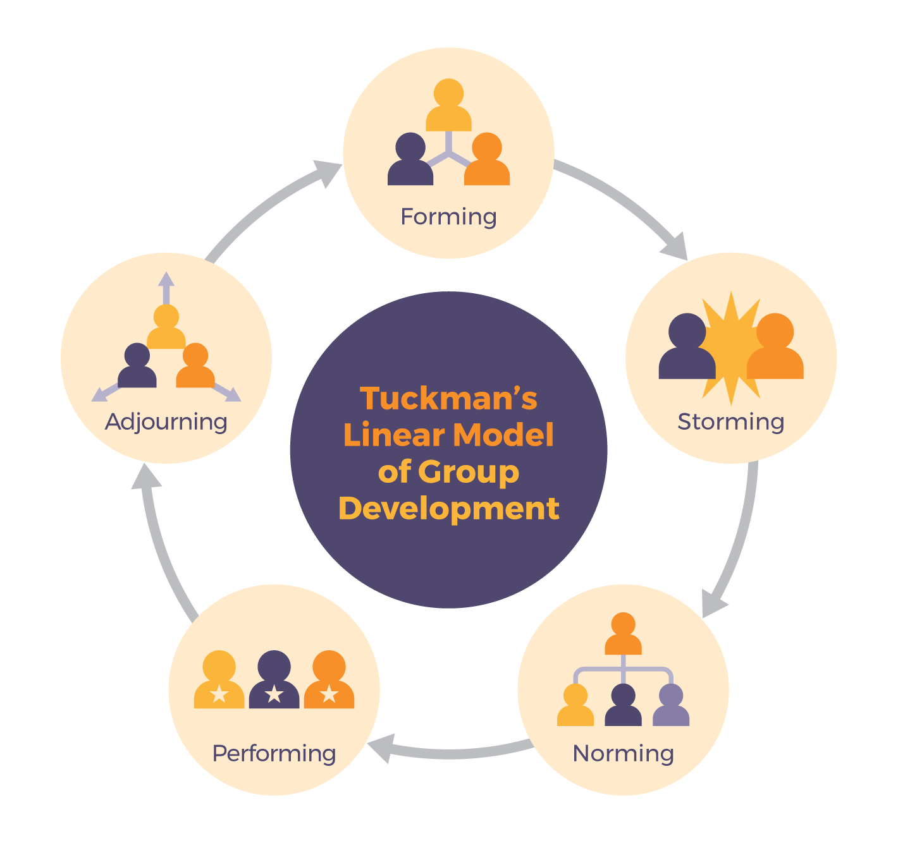
Figure 2: The Stages of the Tuckman’s Model (Last, 2019).
(Tuckman, 1965, p.389) suggests that the third phase of this model ‘Norming’ is the development of group cohesion and describes this part of the model as being where group members accept the behaviours and thoughts of others team members and that the group becomes one by its member acceptance of others.
It is possible that some teams will not be able to function within the Tuckman model. Tuckman’s (1965, p.384-399) research suggests that in few cases, a team may not be able to progress past the storming phase of the model and unable to progress onto norming. This can be due to members of the group forming opinions of one and other and voicing their opinions loudly, also some will talk about members with other members as a way to form alliances, this is in aid to define their role within the group. However, at this state, it would be the leads responsibility to resolve issues so the group can evolve from this state, however this is not always possible in few cases and for some teams, they are unable to pass this stage making them unable to function (St. Thomas Aquinas College, 2016). An example of this may be when an obvious leader does not come forward in the group and there are too many similarities in the members. This could cause them to clash more often. Due to this, the storming within the group will continue.

Belbin’s Team Role Model
Belbin’s model identifies 9 different roles that fall under 3 separate categories. Each role has clear behavioural and interpersonal strengths as well as weaknesses. These categories and roles are as follows:
Action orientated roles
- Shaper
- Implementor
- Completer/finisher
People orientated roles
- Coordinator
- Team worker
- Recourse investigator
Thought orientated roles
- Plant
- Monitor – evaluator
- Specialist
The model suggests that a successful team needs to have at least one individual from each of the above roles and that a team would be un-balanced if they had multiple people of on behaviour. Highlighting that teams’ weaknesses causing a team not to function. This is said to then cause those team members to compete for the tasks that they excel at rather than cooperate for the good of the team. The Belbin theory suggests that by having a deeper understanding of your position and role within a team, you will have an ability to manage your strengths and weaknesses and improve the way you contribute as a member. Aritzeta et al (2007, p.99) suggests that in the model, a role is defined by six factors: “personality, mental ability, current values and motivation, field constraints, experience, and role learning”. It’s suggested that Belbin that high performing teams need to have a balanced variety of all roles which will aid to increase the performance of the teams without such balance. (Aritzeta et al 2007, p.99)
Theory of Team Dynamics.
An explanatory theory of team dynamics is Team Dynamics Theory (TDT). TDT aims to explains part of the team dynamics variability and predict team outcomes (TO) by using four inputs which are cohesion (CO), team mental models (TMM), coordination (CD), collective efficiency (CE). TDT is describes as a systematic theory and does not attempt to encompass all team processes and nuances of team dynamics, and instead of finding a rule that covers everything, this theory attempts to find a link between the variables of TO, CO, TMM, CD and CE (Edson Filho, 2018).
Interpersonal Conflict within a Team Environment
(Donohue, 1992, p7 – p10) tells us that there are 7 different levels to interpersonal conflict. These 7 levels start at one where there is no conflict, however, this is said to be a danger if it is constant. This is due to people not being able to build their conflict skills up which when a conflict does arise, the conflict can grow out of control. Level two is described as “Latent conflict” which can be confused for no conflict; however, latent conflict is where a person senses there is an issue however the other person shows no sign of noticing or tries to deny there being an issue. A person in this state however may forget about the problem and revert to a non-conflict situation or the problem could instead manifest into conflict. Level three is as “Problems to solve”. This stage is described as people expressing their concerns and building the courage to face the problem so that hopefully compromises can be taken to solve the issue that is faced. At this level there are no personal attacks or arguments, and focus is retained on the problem. Level four is described as “Dispute”. This stage is described as having a problem to solve, however, includes a “needs centred conflict”. In this stage, individuals insert frequent personal attacks on others that are more destructive rather than constructive. When at this level, Donohue (1992, p7 – p10) described that the needs-centred dimension of the conflict takes precedence over the problem because people's priority is self-protection and not the original problem. To revert from this level of conflict, the writer tells us that “needs-centred issues” needs to be dealt with first and that people cannot talk about substance until they feel respected and dignified. Once this is done, constructive discussions can take place. Level five is described as “help”. In this stage as when people can no longer solve their own dispute because it’s gotten out of hand, normally due to the personal needs’ issues. This normally appears after many failed attempts of handling the dispute. Level six is described as “fight or flight”. In this stage, the parties involved get so angry they don’t think of asking for help. Part of this stage involved parties will either move to destroy the other or try and escape. When at this stage, it is common for persons to send out signals that they want a serious restructuring of the relationship. A way back from this level is for other members of the team to mediate so a solution can be found. Level seven is described as “intractable”. This stage is reached when persons are at fight or flight stage for long periods of time and sustaining the conflict seems to become more of a problem than solving it. The writer suggests that it could be possible to retreat to lower levels at some point if for example parties are successful in a mediation.
(Ilies, 2010, p.46) describes some of the main contributing factors to conflict may be covert hostility and verbal aggression. Interpersonal conflict is a negative interpersonal encounter characterized by a contentious exchange, hostility, or aggression (Ilies, 2010, p.46). It’s said that interpersonal conflict maybe an isolated incident or a common occurrence. Interpersonal conflict within a workplace can include rude behaviour and “respectful yet contentious disagreement”. The writer suggests that unless the individual who is experiencing this situation can take action to stop this, the unreleased energy induced by job stressors will manifest itself internally causing distress and strain (Ilies, 2010, p.46).
I can personally relate to seven levels of personal conflict and have on many occasions seen persons at various levels within this. However, in the professional environment, I don’t often see the level rise above level four of dispute and rarely see it go above level three of problems to solve. If the levels do however rise to conflict or fight or flight, this could have a compromising effect on the professional standards requirements within the police. For example, the policing code of ethics which state that an officer needs to be the following:
- Accountability - You are answerable for your decisions, actions, and omissions.
- Fairness - You treat people fairly.
- Honesty - You are truthful and trustworthy.
- Integrity - You always do the right thing.
- Leadership - You lead by good example.
- Objectivity - You make choices on evidence and your best professional judgement.
- Openness - You are open and transparent in your actions and decisions.
- Respect - You treat everyone with respect.
- Selflessness - You act in the public interest.
(College of Policing, 2014).
If conflict was going to reach levels of dispute, help, fight or flight, or intractable, I don’t believe that positive leadership skills will be shown, poor objectivity will be shown, respect will be lost and while working within the public sector, acting in this way would not be working within the public interest, and you’d wouldn’t be acting with full integrity. When leadership figures break down, so may the teams around them and hinder the performance of a team and lower the overall morale (Harvard Business School, 2019). By failing to meet these policing principles, you’d be failing to comply with professional standards. College of Policing (2014) states that officers must work withing the standards of professional behaviour which include, honesty and integrity, authority, respect and courtesy, equality and diversity, conduct, challenge and reporting of improper behaviour. I believe surpassing levels four through to seven, an officer will not be meeting these standards and again failing to comply with the professional standards of policing.
In conclusion, I believe at my level within the organisation, I have very little need to understand the process of team dynamics and why interpersonal conflict can occur. Also at this stage, I have not needed to have to implement any of the theories that I have discussed to form a team. I can only speculate on how well they work and try and find similarities within the teams that I already work within. I have discussed similarities in my team which is talked about in Donohue’s 7 levels of interpersonal conflict. However, as stated earlier, I personally haven’t had opportunity to see levels of conflict rise above four which is a dispute. I believe this is due to working in a professional organisation where conflict over this level would be considered un-professional by colleagues.

Word Count: 1,645.

Task 4
Relevant areas of the National Policing Curriculum:
Policing the roads, information and intelligence and conducting investigations.

Explain how information and intelligence can be used in the disruption of the more prevalent criminal activity (e.g. drug smuggling, human trafficking, child sexual exploitation, counterfeit goods, organised crime groups and ‘county lines’) by effective policing of the roads.

Outline how ANPR can be used as investigative resource when disrupting criminal activity.

1750 words (+/- 10%: include your actual word count at the end of each section)

ANSWER:

Information and Intelligence within Police
Information and intelligence can be collected in many ways, information can be obtained in calls from the public to police, intelligence is the information derived from multiple sources, graded, and evaluated for authenticity (Bryant, 2019, p.523).
Linking the effective use of roads policing with information and intelligence is vital in the disruption of high-level crime such as drug smuggling, human trafficking, child sexual exploitation, counterfeit goods, organised crime groups and ‘county lines’. A dedicated team within south wales police named the Territorial Crime Team are tasked with denying organised crime gangs the use of the road within the South Wales Police area (South Wales Police, 2021).
The National Intelligence Model (NIM) uses the 3 x 5 x 2 model which is used for the grading of intelligence. Using the grading, you are able to categorise intelligence into its groups. Firstly, the source of the intelligence needs to be graded deemed whether it is reliable, untested, or unreliable. Secondly, the acquisition of intelligence needs to be categorised to whether it is known directly, known indirectly but corroborated, known indirectly, not known or suspected to be false. The sharing of the data needs to be deemed whether lawful sharing is permitted or lawful sharing is permitted with conditions (National Anti-Fraud Network, 2021).
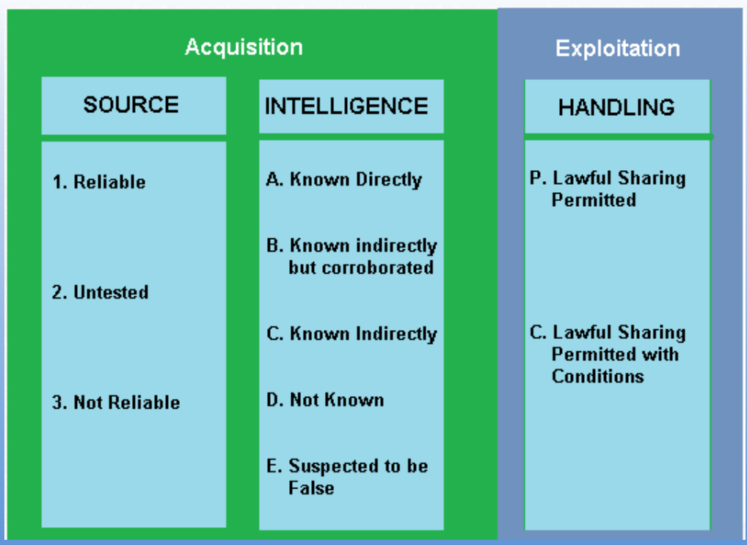
Figure 3: 3x5x2 Model (National Anti-Fraud Network, 2021).
Intelligence can be gathered in many ways, for instance, intelligence can be gathered through the public when they call police regarding their concerns for something, use of CCTV, covert human intelligence sources (CHIS), social networks, covert policing, surveillance and so on. (Bryant, 2019, p.522 – 535).
Once the intelligence is gathered regarding a related offence, intelligence officers are then able to combine what is called an ‘intelligence package’. Intelligence packs are fundamental to police operation planning. An ideal package would preferably contain highly accurate pictures and information of how crimes are carried out, in what locality, by whom, with what success, how the acquisitions from the crime are fenced, how money is laundered and by whom, what the likelihood is of repeat victimisation, and how the crime series is likely to develop (Bryant, 2019, p.535). This information is then likely to be disseminated to the wider policing force so that the intelligence can be acted upon. This is where the link would be brought to roads policing.
County lines
The National Police Chiefs Council (NPCC) define ‘county lines’ as:

“A term used to describe gangs and organised criminal networks involved in exporting illegal drugs into one or more importing areas [within the UK], using dedicated mobile phone lines or other form of “deal line”. They are likely to exploit children and vulnerable adults to move [and store] the drugs and money and they will often use coercion, intimidation, violence (including sexual violence) and weapons.”
(National Crime Agency, 2021).
An example of this is when drugs are moved between different parts of the country in aid to set up a supply chain and using vulnerable children and adults to do it.
Drug smuggling/trafficking
The National Crime Agency describe drug trafficking and smuggling as a major source of revenue of organised crime groups, and state that the number of deaths related to drug trafficking in the UK for the year 2016 are 2593 deaths. It is described that there are often deadly, competition between rival crime groups at all stages of class A drug production and supply (National Crime Agency, 2021)
An example of this is when drugs are smuggled into the UK by either ships, lorries, plane or any type of vehicle or on a person so that it can be sold later on down the line.
Human Trafficking
The charity Anti-Slavery International (2021) describe that human trafficking is the process of trapping people through the use of violence, deception, or coercion and exploiting them for financial or personal gain. This can mean that girls are groomed and forced into sexual exploitation and men are tricked into accepting risky job offers and trapped in forced labour building sites, farms or factories. This often is used with the production, transportation, and supply of drugs within the United Kingdom.
An example of this is a foreign national being tricked into moving from their country into the UK at the promise of a good paying job and then sent to work inside a cannabis factory with little or no pay at all and no freedom to leave.
Child Sexual Exploitation
Child Sexual Exploitation is the process of sexual abuse to children. It is when a child or young person is exploited and they’re given things such as gifts, drugs, money, status, or affection, in exchange for performing sexual activities. The children are often tricked into thinking they’re in a loving and consensual relationship. The NSPCC state that children and young people in gangs can be sexually exploited (NSPCC, 2021).
An example of this is young children being used for sexual gratification in a criminal organisation.
Counterfeit Goods Fraud
Counterfeiting goods a type of fraudulent activity whereby goods including fake clothes, bags, accessories and perfumes that imitate recognised brands, also poor-quality pirated copies of DVD’s, CD’s and computer games. It’s said that these items can then be sold in markets, in pubs and door-to-door or even online auctions or web marketplaces. They also state that the money which these products are bought with usually end up funding organised crime such as drug dealing (Action Fraud, 2021).
An example of counterfeiting goods is importing fake goods from countries outside of the UK and selling them within the UK and marketing them as branded items.
All of the above-mentioned areas make up and form organised crime and as of 2013, it was estimated that 36,00, organised criminals in 5,300 groups affecting the UK (CPS, 2017a).

How to disrupt criminality by effectively policing the roads
Police have certain powers which help them effectively police the road which are as follows:
Section 163 of the Road Traffic Act 1988 which gives a constable in uniform or traffic officer the power to stop any mechanically powered vehicle used on a road. (Section 163 Road Traffic Act 1988)
Section 4 of the Police and Criminal Evidence Act 1984 will either allow all vehicles or those which face a certain criterion to be stopped in a particular locality in order to locate an offender or witness involved in an indicatable offence (subject to authorisation of a police officer to the rank of Superintendent or above). The location of such road checks is integral to achieving this objective. It should afford maximum protection to both the public and police while giving little warning to the suspect and no escape routes (Section 4 Police and Criminal Evidence Act 1984).
Section 60 of the Criminal Justice and Public Order 1994 gives preventive stop and search powers (subject to authorisation of a police officer to the rank of Inspector or above) to the police where violence is anticipated in a particular location (Section 60 Criminal Justice and Public Order 1994).
With the effective use of these powers, a roads policing officer is able to effectively stop and disrupt high level criminality. Police and roads policing officers also have the use of automatic number plate recognition (ANPR) cameras which are able to automatically read number plates of vehicles on the road. It’s described as an “effective way of identifying vehicles and matching them against predetermined indices or flags” (College of Policing, 2013). The indices and flags that are mentioned, all comprise intelligence that the police agency hold on database. These can include names of persons that are linked to the vehicle, previous incident involvement information, insurance, mot and tax information, and also markers can be placed on ‘vehicles of interest’ by the previously mention intelligence officers if it is believed that a vehicle is linked to the high-level crime.
ANPR
ANPR is able to disrupt criminalities use of the roads by automatically reading number plates of vehicles allowing them to be compared against a database of records, provides tactical options to disrupt, prevent and detect criminals, identify a vehicle of interest based on the number plate it is displaying (College of Policing, 2013).
ANPR and its link to NRD
NRD which is abbreviated for Number Plate Reading Device is a technology which is linked to ANPR. These NRD’s can be used in static or movable locations, used in multi lane traffic, can be CCTV integrated, mobile locations and also covert locations (College of Policing, 2013).
The ability for NRD to be used on mobile units allows for police cars to use ANPR technology. ANPR systems which are fitted to police vehicles should remain active as much as possible to gather and read data to collect intelligence which would otherwise not be gathered (College of Policing, 2013). This allows roads policing units to be able to flag cars while mobile, without any human interaction to identify ‘vehicles of interest’. With doing so, this will allow for the most effective policing of the roads.
MAV systems who have been providing ANPR systems to police forces across the world and in the United Kingdom for the past 15 years state that ANPR is able help in the efforts to deter and disrupt criminality to a national level and is able to help tackle travelling criminals and organised crime groups and states that ANPR provides lines of enquiry and evidence in the investigation of crime throughout England, Scotland, Wales and Northern Ireland (MAV Systems Limited 2021).
Conducting investigations
Once an officer has reasonable suspicion that an offence has been committed or they reasonably suspect that an offence is in the process of being made, section 22 of the Criminal Procedure and Investigation Act 1996 (CPIA) states what an investigation is by describing it as ‘investigation conducted by police officers with a view to it being ascertained whether a person should be charged with an offence, or whether a person charged with an offence is guilty of it’ (Section 22 Criminal Procedure and Investigations Act 1996). Defined within the CPIA code of practice, it defines that the legislation also applies to if an officer believes that a crime may be committed, which is not clearly defined within the legislation (Ministry of Justice, 2015).
When an officer begins an investigation, that officer needs to ensure that they are acting in line with the CPIA Codes of Practice. It is understood that to ensure compliance with the code of practice, it must be ensured that investigators know when an investigation has begun, and that the police should primarily conduct the investigation however, the code also applies to anyone who isn’t a police officer that has been tasked with the investigation, the code also defines relevant material evidence in an investigation as any material which the investigator believes to have bearing on the case (CPS, 2017b).
Once an investigation is launched, it is encouraged that the investigator leading the investigation continues to use the National Decision Model (NDM) when making decisions within the investigation, however, it is also observed that the NDM may be better suited for circumstances where a one-off decision is required rather than the multiple decision required during an investigation (Bryant, 2019, p.543).
Conclusion
In conclusion, throughout this task, I have explained how a multitude of information and intelligence is gathered, evaluated, and made available for officer working on the frontline. I have explained how appropriate use of the national intelligence model is used and how it helps categorise the information thus gathered. I have explained the links between high level crime such as organised crime and county lines along with the offences that are normally committed within their meanings and how they can be effectively disrupted by appropriate use of roads policing. I have also outlined how ANPR cameras can be effectively used as an investigative resource in disrupting criminal activity.
Word Count: 1,890.

Task 5
Individual Learning Plan

ANSWER:

Knowledge, Skills and Experience Assessment

 | REQUIRED |  |  | RATING |  |  | DEVELOPMENT NEED
KNOWLEDGE | Low  1-4 | Med  5-7 | High  8-10  9 | Low  1-4 | Med  5-7  6 | High  8-10 | - Case File Assembly  I have picked case files as an area to which I can improve my knowledge as there are still numerous areas which I am still not knowledgeable in. I have also prepared few files for crown court which require alternative case documents than if it was to go to Magistrates Court. Due to being a response officer, I also haven’t had chance at dealing with a more complex investigation which requires extra knowledge for files.  However, due to the continuous changes that the CPS require, this has made learning case file skills extra difficult, but with extra focus on case file assembly, such as requesting training from the force, it should give me the knowledge required.
SKILLS | Low  1-4 | Med  5-7 | High  8-10  10 | Low  1-4 | Med  5-7  7 | High  8-10 | - Interviewing  I have picked interviewing skills as an area for improvement as there are many more skills to be developed in interviews. One extra area to improve in my interviewing skills is my note taking ability. I will correct this by researching note taking skills online and continued practice while interviewing.
EXPERIENCE | Low  1-4 | Med  5-7 | High  8-10  10 | Low  1-4 | Med  5-7  6 | High  8-10 | - Roads Policing  I have picked Roads Policing as an area to improve as there are areas to which I have had very little experience, such as issuing Section 59 Warning Notices or Seizing vehicles under section 165A of the Road Traffic Act. However, with increased attention on my Road Policing skills, I will be able to build the experience necessary.

Bibliography & References:
Action Fraud (2021) Counterfeit goods fraud, Available at: https://www.actionfraud.police.uk/a-z-of-fraud/counterfeit-goods-fraud (Accessed: 31 December 2021).
Anti-Slavery International (2021) What is human trafficking, Available at: https://www.antislavery.org/slavery-today/human-trafficking/ (Accessed: 31 December 2021).
Aritzeta, A. et al. (2007) ‘Belbin’s Team Role Model: Development, Validity and Applications for Team Building’ Journal of Management Studies, 44(1), pp. 99-118, DOI: https://doi.org/10.1111/j.1467-6486.2007.00666.x (Accessed: 23 December 2021).
Bryant, R. Et al. (2019) Blackstone’s Handbook for Policing Students, 14th edition, New York: Oxford University Press.
Channel 1 Creative Media (2020) Building Resilience [Video]. Available at: https://video-alexanderstreet-com.ezproxy.uwtsd.ac.uk/watch/building-resilience/details?context=channel:psychology (Accessed: 02 January 2022).
College of Policing (2013) Disrupting criminality, Available at: https://www.app.college.police.uk/app-content/road-policing-2/disrupting-criminality/#automatic-number-plate-recognition- (Accessed: 31 December 2021).
College of Policing (2013) National Decision Model. Available at: https://www.app.college.police.uk/app-content/national-decision-model/the-national-decision-model/ (Accessed: 19 December 2021).
College of Policing (2014) Code of Ethics, Available at: file://swp-rest.police.int/data/home/swp6704/Documents/University/Essay%20help%20documents/Harvard-eng_v.1.2.pdf (Accessed: 30 December 2021).
College of Policing (2015) Context and dynamics of domestic abuse. Available at: https://www.app.college.police.uk/app-content/major-investigation-and-public-protection/domestic-abuse/context/ (Accessed: 19 December 2021).
CPS (2017a) Organised Crime – Strategy, Available at: https://www.cps.gov.uk/organised-crime-strategy (Accessed: 07 February 2022).
CPS (2017b) Disclosure Manual: Chapter 1 – Introduction, Available at: https://www.cps.gov.uk/legal-guidance/disclosure-manual-chapter-1-introduction (Accessed: 01 January 2022).
CPS (2018) Admitting Evidence Under Sections 9 and 10 Criminal Justice Act 1967, Available at: https://www.cps.gov.uk/legal-guidance/admitting-evidence-under-sections-9-and-10-criminal-justice-act-1967 (Accessed: 20 December 2021).
Dijk, A.V., Hoogewoning, F., and Punch, M. (2019) ‘Running on Empty: reinvigorating policing through ‘what matters’’, Perspectives on policing, Issue 5, Available at: https://www.police-foundation.org.uk/2017/wp-content/uploads/2010/10/perspectives_on_policing_running_on_empty_FINAL.pdf.pdf (Accessed: 31 January 2022).
Donohue, W.A. (1992) Managing Interpersonal Conflict, pp.7-10, DOI: http://dx.doi.org/10.4135/9781483325873.n1 (Accessed: 29 December 2021).
Filho, E (2018) ‘Team Dynamics Theory: Nomological network among cohesion, team mental models, coordination, and collective efficacy’, Sport Sciences for Health, 15 (1), pp. 1-20, Available at: https://link.springer.com/content/pdf/10.1007/s11332-018-0519-1.pdf (Accessed: 22 December 2021).
Greater London Authority (2019) Assembly response to reports of "dangerous low" policing resources, Available at: https://www.london.gov.uk/press-releases/assembly/assembly-response-to-report-on-policing-resources (Accessed: 31 January 2022).
Harvard Business School (2019) Leadership under pressure: 3 strategies for keeping calm during a crisis, Available at: https://online.hbs.edu/blog/post/leadership-under-pressure (Accessed: 07 February 2022).
Healthy Learning (2015) Transforming Stress into Power: Balance for Resilience [Video]. Available at: https://video.alexanderstreet.com/watch/transforming-stress-into-power-balance-for-resilience. (Accessed: 02 January 2022).
HMICFRS (2015) PEEL: Police effectiveness 2015 (Vulnerability), Available at: https://www.justiceinspectorates.gov.uk/hmicfrs/wp-content/uploads/police-effectiveness-vulnerability-2015-south-wales.pdf (Accessed: 20 December 2021).
HMICFRS (2020) State of Policing, Available at: https://www.justiceinspectorates.gov.uk/hmicfrs/wp-content/uploads/state-of-policing-2020.pdf (Accessed: 02 January 2022).
HMICFRS (2021) Pandemic has intensified vulnerability and increased demand on police, Available at: https://www.justiceinspectorates.gov.uk/hmicfrs/news/news-feed/pandemic-has-intensified-vulnerability-and-increased-demand-on-police/ (Accessed: 02 January 2022).
Home Office (2020) Police Funding for England & Wales 2015-2021, Available at: https://assets.publishing.service.gov.uk/government/uploads/system/uploads/attachment_data/file/900017/police-funding-england-and-wales-2015-to-2021-hosb1620.pdf (Accessed: 02 January 2022).
Ilies, R. et al. (2010) ‘A within-individual study of interpersonal conflict as a work stressor: Dispositional and situational moderators’. Journal of Organizational Behavior. (32) pp.44–64, DOI: 10.1002/job.677 (Accessed: 29 December 2021).
Institute for Government (2019) Police, Available at: https://www.instituteforgovernment.org.uk/publication/performance-tracker-2019/police (Accessed: 01 February 2022).
Last, S (2019) Technical Writing Essentials, Available at: https://pressbooks.bccampus.ca/technicalwriting/chapter/understandingteamdynamics/ (Accessed: 23 December 2021).
Lockey, S. et al. (2021) ‘The impact of workplace stressors on exhaustion and work engagement in policing’, The Police Journal, pp. 1-17. DOI: https://doi-org.ezproxy.uwtsd.ac.uk/10.1177/0032258X211016532 (Accessed: 01 January 2021).
MAV Systems Limited (2021) Police and Security, Available at: https://www.anprcameras.com/anpr-solutions/police-security/ (Accessed: 31 December 2021).
McDaniel, J.L.M. et al. (2020) Policing and Mental Health, DOI: https://doi.org/10.4324/9780429470882 (Accessed: 01 January 2022).
Ministry of Justice (2015) Criminal Procedure and Investigations Act 1996 (section 23(1)) Code of Practice, Available at: https://assets.publishing.service.gov.uk/government/uploads/system/uploads/attachment_data/file/447967/code-of-practice-approved.pdf (Accessed: 01 January 2021).
National Anti-Fraud Network (2021) Intelligence Management 3 x 5 x 2, Available at: https://www.local.gov.uk/sites/default/files/documents/Intelligence%20Management%20Training.pdf (Accessed: 31 December 2021).
National Crime Agency (2016) Guidance on reporting routes relating to vulnerable persons. Available at: https://www.nationalcrimeagency.gov.uk/who-we-are/publications/45-guidance-on-sars-reporting-routes-relating-to-vulnerable-persons/file (Accessed: 19 December 2021).
National Crime Agency (2021) County Lines, Available at: https://www.nationalcrimeagency.gov.uk/what-we-do/crime-threats/drug-trafficking/county-lines (Accessed: 31 December 2021).
National Crime Agency (2021) Drug trafficking, Available at: https://www.nationalcrimeagency.gov.uk/what-we-do/crime-threats/drug-trafficking (Accessed: 31 December 2021).
NSPCC (2021) Child Sexual Exploitation, Available at: https://www.nspcc.org.uk/what-is-child-abuse/types-of-abuse/child-sexual-exploitation/ (Accessed: 31 December 2021).
Oxford Reference (2021) Team Cohesion, Available at: https://www.oxfordreference.com/view/10.1093/oi/authority.20110803102757913 (Accessed: 21 December 2021).
Police and Crime Commissioner (2019) Tackling Violence Against Women and Girls: a Joint Strategy. Available at: https://www.southwalescommissioner.org.uk/media/1367/2623-19-vawg-joint-strategy-final-30719.pdf (Accessed: 20 December 2021).
Police Federation (2019) Government must face facts - extreme stress in policing is real, Available at: https://www.polfed.org/news/latest-news/2019/government-must-face-facts-extreme-stress-in-policing-is-real/ (Accessed: 31 January 2022).
Section 163 Road Traffic Act 1988, c.1. Power of police to stop vehicles, Available at: https://www.legislation.gov.uk/ukpga/1988/52/section/163 (Accessed: 31 December 2021).
Section 2 Fraud Act 2006, Available at: https://www.legislation.gov.uk/ukpga/2006/35/section/2 (Accessed: 20 December 2021).
Section 22 Criminal Procedure and Investigations Act 1996, c.1. Available at: https://www.legislation.gov.uk/ukpga/1996/25/section/22 (Accessed: 01 January 2022).
Section 24 Police and Criminal Evidence Act 1984, Available at: https://www.legislation.gov.uk/ukpga/1984/60/section/24 (Accessed: 20 December 2021).
Section 4 Police and Criminal Evidence Act 1984, Road Checks, Available at: https://www.legislation.gov.uk/ukpga/1984/60/section/4 (Accessed: 31 December 2021).
Section 60 Criminal Justice and Public Order 1994, Powers to stop and search in anticipation of violence, Available at: https://www.legislation.gov.uk/ukpga/1994/33/section/60 (Accessed: 31 December 2021).
Section 9 Criminal Justice Act 1967, Available at: https://www.legislation.gov.uk/ukpga/1967/80/section/9 (Accessed: 20 December 2021).
Shane, J.M. et al, (2019) Stress Inside Police Departments, DOI: https://doi.org/10.4324/9780429297229 (Accessed: 01 January 2022).
Silverman MN, Deuster PA. (2014) Biological mechanisms underlying the role of physical fitness in health and resilience. Interface Focus, 4, pp. 1. DOI: http://dx.doi.org/10.1098/rsfs.2014.0040 (Accessed: 02 January 2022).
South Wales Police (2008) Adults at Risk, Available at: https://www.south-wales.police.uk/SysSiteAssets/media/downloads/south-wales/about-us/policies-and-procedures/english/adults-at-risk---english.pdf (Accessed: 20 December 2021).
South Wales Police (2021) Road Smart, Available at: https://www.south-wales.police.uk/police-forces/south-wales-police/areas/campaigns/campaigns/road-smart/ (Accessed: 31 December 2021).
St. Thomas Aquinas College (2016) Understanding Group Dynamics [Video]. Available at: https://www.youtube.com/watch?v=uL6x99-VSBA (Accessed: 24 December 2021).
Tuckman, B. W. (1965) ‘Developmental Sequence in Small Groups’ Psychological Bulletin, 63(6), pp.384-399, Available at: https://web-p-ebscohost-com.ezproxy.uwtsd.ac.uk/ehost/pdfviewer/pdfviewer?vid=5&sid=96e84c6c-1f2f-479b-8491-b1ccd6e5a5ce%40redis (Accessed: 23 December 2021).

