Big Data Report
Course – Web Development
Name - Liam Salter | Student Number - 1702256
2020
Table of Contents
1. Introduction. 2
2. Big Data. 2
2.1. What is Big Data? 2
2.2. The 4 V’s. 2
3. CAP Theorem. 3
3.1. What is CAP Theorem? 3
3.2. Compromise Examples. 3
4. Relational Databases vs NoSQL. 4
4.1. ACID. 4
4.2. BASE. 4
4.3. Relational vs NoSQL Contrasts and Comparisons. 4
4.4. Situations with strengths of both database types. 5
5. Zang Technologies. 5
5.1. Chosen NoSQL Database Evaluation. 5
5.2. NoSQL Database Implementation. 5
6. Conclusion. 6
7. Appendices. 7
7.1. Appendix 1. 7
7.2. Appendix 2. 7
7.3. Appendix 3. 8
7.4. Appendix 4. 8
7.5. Appendix 5. 9

Introduction.
In this report, the core subjects of Big Data will be discussed. This includes discussing what Big Data is, explaining what the 4 V’s mean. The CAP theorem will be discussed by detailing what the CAP Theorem is and what each compromise must be taken for each combination of the CAP Theorem implementation. Relational Databases vs NoSQL Databases will be discussed by detailing what is meant by ACID and BASE, contrasts and comparisons will be made between these 2 types of databases along situations which utilise strengths of both types of database. Finally, a NoSQL database will be chosen and evaluated for the fictional company Zang Technologies.

Big Data.

What is Big Data?
Big Data is a term with many definitions; however, the most used definition is derived from Gartner, circa 2001. “Big data is high-volume, high-velocity and/or high-variety information assets that demand cost-effective, innovative forms of information processing that enable enhanced insight, decision making, and process automation.” [1]. Simply, Big Data is a term for large, highly complex data sets from new data sources. These data sets are so incredibly large that traditional data processing programs and software are unable to manage said data. However, with these incredibly large volumes of data, businesses can confront problems that were previously thought extremely difficult. For example, individual personalization for millions of users, and insight to billions upon trillions of pieces of data [2].

The 4 V’s.
The 4 V’s in Big Data are the 4 dimensions of Big Data, these being Volume, Variety, Velocity Veracity. The 4 V’s make up the reasoning why specialist software is required to handle Big Data. However, there is a 5th V, this being Variability, however, this is not commonly used compared to the 3 or 4 V’s.
The first V, Volume, refers to the amount of data is being stored and/or processed, which is now commonly higher than the terabytes and petabytes. In Big Data, extremely high volumes of low-density, unstructured is constantly being processed at any given time, as previously mentioned, conventional methods of data processing cannot handle this therefore new technologies have been created to handle these vast amounts of data. An example of an extremely large, high volume data set would be the amount of credit and debit cards transactions on any given day in Europe.
The second V, Variety is the primary reason where the “Big” in Big Data is derived from. Big Data as whole comes from a great many sources, however the 3 primary types of sources that data is grouped into are Structured, Semi-structured and Unstructured data. The variety in this data is another reason why specialist software is required to process and handle this data. An example of high variety data would come from CCTV footage, this is due to the video data, the audio data and the locations of where the footage was taken from.
The third V, Velocity, refers to the speed in which the data is generated, primarily real-time or near real-time streams of data. High velocity data is data that is generated at such a high speed that it makes up another reason why specialist software is required to handle Big Data. An example of high Velocity data would be Twitter posts, Facebook messages, YouTube videos etc.

The fourth V, Veracity, refers to the overall quality of the data that is being gathered and analysed. There are two distinct types of Veracity in big data, High Veracity and Low Veracity. High Veracity data is data that has many records that are relevant and is important to analyse, as it holds meaningful data which will add the overarching results. Low Veracity data on the other hand is data that contains large quantities of irrelevant data that would add nothing to the overarching results. The meaningless data is known as noise in Big Data. An example of High Veracity data would be data gathered from a medicinal trial [3].
The fifth V, Variability, refers to a few factors, one of these factors being the amount of inconsistencies found within the data that has been gathered, these inconsistencies must be identified with software before being considered meaningful and before any analysis can occur on the data [4]. Another factor of variability within Big Data is that the meaning of data is constantly changing, and data can be interpreted in different ways. A real world example of this would be that in a game show, a question has a correct answer, however that answer can be worded in many different ways but still be correct [5].

CAP Theorem.

What is CAP Theorem?
Previously, when more data needed to be stored or processing power needed to be increased, the answer to this problem was to take the big iron approach and expand vertically, by getting more and more powerful machines to meet demands. However, with the introduction of distributed systems and advances in parallel processing, the new answer to solve these problems is to expand horizontally, this means acquiring more machines to perform the same operations in parallel. Many programs have been developed which utilise the horizontal expansion such as Zookeeper, Storm and most popularly Hadoop. However, to utilise these tools properly, the CAP theorem must be understood. The CAP Theorem is an acronym for Consistency, Availability and Partition Theorem. Simply, the CAP Theorem is an idea that a distributed database system can only utilise 2 of the available 3 ‘perks’ of CAP [6]. For example, if the distributed database system wanted to utilise Consistency and Availability, Partitioning would have to be sacrificed, as it could not be possible to utilise all three under the CAP Theorem.
The first part of the CAP Theorem is Consistency, this means that there are consistent copies of the data across all available nodes. Practically, if a read operation was performed, the value of the most recent write will be returned by all available nodes.
Secondly is Availability, this means that the distributed system must remain operational 100% of the time. Also, it means that a every request that is made against the system must guarantee a response even if the response was a success OR a failure.
Finally, the last piece to the CAP Theorem is Partitioning, this means that if a part of the network fails, consistent data will still be available. A distributed database system that is partition tolerant can withstand a significant amount of network failure, on the condition that the entire network does not fail [7].

Compromise Examples.
The first compromise that can be made in accordance with the CAP Theorem is that Consistency is sacrificed. The benefit to sacrificing consistency in a distributed system is that customers receive faster responses as there is no need to wait for the backup server to confirm that a backup has taken place. However, the drawback to this is that if the primary server goes down and the copy to the backup server also fails, this means the wrong data will be sent to the customer. A query sent to the backup server now provides incorrect information as the changes made to the primary were lost, this means the data is now inconsistent.
The second compromise that can be made is that Availability is sacrificed. The benefit to this is that a two-stage commit can be applied so that the customer does not get a response until the data has been backed up, this means that the data is consistent. However, this now means that the most recent data is not available to the customer until the backup server has completed the backup and has responded accordingly. This now means that if the acknowledgement fails, the data now becomes unavailable.
The final compromise that can be made in accordance with the theorem is that Partitioning is sacrificed. As partitioning is related to the inability to at least two servers being unable to communicate, this can be rectified by either allowing the servers to respond a query or by disabling a server and make the data unavailable to some users. However, partitioning, comparatively is less of an issue compared to the trade-offs of either consistency or availability [8].

Relational Databases vs NoSQL.

ACID.
In relational database terms, ACID is an acronym which stands for Atomicity, which means that there is a guarantee that either the entire transaction will succeed or none of it will, in the eventuality of a transaction failure. Consistency, which means that there is a guarantee that all available data is consistent, including all defined rules. Isolation, which means that all transactions will occur independent of other transactions and will not be affected by other transactions. Finally is Durability, which means that if a transaction is committed, it is guaranteed to stay in the system, even if the system suffers a failure immediately after the transaction [9]. ACID itself is a standard that was created to ensure that database transactions are processed in a safe and reliable manner. ACID also is the primary standard which relates to how databases go about recovering from a mid-transaction failure. This means ACID prioritises Consistency over Availability [10].

BASE.
In NoSQL database terms, BASE is the equivalent term to ACID for NoSQL database systems. BASE is an acronym for Basically Available, which means that even if a node in the system fails, another node will have the data available for queries to be executed on it. Soft-state, which means that the state of the data can change over time, even without the data being directly changed, this is due to eventual consistency. Finally, there is Eventual Consistency, this means that if a server cluster fails, the NoSQL database system will still provide an answer and eventually will have consistent data [11]. BASE, like ACID, is a standard that was created to assist in certain database operations. However, unlike, ACID, it is a standard which prioritises Availability over Consistency. BASE was derived from the CAP Theorem where consistency is sacrificed, and eventual consistency takes its place [12].

Relational vs NoSQL Contrasts and Comparisons.
One contrast between the two types of database is that NoSQL databases are schemaless, this means the programmer is allowed the freedom of being able to construct how the database handles, stores and processes data, compared to a premade schema based system where pre made rules and definitions must be followed for the database to function properly. However, there is a downside to this whereas a schema must be built from the ground up, unforeseen problems and bugs can occur down the line, however this can be mitigated through following theorems such as the CAP Theorem. A comparison between how both types of database can be made about how they go about storing and handling data, which relates to the previous statement. NoSQL databases can be built around data in a very individual way, such as Key/Value Pair databases, Document based databases, Graph based databases, Column Family databases and so. This allows heavy customisation on how data can be stored, handled, processed etc. In comparison to SQL, where certain pieces of data can be stored, there are relational rules that must be followed, there must always be rows and columns etc [8].

Situations with strengths of both database types.
There is a form of database which allows for the combination of relational and NoSQL databases, this is known as a Hybrid Database. Hybrid Databases offers the combination high performance main memory based processing along with the incredibly large storage capabilities of physical, on-board storage [13]. See Appendix 1 for a diagram for a Hybrid Database. An example of how a Hybrid Database could be implemented is to enhance ERP Solutions through using a Document Database. ERP Solutions primarily are relational base database systems, which means they lack the ability to let users to customise entry forms. However, by adding a NoSQL document database, users are now granted the flexibility they need. Because of this, the data will be now be stored as documents, and will now be ready for parameter changes which may occur in the future. Another example of how a Hybrid Database system could work is Fraud Detection and Prevention. Data such as web server data, credit card information, ports, gateways are stored in relational databases, but if the volume is substantial enough, there could be problems down the line, however, by adding a Column Family database, this would negate this problem as this type of NoSQL database is designed with fast writes in mind, as they are built for large volumes of data, read and write performance and high availability [14].

Zang Technologies.

Chosen NoSQL Database Evaluation.
The chosen NoSQL Database processing software is MongoDB. MongoDB was chosen as MongoDB is a Document based management system. A Document based management system was chosen as it can handle more complex data, in comparison to other forms of managements systems such as key/value pair databases. All related attributes are managed and stored within one overarching document object; This means that querying would be much easier. This would affect Zang Technologies as it would hold thousands of pieces of data, such as building information, product information, employee information etc [15].

NoSQL Database Implementation.
As seen in this image, this shows that a CREATE operation is being performed which is creating employee information. It is also creating a test loop which is creating 100 test fields. Please see Appendix 2 for the image of the CREATE operation being performed in code.
As seen in this image, this shows that a READ operation is being performed which is reading how many documents have been created and finding a specific document. Please see Appendix 3 for the image of the READ operation being performed in code.
As seen in this image, this shows that an UPDATE operation is being performed which is updating the name of an employee named John Jones. It will return a no update as there is no employee named John Jones. Please see Appendix 4 for the image of the UPDATE operation being performed in code.

As seen in this image, this shows that a DLETE operation is being performed which is deleting a field in the test document with the number of 55. Please see Appendix 5 for the image of the DELETE operation being performed in code.

Conclusion.
In conclusion, Big Data has been discussed by detailing what Big Data is along by detailing what are the 4 V’s are. The CAP Theorem has been discussed by detailing what the CAP Theorem is and what compromises must be made when following the CAP Theorem. Relation Database Vs NoSQL Databases have been discussed by detailing what is meant by ACID and BASE, the comparisons and contrasts between these two types of databases have been detailed and what type of situations both types of databases would excel in. Finally, a NoSQL database system was chosen and evaluated and implemented for a fictional company known as Zang Technologies.

Appendices.

Appendix 1.
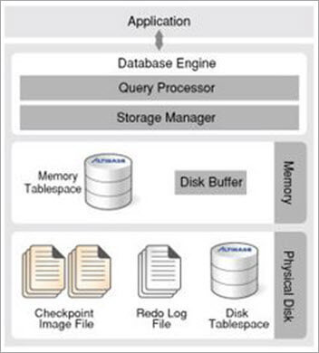

Appendix 2.
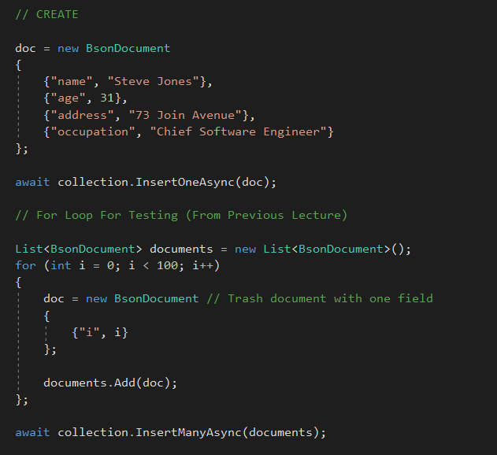

Appendix 3.

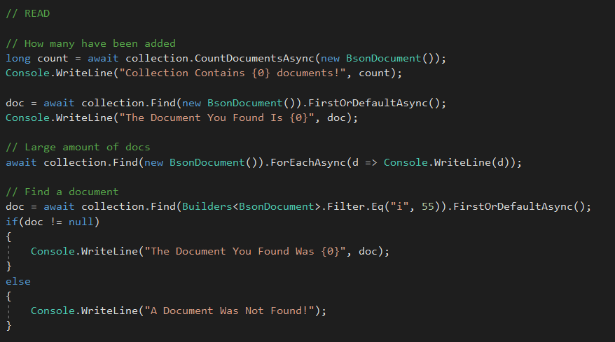

Appendix 4.

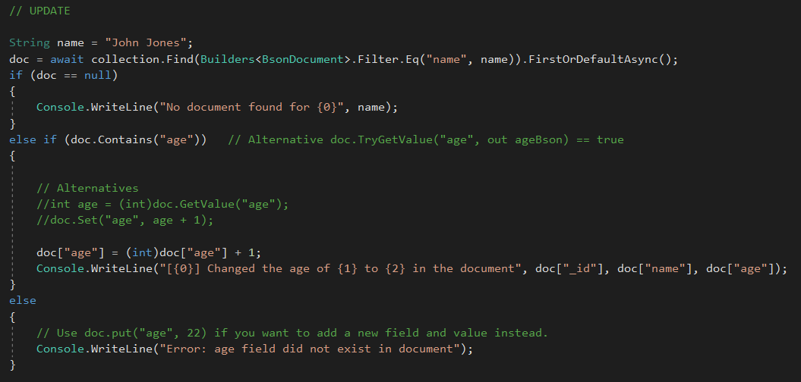

Appendix 5.

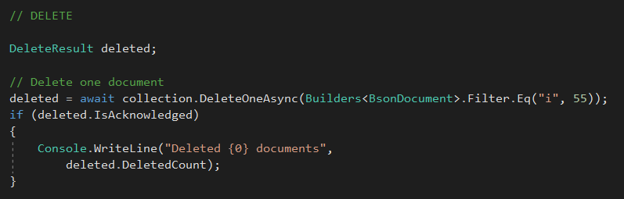

References

[1] | Gartner, “Gartner Glossary - Big Data,” Gartner, [Online]. Available: https://www.gartner.com/en/information-technology/glossary/big-data. [Accessed 25 March 2020].
[2] | Oracle, “What Is Big Data?,” Oracle, [Online]. Available: https://www.oracle.com/uk/big-data/guide/what-is-big-data.html. [Accessed 25 March 2020].
[3] | Big Data Framework, “The Four V's of Big Data,” Big Data Framework, 12 March 2019. [Online]. Available: https://www.bigdataframework.org/four-vs-of-big-data/. [Accessed 25 March 2020].
[4] | G. Firican, “The 10 Vs of Big Data,” Transforming Data With Intelligence, 8 February 2017. [Online]. Available: https://tdwi.org/articles/2017/02/08/10-vs-of-big-data.aspx. [Accessed 25 March 2020].
[5] | E. Mcnulty, “UNDERSTANDING BIG DATA: THE SEVEN V’S,” Dataconomy, 22 May 2014. [Online]. Available: https://dataconomy.com/2014/05/seven-vs-big-data/. [Accessed 25 March 2020].
[6] | S. S. Nazrul, “CAP Theorem and Distributed Database Management Systems,” Towards Data Science, 24 April 2018. [Online]. Available: https://towardsdatascience.com/cap-theorem-and-distributed-database-management-systems-5c2be977950e. [Accessed 25 March 2020].
[7] | N. A. L. Seth Gilbert, “Perspectives on the CAP Theorem,” NUS | MIT, 2011.
[8] | M. Dacey, 1. Intro to NoSQL, Swansea: UWTSD | Mike Dacey, 2019.
[9] | R. Ajayi, Acid Properties, CAP Theorem & Mobile Databases, Colorado: Colorado Technical University, 2015.
[10] | Database Guide, “What does ACID mean in Database Systems?,” Database Guide, 20 June 2016. [Online]. Available: https://database.guide/what-is-acid-in-databases/. [Accessed 26 March 2020].
[11] | M. Dacey, 3. Batch Layer, Swansea: UWTSD | Mike Dacey, 2019.
[12] | B. M. Sasaki, “Graph Databases for Beginners: ACID vs. BASE Explained,” Neo4J, 13 November 2018. [Online]. Available: https://neo4j.com/blog/acid-vs-base-consistency-models-explained/. [Accessed 26 March 2020].
[13] | Altibase, “WHAT IS A HYBRID DATABASE?,” Altibase, [Online]. Available: http://www.altibase.com/product/what-is-a-hybrid-database-2/. [Accessed 26 March 2020].
[14] | A. Maislos, “Hybrid Databases: Combining Relational and NoSQL,” Stratoscale, 30 March 2017. [Online]. Available: https://cdn.softwaretestinghelp.com/wp-content/qa/uploads/2019/11/Hybrid-database.jpg. [Accessed 26 March 2020].
[15] | M. Dacey, 3a. Intro to Document Databases, Swansea: UWTSD | Mike Dacey, 2019.

