
Programme | Master of Business Administration
Module Name | Marketing Management
Module Code | LCMB7024
Assessment Title | Assessment component 1: Marketing Environment Analysis
Topic | Marketing Environment Analysis of Pioneer and Follower Organisations in the Electric Vehicle Industry: A Comparative Study of Tesla and BYD
Student Name | Vivekananda Reddy Singireddy
Student ID | 2529561
Lecturer | Laila Maazouz  Dian Mayasari
Word Count | 2750 Words
Submission Date | 23-03-2026

Table of Contents
1. Introduction 3
2. Industry Context and Company Overview 3
2.1 Electric Vehicle Industry Overview 3
2.2 Tesla – Pioneer Organisation 4
2.3 BYD – Follower Organisation 5
3. Task 1 – Macro Marketing Environment Analysis 5
3.1 Macro Factor 1: Technological Advancement 6
3.1.1 Impact on the Electric Vehicle Industry 6
3.1.2 Opportunities and Threats for Tesla 6
4. Task 2 – Strategic Responses of Tesla and BYD 9
4.1 Tesla Strategic Response 9
4.2 BYD Strategic Response 10
5. Comparative Evaluation 12
6. Conclusion 14
6. References 16

List of Figures
Figure 1 Global Electric Vehicle Sales Growth 5
Figure 2 BYD Surges Past Tesla to Become World's Leading EV Brand 6
Figure 3 Tesla Differentiation Strategy Fit 10
Figure 4 Ansoff matrix principles 11
Figure 5 Tesla vs BYD Global EV Deliveries Comparison 15

List of Tables
Table 1 Strategic Framework Comparison 9
Table 2 Ansoff Growth Strategy Comparison 10

1. Introduction
In the context of the electric vehicle (EV) industry, which is evolving rather swiftly, one of the extremes of innovating a competitive edge is the first-mover (pioneer) presence, and the other one is a fast-follower. Cirik and Makadok (2023) define the first-mover advantage as the capacity of a first mover in the market to gain market share, technology and customer loyalty before new entrants, and it is commonly achieved through preemptive investment into innovation. Fast followers, on the other hand, capitalize on the work of the pioneers, learn their errors, and there is a low chance of entering the industry, and focus on cost-efficiency and rapid expansion. The report consists of the critical analysis of the influence of two key Macro-environmental factors, the technological advancement and government policies/regulations, on Tesla as a pioneer/first mover, and BYD as a fast follower of the global EV market. Tesla has been a leader in the high-performance EVs and software ecosystems in comparison to BYD that has been a leader in terms of vertical integration and cost leadership to capture huge volume with a specific focus on price-sensitive segments (Belsare, 2025). These two companies are the most suitable contrast that should be used in the analysis of pioneer-followers as they can be contrasted in terms of the strategic approach and the resulting position within the world market Tesla provides the lead with its superior innovations, and BYD provides the mass-market lead (Liu et al., 2025). The report assesses the impact of these selected macro factors (Task 1), and subsequently evaluates the strategic reactions of both of these firms in references to Porters Generic Strategies and Ansoff Growth Matrix (Task 2) and draws a comparative evaluation and finalizes long-term positions (IEA, 2025).

2. Industry Context and Company Overview

2.1 Electric Vehicle Industry Overview
In 2025, global BEV sales reached approximately 14–18 million units (depending on plug-in inclusion), with BYD holding ~19–20% market share and Tesla ~8–9% (Yahoo finance, 2026). The sector is strategically polarised between premium differentiation (high-tech, high-price) led by pioneers like Tesla, and cost-scale competition (affordable volume) pursued by fast followers like BYD (Wuttke and Whitfield, 2025).
(He and Hao, 2023).
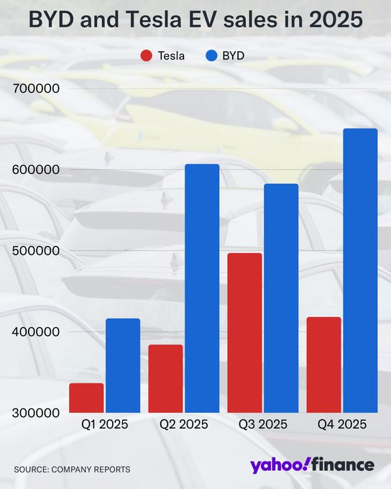
Figure 1 Global Electric Vehicle Sales Growth
Source: Yahoo finance, 2026

2.2 Tesla – Pioneer Organisation
Tesla is the first organisation within the EV business that has set the pace in terms of technological development, branding, and product diversity. With its emphasis on the high-performance automobiles and self-driving features, along with the built-in software, Tesla has been able to create a robust international presence, with substantial market shares in North America and Europe (Liu, Boothman and Graham, 2025).
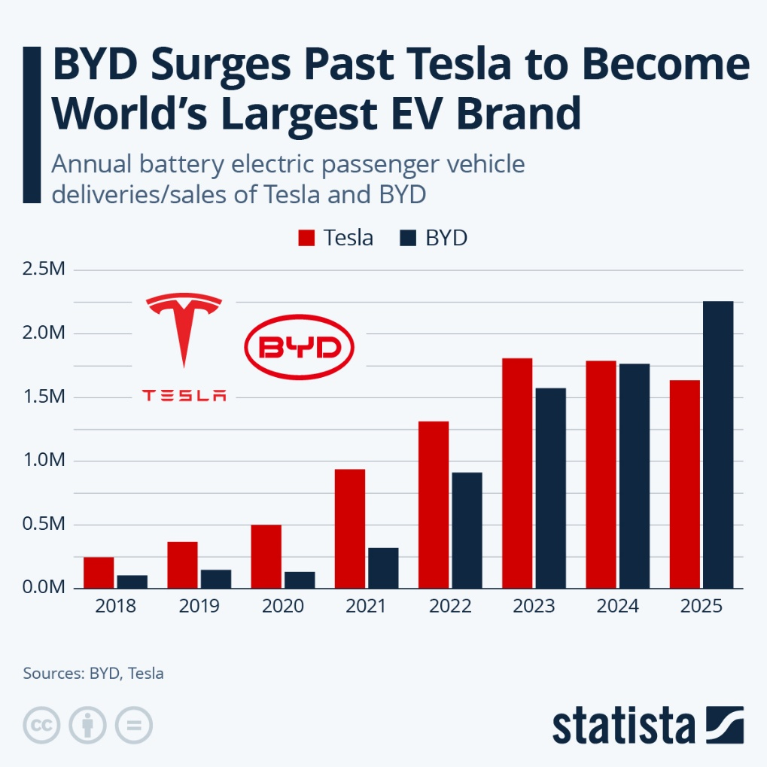
Figure 2 BYD Surges Past Tesla to Become World's Leading EV Brand
Source: Statista, 2026

2.3 BYD – Follower Organisation
The cost leadership strategy has helped Chinese manufacturer BYD to become a strong competitor. Vertical integration and economies of scale have allowed BYD to be a low cost producer so that it can be a consumer to the mass market (Li, 2024).
This makes BYD a typical fast follower: joining the business when Tesla showed the market demand, and quickly moving to low-cost production to take advantage of learning and government support, not copying it in its pure low-end form.

3. Task 1 – Macro Marketing Environment Analysis
PESTEL frameworks are used when analyzing macro-environmental forces of companies in a given sector (Belsare, 2025). PESTEL is an acronym that denotes Political, Economic, Social, Technological, Legal and Environmental, which are drivers of the outer environment in which companies are operating. The two macro-environmental forces; Technological Advancement and Government Policies/Regulations are the focus of this report since they are key determinants of strategies that Tesla and BYD can apply to emerge successful in the electric vehicle (EV) sector.

3.1 Macro Factor 1: Technological Advancement

3.1.1 Impact on the Electric Vehicle Industry
One of the greatest forces that affect the electric vehicle industry is technological advancement. Advancement in battery development, charging systems and auto-driving have contributed greatly toward enhancing the performance of the vehicles hence adoption of EVs by consumers. Efficiency in the battery has enhanced the range of travel and shortened the time spent sponsoring such vehicles making electric vehicles more practical to use on a daily basis. Besides that, there have been advancements of safety and user experience through digital technology like vehicle software and artificial intelligence.
Competition among the EV makers in the technological front has as well been enhanced with companies pumping a great deal of investment in research and development in attempt to lead technically. The constant evolution of battery production and energy control systems enables the companies to be able to differentiate their products and stay competitive (Shavkatovna, 2026). Moreover, the development of technologies has helped to increase the spread of EV manufacturing across the world at high speed and introduce new competitors on the market (Wuttke and Whitfield, 2025). With the technological capabilities becoming dynamic companies have to constantly modify their strategies in order to be competitive in this fast changing industry.

3.1.2 Opportunities and Threats for Tesla
The innovation with the electric mobility has opened up great opportunities to Tesla due to the technological development, whereby the company has been able to position itself as the global leader in innovation in the field of electric mobility. The Tesla company has excellent research and development as a core strength and this has made it have superior battery systems, autonomous driving, and an integrated software platform, which makes its vehicles stand out among others. These inventions have enhanced the prestigious brand image of Tesla and have solidified its status of an industry leader in EVs (Mei, 2025).
Nonetheless, there are also some challenges that Tesla faces with the technological development. The cost of research and development to ensure that it keeps up with the technological factors is too high and imposes high financial strain on the company. Moreover, other competitors are starting to copy technological innovations at Tesla more often, decreasing the technological edge of the company longer in terms of time. As an example, the gap in range/performance is reduced by competitors, as some 2025 models are equivalent or even superior to the specifications of Model 3/Y at a lower price (Liu et al., 2025). This erodes the differentiation moat of Tesla as compared to the cost advantage of BYD with premium buyers increasingly price-sensitive.
3.1.3 Opportunities and Threats for BYD
Another opportunity that BYD has generated is through technological progress, especially its capacity to manufacture batteries with great capabilities and vertical integration. BYD manufactures its batteries and parts hence the company is able to save on production and enhance the efficiency in operations. This technological potential enables BYD to manufacture electric vehicles with lower prices but at good performance specifications.
However, the vertical integration by BYD (in-house batteries, estimated at 17 per cent of the world market) transforms technological advances into cost-reduction of unit costs at scale, which makes it more adaptable as compared to Tesla depending on premium pricing (Wuttke and Whitfield, 2025).
3.2 Macro Factor 2: Government Policies and Sustainability Regulations
3.2.1 Impact on the EV Industry
The sustainability regulations and government policies have significantly contributed to the electric vehicle industry development. Most governments have also come up with policies that have the effect of curbing the levels of greenhouse gas emissions and support green transportation. Some of these policies involve providing financial subsidies on the purchase of EVs, tax subsidies, and policies that force manufacturers to make cars with lower emissions.
These regulation efforts have helped electric vehicles to be used more quickly spread globally and prompt automobile companies to invest in EV technology. Regarding renewable energy integration and the creation of charging infrastructure, environmental policies also facilitate the creation of an EV ecosystem. The role of government therefore plays a significant part as an external force that influences industry development and competition (Afshar and Shah, 2025).
3.2.2 Impact on Tesla
Tesla has had a lot of opportunities presented through government policies, which have promoted the use of electric vehicles across the world. EV incentives have boosted the Tesla car demand among consumers and have been used to expand to the new markets. Moreover, Tesla has a good brand image of being environmentally friendly, which compliments sustainability policies that governments have brought in a bid to minimize carbon emissions.
Policy changes also have the potential risks to Tesla, however. The subsidy cut or the abolishment of EV in some areas might decrease the number of consumers and influence the sales results. Besides, geopolitical unrests and regulatory limits in foreign markets can limit the international expansion of Tesla. The increase in Tesla sales of approximately 9 per cent in 2025 is an example of increased vulnerability to policy changes, as subsidies have been phased out in Europe in recent years and tax breaks revised in the U.S, which can affect the company (Statista, 2026).
3.2.3 Impact on BYD
BYD has also received a lot of help due to government policies, especially in the Chinese market where the government assisted to a lot in the development of domestic EV companies. BYD has been able to grow production, market share quite quickly using the financial incentives, industrial policies and investments in infrastructure. This has made the Chinese electric vehicle manufacturers achieve massive influence globally in the electric vehicle sector (Hossain, 2024).
However, the problem of international regulatory barriers and trade restrictions is also encountered by BYD when it enters into international markets (Gong, 2025). The variation in environmental standards and legal requirements of different countries can raise the complexity of operations and influence the international population growth plans. The company should thus be keen not to offend international regulatory frameworks in order to maintain its growth path.

4. Task 2 – Strategic Responses of Tesla and BYD

4.1 Tesla Strategic Response
Porter’s Generic Strategy
The differentiation strategy is the key strategy that Tesla uses to sustain its competitive edge in the electric car market. Tesla can distinguish from the competitor by providing to its customers high-technological innovation, high-brand positioning through autonomous driving systems, high-performance battery technology, and integrated software platforms. This differentiation strategy makes Tesla be able to set high prices and sustain a solid brand in the world markets. The innovation-based strategy enables it to react to technology changes in the EV business well. Tesla is technologically ahead of the pack and there is a constant flow of new product features which bring a value to the customers by prioritising research and development. Differentiation is also one of the decisive strategies that Tesla would need to remain in the market as competition heats up (Ikrama and Qumer, 2025).
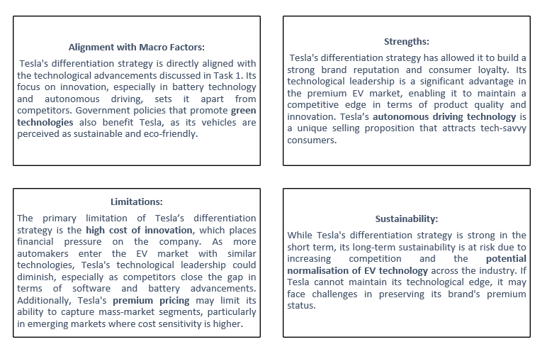
Figure 3 Tesla Differentiation Strategy Fit
Source: By learner
Ansoff Growth Matrix
The Ansoff Growth Matrix can also be applied to the analysis of the growth strategy at Tesla. The company has focused on development of the market through expansion into international markets such as those in Europe, and Asia. This plan has helped Tesla reach more new customers in the world and penetrate new markets.
Tesla is also interested in product development where new models of vehicles and energy products are launched. The latest developments that have taken place are new product releases through the unveiling of the Cybertruck and cutting-edge energy storage principles, clearly showcasing the desire of Tesla to broaden its technological base and range of products. These plans will enable Tesla to ensure its long-term growth and competitive position in the EV market.
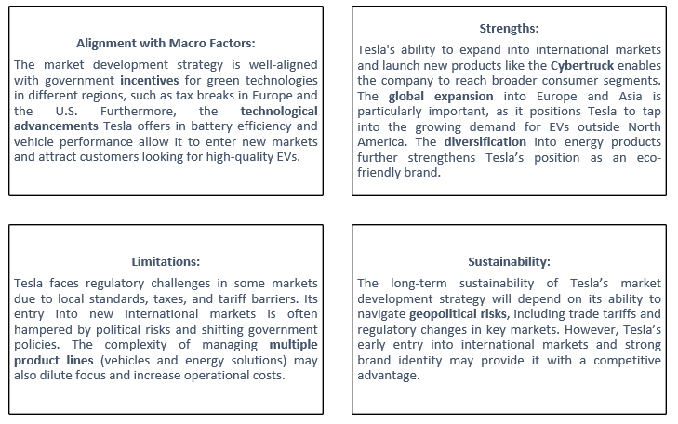
Figure 4 Ansoff matrix principles
Source: By learner

4.2 BYD Strategic Response
Porter’s Generic Strategy
BYD mainly adheres to the cost leadership strategy with differentiation aspects. The company takes advantages of the capacity to manufacture in bulk and vertical integration to make electric vehicles affordable. Being able to manage the production and supply chains of batteries, BYD minimizes production expenses and attain an operation-effective procedure.
This low cost leadership business model enables BYD to focus on the masses market consumers and compete favorably with high end EV brands like Tesla. Simultaneously, technological innovation in battery systems and energy efficiency is another technological aspect, through which the company differentiates its vehicles. This mixed strategic model would allow BYD to increase its market share all over the world and fish with large-scale EV companies (Hao and Hao, 2026).
Table 1 Strategic Framework Comparison
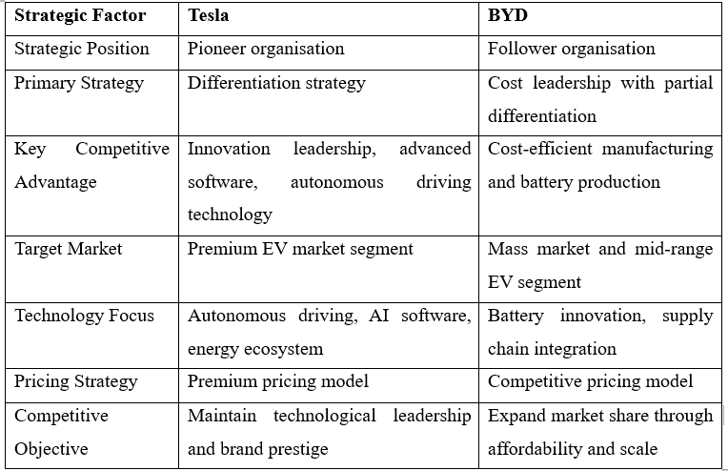
Source: By learner
Ansoff Growth Matrix
The growth strategy by BYD indicates a high level of penetrating the Chinese market where the company has gained a strong market presence. BYD has gained market share in its homeland through its price-cutter mode and quantity production.
Another strategy that the company has engaged in to develop its market includes internationalizing into other markets like Europe and Southeast Asia. Also, BYD is also working on product development by launching various EV models in various price segments that would allow the company to reach a wide range of consumers.
These strategic plans show how follower organisations may use advantageous operation efficiency and volume to compete with innovative companies.
Table 2 Ansoff Growth Strategy Comparison
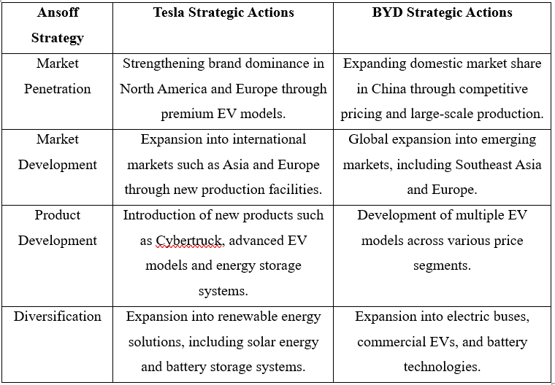
Source: By learner

5. Comparative Evaluation
The Tesla and BYD approaches to the electric vehicle (EV) market response in a different manner since they are a pioneer and follower.
Resilience to Policy Change:
Tesla is highly dependent on the green policy and government subsidies in the developed world (Statista, 2026). Alteration of policy or subsidy cuts would be catastrophic to the high-end pricing and sales of Tesla. Instead, BYD is more resilient due to its cost leadership strategy that is supported by vertical integration and positive support by the Chinese government. Since affordability is one of the priorities, BYD will be able to remain competitive even in case of any changes in policies.
Competitive Advantage Defensibility:
Technological technology in battery systems, autonomous driving and software integration have kept the company ahead of its competitor, but the advancement is declining with the rivals Lucid and conventional automakers closing the technological performance (Liu et al., 2025). On the other hand, BYD can guarantee a competitive advantage in the mass-market EVs with its cost leadership which offers high-quality and cheap cars. Despite that Tesla leads in technology, BYD is the leader in the production of affordable EVs in price sensitive markets.
Scalability:
Tesla has already gone international with Gigafactories at Europe and Asia, but the premium pricing model will have a limit point in the new markets. On the other hand, BYD has been the best in scalability by focusing on mass production at affordable prices. It has contributed to the rapid growth of BYD especially in the Southeast Asia and Eastern Europe as it can expand its production within a short period of time and remain cost effective (Reuters reports, 2026).
Threat of International Expansion:
Despite Tesla being in a position to enter into the international markets, it is susceptible to geopolitical risks and regulation. The domestic coverage and low pricing of BYD also helps the company to overcome international barriers especially in the new market.
Final Judgment:
In general, Tesla may remain a market leader on the higher differentiation of the premium and ecosystem brand in the market where innovation is valued, but BYD seems to be more competitive in the long-term growth due to scale effects in the price-sensitive and policy-driven markets, as pioneers lose value in technological catch-up (Wuttke and Whitfield, 2025).
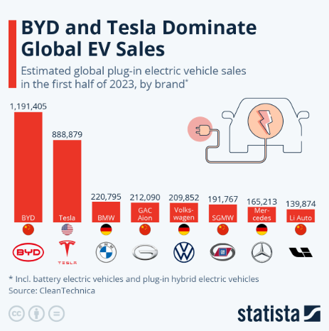
Figure 5 Tesla vs BYD Global EV Deliveries Comparison
Source: Statista, 2023

6. Conclusion
This report has demonstrated that the competitive environment in the EV industry is largely influenced by technological advances and government policies. Task 1 elicited the reality that with high battery/software development, pioneers like Tesla have an edge but fast-followers like BYD have a chance to reap volume-based economies of scale and integration and supportive policies (especially in China) are in the favour of volume players. Task 2 demonstrated that the differentiation and market / product development strategies sustain the premium positioning of Tesla, and the cost leadership and broad Ansoff penetration / development provide the potential global fast growth of BYD. Comparatively, BYD is more tolerant to policy change and has a greater scale capacity of the future markets, with Tesla continuing to dominate in the technology-based and high-margin markets. The first mover does not necessarily assure the ability to dominate in the long term, and victory cannot be achieved without changing the macro levels into defensible advantages. Lastly, BYD appears to be better placed to make long-term volume growth into a more competitive EV market, and Tesla has its future in ensuring ecosystem leadership is further entrenched and ecosystem breakthroughs are autonomous possibilities.

6. References
Afshar, M.Z. and Shah, Dr.M.H. (2025). Strategic Evaluation Using PESTLE and SWOT Frameworks: Public Sector Perspective. SSRN Electronic Journal, 3(1). doi: https://doi.org/10.2139/ssrn.5141505.
Belsare, H.V. (2025). PESTLE ANALYSIS. International journal of advanced research, [online] 13(02), pp.2320–5407. doi: https://doi.org/10.21474/IJAR01/20411.
Cirik, K. and Makadok, R., (2023). First-mover advantages versus first-mover benefits: What’s the difference and why does it matter?. Academy of Management Review, 48(3), pp.409-431.
Gong, Z. (2025). Tesla vs BYD: Who Performs Better in the Marketing Battle of EVs? Advances in Economics Management and Political Sciences, 182(1), pp.72–75. doi: https://doi.org/10.54254/2754-1169/2024.23660.
Hao, Y. and Hao, Y. (2026). The dynamics of competition in the Chinese electric vehicle market: Insights from BYD’s market evolution. International Journal of Industrial Organization, [online] 105, p.103256. doi: https://doi.org/10.1016/j.ijindorg.2026.103256.
He, W. and Hao, X. (2023). Competition and welfare effects of introducing new products into the new energy vehicle market: Empirical evidence from Tesla’s entry into the Chinese market. Transportation Research Part A: Policy and Practice, [online] 174(103730), p.103730. doi: https://doi.org/10.1016/j.tra.2023.103730.
Hossain, M. (2024). How Chinese Companies are Dominating Electric Vehicle Market Worldwide. California Management Review Insights. [online] Available at: https://cmr.berkeley.edu/2024/03/how-chinese-companies-are-dominating-electric-vehicle-market-worldwide/.
IEA (2025). Trends in electric car markets – Global EV Outlook 2025. [online] IEA. Available at: https://www.iea.org/reports/global-ev-outlook-2025/trends-in-electric-car-markets-2.
Ikrama, S. and Qumer, S.M. (2025). BYD Vs. Tesla: Who Will Win the Global EV Race? Case Folio-The IUP Journal of Management Case Studies, 25(3), pp.35–50. doi: https://doi.org/10.71329/casefolio/2025.25.3.35-50.
Li, Y. (2024). Comparative Analysis of Chinese New Energy Vehicle Enterprises. Highlights in business, economics and management, 24, pp.802–807. doi: https://doi.org/10.54097/2h4q2h28.
Liu, C.C., Boothman, S.G. and Graham, J.D. (2025). The Rise and Recent Decline of Tesla’s Share of the U.S. Electric Vehicle Market. World Electric Vehicle Journal, [online] 16(2), pp.90–90. doi: https://doi.org/10.3390/wevj16020090.
Mei, Z. (2025). Teslas Triumph in the Chinese Market: An Analysis of Opportunities and Challenges. Advances in Economics, Management and Political Sciences, [online] 189(1), pp.189–194. doi: https://doi.org/10.54254/2754-1169/2025.bl24134.
Reuters reports, (2026). Global EV sales growth likely to slow after 20% jump in rocky 2025, research firm says. https://www.reuters.com/sustainability/climate-energy/global-ev-sales-growth-likely-slow-after-20-jump-rocky-2025-research-firm-says-2026-01-14/
Shavkatovna, O.P., (2026). COMPETITIVE ADVANTAGE AND STRATEGY FORMULATION IN MANAGEMENT. Shokh Articles Library, 1(2).
Statista, (2023). BYD and Tesla Dominate Global EV Sales. https://www.statista.com/chart/30758/most-popular-plug-in-electric-car-brands/?srsltid=AfmBOorNpx4WcZisfjSzhurdRtexQO4_VPeif3o92Wmwr997ZvvTRuDn
Statista, (2026). BYD Surges Past Tesla to Become World's Leading EV Brand. https://www.statista.com/chart/33709/tesla-byd-electric-vehicle-production/
Wuttke, T. and Whitfield, L. (2025). China’s technological catch-up and leapfrogging in electric vehicles: A firm-level study of BYD and CATL. Progress in Economic Geography, p.100054. doi: https://doi.org/10.1016/j.peg.2025.100054.
Yahoo finance, (2026). BYD sold 2.26 million electric vehicles in 2025, surpassing Tesla and making it the largest EV market. https://x.com/YahooFinance/status/2007117455513047305/photo/2

