
MANAGEMENT ACCOUNTING
LCBB5002

ASSIGNMENT 2: WRITTEN REPORT
STUDENT NAME: AMNA MASAUD
STUDENT ID: 2113737
LECTURER: WINIFRED SORIBE
UNIVERSITY OF WALES TRINITY SAINT DAVID

TABLE OF CONTENTS

PART A 2
(i) Monthly control report 2
(ii) Performance report 2
(iii) Recommendations 4
PART B 5
Amana Ltd selling products directly on Amazon 5
REFERENCES 9

PART A

Monthly control report
Below has been developed by the assigned manager the monthly control report for Amana Ltd, a family-owned business, located in England. In the report have been included: original, fixed, and flexed budgets and the variances.

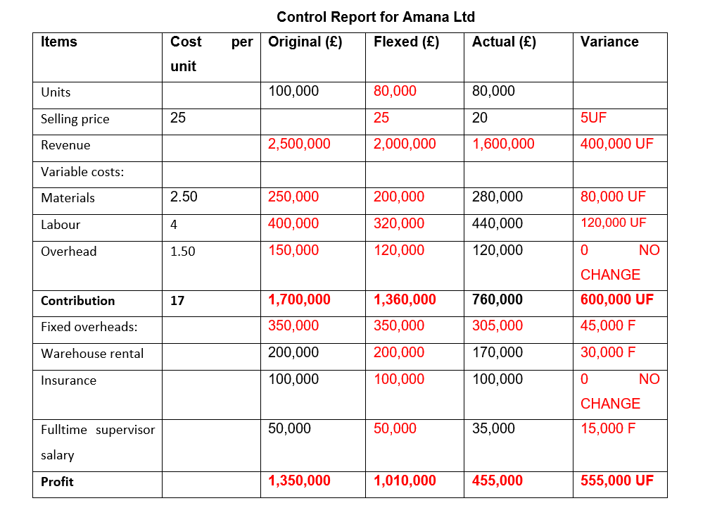

Performance report
According to Census (2021), COVID-19 pandemic had a major impact on
England’s tourism in 2020 and 2021 as the government implemented restrictions that were preventing tourism for large periods of time. As a nationwide lockdown has been announced on 23rd of March, all the non-essential shops had to close their doors. This was as well Amana’s case, hence why its revenue had been drastically affected. Being a non-essential business, the shops managed to be open only for few months during the summer of 2020 and then closed again for the winter period, until February 2021. Based on this, the manager appointed by Amana has developed a monthly control report where different aspects of company’s performance can be observed:
- Overall, there has been an unfavourable variance for revenue (£400,000),
labour (£120,000) and materials (£80,000). Because of the worldwide situation, the targeted revenue has not been achieved and the company had to spend more on the labour (many people didn’t want to expose themselves to the risk of catching the virus) and materials (the suppliers were increasing the prices due to the situation in China, where the products were manufactured). (GOV,2022)
- The selling price had to be lowered to £20/unit, hence why there has been an
unfavourable variance of £5/unit. This action has been taken in order to attract customers and increase the sales. In 40 years on the market, Amana never had to take such drastic decisions, but was their only chance of generating some income.
- The non-financial performance indicators, such as: supplier delivery times,
set-up times, defect levels have played an important role in Amana’s performance as there have major delays or cancellations because of the pandemic that were out of business’ control. (Atrill and McLaney, 2018)
- There have been favourable variances for the fixed overheads: the company
managed
to save £30,000 on the warehouse rental and £15,000 for the supervisor’s salary. Unfortunately for the long-term, these numbers will not be sustainable as the country will start to recover from pandemic’s impacts: the rent prices will increase, and people will request a pay rise. According to LandlordZone (2022), COVID-19 had a devastating impact on commercial properties and their rent rate has drastically decreased, hence why the lower prices. But, as the economy recovers, there will be higher demand for rental spaces, especially warehouses and the prices will go up. Amana’s needs to take this in consideration and allocate extra funds when developing the budget for the post pandemic period.
- There has been no change for the overhead and insurance: it is desirable to
keep them lower in order to obtain a lower overall cost.
- Because of the higher cost of variable materials, there can be observed a loss
in profit of £555,000.
By preparing a performance report for Amana’s there have been highlighted several advantages that will be beneficial for the business:
- It provides transparency for all the members of the company and allows them how the resources have been allocated.
- Can be discovered possible errors in the budgeting process.
- Can measure productivity in terms of reaching financial goals.
- The report is created by certain regulations that are helping the company to adhere to certain laws and standards. (Indeed, 2022)

Recommendations
For Amana to meet the challenges caused by the pandemic, needs to react in decisive and perceptive ways. It is time to seize the opportunities that are primordial for recovery. For this to be possible, there can be conducted a post pandemic review in order to collect insights and data of the situations encountered and use them to create an action plan that can enhance company’s value and build its resilience. (PWC, 2022)
As part of the action plan for Amana to recover post pandemic, there are few
recommendation that can have a positive impact in company’s development and wellbeing:
- E-commerce surged during the pandemic as its share of total retail sales
increased by two to five times across the world. (McKinsey, 2021) Taking this into consideration, Amana should take in consideration to open an e-commerce platform, where the souvenirs can become available to a wider market and attract potential customers.
Companies will start to compete for premises as they are looking to increase their workforce. Hence why, Amana’s CEO needs to secure the warehouse rental at a sustainable rate. For this to be possible, can increase the length of the contract in order to proof the lender that is a trustworthy tenant and secure a better rate. (LandlordZone, 2022)
- Instead of having a full-time supervisor position, the attributions can be spread between the
members
- Zero hours contracts can be implemented for the warehouse workers, benefiting of more
flexibility for the employees, but as well for the employer, managing to reduce the salary costs.
- By changing the supplier (from China) with a local one, Amana can save on import taxes,
transport and can reduce the delays encountered when products are brought from abroad.
- The company can adopt automation for the sorting and tracking the merchandise in the
Warehouse. By making this change, the warehouse employees can focus on different tasks and improve efficiency. (McKinsey, 2021)
- Some of the raw materials can be outsourced from low-cost countries, such Vietnam or
Cambodia.
- Keep a high management of cash taxes and obtain potential refunds, where possible to save
some of the money lost.
In conclusion, to achieve a broad-based recovery, Amana needs to move with the same willingness it used to respond to the changes and constraints imposed by the pandemic. For this to be possible, there should be enabled higher productivity growth, expansive consumption, and more motivated employees. As well digital and technology adoption can increase productivity and efficiency. The workforce disruptions need to be mitigated and offer support for the vulnerable workers in their career development. In terms of the suppliers, there should be developed strategies to digitize the supply chain, invest in sustainable operations and utilize automation that will align with Amana’s values. (McKinsey, 2021)

PART B

Amana Ltd selling products directly on Amazon
According to Semerádová and Weinlich (2022), digitization is using digital technologies to update and change business models and generate new opportunities, revenue, and value. COVID-19 pandemic highlighted the need of focusing on the business’ digital transformation which spins around customers, their needs, and requirements. The key drivers of digital transformation are optimization, operational flexibility, and customer experience, which together with the new sources of information and ecosystems are leading to the transformation of the business model. It is exactly what Mr. Amana needs to take in consideration in order to consolidate its business for the nowadays’ market. As the human element is crucial for the process, Amana decided to move only 50%of its sales online, still wanting to keep the shops from London open. However, although the pandemic is a very important topic worldwide, there are only few studies that are demonstrating the impact that is having towards retail’s evolution. There is likely that are going to be changes in consumers, retailers’ behaviour, and shopping patterns. Because of this, Mr. Amana needs to be very precocious and analyse which will be the costs involved in this transition and what choices to make.
At least for the first year of shifting towards the online sales, will be more beneficial for Amana Ltd if would be selling directly on Amazon as involves less costs, risks and the traffic will be higher compared with a brand-new unknown website that needs to generate traffic. Furthermore, will be analysed the costs involved in selling on Amazon, the advantages, and disadvantages and which will be the future perspectives for the business.
It is more convenient for Amana to sell on Amazon than to create its own website because Amazon takes care of all the maintenance, costs and management that need to be taken care when running an e-commerce platform. As well the costs involved with web hosting and redesigned can go towards other spendings as will not be necessary on Amazon. As all the platforms, there are positive parts, but as well negative that come when deciding to manage a business (Digital, 2022):
ADVANTAGES:
- Bigger amount of traffic (Amazon receives around 214 million unique customers on a monthly basis.
- Brand recognition, customer loyalty, more trustworthy than other similar platforms or websites
- There is no need of designing, hosting, and developing a website as everything is taken care of Amazon.
- Highly scalable: can track the demand, traffic, and update the inventory levels.
- High level of protection against fraud as the payments are managed directly by Amazon.
- Outsource storage, returns and customer service.

DISADVANTAGES:
- Huge amount of competition and sometimes only the price can make a difference until gaining enough positive reviews from the customers.
- Amazon has full control over the listings and can remove products, descriptions, listings, and flag when the rules are not obeyed.
- Subject to fees that are considerably reducing the profit margin if the terms and conditions have not been fully understood.
- Limitation in number of reviews that can be received daily or weekly in order to prevent the false reviews.

According to Amazon(2022), the platform is handling the hosting tasks, being responsible for:
- Maintaining the platform and Seller Central
- Keeping the products live and accessible
- Providing secure experience for the seller and buyers
- Taking care of the ads
- Delivering seller payment
- Providing support for the seller
- Sorting out customer support issues
However, except all the capabilities that Amazon has, Mr. Amana needs to take in consideration as well the relevant costs that will come if activating on this marketplace.
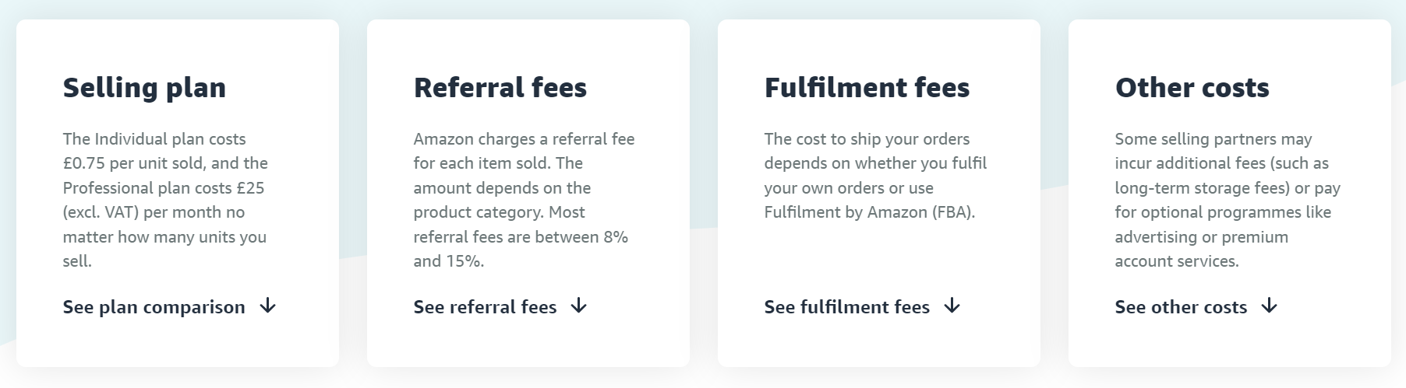
Figure 1: Amazon’s selling costs (Amazon, 2022)

As shown in Figure 1, Amazon has four main categories of fees:
- Selling plan: there are two plans available one for under 35 items sold and one for above.
For Amana the Professional one will be convenient as it facilitates the possibility of selling more than 35 items a month. It costs £25/ month and comes with several benefits: advertising the products, qualifying for top placement in items description pages, accessibility to use selling tools such as APIs and reports and the possibility of selling product from restricted categories.
- Referral fees: selling partners are paying referral fees on each item sold. Amazon is
deducting the applicable fee percentage that is deducted from the total sales price. The total sales price is composed of the amount paid the buyer (item price plus delivery or wrapping charges). As the souvenirs are part of ‘everything else’ category, the referral fee is 15.3%, with a minimum of £0.25/ item, as shown in Figure 2.

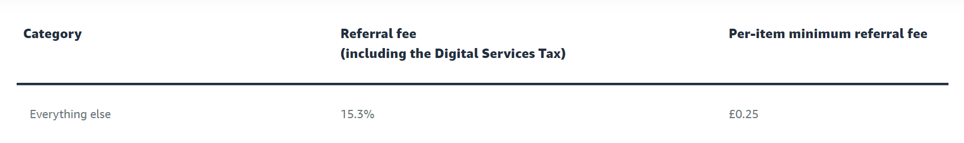
Figure 2: Referral fee (Amazon, 2022)

- Fulfilment fees: depend on whether the Amana decides to ship the products itself or use the
Fulfilment by Amazon to handle its logistics and offer Prime shipping for the products. In this case, Amana is using Amazon to handle the logistics and the cost is £50,000
- Other costs: may occur when calculating the full cost and might contain optional
programmes that are helping to increase sales. Additional selling fees are: inventory fees (if the store inventory is in an Amazon fulfilment centre), high-volume listing fees (apply if it exceeds 2 million SKUs in a month), refund administration fee (it an order is refunded, Amana will receive the amount of the referral fee paid for the items, minus the refund administration fee which is less than £5.00 or 20% of the referral fee. (Amazon, 2022)
In conclusion, according to Parry (2011), merchants who have been unsure in using third-party ecommerce platforms, should give Amazon a try as its sellers increased by 46% in the fourth quarter. Amazon’s stronghold on ecommerce represents a reason why sellers need to adhere the platform. By doing this, Amana will gain a lot of traffic and sales that can not be achieved in such a short period on a personal website. As Amazon is known as the largest online retailer, Amana will start to gain popularity and if in the future will decide to open its own website, people will know already the products and the name of the company. In terms of the cost to sell, it is based on pay-per-performance and is more flexible for Mr. Amana in the first year of activating online. However, no matter the size of the brand, Amazon remains a well-known platform of getting the product in front on audiences.

REFERENCES

Amazon (2022). Grow your business, cost-effectively. [Online]
Available at: https://sell.amazon.co.uk/pricing?ref_=sduk_soa_priov_n [Accessed 8 1 2023].
Atrill, P. and McLaney, E.J. (2018) Management accounting for decision makers. Ninth edition. Harlow: Pearson.
Census (2021). Coronavirus and the impact on the UK travel and tourism industry. [Online]
Available at: https://www.ons.gov.uk/businessindustryandtrade/tourismindustry/articles/coronavirusandtheimpactontheuktravelandtourismindustry/2021-02-15 [Accessed 8 1 2023].
Digital (2022). Selling on Amazon vs building your own website. [Online]
Available at: https://digital.com/best-ecommerce-platforms/selling-on-amazon-vs-building-your-own-website-for-ecommerce/
[Accessed 12 1 2023].
GOV (2022). Overseas Business Risk: China. [Online]
Available at: https://www.gov.uk/government/publications/overseas-business-risk-china/overseas-business-risk-china [Accessed 10 1 2023].
Indeed (2022). What Are Performance Reports? (With Benefits and Tips). [Online]
Available at: https://ca.indeed.com/career-advice/career-development/performance-reports [Accessed 12 1 2023].
LandlordZone (2022). What’s the outlook for UK commercial property, post pandemic & Brexit?. [Online]
Available at: https://www.landlordzone.co.uk/news/whats-the-outlook-for-uk-commercial-property-post-pandemic-brexit/ [Accessed 12 1 2023].
McKinsey, 2021. What’s next for consumers, workers, and companies in the post-COVID-19 recovery. [Online]
Available at: https://www.mckinsey.com/featured-insights/future-of-work/whats-next-for-consumers-workers-and-companies-in-the-post-covid-19-recovery [Accessed 7 1 2023].
Parry, T. (2011) ‘Selling on Amazon and Google Boosts Merchants’ Margins’, Multichannel Merchant [Preprint].
PWC (2022). Learning from the impacts of COVID-19 and leading the recovery. [Online]
Available at: https://www.pwc.com/gx/en/issues/crisis-solutions/covid-19.html [Accessed 10 1 2023].
Semerádová, T. and Weinlich, P. (2022) Moving businesses online and embracing e-commerce: impact and opportunities caused by COVID-19. Edited by T. Semerádová and P. Weinlich. Hershey, Pennsylvania: Business Science Reference.

