Assessment 1 – Changemakers: Building your Personal Brand for Sustainable Employment (BMSP5014/C)
This report is a three-piece e-portfolio consisting of a personal development plan, a curriculum vitae, and a zander letter. [This report will be formatted in print layout Microsoft Word .docx style]

Personal Development Plan – 700 words
In this module we have been learning about how to best utilise our skill sets to make ourselves as employable as possible, here I have chosen to write a personal development plan, which is framework for setting action plans for current and future goals and events. But first, it’s important to understand what it takes to write a good personal development plan. [1]
Setting Goals.
Setting reasonable achievable goals is something I have always aimed to do effectively, my goals in life are rather simple. At the heart of all of these, is the goal of freedom, I have always seen freedom as a desirable end point to all my work and life choices. I have always felt the need to remain free from employers, or my parents, or anyone else in life wishing to control my actions in some way. As an adult and a libertarian, I strive for total independence in my life.
Prioritising these goals
It’s very important for me to prioritise my goals, for example, I can’t totally prioritise my goal of retiring at the age of 20 as it would be unfeasible and impractical, I have a lot to achieve in my lifetime before I chose to quit working. A goal I have always put in the forefront of my mind is the goal of independence, even if it’s just little by little every day, for starters. I moved out of my parents’ house at age 18, I started university right after college in the same year, despite the shock of covid 19 and home learning, I kept ploughing ahead and I chose to make the most out of my youth. I landed my first job at age 15 and I’ve been working ever since. I prioritised my goal of making sensible investments when in 2021 I cashed out my entire cryptocurrency portfolio to buy my first car, I’ve held responsible and long-term employment since moving and in my second year of university I’ve worked hard enough to afford my dream car. These goals have always been priorities to me ever since I was young, however I can usually mark the start of this commitment to greatness to late 2016. [2]
Setting deadlines
Setting a deadline for a task is something I don’t often do, as many of my life goals simply cannot be measured in time as there are too many unforeseen factors that could slow me down or even speed me up. For example, I want to get a cut and muscular body, for appearance and health reasons. I’ve been going to the gym for over a year now with consistent and measurable success, I’ve seen substantial weight gain and muscle growth since I started, setting a deadline for this seems unreasonable as you can never really get too strong, and factors like my sleep irregularity and poor diet could certainly slow me down, going from being skinny to muscular also takes a longer time when comparing it to losing weight. While setting a deadline could be good motivation, it seems unpractical given the timescale of my task. [3]
Recognising threats and opportunities
I’m often late to exploiting random opportunities in life, whether economic or personal, like a slow lumbering bear I take my time to get moving and working. I missed out on a lot during covid, but I made up for a lot of it by taking up new skills and discovering my love for the great outdoors, instead of getting a summer job or going on dates, I took up hiking and fishing. I didn’t start this right away at the time of lockdown as during this time we couldn’t foresee that out 2-week lockdown would run over to 2 years.
Developing my skills and increase my knowledge
I am always dedicated to increasing my skills and relevant knowledge, its why I attend university and read so much.
Using my support network
I don’t have that much of a network as of right now. Mostly being just my classmates in university or my great teachers and professors, my family is a good network with whom I often rely on for emotional support.
Measuring my progress.
At this time in my life, it’s difficult to measure my progress, in a metaphorical sense of life, I’ve only just started, the only measure of success I can give myself right now would be to compare myself to my peers, some are doing better than me, and some are doing worse, but as it’s still early days I can’t rely on this envious self-comparison to help guide my future life making decisions.

[End of page]
Curriculum Vitae – 700 words
Harri Gerald Dendle
Telephone: 44 123456 78910 1600 Pennsylvania Avenue D.C.
Email: student2103763@uwtsd.ac.uk

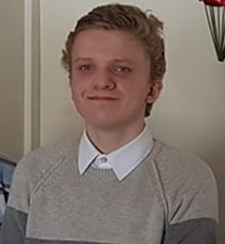
~ About me ~
I am a highly motivated and adaptable business student attending my second year of university at University of Wales Trinity Saint David in Carmarthen. My course is three years in duration so I would like to gain relevant first-hand business experience while I work to get my bachelor’s degree.
I have held many part-time jobs since I moved to attend university, I am a dedicated hard worker who is committed to improving my skillset and furthering my career development
For more information check out my LinkedIn
~ Relevant skills ~
- Dedicated and committed hard worker. I aim to please.  - I can be very flexible with my time. Available 5 days a week at any time of day. Even at night  - Skilled with technology. I’ve been familiar with computers my whole life and I took IT for 4 years, so I am skilled with electronic inventory systems and such  - I am great with people. I can effectively and communicate with my team and politely serve my customers | - I’m a fast learner. I can learn all the  ins-and-outs of the job in a matter of hours  - I’m highly motivated to improve my skills and test my work ethic  - Prepared for a long-term investment. I am looking to work 5 days a week for 3 years to support my studies
~ Education ~
GCSE and A-Level Business studies [2017 – 2021]
Having studied retail business and management for four years prior I have deep knowledge and academic experience of how businesses function and operate. Valuable knowledge and intuition when it comes to business operations. This was at Tonyrefail Community School

GCSE and A-level ICT [2017 – 2021]
Throughout my time in GCSE and sixth form I took an extensive introduction to computing in the business world. I am well versed and skilful in Excel spreadsheets and Access databases. I even built my own PC last year by myself. This was also at Tonyrefail Community School
Business and Management BA [2021 – 2024]
I am currently studying at University of Wales Trinity Saint David Carmarthen to get a Bachelor of Arts in Business and Management. My course is three years long with a dissertation at the end of it. And I am currently finishing my second year. When I get my degree, I will be looking to work in general business managerial environment.

~ Previous Experience ~
Tesco Carmarthen [2021 – 2022]
Working at Tesco in Carmarthen was my first dive into real employment, I would show up, punch my timecard, do my work and clock out 8 hours later. I worked primarily at the tills, however I was often moved around the store and given lots of other jobs to do. This is where I learned proper customer service and co-worker etiquette. This is also where I learned the general workplace mannerisms to take up to improve my quality and speed of work
Domino’s Pizza Carmarthen [2022 – 2023]
I currently work here, I really enjoy my job position, as a delivery driver I’m given a lot of freedom in my work in addition to many helpful benefits. Working here I get to experience all aspects of the job, serving customers, taking orders, solving problems, and functioning in a teamworking environment. I get along with everyone in our little store, and I enjoy hitting the road to fulfil orders in my car. I enjoy the extra work I am given outside of driving, folding boxes and cleaning dishes satisfies the inner task master inside of me.
[4] [5] [6]

Zander Letter – 600 words
Dear Harri from the past
The date today is the 12th of June 2024, and I am totally blown away by all the change I’ve put myself through over these past 13 months. It pleases me to say that I really took off running with adulthood, and became the man I’ve always aspired to be, lets touch briefly on all these little things you’ve wanted to do for so long.
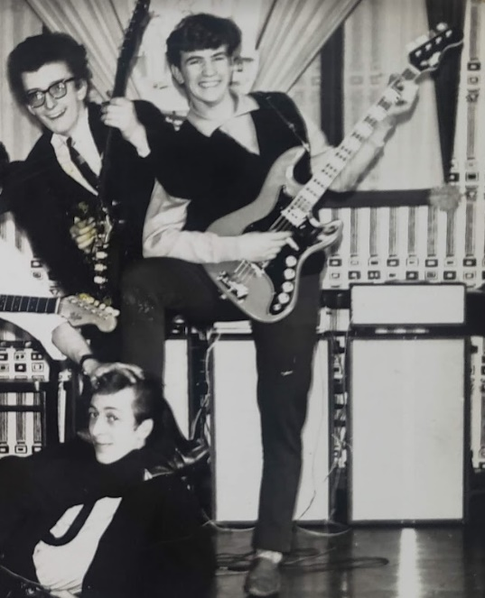
This one is definitely the most important to you, getting back into learning how to play guitar, and more specifically, electric guitar. Since you were a small boy, you’ve always aspired to become like the rockstars on the radio, and when you were 10 years old and still in primary school you got your first guitar along with lessons. An acoustic one, with sparse time for practise, it seems clear now that was a poor way to start learning, moving into a new comprehensive school you had sadly dropped all interest for this musical passion and had forgotten all about it up until your second year of university, it was a turbulent time in that old school, you know I’ve still not recovered from that awful place even now. But with the money you saved up from working over the summer of ‘23 you finally bought that Les Paul and started playing, Dad was so proud that you reclaimed that lost passion, because you remind him of his father, the 60’s beatnik who sadly passed away that summer of his pulmonary fibrosis. But don’t be sad, that part of him still lives on in you, and that passion is never going to wither, you finally have a true talent that you can show off and please the ladies with. [7]
Moving on though, the snowball of achievements keeps on rolling, lets shoot them as briefly as I can. Physical fitness, Throughout the year you made great strides in your weightlifting and fitness career, working in deadlifts, night-time cross country running and long-distance swimming. [8]
Secured that dream car, with all the money you saved up working your delivery job you finally scraped enough cash to buy that Mazda MX-5, and you finally got to sell that ugly red nugget i10, With the sleek topless sports car you found new friends in the car scene and learned a lot about proper and thorough car body and engine maintenance, it’s like a hobby on wheels that you can show off and get around in, and with style.
Got a job doing something you love, working all summer long as a delivery driver, you picked up a lot of cash to start your first ever business endeavour, with the opening of your car washing business that summer you raked in enough seed capital to truly invest in yourself and your future, by cleaning peoples cars professionally and efficiently at a great cost, its was such a great start to our thriving business career. With all the hard work you put in with those 3 years in Carmarthen, you really made yourself and your family proud. [9]
I know in future, you’ll write another letter to future me, telling me all about your new wife and your big new home, your thriving auto racing business and such, I really look forward to writing that when I get the time. For now, I trust that you’ll continue to work hard and push yourself into being successful in the all the areas you are determined to earn brilliance in.

References Cited:
- A Personal Development Plan (PDP) Guide & Template (2023) High Speed Training https://www.highspeedtraining.co.uk/hub/personal-development-plan-template/ - Accessed on 25-04-2023
- What is a personal development plan? (2023) CPD Online College – Michelle Putter https://cpdonline.co.uk/knowledge-base/business/what-are-personal-development-plans/ - Accessed on 25-04-2023
- How To Write A Personal Development Plan IN 4 Easy Steps (2021) upskill coach https://upskillcoach.com/blog/how-to-write-a-personal-development-plan/ - Accessed on 25-04-2023
- How to write a CV (2023) National Careers Service https://nationalcareers.service.gov.uk/careers-advice/cv-sections - Accessed on 25-04-2023
- How To Write A Good CV (2019) Jobs.ac.uk https://career-advice.jobs.ac.uk/academic/how-to-write-a-good-cv/ - Accessed on 25-04-2023
- How to write a CV (2021) Prospects https://www.prospects.ac.uk/careers-advice/cvs-and-cover-letters/how-to-write-a-cv - Accessed on 25-04-2023
- Transform Your Professional and Personal Life with the Art of Possibility (2000) Creativity at Work – Benjamin Zander https://www.creativityatwork.com/art-of-possibility-ben-zander/#:~:text=In%20writing%20their%20letters%2C%20Zander,written%20in%20the%20past%20tense - Accessed on 26-04-2023
- We’re all ‘A’ grade. Orchestra conductor Benjamin Zander’s secret for unlocking greatness (2014) Challenging Coaching – Ian https://challengingcoaching.co.uk/were-all-a-grade-orchestra-conductor-benjamin-zanders-secret-for-unlocking-greatness/ - Accessed on 26-04-2023
- Giving myself an A – the letter to myself (2021) (2021) Medium - Jakub Jurkiewicz https://jjurkiewicz.medium.com/giving-myself-an-a-the-letter-to-myself-2021-886b44946e63 - Accessed on 26-04-2023

