Provide a critical reflection of your roles and responsibilities within a wider archaeological project considering the requirements for professional and ethical judgement, and your relationships with other team members and other stakeholders

Introduction
Lewis and Gospel (2011) describe technical roles as involving specialised work in which the post-holder is trained and has developed the required skills through ample practical experience. However, in reality, technicians perform a much more diverse role, especially in Higher Education institutes, and must adapt not only their approach but their overall skillset to meet contrasting demands as and when they arise (MI Talent 2022). This has certainly been my experience so far as an Assistant Technician in Durham University’s Archaeology Department. Since starting the role in 2022, it has been a constant learning experience, and I have found myself engaging in numerous different aspects of archaeological research, through which I have developed a plethora of specialist and general skills. This critical reflection examines my first experience of being involved in a large-scale commercial project, considering both the positive and negative elements together with the many learning outcomes that arose from the situation. My role within this project undertaken by the Durham Archaeomaterials Research Centre (DARC Lab), compelled me to confront my approach to tasks by exploring my work ethic and response to responsibility. It also caused me to appreciate my role as a technician in a research-led university, whilst also interrogating the pressures that technicians face. Perhaps most importantly however, this project helped me understand the practicalities of research, and the need for a team to communicate effectively in order to achieve realistic, defined goals. These key impacts will be explored throughout the critical reflection of this rather complex multifaceted project, adapting Gibbs’ (1988) technique of structured debriefing to structure the essay. Ultimately, this essay endeavours to critically evaluate my role and responsibilities within this specific project, whilst also reflecting on the influence it has had on my professional and ethical judgement and my role as an archaeological technician in general.
Description of Situation and Response
In late 2022, I was asked by the manager of the DARC Lab (referred to as “the academic”) to cost equipment and consumables for a geoarchaeological method they agreed to undertake as part of a large incoming commercial contract. This particle size analysis (PSA) method was new to both me and the academic, and had not previously been carried out in our department’s labs. As requested by the client, PSA would be used to analyse soil samples from a British site, alongside phosphate analysis and organic matter content determination via loss on ignition (LOI). It was agreed between myself, the academic, and my line manager that I would support the necessary sample preparation where possible, due to the scale of the project. This provided a welcome opportunity to gain experience in geoarchaeology, which I was relatively new to at the time. I was excited to develop and expand my technical skillset whilst also improving my understanding of how large-scale lab-based commercial projects worked, so that I could support future projects in this lab and others. I was told my involvement would include drying and weighing samples, carrying out LOI analysis, and undertaking sample preparation for PSA; with the workload for the latter two tasks shared between myself and the academic.
With this agreed plan I felt ready and keen to begin the project, and started by creating a risk assessment for PSA (see supporting documentation) and drying the samples. However, issues soon started to arise. Departmental equipment planned to be used for PSA was found to be unsuitable and was either too expensive to replace or wasn’t available. Additionally, after I finished drying the 130 samples, the academic informed me they had agreed to analyse 250 more using LOI and phosphate analysis, which also needed to be prepared. This was frustrating, and I felt quite shocked by this unexpected increase in workload, not least because myself and my line manager had made it clear in planning discussions that we needed to know exact technical support requirements, so we could ensure I had capacity to take on the project whilst still fulfilling my other duties. The most pressing issue however, was that emergency roof repairs were about to begin and the Department’s extraction would be switched off, making it impossible to use the fumehood and furnace for PSA and LOI. Thankfully, we liaised with the Geography Department’s technical team, and were able to use their labs and equipment, with me taking responsibility for managing lab bookings and supervising archaeological work. Whilst this felt daunting at first, Geography’s technicians were incredibly helpful, kindly providing me with training and protocols for both analyses (see supporting documentation).
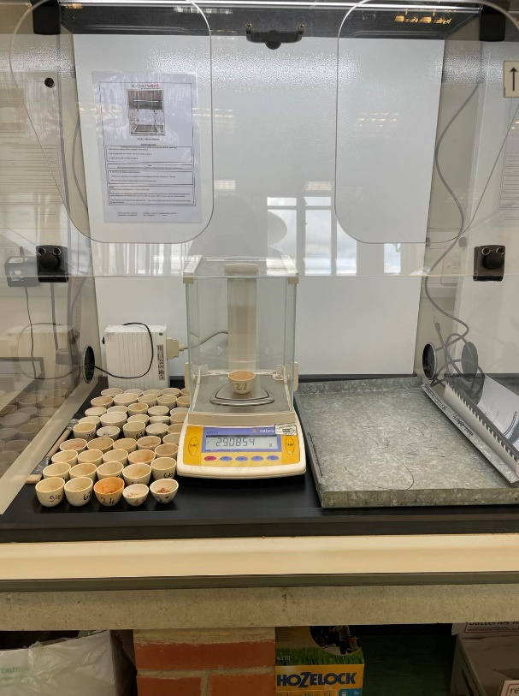
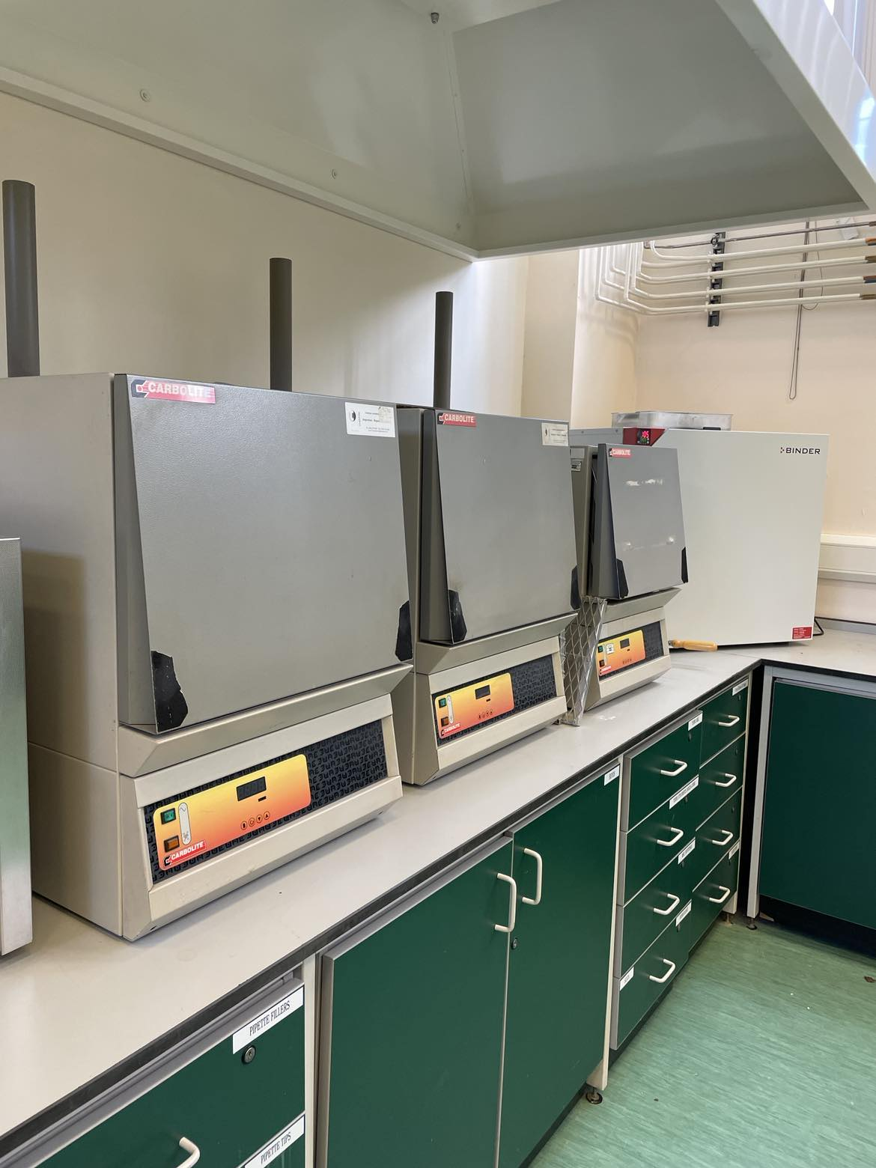
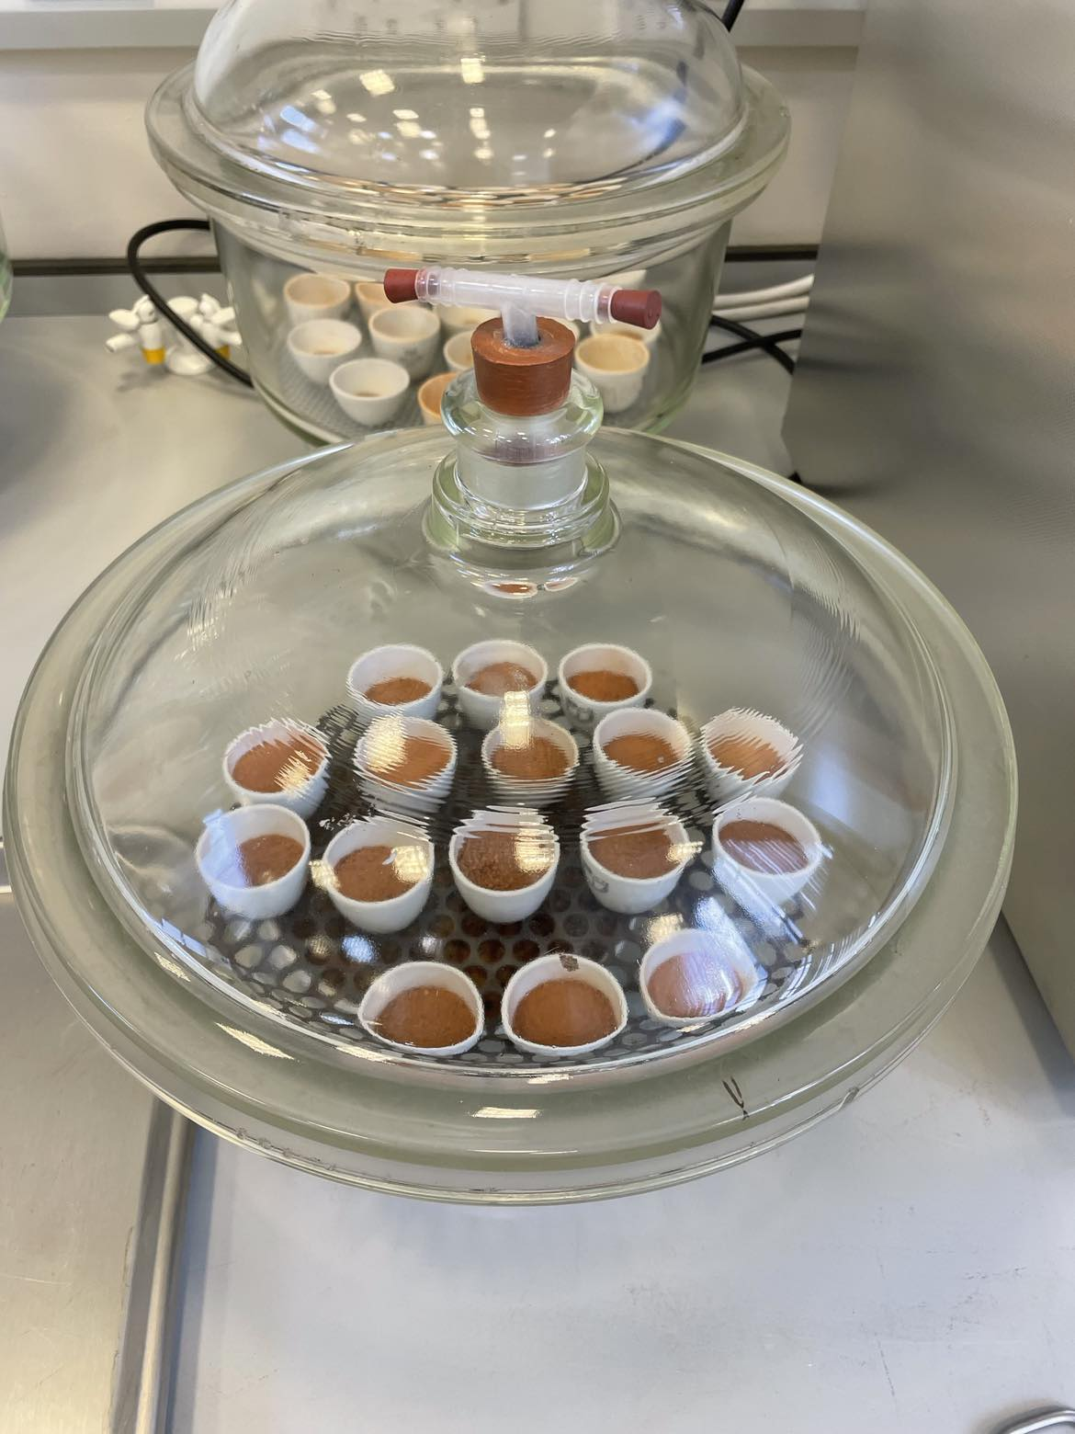
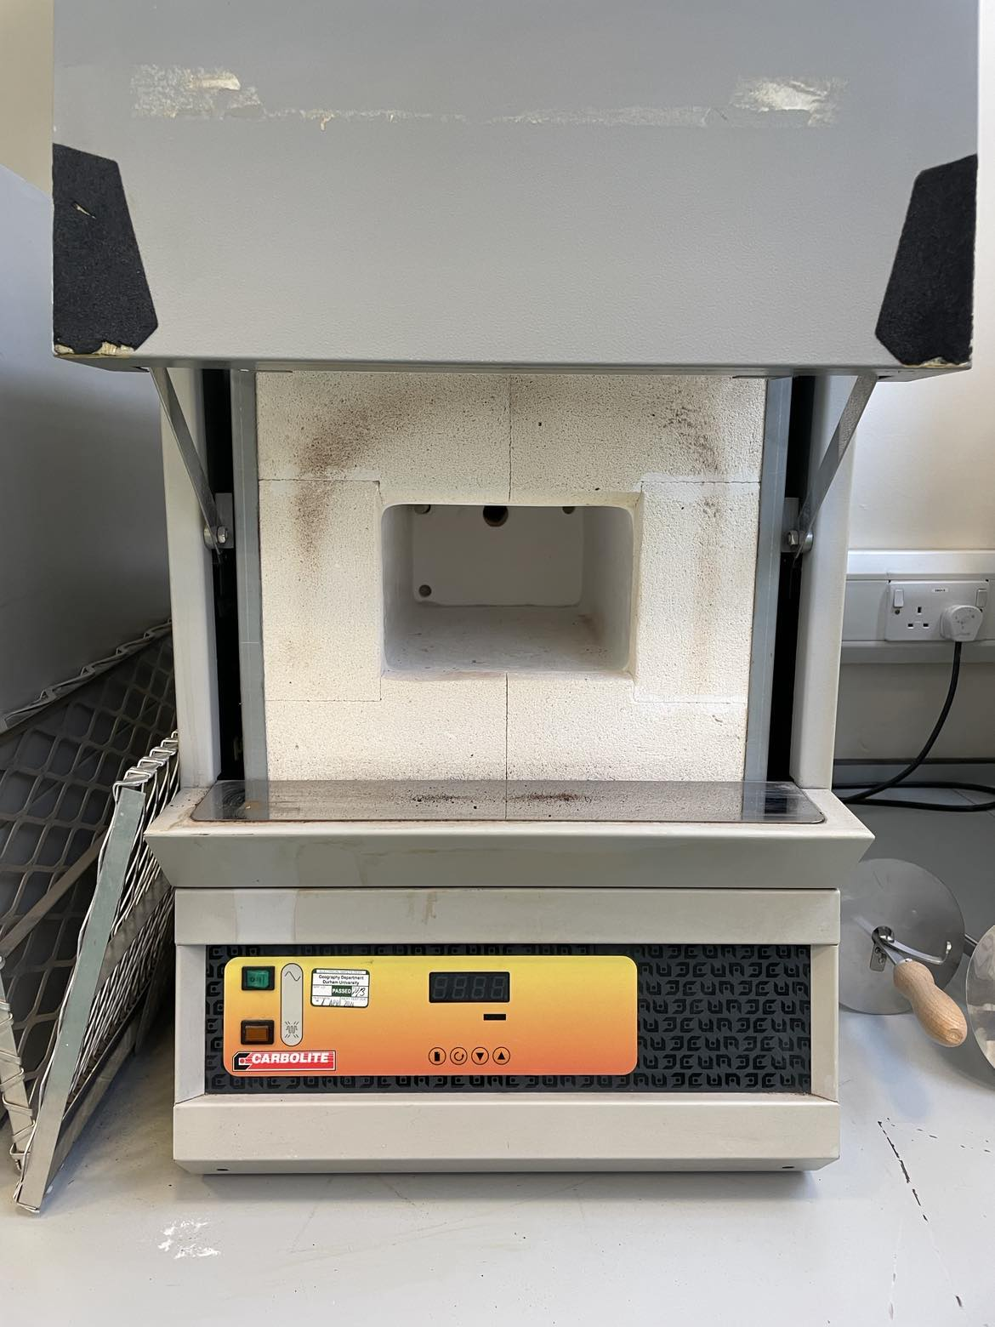
Once these mitigating arrangements were in place, LOI work began in May 2023 (figure 1). This took four weeks to complete with me working two or three days per week in Geography. Unfortunately, due to personal circumstances, the academic was no longer able to support sample preparation and analysis, and responsibility was instead passed entirely to me. Truthfully, I struggled with the weight of this responsibility, and feared letting the academic down. However, I tried to counteract any further issues by being as organised and efficient with my time as possible. I arranged student supervisions around times that I needed to be in the lab myself, recorded all sample weights in an excel file and applied a formula to calculate LOI (figure 2), and tracked which of the 380 samples had been analysed. In doing this, I was able to provide the academic with the results in a timely manner, so they could be compiled into a report and sent to the client on time.
B
D
C
A

Figure 1: The LOI process involved multiple steps. 3-5mg of each sample was added to pre-weighed crucibles (A), which were then dried and reweighed before being ignited in the furnace at 550°C for four hours (B). Using two furnaces, approximately 50 samples could be processed per day (C). Once ashed, the samples were dried in the desiccators (D) and reweighed, with weights recorded and LOI (%) calculated in an excel spreadsheet.
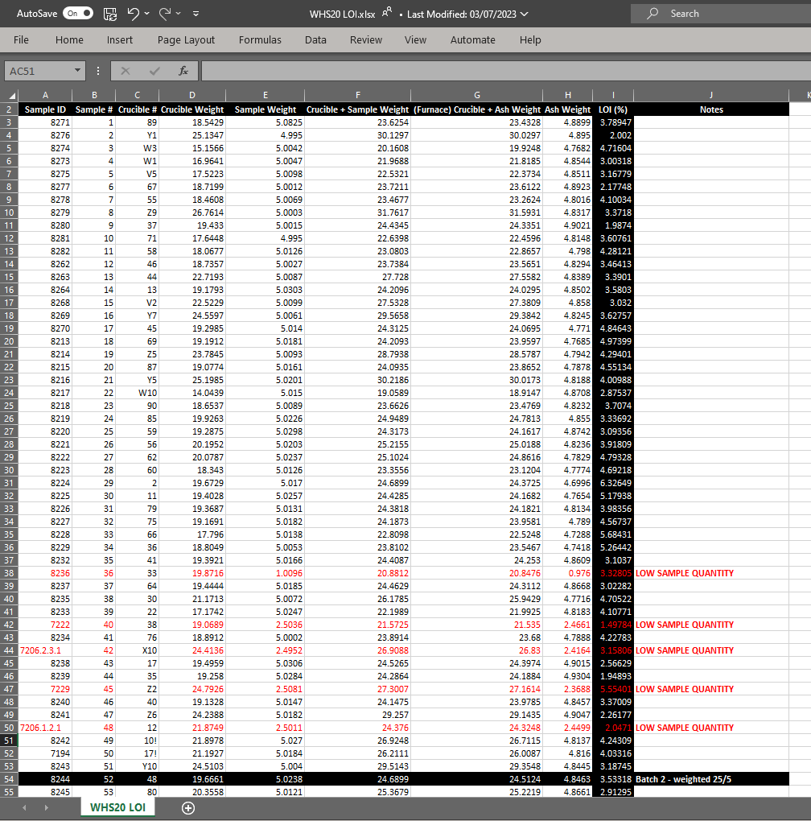
h
Figure 2: This screenshot shows the layout of the excel spreadsheet used to compile the results of LOI analysis of 380 soil samples. The equation input within the LOI (%) column uses the protocol’s formula to automatically calculate the LOI result when all weights are recorded. Samples for which a low quantity of material was available for LOI following phosphate analysis are highlighted in red to indicate potential unreliable results.

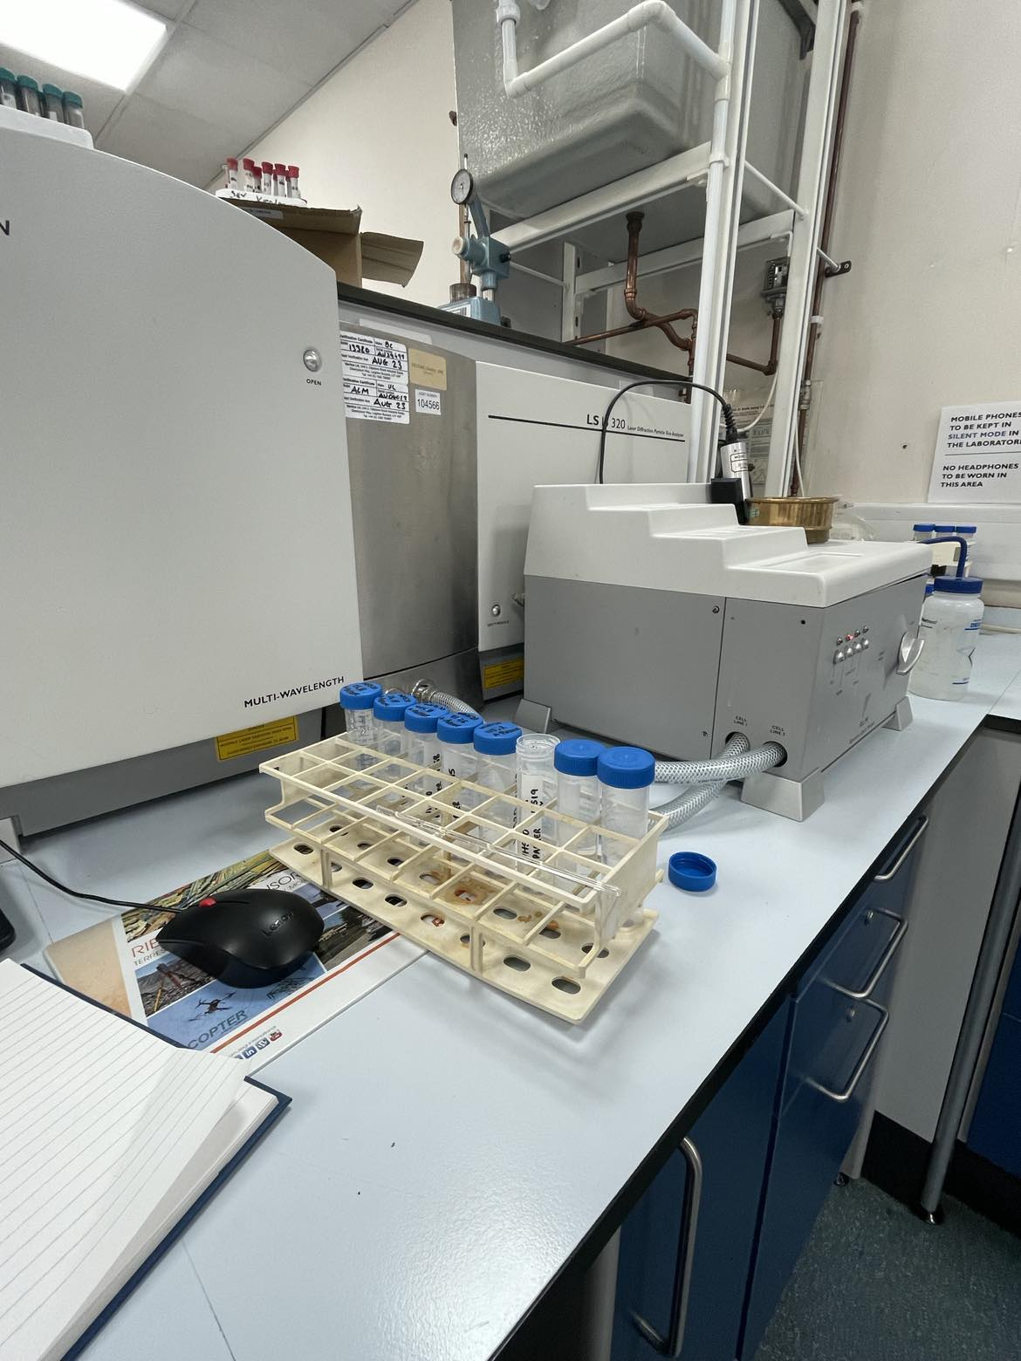
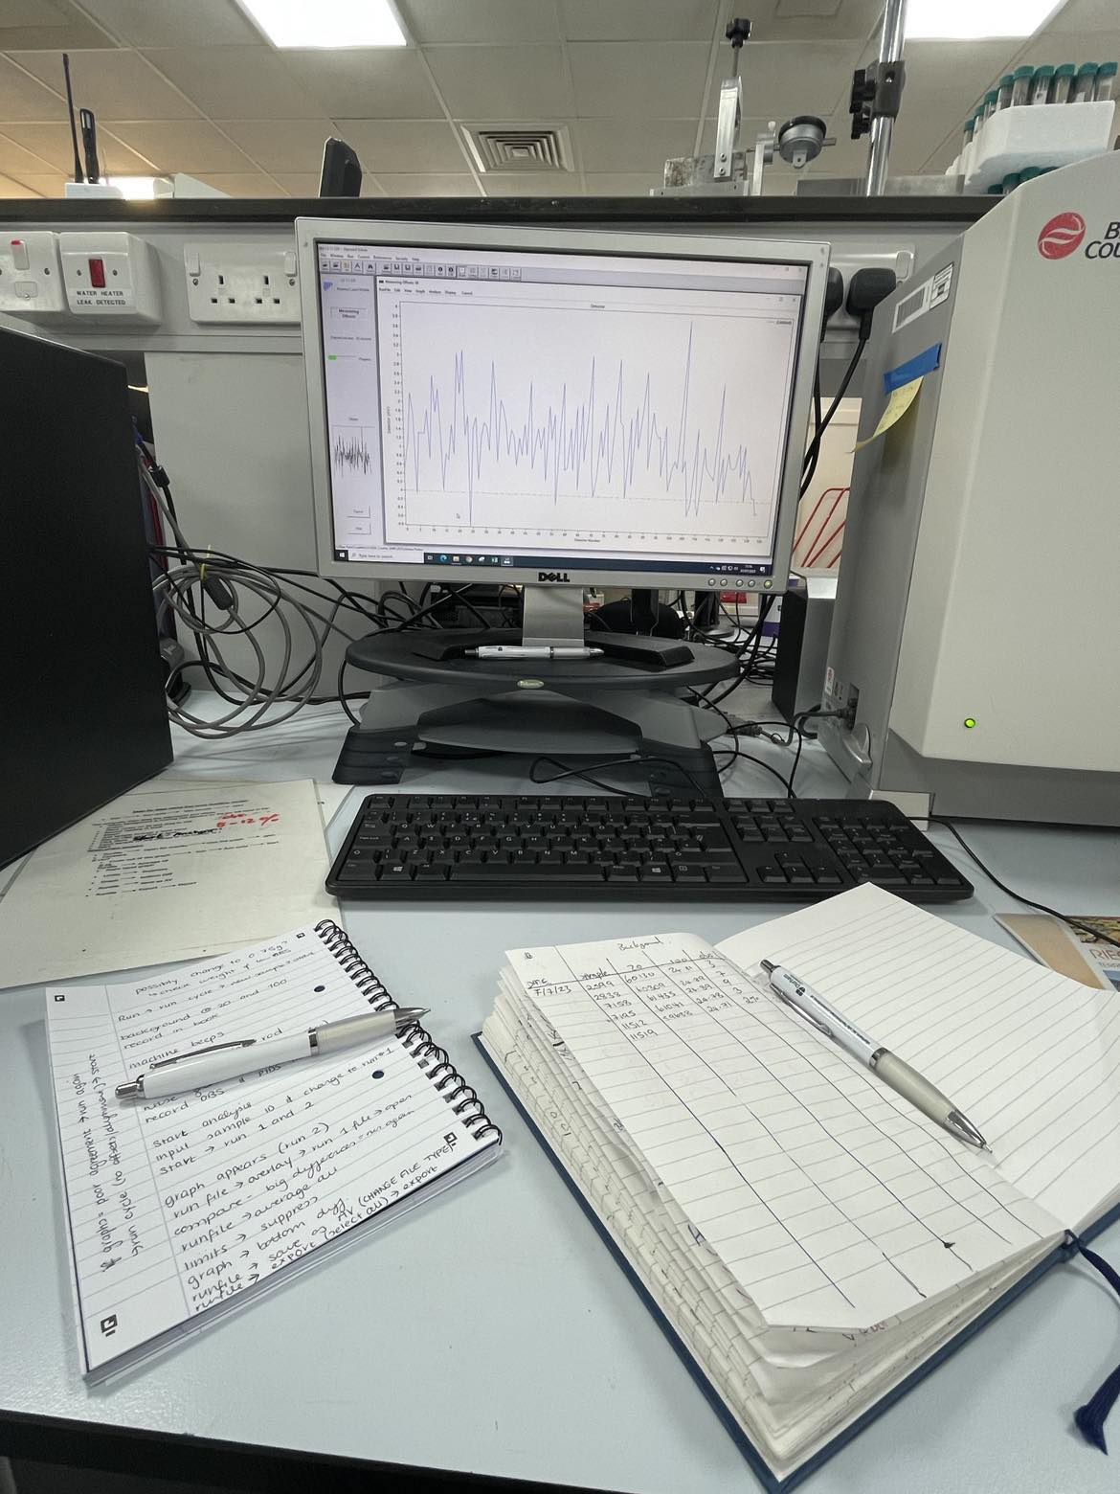
I also took initiative by running a batch of PSA control samples in July to check if the sample weights were suitable. This turned out to be a crucial decision as the weights were too low to yield accurate analysis results, so I was able to amend this for all other samples. The academic had capacity to support some PSA sample preparation and analysis, and I was grateful to have help. However, as they didn’t fully understand the specificities of the PSA process, the academic perhaps naively gave the client an ambitious deadline, not taking into account the length of time the laser granulometer needed to analyse each sample. This placed additional pressure on both of us and caused some conflict, as whilst I believed it was important to stick to the protocol to ensure integrity and comparability of results, the academic looked for ways to make the process more time efficient. Nevertheless, working as a team we managed to complete sample analysis (figure 3) in eight days over two weeks, and the PSA results were submitted to the client just after the deadline.
A
B

Figure 3: Following sample pre-treatment involving digestion of organic materials using Hydrogen Peroxide and deflocculation using Sodium Hexametaphosphate, the PSA samples were analysed on the Coulter laser granulometer (A). This required loading each sample into the machine, recording background measures, and analysing the graphs produced by the duplicate sample runs to ensure they matched (B). All results were then exported and sent to the academic to pass onto the client.

Evaluation and Reflection
Following this at times overwhelming project, I initially felt disheartened in my ability to take responsibility in commercial projects, and began to question my capabilities in my role as a technician overall. The effort I had put into this project despite the time pressure and physical burden of continuous lab work, had not been enough to meet the deadline on time, and I felt like I had let myself, the academic, and the client down. Yet, it was not until reflecting on the situation, that I realised just how much I had achieved and learned. As a Grade 3 technician, I managed to plan, undertake, and adapt the preparation and analysis of 380 LOI samples plus another 130 for PSA largely by myself, whilst working in a new lab with new people, undertaking entirely new processes in a new field of study, and also contending with the fallout from large-scale emergency repairs in my own Department. I recognised therefore, that my stress and worries had largely come from my lack of experience in all aspects of the situation, rather than my lack of competence. This was a valuable insight to uncover, as I could relate it to my approach to work elsewhere. In situations where I believe my abilities and professional judgement are not suitable to meet perceived demands (Dietz et al. 2017), I now realise I have a tendency to be overly self-critical and put additional pressure on myself to do everything right so as not to be a burden or liability, which is likely linked to my perfectionistic standards (Besser et al. 2004; Ocampo et al. 2019). I can see that my lack of self-confidence and fear of not living up to perceived expectations made the situation harder for myself, as my doubtful viewpoint combined with the unprecedented circumstances impacting the project, made my responsibilities feel like a burden that I had to bear alone (Besser et al. 2004). Ultimately, although I managed to handle the responsibility of this project and the various unexpected circumstances accompanying it, in future I imagine I would cope much better if I sought more guidance and confided in others about my doubts and concerns.
With this observation in mind, I was also able to reflect on my time spent with Geography’s technicians and the importance of understanding the practicalities behind research. Their breadth and depth of knowledge was notable, and I felt reassured in my abilities through their praise, trust, and acknowledgement that confidence comes with experience (Lewis and Gospel 2011). As with many technical teams, there was a clear prioritisation of complying with protocols and best practice to safeguard health and safety and a productive working environment (MI Talent 2023). Recognising this, I realised that perhaps my frustrations with the academic’s attempt to “cut corners” and ignore aspects of the protocols, stemmed from my experience working on isotope projects, where strict protocol adherence is required to prevent sample contamination and ensure reliable data production (see for example Ambrose 1990; Beaumont et al. 2013). In hindsight, because I prioritised it myself, I had assumed all protocols would be followed as part of good professional and ethical practice, especially in geoarchaeology, where discrepancies between methodologies have been proven to affect results of analyses such as LOI (Holliday et al. 2004; Hoogsteen et al. 2015). This recognition helped me appreciate how developing and utilising my own professional and ethical judgement is reliant on me having a full understanding of the work I am carrying out, especially in contexts where, as a technician, I am the person responsible for physically interacting with the samples to provide data which the academic gives theoretical and scientific context to (Lewis and Gospel 2011). In this situation I admittedly felt out of my depths initially without this background knowledge, and as a result felt anxious about making mistakes. In retrospect, I should have researched the processes more before starting, and asked the academic to show me how the data I collected would be analysed for the client in order to understand the sampling methods in context. However, I also believe that as a junior member of staff, the academic should not have placed this volume of work solely under my responsibility, as whilst I was capable, working above my current job requirements with less support and communication than promised put excess pressure on me and made me feel like my role was a resource being used to achieve results in an unrealistic timeframe (MI Talent 2022). Overall, this experience made me value the practical perspectives my role allows me to offer within projects, whilst also emphasising that clear communication within a team is imperative for technicians to effectively support researchers and understand their decisions and priorities.

Conclusion
Although this project was undoubtedly difficult at the time, taking the time to reflect on it has proven how educationally beneficial it was for me as an introduction to the often turbulent nature of large-scale commercial projects. Despite the novelty of the situation, I quickly picked up the skills required for LOI and PSA, and gained enough competence to teach others the processes, which I continue to do in my role now. Having the opportunity to network with technicians in another department also taught me that the workload and confidence issues I face in my role are not unique, and proved to me the importance of learning by doing. Even the negative outcomes yielded considerable learning outcomes. In recognising my own weaknesses such as my perfectionistic tendencies and reluctance to confide in others when struggling, I now actively try to identify when these stress responses interfere with my work and regularly communicate concerns with my line manager. Furthermore, despite this being a “trial by fire” introduction to geoarchaeology, I have not let this dissuade my interest in learning new skills, and have recently agreed to take on another geoarchaeological commercial project. Following this experience, I have worked with my line manager to introduce changes to better manage and protect my time, including having a designated day a week for work in different commercial labs. This has been incredibly useful so far, and has ensured I have a regular routine that avoids one project monopolising my time. In summary, this largely successful project taught me more about myself and my professional and ethical judgement than I expected, and I intend to consolidate these learning outcomes into my everyday practice. I now understand and value the essentiality of technicians to the generation of scientific knowledge (Iliffe 2008), and the crucial shared responsibility within project teams to uphold effective communication.

Bibliography
Ambrose, S.H., 1990. Preparation and Characterisation of Bone and Tooth Collagen for Isotopic Analysis. Journal of Archaeological Science, 17(4), pp. 431-451
Beaumont, J., Gledhill, A., Lee-Thorp, J., Montgomery, J., 2013. Childhood Diet: A Closer Examination of the Evidence from Dental Tissues Using Stable Isotope Analysis of Incremental Human Dentine. Archaeometry, 55(2), pp. 277-295
Besser, A., Flett, G.L., Hewitt, P.L., 2004. Perfectionism, Cognition, and Affect in Response to Performance Failure vs. Success. Journal of Rational-Emotive and Cognitive-Behaviour Therapy, 22(1), pp. 297-324
Dietz, A.S., Driskell, J.E., Sierra, M.J., Weaver, S.J., Driskell, T., Salas, E., 2017. “Teamwork Under Stress” In Salas, E., Rico, R., Passmore, J. (Eds.) The Wiley Handbook of The Psychology of Team Working and Collaborative Processes. Chichester: John Wiley and Sons Ltd, pp. 297-315
Gibbs, G., 1988. Learning by Doing: A Guide to Teaching and Learning Methods. Oxford: Oxford Polytechnic Further Education Unit
Holliday, V.T., Stein, J.K., Gartner, W.G., 2004. “Appendix 3: Variability of Soil Laboratory Procedures and Results” In Holliday, V.T. (Ed.) Soils in Archaeological Research. New York: Oxford University Press, pp. 363-374
Hoogsteen, M.J.J., Lantinga, E.A., Bakker, E.J., Groot, J.C.J., Tittonell, P.A., 2015. Estimating Soil Organic Carbon Through Loss on Ignition: Effects of Ignition Conditions and Structural Water Loss. European Journal of Soil Science, 66(2), pp. 320-328
Iliffe, R., 2008. Technicians. Notes and Records of the Royal Society, 62(1), pp. 3-16
Lewis, P.A., Gospel, H., 2011. Technicians Under the Microscope: A Study of the Skills and Training of University Laboratory and Engineering Workshop Technicians. London: Gatsby Charitable Foundation
MI Talent 2022. The TALENT Commission: Technical Skills, Roles and Careers in UK Higher Education and Research. Birmingham: Midlands Innovation
MI Talent, 2023. Creating and Maintaining Safe Environments: The Role of Technicians in Health and Safety. Birmingham: Midlands Innovation
Ocampo, A.C.G., Wang, L., Kiazad, K., Restubog, S.L.D., Ashkanasy, N.M., 2019. The Relentless Pursuit of Perfectionism: A Review of Perfectionism in the Workplace and an Agenda for Future Research. Journal of Organisational Behaviour, 41(2), pp. 144-168

