NAME: THIERRY NICOLAS CRETIN

STUDENT NUMBER: 1715703

MODULE CODE: DSAW4077

MODULE TITLE: PREPARING FOR WORK-BASED LEARNING

INDEX PAGE

CURRICULUM VITAE 3-7

ORGANIZATIONAL CHART 8

JOB DESCRIPTION 9-10

TRAINING NEED ANALYSIS 11

PERSONAL DEVELOPMENT PLAN 12

PRESENTATION 13-19

REFLECTIVE ESSAY 20-23

Curriculum Vitae
NAME: MR.THIERRY NICOLAS CRETIN
ADDRESS: CORNER ARIANNE & ROCHES-BRUNES AVENUE, MORCELLEMENT NOUVELLE VILLE, ROCHE-BRUNES, ROSE-HILL, MAURITIUS, POSTAL CODE 71233
PHONE NUMBER: +23059192045
EMAIL ADDRESS: nicolas.cretin09@gmail.com

PROFESSIONAL SUMMARY
The past 20 years have been a fruitful journey in the hospitality industry with opportunities to work in the food & beverage department of various properties in Mauritius and overseas, taking part in the opening of five stars hotels, restaurants, bars and recently in the reopening of my present hotel. On the job training as well as the specialized courses at the Hotel School of Mauritius enabled me throughout these years to evolve and gain more competencies. The changing dynamics of the hospitality industry made me shift from managerial to leadership styles towards developing, recruiting talent, coaching, monitoring and retaining employees to ensure standard compliances are maintained.
The constant evolution/demand of customers enabled me to constantly innovate products and services towards more systematized approach in the way I manage myself to better lead others.

EDUCATION
- Certificate in Higher Education in Professional Practice, University of Wales St. David
- WSET level 2(Wine and Spirit Education Trust),South Africa/2012
- National Trade Certificate level2(Supervisory level)Hotel school of Mauritius/2001 to 2002
- National Trade Certificate level3 (Under National Apprenticeship Scheme)Hotel school of Mauritius/1998 to 2000
- G.C.E “O” Level/1997

EMPLOYMENT HISTORY
- LUX*Resorts & Hotels
September 2018 till now
Food & Beverage Manager
Implementing new food & beverage concepts for the reopening of the resort in 2017.Administration of a 140 employee division, overlooking the planning, budgeting, organization, coordination of a department consisting of 5 restaurants, 7 bars, 24-hour In Room Dining. Ensuring that the execution of our brand promise is respected in each food & beverage component. Develop knowledge and competencies of subordinates by providing on-the-job training, coaching based on managers’ appraisal as well as conducting regular audits. Extracting, interpreting, addressing issues and comments posted on social media and direct feedback and drafting corrective action plans. Preparation of budgets based on forecast, monitoring sales, loss and profits to maintain forecasted revenues.
Innovate products and services towards more systematized approach in order to meet guest satisfaction based on feedback platform (Social media).Developed a more down to earth approach towards employees to have insights on how to better retain them.Assited in the implementation of the LUX*App which is a mobile application for in house guest on all the food & beverage offerings and activities in the hotel

August 2015 to September 2018
Assistant Food & Beverage Manager
Assisting the Food and Beverage Manager to ensure proper management of the Food & Beverage outlets Communicate with guests on service quality standards and guest ensuring satisfactions are maintained at all times.
Maximize upselling opportunities in the Food & Beverage outlets. Assist the Food & Beverage Manager to prepare reports and compile records on costs and revenues. Overlooking the daily operation to ensure proper manning and service delivery. Participated in the reopening of the hotel and assisting the Food & Beverage Manager to the implementation of new restaurants & bar concepts.

- Fourseasons Hotels & Resorts, Mauritius at Anahita
April 2013 to August 2014
Restaurant Manager/main and contemporary steak house restaurant
Managing a 200 covers restaurant, coordinating both breakfast and dinner service. Improved service by anticipating forecast occupancy, recruitment, budgeting, implementation of new themes nights by evaluating the business trends based on local culture, beverages, food and wine cost controlling.
Implementation of new menus and developing new breakfast and dinner themes. Uplifting the restaurant score audit after to 96%, raising the level of service to one of the highest in the company. Generated an increase of 20% on wine sales by introducing a wider wine experience to in house guests.

October 2011 to April 2013
Restaurant Manager/pool and beach
Managing a 250 covers restaurant, attained the benchmark standards in both restaurant and bars while generating revenue, maintaining customer satisfaction and reviewing budget, implementation of new themes nights, beverages, wine cost controlling and implementation of new menus.
Developed the island lifestyle concept for foreigners and enhancing their spending by developing and implementing a simplified food offering & service concept. Maintaining the restaurants standards and manning. Organizing the yearly New Year’s Eve party for 400 guests, overseeing all set ups, decoration and proper service execution.

October 2009 to September 2011
Restaurant Manager/Italian restaurant
Oversaw an 80 covers restaurant, maintaining standards, recruitment, budgeting, food, beverages and wine cost controlling.
Assisted and guided the culinary team in drafting the menus, promoting the restaurant to the locals to make them discover traditional Italian food and culture. Maintaining the company’s core standards & assessing the team performance by conducting regular audits.

August 2008 to August 2009
Assistant Restaurant Manager/Italian restaurant
Opening team of the first brand property in Mauritius. Implementing the corporate standards and consolidated the brand guidelines, training of team and assisting the restaurant manager in the daily operation of an 80 covers restaurant.
Planning of daily task, ensuring that all service, standard compliances are respected and ensuring that all set corporate standards are met.

- Shanti Maurice(Ananda Hotel & Resorts)
November 2006 to July 2008
Food & beverage supervisor
Opening team of the first SPA destination in Mauritius, in charge of the Italian reastaurant.Blending the wellness side of holidays and tailored made services through gastronomy & hospitality.
Tailor made service based on customer’s body type and adapting the usual food & beverage service along with the Ayurveda lifestyle approach. In charge of the daily operation of an 80 seats restaurant.

- Dinarobin Hotel(Beachcomber Hotels & Resorts)
October 2005 to July 2006
Chef de Rang
Fine dining restaurant (Saveurs des iles), fusion of Mauritian products with French gastronomy. Ensuring the service and applying the knowledge of food and drinks pairing.
Promoted the fusion restaurant concept in each guest interaction, developed the upselling and suggestive selling techniques.

- Ste.Anne Resort, Seychelles(Beachcomber hotels & Resorts)
September 2002 to September 2005
Chef de rang
Opening team where the Mauritian ‘savoir faire’ was introduced in Seychelles Islands. Setting up of various restaurants, training on concepts and implementing the company standards. Focus on high service level and traditional food & beverage services (French, English and Russian style).Developed a more refined way of serving and attending customers.

- Sugar Beach(Sun Resorts)
February 2002 to April 2002(Internship from Hotel school of Mauritius)
Waiter
Internship in various Food & Beverage department for specialization in food and beverage services. Acquiring in depth managerial skills in the various Food & Beverage operations of the hotel. Shadowed outlet managers in their daily tasks, participated in the operational meeting and drafted assignment based on good work practices

- Prince Maurice(Constance Hotels & Resorts)
February 2002 to April 2002(Internship from Hotel school of Mauritius)
Waiter
On the job training in one of the best 5 star hotel on the island. Familiarization on the different style of restaurant and bars operation. Acquired more functional skills on personalized restaurant service, wine knowledge, and French service style.

- One & Only’ Touessrok(Sun Resorts)
April 1999 to April 2001(Apprentice scheme, Hotel school of Mauritius)
Trainee waiter
Followed both academic and on the job training at the Hotel School of Mauritius for certification in National apprenticeship scheme in the hospitality industry. Experienced real insights of the job to have better ability and skills in both functional, conceptual needs and to work in the food & beverage department of a hotel.

SHORT COURSE TRAINING AND AWARDS
- Mind Power Program(John Kohoe)Facilitated by Robin Banks, August 2018
- Sometimes you win sometimes you learn(John Maxwell),7th September 2017
- The energy journey(Learning to lead)Facilitated by Colin Hall 11th & 12th October 2016
- Focused recruitment skills workshop(Alentaris),11th & 12th August 2016
- LQA (Leading quality assurance), outstanding employee, 24th May 2014
- DLP (Dynamic Leadership Program), November 2013
- STEPS (Managing self & others), from 23rd May to 24th September 2012

OTHERS
- TEWF(TOURISM EMPLOYEE WELFARE FUND)
March 2016
Coaching and working with restaurant team members towards the 1st prize at National level for best table setup and food presentation
- MONIN CUP COCKTAIL COMPETITION,MAURITIUS(Pop Art theme)
November2016
Coaching of one bartender towards winning the 1st prize at National level
- TEWF(TOURISM EMPLOYEE WELFARE FUND)
October 2017
Coaching one bartender towards winning the 1st prize at National level.

Organizational Chart

General Manager

Food & Beverage Manager

Assistant Food & Beverage Manager

Assistant Food & Beverage Manager

Restaurants Operations Manager

Manager

Senior Restaurant
Manager

Manager

Restaurant Manager

Manager

Bar Manager

Manager

Assistant Restaurant Manager

Manager

Restaurant Supervisor

Manager

Supervisor

Supervisor

Asst Bar Mgr

Supervisor

Asst room service manager

Head Sommelier

Restaurant Manager

1

Restaurant Manager

1
Room service Manager

Bodrum Blue
INTI
Room service
Sommelier
Assistant F&B Manager

Food & Beverage Manager Job Description

MAIN DUTIES & RESPONSIBILITIES
- Planning, organizing and coordinating the smooth and efficient day to day operations of the Food & Beverage department.
Ensure the consistency of the newly introduced restaurant & bars concepts (Peruvian, Turkish, and Gin bar)
- Communicate with guests to ensure that service quality standards and guest satisfactions are maintained at all time
Forwards and acknowledge any feedback, tailor made services to ensure that expectations are met at all times
- Maximize upselling opportunities in the Food & Beverage outlets to meet the yearly budget of MUR 10,00000 on revenue on a yearly basis
Seeking more sponsorship from suppliers to reduce purchases, consigning beverages & reduce the inventories of high cost commodities
- Prepare revenue reports and compile records on Food & Beverages revenues
Send weekly reviews to the general manager and adjusting sales strategies based on revenues
- Maintaining the LUX* Resorts & Hotels' brand reputation by reviewing all standards weekly with the outlet manager
- Actively participate in team Members’ planning to ensure the smooth and efficient operations of the outlets.
Organizing and reviewing the manpower based on the various events that are organized at the hotel
- Conduct frequent spot checks within the Food & Beverage department to monitor HACCP standards (Health Hazard Analysis Critical Control Point) on hygiene and food safety regulations are respected
- Participate actively in the preparation of budgets of Food & Beverage operations
Compile and send weekly reports to the general manager to monitor revenue versus the forecasted budget
- With the collaboration of the Outlet Managers, implement effective control of Food & Beverage costs among all the outlets.alignning the beverage cost to 29%, cellar cost of 30% & food cost of 40%
- Maintain the budgeted manning ,assist in the recruitment of new team members
Retention of talents, create incentive program & mentoring program

PROJECTS
- LUX*App(mobile application for in house guest)update, monitoring mobile chat process for each point of sales, input all updated information of the Food & beverage offering available at the resort

TRAINIING
- Develop knowledge and competencies of subordinates by providing on-the-job training and coaching
- Implementation of the mentoring program for team members and assessing their progress based on their evaluation performance

SOCIAL MEDIA
- Reviewing of comments trip advisor, adapting to the short fall that guest have experience, spot the recurrent issues & follow up with guests on comment
- Assisting the outlet managers in responding to guest feedback & monitoring the comments received for each restaurant

RECRUITMENT
- Participate & animate external job fairs to hire talents.

BANQUETTING
- Develop the outside catering package for nonresident guest & promote the LUX* standards as benchmark of service

Training Needs Analysis

What am I good at? | What do I need to work on?
- Taking new challenges  - Recognizing peoples input in any task  - Team player, participates actively in projects  - Executes any task in a timely way  - Curious in findings new concepts and trends in food and beverage  - Consistent in my work | - Managing finance fundamentals  - Leading projects and involving subordinates in the process  - Coaching style  - Problem solving(Managing conflicts)
What could help me along? | What might stop me?
- Have more one to one meeting with the financial controller  - Create a mutual trust with colleagues to have more genuine feedbacks and communication  - Setting clear rand realistic goals to my team, involving them in the decision making and accept feedbacks  - Identify specific training needs for each person rather than generic ones & tailor made it based on their strengths & weaknesses | - Not dedicating time for discussion  - Have apprehensions rather than comprehension on feedbacks that I get  - Doing all assigned task by myself and criticizing others  - My ego

Personal Development Plan

Development  Need Identified | Development  Objective/s | Method | By Whom | By When | Review
Knowledge on  finance fundamentals | Preparing and interpreting  forecasted budgets, maintaining food and beverage cost of the  department Familiarization with excel spreadsheet from finance | Reviewing targets with the financial  controller based on revenue reports,  communicate the targets  regularly with the team and having  Clear insights of based on financial figures. Monitoring on a weekly basis the profit generated | Coaching from the  financial controller  Robert Sidonie | Starting as from the  1st September 2018  until June 2019 | Ongoing reviews on  Revenues(Daily & monthly)
Improve skills on  managing conflicts | Assess processes/issues with other head of department,  Improve the delivery of services by sharing clear genuine and precise feedback. | More one to one meetings with the  stake holders , understanding their own challenges & focus on our Lux*shining hospitality  standards as benchmark | General manager Brice Lunot & quality  assurance manager  Akhtar Bholah | Starting as from the  1st September 2018  and ending September 2019 | Ongoing & will be reviewed as an objective to be met in the yearly appraisal
Coaching &  communication | Maintain a learning and ongoing training culture in the department | Lead and developed on-the job tailored  Training plans for individuals.  Outsource specialized training to assist learning,  continuous audits on our service to adjust progress  using the ‘up your service method’ | Training & quality  assurance manager  Akhtar Bholah | Starting as from the  1st September 2018  and ending September 2019 | Ongoing & will be reviewed as an objective to be met in the yearly appraisal
Leading projects and  assessing progress | Setting precise, clear and realistic projects for the food & beverage department. Communicate  Progress fairly & accept  Issues that may be faced | Staying in touch with the  worldwide trend of food &  beverages, visit other  Properties, getting insights from websites & trip advisor. Have a proper benchmark of the product and include others in the implementation | Nicolas Cretin, food & beverage manager  General manager  Brice Lunot, Jenna  Perrier marketing  Executive and financial controller Robert Sidonie | Starting as from the  1st September 2018  until June 2019 | Ongoing & will be reviewed as an objective to be met in the yearly appraisal

Presentation

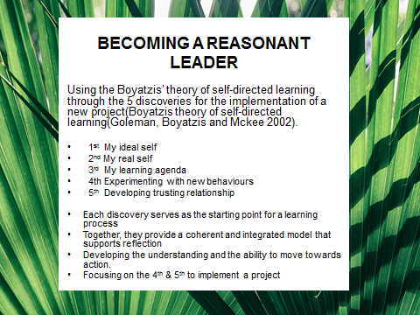

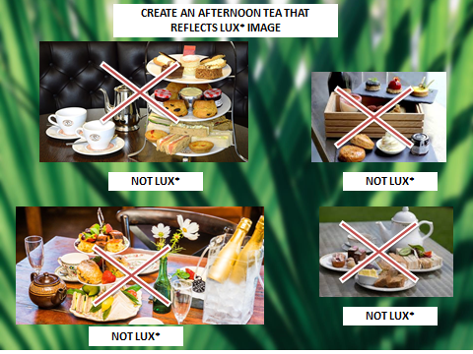

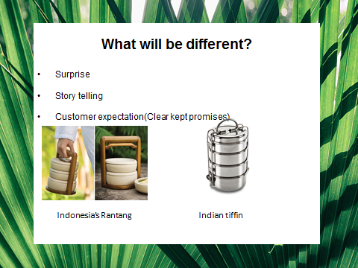

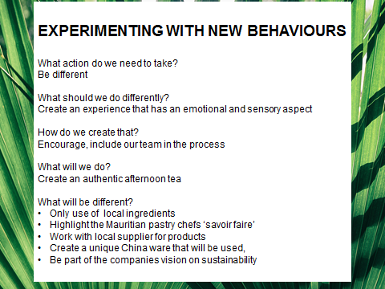

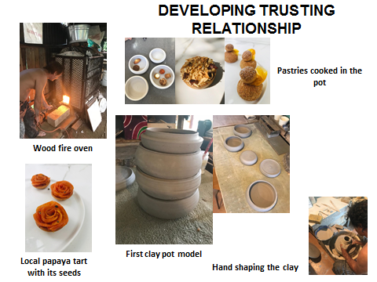

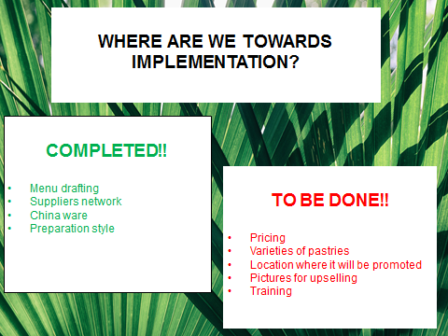



Reflective essay

For me discovering that my preferred learning style as being multimodal was relevant to my personality and actual state of mind. Having read the different preferences listed in VARK(Visual, aural, read and write, kinesthetic)the theory that best describes me from the time I started my career in 1998 as a trainee waiter until now I 2018 as Food & Beverage manager would be the Boyatzis’ Theory of Self-directed Learning (Goleman, Boyatzis and McKee, 2002) through the five discoveries. The different stage in a person personal or even professional endeavor goes through these steps. This model would be similar to a phone upgrade if I may put it in to these words. I had no clue on my ideal self when I started, I did not really know what would be my path and achievements. The perspective of a career in the hospitality industry did not event cross my mind what was meaningful to me was to have a job and be dependent As years passed, my ideal self started to manifest as I got trained to be a specialized Food & Beverage person, what I was doing started to be relevant. My character started to forge & a new identity started emerging. Opportunities started to lie on my path and this was the time to take control of my life. Defining me at that time as a learner would be as an activist, the importance of being enthusiastic and throwing me in any new trends resulted in many non-tangible outcomes that only gave a short term solution rather than a long and lasting outcome. This all started when I realized that learning is a lifetime journey that will end at any destination that I would like it to end. ‘This self-directed learning intentionally developing or strengthening an aspect of what you are or who you want to be, or both’ (Goleman 2002 page 109-12).Recalling that I said to myself as mentioned by the first question in the discovery: “What does my ideal self-want in his life.

How I acted started the process of being ‘my real self’. Moving to a higher position had to undergo radical transformation without losing my authenticity and responding to the changes that surrounded me. Thinking SMART (Specific, measurable, achievable, realistic, time framed) this is exactly what has evolved in me and how I discovered my real self. I did not realize that I had consequent gaps , sometimes my close peer had to stop me as my action were sometimes only over reacting to situations. What I wanted was to be always right. In a certain way it was an autocratic styled behaviour. This is where my strengths & weakness were trapped in an emotional whirlpool that was only wining without going anywhere. Understanding personal authenticity started to have greater meaning when I understood its power. Taylor define it as follows ‘Being true to myself means being true to my own originality and that is something only I can articulate and discover. In articulating it, I am also defining myself’ (Taylor, 1999, page 29).Another factor that redefined my view is also expressed as our ability.to develop talents of different working backgrounds that will blend into our corporate culture by contributing to their critical out of the box perception and challenge our mindset. Kovan and Dirks (2003) provided a powerful example of the integrate nature of personal development in their study of environmental activists: ‘The activists’ descriptions of their experience implicitly portray a multiplistic sense of self.’ Looking back at what I was connected, reacting, analyzing things was not only my character but many component that had been adding on to my subconscious mind, emotions, belief system, spiritual faith, peer pressure, family opinions had emerged. Was my life wrong, did the choices that I made stimulated who I am today? Yes some of them to be honest.

My understanding of learning revealed the causes of the loop holes in me. From my perspective it is the concept of how our educational system is set. Educational bodies, coaches and managers that I have encountered did not understand that I was developing my own learning style to a multimodal one. At first there were a lot of apprehension rather than comprehension on feedbacks that I got. When I questioned myself before I would have said “what did you do wrong “Rephrasing that today as I am writing this essay would be “how could I do it better next time”. Learning is indeed something that has a lot more outcomes than shortfalls; it revealed evidence on my potential, motivated me to be a more authentic person and enhanced my creativity. Before my values were in front of me and I did not use them as a tool to adapt and interprets things. As an example, one simple issue that we faced before was the early morning amenities displayed at our coffee parlor were not popular even though we were using the best ingredients to showcase them. We believed that we were not upselling them enough to our guests. At that time we were not asking ourselves the good questions. I had to think outside the box and started to ask myself these questions: What am I focusing on? How can someone else give me an advice and help? What can I do to make it better? This revealed to turn to a completely different answer to what was expected. This was the start of experimenting with new behaviour. The outcome was rather successful, instead of displaying healthy sandwiches, we implemented healthy shakes which were what people going to the gym wanted and the conclusion of reaching the customer expectation was only a matter of shifting a belief system. This simple but deep learning allowed me to have broader insights on issues that were defined, testing their solutions and applying them.

Even though I have clearer insights on myself this does not mean I am perfect and that I overcome any challenging situation. In certain ways my effectiveness has enhanced towards an ability to understand. What would challenge me is how others will react to my perceptive, the comprehension versus apprehension always comes back and it makes me feel that I have not really reach my potential, I have had many challenges before particularly when I was a line staff, my beliefs were the only essential things for me, there was no place or time for compromise. That really caused many issues in my perception as compared to now the comprehension of things makes more sense. How will I succeed, how others play an important part in my achievement. I was alone at that time jailed in my ego, I could have stayed the same but this would not have open possibilities for new thoughts, feelings on how I can do better and be authentic at the same time. My belief system was not bad; I did not placed the correct blocks of my personal experience in correct order.

My next step after analyzing, reassessing my behaviours and critically reflect on my past assumptions developed the power and the ability to experiment new thoughts on particular outcomes that might arouse. Success is a choice that I have the ability to direct, redefined at any stages and I have already started to act upon my own path, where I defined success as a choice. This can be done by personal transformation by the reflective criticism of our beliefs system, how we react, interpreted problematic outcomes; this authentic willingness to change what is not right is the first steps to reaching our potential. Changing from the managerial to the leadership style proves that we create more values in people perception as we are inspirational. All the previous experiences that I have related before are without any doubt a benchmark on which my development plan will be based Looking back at my career when I started 20 years back the changes that have occur in our industry has also brought significant change in people. My opinion on things has also evolved based on my personal, academic and functional experience. As leaders we are always expected to bring new things, be innovative, motivate others and inspire. Our main purpose is to lead change, this understanding is fundamental to me as a learner Building trust and relationship is the key component to success. The development, inclusion and understanding of our workforce are crucial. Most important showing concern to others opinion is the main ingredient to the recipe of success as basic communication is the foundation of trust, which gives confidence to either the sender or the receiver. This is how the fifth discovery enters into the game, learning through authentic relationship. The changing dynamic, economic and social transition of our world made people think react and act differently today. Our current work force as mostly GenY and millennials born after the 1980’s.Do we cluster them in GenX framework? My question is, how do we include them in our belief system? I find that it is crucial to develop the participative approach to make changes achievable. Tamara Erickson mentioned: your Gen Y colleagues, no matter how “golden, “often receive indiscriminant, same-for-all counsel. Like college freshman, they have to study the core curriculum before they can spend much time concentrating on a major. So they may sit in on group sessions to learn more about the corporation’s values and strategies, for example, or receive coaching on writing effective memos. Much of their mentoring is either broad orientation or basic tactical learning. As a result, it covers a wide range of skills and knowledge, and can be hit or miss-more like the rewards from a slot machine than a payout for a poker game well played (Harvard Business Review Press, 2008,2008, and 2010)’.To reinforce & quantify the power of supporting learning to other by authentic leadership could be as this example: ‘workers consider training to be as valuable as a raise, employer-provided training has the same effect on job satisfaction as a17.17% net wage increase, according to a study of nearly 5,000 workers in Spain by Santiago Budria of the University of Madeira. Other studies showing low productivity gains from training are overlooking the subjective benefits of on-the-job learning ‘(Budria, Santiago, “The shadow value of employer provided training”. Journal of the Economic Psychology 33, no.3, June 2012, page 494-514).What I find is that we have already shifted to a more effective method of working; we have fallen into the trap of not giving people enough insights on what we really are and what we want to achieve. Bowers identifies it as: Transitional phase in the process of modernization in which the breakdown of traditional form of authority through a more democratic and educative process(Quoted in Merizow , Transformative Dimension of adult learning, page 4/Bowers, C.A, The promise of the theory: Education and the politic of the cultural change, New York: Longman 1984).
Moving forward as part of my development plan it have two needs that have been identified that will require to reinforce the Boyatzis self-learning style as a practitioner. Coaching will be a focus for me as my objective will be to maintain a learning and ongoing training culture in my establishment, I have already started to put in place amongst the senior team members to lead tailored made training plan for individuals. My personal appreciation on how to implement the learning style as part of my ongoing progress and methodology that will be used is linked to what my objectives are. The second point in my development plan is leading projects, success is difficult to measure on this one, I can be interpreted in different ways by different persons. In the past success was something that had to reach perfection right away and if not caused frustration. After reassessing my learning style and agenda by applying a more systematized approach, I feel that my definition of leading projects would be: what could I have done better, do I think that this project has not lost its momentum.
The leadership skills that I have gained would be blocks that have been assembled over time through effective experimentation, building of relationships, clear goals, learning from past experiences and most important inspiring others. It is clear that my growth has started when it started in the people with whom I interacted as my goals was part of their goals as well. “It is impossible to measure initial conditions with enough precision to determine causal relation accurately, unpredictability, therefore is unavoidable. Unlike linear system, in which causes and effects are proportional, in recursive systems, complex feedback and feed-forward loops generate causes that can have disproportionate effects” (Taylor, 2001, page 24)
The importance of being an effective leader is now clear to me and as a support the Boyatzis five stages process have a solid and meaningful foundation to be successful. In this current business I have learned that self-actualization, redefining myself, redirecting my thoughts is like software that is continuously updating & upgrading itself. Our world personal and professional is on the move & we are bound to move along. The new generation of workers will depend on what we want to set for the future and developing my strengths to deliver or walk the talk that that I intend is now not a belief but a reality.

