How did the tyrants of Syracuse maintain their power between the 5th and 3rd centuries BC?
Tyranny was very prevalent in the Ancient Greek world at many times throughout its history. The archaic period saw the Homeric kings and the Tyrants of Athens, and in the 4th century tyranny in the Greek world saw a large increase in prominence with people such as Jason of Pherai. However during the 5th century BC we see very few prominent tyrannies in the Greek world besides those which are based in Syracuse. One reason for this could be because of the prominence of Athens and that the Athenians tended to be opposed to tyranny. Syracuse is an exception as there are many tyrants who existed in the 5th century such as Gelon and Dionysius I.
Syracuse was an Ancient Greek Polis, located on the south eastern coast of Sicily. Syracuse has a long history of tyrants starting with Gelon in 485 BC and ending with Hieronymus who was assassinated in 214 BC. As well as Tyrants, Syracuse also had multiple periods of democratic rule such as that which was formed by Timoleon. This means that Syracuse provides a unique study on the power of tyrants as it gives an opportunity to look at successful individuals such as Gelon, Dionysius I and Hiero II, as well as a multitude of unsuccessful tyrants such as Thrasybulus and Hieronymus who ended up being deposed. This essay shall examine how tyrants used popularity, wealth, military power and their presentation of themselves and how these factors, contributed to the rise and fall of tyrannical regimes.
The primary source for the study of Sicilian tyrants is Diodorus as he has much more of a focus on Sicily and the Greek west than people such as Thucydides. However other sources such as Polybius and Herodotus are also useful for studying tyrants at specific points in time, for example Polybius is useful for studying the reign of Hiero II as he covers this time period in detail in his work. Using the ancient literary sources can be problematic as most of them are written at a time when the general opinion seems to be against Tyranny and this is reflected in their writing. Diodorus is often regarded as a problematic source for many reasons. Diodorus is also well known for the moralising aspect of his histories which particularly affects his representation of the tyrants as he may be emphasising certain aspects of the individual to make them either an example of a morally good person or a morally bad individual. Diodorus is also problematic as he wass writing in Rome and the Romans generally view tyranny as a negative thing which may have affected his selection of instances to mention or have led him to portray some tyrants such as Dionysius I in a negative light. This second issue is not exclusive to Diodorus, in fact the vast majority of our ancient sources are written either in Rome or in 5th century Greece, where the Persian invasion had caused a negative reaction to tyrants. This reaction is especially noticeable in Herodotus’ work as Herodotus tends to emphasize the Greek’s freedom as opposed to the Persian’s ‘slavery’ as they serve under a king. Herodotus’ Histories had a profound influence on the other sources which are mostly written later, this means that Herodotus’ negative attitude towards tyranny and tyrants gets passed on through the other sources.
Another problem with the literary sources which have survived is that very few if any of them have any first-hand experience with Tyrannical Syracuse; although Diodorus is Sicilian he was born and was writing around 200 years after the fall of Syracuse. It is unlikely that many of the other authors who wrote about Syracuse visited it. However we are aware that Diodorus used a historian named Philistus who served under Dionysius I although it is impossible to tell how much Diodorus was influenced by him as Philistus’ work has not survived to this day. Given the negative tone which Diodorus talks about Dionysius I and the Syracusan tyrants in general it is doubtful that Philistus had a major impact on Diodorus’ library.
Although problematic, we have no choice but to use written sources as they provide us with the best and most detailed accounts of Tyrants in Syracuse, however this essay will also use numismatics to study the representation of the Tyrants and how they portrayed themselves as well as briefly looking at archaeological remains of buildings that were funded by the tyrants.

Firstly, this essay looks at the popularity of the Tyrants and how vital this was to the protection of the power particularly popularity with the people of Syracuse. The first example which this essay looks at is the popularity of Agathocles and how this helped him to create a new dynasty. Agathocles established himself as tyrant of Syracuse after the oligarchic regime which had been set up by Timoleon meaning that he was a new tyrant which would undoubtedly lead to some unpopularity as some Syracusans would likely rather stay with the system currently in place the make themselves subject to Agathocles and Diodorus reports that many of the Syracusan elite were “restrained by fear to submit [to Agathocles as Strategos Autokrator] whilst others being no match for the crowd were deterred from making any hostile action” and Diodorus also reports that Agathocles was elected the sole general by the Syracusans. This shows that although Agathocles was unpopular with the elite, who he was deposing, he was popular with the lower classes and this popularity meant that the people who were hostile towards him could not act due to his large support in the city, However Polybius appears to contradct Diodorus’ account of Agathocles’ rise to power as he reports that Agathocles “had a reputation for extreme cruelty in his original measures for the establishment of his dynasty” although Diodorus does mention the fear of the elite, he also mentions popularity among the masses which allowed Agathocles to establish his power which Polybius fails to mention, this could be due to a different focus, where polybius’ account is solely focused on Agathocles’ treatment of the elite whereas Diodrus takes a more holistic approach to the recording of Agathocles’ rise to power. Both Polybius and Diodorus record that for the latter part of his reign, after he was firmly established as tyrant, Agathocles was a very popular tyrant and that this helped to maintain his power and protect it from rebellions or attempted coups. However it is not just popularity with the citizens of Syracuse which is important to the maintenance of the power of the Tyrants, the popularity and general perception of the tyrant by outsiders is also important to the protection of power Probably the best example of this in the ancient world is that of Gelon who according to Diodorus “enjoyed high favour among the Sicilian Greeks” on account of his military success against the Carthaginians as well as his treatment of subjugated peoples and his attitudes towards the other Greeks. and because of this popularity Diodorus also reports the Gelon “Lived in uninterrupted peace”. This shows how much of an affect popularity outside of the city of Syracuse itself as well as having good diplomatic relations can help a tyrant to maintain their power.
Another aspect of the importance of popularity is that it can ensure the continuation and maintainance of future tyrants and help to establish a dynasty for example Diodorus records that, though Hiero I was not a very popular tyrant and many men thought about revolt and overthrowing Hiero, they did notrebel and allowed Hiero to remain tyrant on account of the way in which his brother, Gelon, had treated the Syracuseans and the Sicilian Greeks in general. This both shows how a good legacy can insure the power of your successor and is therefore very important to maintaining the power of the tyrants. However this does not work forever as is shown by the fact that although Hiero was able to use the legacy of Gelon to maintain his power, their other brother, Thrasybulus was incredibly unpopular and was deposed, despite his relation to Gelon. This shows that although having a good legacy makes it easier to maintain power, it does not work if the Tyrant himself is incredibly unpopular such as Thrasybulus was.
The second factor which the tyrants used to maintain their power is the vast amounts of wealth they accumulated. The best example of wealth is Dionysius I of Syracuse as he uses his wealth very effectively to establish and maintain his power. The first thing which is worthy of note is Dionysius’ use of his wealth to gain popularity. Dionysius was a tyrant who was establishing a new dynasty and who took over from a democratic regime, therefore popularity amongst the people was incredibly important to his maintenance of power. To increase his popularity Dionysius gave land to many citizens and also to ex slaves, this will have bought him popularity amongst a large proportion of the city which has been previously discussed is vital for maintaining power.
However it is not just the increase of popularity which Dionysius used his money for, Dionysius spent vast amounts of money and fortified the island of Ortygia which was a very effective use of wealth as it meant that if civil unrest did break out, he could fortify himself in his fortress on the island of Ortygia making it very difficult to overthrow him. Dionysius also equipped 1000 men with weapons and armour out of his own pocket this will have increased both his popularity and it also gave him well equipped loyal soldiers meaning that he could rely on these men when civil unrest or invasions threatened his power. However these are not the only troops which Dionysius could reply on, due to his vast wealth he could also afford to hire many mercenaries and as a result he had a large army which was loyal to him as opposed to the state, this meant that he could use it to put down civil unrest and protect his power more easily. Dionysius was not the only tyrant to make extensive use of mercenaries, as Lewis points out, as a result of the large scale wars of the 5th century, there was a ready supply of mercenaries which allowed rich individuals such as tyrants to amass a private army and take and maintain power,
Wealth itself cannot be relied on without popularity though as is shown by Thrasybulus who was incredibly wealthy and hired vast amounts of mercenaries to try defend his power from the civil unrest that was happening was too unpopular and Diodorus states that the “momentum of the uprising was unstoppable” this shows that although wealth is useful, if a tyrant is unpopular, their power is still at risk as is shown by the case of Thrasybulus.
Many tyrants also used their military successes to establish their power, for example Dionysius I was appointed as the supreme general due to lead the war against Carthage he then used this power to become the ruler of Syracuse. similarly Agathocles also was originally a general in a war against Carthage this shows how individuals could exploit times of need in war to increase their own power and become tyrant.
Furthermore tyrants could also solidify their power with great military victories such as Gelons victory over Carthage at Himera or Hiero I at the battle of Cumae against the Etruscans, as shown earlier, Gelon was very popular withother Greeks partly because of his victories over carthage.
A further way in which the tyrants of Syracuse maintained their power was in their representation, of themselves especially on coinage. The first aspect of the representation of the tyrants is the titles which they used. There is much debate about the titles which the Deinomenid dynasty used as there are plentiful examples in the ancient sources of the Deinomenids being referred to as both Tyrants (Tyrannos) and also as Kings (basileus) however it is entirely possible that these titles which are assigned by authors either as labels to allow their readers to understand the politics of Syracuse better or to make points. Diodorus is a key example of this as he describes both Gelon and Hiero I as Basileus whereas he gives Thrasybulus the title Tyrannos, it seems unlikely that Thrasybulus would use a different title to his brothers Gelon and Hiero especially since Gelon in particular has been a popular tyrant, it is far more likely that this is an example of the moralizing aspect of Diodoras’ work and that the use of the title Tyrannos instead of Basileus is the emphasize a more tyrannical rule and therefore presenting Thrasybulus in a more negative light than that of his brothers and predecessors Gelon and Hiero I. Furthermore on inscriptions written by the tyrants themselves and on the coinage of the demantoids they never give a title, this could potentially mean that the Deinomids did not use a title. Pausanius records an inscription left by Hiero’s son Deinomenes and in this there are no titles given to either party except that Hiero is referred to as Deinomenes’ “Syracusan father” suggesting that he is emphasizing his Syracusan heritage as opposed to his fathers rank. This is vital for the protection of the power of the Syracusan tyrants as it presents Hiero and his son as ordinary Syracusan citizens, this can be compared to early roman emperors and their portray as being the “Princeps”, the Syracusan tyrants also seem to portray themselves as the “First among equals”. Emphasizing their Syracusan identity is especially important for the Deinomenids as they were not actually Syracusans but are instead outsiders from Gela so they may be trying to present themselves as Syracusan private citizens so that they are not seen as a tyrannical overlord from another polis. Harrell agrees and also argues that in inscriptions the Deinomenid dynasty presented themselves as representatives of Syracuse this will encourage the citizens of Syracuse to feel more positive about tyranny as the Deinemonids are presenting themselves as being a citizen and an ambassador as opposed to a foreign tyrant. This is particularly important for the deinonids in Syracuse as previously the city had been ruled by a democratic regime and before that an oligarchic one. This means that the Syracusans were used to feeling important and by presenting themselves as ambassador citizens the tyrants give the illusion that the Syracusans still have some power. This being said the inscriptions, although not explicitly stating the political position and supremecy of the Deinomenid dynasty there are subtle allusions made to it such as in an inscription on a helmet that was dedicated, celebrating the Syracusan victory over the Etruscans at the battle of Cumae Hiero I writes “Hieron, son of Deinomenes, and the Syracusans (dedicated) to Zeus Etruscan spoils from Cumae.” Here Hieron is showing himself to be very prominent in Syracuse as he mentions himself first however he is explicitly stating his power or leadership of the battle, furthermore, in the inscription Hiero is mentioned at the top, on a separate line to the Syracusans Griffin argues that this is insignificant however I disagree as although this may be a decision primarily to do with ease of reading so the helmet does not need to be rotated to read it as Griffin suggests, the placement of Hiero at the top makes a significant but subtle statement that he is the leader of the Syracusans without explicitly saying so.
The majority of this section has been focused of the Deinomenid dynasty as the majority of modern scholarship on the representation of the Syracusan tyrants has focused on the Deinomenids, particularly Hiero I. Through numismatics this essay also looks at the change in representation of the tyrants over time. Firstly coins from the deinomenid dynasty typically show a head of the goddess Arethusa and are only inscribed with the name of the city Syracuse (Syrakosion) and on the other side of the coin a charioteer with the goddess Nike, this coin design appears to be an adaptation of the coin designs which were present towards the end of the period known as the ‘first democracy’ of Syracuse this further backs up the point the the Deinomenids were trying to subtly show their power whilst avoiding direct reference to it as putting a depiction of themselves or their name on a coin is a clear declaration that you are a king or a tyrant. The maintaining of the coinage style and iconography will have helped the tyrants to maintain their power as it will have minimized the changes felt by the citizens of Syracuse as they adjust to a new tyrannical regime. This pattern appears to continue into the reigns of Dionysius I and Dionysius II with minor changes to the design of the coin however the iconography remains relatively similar. However during to the reign of Hiero II iconography on coins changes and Hiero starts depicting himself on coins as well as inscribing his name, Hiero (Hieronos) this suggests a movement away from subtle allusions to kingship and representations as “equal citizens” to representing themselves as supreme rulers this is possibly because the Syracusans had been ruled by Pyrrhus before the reign of Hiero II as well as the fact that, by this point, Syracuse had a long history of Tyrants as it had been first ruled by Gelon 200 years before, this means that subtle allusions to the tyrants power are no longer necessary and tyrants such as Hiero II can protect their power by using coinage to display the legitimacy of their rule. It should be noted however that Hiero II still does not put a title on his coinage like Pyrrus had done when he ruled Syracuse before (inscribing the title basileus on his coinage) this suggests that although Hiero II puts his face on his coinage and his name he still does not inscribe a title suggesting that there is still a slight element of subtle representation present in the coinage. Furthermore Hiero II only depicts his own face on his bronze coinage and the gold and silver coinage which he minted has very different depictions this coin shows a depiction of Athena on one side and on the other a scene of a charioteer which appears to be a common feature of coinage throughout Syracuse’ history showing some form of continuity from the older coins of the Deinomenid dynasty. When you get to the last tyrant of Syracuse, Hieronymus, His coinage seems to be very similar to that of Pyrrhus when he ruled Syracuse and he is the first tyrant of Syracuse to use any title on his coinage, adopting the title of king (Basileus) the coins of Heironymus seem to be a significant deviation from the traditional coinage and how the tyrants represent themselves, styling himself after Pyrrhus. Weather this had any profound affect however Hiernymus appears to have been a very unsuccessful tyrant as he was assassinated not long after becoming leader of the polis.

In conclusion the tyrants of Sicily had varying levels of success when it came to maintaining their power. With people such as Gelon doing it very successfully and others such as Thrasybulus failing to maintain their power. To maintain power the tyrants of Syracuse needed to be popular as the citizens of Syracuse often removed tyrants they were unhappy with and to a certain extent the tyrants also needed wealth to be able to create a loyal army to protect their power, however the most successful tyrants were the ones who used wealth and iconography combined with the way in which they presented themselves to gain popularity in Syracuse and therefore their power was protected by the citizens who were loyal to them. Therefore it can be argued that the main way in which the Tyrants of Syracuse maintained their powers was by being popular with the citizens of Syracuse and when they failed at doing so they were often overthrown.
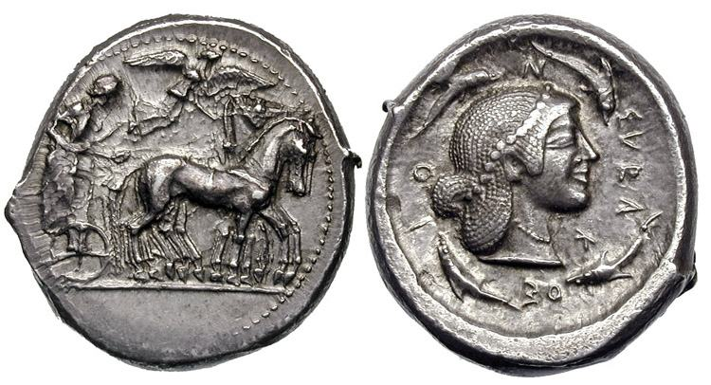
Figure 1

Silver Tetradrachm, Syracuse, C. 467-460 BC after wildwinds
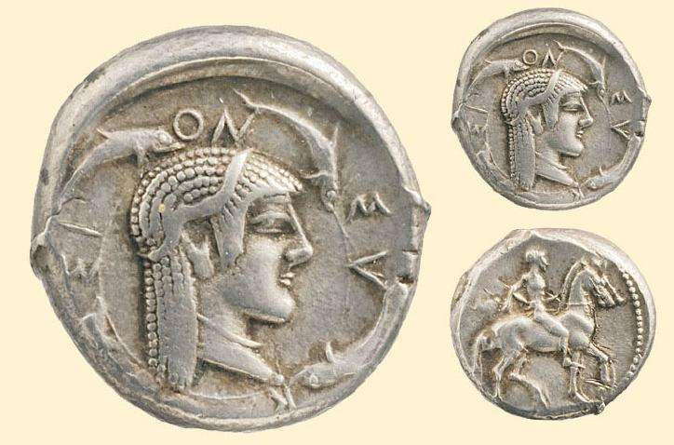
Figure 2

Silver Didrachm , Syracuse. c. 490-485 after wildwinds

Figure 3
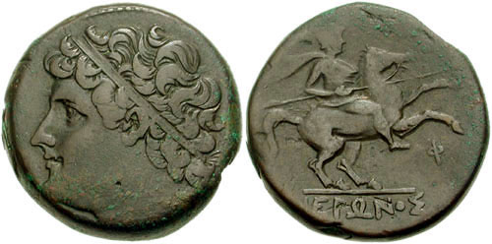

Bronze coin, Syracuse c275-215 after wildwinds

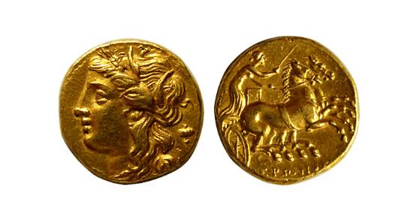
Figure 4

Gold decadrachm, Syracuse c 275-269 after wildwinds

Figure 5
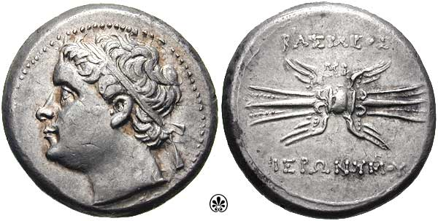
Silver coin, Syracuse, c214-215 BC after wildwinds

Bibliography
Griffin, M. J. (2005) The Tyrannies in the Greek Cities of Sicily: 505-466 BC. PhD, University of Leeds.
Harrell, S. (2002) ‘King or Private Citizen: Fifth-Century Sicilian Tyrants at Olympia and Delphi’, Mnemosyne 55 (4): 439-464.
Lewis, S. (2009) Greek Tyranny. Exeter: Bristol Pheonix Press
Wildwings “Ancient coinage of sicily, Syracuse” [online] available from www.wildwinds.com/coins/greece/sicily/syracuse/i.html [accessed 02/05/18]
Pausanius Description of Greece Jones (Trans)
Diodorus Biblioteke Oldfather (trans) 1989 harvard university press, London.
Polybius Histories Shuckburgh (trans) 1889, london

M. Griifin 2005
M. Griifin 2005
M. Griifin 2005
S. Lewis 2009
M. Griifin 2005
Diod 19.9
Polyb 19.32
S. Lewis 2009
Diod 11.67.2
Diod 11.67.4
S. Lewis 2009
Diod 14.7
Diod 13.96
Diod 11.67-68
S. Lewis 2009
S. Lewis 2009
M. Griifin 2005
Paus 8.42.9
S. Harrell (2002)
S. Harrell (2002)
S. Harrell (2002)
M. Griifin 2005
M. Griifin 2005
See figure 1
See figure 2
See figure 3
See figure 4
See figure 5

