Assignment 2: Project Management
Nicholas Gelstharp (2211042)
Changemakers: Creativity and Value Creation
6/13/23

Contents

Link to E-portfolio: 2
Task 1: 2
References for Task 1 4
Task 2 6
Task 3 8
References for Task 3 8

Link to E-portfolio:

https://sites.google.com/view/ngchangemakersassignment2/home

Task 1:

Quantitative and qualitative data are terms that are synonymous with each other, however the objectives of each are very different with qualitative analysis being more concerned with why and quantitative analysis concentrating on the how.
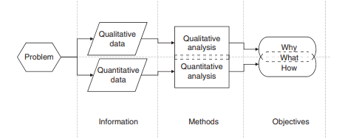
[1]
Two different types of quantitative analysis include descriptive statistical analysis and inferential statistical analysis. These two types of quantitative analysis are concerned with brining accuracy to research that involved an element of statistical analysis. Descriptive statistical analysis, the aim is to turn mathematical data into a plain English summary using terms such as many, most and few. There are many use cases for this such as understanding a patient population [2] , where the raw data can be overwhelming and descriptive statistical analysis is performed to simplify the key findings. Below is an example of an excel chart. This can be summarised as Most people own an Apple mobile phone. Few have a mobile phone manufactured by Google.
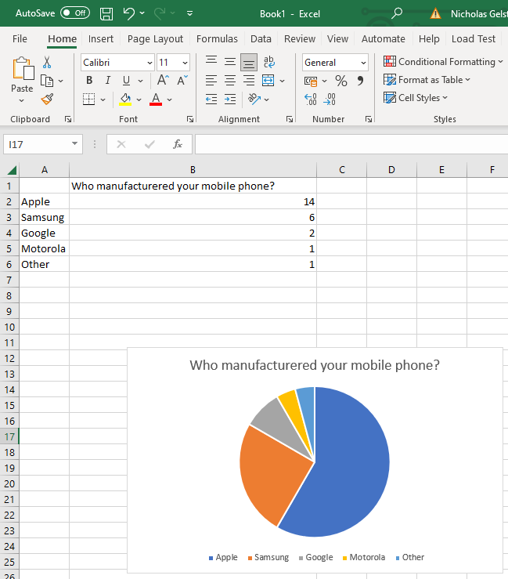

Inferential statistical analysis is a form of quantitative analysis that aims to draw conclusions from data that may involve an element of inference. For example, a use case may be what is the largest contributing factor in explaining the growing unemployment rate in Wales compared to England [3]. With this element of inference, there are ways to try and ensure as much accuracy is gleaned as possible through using systems such as the 5-step process recommended by Lawrence F Kamin [4]. Below is a chart and excel example data that could be used for inferential statistical analysis.
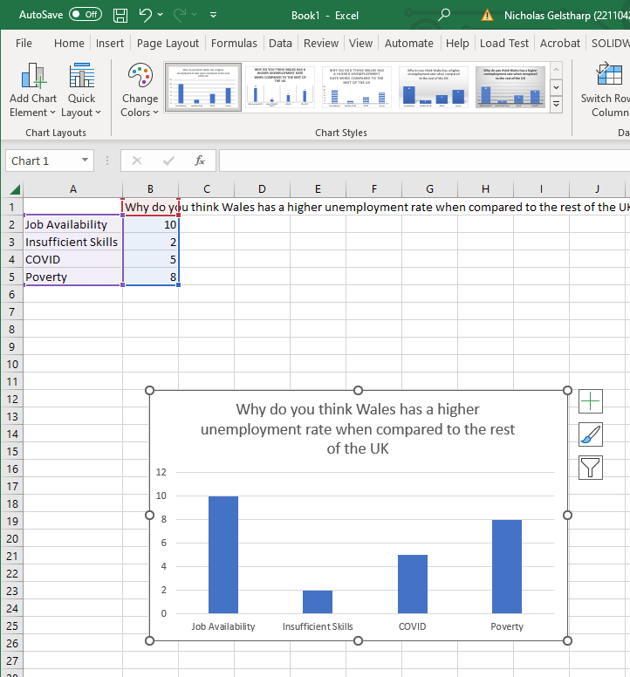
A further example of a use case for inferential statistical analysis would be estimating population growth, which would infer a growth rate based on historical data [5].

References for Task 1

[1] | H. Tang, in Engineering research: design, methods and publication, Wiley, 2020, p. 214.
[2] | J. L. Lay, E. Alfonso-Lizarazo, V. Augusto and B. Bongue, Prediction of hospital readmission of multimorbid patients using machine learning models, vol. 17, p. 12, 2022.
[3] | BBC, “Unemployment rise in Wales conerning, Vaughan Gething says,” June 13 2023. [Online]. Available: https://www.bbc.co.uk/news/uk-wales-65887988. [Accessed 13 June 2023].
[4] | L. F. Kamin, Using a Five-Step procedure for Inferential Statistical Analyses, vol. 72, pp. 186-188, 2010.
[5] | Office for National Statistics, “Population Projections,” 2020 March 24. [Online]. Available: https://www.ons.gov.uk/peoplepopulationandcommunity/populationandmigration/populationprojections. [Accessed 2023 June 13].

Task 2

https://sites.google.com/view/ngchangemakersassignment2/task-2
Screenshot of e-portfolio pages related to task 2:
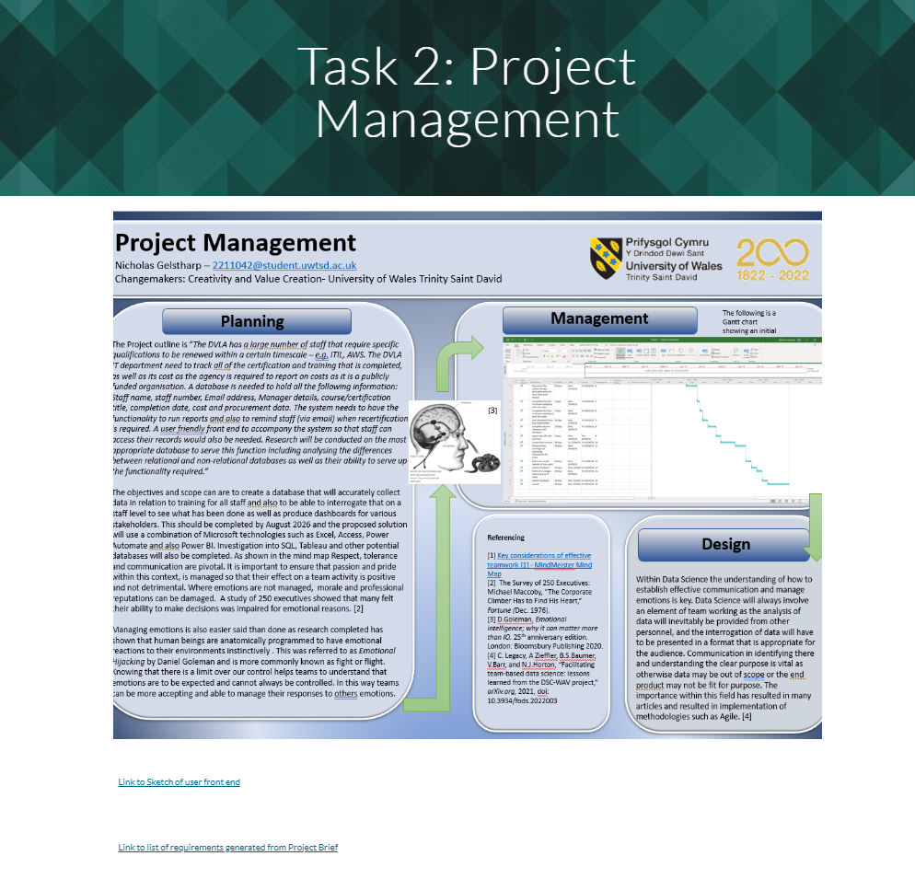

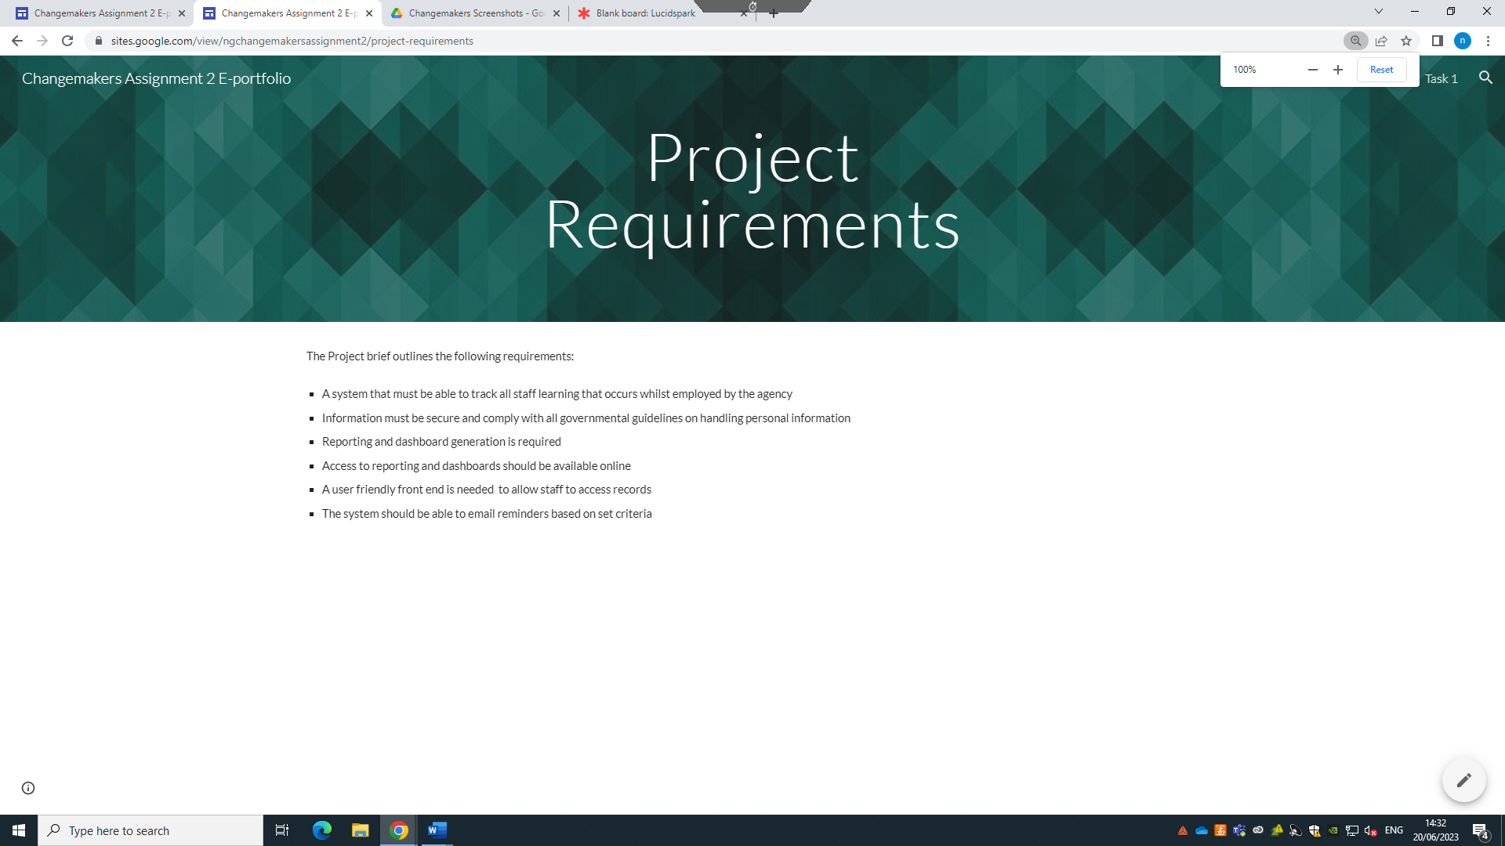

Task 3

I intend on using this opportunity to develop many new skills. First and foremost I will use the opportunity to refine my research skills to ensure that the data is gathered, processed and analysed in a consistent manner that will generate the best outcome by using techniques during interviews such as those shown below.[1]

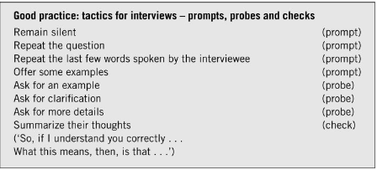

I will also be developing specific skills around technologies which may include SQL, mongoDB, Excel, PowerBI and Python which allow me to both complete this project and also have these transferable skills that I can then use in the future. I will also develop my project management skills to ensure that items of work are delivered on time and as required using a control cycle of plan, delegate, monitor, report and control and then repeating this cycle throughout. [2]
The new project will have a positive impact on the people that work for the DVLA as they will be able to produce records which show what they have learned, when and what it was. This will also allow reporting that will assist senior management in identifying individuals for posts and key activities within the organisation which is something that is not currently possibe. The general public may also benefit as any freedom of information act that is submitted, will be answered in a timely and accurate fashion which will increase transparency and help the organisation build trust. Using key performance indicators [3] that look to measure success across these multiple perspectives and this could also help refine the questions asked when surveying people.
The main challenge with this project is that I am limited by local policies on what software and technologies will be available to me and that may limit the scope. There are also challenges around getting the historic data and making sure that it is accurate so that the new system does not inherit the flaws of the old one. I can get around this by being in constant contact with my manager to ensure that I only investigate approved tech, and also to ensure that the data I am importing into the system has been verified and is accurate. Also by being in constant contact I can ensure that the solution designed is fit for purpose.

References for Task 3

[1] M. Denscombe, The good research guide : for small-scale social research projects, 4th ed. Maidenhead, England: McGraw-Hill/Open University Press, 2010.
[2] P. Roberts, Effective project management. London, UK ;: Kogan Page, 2011.
[3] B. Marr, Key performance indicators : the 75 measures every manager needs to know, 1st ed. Harlow: Pearson, 2012.

