ASSIGMENT 2
Practical Task
Menu
Module code: BMIH4002
Module name: Food &Beverage Operations
Student ID: 2026017
Student name: Tana Racova
Lecture name: Laurence Blake

Habibi 
Mediterranean restaurant In the Hotel Trinity Swansea

Starter
Humus
Tzatziki
Falafel
calamari
king prawns
Soup of day
ALL STARTERS EACH 4£
3 STARTERS 10 £

Meals
All meals have choice of two sides: Turkish break, salad, rice , chips
Grill
Lamb ribs…..15£
Lamb chops…..17£
Chicken wings…..11£
Kofte…..13£
(Lamb, chicken, mix)
Shish…..14£
(Lamb, chicken, mix)
Kebab…..15£
(Lamb, chicken, mix)
Special plate
Include bottle of wine
Casillero del dialblo of choise
Mix grill for 2…..35£
Mix grill Share for 4…..50£
seafood
Salmon….15£
Seabass…..16£
king prawns…..13£

Kids meal …5 £
Chicken burger ….
Turkey sauseges
Chicken nuffers

Dessert 4£
Baklava
Fudge chocolate cake
Oreo cake
Rafaelo cake

Drinks

Soft drinks
Fanta
Sprite
Pepsi
Ayran
Soda water
EACH 3£

Hot drinks
Turkish tea
Turkish coffee
Hot chocolate
Cappuccino
Late
EACH 2£

Alcohol drinks
Heineken…..4£
Stella Artois…5£
Guinness…..4£
Casillero del diablo wines
(Merlot, Shiraz, Malbec, Chardonnay, Cabernet, Sauvignon)…each 13 £
Sparkling Rizzi Rose…11£
Prosecco …15£

Opening time
Monday – Sunday
11:00 AM – 23:00 PM
ORDER:


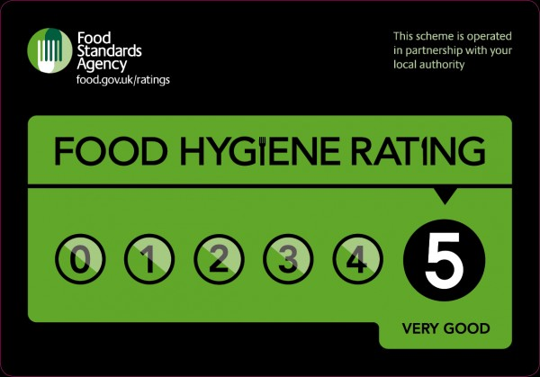

Allergen and nutritional information can ask staff or fine on information screen

Reference list
- Food hygiene rating Available in: https://ratings.food.gov.uk/ (Accessed: 22 February 2022)
- Business guidance Available in: https://www.food.gov.uk/business-guidance/allergen-labelling-for-food-manufacturers (Accessed: 23 February 2022)

