3 words: Abstraction, Pareidolia and Affect
This essay will explore three key concepts that captivate my interest, Abstraction, Pareidolia and Affect. Abstract art challenges traditional representations, inviting viewers to engage with emotions and ideas beyond the surface. Meanwhile, pareidolia argues that our brains are weird to see something in everything based on our emotions and affect being the theory being how what we feel can affect our experiences.
Abstraction
According to the Cambridge Dictionary (2018) abstract is defined as “to refer to a type of painting, drawing, or sculpture that uses shapes, lines, and color in a way that does not try to represent the appearance of people or things”. This refers to art that is created with minimal to no form as a tool of expression of emotions or thoughts. However, according to Sparks Gallery, abstract art is” a non-objective art form that breaks traditional, realistic art styles.”. Therefore, to create art and patterns in an abstract way is to draw and paint with no focus on how the outcome might depict a subject figuratively.
In its most basic form, abstract art can be split into two subcategories. According to The Art Story (2011) they are “Abstracted art, which is based in some form, on reality and nonobjective abstraction which does not contain an identifiable subject or scene”.
Abstracted art can allow artists to break free from traditional representation and explore their own unique styles while also keeping their original inspiration and feeling. This form of art still evokes individual emotion for viewers but still allows artists to keep their intentions clear. John Berger in Ways of Seeing says, “The relation between what we see and what we know is never settled.” (Berger,1972, p.7). This highlights how abstracted art challenges viewers to interpret and engage with the artwork on a personal level while also remaining accessible for all viewers as there will be a base level of understanding in the form. Abstracted art with a form creates a dialogue that can be both personal and universal, making it a valuable form of expression for artists.
The lack of recognizable structure in nonobjective abstraction may lead to ambiguity and confusion for viewers. As art historian Rosalind Krauss noted in The Originality of the Avant-Guarde “The work of art is not a thing it's a process.” (Krauss,1985, p.151-170). This highlights how the absence of form can create challenges for artists, as they may struggle to guide their viewers' interpretation and ensure that their intended message is effectively communicated. In this way, the freedom that abstraction offers can become limited when clarity is desired.
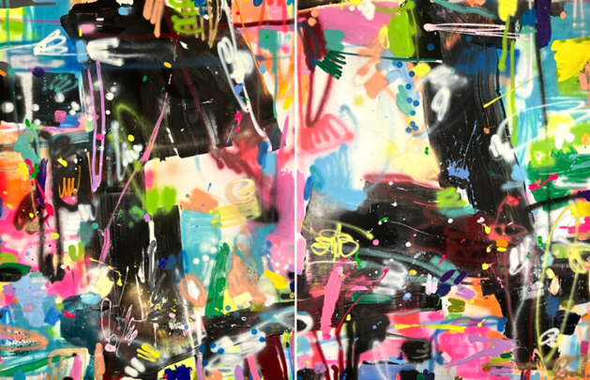
However, nonobjective abstraction does not have any direct form to obtain as there is no specific object to interpret, but rather a specific emotion and or atmosphere. An example of an artist who creates nonobjective abstraction art would be Maria Esmar, specifically her piece “Energy” sees Figure 1. This liberation enables artists to explore pure color and texture creating work that evokes emotions and ideas directly. Viewers are invited to engage with the artwork on a personal level, interpreting its meaning through their own experiences and perspectives, leading to a deeply individual and subjective connection with the piece. This form of art encourages innovation and experimentation, pushing the boundaries of artistic expression and challenging traditional notions of what art can be. Abstracted art to some extent limits the viewer's creativity in such a way that there is an original form that can only hold so much variation within perception and creation. It holds a general form from an inspiration, and this can often serve as a constraint for some artists, limiting their creative expression and forcing them to conform to established conventions.
Figure 1: Energy (Maria Esmar 2023)

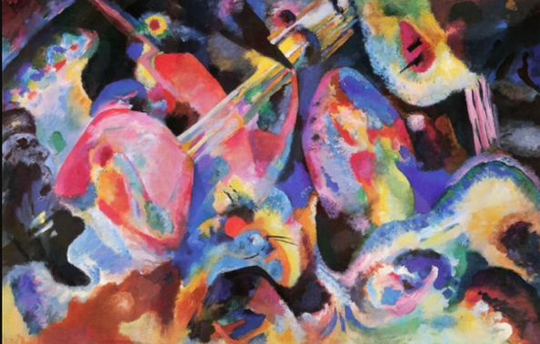
Where artists are bound by the need to depict recognizable subjects, they may find themselves struggling to convey their true emotions or ideas. As artist and theorist Wassily Kandinsky stated in Concerning the Spiritual in Art, “Color is the keyboard, the eyes are the harmonies, the soul is the piano with many strings.” (Kandinsky,1911, p.33). This suggests that when artists are confined to representational forms, they may struggle to explore the full range of their creative potential, as they are unable to express the deeper emotional and spiritual connections that art can evoke.
Figure two: Improvisation, Deluge (Wassily Kandinsky 1909)
Kandinsky’s synesthesia, where he experienced colors as sounds and vice versa, deeply influenced his artistic journey. This unique sensory intersection fueled his passion for
abstract art, allowing him to translate musical compositions and emotional experiences directly onto canvas. An example of this would be his piece Deluge from his Improvisation collection shown in figure two. This piece is a form of abstracted art as it shows a vague depiction of a form which will vary based on the viewer. Believing that color could evoke specific emotions, like music, Kandinsky sought to liberate painting from representational forms. His synesthetic perception encouraged him to explore the spiritual and emotional depths of color and form, paving the way for groundbreaking abstract works that resonate with visual music.
His synesthesia empowered him to break free from the constraints of traditional art, embracing abstraction as the ultimate means of expression. He saw abstract art to capture the inner essence of reality, revealing the hidden harmonies and spiritual dimensions that lay beneath the surface of the visible world. He advocated for an art style that transcended the material world, aiming to awaken the viewer's inner self through the emotional power of color and form. He believed that art should be a spiritual experience, capable of elevating the soul and connecting individuals deeper. His teachings inspired generations of artists to explore the expressive potential of abstraction, encouraging them to tap into their own experiences and create art that resonated with emotional and spiritual meaning.
Pareidolia
The psychological phenomenon pareidolia refers to “a situation in which someone sees a pattern or image of something that does not exist, for example a face in a cloud” (Cambridge Dictionary 2018). Pareidolia is where the mind responds to a stimulus by perceiving a familiar pattern where none exists, this often involves seeing faces in inanimate objects such as spotting a face in the clouds or on the surface of a rock. It occurs because our brains are wired to quickly recognize patterns, especially faces, as a survival mechanism. While pareidolia can be a source of amusement, it also highlights how our beliefs are actively constructed rather than passively received.

The quote “We don't see things as they are, we see them as we are” by Anais Nin in her book Seduction of the Minotaur (Nin, 1958, PAGE) perfectly encapsulates the essence of pareidolia. When we see a face in something, it’s not an objective observation but a projection of our own experiences, memories, and emotions onto the ambiguous world around us. Our brains fill the gaps creating meaning where non inherently exists, proving our perception is deeply personal and subjective. Individuals' history and cultural backgrounds, shape what we are likely to perceive. For example, someone who has recently experienced loss might see sad faces in objects, while someone who is religious may find symbols in natural formations. This quote highlights that pareidolia is not just a trick of the mind, but a profound reflection of our inner selves influencing our external reality. Furthermore, this concept challenges the idea of universal truth, suggesting that what we believe to be real is filtered through our personal lens. Pareidolia becomes a reminder that our perceptions are subjective interpretations rather than objective truths. It underscores the importance of empathy and understanding, acknowledging that others may perceive the world differently based on their unique experiences and perspectives.
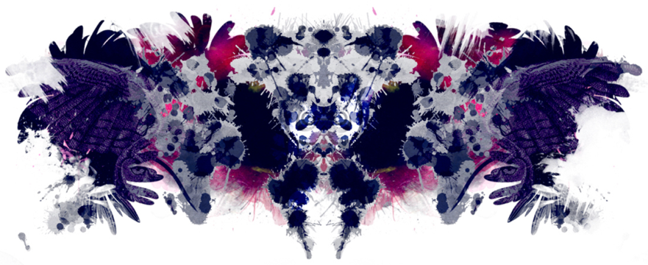
It is an aspect of psychology that is used daily by many, it shapes our interpretation of art and design, social interactions, and some job atmospheres. Therapists especially leverage this phenomenon through techniques like the Rorschach inkblot test, using ambiguous images to prompt patients to project thoughts and feelings, offering valuable insights into their subconscious see figure three. By exploring these perceived patterns, therapists can uncover underlying emotions, anxieties or unresolved issues making pareidolia a unique tool for self-discovery and emotional exploration. Pareidolia can influence humans by triggering emotional responses, such as comfort from seeing a familiar face, or anxiety when perceiving threatening images. It affects decision-making in situations like interpreting religious symbols or assessing risks based on perceived patterns.
Figure three: Rorschach ink test
Beyond the Rorschach test, pareidolia plays a role in other therapeutic approaches, such as art therapy, where patients create and interpret art to express their inner states. The act of finding recognizable forms or emotions in abstract art can be a cathartic process, allowing individuals to externalize and process complex feelings. Additionally, therapists may use guided imagery or visualisation techniques that encourage patients to find symbolic meanings in natural scenes or imagined landscapes. This can help uncover hidden emotions or provide a sense of comfort and control. In daily life, understanding pareidolia can enhance our awareness of how our mind shapes our perceptions. Recognizing that we often project our own feelings and expectations onto the world can improve communication and empathy in social interactions. It can also foster a greater appreciation for the subjective nature of reality, encouraging us to consider different perspectives and interpretations.

The link between pareidolia and abstract art lies in their shared ambiguity and reliance on subjective interpretation. Abstract art, by its nature, lacks clear representational forms, inviting viewers to find their own meaning and connections within the artwork. When confronted with an abstract painting or sculpture, our minds actively seek recognizable shapes, faces, or scenes even if none were intentionally created by the artist. Abstract art provides pareidolia a canvas to flourish, allowing viewers to project their own experiences, emotions and memories onto the artwork. The resulting interpretation is a unique blend of the artwork’s inherent qualities and the viewers personal perspective, demonstration the powerful connection between perception, imagination and the creation of meaning.
However, pareidolia does also offer a critique of the idea that abstract art is entirely free of representation or meaning. Some argue that abstract art is purely about form, color and composition, existing outside of any representational context. However, pareidolia suggests that viewers will inevitably find patterns and meanings, even in the most abstract works. This implies that abstract art can never be truly “pure” or devoid of content, as the human brain is hardwired to seek out familiar forms and narratives. By highlighting the role of subjective interpretation, pareidolia challenges the notion that abstract art can be appreciated soley for its aesthetic qualities, independent of any representational or emotional associations. It suggests that the viewers own experiences and biases play crucial role in shaping their understanding of the artwork, blurring the line between pure abstraction and subjective representation.
This idea is supported by art critic Rober Hughes as he once stated in his book The Shock of the New “The best art is the one that makes you see” (Hughes, 1980, p.). So, if the “best art” helps you see something, even in abstract forms, pareidolia explains why your brain fills in the gaps and finds familiar faces or meanings. This further blurs the line of what’s truly abstract as your mind always seeks to make sense of it.
Affect
The affect theory is, “a subfield that encourages us to think about how we interact with each other and the world along registers that are not reducible to language” (Schaefer, Oxford University, N.D.). The affect theory explores how emotions and feelings shape our experiences, thoughts and interactions. It goes beyond simply labeling emptions to understanding how they move through us, influencing perceptions and behaviors. Affect theory suggests that these feelings are not just personal but also social and cultural forces that can connect and divide us, shaping everything from our political views to our artistic expression. Ultimately, it offers a lens to examine the often-overlooked emotional undercurrents that drive human life.
Furthermore, the affect theory challenges the traditional view of emotions as secondary to reason. Instead, it posits that affects are primary, pre-cognitive and often unconscious, shaping how we perceive and react to the world. An example in daily life would be listening to a particular song and how it can instantly change your mood or how a tense atmosphere in a room can make you feel uneasy, even before you consciously understand why. These immediate, visceral reactions are the focus of affect theory, highlighting the power of feelings in shaping out experiences. As well as this, affect theory is interdisciplinary drawing from fields like psychology, sociology and literary studies. It’s used to analyze everything from political rhetoric to consumer behavior, revealing how emotions are manipulated and mobilized. For example, understanding the affective power of certain images or narratives can explain why some political messages resonate so strongly, or why certain brands evoke feelings of loyalty and desire. By examining these emotional dynamics, affect theory provides a deeper understanding of human behavior and social phenomena.
From a phenomenological perspective, affect theory delves into how emotions are directly experienced and shape our conscious awareness. Phenomenology emphasizes the lived experience, and affect theory complements this by exploring how feelings color and influence our perception of the world. It suggests that our emotional states are not just internal reactions but are intertwined with how we encounter and interpret phenomena. Therefore, understanding affect through a phenomenological lens means examining how emotions are embodied, how they structure our understanding ad how they contribute to the unique, subjective nature of our individual experiences.
In the context of hauntology, affect theory provides a framework for understanding how the past continues to resonate and exert influence on the present. Hauntology according to Paige Allen is “about lost time than lost souls: hauntology is concerned with what is no longer, what is not yet, what may never be. The word attempts to describe the state of the twenty-first century as a time not only longing for irretrievable pasts but also mourning lost futures.” (Allen, 2023). This finds a compelling ally in affect theory, which illuminates how these spectral presences evoke feelings of nostalgia, loss or unease. Affect theory explains how these feelings aren’t just intellectual acknowledgments of the past but are embodied experiences that shape our current emotional landscape. By exploring the affective dimensions o hauntology, we can better understand how cultural memories, loss futures and lingering traces of the past continue to impact our emotional and cultural lives.
Mark fishers work provides a critical lens through which to examine affect theory, particularly in the context of late capitalism. Fisher in his book, Capitalist Realism: Is there No Alternative? described depressive hedonia as a state where “pleasure and enjoyment become impossible” (Fisher, 2009, pp.21–22). This quote shows how capitalism can warp our affective capacities. He argued that mental health issues are often a consequence of capitalism, not merely individual problems, highlighting how systemic forces shape our emotional experiences. Fishers’ analysis suggests that affect theory must consider the broader socio-economic context, revealing how capitalism can manipulate and commodify our emotions, leading to a pervasive sense of alienation and disaffection.
In conclusion, after researching my three key words I have found ways that they link but also how they challenge aspects of one another. These ideas have found me questioning whether anything is truly abstract or due to our physiological tendencies will there always be something in everything we see. This has led me to the question of “Is anything ever truly abstract?”.

Bibliography
Allen, P. (2023). What is Hauntology? [online] Perlego Knowledge Base. Available at: https://www.perlego.com/knowledge/study-guides/what-is-hauntology/# [Accessed 7 May 2025].
Cambridge Dictionary (2018) Definition of Abstract Available at: https://dictionary.cambridge.org/dictionary/english/abstract (Accessed: 13th March 25)
Cambridge Dictionary (2018) Definition of Abstraction Available at: https://dictionary.cambridge.org/dictionary/english/abstraction (Accessed 27th March 25)
Cambridge Dictorary (2018) Definition of Pareidolia Available at: https://dictionary.cambridge.org/dictionary/english/pareidolia (Accessed: 26th March 2025)
Donovan Schaefer, Oxford University, Affect Theory, Available at: https://ora.ox.ac.uk/objects/uuid:47cab9ea-4068-411b-b5d1-db0a497f64ed/files/m7e352e5f018c229115973152e28379bd#:~:text=Page%201-,Abstract%3A%20Affect%20theory%20is%20a%20subfield%20that%20encourages%20us%20to,understand%20the%20experience%20of%20animals. (Accessed on 6th of May 2025)
Fisher, M. (2009). Capitalist Realism: Is There No Alternative? pp.21–22. ‘pleasure and enjoyment becomes impossible’.
John Berger (1972) Ways of seeing, P.7
Nin.A (1958) Seduction of the Minotaur, p.
Rober Hughes (1980) The Shock of the New p.
Rosalind Krauss (1985) The Origian;itly of Avant-Guarde, P. 151-170
Sparks Gallery (date) What is abstract art? Definitions and Examples Available at: https://sparksgallery.com/learn/what-is-abstract-art#:~:text=Abstract%20art%20is%20a%20non,story%20or%20portraying%20realistic%20subjects. (Accessed: 27th March 25)
The Art Story (2025) Abstract Art Available at:https://www.theartstory.org/definition/abstract-art/#:~:text=At%20its%20most%20basic%2C%20abstract,belonging%20to%20the%20first%20category. (Accessed: 26th March 25)
Wassily Kandinsky (1911) Concerning the Spiritual in Art, P.33

Figures:
Figure one- Maria Esmar (2023) Energy [mixed media on canvas]. Avalible at: https://www.mariaesmarartgallery.com/artforsale2/cwhnld53q6mwrqfi (Accessed: 27th March 2025)
Figure two- Wassily Kandinsky (1909) Improvisation. Deluge [oil paints on canvas] Available at: https://www.wassilykandinsky.net/work-32.php (Accessed:1st May 2025)
Figure three- Rorschach test ink splatters [ink] Available at: https://www.insomniac.com/magazine/we-had-everyone-at-dirtybird-take-a-rorschach-test/ (Accessed: 5th May 2025)

