

Module: Marketing Management

Module Code: LCMB7024

Assignment Title: Assessment component 1: Marketing Environment Analysis

Student Name: Dhruv Girishbhai Shingala.

Student ID: 2530033

Lecturer’s Name: Dr Laila Maazouz (London)

Work Count: 2716 Words

Table of Contents
Introduction 4
Task 1: Critical Analysis of the Macro Marketing Environment 4
1.1 Macro marketing environment and strategic marketing management 4
1.2 PESTLE Framing and Selection of Focal Macro Actors 4
1.3 Industry Context and Company Selection 6
1.3.1 UK grocery market context 6
1.3.2 Ocado as pioneering organisation 7
1.3.3 Tesco as follower organisation 7
1.4 Economic Environment: Opportunities, Threats and Competitive Implications 8
1.4.1 Economic force within the PESTLE framework 8
1.4.2 Opportunities and threats for Ocado 9
1.4.3 Opportunities and threats for Tesco 9
1.4.4 Effect on competitive position 9
1.5 Technological Environment: Opportunities, Threats and Competitive Implications 9
1.5.1 Technological force within the PESTLE framework 10
1.5.2 Opportunities and threats for Ocado 10
1.5.3 Opportunities and threats for Tesco 10
1.5.4 Effect on competitive position 11
1.6 Comparative Discussion of Macro-Environmental Impact 11
Task 2 structure 12
2.1 Strategic Context 12
2.2 Ansoff Matrix 12
2.3 Ocado: Ansoff Analysis 13
2.4 Tesco: Ansoff Analysis 14
2.6 Porter Strategies 14
2.7 Ocado: Porter Analysis 15
2.8 Tesco: Porter Analysis 15
2.9 Strategic Fit 16
Conclusion 16
References 17

Introduction
This report critically examines the impact of macro marketing environment on strategic performance in UK grocer retail on the basis of comparing Ocado as an innovator with Tesco as a follower. The focus of the analysis is on economic and technological forces since their impacts are not uniform: inflation is more likely to favour scale, pricing flexibility and broad value propositions. Additionally, technological change has a stronger benefit to firms that can digitally embed and fulfil their value propositions. There the argument explores more than opportunity and threat, the reorganising capabilities of external pressure, which can reorganise competitive position, as opposed to constricting performance.

Task 1: Critical Analysis of the Macro Marketing Environment

1.1 Macro marketing environment and strategic marketing management
Strategic marketing management is shaped by external market conditions, not merely by managerial intent, due to firms competing within constraints they do not control. PESTLE frameworks can be effectively used selectively such as political, economic, social, technological, legal and environmental forces are not equally significant in industries or time frames. A broad scan is not as useful analytically in UK grocery retail as the macro forces that have a material impact on demand and rivalry. Economic pressure modifies value perception and price sensitivity, whereas technological change remodels channel behaviour and fulfilment ability; both forces modify not only its performance (Kotler and Keller, 2021; Jobber and Ellis-Chadwick, 2023).

1.2 PESTLE Framing and Selection of Focal Macro Actors
PESTLE frames the macro environment in perspective based on political, economic, social, technological, legal and environmental forces. However, its strategic worth is in prioritisation and not coverage. In the case of Ocado and Tesco, economic and technological factors are the most crucial due to they directly change the foundation of competition in the grocery market more than other aspects. In the economic sector, the UK food and non-alcoholic beverage inflation stood at 4.5% in December 2025, that means that it is still straining household budgets and causing consumers to be increasingly price and value conscious (ONS, 2026a). This situation tends to favor Tesco size, pricing freedom and value architecture of loyalty over Ocado convenience-led proposal. Online sales recorded a 29.4% share of all retail sales in December 2025, which proves that online channels continue to be structurally significant in UK retailing (ONS, 2026b).
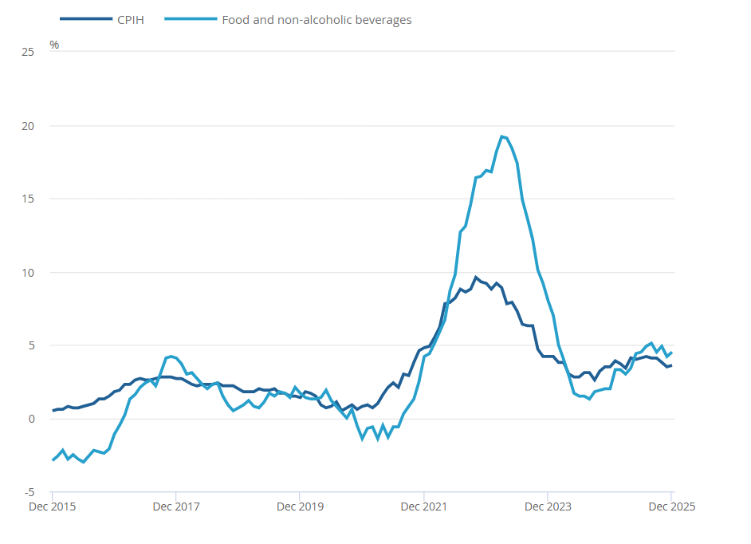
Figure : UK food and non-alcoholic beverage inflation rate
(Source: ONS, 2026a)
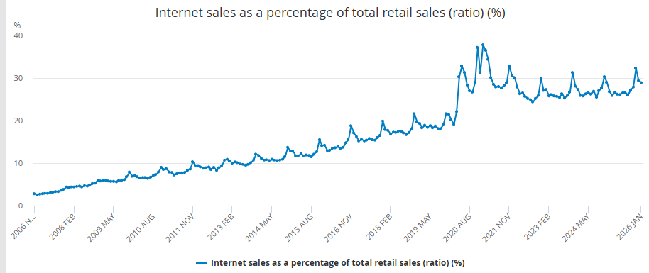
Figure 2: Internet sales as a percentage of total retail sales (ratio) (%)
(Source: ONS, 2026b)

1.3 Industry Context and Company Selection

1.3.1 UK grocery market context
Grocer retail in the UK is a suitable location to apply the brief due to the fact that competitive position is determined by market scale and digital capability as opposed to size alone. Tesco has been confirmed as leading the market with a market share of 28.3% in the 12 weeks to 5 October 2025, with Ocado, though at market share of 2.0% remaining the fastest-growing British grocer with its sales growth of 13.6%. This gap is important for the analysis due to its display that power and innovation are more concentrated in other companies. In addition, comparing pioneers with followers is more accurate than simply dividing firms into leaders and laggards. (Kantar, 2025).
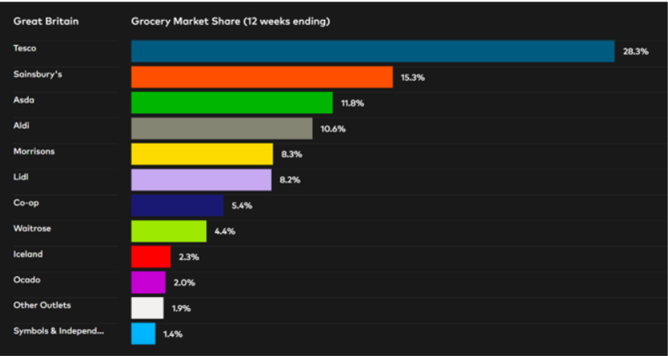
Figure 3: grocery market share
(Source: Kantar, 2025)

1.3.2 Ocado as pioneering organisation
Ocado is more persuasively described as the first mover organisation since its contribution to UK grocery has been to transform the manner in which value is applied through online fulfilment as opposed to the option of being involved in online retail. According to Ocado, it was formed as the first pureplay online grocer in the UK and created a technology-driven fulfilment framework based on proprietary systems and automated customer fulfilment centres (Ocado Group, 2025). This helps better define pioneering in terms of business-model innovation, which is more related to the theory of first-mover advantage than first-mover alone (Lieberman and Montgomery, 1988).

1.3.3 Tesco as follower organisation
Tesco should be considered as the follower in the comparison not because it is a strategically weak company. However, its online grocery strength is based on adaptation, scale and competitive response, but not on the origin of the technology-led model. The difference is more accurate to the brief that structural power is in breadth and price architecture and established reach in Tesco, and in redefining the online grocery model itself in Ocado. In that way Tesco is a symbol of follower power with scaled implementation and Ocado is a symbol of pioneer power with market-shaping innovation (Kantar, 2025; Lieberman and Montgomery, 1988).

1.4 Economic Environment: Opportunities, Threats and Competitive Implications

1.4.1 Economic force within the PESTLE framework
In PESTLE, the economic environment will be of concern since it has a direct influence on household buying capacity, the freedom of retail prices and the perceived value of grocery propositions. The UK has a rate of 4.5% non-alcoholic beverage and food inflation as of December 2025 and 3.6% all-household cost inflation meaning that the consumer budgets remain strained and the demand environment is not completely normalised (ONS, 2026a; ONS, 2026c).
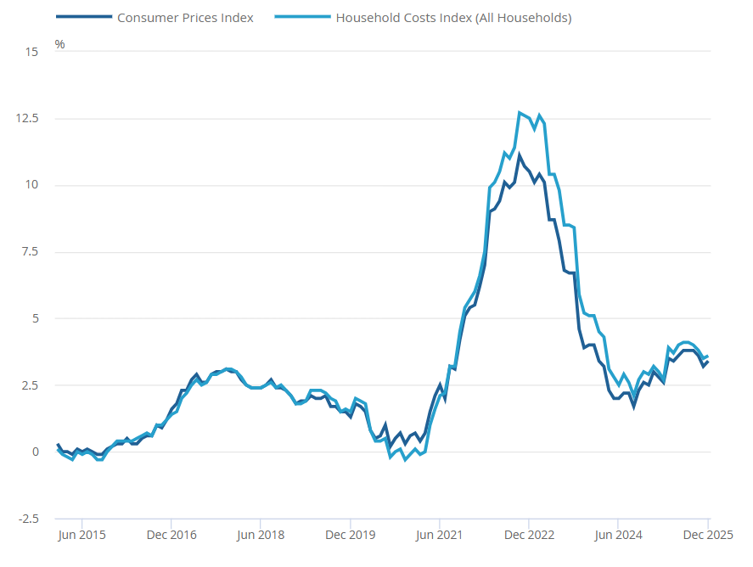
Figure 4: Household Costs Indices and Consumer Prices Index
(Source: ONS, 2026c)

1.4.2 Opportunities and threats for Ocado
In the case of Ocado, economic pressure poses a more severe strategic threat since its offering relies partially on convenience, quality of delivery, and digitally enabled service premium. In tightening household budgets, the attributes may be reviewed relative to basket cost, customer retention becomes more tenuous than in the value-based formats. This threat can be seen in the market structure: even with the excellent momentum, Ocado share stood 2.0% during the 12 weeks to 5 October 2025. It indicates growth fails to remove scale advantage in a price-sensitive market (Kantar, 2025). However, the same environment provides selective opportunity.

1.4.3 Opportunities and threats for Tesco
In the case of Tesco, the economic environment is less hostile since inflation reinforces the significance of scale, freedom of pricing, and value communication by loyalty. The market share of Tesco in the 12 weeks to 5 October 2025 is 28.3%, that means that the wide market coverage is a significant strength as consumers become increasingly price-aware (Kantar, 2025). This is supported by Tesco itself evidence of the UK online sales increasing 11.4 % in the first half of 2025-26. Additionally, online market share of 36.9% proves that value-led scale can be replicated online and not just in stores (Tesco, 2025a). However, the risk is margin pressure in a market where the focus is placed on price, share defence might need more pronounced promotions and a stricter price structure.

1.4.4 Effect on competitive position
The economic environment makes Tesco stronger than Ocado since inflation favors breadth over convenience-led differentiation, price credibility and loyalty-led value over convenience-led differentiation. Economic stress makes its premium service logic narrower in the competitive reach of Ocado, that can nevertheless grow. It is the same macro force that does not impact performance in a direct manner, but redistributes relative advantage to the scaled follower instead of the digital pioneer.

1.5 Technological Environment: Opportunities, Threats and Competitive Implications

1.5.1 Technological force within the PESTLE framework
The technological environment is strategically important within the context of PESTLE since it redefines the manner in which value is created, accessed and defended within the grocery context. Online sales in the UK retail also accounted for 29.4% of total retail sales in December 2025, that confirms that online channels are not a fringe part of the structure but a structurally important part of the business. This makes fulfilment capability, data use, and digital user encounters key aspects of competition in grocery, rather than just secondary operational issues.

1.5.2 Opportunities and threats for Ocado
Technology is a stronger opportunity for Ocado due to it being embedded in the firm business model rather than added as a support operation. According to Ocado, the company has developed into what the company considers to be the first pureplay online grocer in the UK, into a technology-driven enterprise that has been designed around automated fulfilment and proprietary systems (Ocado Group, 2025). That positioning provides it with a differentiated foundation of competition in a market where digital promptness is still essential. This model is healthy in its operations performance: Ocado Retail revenue grew 16.3% in the first half of 2025 and group revenue grew 13.2%. It indicates that technology-driven service delivery remains able to drive customer demand (Ocado Group, 2025a). The risk is that technology-dependence increases execution risk, however. Increased fixed investment, complexity and imitation pressure in the system can dilute advantage when the ability costs are not matched with customer growth.

1.5.3 Opportunities and threats for Tesco
Technology is an opportunity and point of strategic pressure to Tesco. It provides dimensions to expand omnichannel accessibility, customise worth and protect convenience without forfeiting the economies of scale of mass grocery retail. The online sales growth of 11.4%, the online market share of 36.9% and the 70,000 weekly slots of delivery introduced by Tesco in the first half of 2025-26. It demonstrates that the company is leveraging technology to improve but not disrupt its current market strength (Tesco, 2025a).

1.5.4 Effect on competitive position
Technological change is more directly beneficial to Ocado since digital capability is its core competitive advantage, and Tesco applies technology more instrumentally to build upon an already broad offer. Tesco is still strong because of scale, but technology enhances Ocado differentiation more than it changes Tesco model. The technological environment thus changes competitive advantage to the first mover more than the second mover.

1.6 Comparative Discussion of Macro-Environmental Impact
The joint analysis reveals that macro forces do not impact Ocado and Tesco equally since the strength of each company lies on another strategic platform. Tesco is better placed under the pressure of the economy, as inflation acts to raise consumer consideration of price, range and value, which Tesco is able to provide with its size and market coverage (Kantar, 2025; ONS, 2026a). In comparison, technological change provides Ocado with a better advantage since digital fulfilment and platform capability are core to its offer and not ancillary support functions (Ocado Group, 2025a). The outcome is a conditional competitive framework: Tesco is in a stronger position where affordability is the defining factor in demand. Additionally, Ocado is in a relatively stronger position where convenience, digital service quality and innovation in fulfilling customer choices become more decisive (Tesco, 2025a).

Task 2 structure

2.1 Strategic Context
Tesco was economically more advantaged due to inflation, which heightened the importance of the price and enhanced competitive merit of scale. Moreover, pricing flexibility and retention based on loyalty as seen in Tesco leading the market and due to increased sales via digital platforms (Tesco, 2025a). On the other hand, technological change has advantaged Ocado since digital fulfilment, automation and platform capability are inherent in its model and not added as assistance mechanisms (Ocado Group, 2025a).

2.2 Ansoff Matrix
This applies to the Ansoff matrix since it identifies four growth paths that have varying strategic implications: market penetration, market development, product development and diversification (Ansoff, 1957). Its usefulness here is analytical and not descriptive, as it enables the assessment of whether Ocado and Tesco are maintaining growth by exploiting existing demand, broadening its scope, polishing the offering or transitioning to the next capability areas.
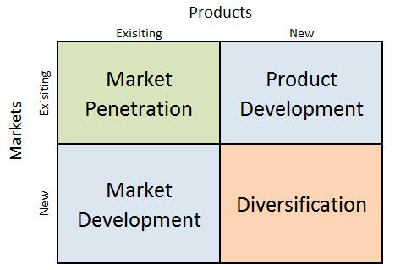
Figure : Ansoff’s matrix
(Source: self-created)

2.3 Ocado: Ansoff Analysis
Ocado’s strategic response is best explained by product development and related diversification. The continued improvement of automated fulfilment and service (as shown by group revenue increasing to £674.0 million, up 13.2% in the first half of 2025) shows the continued development of technology-driven enhancement of the service that contributes to the growth. The issue of related diversification also applies since the logic of growth of Ocado will not only be based on the retail transactions but on technology and fulfilment capabilities. On the other hand, an aspect of the commercial offer and not a background operational tool (Ocado Group, 2025a). It makes strategic sense in the context of technological change, as it indicates the type of capability-based expansion that is inherent to innovative companies. Their competitive edge lies in the ability to create new competitive spaces, rather than in the ability to maintain the old ones (Lieberman and Montgomery, 1988). However, this path is more open to inflationary pressure since higher-risk paths of Ansoff require consumers to stay afflicted by convenience and innovation to such a degree that they would pay a premium on the services.

2.4 Tesco: Ansoff Analysis
The reaction of Tesco can be explained in terms of market penetration and market development. Market penetration can be seen in its attempts to intensify existing demand by price lay-out, selling depth and customer retention by loyalty. Additionally, market development can be seen in the ongoing expansion of digital reach and not in a redesign of the model. During the first half of 2025-26, Tesco announced it had grown its online sales by 11.4%, online market share by 36.9% and added 70,000 weekly delivery slots. It indicates it is building on existing strengths instead of radical innovation (Tesco, 2025a). It is a less risky Ansoff pathway since it leverages the established customer trust and market size as compared to depending on demand that is based on innovation. Strategically, it makes Tesco response more resilient to economic pressure, despite being less transformative than that of Ocado. Tesco is thus maintaining its growth by adapting and extending rather than redefining the market.

2.6 Porter Strategies
The second evaluative lens is Porter Generic Strategies, that analyses how the firms protect the competitive edge by focusing on cost leadership or differentiation. They are helpful in this case because they explain how Ocado and Tesco could be maintaining growth on fundamentally different competitive grounds and not just on different growth paths (Porter, 1985; Tanwar, 2013).
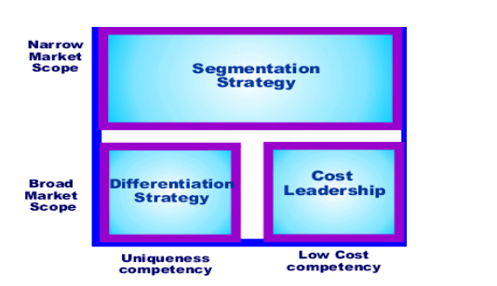
Figure 5: Porter’s Generic Strategies
(Source: Tanwar, 2013)

2.7 Ocado: Porter Analysis
Ocado can be understood through differentiation since its benefit is seen in convenience, quality of fulfilment and digital experience as opposed to price leadership. Its 2025 six-month performance, which includes 13.2% group revenue growth and 16.3% Ocado retail revenue growth. It indicates that clients continue to reward this service-based model when digital convenience is strategically rated (Ocado Group, 2025a). However, differentiation is smaller during inflation since price-sensitive households will be less mindful to absorb a service premium, and the scope of Ocado appeal is constrained even in the context where the model is still operationally distinctive (Davey, 2025a).

2.8 Tesco: Porter Analysis
Tesco can be best explained by the broad cost leadership in the sense that its position is based on scale and price credibility, depth of its own label and a sense of loyalty as opposed to technological uniqueness in isolation. Tesco with a market share of 28.3% in 12 weeks to 5 October 2025, and Tesco itself posted 11.4 percent UK online sales growth and 36.9% online market share. It means that value-based scale is defensible in both the physical and online channels (Davey, 2025b; Tesco, 2025a). However, Porter is not the ideal, as Tesco competes via convenience, service, and innovativeness in addition to the price.

2.9 Strategic Fit
Ansoff and Porter demonstrate that competitive advantage in this case is conditional and not fixed. Tesco is a better strategic fit when economic pressure is dominant due to the fact that inflation raises the value of scale, price discipline and wide-market availability, which are conducive to market penetration and cost-based competition (Tesco, 2025a; Davey, 2025b). Technology and quality of fulfilment is relatively stronger when Ocado grows when the differentiation and capability-based development is the competitive logic. Additionally, price defence is the defence instead of the dominant competitiveness of the product (Ocado Group, 2025a). This does not mean that one company has a universally better strategy but rather, each is advantaged by a different macro environment.

Conclusion
The comparison reveals that the macro-environmental change does not equally impact Ocado and Tesco. The Tesco scale-based, value-led strategy is reinforced by economic pressure, whereas technological change is more evident in supporting the differentiation of Ocado based on fulfilment and digital capability. Ansoff and Porter present two different yet consistent strategic reactions. Tesco currently is better fitted in inflationary conditions. However, Ocado is at a relative advantage when the role of convenience, innovation and technology-driven service quality is increasingly weighty in customer selection.

References
Ansoff, H.I. (1957) ‘Strategies for diversification’, Harvard Business Review, 35(5), pp. 113–124. Available at: https://archive.org/download/strategiesfordiversificationansoff1957hbr/Strategies%20for%20Diversification-Ansoff1957-HBR.pdf
Davey, J. (2025a). Britain’s Ocado says priority is to turn cash flow positive in 2025/26. Reuters. [online] 17 Jul. Available at: https://www.reuters.com/technology/britains-ocado-says-core-priority-turn-cash-flow-positive-202526-2025-07-17/
Davey, J. (2025b). ‘UK grocery inflation accelerates to 5.2%, says Worldpanel’, 14 October. Available at: https://www.reuters.com/business/retail-consumer/uk-grocery-inflation-rises-52-says-worldpanel-2025-10-14/
Jobber, D. and Ellis-Chadwick, F. (2023) Principles and Practice of Marketing. 10th edn. London: McGraw Hill.
Kantar (2025) Shoppers struggle to juggle cost, sustainability and health. London: Kantar. Available at: https://www.kantar.com/uki/inspiration/fmcg/2025-wp-shoppers-struggle-to-juggle-cost-sustainability-and-health
Kantar (2025) Shoppers struggle to juggle cost, sustainability and health. London: Kantar. Available at: https://www.kantar.com/uki/inspiration/fmcg/2025-wp-shoppers-struggle-to-juggle-cost-sustainability-and-health
Kotler, P. and Keller, K.L. (2021) Marketing Management, Global Edition. 15th edn. Harlow: Pearson.
Lieberman, M.B. and Montgomery, D.B. (1988) ‘First-mover advantages’, Strategic Management Journal, 9(S1), pp. 41–58. Available at: https://sms.onlinelibrary.wiley.com/doi/10.1002/smj.4250090706
Lieberman, M.B. and Montgomery, D.B. (1988) ‘First-mover advantages’, Strategic Management Journal, 9(S1), pp. 41–58. Available at: https://sms.onlinelibrary.wiley.com/doi/10.1002/smj.4250090706
Ocado Group (2025) 25 years of Ocado Group from online grocer to global technology pioneer. Hatfield: Ocado Group. Available at: https://www.ocadogroup.com/newsroom/stories/25-years-of-ocado-from-online-grocer-to-global-technology-pioneer
Ocado Group (2025a) Half year results 2025. Hatfield: Ocado Group. Available at: https://www.ocadogroup.com/investors/results-and-presentations/half-year-results-2025
ONS (2026a) Consumer price inflation, UK: December 2025. Office for National Statistics. Available at: https://www.ons.gov.uk/economy/inflationandpriceindices/bulletins/consumerpriceinflation/december2025
ONS (2026b) Internet sales as a percentage of total retail sales (ratio) (%). Office for National Statistics. Available at: https://www.ons.gov.uk/businessindustryandtrade/retailindustry/timeseries/j4mc/drsi
ONS (2026c) Household costs indices for UK household groups: October to December 2025. Newport: Office for National Statistics. https://www.ons.gov.uk/economy/inflationandpriceindices/bulletins/householdcostsindicesforukhouseholdgroups/octobertodecember2025
Porter, M.E. (1985) Competitive Advantage: Creating and Sustaining Superior Performance. New York: Free Press.
Tanwar, R. (2013) ‘Porter’s Generic Competitive Strategies’, Journal of Business and Management, 15(1), pp. 11–17. Available at: https://sswm.info/sites/default/files/reference_attachments/TANWAR%202013%20Porter%E2%80%99s%20Generic%20Competitive%20Strategies.pdf
Tesco (2025a) Interim Results Trading Statement 2025/26. Welwyn Garden City: Tesco PLC. Available at: https://www.tescoplc.com/interim-results-trading-statement-202526/

