Introduction
A new act was passed by the Welsh Assembly Government December the 12th 2016, which was a year after it was first mentioned by the then Minister for Lifelong Learning and Welsh Language, Mr Alun Davies. It was after this that the legislation became the Additional Learning Needs and Education Tribunal (Wales) Act 2018 rather than the Special Educational Needs (SEN) framework. However, this new act will not be implanted into the counties across Wales until September of 2020 (M, Dauncey, 2018).

As of September 2020, individuals with Additional Learning Needs will be supported through the new act whereas individuals who have been diagnosed as SEN before this will still be supported through the Special Educational Needs framework but will transition over a three year period so that they are eventually cared for under the new ALN act.
The Welsh Assembly Government informs us that the new act is one that will support ALN children from birth until they are in further education/up until the age of 25 (M, Dauncey, 2018).

How long does it take to create and have a new act put into place?
Before an act is passed by the parliament it is known as a bill and The Parliamentary Monitoring Group (no date) informs us how long this takes. It takes parliament on average 153 days to pass a bill however some bills are processed and made into acts a lot sooner than others. There is also the possibility that some bills are failed.
Additional Learning Needs and Education Tribunal (Wales) Act 2018
Research – How is the act different to the current framework?
University College London (2015) conducted some research into the current SEN framework being altered and changed into the new ALN act within Wales. During the research paper it is discussed how the Education Act 1996 is followed closely as well as the code of practice.
The new act consists of 10 aims. These are:
- Replacing the term SEN with ALN.
- A 0 – 25 age range.
- A unified plan.
- Increased participation of children and young people.
- High aspirations and improved outcomes.
- A simpler and less adversarial system.
- Increased collaboration.
- Avoiding disagreements and earlier disagreement resolution.
- Clear and consistent rights of appeal.
- ALN code.
(Welsh Government, 2017)


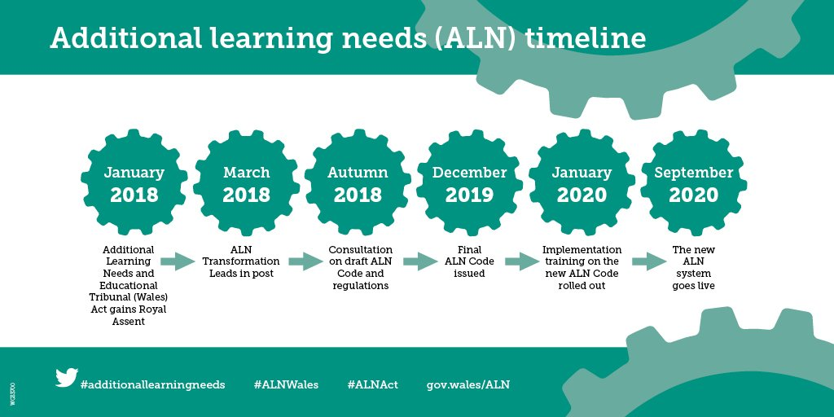
Ffion Grug Evans
1600990
EAEE2006
What the new act means for teachers/ALNco’s across Wales
As the Down’s Syndrome Association (2016) states, the new additional learning needs and education tribunal (Wales) act is set to replace the current SEN framework and introduce an ‘individual development plan’, however, this may mean more paper work to be completed. The association also describes how the new act aims to help parents, children and other young people the opportunity of being more involved in decision making about their education. This could result in teachers and additional learning needs coordinators not only having to complete more paper work but also needing to hold regular meetings with families of ALN children. Although this will be beneficial to the child, it may be rather time consuming.
The effect that the new legislation will have on current SENco’s
- May need to re-apply for their current position within the workplace. Some may even lose their role.
- More paper work especially with regards to transferring current children with additional learning needs from the SEN framework to the ALN and Education Tribunal (Wales) Act 2018.

