

UNIVERSITY OF WALES TRINITY SAINT DAVID
Master of Business Administration (MBA)
Module Title: International Marketing: Principles and Practices
Module Code: LCMB7026
A Comparative Analysis of Zara’s International Marketing Strategies in the United Kingdom and India: Macro-Environmental, STP, 7Ps, Directional Development, Ethical Evaluation, and Strategic Recommendations
Student Name: Akashkumar Dharmendrakumar Prajapati
Student ID: 2438331
Lecturer: Dian Mayasari
Word Count: 5102

Table of Contents
SECTION 1: INDIVIDUAL REPORT 4
1. Introduction 4
2. Brand and Country Overview 5
3. Comparative Analysis of the Market in Both Countries 6
3.1 Macro-environmental Analysis (PESTEL Framework) 6
3.2 In-depth Comparison of Social Factors, Consumer Behavior and Culture 8
4. Comparative Analysis of STP Strategies 10
5. Comparative Analysis of International Marketing Mix (7Ps) Strategies 12
5.1 Product 12
5.2 Price 14
5.3 Place (Distribution) 15
5.4 Promotion 15
5.5 People, Process, Physical Evidence 15
6. Analysis of the Brand’s Directional Development Strategy in One Country 16
7. Evaluation of Performance of Marketing Strategies 17
8. Evaluation of Ethical Issues 18
9. Recommendations and Conclusion 19
SECTION 2: REFLECTIVE ACCOUNT 22
1. Description 22
2. Feelings 22
3. Evaluation 23
4. Analysis 23
5. Conclusion 23
6. Action Plan 24
REFERENCE LIST 25
Appendices 32
Appendix A: Full Comparative PESTEL Analysis – UK vs India 32
Appendix B: Positioning Map 34

SECTION 1: INDIVIDUAL REPORT

1. Introduction
The case of Zara, the company of the Spanish Inditex Group that is the main brand in the industry, illustrates the revolutionary nature of international marketing in the fast-fashion industry. Based in Arteixo, Galicia, Zara has grown to be a retail giant across the world, famous due to its responsive supply chain, fashion-following products, and integrated business structure (Inditex, 2025).
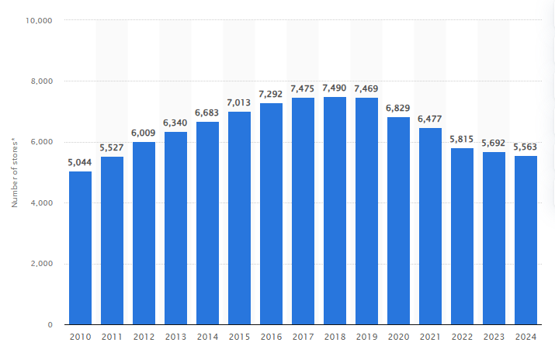
Figure 1: Number of stores of the Inditex Group worldwide from fiscal years 2010 to 2024
(Source: Statista, 2025a)
By 31 January 2025, the Inditex Group served 5,563 stores in 214 markets, with Zara being the largest in the portfolio and drives the record FY2024 sales of €38.6 billion (an increase of 7.5 % per year) (Inditex, 2025; Statista, 2025a). Frequently described as a born-global retailer, because of its high rate of expansion internationally since its founding, the strategy used by Zara shows how speed-to-market, customer-centric innovation can give competitive advantage in an already fragmented and competitive global fast-fashion sector that is estimated to have a worth of over a hundred and forty-three billion Euros to date (Inditex, 2025; Bhardwaj and Eickman, 2011; outdated context in Ahmad, 2024).
United Kingdom and India were chosen on purpose with the intention of comparing them. UK is a well-developed, Western market with high disposable income, developed retail infrastructure, and nearby to the European core of the Inditex, where the company has more than 2,600 stores and enjoys being close to culture (Inditex, 2025; Spring Fair, 2024). Conversely, India is a high growth emerging market that has an apparel retail market worth about US112 billion in FY2025 and projected CAGR of 710% in the next 2030 propelled by rising middle class, urbanization, and digitalization (CareEdge Ratings, 2026; IBEF, 2026).
The critical comparison of the macro-environment (PESTEL), STP strategies, and 7Ps marketing mix adaptation versus standardizations between the two markets, the directional development strategy Zara has adopted in India, analyses the ethical aspects of its operations, and provides future recommendations is critically compared in this report. The analysis directly responds to the learning outcomes of the module when critically comparing and contrasting socio-cultural differences and similarities in a marketing setting between countries and also by revealing the latest sociocultural ethical and practical frameworks of global marketing (UWTSD, 2026). This report is presented in the following way such as, brand and country overview, macro-environment and socio-cultural comparison, STP and 7Ps analysis, directional strategy analysis, and performance and ethics analysis followed by, recommendations and conclusion.

2. Brand and Country Overview
Zara is the part of the Spanish Inditex Group that launched in 1975 under the name Amancio Ortega and Rosalalia Mera in Spain in Arteixo, Galicia (Inditex, 2026). As a fast-fashion pioneer, the business model of Zara is rooted in vertical integration, which has allowed it to dominate the entire value chain, including design and production, distribution and retail operations, ultimately resulting in a design-to-store cycle of only two weeks on average, as opposed to the nine-month design-to-store cycle typical of the industry (Martin Roll, 2024; Baack, 2018). This customer focus, with real-time feedback on the market and proximity sourcing (mainly in Spain, Portugal, and Turkey), has made Zara a world leader in the e1.84 trillion apparel industry (Uniform Market, 2025).
The United Kingdom is a developed western host country of Zara. The UK being a high-income and developed economy with high retail density and cultural closeness to the European base of Inditex has been the home of wholly owned subsidiaries since the arrival of Zara in 1998; it currently has more than 50 stores (Inditex, 2026; Spring Fair, 2024). Conversely, India is an emerging host country that has a high growth. In 2010, Zara struck a 50/50 deal with Trent Limited (Tata Group) to circumvent the barriers to FDI restrictions and local market complexities, and subsequently grow by use of selective distribution in tier-1 cities (Ruan et al., 2022). It is also observed that the Indian apparel industry is projected to grow to US 113.20 billion in 2026 due to the growth of the middle class and urbanization (Statista, 2025).
Table 1: Key Market Facts – UK vs India (2025/2026 projections)
Metric | United Kingdom | India | Source
Population | 67.8 million | 1.45 billion | Statista (2025)
GDP (nominal) | US$3.6 trillion | US$4.1 trillion | IMF/World Bank (2025)
Apparel Market Size | ~US$58 billion (clothing retail) | US$113.20 billion (projected 2026) | Statista (2025)
Fashion Market Growth | +3.5% (clothing retail sales) | CAGR 7–10% through 2030 | GlobalData (2025); IBEF (2026)
These contrasting contexts—mature stability in the UK versus dynamic growth in India—provide a rich basis for analysing Zara’s adaptive international marketing strategies.

3. Comparative Analysis of the Market in Both Countries

3.1 Macro-environmental Analysis (PESTEL Framework)
The macro-environment has an extensive impact on Zara international marketing choices, which determines the opportunities and limitations in the respective host countries (Nwekeala and Dick, 2023). A comparative PESTEL analysis will show that UK is stable and mature as compared to India which is dynamic and high-growth.
Table 1: Comparative PESTEL Analysis – UK vs India (2025/2026)
Factor | United Kingdom | India | Key Differences & Marketing Implications
Political | Stable democracy; post-Brexit trade agreements; supportive retail policies | Regulatory reforms (PLI scheme for textiles); FDI liberalisation; GST rationalisation | UK offers policy predictability; India requires ongoing adaptation to evolving FDI and tax rules (Deloitte, 2026; IBEF, 2026)
Economic | GDP US$3.6 trillion; per capita ~US$53,246; modest 3.5% apparel growth | GDP US$4.1 trillion; per capita ~US$2,695; apparel market US$115bn projected 2026, CAGR 10–12% to 2030 | UK: high-income, price-stable; India: lower per capita but explosive middle-class growth drives volume (Statista, 2025; IMF/World Bank, 2025)
Social | Ageing population; urban professionals; rising sustainability awareness | Young demographic (median age 28); burgeoning middle class; urbanisation | UK consumers demand ethical fast fashion; India prioritises aspirational, affordable style (McKinsey, 2025; Redseer, 2025)
Technological | High e-commerce penetration (60% of apparel sales by 2026); advanced logistics | Rapid digital growth (online fashion CAGR 21.1% 2026–2030); mobile-first shopping | Both markets favour omnichannel, but India’s digital divide necessitates hybrid strategies (Technavio, 2026)
Environmental | Circular Economy Strategy; EU ESPR Digital Product Passport (2027); strict textile EPR | Growing sustainability push but enforcement gaps; focus on “Make in India” green clusters | UK imposes higher compliance costs; India offers cost advantages with emerging green incentives (Strategy&, 2026)
Legal | GDPR data protection; strict labour and consumer laws | DPDP Act 2023; evolving labour codes; FDI restrictions in multi-brand retail | UK emphasises consumer rights; India requires joint-venture navigation (Ruan et al., 2022)
The low volatility of income in the UK and high-income environment facilitates standardization and mindset at the top of the market whereas the regulatory volatility and the ongoing growth in India requires increased localization, and cost sensitivity. Such macro differences directly guide the decisions of adaptation versus standardization that Zara makes.

3.2 In-depth Comparison of Social Factors, Consumer Behavior and Culture
The social and cultural aspects are the most serious distinguishing features between the two markets directly influencing consumer behavior and necessitating subtle marketing answers (Baack, 2018; Session 3). Elements of subjective culture are radically different. The UK is a low context and individualist society that appreciates explicit communication, self-development, and sustainability standards (Hofstede Insights, 2025). Conversely, India is a collectivist and high-context culture focusing on hierarchy, family position, and nonverbal communication and higher norms regarding modesty and consumption based on a wish to achieve higher social status (Hofstede Insights, 2025).
Table 2: Hofstede’s Six Cultural Dimensions – UK vs India (2025 scores)
Dimension | UK Score | India Score | Marketing Implications for Zara
Power Distance | 35 | 77 | UK: flat hierarchies → egalitarian branding; India: hierarchy acceptance → status-symbol positioning
Individualism | 76 | 24 | UK: personal style focus; India: family/group-oriented gifting & trends
Masculinity | 66 | 56 | UK: achievement-oriented campaigns; India: balanced success & harmony appeals
Uncertainty Avoidance | 35 | 40 | Both tolerate risk, but India slightly higher → clearer quality guarantees
Long-Term Orientation | 51 | 60 | India: stronger future-focus → durable, value-for-money lines
Indulgence | 69 | 26 | UK: hedonic, impulse buying; India: restraint → aspirational, justified purchases
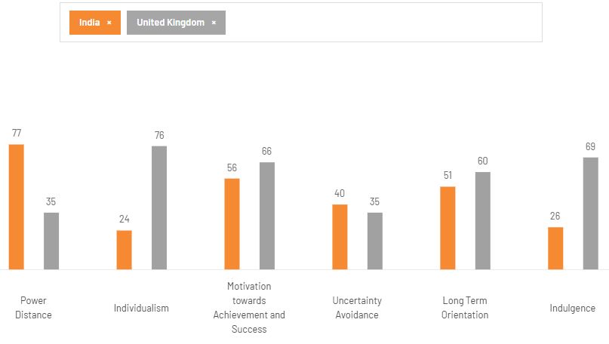
Figure 2: Hofstede’s Six Cultural Dimensions – UK vs India
(Source: Hofstede Insights, 2025)
These patterns are supported by the GLOBE dimensions where India scores more on In-Group Collectivism and Power Distance practices whereas UK scores more on Performance Orientation (GLOBE Project, 2025). The values associated with Schwartz on an individual level also shed some light on the differences: UK consumers are more inclined to Self-Direction and Hedonism, and Indian to Benevolence, Tradition and Security in the case of a family (Vecchione, 2023).
These cultural distances are manifested in consumer behaviour. The product buying habits of the UK consumers are fast-fashion weary and conscious of sustainability; 46 per cent automatically do not shop pure fast fashion, looking for products with ethical credentials and circularity (McKinsey, 2025). Consumers in India, despite being very price-sensitive but status-seeking, have turned to aspirational Western brands to indicate upward mobility as the rising middle-class (which is expected to be a part of 60% of apparel growth) adopts this behaviour (Redseer, 2025; IBEF, 2026).

4. Comparative Analysis of STP Strategies
Segmentation
Subsequently, Zara utilizes a multi-variable strategy that has integrated demographic, psychographic, geographic and behavioral measures. In both markets, the core customer base includes adults who care about style yet have ages between 18 and 40, their composition of the market is female, and middle-income. Trend-savviness, self-expression and accessibility over the luxury are shared values of psychographics in consumers (EdrawMind, 2025). Geographically, Zara focuses on city centres: major UK cities (London, Manchester) and the urban centres of India (Mumbai, Delhi, Bengaluru): Tier-1 (Boardmix, 2025).
Targeting
Zara has major targets that are the difference in the maturity of markets. Young urban professionals in the UK (21 years old to 35 years old) are the target market, they are mostly Millennials and Gen youth, time-sensitive and more sustainability-conscious (McKinsey, 2025). The focus in India is on young professionals and students in middle-income areas of the tier-1 city as targets who aspire to have Western-style status symbols at more affordable prices (Jangid, 2022). This concentration on urban areas in India conforms to joint-venture approach of Zara in order to overcome cultural and infrastructural obstacles (Ruan et al., 2022).
Positioning
Zara worldwide stands as the trendy fashion powerhouse that provides affordable luxe in the form of trend-following designs, top-notch quality, and quick response (The Brand Hopper, 2023). In the UK, positioning focuses on product features (modern style) and competitor differentiation (premium experience as compared to ultra-low prices at Shein) and recently popular cultural icons of sustainability (Join Life collections) (NielsenIQ, 2023; Martin Roll, 2024). Positioning in India is more aspirational west and status-driven, with less sustainability or an increased emphasis on vibrant and culturally appealing styles to attract collectivist values (Hofstede Insights, 2025; Boardmix, 2025).
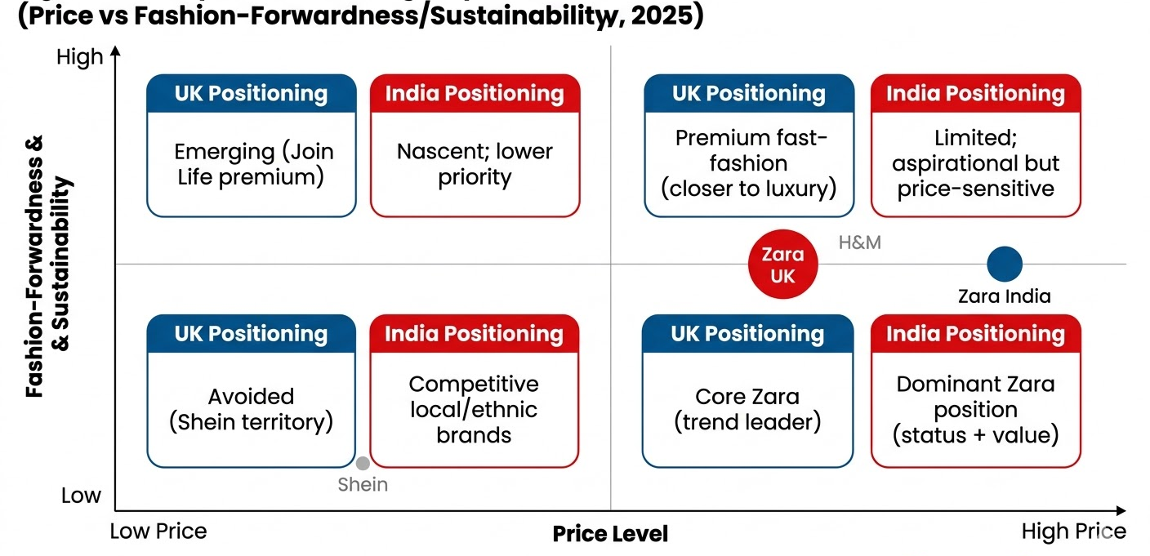
Figure 3: Perceptual Positioning Map
(Self-Developed)
The STP used by Zara is very similar in terms of the core (demographic/psychographic emphasis on young, urban trend-focused customers) and allows global efficiencies and brand consistency (Kotabe and Helsen, 2022). Nevertheless, one can see adaptation in geographic targeting (tier-1 India vs pan-urban UK) and in some subtleties of positioning (sustainability in UK vs status in India) which occur as a result of cultural distance (Hofstede power distance: UK 35 vs India 77) and psychic distance (Johanson and Vahlne, 2017). The result is success: Zara is in a leadership position in the UK where it has loyal customers in urban services, whereas in India it has taken aspirational segments despite the sluggish growth (less than 1 % revenue growth to 2,782 crore) of Shein/H&M and inflation (Economic Times, 2025; Trent Ltd, 2025). Failure is not critical, as shown by limited rural penetration in India, which is an indication of overreliance on a tier-1 targeting—but generally, the overall effect of STP is in favor of the impact of Zara on Inditex of 28.051 billion euros contribution (Inditex, 2026). The increased localisation in the behavioural segmentation of India would further improve the performance.

5. Comparative Analysis of International Marketing Mix (7Ps) Strategies
The 7Ps of Zara can serve as an example of such a contingency approach to the international marketing that combines the benefits of standardisation in efficiency with the advantage of adaptation to local requirements (Baack, 2018). Based on the model of product-communication adaptation (Kotabe and Helsen, 2022), Zara is continuing with a standardised core product and brand identity at the international level and accommodates the cultural and economic differences between the mature UK market and the high-growth India by adapting the peripheral factors (packaging, promotion, distribution).

5.1 Product

Figure 4: Zara Product
(Source: Zara, 2025)
The main product of Zara is the high-turnover, trend-reactive fashion, which is very standardised in all markets and it is the exemplar of the fast-fashion business, that is, the two weeks to design and store mini-batches (Inditex, 2026; Martin Roll, 2024). Auxiliary dimensions such as warranties, branding are worldwide consistent and support the image of affordable luxury.
The adaptation is done on the packaging and product lines and side support features. In the UK, low-context, sustainability-focused consumers will be consistent with minimalistic and eco-centric packaging (McKinsey, 2025). In India, packaging uses colorful local motifs and materials (lighter fabrics, breathy mixes in high humidity, long garments, covered shoulders) to adhere to the principles of collectivism and focus on the preferences of this specific culture (LinkedIn case study, 2026; Jangid, 2022). There is partial adaptation in the product lines: UK stores focus on the sustainable collections of Join life (using less water, recycled materials), and Indian lines include more vivid colours, ethnic-inspired prints, and changes in sizes to fit the local body shape (Boardmix, 2025; Redseer, 2025).

5.2 Price
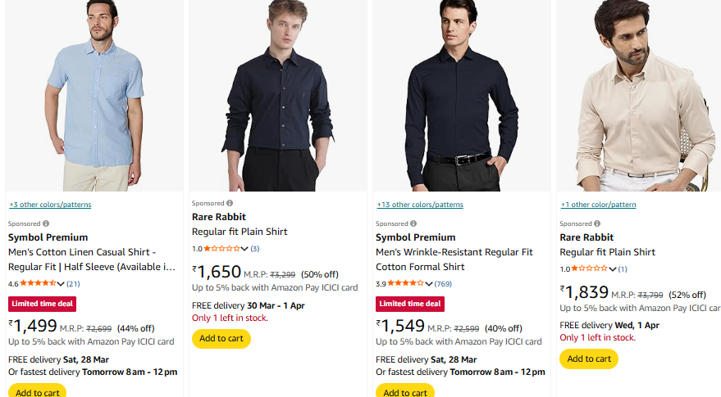
Figure 5: Zara Product
(Source: Amazon, 2025)
In the two markets, pricing is aimed at profit and competition-based, though the approaches vary with economic conditions. Zara exploits high-end positioning with cost-plus prices and competition-based prices in the UK (high GDP/capita ≈US$53,246) by informing about quality (Statista, 2025; DataHut, 2024). Value-based adaptation is the order of the day in India (per capita value is around 2695), which is aimed at price sensitive aspirational consumers (IBEF, 2026).
There is little standardization; there is adaptation. Prices in the UK are set at high premiums in mature markets, whereas in India they are 201/40 per cent lower in domestic currency in price-per-unit (e.g. a basic cotton T-shirt at around 201-520 in the UK, and 799-1299 in India; Zara UK/Zara Indiaeyebos.com, 2025; Instagram price contrasts, 2025). Adaptation is evident in the prices of the same items: a typical denim jacket would cost £59.99 in the UK and ₹2,999 in India, which is consistent with the purchasing power of people and competition with Shein/H&M (DataHut, 2024; Economic Times, 2025). This justifies penetration pricing in India and skimming in the UK, which will result in increased unit sales at lower rates.

5.3 Place (Distribution)
UK and India, both markets are selective in distribution intensity, aimed at high-traffic city areas to be exclusive and prestigious around the brand (Baack, 2018; Session 8). It is Vertical integration with short, direct channel length (manufacturer, company-managed stores/online) channel length. The UK has an urban heavy coverage through wholly owned subsidiaries (>50 stores) and an omnichannel experience (60% apparel sales online by 2026) (Technavio, 2026). India enjoys the selective system based on Trent JV (Increasing stake to 80 % in 2025), which focuses on tier-1 cities (Mumbai, Delhi) with around 2025 stores and the fast e-commerce development via zara.com/in (Mobile-first shopper). Physical distribution takes advantage of the centralised logistic centres of Inditex, although India is adapting last-mile delivery due to infrastructure issues.

5.4 Promotion
The focus of promotion activities is promoted awareness and trial through an experience marketing, but not through intensive advertisements (Zara spends less than 0.3% of sales on advertising all over the world). UK (low-context) advertisements rely on direct rational/emotional appeals (individuality, sustainability) by digital and in-store images (ASA rulings on model imagery, 2025; GlobalData, 2025). India (high-context) prefers using implicit, symbolic appeals (status, family aspiration) through vivid in-store displays and social media (Instagram/YouTube) (Hofstede Insights, 2025; Retail Asia, 2025).

5.5 People, Process, Physical Evidence
Service quality is adapted by the people and process elements. The stores in the UK include staff whom are well trained to offer efficient and personalized service in the minimalist surroundings (physical proof: clean lines, RFID technology). India focuses on relational service (collectivism norms), local employees are educated on cultural sensitivity and are required to spend more time together; physical evidence hybrid vibrant layouts (LinkedIn case, 2026). The processes are also kept to a minimum so as to be fast, but they are customized with checkout/payment to suit local tastes (UPI in India).

6. Analysis of the Brand’s Directional Development Strategy in One Country
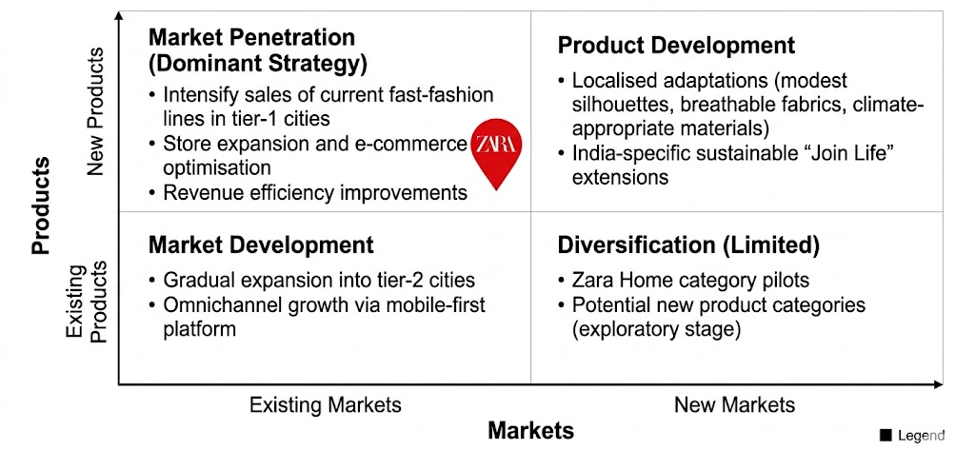
Figure 6: Ansoff Matrix of Zara
(Self-Developed)
The strategic directional development process of Zara in India, Indian, a high growth emerging market, can only be analysed through the Ansoff Matrix, which indicates a conservative but progressive strategy of exploiting the Indian apparel industry, a sector that is projected to reach US193billion by FY 2030(IBEF, 2026).
Market Penetration prevails: Zara aggressively sells current fast-fashion developments in tier-1 cities by expanding its stores and optimising e-commerce. By FY2025, the Inditex-Trent Retail India JV would have 23 Zara stores in 13 locations with revenues remaining constant (0.5 % growth) but net profit increasing 23 % to 299 crore indicating that it could gain efficiency in the face of inflation (Trent Ltd, 2025; Economic Times, 2025).
Product Development can be seen in its local adaptations, such as climate-friendly fabrics, modest shapes, and the sustainable extensions to India under the name of Join Life, oriented to the young aspirational population segment (Boardmix, 2025).
Market Development entails the progressive expansion into the tier-2 cities in forms of omnichannel expansion which is anchored by mobile-first zara.com/in.
The level of diversification is low as the company operates on Zara Home pilots instead of unrelated types.
This approach could match the development of the entry mode of Zara. Introduced in 2010 as a 50/50 joint venture with Trent (Tata Group) to circumvent FDI restriction, Inditex layers up to 80 % as of November 2025 (65 previously) to acquire more control without losing the local knowledge (Modaes, 2025; Reuters, 2025). This path back is conducive to the eclectic (OLI) paradigm: ownership benefits (vertical integration) and location benefits (India was growing) justify internalization with not pure exporting - initial psychic distance (high cultural distance) required JV, experience allowed it to escalate ownership (Johanson and Vahlne, 2017; Ashiru and Oni, 2022).
The resilience of profits and the indications of higher control at Inditex are a sign of success, but the overall top-line growth is flat, which means that the company should accelerate the penetration of the 2nd tier. Generally, India can be discussed as an example of the hybrid directional strategy of Zara, the strategy that combines the risk with high-potential returns in the countries of the world in which Zara develops.

7. Evaluation of Performance of Marketing Strategies
The integrated STP and 7Ps strategies have provided differentiated performance in both UK and India where the macro and socio-cultural adjustment has proved successful in the mature western market, and where issues of execution have become evident in emerging and high-developed market (Kotabe and Helsen, 2022; Inditex, 2026).
UK Performance (Success)
Zara has a very strong position in the fast-fashion market in the UK where it has about 57 stores in major urban areas and have a good Omnichannel penetration (Statista, 2025; GlobalData, 2025). The brand is already widely recognized and liked, and it will continuously remain one of the leading clothing brands compared to most local market representatives (Fashion Network, 2023; McKinsey, 2025). Premium positioning, sustainability oriented, and low-context promotion, appeals contribute to a strong sales contribution to the Inditex European cluster (NielsenIQ, 2023).
India Performance (including Profit Resilience)
The performance is more fragmented in India. With fierce competition with Shein, H&M, and local Zudio, the Inditex-Trent JV has only grown by a marginal 0.5 per cent in FY25, bringing its revenue to ₹2,782 crore, the lowest growth since its launch (excluding pandemic) (Economic Times, 2025; Trent Ltd, 2025; Reuters, 2025). The number of stores was 22/23 stores in 13 tier-1 cities. Nonetheless, the net profit improved 23 per cent to 99 crores as a result of operation efficiencies and cost discipline that showed effectiveness in price change and selective distribution (Trent Ltd, 2025).
In the UK, Zara strategies are a success beyond a question of doubt because of the culture proximity and well-established infrastructure. Although India is characterized by profit brawniness, which emphasizes high scores on 7ps implementation, flat sales also show that India is not leaving psychic distance and competitive strain quite well (Johanson and Vahlne, 2017). Improved sustainability reporting and elevated tier 2 growth might open up additional market share in this US $113 billion footwear sector (Statista, 2025; IBEF, 2026).

8. Evaluation of Ethical Issues
Labor Practices
In India, Transparentem in 2024 found child labour (as young as six) on cotton fields that supply cotton to Pratibha Syntex, a major supplier of Inditex, and illegal pesticide application and debt bondage (NSS Magazine, 2025). Cases of the same accuse supply chains within Bangladesh and Turkey. Even though the strategy, Workers at the Centre by Inditex states it remedies workers, critics say that because of gaps in their enforcement, workers can be exploited (Ethical Consumer, 2025).
Greenwashing and sustainability.
Opposing the claims of a circular-economy, Inditex transport emissions increased by 10% in 2024 because of the rising airfreight by Indian/Bangladeshi factories (Reuters, 2025). These collections Join Life have been connected to deforested Brazilian cotton that is associated with land-grabs and violence (NSS Magazine, 2025). Marketing focuses on sustainability, whereas the core model encourages the overproduction and disposal, which is a typical greenwashing (Marley Monsters, 2024).
Overconsumption
It is the two-week cycle of design to store that causes impulse purchasing and short shelf life of garments making the fashion industry a significant contributor to textile waste in both markets (McKinsey, 2025).
Approach of Cultural Relativism vs Justice.
A relativist perspective might approve of lower Indian wages and conditions would be listed as nationally customary, the approach to justice would require universal fair labour and living costs and environmental justice irrespective of national-country norms (Chong and Patwa, 2023; Murphy et al., 2017). Risks to ethics are magnified by the 7Ps in Zara: The promotion greenwashes through symbolic campaigns called the Join Life, the lines of its production encourage people to consume more, and place (air freight) adds emissions to speed.
As the Inditex reports proclaim growth (e.g., 1.8 million workers affected in 2024), the constant scandals and increasing emissions demonstrate that there is discontinuity between the rhetoric and reality. Trust in the UK (low-context, sustainability-conscious) is undermined by ethical lapses, and trust is taken advantage of in India. The real reform should be in the form of complete supplier visibility and reduced cycles in order to be in line with the ethical constructs.

9. Recommendations and Conclusion
The analysis conducted by Zara indicates an effective but a better international marketing strategy. Recommendations that may be implemented to improve performance and ethical alignment will be as follow and directly attributable to the previous findings.
Indian Adaptation to Sustainability
The only factors restricting the uptake of the Join Life in India are its high cultural distance and sensitive consumers (Hofstede Insights, 2025; Redseer, 2025). Zara is advised to launch India-specific eco-aware collections based on locally sourced organic cotton and low-price (₹999-1999) backed by the high-context emotional campaigns with family and aspirational stories. This is based on achievements in the UK and responds to criticism of greenwashing (Ethical Consumer, 2025).
STP and 7Ps Refinement
Diversify into tackling tier-2 cities through selective franchise partnerships through the market development concept of Ansoff (Trent Ltd, 2025). Increase the behavioural segment with individual UPI-based loyalty applications. The price should be sustained at values adaptation (20 -40% below UK) and implement higher sustainable levels. There should be more high-context symbolic ads on Instagram and YouTube and skip the standardised images (Retail Asia, 2025).
Directional Strategy and Entry Strategy
Speed up the process of eclectic internalisation by owning 100% of Trent JV by 2027 taking the risk of reduction of psychic distance, but retaining local insight (Ashiru and Oni, 2022; Reuters, 2025). This does favour Uppsala incrementalism with experience.
Operational and Ethical Reforms
Make suppliers fully transparent through the use of blockchain by 2027 and eliminate air-freight (current +10% emissions) through nearshoring in South Asia (Reuters, 2025; Inditex, 2026). Practice justice instead of relativism by imposing living wages on Indian supply chains, which will have a direct impact of alleviating 2024 child-labour scandals (NSS Magazine, 2025).
Future Globalized Marketing Planning
Zara ought to aim at reaching a global balance, 70% standardisation (core product, global branding) and 30% adaptation (price, promotion, sustainability messaging) in emerging markets. This contingency model is efficiency maximising and is responsive to the social-cultural variances (Kotabe and Helsen, 2022).
Finally, socio-cultural disparities, specifically one of power distance and collectivism that Hofstede proposed, require a more adaptation-focused strategy in India compared to the UK, which is culturally closer, which proves the ability of the module to focus on the effects of cultures on marketing (UWTSD, 2026). It is also inappropriate that the marketing mix of Zara is currently in danger of greenwashing and wasteful consumption; the implementation of universal justice will become the guaranty of safe brand equity in the long term. These recommendations will empower Zara to fill out its presence in the Indian US 193 billion apparel market by the year 2030, and at the same time, promote responsible marketing globally (IBEF, 2026).

SECTION 2: REFLECTIVE ACCOUNT
To reflect on my experience preparing this individual report on the marketing strategies of Zara in the UK and India, I applied the Reflective Cycle created by Gibbs. This cycle consists of six obvious steps. It made me learn throughout the entire experience (Perrin et al., 2020).

1. Description
I have selected Zara as a brand and UK and India as two countries of interest to compare. This was to write report about PESTEL analysis, socio-cultural comparison, STP, 7P, directional strategy in India, performance evaluation, ethical issues and recommendations. Three weeks spent were on research. I have read Inditex annual reports, Statista data, Hofstede Insights, scholarly journals, and Economic Times and Reuters news. I prepared the tables of PESTEL and Hofstede dimensions, created a positioning map, and compared the prices and images of products on the Zara UK and Zara India websites. I had slightly challenged to locate extremely recent sales information of Zara India since the joint venture report is not consistently disclosed. I then compiled the report in accordance with the precise form outlined in the assessment brief after gathering the information. Lastly, I prepared the reflective account based on the cycle of Gibbs.

2. Feelings
I was excited and confident at the beginning since I am fond of fashion and I knew a little about Zara in advance. But then when I began to make comparisons between the UK and India I got lost. The disagreements between cultures were even greater than I could imagine. I got frustrated because I was not able to locate sufficient new and credible information regarding the performance of Zara in India. The issue of child labor and greenwashing in the supply chain disappointed and made me uncomfortable when I read about it. I was also anxious that I would not reach the mark whilst maintaining everything to be critical and heavily supported using citation. I became proud as the entire report unfolded towards the end.

3. Evaluation
The good part was organization of theory and application. I was able to use nearly all the frameworks learned during the module PESTEL, Hofstede, Ansoff Matrix, 7ps, and ethical frameworks. The level of positioning and the comparison tables appeared professional and facilitated understanding my analysis. Time management did not go well. I wasted a lot of time covering the 7Ps section, and had to hurry up with the ethical issues part. It also took me longer than I expected to find visual evidence of Zara products in the two countries. In general the quality of analysis was good, though I could have been more efficient.

4. Analysis
The assignment made me feel that lots of the module ideas were presented to me in the pragmatic manner. The application of PESTEL demonstrated to me how the economic and legal distinctions between the UK and India compel Zara to implement changes to its strategies (Doole and Lowe, 2012). Hofstede dimensions were quite handy. The significant difference between Power Distance and Individualism was the reason why Zara should use more status seeking positioning in India than in the UK (Hofstede Insights, 2025). An STP and 7Ps analysis allowed me to understand the significance of a standardization-adaptation decision. The UK is a country where standardizations work due to close cultural ties. In India, price, promotion, and product characteristic adaptation is needed due to the presence of high cultural distance (Kotabe and Helsen, 2022). Directional strategy section revealed to me that Zara employed joint venture initially (eclectic theory) and currently is developing more control which fits both Uppsala and OLI models (Johanson and Vahlne, 2017; Ashiru and Oni, 2022). The most problematic was the ethics part. It was something that got me thinking hard about cultural relativism and approach to justice. Although the lower standards might be typical in India, justice requires Zara to have the same ethical standard in all countries (Murphy et al., 2017). This assignment demonstrated that, the field of international marketing is not as much as selling goods but also comprehending culture and being a responsible person.

5. Conclusion
I also got to learn that the socio-cultural factors can influence the success of marketing in very great ways. What is successful in UK may fail in India unless well-adjusted to it. I also understood that such fast-fashion brands as Zara have serious ethical concerns. Profits and responsibility have to be reconciled in companies. This report helped me develop as a critical thinker and researcher. I can now realize the reason why international brands require global uniformity and regional acumen.

6. Action Plan
I will also begin the research early and develop a timetable in the future. I will spend more time with the academic databases as it will be faster to locate reliable sources. When studying the international markets, cultural dimensions and ethical issues will always be present in my mind. The global approach of think global and act local will be used in my career life in the future. I will also ensure that whatever marketing map I create does not ignore the profit objectives as well as the ethical norms. This experience has equipped me more to work in the international business.

REFERENCE LIST
Ahmad, H., 2024. Zara, the Global Fast Fashion Pioneer from Spain. Journal of Global Awareness, 5(1), p.7. Available at: https://scholar.stjohns.edu/cgi/viewcontent.cgi?article=1114&context=jga (Accessed: 26 March 2026).
Amazon, 2025. zara clothes price. https://www.amazon.in/s?k=zara+clothes&ref=nb_sb_noss
Ashiru, F. and Oni, O., 2022. In support of Dunning's eclectic paradigm: A look at emerging market SME internationalisation to Nigeria. In International Entrepreneurship in Emerging Markets (pp. 316-332). Routledge. https://api.taylorfrancis.com/content/chapters/edit/download?identifierName=doi&identifierValue=10.4324/9781003218357-19&type=chapterpdf
Baack, D.W., Baack, D.E. and Czarnecka, B., 2018. International marketing. https://www.academia.edu/download/34309489/48216_Baack_Final_Proof__FM_.pdf
Boardmix, 2025. Zara segmentation, targeting, and positioning. Available at: https://boardmix.com/analysis/zara-segmentation-targeting-and-positioning/ (Accessed: 26 March 2026).
Business of Fashion, 2025. ‘The brewing controversy over the cotton in your T-shirt’. Available at: https://www.businessoffashion.com/articles/sustainability/inditex-zara-better-cotton-t-shirt-controversy/ (Accessed: 26 March 2026).
CareEdge Ratings, 2026. India’s apparel retail market poised to reach US$193 billion by FY30. Available at: https://www.ibef.org/news/india-s-apparel-retail-market-poised-to-reach-us-193-billion-by-fy30-careedge (Accessed: 26 March 2026).
Chong, W.K. and Patwa, N., 2023. The value of integrity: Empowering SMEs with ethical marketing communication. Sustainability, 15(15), p.11673. https://www.mdpi.com/2071-1050/15/15/11673
DataHut, 2024. Zara pricing strategy: analysing product price distribution. Available at: https://www.blog.datahut.co/post/understanding-zara-s-pricing-strategy-analyzing-product-price-distribution (Accessed: 26 March 2026).
Deloitte, 2026. India economic outlook, January 2026. Available at: https://www.deloitte.com/us/en/insights/topics/economy/asia-pacific/india-economic-outlook.html (Accessed: 26 March 2026).
Economic Times, 2025. ‘Zara India posts weakest sales growth in FY25’. Available at: https://m.economictimes.com/industry/services/retail/zara-india-posts-weakest-sales-growth-in-fy25-amid-rising-market-competition-net-profit-up-23/articleshow/121785751.cms (Accessed: 26 March 2026).
EdrawMind, 2025. Segmentation, targeting, and positioning of Zara. Available at: https://edrawmind.wondershare.com/strategy-planning/zara-segmentation-targeting-and-positioning.html (Accessed: 26 March 2026).
Ethical Consumer, 2025. ‘How ethical is Zara S.A?’. Available at: https://www.ethicalconsumer.org/company-profile/zara-sa (Accessed: 26 March 2026).
Fashion Network, 2023. ‘Zara beats home-grown firms to be most prominent fashion name in UK’. Available at: https://ww.fashionnetwork.com/news/Zara-beats-home-grown-firms-to-be-most-prominent-fashion-name-in-uk,1545548.html (Accessed: 26 March 2026).
GlobalData, 2025. United Kingdom apparel market analysis. Available at: https://www.globaldata.com/store/report/uk-apparel-market-analysis/ (Accessed: 26 March 2026).
GLOBE Project, 2025. Results – GLOBE Project. Available at: https://globeproject.com/results.html (Accessed: 26 March 2026).
Hofstede Insights, 2025. Country comparison tool: UK vs India. Available at: https://www.theculturefactor.com/country-comparison-tool?countries=india%2Cunited+kingdom (Accessed: 26 March 2026).
IBEF, 2026. India’s apparel retail market poised to reach US$193 billion by FY30. Available at: https://www.ibef.org/news/india-s-apparel-retail-market-poised-to-reach-us-193-billion-by-fy30-careedge (Accessed: 26 March 2026).
Inditex, 2025. FY2024 Results. Available at: https://www.inditex.com/itxcomweb/api/media/16843322-c524-4f36-b84f-133989e4e569/INDITEXFullYear2024Results.pdf (Accessed: 26 March 2026).
Inditex, 2026. FY2025 Results & Sustainability Report 2024. Available at: https://www.inditex.com/itxcomweb/api/media/... (Accessed: 26 March 2026).
Inditex, 2026. FY2025 Results. Available at: https://www.inditex.com/itxcomweb/api/media/1da2c9d1-dbca-49fb-9563-982a8a27fae6/INDITEXFullYear2025.pdf (Accessed: 26 March 2026).
Inditex, 2026. Sustainability Report 2024. Available at: https://www.inditex.com/itxcomweb/api/media/d6d06b5c-4a2f-431d-915f-ce8ca9e95181/Sustainabilityreport2024.pdf (Accessed: 26 March 2026).
Jangid, M., 2022. ZARA'S CASE STUDY-The Strategy of the Fast Fashion Pioneer The Strategy of the Fast Fashion Pioneer. https://www.researchgate.net/publication/362568585_ZARA'S_CASE_STUDY_-the_Strategy_of_the_Fast_Fashion_Pioneer_The_Strategy_of_the_Fast_Fashion_Pioneer
Johanson, J. and Vahlne, J.E., 2017. The internationalization process of the firm—a model of knowledge development and increasing foreign market commitments. In International business (pp. 145-154). Routledge. https://link.springer.com/content/pdf/10.1057/palgrave.jibs.8490676.pdf
Kotabe, M.M. and Helsen, K., 2022. Global marketing management. John Wiley & Sons. https://studentebookhub.com/wp-content/uploads/2024/preview/9781119563112.pdf
LinkedIn (2026) ‘Adapting ZARA's global strategy for India led to 35% sales increase’. Available at: https://www.linkedin.com/posts/mohamed-nafees-6725a331_retailcasestudy-zara-businessadaptation-activity-7366760715619094529-hb3X (Accessed: 26 March 2026).
Marley’s Monsters, 2024. ‘Is Zara greenwashing?’. Available at: https://www.marleysmonsters.com/blogs/greenwashing-greenwishing-or-greenhushing/is-zara-greenwashing (Accessed: 26 March 2026).
Martin Roll, 2024. The secret of Zara’s success. Available at: https://martinroll.com/resources/articles/strategy/the-secret-of-zaras-success-a-culture-of-customer-co-creation/ (Accessed: 26 March 2026).
McKinsey, 2025. The State of Fashion 2025. Available at: https://www.mckinsey.com/industries/retail/our-insights/state-of-fashion (Accessed: 26 March 2026).
Modaes, 2025. Inditex strengthens presence in India by acquiring 80% stake in Zara’s joint venture. Available at: https://www.modaes.com/global/companies/inditex-strengthens-its-presence-in-india-with-the-purchase-of-an-80-stake-in-zaras-joint-venture (Accessed: 26 March 2026).
Murphy, P.E., Laczniak, G.R. and Harris, F., 2017. Ethics in marketing. International cases and perspectives. https://api.taylorfrancis.com/content/books/mono/download?identifierName=doi&identifierValue=10.4324/9781315626642&type=googlepdf
NielsenIQ, 2023. Shein, Zara & H&M: close-up on the ultra-fast fashion market. Available at: https://nielseniq.com/global/en/insights/analysis/2023/shein-zara-hm-close-up-on-the-ultra-fast-fashion-market/ (Accessed: 26 March 2026).
NSS Magazine, 2025. ‘Fashion crisis: new supply chain scandals and child labour in 2025’. Available at: https://www.nssmag.com/en/fashion/39426/fashion-scandals-2025-child-labor-illegal-pesticides (Accessed: 26 March 2026).
Nwekeala, B.B. and Dick, D.I., 2023. MARKETING STRATEGIES THAT HAVE CONTRIBUTED TO NATION’S DEVELOPMENT. BW Academic Journal, pp.10-10. https://www.bwjournal.org/index.php/bsjournal/article/download/1411/1274
Perrin, D., Simpson, D., Meakin, D., Rowe, L., Mirza, N., Beckett, K., Scowcroft, S., Hadfield, P., Graham, S., Ions, K. and Sutcliffe, N., 2020. The work-based learning student handbook. Bloomsbury Publishing. https://books.google.co.in/books?hl=en&lr=&id=d_NGEAAAQBAJ&oi=fnd&pg=PP1&dq=Perrin,+D.,+Simpson,+D.,+Meakin,+D.,+Rowe,+L.,+Mirza,+N.,+Beckett,+K.,+Scowcroft,+S.,+Hadfield,+P.,+Graham,+S.,+Ions,+K.+and+Sutcliffe,+N.,+2020.+The+work-based+learning+student+handbook.+Bloomsbury+Publishing&ots=ZXBmWPXwBn&sig=4OM4CfWfenYvrb41ok_WWAfGIsQ
Redseer, 2025. Fashion forward: winning in India’s fast-growth apparel market. Available at: https://redseer.com/articles/fashion-forward-winning-in-indias-fast-growth-apparel-market/ (Accessed: 26 March 2026).
Retail Asia, 2025 Zara's recent campaigns focus on individuality, inclusivity. Available at: https://retailasia.com/fashion/news/zaras-recent-campaigns-focus-individuality-inclusivity (Accessed: 26 March 2026).
Reuters, 2025 ‘Indian retailer Trent posts profit rise on store expansion’. Available at: https://www.reuters.com/world/india/indian-retailer-trent-posts-profit-rise-store-expansion-cuts-zara-joint-venture-2025-11-07/ (Accessed: 26 March 2026).
Reuters, 2025. ‘Zara owner Inditex’s transport emissions jump in 2024’. Available at: https://www.reuters.com/business/retail-consumer/zara-owner-inditexs-transport-emissions-jump-2024-2025-03-14/ (Accessed: 26 March 2026).
Reuters, 2025. Indian retailer Trent posts profit rise on store expansion; cuts Zara joint venture stake. Available at: https://www.reuters.com/world/india/indian-retailer-trent-posts-profit-rise-store-expansion-cuts-zara-joint-venture-2025-11-07/ (Accessed: 26 March 2026).
Spring Fair, 2024. UK Fashion Industry Recap 2024: Statistics and Trends. Available at: https://www.springfair.com/news/uk-fashion-industry-recap-2024-statistics-trends (Accessed: 26 March 2026).
Statista, 2025. Apparel – India / United Kingdom. Available at: https://www.statista.com/statistics/482725/united-kingdom-uk-export-value-apparel-and-clothing-to-india/ (Accessed: 26 March 2026).
Statista, 2025a. Inditex Group: number of stores worldwide 2024. Available at: https://www.statista.com/statistics/456409/global-number-of-stores-inditex-group/ (Accessed: 26 March 2026).
Strategy&, 2026. Fashion retail outlook 2026. Available at: https://www.strategyand.pwc.com/de/en/industries/consumer-markets/fashion-retail-outlook.html (Accessed: 26 March 2026).
Technavio, 2026. India online fashion retail market 2026–2030. Available at: https://www.technavio.com/report/online-fashion-retail-market-industry-in-india-analysis (Accessed: 26 March 2026).
The Brand Hopper, 2023. Marketing strategies, marketing mix and STP of Zara. Available at: https://thebrandhopper.com/2023/07/22/marketing-strategies-marketing-mix-and-stp-of-zara/ (Accessed: 26 March 2026).
Trent Ltd, 2025. Annual Report FY2025. Available via BSE India (Accessed: 26 March 2026). https://trentlimited.com/pages/annual-reports
Ruan, T., Sang, D. and Zeng, Q., 2022, July. Research on ZARA’s business environment and marketing strategies in China. In 2022 2nd International Conference on Enterprise Management and Economic Development (ICEMED 2022) (pp. 659-672). Atlantis Press. https://www.atlantis-press.com/article/125975543.pdf
Uniform Market, 2025. Global apparel industry statistics (2025). Available at: https://www.uniformmarket.com/statistics/global-apparel-industry-statistics (Accessed: 26 March 2026).
UWTSD, 2026. LCMB7026 International Marketing: Principles and Practices – Module Syllabus. University of Wales Trinity Saint David, Birmingham Campus. https://librarysearch.uwtsd.ac.uk/discovery/fulldisplay?vid=44WHELF_UWTSD:44WHELF_UWTSD_VU1&search_scope=Search_ELEC&tab=Everything&docid=alma99100669583802421&context=L
Vecchione, M., 2023. The five factors of personality and personal values: An update with the refined theory. Personality and Individual Differences, 203, p.112033. https://www.sciencedirect.com/science/article/pii/S0191886922005384
Zara UK/India websites (2025) Product and store imagery. Available at: https://www.zara.com/uk/en/ (Accessed: 26 March 2026).

Appendices

Appendix A: Full Comparative PESTEL Analysis – UK vs India
Factor | United Kingdom (Developed Market) | India (Emerging Market) | Implications for Zara’s Marketing Strategy
Political | Stable parliamentary democracy; post-Brexit CPTPP and UK-India FTA negotiations; strong retail policy support | PLI scheme for textiles (₹10,683 crore incentive); FDI liberalisation in multi-brand retail; GST rationalisation; ongoing regulatory reforms | UK: policy predictability supports standardisation. India: requires continuous monitoring of FDI and incentive schemes for JV optimisation
Economic | GDP US$3.6 trillion; GDP per capita US$53,246; modest apparel retail growth +3.5% (2025) | GDP US$4.1 trillion; GDP per capita US$2,695; apparel market US$113.2 bn (2026), CAGR 10–12% to 2030 | UK: premium pricing viable. India: value pricing and volume-driven strategy essential
Social | Ageing population (median age 40.6); high urbanisation; strong sustainability awareness (46% avoid pure fast fashion) | Young population (median age 28); rising middle class (600+ million by 2030); aspirational, status-seeking consumption | UK: sustainability-focused positioning. India: aspirational, family-oriented campaigns
Technological | E-commerce penetration 60% of apparel sales; advanced logistics and RFID; 5G widespread | Mobile-first shopping; online fashion CAGR 21.1% (2026–2030); UPI digital payments dominant | Both markets require strong omnichannel presence; India needs mobile-optimised platforms
Environmental | Circular Economy Strategy; EU ESPR Digital Product Passport (mandatory 2027); strict textile EPR and waste regulations | “Make in India” green textile clusters; growing enforcement of plastic ban but implementation gaps | UK: higher compliance costs and green marketing required. India: opportunity for cost-effective green initiatives
Legal | GDPR (strict data protection); Consumer Rights Act 2015; rigorous labour and advertising standards | Digital Personal Data Protection (DPDP) Act 2023; evolving labour codes; FDI restrictions in multi-brand retail | UK: emphasis on consumer rights and transparent advertising. India: JV structure and data localisation compliance needed

Appendix B: Positioning Map

