

Component 2: Written assessment:

Problem Analysis and Solution Development
  - Student Name: Moses Pappoe
  - Course Name: Analysing & Solving Problems.
  - Module code: ACCA4019
  - Instructor Name: Nouh Elmitwally
  - Date: 26th March 2026.

1. Problem Deconstruction.
To address this scenario effectively, the problem must first be decomposed into its constituent elements. As postulated by Wing, the concept of Problem deconstruction is steeped in the notion of breaking a huge problem, into smaller manageable pieces where each piece becomes a sub-problem which is solved separately [1]. By resolving these components individually, the cognitive load of the primary problem is significantly reduced, rendering the task less overwhelming. This granular approach facilitates a 'laser focus' on specific variables, ensuring that the broader complexity does not distract from the systematic resolution of each sub-problem.
A careful evaluation of the scenario results in its break down into the following sub-problems:
- Classroom over and under-utilization. Some classrooms have too many students over the normal capacity whiles other rooms have less students than it should have, a glaring mismatch of room capacity and scheduling.
- Timetable clashes. An inefficient course time-tabling structure or an error-ridden class-availability Rota, results in two or more classes being scheduled for the same room at the same time.
- Time wastage due to travel time. This is the result of consecutive lessons not scheduled in proximity to the next lesson’s classroom and as such students and staff must move over a distance for their respective lessons. This might reduce actual teaching time and affect the quality of teaching if there is a rushed delivery of content to make up for lost time. Additionally, any attempt to reclaim this time by extending a lesson beyond its allocated slot creates a ripple effect of delays, compromising the punctuality and integrity of the entire institutional timetable.
Requirements identified from the sub-problems, which must be implemented to solve this problem are as follows:
- An efficient allocation of classrooms with a consideration of class sizes and room capacities.
- A significant reduction in time-wastage due to the movement of students and staff between classrooms/lessons
- An efficient timetabling system that will ensure punctuality of lessons without scheduling conflicts.
Using Abstract Thinking, which requires taking on a wholesome approach and exploring complex ideas rather than relying on the specifics or what can be seen physically [2], the next step will be to formulate a range of general solutions to the sub-problems; - thinking outside the box. These probable solutions will then be categorized using the MoSCoW technique, which is a framework designed for deciding and prioritizing which solutions / requirements are most essential in solving the problem [3].
The relevant variables are:
ClassSize – total number of students enrolled in the course.
ClassroomCapacity - The maximum number of students a room can legally/physically hold.
LocationProximity – The physical location or distance between classrooms which impact travel time.
TimeSlot – Scheduled time for each lesson, start and end times.
ClassDuration – The allocated length of time for each lesson.
TeacherSchedule – The consecutive lessons that a teacher teaches in the same location.
RoomFeatures – Rooms with special or extra features like wheelchair accessibility and projectors.

Using the MoSCoW technique to prioritize the implementation of proposed solutions, which distinguishes between needs and wants, leads to the below proposals:
Must Have: Essential requirements, without which the solution will be a failure.
- Clash-proof scheduling (two classes should not be erroneously scheduled in one room).
- Class size and room capacity matching.
- Specialized room allocation (e.g., Chemistry labs for Chemistry).
- Consecutive lessons hosted at same location to reduce movement.
Should Have: Necessary but not of upmost importance and can be delayed if need be.
- Proximity-based scheduling (back-to-back classes in the same building)
- High room utilization rates/ tracker.
Could Have: Optional but desirable proposals that can be implemented barring time and cost limitations.
- Automatic detection of available classrooms to aid swift allocation.
- Room utilization survey.
Won’t Have: Solutions of least priority and will not be considered in the current scope.
- Real-time data collection for daily absences to aid in rescheduling.
- Student walking speed profiles.

Through the systematic deconstruction of the scenario, the identification of key variables, and the prioritization of requirements via the MoSCoW framework, the problem is transformed into a manageable structure.

2. Proposed Solution.
The following section presents a structured solution, including a flowchart and a detailed explanation. It is designed to assign rooms according to class size, avoid scheduling conflicts, and reduce movement time between consecutive sessions.

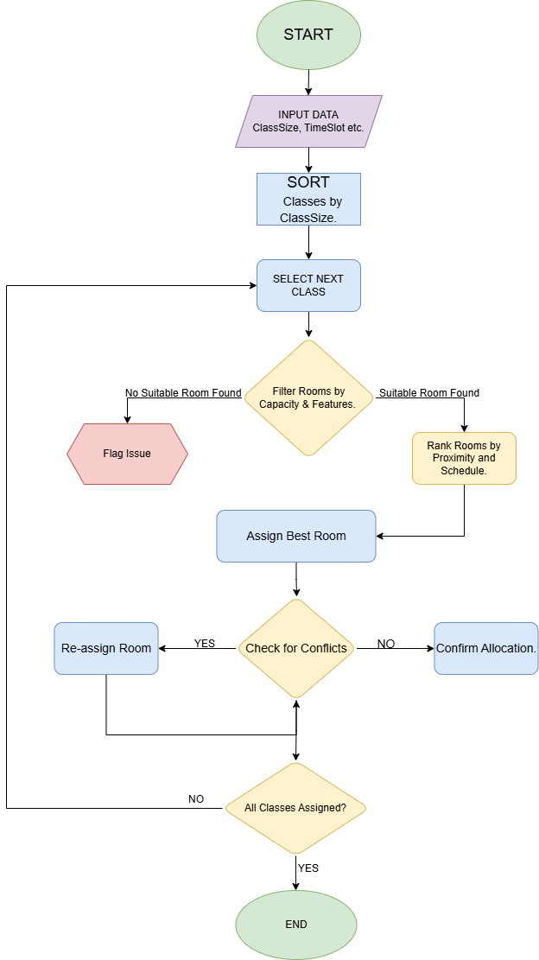

STEP 1: Data Collection.
This step begins with the collection of data for the variables. ClassSize ensures the room fits students. ClassroomCapacity prevents overcrowding. TimeSlot and ClassDuration define when rooms are needed. TeacherSchedule helps minimise unnecessary movement. LocationProximity reduces travel time. RoomFeatures ensures specific teaching needs are met.
This step builds the foundation for accurate scheduling.
STEP 2: Sort Classes by ClassSize (Largest → Smallest).
Using the Greedy Heuristic Algorithm, which adopts a "Hardest First" approach to scheduling [4], priority is given to large classes and specialized rooms to ensure efficiency. Larger classes are scheduled first because they have fewer suitable rooms and are at higher risk of overcrowding.
This prevents large classes from being left without appropriate rooms.
STEP 3: Select next class.
The system processes one class at a time. It will pick the first class from the results of the applied filter. Doing this ensures that we continue to apply the distribution on priority bases.
Keeps allocation structured and manageable
STEP 4: Filter Suitable Rooms.
Rooms are filtered based on: Capacity ≥ ClassSize, which avoids overcrowding and the required RoomFeatures to ensure maximum teaching goals are met.
This step directly tackles both overcrowding and inappropriate room use.
STEP 5: Check Room Availability.
If there are no rooms that meet the criteria, the system will flag for overcrowding risk (class too large) or underutilisation issue (only large rooms left for small class).
This will require administrative intervention to fix this issue, either by splitting classes to fit ClassRoom capacity or adjusting schedules.
STEP 6: Rank Suitable Rooms.
Available rooms are ranked based on: LocationProximity to minimise travel time between lessons and TeacherSchedule to keep teachers in nearby or same rooms for consecutive sessions.
Improves efficiency and reduces lost time between classes.
STEP 7: Assign Best Room.
The most suitable room is selected and assigned. The system will update that room’s availability by marking it as occupied for that TimeSlot and ClassDuration.
This ensures the optimal use of space and resources and prevents double-booking.
STEP 8: Check TimeSlot Conflicts.
Before finally confirming the ClassRoom, one last check will be made to thoroughly ensure that; no room is double-booked and no teacher is assigned to two places at once. When both are satisfied, system will confirm assigned room. If conflicts occur, system will try the next best alternative room or re-rank options.
Eliminates scheduling clashes.
STEP 9: Loop Process.
The above steps will be repeated until every ClassSize has a ClassRoom.
This guarantees a full timetable coverage that resolves the college’s problems and achieves the desired outcomes of
- No overcrowding
- Minimal underutilisation
- Reduced travel time
- No clashes

3. Reflection and Justification.
The solution to the college’s classroom allocation problem was effective because it applied key computational thinking techniques: decomposition, the use of a heuristic algorithm, a structured flowchart, and clearly defined variables.
Decomposition played a crucial role by breaking down a complex scheduling problem into smaller, manageable parts. Instead of attempting to assign all classrooms at once, the problem was divided into tasks such as analysing class sizes, checking room capacities, and evaluating time slots. This made the process more organised and reduced the likelihood of errors, ensuring each constraint was addressed individually before combining them into a complete solution.
The Greedy Heuristic algorithm further enhanced efficiency by prioritising practical decision-making over exhaustive searching. For example, assigning larger classes first ensured that rooms with higher capacities were used effectively, reducing the risk of overcrowding. Similarly, ranking rooms based on proximity and teacher schedules helped minimise travel time. The heuristic approach prevented small groups of classes from monopolizing large lecture halls which was a realistic solution within the constraints of a real college environment.
The flowchart contributed by providing a clear visual representation of the process. It allowed each step, including decision points such as checking room suitability and time conflicts, to be logically followed and easily understood. This not only improved clarity but also made it easier to debug and refine the process if needed.
Finally, the use of well-defined variables such as ClassSize, ClassroomCapacity, TimeSlot, and LocationProximity ensured that all relevant factors were consistently considered. These variables enabled accurate comparisons and informed decision-making throughout the algorithm. While not guaranteed to produce a perfect solution in every theoretical case given the assumption that all required data is available and accurate,(without factoring in real-life mishaps like last minute cancellations, emergencies, or unforeseen scenarios), together, these methods have created a structured, efficient, and reliable system that has successfully resolved the issues of overcrowding and underutilisation in the college scenario.

References

[1] | W. J.M, “Computational Thinking,” Communications of the ACM, vol. 49, no. 3, pp. 33-35, 2006.
[2] | D. S. Kurt, “Piaget’s Formal Operational Stage of Cognitive Development,” 21 09 2023. [Online]. Available: https://educationlibrary.org/piagets-formal-operational-stage-of-cognitive-development/. [Accessed 16 03 2026].
[3] | DSDM Consortium, “The DSDM Agile Project Framework,” Agile Business Consortium, 2014.
[4] | Z. A. S. R. J. A. P. A. &. R. M. Siddiqui, “On the Connection of Matroids and Greedy Algorithms.,” International Journal of Electrical and Electronics Research, vol. 10, no. 2, pp. 126-130, 2022.

