Natashia Cooney
Human development
EAEE4003/C

Early years learner support handbook

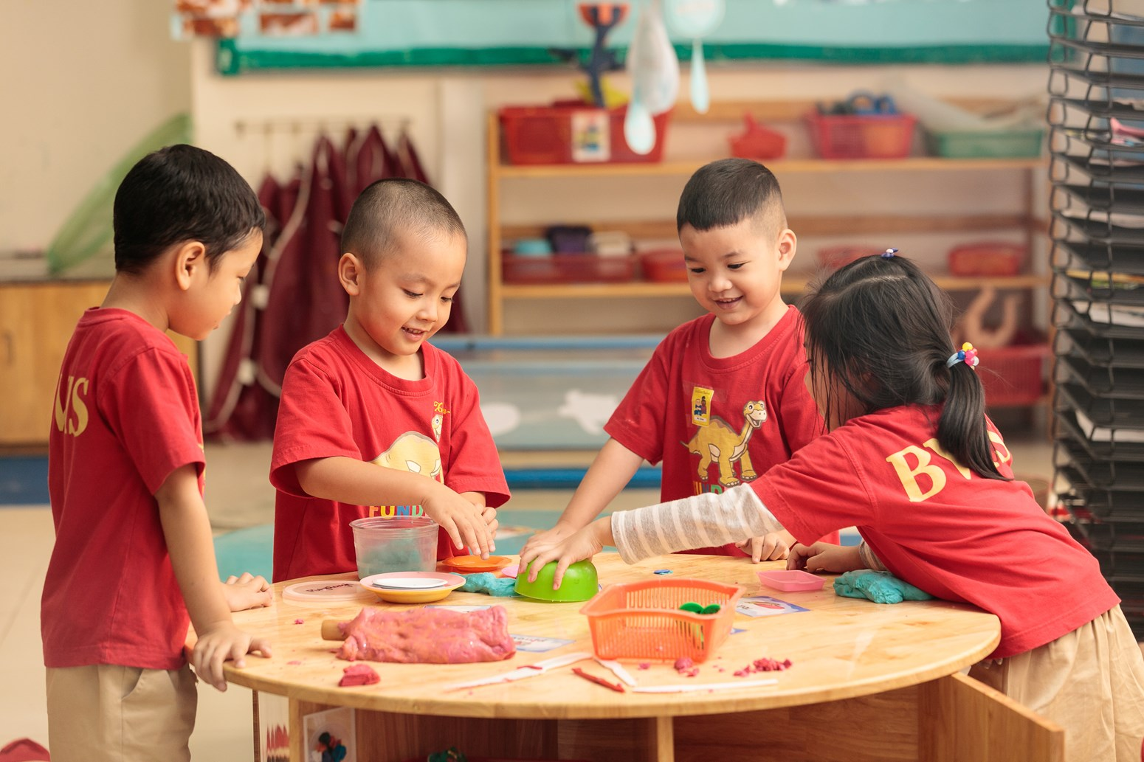

(Source: British Vietnamese International School, 2019)

Contents

Introduction
The Role of the Adult
The Children’s Needs
Partnerships
Interventions
Proposed Outcomes
References

Introduction
This handbook is suitable for all practitioners working in an early year setting. The handbook is designed to help give a better understanding and knowledge about many different areas in a pre-school setting and much more.
There are many roles in supporting the children, parents, and the practitioners in any setting.


(Source: Early Years Matter, 2020)
This handbook can be used to have a better understanding of how different children will settle in and what ways work best for all children as not all children will have the same types of comforts.
When it comes to the role of the adult this handbook also can help by guiding practitioners to communicate in different ways with parents, carers, and other services.
Good practice highlights the importance of transitions being managed and planned carefully with an understanding of children’s needs and respecting parents as part of the process in supporting children’s learning and transitions. Successful transitions are reliant on a commitment from all the practitioners involved in the process to develop effective communication and information sharing protocols.
Transitions are a particularly important process for children to go through as there is a lot of change happening moving from one setting to a new setting for example, from day care to a school setting.
All children will cope differently to new transitions happening around them or that they are involved in. some children may adjust to a new setting happily and with confidence other children may be shy starting and may take a little while to gain confidence to do things by themselves. Having the practitioner and the parents to be able to communicate together properly and smoothly will be beneficial towards the child settling into the new setting as the practitioner and the parents will be on the same page to help the transition be the best possible for the child.

The Role of the Adult
Practitioners in an Early Year setting need to be able to ensure that all children in the setting are cared for equally and fairly. A child is assigned a Key Worker or Person within an education setting. They need to be able to identify each child’s way of adjusting to new surroundings and transitioning to a new environment, such as a nursery to first day in a school surrounding. It is also very important for the families of the child to be supported during a new transition, as it gives the family or guardian a peace of mind knowing the child is in a safe environment and is happy and comfortable.
‘Dewey believed teachers should never pressure students to conform. Instead of going into a classroom with certain expectations, accept students of all different cultures, religions, and family backgrounds. Within individual school regulations, respect students who wear different or unusual attire.’
Independence should be encouraged from the first day, which will help the child to settle into a new setting and can build confidence. A practitioner can encourage a child’s independence by showing them where supplies, their seat and the toilet are. They can also create a visual picture for the child, so they are able to find their own coat peg.
‘Independence is an essential life skill and one that needs to be nurtured from an early age. The term is often understood to mean a range of skills, from helping children to be apart from their families to developing skills in dressing and encouraging them to think for themselves.’
Another important role of the adult in a childcare setting is to allow children to explore and take risks through play, in a safe environment, to develop key skills, they will use in adulthood. Outdoor play is as important and indoor play, as the children can experience nature and play openly using their imagination. Fredrich Froebel (1782) is a theorist who encouraged natural play outdoors. He believed in not pushing the children too fast beyond their abilities and to stimulate their imagination.
‘Froebel believed that it was important for practitioners to understand the principles of observation including professional practice, the multiple lenses through which they see children- and that children see their worlds, as well as offering children freedom with guidance and considering the children's environments including people and materials as a key element of how they behave.’
When a parent or carer is unable to be with the child for the duration of the day in an early years setting, there are several measures that can be done in the home setting by the parent or carer to ensure the child is comfortable and understands the transition such as;
- Talking about the new setting to the child
- Arranging welcome sessions prior to start date
- Walking the child into the setting
- Allowing the child to bring a comforter from home
- Ensuring there is minimal change to the family routine outside of school
These kinds of measures will be good to do with children starting a new setting as it will enable the child/children to feel more comfortable about starting somewhere new. They will also feel more comfortable about going somewhere new by having the transition spoken about to them in advance as the child will know what will be happening, and by going to see the new setting prior to starting will encourage the child to want to go as they will be aware of the new surroundings and the new teachers they will have. When it comes to a child having a new routine it can be ideal not to have much more change going on outside of school as this could disrupt the child ever more which initially could make the transition harder for the child to grasp.
The word safeguarding is used to describe protecting children from any harm, abuse, and the basic needs of self-care. These have been made to make sure that all children in a practitioner’s care are given safe and effective care. The practitioner who works with children in the early years’ setting should have a great awareness of the signs and symptoms that suggest that a child’s wellbeing is at risk. Not only should they be able to stop the indicators, but they also need to know how to react to and resolve the situation, and how to make the essential referrals for child protection. It is every practitioner’s responsibility to safeguard children in an early years’ setting. This should be done in an established and appropriate manner, so any problems and worries are solved before they have a damaging effect on any child. When in and early years setting the practitioner’s need to be up to date with the role of safeguarding children in the setting. There are numerous policies and measures that a practitioner is compelled to comply with guarantee that the safety and wellbeing of all children in their care. All these important aspects of safeguarding also apply to transitions as they can also help a child to ease into a new setting. Transitions are really important in a child’s life as it allows them to be able to settle into new places and get used to seeing unfamiliar surroundings and meeting new people, which in the future of the child they may have more confidence going to new places and meeting new people.
For efficient safeguarding, the following values should be followed to:
- A child’s happiness and needs should always be put first.
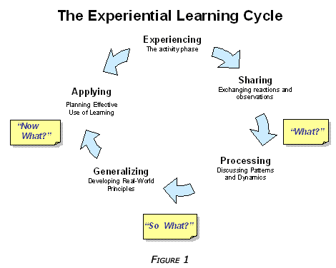
- Any problems should be dealt with before they affect a child’s wellbeing and turn out to be damaging.

(Source: Pinterest No Date)

Children’s Needs
When children are in an Early Years Setting, they need to be able to feel comfortable and safe in the environment. From the moment they start a new setting they should be.
- Welcomed
- Safe
- Valued
- Treated equally
- Emotional supported
- Food and drinks
- All supplies and furniture at child’s level
Not all children will learn at the same pace the practitioner will need to be able to help all children to learn in their own ways to be able to further their education, confidence, knowledge and understanding. In a class setting all the supplies and furniture should be at the child’s level as that will give the children some independence and creativity to be able to get the supplies needed. There may be some children in the setting that will need additional learning support such as one to one support, speech and language and a translator.
As maria Montessori (1914) states children should be allowed to choose what they want to engage with and for how long, which will enable the children to be able to learn to do it for themselves. Maria Montessori’s theory explains the importance of natural and open play as it allows children to have more imagination in what to play and how, it also gives the children a lot of independence in their play and to be able to take risks in certain areas of play.
Montessori supported that the development of the imagination should not be split from the development of the intelligence. These two functions run together, supporting each other.
‘The secret of good teaching is to regard the child’s intelligence as a fertile field in which seeds may be sown, to grow under the heat of flaming imagination’ (Montessori cited in Standing 1962).
She was wary of those who sought to cultivate the intellect and the imagination separately, particularly when the imagination was nurtured by fairy tales in a makebelieve world full of marvels, completely disconnected from the real world in which people live (Montessori 1989).
‘Play gives children a chance to practice what they are learning.’
- Fred Rogers
One of Bowlby's main ideas about attachment behaviour was that it developed to ensure survival by protecting the child from environmental dangers. He explained this guideline process as: "any form of behaviour that results in a person attaining or retaining closeness to some other distinguished and preferred individual, who is usually regarded as stronger and/or wiser” Bowlby(1992). Through attachment behaviour like crying, reaching out and smiling, the child seeks to connect to a parental figure. Cooperating over a longer period of time with a sensitive, responsive parental figure will teach the child how to satisfy his or her needs, help develop self-efficiency, and result in a lasting affective bond between the child and the parental figure.

Safety needs may be different for each child. For a child, this need may as the need for a safe family environment. There must be safety in the home, with warmth and love.
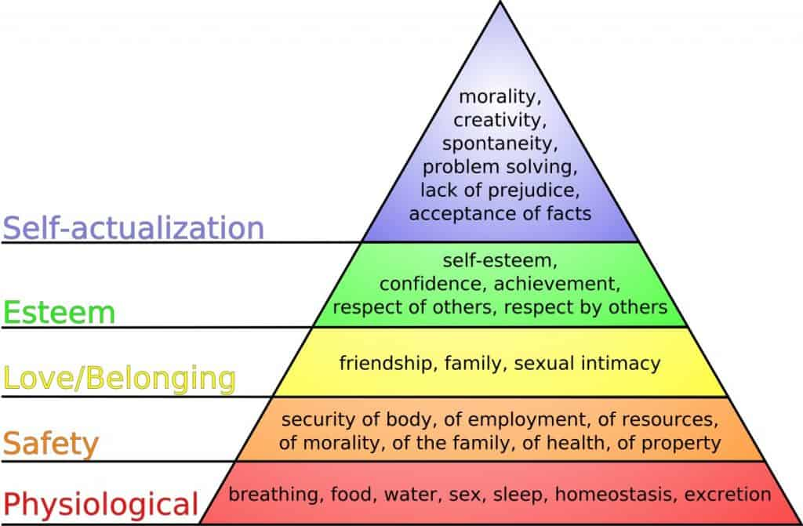
(Source: Maslow’s Hierarchy of Needs (2020)

Maslow’s Hierarchy of needs is a respected assessment that is used in many different professions, mainly those in the fields of education and health care. the ideas of needs are focused on order, as the body needs the most basic needs for survival before moving on to more difficult needs.
Maslow (1943) originally stated that individuals must satisfy lower level needs before continuing to meet higher level growth needs. However, he later explained that fulfilment of a needs is not an “all-or-none” phenomenon, admitting that his earlier accounts may have given “the false impression that a need must be satisfied 100 percent before the next need emerges” (1987).

Partnerships
Partnerships are a big part in Early Years Setting as the practitioners, parents, social workers, school nurse and speech and language all need to work together to ensure the child has a smooth settling in period.
There are many ways practitioners and parents can work together. The EYFS concentrates on four factors, including:
- Supporting learning and development
- Sharing information
- Supporting
- Making decisions and encouraging different methods and courses of action.
It is important that parents are kept informed throughout the child’s attendance in the setting so that they know how the child is progressing throughout the class. Every child should be treated fairly and equally no matter their disability, ethnic, religion, class, or poverty.
It is good for a parent to be involved in the partnership of the child.
- They know their child best
- They feel comfortable with asking for help or advice
- Makes the transition smoother process
Different settings may have different ways of communicating with parents/guardian but there is no right or wrong way of having a partnership.
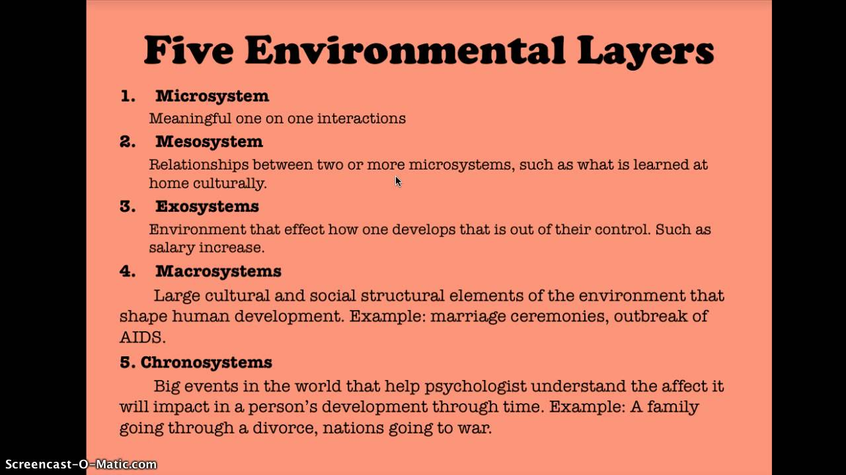
Bronfenbrenner ecological model acted as a structure for the study as it focuses on the connection between home and school setting that impacts the child’s development and learning. If there is not any communication between the school and home, then that can take a negative lap in the child’s learning and further education. As if there is a lack of communication then neither parent nor practitioner will know how the child is progressing in either setting.

(Source: Bronfenbrenner Ecological Theory, 2014)

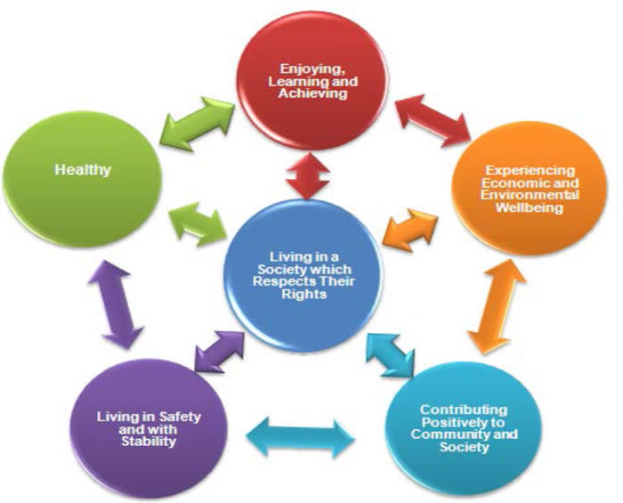
It is vital for parents and other agencies such as speech and language therapists, translator or support agencies to have a good channel of communication because if there is a delay in the child’s development or a language barrier then the partnership will be able to make a decision as for what is best for the child to develop the skills better.

(Source: Making Life Better Together No Date)

Interventions
Intervention is also known as early help. It can happen at any stage of a child’s education. Before a practitioner can detect any problems with a child they would need to do and assessment or an observation on the child by using development sheets or an activity. Once that is completed and the practitioner has gone over the observation and notices there may be a problem they notify the parents to inform them of the concern and they are then able to make a plan together that could result in a better education outcome for the child.

‘Providing timely support is vital. Addressing a child or family's needs early on can reduce risk factors and increase protective factors in a child's life’ (Early Intervention Foundation (EIF), 2018).
It is important to try and notice any help needed so any interventions needed can be put in place. This can be achieved by giving children start or year and end of year test to see where they were and where they are before moving up a class or school. These can point out if there is any extra help and support is needed.
Protective factors can reduce risk to a child's wellbeing:
- evolving strong social and emotional skills
- having a strong social support for the family – including support
- good parental mental health
- income support, benefits, and advice
A good way to get to know the children is an all about me sheet which will tell you personal things to each child such as:
- likes/dislikes
- favourite toy
- any pets
- favourite colour
- any toys they prefer to play with

Outcomes
All children are never the same and all learn at different paces. They all have different traits, skills, backgrounds, personalities, and abilities which will allow them to settle into a new transition and a new routine differently to one another.
All children should receive equal support and care for the best possible outcomes of the child regardless of disabilities, speech, or hearing difficulties. The rate of development will be different for all the children in the class setting.
Vygotsky (1896) believed that children are active learners but not solitary learners like Piaget’s theory. He pointed out that children need to interact with other people/children who were more skilled than themselves to further their own education and understandings. This would then allow the child to try to push their own education further and gain more knowledge. Vygotsky (1896) he believed that children who pretend played were gaining more experience of the real world such as being parents or a truck driver which applies to adult life.
Allowing children to have a lot of active learning can help to enhance their understanding of the world they will grow up into. Also allowing them to be more hands on with learning such as messy play and rainy days outside playing can promote a boost in their imagination and understanding of nature.
By having a get to know me sheet is a really good way to get to know a child especially if they are very shy and/or nervous of starting a new setting. Having items already in place for a child starting for the first time can also help to build the child’s confidence in coming into class and meeting everyone who is present at the time and making new friends.

Reference list

British Vietnamese International School (2019) Supporting Early Years learners to transition successfully to new school environment. [image] Available at: https://www.nordangliaeducation.com/en/our-schools/vietnam/ho-chi-minh-city/bvis/article/2019/1/21/supporting-early-years-learners-to-transition-successfully-to-new-school-environment. (Accessed: 26th November 2020).

Early Years Matters (2020) Early Years Matter. [image] Available at:
https://www.earlyyearsmatters.co.uk/eyfs/positive-relationships/transitions.(Accessed:26th November 2020).

Hayde, and Brendan (2011) Montessori and Jerome W. Berryman: work, play, religious education, and the art of using Christian language system. Available at: https://whel-primo.hosted.exlibrisgroup.com. (Accessed:26th November 2020).

How Children Learn through Play (2020). Available at:
https://www.whitbyschool.org/passionforlearning/how-do-children-learn-through-play. (Accessed: 26th November 2020)

Early Education; The British Association for Early Childhood Education. Available at:
https://www.early-education.org.uk/about-froebel (Accessed:27th November 2020)

What are the safeguarding procedures in early years? | Online DBS Checks (Accessed:25th November 2020)

Bronfenbrenner’s Ecological Theory (2014) Available at: Bronfenbrenner's Ecological Theory - YouTube. (Accessed:27th November 2020)

How to Apply John Dewey's Theories in the Classroom. Available at: https://classroom.synonym.com/apply-john-deweys-theories-classroom. (Accessed: 27th November 2020)

https://moodle.uwtsd.ac.uk/pluginfile.php/214826/mod_resource/content/1/141124-transition-guidance-en-v1.pdf (Accessed:27th November 2020)

Ramsdal, G. Bergvik, S. and Wynn, R. (2018) Parent -child attachment, academic performance, and the process of high school dropout; A Narrative Review. Attachment and Human Development. (Accessed:27th November 2020)

Bowlby, J. (1969/1982). Attachment and loss. Vol. 1. Attachment. New York, NY: Basic Books. Available at: https://web.b.ebscohost.com/ehost/results. (Accessed:27th November 2020)

4 Holistic Classroom Ideas Inspired by Maslow’s Humanist Approach (2019). [image] Available at:https://www.gettingsmart.com/2019/10/4-holistic-classroom-ideas-inspired-by-maslows-humanist-approach/. (Accessed:27th November 2020)

An Exercise in Personal Exploration (2009): Maslow’s Hierarchy of Needs. Available at: https://scholar.google.co.uk/scholar. (Accessed: 27th November 2020).

Maslow’s Hierarchy of Needs. Available at: https://www.simplypsychology.org/maslow (Accessed: 27th November 2020)

Managing Transitions in Early provisions. (2019). Available at: https://app.croneri.co.uk/feature-articles/managing-transitions-early-years-provisions (Accessed: 27th November 2020)

Stars (2020) Available at https://www.starschildcaregroup.co.uk/blog/4-reasons-every-nursery-should-have-a-partnership-with-parents (Accessed: 27th November 2020)
Early Years Carers (2020) Available at:https://www.earlyyearscareers.com/eyc/early-years-practice/parent-partnerships-important/ (Accessed: 27th November 2020)

Pinterest (No Date). [image] Available at:
https://www.pinterest.co.uk/pin/521854675554884931/ (Accessed:27th November 2020)

Making Life Better Together (No Date). [image] Available at:
https://www.makinglifebettertogether.com/early-years/ (Accessed: 27th November 2020)

NSPCC Learning (2020). Available at: https://learning.nspcc.org.uk/safeguarding-child-protection/early-help-early-intervention (Accessed: 27th November 2020)

