  Component One: Student Journal (learning log) 750 words +/- 10%  Contribution to Overall Module Assessment: 25% | Student No: | Elena Caragicu
 | Module Title: | Operating Hotel Facilities
 | Module Code: | BMIH4006
 | Lecturer: | Giulia Chifari
Introduction:
I was appointed in the housekeeping department during my job employment in the hospitality sector. This professional experience allowed me to gain insight into my strengths and weaknesses and all the operational activities' importance and significance in the growth and success of the hotel. I will use the Gibbs Reflective Model to better evaluate all the potential skills and weaknesses in my skillset. My thoughtfulness, emotions, and lessons learned during my job employment.
Description: In the hospitality sector, housekeeping is the crux sector to make sure of cleanliness, organization, and a distinct environment to anticipate guests’ preferences to increase the overall guest experience of staying. I was very nervous and excited when I started my job role in the fast-paced vibrant professional sector in the housekeeping department.
Feelings: I was very excited at the start but later in my job employment, I faced many difficult times which provided me with better opportunities to learn to improve my skillset and become prepared to better compete in this fast-paced hospitality sector. I developed my skill in detail-oriented and problem-solving to increase overall working efficiency during my job employment (Wirya, 2023).
Evaluation: physical strength is very demanding in the housekeeping job and I found it very challenging. The ongoing lifting objects, bending and carrying from one place to another required physical strength and stamina which was not highlighted before. I struggled a lot in making my body resilient and able to perform physical activities during job employment as the housekeeping sector to better perform multiple activities on time (Tra, 2020).
Analysis: I identify that it is very important in any business sector to have effective communication skills to interact with each other and with the customers. Coordinating tasks, organising, prioritising and delegating activities in team members in housekeeping need communication skills to make sure everyone strives for the universal goal of the organization. Sometimes, misunderstandings lead to conflicts among employees and miscommunication results in inefficiencies in the provided services within the sector and organization. Therefore, training and ongoing hands-on practical exercises are advised by the management to improve our communication skills. I also preferred to seek advice and reviews from my senior experts and develop a culture of open discussion to promote effective interpersonal relationships in the housekeeping sector (Wirya, 2023).
Conclusion: I was provided with extensive information and knowledge during my job employment in the hospitality sector in regulating a clean and structured hospitality sector. I was pushed out of my comfort zone during my employment to push my boundaries and perform better by adopting learning and improving culture in the workplace which made me prompted and inspired me to seek further progress in the hospitality sector (Cendon, 2020).
Action Plan: After evaluating all the areas of strengths and weakness, I plan to actively seek action plans to better make some changes and improvements in my weaknesses and better make myself ready for future business endeavours.
In conclusion, my job role in the hospitality sector was full of excitement and valuable experience of learning and gaining knowledge to better develop my personal and professional growth by using the Gibbs Reflective model.

Component Two: Health and Safety Guide
Contribution to Overall Module Assessment: 25%
Introduction
In the XXX Hotel, we welcome you, we have a working culture to provide the best facilities to the employees such as well-being and safety during work. We also have a standardized principle and Guide of Health and Safety Guide to implement and enforce in the working culture of housekeeping to provide a secure environment during cleaning, mopping, and room service without any casualties or incidents (Jamadar and Zade, n.d).
Precautions
- Personal Protective Equipment (PPE): The housekeeping staff must wear PPE including closed toe, gloves, and slip-resistance slippers or shoes to avoid any potential harm to the skin.
- Chemical Handling: All the inventory products must be labelled and employees must be trained to use these chemicals and tools during cleaning activities. These precautionary measurements cover under MSDS or Material Safety Data Sheets.
- 3. Ergonomics: To avoid any sprains and injuries, the staff is properly trained to lift heavy objects from one place to another and learn to use trolleys and carts for heavy objects (Alcalde-González, Mozo and Bustos, 2021).
Procedures: Safe Room Cleaning another
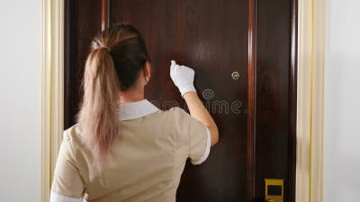
- Entry Procedure: Always knock before entering the room to announce your presence to avoid intruding on guest’s privacy. Quickly inspect the room for any quick service required as mopping and drying the floor etc.
- Cleaning Procedure: Make sure of proper ventilation during cleaning. Start from the upper level and end with lower-level cleaning to make it quick and efficient.
- Exit Procedure: always make sure to remove all the materials, tools, and equipment for cleaning after room service and lock the room properly to ensure of privacy and safety of guests (Nimri et al., 2020).
Equipment: Essential Tools for Safe Room Cleaning
Cleaning Agents: Always use hazardous approved substances and chemicals for cleaning.
Microfiber Cloths: Always use this fibre to avoid any kind of stains and dust remaining on surface.
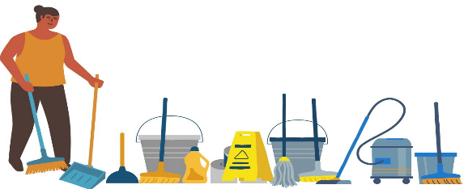
Trolleys and Carts: Used to carry heavy loads and objects from one place to another.
Wet Floor Signs: Make a sign on the wet floor to make guests aware during walking and passing through.
Vacuum Cleaners with HEPA Filters: Use high-quality Air filters in vacuums to make sure of pure air in the hotel after cleaning (Wirya, 2023).
Hazard Mitigation
1. Slips, Trips, and Falls
Make a sign on the wet floor to make guests aware and avoid any kind of trip and slip.
2. Chemical Exposure
All the products to be used in cleaning must be labelled for staff members to carefully read before using.
3. Ergonomic Hazards
Employees in the housekeeping sector are motivated to take regular breaks to avoid being tired and make loss and inefficient services to the guests.
We XXX Hotel aim to provide a working culture of productive and security by abiding by all these above-discussed guidelines and instructions. Employees need to abide by these instructions and guidelines to better provide a secure and healthy working culture to both employees and guests (Tra, 2020).

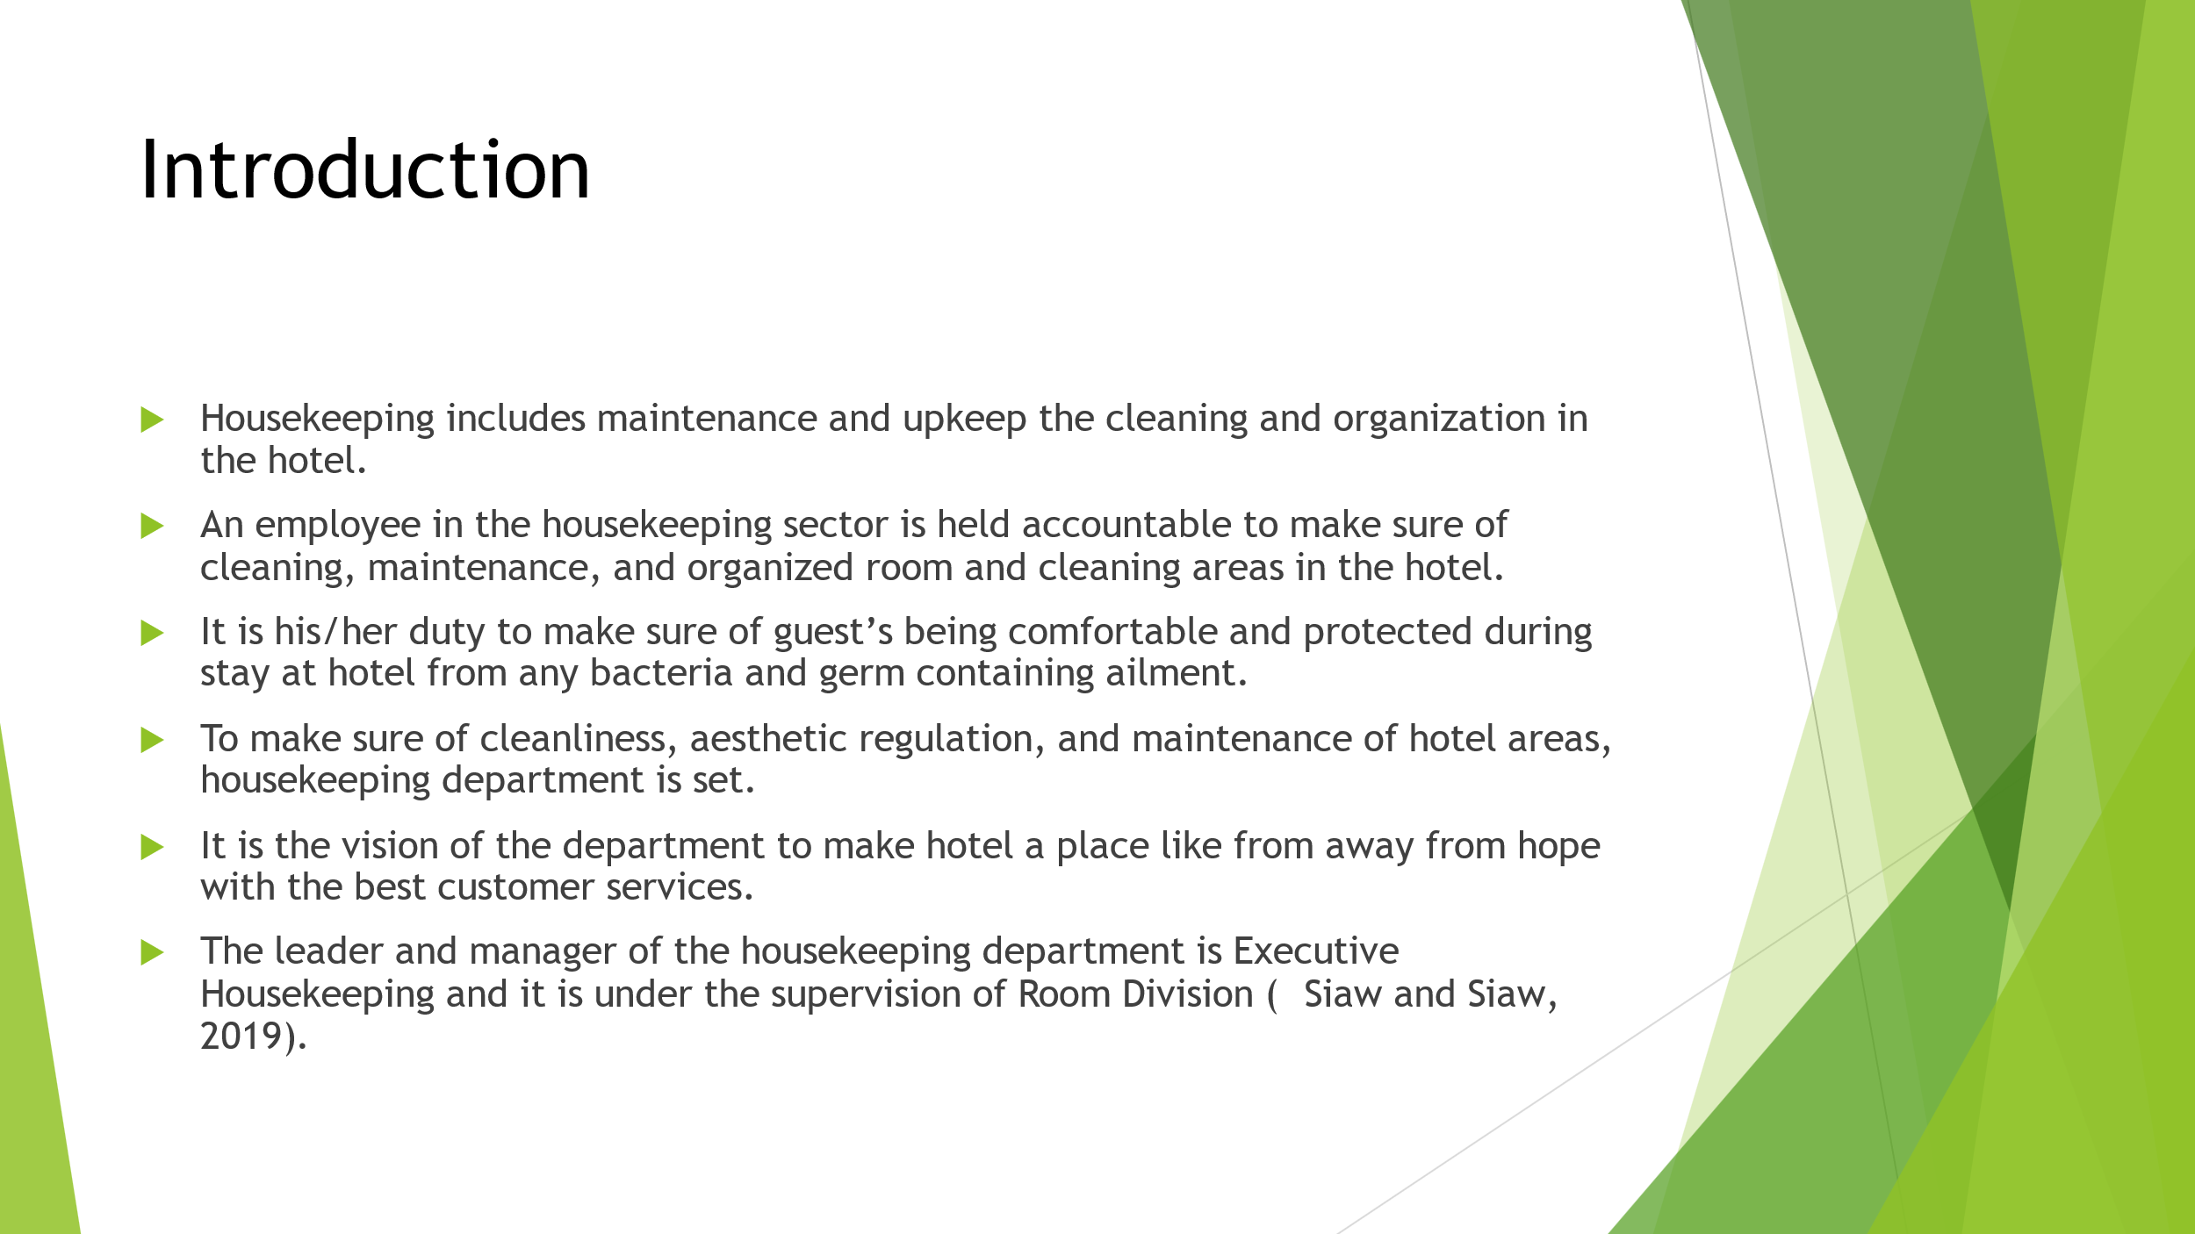
To perform different duties and tasks of cleaning like mopping, dusting, polishing, removing waste, and hygiene are all the responsibility of housekeeping in the hotel.

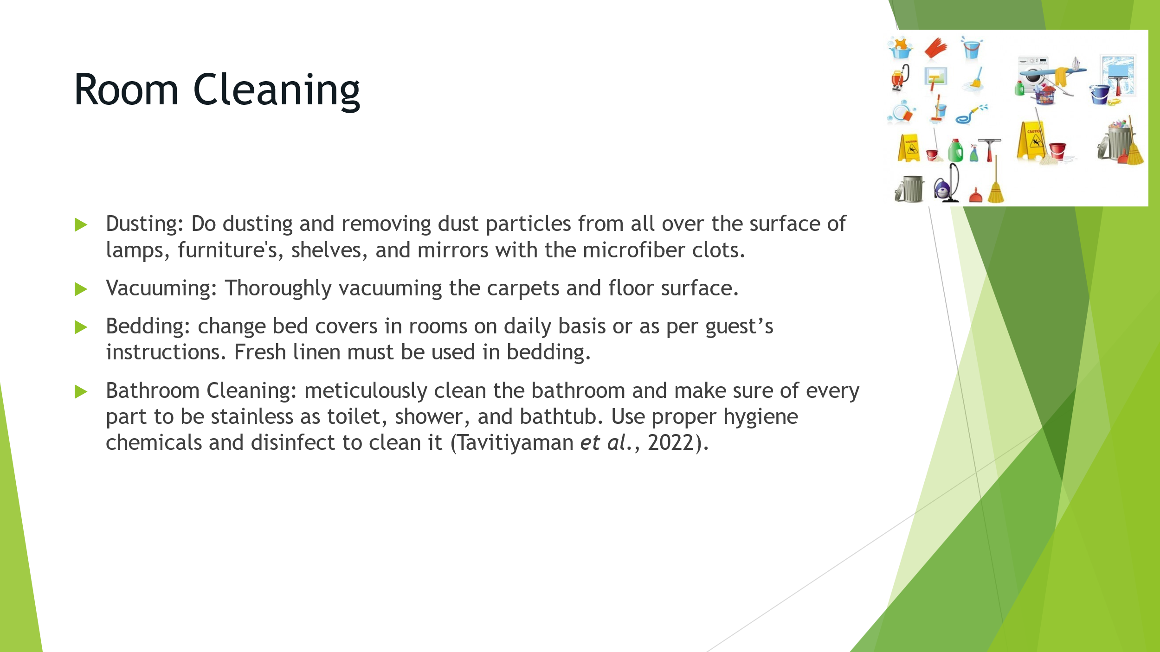
In the hotel industry, room attendants are of great importance as they are the face of he hotel to be in direct contact with guests on daily basis during room service.
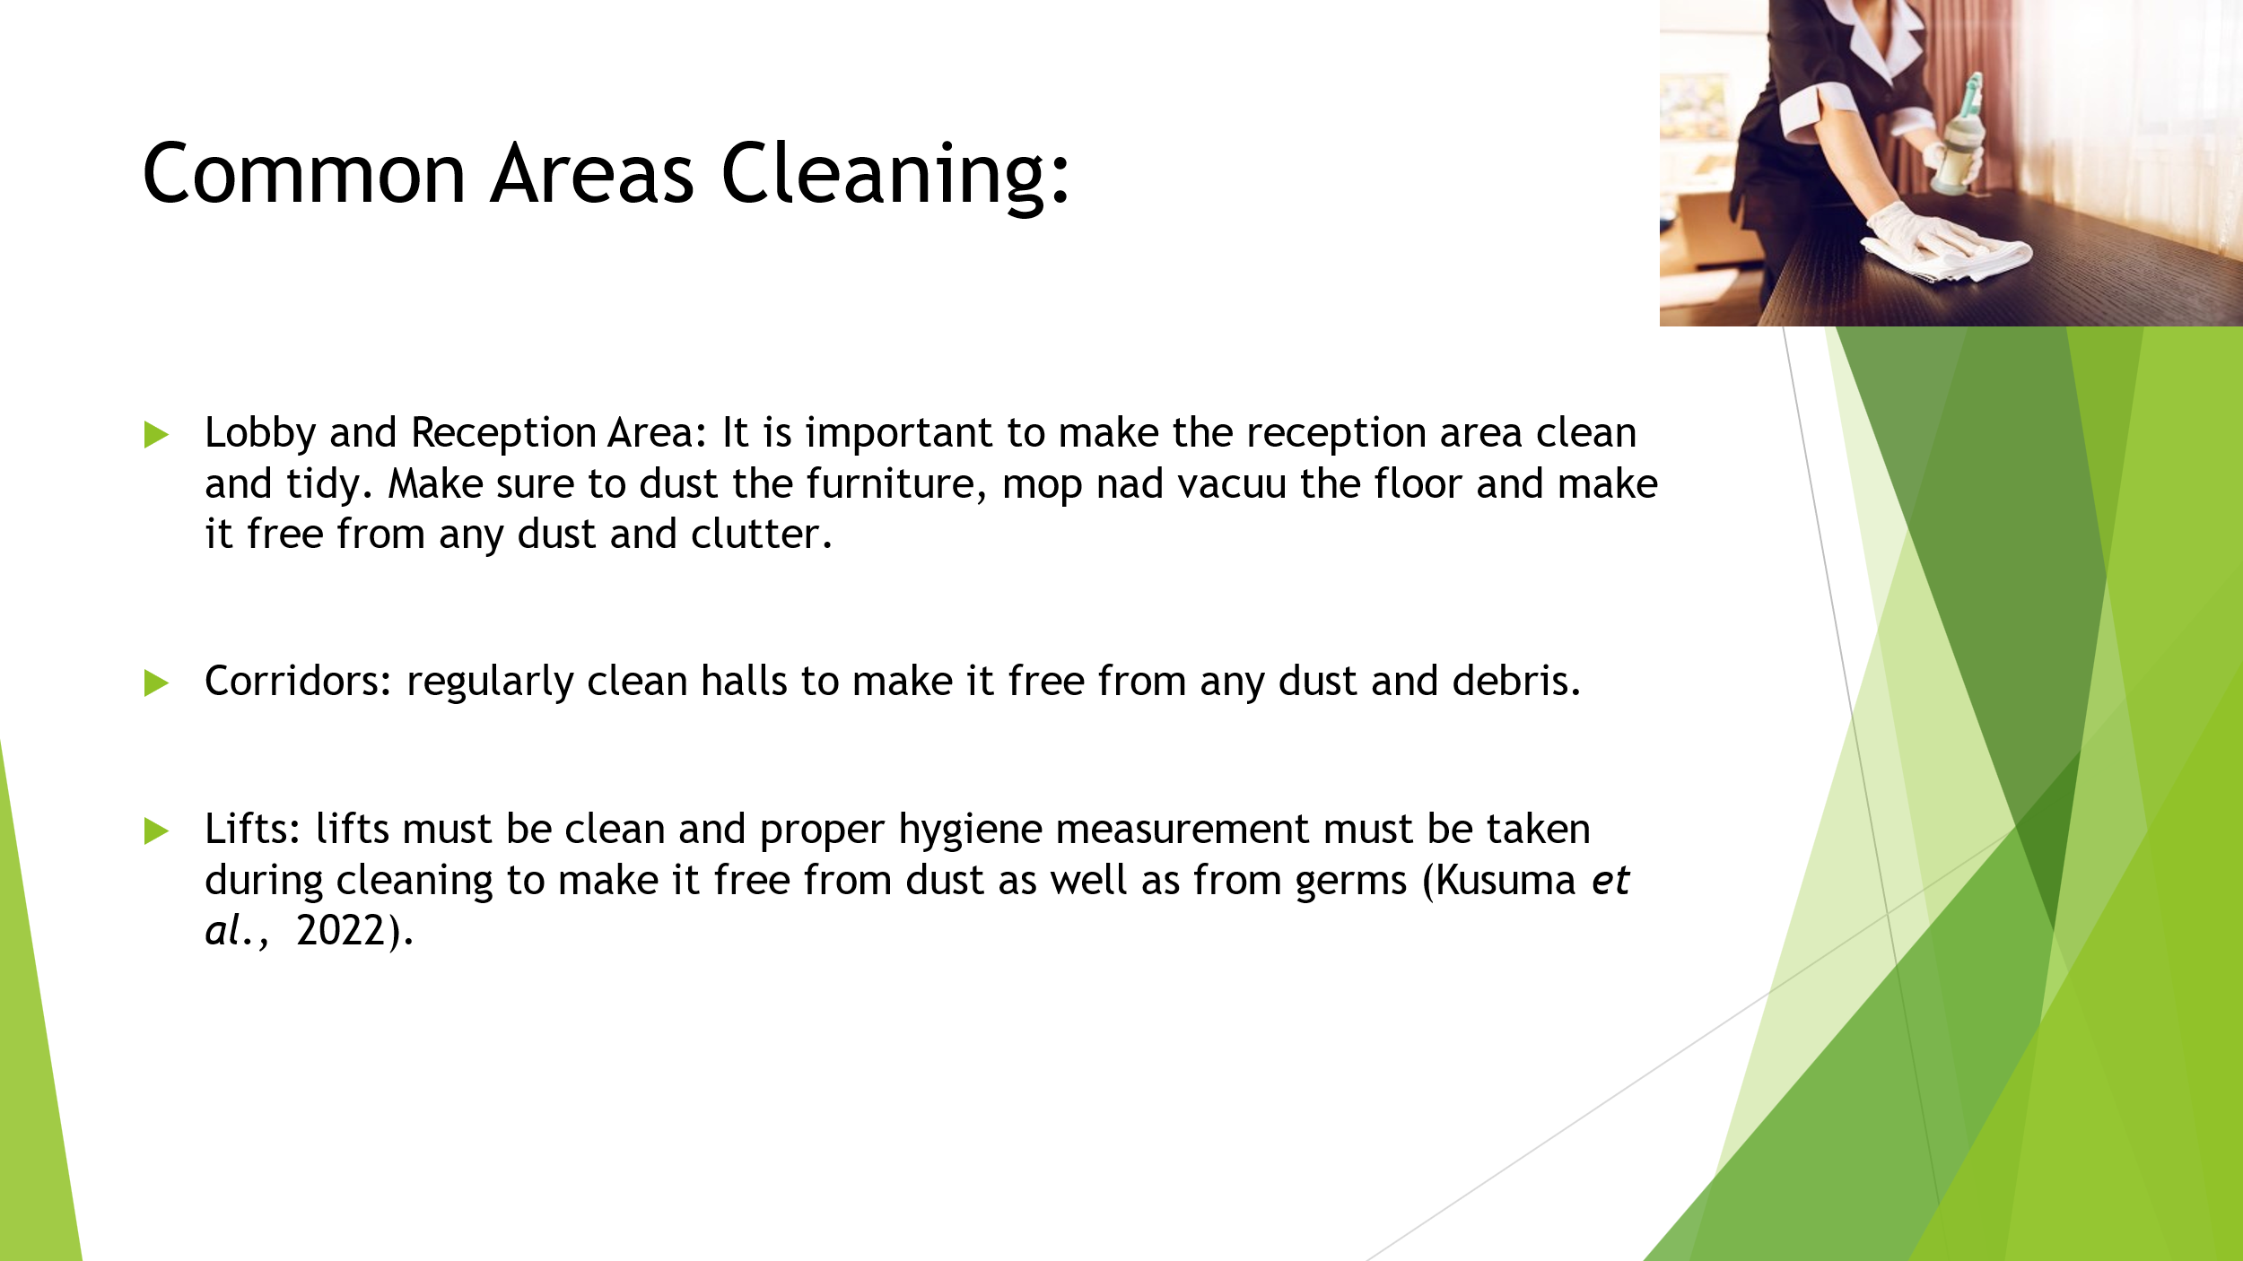
It is very essential to make the lobby of the hotel look organized as it is the face of the hotel and the reception desk must be clean and organized to avoid any traffic during reservation as all the documents and required material for transactional and check in process on hand reach. Using clean signs to make sure of the visibility to the guests for check-in section and check-out to minimize the rush and commotion.
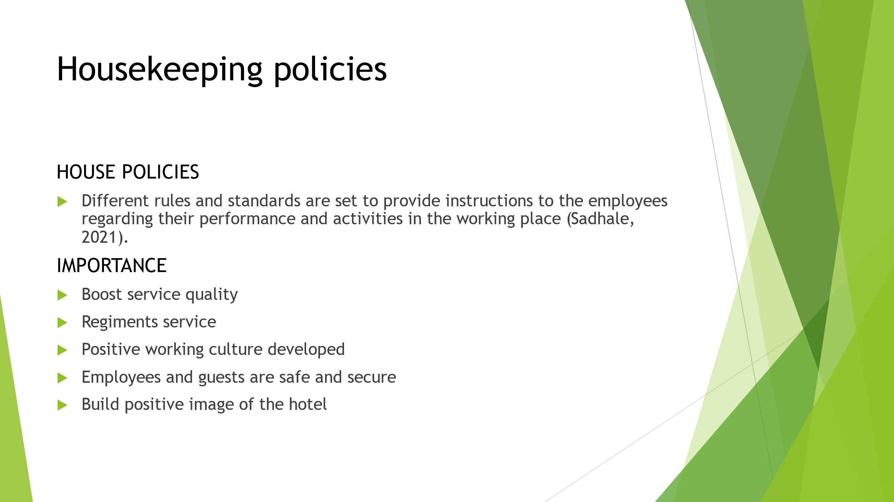
Employees must abide by the in-house restrictions and rules as food, chewing gum, smoking, and telephone. Illegal activity of theft and destruction to hotel property any favoritism incentives like meals, discounts and any discriminated services. Limited access of authority of different prime locations of hotel as employee entrance parking, pool, and kitchen area.
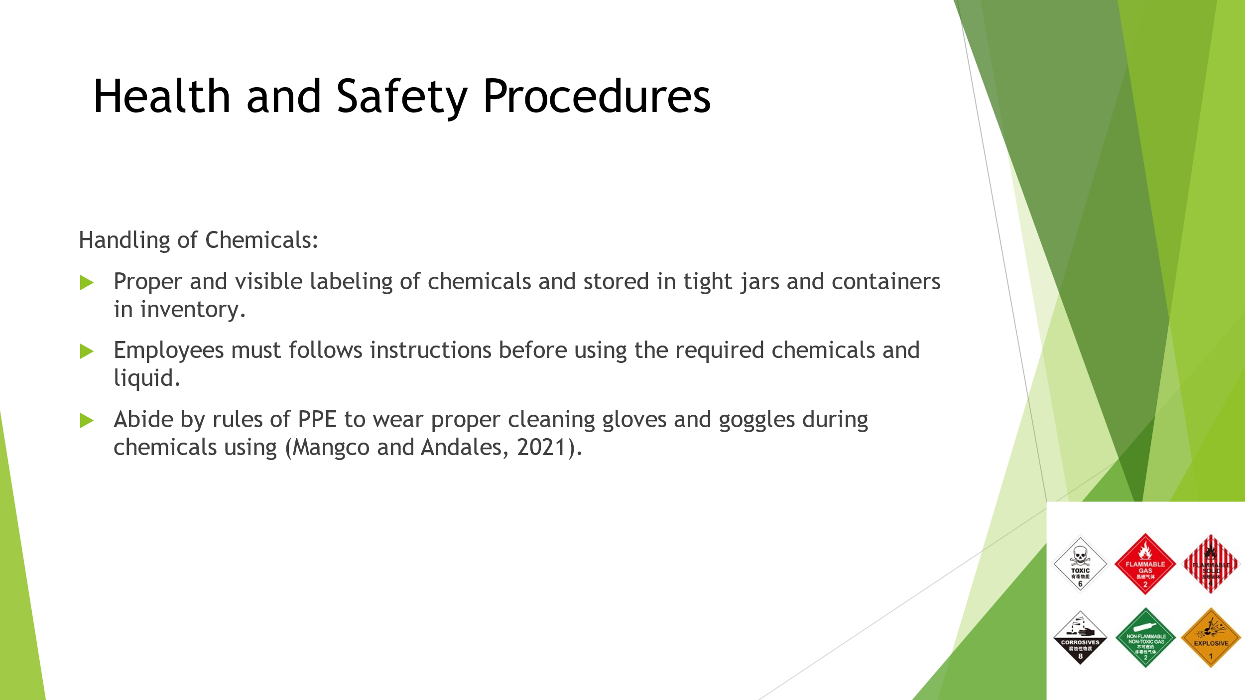
- No hazardous and serious chemical must not be used in cleaning.
- All the working activities and actions must be abide by the legal guidelines of the regional standards.
- Employees must be trained prior using these chemicals to avoid any accident and harm to the employees during cleaning and performing other activities.

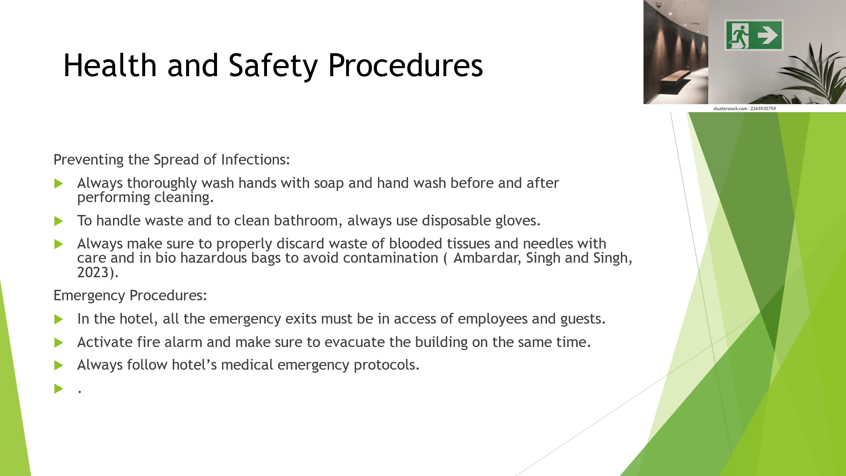
Risk assessment of the premises needed to make sure of the guests as well as employee’s safety by abiding all the legal policies and guidelines of working activities in the hospitality sector. This process of risk assessment allow business owners to focus on the risks of any kind that might damage the reputation of hotel and evaluation of these risks also help to determine any uncertain situation like injury to the head of department which can affect the overall activity and operational performance of the whole department.
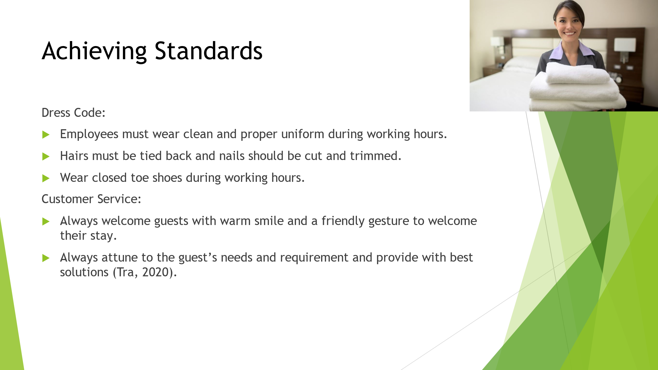
Employees must wear clean and proper uniform during working hours.
Hairs must be tied back and nails should be cut and trimmed.
Wear closed toe shoes during working hours.
Customer service must be exceptional to make the journey best memories of guests.
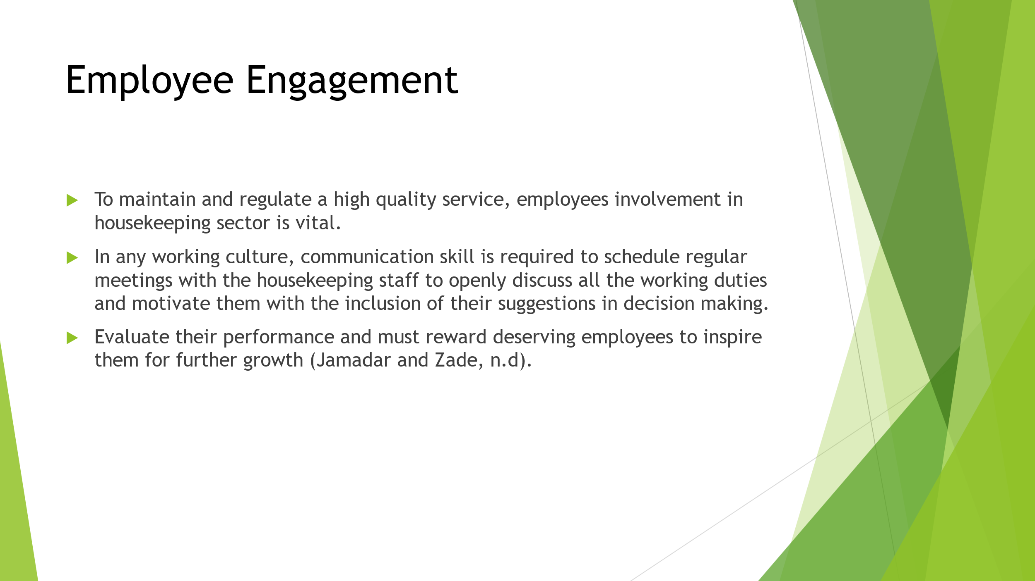
Hospitality sector can foster a working culture in which committed, motivated, and dedicated employees provide best services to the guests.
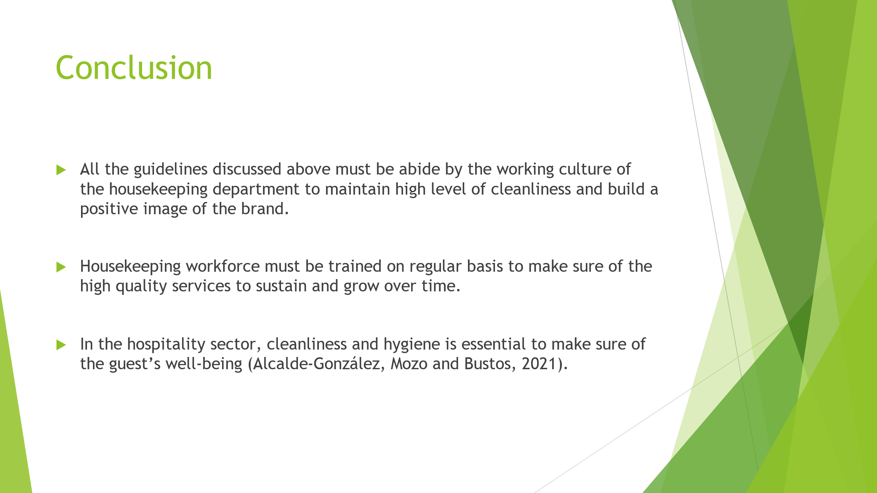
In result, it is our prime duty being a member of the hospitality department to provide best quality services to the potential guests during their stay and make them enjoy the best days of their life during staying with the abiding of all the safety and hygiene policies and legal standards to perform risk assessment in evaluating risks and issues and providing on time quick innovative solution in the working culture of hospitality sector.
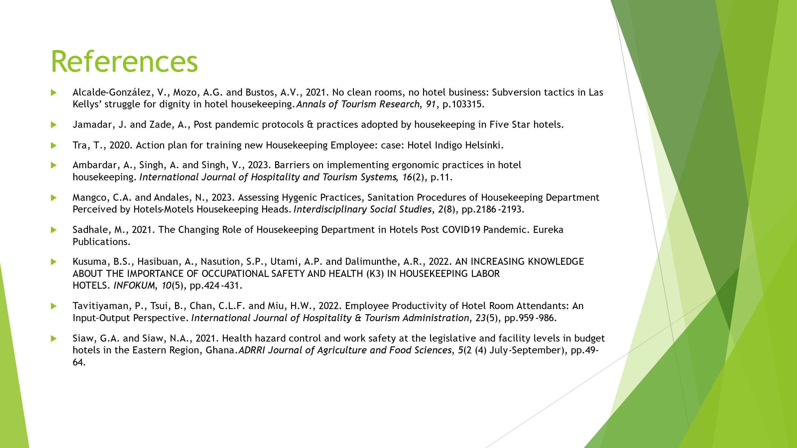

Reference List
Aagaard, L.K., 2023. When smart technologies enter household practices: The gendered implications of digital housekeeping. Housing, Theory and Society, 40(1), pp.60-77.
Alcalde-González, V., Mozo, A.G. and Bustos, A.V., 2021. No clean rooms, no hotel business: Subversion tactics in Las Kellys’ struggle for dignity in hotel housekeeping. Annals of Tourism Research, 91, p.103315.
Cendon, E., 2020. From Reflective Practice to Critical Thinking: The Reflective Practitioner in Higher Education. In Handbook of Research on Operational Quality Assurance in Higher Education for Life-Long Learning (pp. 189-211). IGI Global.
Jamadar, J. and Zade, A., Post pandemic protocols & practices adopted by housekeeping in Five Star hotels.
Nimri, R., Kensbock, S., Bailey, J., Jennings, G. and Patiar, A., 2020. Realizing dignity in housekeeping work: Evidence of five star hotels. Journal of Human Resources in Hospitality & Tourism, 19(3), pp.368-387.
Rosemberg, M.A.S., 2020. Health and safety considerations for hotel cleaners during Covid-19. Occupational Medicine, 70(5), pp.382-383.
Tra, T., 2020. Action plan for training new Housekeeping Employee: case: Hotel Indigo Helsinki.
Wirya, I.M.S., 2023. Analysis of the Implementation of Standard Operating Procedures (SOP) in the Housekeeping and Front Office Department of Frii Bali Echo Beach Hotel Canggu. Jurnal Manajemen Pelayanan Hotel, 7(1), pp.192-223.

