A marketing plan is written for
Premier Inn Hotel

Student Name:Madalina Elena Buhus

Student ID:2210857

Marketing Essentials BMIH4005

Lecturer:Luciana Suardi

Word count: 1449
Table of Contents
Introduction 3
Situation analyses (5’Cs) 4
Company 4
Customers 4
Competitors 4
Collaborators 5
Climate 5
Objectives 6
Smart Target 6
Strategy 6
Tactics 7
Marketing mix of Premier Inn Hotel 7
Action 8
Control 9
Conclusion 9
References 10
PowerPoint Presentation 11

Introduction
The Presentation is prepared for making a marketing plan to attract potential customers to Premier Inn Hotel. Premier Inn Hotel is a famous global brand which provides limited service. It is a UK hospitality company which was created by Whitbread. The marketing plan is created by the CEO of Premier Inn Hotel in the report for attracting potential customers to the hotel. The marketing mix is the sum of actions and framework that a company uses to influence the customers to buy a product or service (Goi, 1970). The report will explain the SWOT analysis for internal analysis, PESTEL analysis for identifying environmental effects, Porter’s Five Forces and STP analysis for identifying potential customers, Smart target for targeting and Bowman’s strategy clock for explaining options for positioning.

Situation analyses (5’Cs)

Company
SWOT analysis model has been used to analyze the hotel’s macro environment.
Strengths | Weaknesses
- Huge hotels and rooms (827 hotels and 80000 rooms) | 1. The hotel provides limited service
- 76.3% of occupancy rate in Premier Inn Hotel (Hariadi, 2021) | 2. The hotel has a limited appearance globally
- Higher brand value | 3. Hygiene issues
- Hotels located in airports, suburbs and city centres
Opportunities | Threats
1. The hotel has the scope to expand the hotel globally | 1. Competitors are the main threats to Premier Inn hotel
2. It can conduct marketing activities to attract potential customers | 2. Social media rumours and fake news

Customers
Segmentation: Premier Inn Hotel has segmented its customers based on profession, age, family and customer’s financial abilities.
Targeting: The target customers of Premier Inn Hotels are visitors and backpackers who are visited from distant places (Steenbeck, 2021).
Positioning: The hotel is reputed as a low-budget hotel in the UK.

Competitors
Porter’s five forces have been used to analyze the competitors and competitive situation.
Threats of the new entrance | Bargaining power of suppliers | Bargaining power of customers | Threats of substitutes | The intensity of the rivalry
The new entrance has a low chance to enter the market and conduct a hotel chain globally (Morrison, 2016). | There have huge suppliers in the UK and so suppliers have a medium chance of bargaining. | The hotel provides quality services at a low price and so customers have a low chance of bargaining | There have a few competitors of Premier Inn Hotel which are conducting a hotel chain. | There has medium competitive rivalry in the market.

Collaborators
B2B relationships: The hotel can conduct a business-to-business relationship with suppliers to get the raw materials.
Partnerships: Premier Inn Hotel can make partnerships with domestic and global hotels to expand its brand (Tempest, 2021).
Franchises: The hotel can permit the franchisee of such countries in which it does not conduct its business.

Climate
The PESTEL analysis model is used to analyze the microenvironment of Premier Inn Hotel.
Factors | Positive Impacts | Negative impacts
Political | Premier Inn Hotel requires considering government rules and regulations. | The hotel operates its business globally and so it faces challenges with different laws and regulations.
Economic | The hotel contributes to the global economy. | Cost of the huge number of hotels
Social | It provides quality services to meet the customer expectation (Ghandour et al, 2015) | Sometimes, customers gain some negative experience
Technological | The hotel provides online booking facilities | Premier Inn Hotel faces social issues to conduct marketing
Environmental | It conducts CSR to reduce carbon | The hotel has some adverse impacts on the environment
Legal | It follows different business laws and policy | It faces different legal issues

Objectives

Smart Target
Specific: Attracting new customers and increasing room sales
Measurable: Conducting the marketing plan effectively
Achievable: The target can be gained by effective implementation of the plan (Maxwell et al., 2015).
Realistic: Enough resources will be used to apply the plan.
Timely: The hotel will be achieved in 10 months.

Strategy
The value proposition is the unique services and features which are used by a company to attract new customers (Payne et al., 2017). Premier Inn Hotel can communicate the value proposition and differentiate its brand by providing quality services at a low price, providing discount facilities, free Wi-Fi facilities, special care for disabled people and launching loyalty programs. Moreover, it can offer various types of room services and provide parking, a swimming pool and lounge, a positive experience and well treat and showing respect. It can provide training to its customers to provide the services and maintain the service quality to communicate the value proposition.

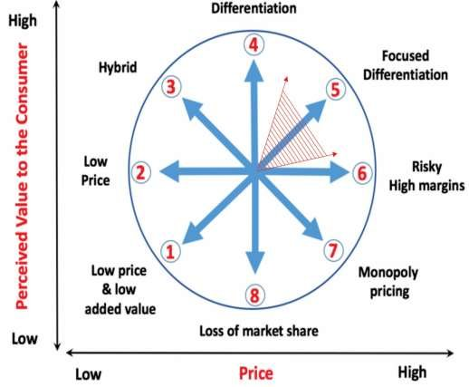
Figure 01: Bowman’s Strategy Clock (Villagrasa et al., 2021)
The hotel can use Bowman’s Strategy Clock as a strategic framework and provide options for positioning in the market based on its perceived value and pricing strategy. The hotel can use the clock through low price and differentiation strategy to communicate and deliver the value proposition.

Tactics

Marketing mix of Premier Inn Hotel
The marketing mix is the sum of actions and framework that a company uses to influence the customers to buy a product or service.
Product: Premier Inn hotel offers limited hotel services with different types of rooms. It provides free Wi-Fi facilities to its customers which easily attracts the customers. The hotel provides breakfast to its customers which menu has huge items for finishing breakfast. The hotel provides special services to kids, disabilities and older people. Moreover, the hotel provides swimming pool, lounge and parking facilities to its customers.
Price: The hotel uses penetration pricing strategies in its hotels. The hotel conducts market research and knows the competitor's pricing to fix the pricing strategy (Singh, 2012). It provides customer value by providing quality services at a lower price. The different price points are displayed based on the types of room quality. Moreover, the hotel sells rooms at different rates which are semi-flex, standards, and advanced, flex and non-flex rates. It uses a value pricing strategy to provide value to its customers.
Place: The location of the customers can be identified through social media tracking. The hotel conducts its business in 827 locations in different countries. It provides online food order services and provides home delivery to customers. Customers can book online through the use of the hotel’s app and website.
Promotion: Premier Inn Hotel uses some channels like advertising, online and social media marketing and outdoor marketing. It will advertise its hotel on social media and its website to attract potential customers. It can use digital media, social media like Facebook, YouTube, Instagram and Twitter, and print media such as newspapers, radio and outdoors to advertise the hotel. The hotel has invested a lot of money which is about $20 million in conducting marketing. It uses Chatbot to contact directly with customers.

Action
Premier Inn Hotel will require prepare 2 months to prepare the plan and research the market. It will make a marketing channel schedule and implement them in March 2023. The channels are advertisement, online promotion and outdoor. To apply the marketing channels, the hotel will require one to two months. In April 2023, the hotel will collect feedback from customers about the channels and marketing effectiveness.
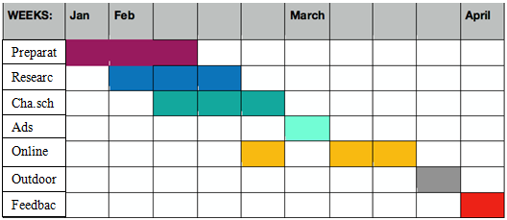
Figure 02: Gantt chart (Gantt, 2015)
The hotel will prepare for the plan and research within January and February 2023. It will create a schedule of marketing channels and apply them within March. The hotel will collect feedback in April. The company can use online marketing as people use social media most of their free time.

Control
USP: Premier Inn Hotel is a renowned hotel chain for low-price hotels in the UK.
Features: Unique and quality services, suitable for travellers and backpackers, and lower price.
Benefits: The benefits the hotel provides are discount facilities, parking, swimming pool and lounge facilities, Wi-Fi facilities, different types of rooms and special care for disabilities.
The Hotel’s success can be evaluated based on the number of potential or new customers. If it can attract enough new customers, it can provide a positive experience to the customers to improve the positive image. As a result, it will increase its profits in future.

Conclusion
The presentation has presented the marketing plan for attracting new customers to Premier Inn Hotel. The target customers of Premier Inn Hotels are visitors and backpackers who are visited from distant places. There has medium competitive rivalry in the market. Premier Inn Hotel can communicate the value proposition and differentiate its brand by providing quality services at a low price, providing discount facilities, free Wi-Fi facilities, special care for disabled people and launching loyalty programs. By implementing the Framework and the overall plan, the hotel can successfully attract new customers. The hotel faces some issues during the implementation which are brand consistency, rising travel agency, and using traditional strategies. To overcome the issues the hotel can use digital tools and marketing and conduct online travel agencies.

References
Gantt, H., (2015). Gantt chart.
Ghandour, R., Bilal, J. and Mudassar, H., (2015). Relationship between Service Quality, Customer Retention and the role of Social Media-Case study Premier Inn Hotel (UK). Journal of Organizational Studies and Innovation, 2(4), pp.1-12.
Goi, C.L., (1970). Marketing Mix: A review of'P'. The Journal of Internet Banking and Commerce, 10(2), pp.1-11.
Hariadi, D.A., (2021). Evaluasi dan Perkuatan Struktur Beton Gedung Hotel Premier Inn Surabaya Akibat Pembebanan Gempa SNI 1726: 2019 (Doctoral dissertation, Institut Teknologi Sepuluh Nopember).
Maxwell, S.L., Milner-Gulland, E.J., Jones, J.P., Knight, A.T., Bunnefeld, N., Nuno, A., Bal, P., Earle, S., Watson, J.E. and Rhodes, J.R., (2015). Being smart about SMART environmental targets. Science, 347(6226), pp.1075-1076.
Morrison, K., (2016). Sarajevo's Holiday Inn on the frontline of politics and war. Palgrave Macmillan UK.
Payne, A., Frow, P. and Eggert, A., (2017). The customer value proposition: evolution, development, and application in marketing. Journal of the Academy of Marketing Science, 45(4), pp.467-489.
Singh, M., (2012). Marketing mix of 4P’s for competitive advantage. IOSR Journal of Business and Management, 3(6), pp.40-45.
Steenbeck, A., (2021). Lübeck:„Premier Inn “baut direkt am Hauptbahnhof ein neues| SHZ.
Tempest, G., (2008). The development and launch of Premier Inn. Hospitality Review, 10(4), pp.5-11.
Villagrasa, J., Sánchez, F. and Donaldson, C., (2021). DECIPHERING THE STRATEGIC CLOCK HANDS: FROM THEORY TO REALITY. In INTED2021 Proceedings (pp. 9571-9584). IATED.

PowerPoint Presentation


