University of Wales Trinity Saint David
MBA Dissertation
Fadul Mikail Omar: 1912914
Exploring the impact of Brexit on beef importation from Europe into the United Kingdom
Prof. Dennis Pepple

Fadul Omar

Acknowledgment
First, I would like to thank my dissertation committee for the dedication of their time for giving me guidance and support. I could not have reached this goal without the help of my supervisor Professor. Dennis Pepple provided more than inspected wisdom which helped during the course study, and I cannot forget to give a million thanks to programme leader Doctor. Vasilios Tavlaridis for following my progress from the beginning to the end and allowing me to step forward. This could not have been done without my wife Mona Adam's patience and support and beer of my son Rami Fadul and my daughter Nasma Fadul and many other lectures have played a pivotable role in my success I would like to take this opportunity to thank and congratulate them for being always I will remember.

Abstract
The United Kingdom (UK) has decided to exit its membership from the European Union (EU) after the referendum that was held in June 2016. This memorandum event was named Brexit and then the United Kingdom tried to balance the effects of leaving the European single market. The main objective of this research is to investigate the Brexit impact on beef meat importation from European countries, minimize tariff barrier charges to measure economic complications during the process manage to settle a clear procedure of the foreign trade policy on how to import ready processes beef meat and what alternative to building new relationship out of European zone to import beef meat this may have disadvantages about beef quality and distance of transportation those are require a potential considerations. On the other hand, an estimation of the impact of Brexit's advantages and disadvantages in the United Kingdom farm on beef meat production in which the decision made by European Common Agricultural Policy (CAP) has a direct impact on the United Kingdom farm food supply chain because of losing farm support payments on agricultural products and benefit that used to share by both parties.

Table of contents

Acknowledgment 1
Abstract 1
1. Chapter1: Introduction 4
1.1. Background and Problems 6
1.2. Problems 6
1.3. Beef meat importation decreased from the UK market. 7
1.4. Aim and Objective 9
1.5. Research Questions 10
1.6. Significance of Study 10
1.7. Research Methodology 10
2. Chapter 2 Literature Review 11
2.1. Brexit Briefing. 11
2.2. Brexit Process. 11
2.3. Tariffs apply during the Brexit process. 12
2.4. Beef meet. 13
2.5. Brexit and foreign workers in the UK Farm issues. 14
2.6. Total of Beef Imported. 15
2.7. The United Kingdom Beef Meat Export to EU. 16
2.8. Kingdom imports Beef from non-EU Countries. 18
2.9. Selection of the Study 24
3. Chapter 3: Research Methodology 24
3.1. Introduction 24
3.2. Study Design 26
3.3. Technique Methods of Data Collection. 27
3.4. Deductive Research Approach 27
3.5. Study selection 28
3.7. Research Philosophy 29
3.8. Interpretivism 30
3.9. Subjectivism 31
4. Chapter 4 32
4.2. Introduction 32
4.3. Result of the Key Finding 32
4.4. Analysis of Brexit impacting beef importation from the EU. 38
4.5. Tariffs and Trade Cost 38
4.6. Domestic Trade Policy Scenarios EU 39
4.7. Brexit Freedom of Movement 39
4.8. UK current and future relation of beef meat import 40
4.9. The UK and the EU both parties benefit from the Brexit decision term 41
4.10. The UK International Trade Policy relates to EU and Non-countries. 41
4.11. The Britain Brexit International Trade Policy Influence New Strategy 41
5. Chapter 5 44
5.1. Conclusions 44
5.2. Recommendation 46
5.3. Long and Short-term relation with the EU 47
5.4. The United Kingdom future partnership 47
5.5. Limitation of Research 47
5.6. Future consultation 48
6. References 49
7. Appendices 56
8. Signed Approval Ethical From 56

Contents of Figures

Figure 1 Beef Import to UK. 15
Figure 2 Import and Export of Beef Meat. 18
Figure 3 Beef Meat Types. 19
Figure 4 System Theory. 21
Figure 5 Research Design Strategy 27
Figure 6 PRISMA Model 30
Figure 7 The Research Process Elements 31
Figure 8 Study Results 44

Contents of Tables
Table 1 Conceptual Framework. 21
Table 2 Estimated Import and Export Output 23
Table 3 The Difference between Secondary Data and Primary Data 26
Table 4 Reach Strategy 29
Table 5 34
Table 6 Tariffs Scenarios 40

Chapter1: Introduction
Higher education in the master's degree (MBA) dissemination research focuses on investigations on how the United Kingdom’s Brexit impacted beef meat importation from the European countries into the United Kingdom’s market under circumstances of no-deal trade policy agreements and economic complications that may affect the United Kingdom animal farm that could meet the demand in case of the deal has less benefits to the united kingdom farm looking into the best alternative of developing local farm for long term or importation from other countries could lead to consumers questioning the new products or beef meat that imported into the new market the most importance challenge is quality of the products and the price must be competitive in the way that how the beef meat processed compare to the European beef. “Uruguay Beef Production and Competitiveness Uruguay is a traditional beef producer, currently exporting about 5% of the world’s total volume of traded beef. Its beef cattle herd is composed of 12 million heads, mostly of British breeds” (Topolansky, Lestido and Triay, 2021, p 5). After Brexit, the European beef replacement alternative is already in place example, Uruguay is out of the European zone but has become one of the United Kingdom's targeted markets for beef importers experienced and trusted beef exporters and importantly achieving the most competitive beef market.
Chapter two, the literature review includes information identified from the background of the introduction and the main topic that analyses the critical review of the United Kingdom's departure from the European single market and that changes could be affecting free trade policy agreement on both sides, especially farming sector suppliers such as cow beef importation, and investigate on how this situation impacts the United Kingdom economy and what idea could the British government use to support new strategy whether developing the exiting farms and solve the problem of short skilled farm workers or heavily involve in importing from Asia, Africa and South American countries. “We could not fill in two reasons for this reduced interest in British farm work that were mentioned by stakeholders. The first relates to the changing levels of earnings of migrant workers. With the UK pound falling in value against the Euro immediately after the referendum result, migrant workers from other European countries witnessed a sizeable reduction in the value of their wages” (Milbourne and Coulson, 2021, p 5). However, in this scenario, the British farmers concerned with the government have no clear indication of supporting the local farm because showing no interest in keeping the European worker after Brexit by maintaining a better salary to work on the farm and probably expensive to satisfy foreign workers rather importing ready frozen beef meat from other countries compare to the of bring foreign employees cost while the British people have no interest or skilled to work as animal slaughter.
The next step is used to gather information which is represented in chapter three research approach, study design and research methods of data collections chapter four respond to the finding result and discussion of the results and chapter five include the main summarization of the main findings that include conclusion of the research question followed by recommendations, limitation and future recommendation.

Background and Problems
Brexit negotiation is known as the United Kingdom's decision to leave the European Union countries after several years of strong relationships to support economic, social, and political power and enjoy the importation of goods with free trade or non-tariff charges. Zawojska (2019, p 1-2-8) argues that in the United Kingdom referendum which was held on 23 June 2016 about whether the United Kingdom isolate itself or not from the European Union the majority of voters voted in favour of withdrawal from the European Union and in 2020 the United Kingdom has officially left the European Union and free trade agreement changes to an individual as Country to country relations rather than a benefit of a single market.
No-deal choice means the United Kingdom is no longer part of the European Fee Trade Association (EFTA) which is an uncertain future and a consequence of higher no-tariff barriers and difficulty in importing food products as before. “A trade and cooperation agreement were concluded on 24 December 2020 and ratified by the UK Parliament on 20 December 2020 and by the European Parliament on 27 April 2021. The agreement has been provisionally applied since 1 January 2021, although it officially entered into force on 1 May 2021” (Cheptea, Huchet, and Henry, 2021, p 2). According to Bakker et al. (2022, p 30) state that the impact of Brexit focused on importing meat beef from Europe has significantly dropped as part of Agri-farm as the United Kingdom increased its trade barrier with the European Union because Brexit present is commanding a higher food price including processed beef meat imported from the European countries has direct impact after 2019 things has change due to the implementation of trade custom agreement (TCA) in relation food has raised up to 6% at the result affecting the united kingdom economy.

Problems
Assuming that the United Kingdom farm beef production has a short supply to the local market because of the Brexit complication of free trade policy procedures and money value differentiation which is the European farmers struggle to make a profit to import meat beef to the United Kingdom market as used to be or before the United Kingdom withdrawal this scenario will cause short term economics crisis and gradually increase food costs according to the Haw Hamburg University of Germany food science report.
Richau (2022, p 18) argues that the United Kingdom imported over 286 kt of meat beef during the period between 2015 and 2019 from Europe accounting for an average of 94% of the United Kingdom’s total beef import between (2015 and 2019 from Ireland the most leading supplier. Choi et al. (2021, p 12) claim that Brexit results in trade diversion of Brexit trade results in the United Kingdom used by fewer imports from European countries based on the no-deal scenarios, and rather compensated by increasing imports from Asian and African countries. And use the adoption of the domestic market to increase domestic supply and reduce human consumption. On the other hand, the European country's exports to the United Kingdom were significantly reduced instead, changing the direction towards Asian and African markets responded to the changes.

Beef meat importation decreased from the UK market.
The European Union markets or both are using similar techniques to respond to the changes by reducing imports and domestic supply and increasing human consumption in value terms of beef meat. “There is a lot of talk around now about Free Trade Agreements (FTAs), as if they are automatically a good thing. However, there does need to be caution as we do not want the UK flooded with meat from other countries that are either not as well produced as UK meat” (British Meat Processors Association, 2017, p 5). One of the Brexit benefits of the British people is the ability to make decisions easily for example others suggested that high tariff charges on beef meat against the European countries could reduce the unnecessary amount of beef imported into the country and give a great opportunity for local farms to grow or to fill the gap.
The United Kingdom's responses after Brexit according to Zawojska (2019, p 5) argues that the United Kingdom was leaving a single market free trade, customs union, and adopted either European (CET) tariffs or comparatively lower tariffs than those published by the United Kingdom government may reduce the United Kingdom's imports of beef products from Poland as it accesses the United Kingdom's market as a third country. On the one hand, the reduction of current UK tariff protection against third countries' tariff rate on fresh or chilled beef or different types of beef process by 6.8% per 100 kg while Europe's tariff rate of 12.8% per 100 kg would lower the United Kingdom import prices from countries outside the European Union meaning stronger price competition on the United Kingdom’s market for example, Polish exporters on the other hand, given that agri-food trade between the UK and Poland is cheaper because of the imposed tariffs on trade flows between the two countries as well as higher trade costs of a formal customs declaration to formulate animal health certificates rules and regulation of commercial documentation theses divergences would make Polish exports of agri-food products or animals meat less competitive, among others concerning the United Kingdom domestic farm production on beef meat it becomes more attractive and comparatively cheaper.
The European Union replied despite losing the United Kingdom's contribution to the European budget. “This tariff schedule envisaged a significant liberalization as compared to the EU tariff schedule. 87% of total imports to the UK by value would be eligible for tariff-free access. Some products including beef and lamb would continue to be protected by a mixture of tariffs and quotas although at rates lower than those the UK applied as an EU member” (Choi et al, 2021, p 2). However, the United Kingdom's alternative approach is out of the European Union zone. Smis and Shohet (2023) argue that the United Kingdom has built a direct relationship with Brazil and imported around 13,700 tonnes just in the last 7 months alone most of it being corned beef and compared to the largest United Kingdom partner Ireland 109,000 tonnes at the same time import to the United Kingdom. The future of international trade concerns Brazilian beef such as BSE cases or cow disease. “The impact on the UK will likely be minimal, with an influx of Brazilian beef unlikely. Brazil accounts for around 8% of the UK’s beef imports, with the majority of it being corned beef. However, the EU is more reliant, with around 25% of its beef imports coming from Brazil” (Clarke, 2023).
The United Kingdom must consider food health and safety regulations and consumers' risks despite the United Kingdom's economic pressure and look for long-term partnerships to compensate or to fill the gap by leaving the European Union single market where the Brazilian has an open market with wider relationships. “On 23 February 2023, shipments of beef from Brazil to China were suspended over a confirmed case of atypical BSE. This comes under a health protocol maintained between the two countries, requiring the voluntary suspension of sales upon notification of the disease” (Clarke, 2023). It is a consequence of trade relations with the United Kingdom appearing to the new markets after leaving the European single market to achieve sustainable relationships to import beef from other countries considering distances of transportation costs and beef quality consumers questions.
Economical Future Affecting both Sides after Brexit Topliceanu and Sorcaru (2019, p 2) argue that the economic problems and risks caused by Brexit in both parties not only at the economic level but also social, trade problems and the internal crisis the United Kingdom facing is the disappointment of Northern Ireland, Wales, and Scotland asked for independence status because of unclear economic future after Brexit fearing of economics deteriorate. The European Union side could be less impacted than the United Kingdom's economic future uncertainty and the European Union's concern agreement due to the United Kingdom's failure to respect the European citizens' rights due to the absence of the commercial deal that affects the trade on both sides the Europe Parliament block the withdrawal agreement treaty.

Aim and Objective
The aim of this research is to provide a better understanding of the United Kingdom's withdrawal impact on beef meat imports from European countries and British farms' future concerns.
- To explore Brexit's impacts on beef import and export from European countries.
- Identifying the background of the problem to give a clear picture.
- To use a systematic research methodology to uncover empirical studies investigating the Brexit impact on UK beef export and import.
The objective of this dissertation is to increase knowledge based on three questions to investigate how Brexit impacts beef meat import from European countries and foreign trade policy changes about the United Kingdom's international trade policy how both sides' responses to the changes due to the increasing tariff charges and how the United Kingdom's farmers food or beef production processor manage the situations and economic complications in case of beef meat importation has been reduced from the European countries and in what extent government can help local farms to meet the demand. The rest of the European government intends to build an even stronger internal market policy despite some individuals suffering from Brexit impacts and pulling out of the United Kingdom market due to barrier charges.

Research Questions
The research questions are the core of the study concerning the problem found and to write clear findings of the problem and build theoretical knowledge to develop a literature review based on the topic of the United Kingdom beef importation from European countries due to the United Kingdom's withdrawal by using keyword research to find filter relevant question Brexit impact on trade policy relations between both sides, economy uncertainty and the united Kingdom future alternative trade relations and assessing the British farm current situation and future to come.

Significance of Study
The relevance of the study is to find out about Brexit's impact on beef meat importation and exportation in relation to the no-deal agreement and how the United Kingdom farming manages food production in particular beef meat after the European Union budget support entirely stopped from the United Kingdom farming and what is the alternative that could measure to solve the problem or compensate for the ongoing situation while the United Kingdom beef farming production needs to be competitive fit in both situations internally and externally to meet the local demand as still the similar beef products come from different countries may put price pressure on local beef meat and one factor that could impact on the British farm is the new tariffs that already applied to the beef meat export to the European Union could have potential changes.

Research Methodology
This research has included accurate and valid article sources or data collected from Google Schooler engine search by using the related keywords as specific techniques to filter relevant information about the United Kingdom's Brexit pieces of information such as reports, articles, online University libraries, and books recently published to support Brexit's impact in the United Kingdom economy due to trade policy changes about import and export of beef meat from European Union due to the changes about no-deal trade agreement and how the United Kingdom farm affected by Brexit impact. The selection of the 50 articles is used in Chapter 1 to identify the core of the problem which focuses on the background of the problem that is investigated and provides information represented in Chapter 2.
Chapter 2 compromises the related study problem introduced in Chapter 1 from the literature review articles which critically analyses the problem of the Brexit issues based on the information found in the 50 articles. Exclude websites, Google, social media sources, videos, or before Brexit information could be irrelevant but is necessary to know before Brexit how the United Kingdom and Europe trade relations. unless some credible organizations' websites such as the government’s website and farming association. These results discussed in Chapter 3 used the research methodology of data collection the explain all chapters’ section by section for the relevant study information provided in Chapter 4 to identify the complexity of the study and findings limitations of the study and Chapter 5 summarised the entire findings, recommendations, and conclusions.

Chapter 2 Literature Review

Brexit Briefing.
Brexit (Britain's exit) means the official withdrawal of the United Kingdom from the European Union regardless of the long-time strong relationship sharing economic, social, and political power but the United Kingdom has hesitated or refused to join Erro currency back to January 1999 and coins and banknotes launched on January 2002 to promote economic development growth and European integration but the United Kingdom is not part of that development while the British Pound keeps its value as higher than the rest of the European Union. Jawad and Naz (2019, p 2-3) argue that the United Kingdom joined the European Union beneficiaries of the European Economy Community (EEC) in the earlier 1973 and 1975 while the United Kingdom spent most of the time clearing uncertain about being a part of the new membership as European Union one nation economy power.

Brexit Process.
However, the United Kingdom House of Commons voted resulted as 51.89% winners on the 23 June 2016 decision to leave the European Union single market. In 2019 became historical momentum of the United Kingdom's economic isolation was announced by Prime Minister Theresa May based on Article 50 earlier in 2017. Department of Economics, University of York, UK, and Department of Mathematics, University of York, UK Both researchers analyzed from pre-Brexit 2015 to post-Brexit 2017 the United Kingdom economy distracted by Brexit elements the British pound exchange rate going down against the United States dollar while the United Kingdom could benefit from the European Union reduction budget and will at to Gross Domestic Product (GDP) is permanently added budget. “A Brexit without a trade agreement between the European Union and the United Kingdom will give more sovereignty for the British economy to negotiate its trade agreements, without obligation to respect the European economic policies or to pay contributions to the European budget” (Topliceanu and Sorcaru, 2019, p 2). However, the United Kingdom has no more obligations to contribute to the European Union budget based on the withdrawal agreement. “The UK’s withdrawal from the EU will have wide-reaching consequences for the UK and the remaining 27 member states. There is little doubt that the UK agri-food sector is one of the sectors most seriously affected by Brexit: for almost half a century, the UK’s agri-food sector has been intrinsically and intricately linked to its membership of the European Community” (Richau, 2022, p 8).

Tariffs apply during the Brexit process.
Zawojska (2019, p 5) argues that the United Kingdom and the European Union both apply tariffs from the notification of the World Trade Organization (WTO) based on the previous third countries accepting the European countries' Common External tariffs (CET) which have to protect the farming sector among members of the Union for beef meat importation into European Union subject to tariffs of 12.8% in addition to specific tariffs which effective to the valorem rate while the United Kingdom required under the World Trade Organization (WTO) rules to enforce MFN average of import tariffs around 22% food product and in particular import beef meat over 68%. The United Kingdom temporarily announced the import tariff rate on agricultural products could disturbed by a no-deal Brexit by the United Kingdom Department for International Trade during the year 2019. “This option inevitably entails higher trade facilitation costs compared to the UK remaining in the EU because non-tariff barriers (NTBs) in trade would increase. These include the costs of customs clearance, and of determining rules of origin, as well as sanitary and phytosanitary (SPS) and technical barriers to trade” (Choi et al. 2021, p 2). “The majority of beef imports into the EU are subject to ad valorem tariffs of 12.8%, plus an additional fixed amount that can range from €1,414 to €3,041 per tonne, depending on the product. As shown in Table 1, these tariffs could account for well over 100% of the price per unit” (Rusk and Purewal, 2019, p 8). “During the Brexit transition period, the UK remained subject to EU customs legislation, including the EU’s common external tariff (as well as enjoying free trade within the EU member states). This means that the EU’s common external tariff continues to apply” (Kane, 2020). “The European Union has 32 Non-Tariff Measures in force in the case of bovine meat. 24 of the measures are sanitary and phytosanitary, 4 are technical trade barriers, 3 are quantity control measures and 1 is not classified. According to UNCTAD (2020) European Union has four broad models with third countries in the case of NTMs” (Rytkönen, 2021, p 17).

Beef meet.
Shrestha et al. (2018, p 2-3) argue that due to Brexit changed expectations of beef meat, and increased price compared from 2015 to 2022 beef alone price rose more than 23% under this scenario the United Kingdom post-Brexit and the European Union predicted free trade could do less price while the European Union’s World Trade Organisation (WTO) tariffs associates with the United Kingdom which called (Fortress UK) expected imported beef price increases under Brexit conditions. Brexit impact on the United Kingdom farms specifically Scottish farms affected by multiple scenarios related to trade agreements to farming direct support payment under unilateral trade liberalization (LT) and one of the most affected the beef farming processes and unable to export to Europe because of the high beef price and high levels of tariff. The United Kingdom beef production farmers' expectations of the Brexit no-deal trade agreement analyzed by the Scottish group farming system baseline scenarios what is going to happen between 2015 and 2022 due to foreign trade policy changes could impact beef farm import and export from the European Union. “To analyze which countries may be involved in current and future meat imports to the UK. International trade makes up a significant share of the UK's current meat consumption, resulting in the UK's meat consumption representing a significant share of the global trade in meat” (Poppy, Baverstock, and Baverstock, 2019, p 2).
Figure 1 Beef Import to UK.
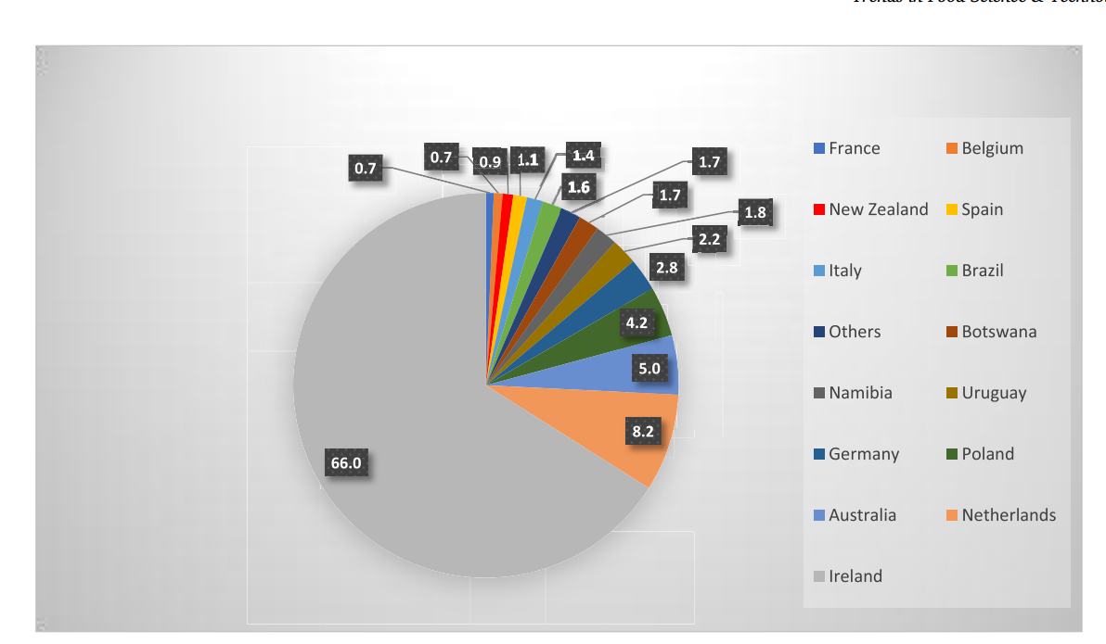
Source adapted from (Poppy, Baverstock and Baverstock, 2019, p 4)
The above chart shows the United Kingdom's partners for beef meat importation Ireland is the most important beef supplier to the British market followed by the Netherlands in addition to the rest of the European countries but Australia and Brazil out of the European zone to import beef more than 12% share in British market it is opportunity to increase the share while the United Kingdom decreased the beef import from the European Union due to Brexit agreement.

Brexit and foreign workers in the UK Farm issues.
Brexit has developed more questions about what coming next to make Great Britain a better future, unfortunately, United Kingdom farmers are suffering from the fund cut which is farmers' support payments organized by the European Union before Brexit and many more benefits that the United Kingdom farmers in food productions disappear because of no-deal Brexit. “Because of labour shortages caused by Brexit, British meat producers have resorted to exporting animal carcasses to the EU for butchering before re-importing the meat, but the UK government has insisted this will be resolved via its domestic workforce” (Foote, 2021). The European Union's response to England will face a high bill to pay skilled workers from abroad to work in the meat industries. The United Kingdom's growing population and high numbers of beef consumers mainly imported from Europe have been disturbed by Brexit events while the United Kingdom's food production farms are not ready to fill the gap. The United Kingdom's beef meat expertise explains the situation due to Brexit changes' impact on foreign workers. “Anti-immigration rhetoric has meant that the UK has come to be viewed as a less welcoming place for EU migrants. In this paper, we explore the shifting position of migrant workers within the UK’s agri-food system in the context of Brexit, with a specific focus on food production and processing” (Milbourne and Coulson, 2021, p 2). To understand the reason for the United Kingdom’s farm system is unclear there is a gap between the British government's foreign policy and the internal farming sector system because of the lack of encouragement of the local employees and less interest in bringing or keeping existing European workers. “The reality is that too many farmers in the UK are overly dependent on CAP-type support. Without an urgent restructuring of how farms are managed and financed, any reduction of CAP-type support will put UK farmers under severe financial pressure. This is particularly the case in the beef and sheep sectors” (Giles, 2019).
After Brexit, the United Kingdom farms lost the European Union Common Agriculture Policy (CAP) and all the support that farmers used to receive is not available anymore and that is one of the main reasons the United Kingdom farmers feel less competitive in beef meat production. “Now they are outside the CAP, the four UK countries have the freedom to redesign their agricultural support frameworks, and this has been seen by many as one of the more concrete opportunities to arise on leaving the EU, including to enhance possible environmental benefits” (Hart and Baldock, 2023, p 2).

Total of Beef Imported.
According to Meat Management. (2021), The least information gathered from HMRC during the 2020 beef imported from the European Union into the United Kingdom dropped by 3% while the Livestock and Meat Commission (LMC) the beef imported from North Ireland into the United Kingdom around 242,838 tonnes of beef meat reduced 3% by 2019 and 16% compared to 2018 less and rest of European countries imported beef counted 237,928 tonnes total of 98% of imported beef during 2019 down by 1% compared to 2018 declined 13 percent but, Island the largest beef importer to the United Kingdom 190,974 tonnes alone during 2020 and second largest imported beef is Poland followed by Netherlands non-European countries beef imports mainly from South American countries with a total of 3,330 tonnes imported from Brazil, Uruguay, and Argentina. “UK agriculture is highly integrated into the EU single market. Overall, 30% of the food consumed in the UK comes from the other 27 member states of the EU (Defra, 2018). In 2016, the UK imported food, drinks, and feed worth £42 billion and exports £20 billion. EU27 accounts for 65% of the UK’s imports and 60% of its exports of agri-food products. The UK mainly imports meat” (Choi et al, 2021, p 7). British Meat Processors Association. (2017, p 2-3) explain that the imports of fresh or chilled beef of more than a three-quarter and mostly boneless cuts require no further processing and could achieve higher prices because of the quality and ready-for-consumption. This is mainly the United Kingdom’s cow beef but the process out of the United Kingdom for quality meat processing in Ireland or the Netherlands and then back to the United Kingdom Supermarket transport costs added and it is critical high prices are challenges to the individual consumer and may change direction for better or affordable prices. This is a clear indication of the United Kingdom government's failure to protect the local farms and not pay attention during the Brexit process back in 2014 and 2015 the United Kingdom used to export more than 100,000 tonnes of meat mostly offal or the remaining part of cut which is not used in the United Kingdom rather high demand to European Union and value of 342 million pounds added to the local economy. However, this figure was significantly declined due to the Brexit no-deal trade policies. “The UK imported an average of 286 kt of beef between 2015 and 2019. Imports from the EU accounted for an average of around 94% of the UK’s total beef imports (2015-2019). Ireland is the dominant supplier. Some of these imports from Ireland are beef that is produced there but exported for further processing” (Richau, 2022, p 18).

The United Kingdom Beef Meat Export to EU.
Ridler (2022) argues that the United Kingdom’s contribution to beef meat exportation types of fresh and frozen sent to European countries is estimated to be 93,200 tonnes up to 30% in nine months only during the year 2022. “The UK exported an average of over 156 kt of beef and beef products per year between 2015 and 2019, equating to an average value of £463 million. Over this period, exports to the EU accounted for an average of 79% of all beef exports, highlighting the significance of the EU market to the UK beef industry” (Richau, 2022, p 23). These indicate positive image than the previous year and it is an incredible achievement for the United Kingdom's meat production industries. However, the below chart explains the beef meat imported and exported in twelve months alone from the beginning of the year 2022 to the year-end. “For instance, Japan lifted its ban on British beef imports in 2019 after 23 years since the ban began. Notably, the export ban had also been in force in the USA until March 2020. On the 30th of September, the first shipment of UK beef departed for the USA according to the British government” (Rytkönen, 2021, p 12). The United Kingdom expanded the beef market nationwide and the inter-American and Japanese markets since the ban was lifted in the early 90s known as mad cow disease (BSE) the United Kingdom trusts food security and quality production of beef meat to ensure that history is not repeating itself about animal health. “The U.S. market had been closed to EU beef since January 1998, when the country introduced import restrictions on beef, sheep and goats and their products because of Bovine Spongiform Encephalopathy (BSE) concerns. BSE is also called mad cow disease” (Desk, 2020).
Figure 2 Import and Export of Beef Meat.
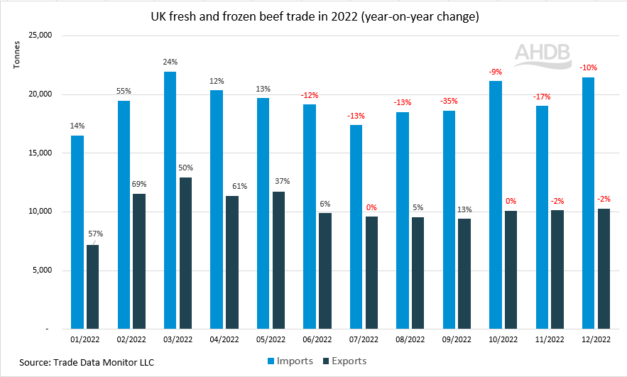
Source adapted from (Shohet, 2023)
According to Shohet (2023), beef meat shipped to the EU and non-EU countries during December 2012 around 10,300 tonnes an increase by 2022 to 20,800 tonnes within competitive prices is proofing that the United Kingdom’s beef meat is in high demand because of the quality check. The diagram below shows that fresh and frozen beef meat types exported to European countries during the three-year period the meat has been processed in three different types of beef boneless cut the highest level of amount export followed by beef carcase despite the base of the different waves but similar monthly exportation.
Figure 3 Beef Meat Types.
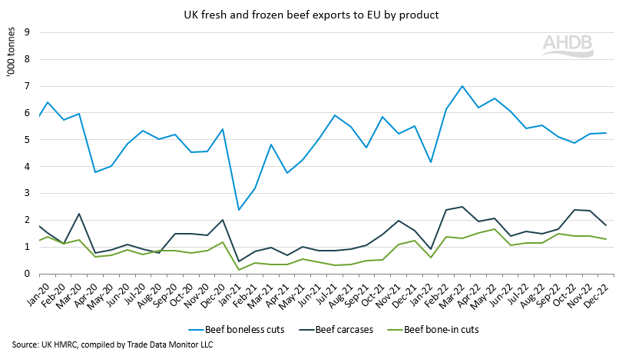
Source adapted from (Shohet, 2023)
The chart lines above show the United Kingdom types of beef meat sent to the European Union in different cutting processes in order to achieve a competitive market because the European nation has strict rules about food product quality beef boneless cut achieved higher results because of the quality no wase include but this kind of beef required intensive lobar and expensive to process and skilled workers while the study found that during the Brexit process, the European skilled farm workers unhappily left the British farm due to Brexit agreement and also the United Kingdom farmers used to send some fresh beef to European countries for processing and send it back then reship again to consumers this could be a costly process especially after Brexit facing a potential change.

Kingdom imports Beef from non-EU Countries.
After Brexit, no-deal free trade created war and an economic gap between the United Kingdom and neighbouring European or economic partners there is a way to still work together, especially in the farming sector because the European farms produce similar products and mainly consume themselves standard by the quality and culturally fit the environment, easy transport products in between because of the well-design transport system and food health and safety regulations. For example, the United Kingdom exports food products to African countries that could be expensive for Africans to buy but might be imported from Africa due to the United Kingdom's currency being different British pound's power against the African currency. “Brexit results in trade diversion. The UK reduces its imports from the EU, and strongly so in the no-deal scenarios, and compensates by increasing imports from Asian and African countries” (Choi et al, 2021, p 12). The United Kingdom's response to the Brexit free trade agreement no-deal free tariff is a rising issue between European farms and the United Kingdom agriculture particularly in beef production farms becoming a single market compared to the European market the United Kingdom government is desperate to find an alternative to reduce beef import from the European countries and willing to open a new relationship deal to expend sustainably market such African countries and Asian countries to beef meat without considering the potential risk such as distance in transportation cost and the other major issues That quality of the meat is important, refrigerator or meat restoration is critical to the United Kingdom’s consumers while British people or mainly indigenes use to eat beef from similar or develop countries which care about animals health and gene to control animal health. In relation to animal genes African animals' health concerns because of the different environmental issues. “The increase in UK-EU trade barriers has led to a 6% increase in food prices in the UK over the period between the end of 2019 and September 2021 in comparison to the years before December 2019” (Bakker et al, 2022, p 5).
There is a major problem in the United Kingdom food production (beef) price increases lack of local decline to meet the required demand and a high decrease in beef products coming from the European countries despite the flooding beef from non-Europe countries it is time for the British farm meat production to review the unexpected food shortest matter and important for the British government to involve. “In terms of value, beef and veal production declined from 2016 to 2019. From 2018 to 2019, the value of beef and veal production decreased by 6.5 percent despite an increase in production volume as prices declined 7.5 percent year over year. At the national level, the value of cattle production was greatest in England at 51%, followed by Scotland at 23%, Northern Ireland at 14%, and Wales at 12%” (Jelliffe et al, 2023). The above very recent research overview of the United Kingdom’s farming expectation of beef production significantly dropped in the past five years due to the Brexit impacts first, is not only because of the European gradual decline of imported beef meat into the United Kingdom market and secondly because of the most of the United Kingdom farm workers are from the European Union countries but workers had been affected during the Brexit process the United Kingdom deteriorated against the Euro and this become a potential risk to the European workers to leave the British farms.
Figure 4 System Theory.
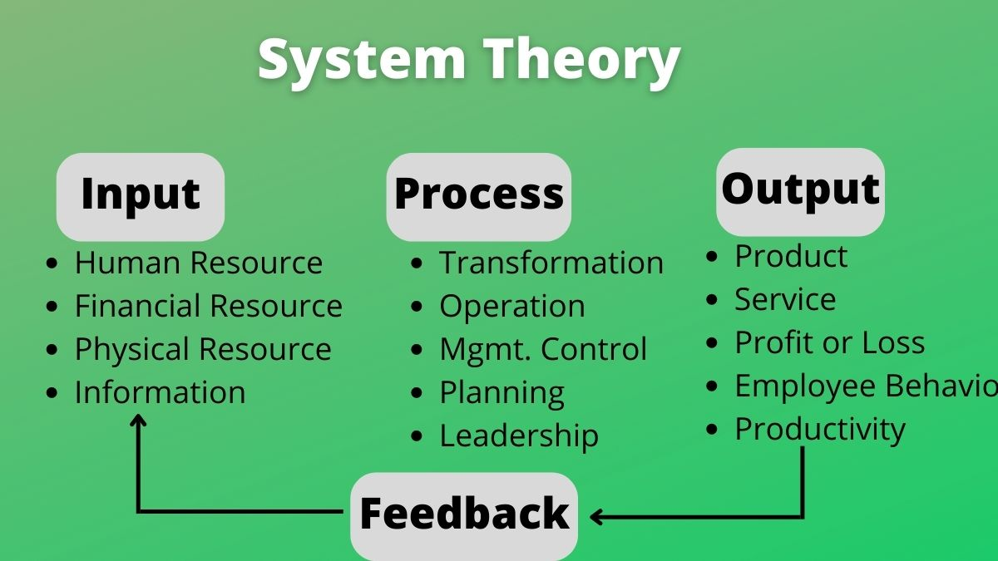
Source adapted from (Mahesh, 2023)

Table 1 Conceptual Framework.
Input | Process | Output
Lacking resources UK farms:  - Farming equipment  - Research and development  - Farmers support fund  - Workforce from the EU  - Technology | - Brexit transition  - Trade policy  - To create a single market  - Tariff cost  - UK relation with EU  - Importation system  - New planning  - Alternative available | - Less import from the EU  - Difficult to export to the EU.  - New tariff policy  - To pay customs duty  - Farming support cut  - Less beef from the EU  - More beef import from non-EU countries  - Archive single market
 | Feedback

According to Arnott et al (2021, p 5-6), changes to agricultural farmland values are driving a major farming change in which connecting land value and price support systems means changes in the United Kingdom farming policy will directly affect the land prices in both ways in winning or losing in the sector. After Brexit, the United Kingdom farms facing environmental change and looking to the changes of environmental outcomes to provide farmers training which can mitigate some risks and help farmers with promotion payment to maintain services or to increase product quality. Bedford (2023, p 2) While farm animal output was not affected in 2020 and is improving in the years after increasing value within over 11.8 billion British pounds by the year 2022, this improvement is directly after Brexit. But Brexit has multiple elements that have impacted the United Kingdom farm it is markedly facing economic difficulty in 2020, falling by one billion British pounds compared to the year before. However, output for crops and other products rose in 2022 which increased in total of 13.3 billion British pounds with an average income of 67,000 British pounds compared to the following farm years 2021. In early 2020, the UK experienced extreme weather which are natural environmental disaster event, giving rise to a late planting season and a dry spring which was directly impacted by both Brexit and the pandemic. Plus, the main problem of the farming support cut. “The domestic policy changes as proposed in the UK Agriculture Bill, particularly the removal of CAP direct payments, which account for a large proportion of the farm business income (FBI), will present UK farmers with substantial challenges” “Ojo et al. 2021, p 3).
Table 2 Estimated Import and Export Output
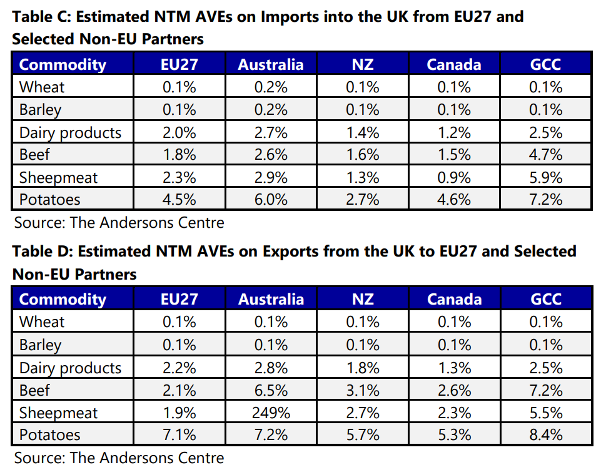
Source adapted from (Haverty, 2023, p 8)
“Results indicate only marginal changes in EU imports, exports, prices, and real income, with stronger negative effects for Ireland and even more for the UK. We expect trade between the EU and the UK to decline by around 10% and for both parties to register stronger losses for beef meat and meat products” (Cheptea, Huchet and Henry, 2021, p 3). Output estimated beef products a part of other products displayed in the tables above number of import and export products analysis outcome in particular, beef meat imported from the European Union is measured as less than average compared to non-EU countries which means the trade relation between the United Kingdom and European countries amount of beef meat products significantly decline during the Brexit process compared to the period before Brexit. The second table shows the United Kingdom's exported products to non-EU countries and the number of exported beef meat substantially higher than the European countries which means the United Kingdom's outcome strongly focuses on building new relationships outside of the European Union zone. “Also, the European Union could obtain a greater integration of community and could implement reforms to avoid other situations similar to those of Brexit. On the other hand, the main economic benefit of the United Kingdom is the decrease in contributions to the European budget. The British gross contributions were almost €17.5 million, from which less than 50% came back as receipts” (Topliceanu and Sorcaru, 2019, p 3).
Haverty (2023, p 5-9) argues that the beef industry sector comes under pressure because of the Brexit outcome despite the existing alternative non-EU partners such as Australia and New Zealand applying significant pressure and trading deals with Canada is a possibility to generate some export opportunities. Identifying a brand recognition of Scotch’s beef which is relatively positioned and safeguarding domestic sales, especially to the United Kingdom’s retailers from overseas competitors will stay crucial. Hart and Baldock (2023, p 2) argue that the United Kingdom is the most advanced in developing a new system of payments to farmers as a new Agriculture Act is already in place, with the planning of public goods and products specified as the main objective of funding. This policy system will continue to chase this goal is being changed as well as direct payments. “Many farms in the UK are now very dependent on migrant labor from Eastern Europe, and in the build-up to Brexit, we have already seen a steady stream begin to leave the country. This is because in some cases, they no longer feel welcome in the United Kingdom” (Giles, 2019, p 3).
The industrial pressure influence will highly change the use of land for industrial feedback suggesting that the trading pressures will have a significant effect on feeding livestock this could be a long-term pressure that will identify the most important elements. In particular, that kind of pressure may motivated by land use changing the appearance to poor profitability in skimming livestock the same as societal needs and these changes will heavily influence the future re-sizing of the industrial structure. Especially in Scotland where has already tree-planting led to declines in beef and sheep populations. “Alternative trade scenarios the UK may adopt following the UK’s withdrawal from the European Union referred to commonly as Brexit. These scenarios are each considered with and without direct agricultural support payments to illustrate the potential impacts on Scottish agriculture post-Brexit” (Shrestha et al. 2018, p 4).

Selection of the Study
Assessing the impact of Brexit on beef meat imported from the European Union in the context of the United Kingdom's exiting the Union market and how this change affects the British farmers who are losing development support from the European Union budget cut used to help farmers in the effect of the tariff charges added cost to the British farmers' import and export to the European countries. The study focused on the United Kingdom's alternative non-European countries to adopt a new strategy of beef meat importation and exportation to lift the economy as a whole to have a clear picture to help beef meat production farms to compensate for the financial support gap that used to come from the European Union.

Chapter 3: Research Methodology

Introduction
This chapter presents how the research methodology has been conducted and the type of research that is aimed to achieve for this MBA dissertation there are two types of research primary and secondary data collection to identify information that relevant research questions to answer or to solve particular research questions problem the primary research use face to face interview, emails and many more to collect data. Mwita (2022, p 2) argues that the primary researcher uses asking questions from a list of questions that have been already provided by the researcher or a face-to-face interview, video conferencing, through word-mouth direct communication between the researcher and responder to collect primary information or data that is not published yet and It could be a time consuming and financial cost. Both of these data research methods require hard work to find the most reliable source to answer selected questions. Ajayi (2017, p 4) argues that secondary data sources imply data gathered by someone else whether secondary data are the data collected by a particular party not related to the research study but collected data for several purposes and used for different times in the past when the researcher uses the collected data it is an automatically becomes secondary data for the present users. Sources of secondary data are government publications websites, books, journal articles, and internal records.
However, this report uses secondary that is already published data which is collecting information methodology using a systematic literature review that gathers information from a Google Scholar engine search that finds published journal articles, scientific research, and government reports to answer relevant questions. Taherdoost (2021, p 5-6) argues that data that is gathered from already published sources in which called secondary data collection whereas the data that is already gathered by someone else for research purposes and used to provide clear information in the literature review section to answer relevant questions for a particular subject or study while the primary data being provided, used and published for other researchers to use as a secondary data user has to make sure for validity and accuracy before using information to avoid bios. However, to make a clear differentiation between primary data and secondary data in the table below:
Table 3 The Difference between Secondary Data and Primary Data
Secondary Data | Primary Data
- Journals and Magazines  - Newspapers and Letters  - Books, E-Journals  - Diaries and Weblogs  - Published Electronic Sources  - Government Records  - Public Sector Records.  - General Websites  - Publish Printed Sources | - Questionnaires  - Interviews  - Focus Group Interviews  - Observations, Survey  - Cas-study and Survey  - Link Analysis  - Process Analysis  - Activity, Sample, Technique.  - Time and Motion Study.  - Experimental Method.

The above table identifies the difference between secondary research and primary research in data collection methodology in which the primary data is a mother creation of the secondary data and becomes ready for others to use and finally aims to achieve a similar objective. However, this research study uses secondary research by using Google Scholar to find reliable and relevant articles for the most published literature review articles including journals, science and institute research, and data selected for use from 2016 to the year 2023 published articles for the entire literature review the method of the data collection was a piece of general information gathered which relate the United Kingdom’s withdrawal from the European Union known as Brexit in which impact on import and export of beef meat and British farmers sector in particular food or beef production number of articles found to address the problem then include the most relevant to the topics and used to complete the study and exclude some to narrow down information has less focus in the research questions.

Study Design
Carter, Andersen, Stagg, and Gaunt (2023, p 3) argue that informed of the contributing research design, is capturing and communicating the cooperation of researchers and participants' co-contribution of data and knowledge creating within the research design, there is explicit critical reflexivity, as the collection of data and analysis required careful thought. This research design was decided as the research questions are central connections to all components. “The research design process in qualitative research begins with philosophical assumptions that the inquirers make in deciding to undertake a qualitative study” (Creswell and Poth, 2016, p 31). The reason for using a qualitative approach is because of the research selection and the use of existing data or secondary data in the articles that were used in the literature review some of them used both quantitative and qualitative approaches or mixed methods statical, numerical, and questionnaire to develop a new idea without someone else work or using any references list. “An important dimension of any qualitatively driven mixed methods project is a commitment to privileging a qualitative approach over a quantitative approach in that the quantitative component takes a secondary role by prioritizing qualitatively driven epistemology and methodology as the core of the overall” (Poth and Shannon-Baker, 2022, p 3).
Figure 5 Research Design Strategy
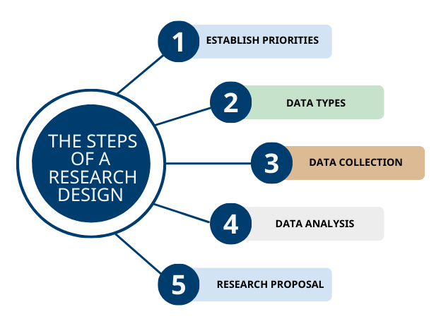
Source adapted from (Bets, 2021)
The above table explains the research design steps and there are multiple research design types it is important for researchers to relate the most relevant to a particular research implementation. Bets (2021) argues that the research design can provide particular strategies for the researcher's investigation project to validate data collection and able to interpret strong qualitative research techniques.

Technique Methods of Data Collection.
This research about the competition of Master of Business Administration (MBA) the established research questions was investigating how Brexit impacts beef meat imported from European countries. Secondary data is used to gather information to answer the questions and identified problems in Chapter 1 and explored in the literature review. Evidence found in the articles was related to the study of the United Kingdom farm budget cut due to the Brexit situation and the significant reduction of beef meat coming from the EU to the UK markets alternative UK future no-EU relationship. However, the study focused on the United Kingdom's Brexit relationship with the European Union. This research involved qualitative data research type articles researcher descriptive experience to identify the relationship between data collection and observation to interpret and understand the research. “Secondary Data Analysis: Similar to archival research, secondary data analysis involves using existing datasets that were collected by other researchers or organizations. Researchers analyze the data to answer new research questions or test different hypotheses. Secondary data sources can include government surveys, social surveys, or market research data” (Alam, 2023).

Deductive Research Approach
The research approach was conducted deductive research using a literature review to gather general information online from Google Scholar based using articles and journals to find specific information related to the research questions. Salomão (2023) argues that Deductive research is a method of research that starts with a theory or hypothesis and is used to test its validity through the collection and analysis of data when the researcher begins with a general theory or ideas that can develop into specific hypotheses based on that theory. Then hypotheses are tested through the collection of data, which is analyzed and determine whether it can support or prove the theory. The deductive research provides a formulation of the research questions based on the existing theory and development knowledge of the research design and is involved in using qualitative research to collect data based on the chosen research methods to interpret the results.

Study selection
The study selection explained the importance of articles selected criteria in which articles' titles were screened for more analysis but before that, the gathered articles selected the most relevant to the research questions which sources found from online Google Scholar the final selections were 16 articles explaining in full details in the figure below.
  - Results
The research database resulted from the articles found in general Google Scholar including irrelevant articles were 8370 articles and mainly limited from the year 2016 to 2023 during the Brexit process were selected 201 articles and the final used articles were 16 as explained in the figure below.
Table 4 Reach Strategy

Search strategies
Keyword  Outcome | How Brexit impact on beef importation from EU  Tariffs charged between the UK and EU beef meat import and export.  The UK farm import by Brexit budget cut from the EU  UK relations with non-EU  United Kingdom response  European Union response

Figure 6 PRISMA Model
Removed before screening
duplicate records removed (n = 0)

Articles identified by searching chosen journals (n =8370)

Screened articles by titles
(n = 201)
Reports not retrieved (n = 105)
Reviewed articles in full text (n = 96)
articles excluded for the
reason (n =51)

Articles used for the (n = 45)

Screening removed articles (n = 8370)
Excluded articles (n = 8169)

The excluded articles were more general.
Were not specific to the questions.
Some articles include non-English language.

Research Philosophy
Coates (2021, p 2) argues that the fundamental of the Research philosophy is to underline a clear picture of philosophical assumptions to point out every decision within the research process to highlight the importance of communicating ideas of expectations throughout the reporting research mouthed to assist the researcher to develop a clear understanding of the phenomenal of the study and alignment with skilful elements of Epistemology, Ontology, and Methodology is required to deploy sense of knowledge depending on the study requirement.

Figure 7 The Research Process Elements

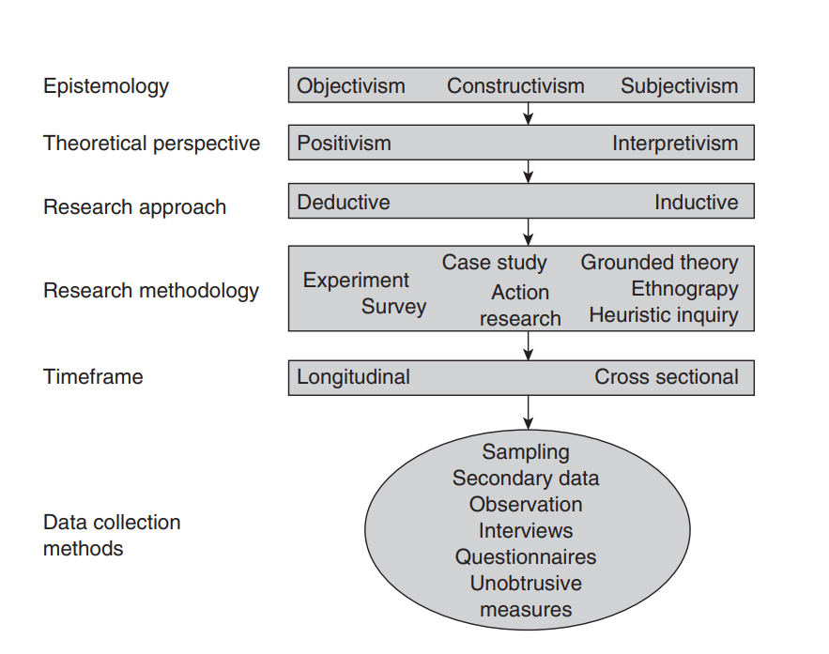
Source adapted from (Gray, 2021)

Interpretivism
Ryan (2018, p 9) argues that interpretivism and positivism both have similarities but interpretivism is historically rooted in anthropology. However, it is opposed to positivism, so is sometimes known as anti-positivism. Interpretivism is described as truth and knowledge is subjective and suited as well as culturally and historically situated and built on people’s experiences and understanding. While researchers can not be isolated from having their own values and beliefs and can be informed in the way which they can be able to collect, analyze, and interpret data.“From an interpretive perspective, all knowledge is grounded in our particular experiences; it is subjective and bound to the natural contexts in which we enact our lives and is thus ontologically relativist” (Hiller, 2016, p 5).
The interpretivism allows the researcher to experience reality through perception and feeling while human can interpret their understanding of the existing objects, therefore, interpretivism can produce quantitative data that can reveal the hidden meanings of data that has been collected and interpreted for a better understanding of the behaviour of factors and rather change the attach knowledge based on the findings information gathered whether true or false can analyze and justify based on the originality. Admin (2023) argues that interpretivism is a theoretical perspective in social science used to understand the subjective experiences of individuals to connect their actions and behaviour concerning the social construction of reality so that Pepple can interpret their meaning of understanding the surrounding world. Interpretivism can provide a clear understanding of individuals' ongoing social interaction including behaviour and experience that is difficult to measure objectivity.

Subjectivism
Park 2022, p 1) argues that subjectivism is a moral statement that states emotions, moral properties, and moral facts do not exist in the real world and are not part of the physical universe example, when people make moral judgments eating an apple is moral then expressing a positive emotions toward eating apple then making a judgment that eating an apple is immoral then people emotions become negative towards eating apple and judgments about eating apple are neither true nor false. “Subjectivity is the quality of human phenomena that allows individual and social instances to generate specific subjective senses and configurations within those human communicative activities” (González, 2019, p 3). “General subjectivism asserts that all judgments, whether moral or factual, are subjective. By contrast, ethical subjectivism asserts that moral judgments are subjective, but that factual judgments are objective, i.e. that moral statements express emotions, so they are neither true nor false, but that factual statements describe the world, so they are either true or false” (Alvaro, 2023, p 2).
The theoretical assumptions identified that researcher judgments are based on existing behaviour and cultural beliefs, for example, the British people voted against Brexit to leave the European Union but the other 48% said no is very close to the winning number but all together believing that democracy is standard of ethical judgment the subjectivism reality interpreted the situation by yes or no base qualitative research data approach then the result reviewed the moral judgments are subjectively correct followed by emotions and believe the reality the United Kingdom out of the European single market for good or bad reasons while the moral judgment supported by good reason and ethical approval. Then Brexit became a tangible fact with true meaning and proofing that it a fundamentally right. But the unclear process could be emotionally considered. The subjectivism philosophy supports qualitative research and inductive approaches in this research.

Chapter 4

Introduction
In this chapter, to analyze the findings result on the research questions the main core of the study problem found in Chapter 1 and discussed in Chapter 2 about the United Kingdom's withdrawal from the European Union changed the way of importation between the two rivals to settle beneficial future potential trade agreements, especially in farming beef meat productions and on how no-deal Brexit impact on beef meat imported from the European Union and similarly exportation could face from both parties tariffs charges by set of barriers customs duty.
To extract more information from the articles based on the selected questions to expand more understanding of the problem to find solutions or to address the issues comprehensively by using the gathered data from 48 articles in the table below which are literately reviewed in the recent date during the Brexit process and must relevant the information contained to answer the chosen questions.

Result of the Key Finding
It provided significant information that investigated the change that impacts beef meat imported from the European Union to the United Kingdom based on the articles that found or published during the Brexit process was from 2016 to 2023. The articles focussed on the Brexit negotiations outcome in trade agreement relations generally data gathered from Google Scholar was 198 articles and the final chosen articles were 48 collected from the database and used to explain or answer the questions that relate to new tariffs challenges to the beef meat importation, the United Kingdom farmers affected by the European Union supports cut and general the United Kingdom economy deteriorated during the Brexit process and future alternatives non-EU countries.

Table 5
No of Study | Study | Purpose | The United Kingdom and  Europe's Response | Brexit outcome
6 | Poppy, Baverstock  and Baverstock (2019)  Cygan (2020)  Hubbard et al. (2018)  Ojo et al. (2021)  Rytkönen (2021)  Richau (2022) | Investigating Brexit's impact on imported beef meat to the United Kingdom and domestic farming demands | Currently, it is the EU's leading meat supplier to the UK market but clear due to Brexit changes. The UK has already developed a new relationship with non-EU countries. | An unclear trade policy between the EU and the UK to import beef meat is a future consideration needed and unsure whether domestic farms meet the requirement for beef meat or not. The UK farm was affected by a budget cut from the EU.
2 | Marouf, Messaili and Dalichaouch (2022)  Baráthová and Qineti (2018) | Exploring the Brexit process the United Kingdom leaving the European Union | On 2016 referendums the United Kingdom has reached the point of leaving the European Union based on the voter’s results. | The United Kingdom used Article 50 Lisbon Treaty review in the negotiations with the  European Union. Brexit related to the trade policy the become a single market while the UK farmers lose farming fund support and affect the British beef meat exporters as the same as beef imported from the EU because of the tariffs change or high charges.
6 | Lupan (2019)  Eiser, McEwen and  Roy (2021)  Oliver (2023)  Oppermann, Beasley and Kaarbo (2020)  Bakker et al. (2022)  Casadei and Iammarino (2021) | Non-tariff barriers after Brexit change based on the number of alternatives. | The United Kingdom out of the single European market decisions is already confirmed. The EU added tariffs for British farmers' exporters | In predictions identified by multiple sources trade barrier costs could be increased in both ways importing or doing business in EU countries.  Increasing trade barriers by 6% in food cost between the UK and EU period between 2019 and 2021 in comparison to the years 2019.
5 | Семенobа (2018)  Hestermeyer and Ortino (2016)  Topliceanu and Sorcaru (2019)  Belke and Gros (2017)  Pigłowski (2021) | Brexit limitations of trade and social movement from European countries | The UK's alternative to seeking new partners is a way to process to find lower trade deals.  The UK benefits from immigration restrictions coming from the EU. | Brexit temporarily creates economic issues, especially in finished products such as processed meat deteriorating financial performance and causing a negative reputation in the UK export beef meat lack of skilled workers from the European countries.
4 | Zawojska (2019)  Cheptea, Huchet and Henry, L. (2021)  Choi et al. (2021) Felbermayr (2019) | Import and export of beef between the EU and the UK posed high tariffs and may not achieve long-term competitive advantage | Poland beef importers to the UK significantly reduced and UK exporters prefer Ireland beef. High tariffs may be good for the internal economy but not for long-term competition. | The United Kingdom focuses on neighbouring Ireland as the largest beef importer and lower cost of goods transportation while the Republic of Ireland benefits from both sides. showing the imports from the EU fell for products that are used as inputs to production for industries in the UK.
3 | Topliceanu and Sorcaru (2019)  Jawad and Naz (2019)  Topolansky, Lestido and Triay (2021) | Brexit impact on the United Kingdom's economy and the European Union's economy and available benefits. | The EU economy was affected by Brexit losing the London market but could gain freedom of financial regulation on the other hand the UK benefited from the budget that used to contribute to the EU budget. | Brexit outcome the UK could gain greater financial freedom and economic control and benefit from 17.5 million Euro already paid back while the EU will not sign a free trade agreement the UK unemployment rate may increase.
3 | Shrestha et al. (2018)  Milbourne and Coulson (2021)  Jelliffe et al. (2023) | The UK farmers' impact of Brexit budget cut.  The EU worker reduction in the UK farms | The United Kingdom will change the farming regulations.  British farmers are lacking skilled staff for beef meat production farms. | The EU agriculture regulation changes will impact UK farms, especially in beef production due to direct payment cuts.  The UK will introduce new tariff reductions on imports of domestic products. Regulations after Brexit affected EU workers in British farms.
1 | Giles (2019) | The European skilled workers leave the United Kingdom farms. | The British government planned a new farming system to help farmers, especially in beef meat productions | Most of the UK farms are now dependent on migrant labor from Eastern Europe but because of Brexit changes workers begin to leave the country because in some cases they no longer feel welcome in the United Kingdom.
2 | Hart and Baldock (2023)  Wilkinson (2020) | Famers in the UK will receive direct payment and benefit from it. | The United Kingdom farmers will not look back to the European assistant. | The UK plan for a new payment system for farmers Agriculture Act is already in place funding policy mechanisms to pursue direct payments.
1 | Arnott et al (2021) | Wales farms and livestock affected by Brexit changes. | The government responded the United Kingdom farmers needed to adapt to the change for the difficulty. | The British government acknowledges that some farming businesses struggle to cope with the situation in beef farming production, but they will benefit from the new scheme.
2 | De Ville and Siles-Brügge (2019)  Joseph (2018) | One of the Brexit cases that the United Kingdom can benefit from | For the UK to control immigration and reduce European living in the UK social cost. | The UK adopted new rules after Brexit changes against the people from EU living in the UK will minimize social and health costs and add value to the UK economy.
5 | Jackson and Shepotylo (2018)  Abbott (2019)  Welfens (2017)  Vickers (2018)  Smith and Nabil (2018) | After Brexit how the UK relations with the EU impact the British economic | The UK has a stronger historical relationship than commonwealth countries some EU | The UK has a good relationship with Commonwealth countries such as Canada, India, Australia, and South Africa business based could help the UK economy.
1 | IJtsma, Levell and Timmer (2018) | The United Kingdom benefits from a new policy to reduce tariffs charge | One of the key advantages that the UK leaving the EU Customs Union is the possibility to pay less for imported input and improve competition. | The British importers assumed that positive effects from the new tariffs policy were relatively lower than expected for the industry improved from outside the EU for some sectors. For the UK export depends on the country's products and may be affected by the exchange rate.
2 | Tian et al. (2021)  Lawless (2020) | The Brexit Impact on the European Union | This could lead to a significant change in the EU's social, economic, and political. | uncertain future of the European Union caused by Brexit because of the unreplaced economic partner one of the challenges to the union's strength will be a decline economically, and politically, and decreased currency value.
2 | Balawajder (2020)  Vaque (2022) | Business-free movement between the United Kingdom and the Republic of Ireland | The Republic of Ireland is one of the important beef meat suppliers in the UK market. | The European Union suggested that the relationship between the EU including Ireland the freedom of economic exchange should continue to support the product movement but unfortunately, Brexit could reduce Ireland's farm dimension of economic loss.
3 | Vásáry (2019)  Dhingra (2019)  Zimmermann (2019) | Brexit can impact multiple benefits that may have direct challenges to the British market and labour shortage. | The EU warned that the UK may struggle to achieve market satisfaction in a short time due to the European rarer relationship. The UK's foreign policy became a threat as more competitive in the EU market. | The United Kingdom plans to increase trade, direct foreign investment and resulting in more productivity. Possible future relationship with the European Union as the rest of the world and benefit to implement independent business internal and external policy to improve new relationships with the rest of the world economy.

Analysis of Brexit impacting beef importation from the EU.
The United Kingdom government decided to develop a single market and to be independent from the European Union one trade union market policy and shift to an international trading agreement resulted in Brexit impacted the domestic farming of beef meat producers suffering from the European Union budget cut from the farming support because of that the united Kingdom farmers beef meat producers struggling to export quantity beef meat to European countries at the same competitive prices the United Kingdom importers and exporters facing differences situations after Brexit shipping from the United Kingdom to European countries that could be affected by tariffs charges apply to most of the products that delivered to the customers with high additional cost compare to the period before Brexit and the other issues that with the United Kingdom exporters lack of financial resources to support the process of producing quality beef meat which is found difficulty to meet the standard with competitive prices. Most Beef meat imported from the European Union significantly dropped after due to the applied tariffs rate by both parties Poppy, Baverstock and Baverstock (2019), and Cygan (2020).

Tariffs and Trade Cost
Table 6 Tariffs Scenarios
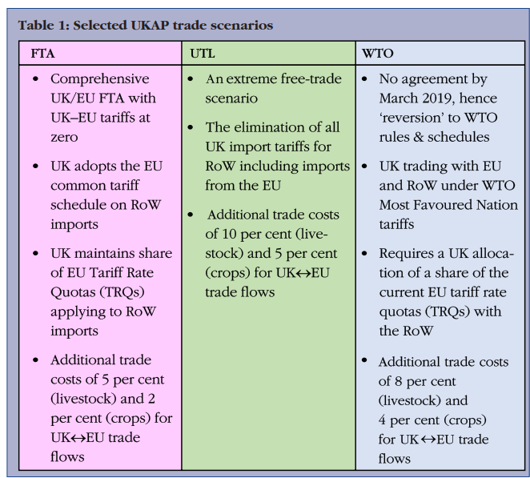
Source adapted from (Hubbard et al. 2018)
Hubbard et al. (2018) argue that the European Union impacted by the Brexit changes in some areas but the United Kingdom agriculture and food sectors were found the most affected by relative tariffs on the beef meat imported into the United Kingdom in multiple ways lack of support in the United Kingdom particularly beef meat and high cost to import from the European Union based on schedule tariffs reduction is not in favour of beef meat which brought from the European countries Highley quality beef meat costly to process boneless beef meat half of slotted animal became waste or remains which can be costly to destroy or environmental hazard similar responded from the British people notified that beef meat imported from Europe has significantly reduced during the Brexit process which is no need for flooding beef and advantage while beef meat reduced to inter the country rather to develop or support the local British farms livestock to reduce unemployment and encourage and train local farmers to the meet the requirements and demand in the other hand argued that the united kingdom fresh cow meat was sent to the European countries for processing to clean the waste to become boneless then reshipped back to the united kingdom consumers.

Domestic Trade Policy Scenarios EU
The European Union related to the domestic trade for direct payment excluded the United Kingdom farms' direct payments based on the scenario being discussed during the trade agreement negotiations under the Brexit agriculture policy given pressure on the British government which did not have a clear plan to support local farmers or to compensate what farmers have been lost or affected by Brexit change and negotiation leading resulted of the united kingdoms has lost the advantage of the single European market and has a potential impact on the United Kingdom economically in return the British government added tariffs on beef meat that imported from the European Union and this one of the main reasons were discussed previously the imported beef meat from the European Union significantly reduces during Brexit process because of the united kingdom’s agreement both parties tariffs added cost may compensate the united kingdom economy but not clear to plan for domestic farming payments (Ojo et al. 2021).

Brexit Freedom of Movement
Richau (2022) argues that the United Kingdom's restriction on European nationals based on the Brexit changes has a clear relationship with the United Kingdom farms and beef meat importation because of the United Kingdom farm workers over 50% were European nationals worked in beef meat, poultry, and dairy sectors plus regular seasonal workers together were affected by the changes such as large number of workers were driven away in a short time from the agriculture sector could have immediate effect on the workplace and create huge gap in the United Kingdom’s sectors and economy. Gathered data found that a number of EU national staff excluded from the beef meat processor including similar sectors, showed the exported beef meat from the EU reduced and imported as a result.

UK current and future relation of beef meat import
Most of the researchers identified that beef meat came to the United Kingdom from Ireland period between 2015 and 2019 over 90% of boneless and fresh cow beef used to come from Ireland (Richau, 2022). The United Kingdom needs a clear farming policy and steps forward to develop farming support systems to stabilize the situation due to Brexit changes (Vaque, 2022). In the research is found the United Kingdom's decision to leave the single European markets less freedom of Business movement of goods and products, tied trade policies, and specific free trade and tariffs benefit among the members of the selected union that may affect the future relationship with the rest of the world (Hajdu, 2022) and Felbermayr, G.J. (2019). The outcome of the United Kingdom was investigated in relation to the European Union Both parties have agreed to sign based on the scenario FTA to the United Kingdom qualified to enter a large market with no-EU countries and able to negotiate soft Brexit within the EU new tariffs in the EU zone (Jackson and Shepotylo, 2018). Non-tariff barriers in some sectors could have an immediate impact on products that were imported from the European Union more than others after Brexit because the United Kingdom planned for a wider relationship alternative to import products such as beef meat imported from Brazil despite the distance and transportation cost the United Kingdom’s could benefit from the cheaper lobar and currency exchange differences while the Brazill capable of producing tonnes of tonnes of beef meat and largest world supplier (IJtsma and Timmer, 2018). The European Union's concern may this related to the United Kingdom in which countries that used to import more food from other countries could face potential challenges due to food prices rise in which witnessing in recent years including the United Kingdom importing high volumes of beef meat from EU before Brexit changed significantly reduced the United Kingdom could face future importation implications to find reliable beef meat importers competitive partners as used to be (Pigłowski, 2021).

The UK and the EU both parties benefit from the Brexit decision term
The EU claimed that the Brexit process left Britain no more part of the EU membership the British population represented more than 13% of the EU population resulting in the EU less social cost and other European Nation maintenance such as health costs and environmental and farming livestock issues expenditure the united kingdom is not part of this sharing benefits in other hand the British people could benefit from the European Union contribution cut, emergent restrictions from Europe countries social and housing benefits and reduce unemployment rate plus border control from non-EU refugees passed by European countries to enter Britain soil illegal (Tian et al. 2021). The United Kingdom's challenges following Brexit changed the face of consumption and demand where the value of imports increased from non-EU countries and decreased exports because the local demand increased while the European Union gradually dropped imported food products and together slowdown the United Kingdom's gross domestic productivity (Casadei and Iammarino, 2021).

The UK International Trade Policy relates to EU and Non-countries.
The United Kingdom left the European Union single market with conditions which for international business conceded to avoid border checks with Ireland to ease tariffs restrictions and other countries like China products come to the United Kingdom passed by EU countries without border restrictions but on the other hand, the European Union insisted good come from the United Kingdom to Ireland treated under the European Union international trade policy (Lawless, 2020). Ireland became a disputed point between both parties because of its geographical location and Ireland's well-being of interest economy future the European Union held the Ireland case as a weakness used against the United Kingdom and conceded as an underpins during the Brexit negotiation despite Ireland being the most important market for the United Kingdom in term of location and largest beef meat importer in respect of other relationship between both parties (Balawajder, 2020).

The Britain Brexit International Trade Policy Influence New Strategy
The United Kingdom government encouraged to development of a new international trade policy strategy to implement potential aspects of the trade deal first, to secure the desired position within the European Union's International Market interests to achieve a competitive advantage in products in particular beef meat importation despite the changes was occur during the Brexit process. However, the United Kingdom government appeared in some weaknesses in achieving tangible trade relations within the European Union's flexible deal about the import and export trade to reflect on the new implementations and failed to secure a free trade agreement with the European Union in the negotiations which started in earlier March 2020. At the same time, the United Kingdom used interchange strategies to negotiate new international trade deals outside the European Union zone to make sure there was no gap to limit the imported products such as beef meat or a shortage in food consumption in the country. (Eiser, McEwen and Roy, 2021).
Figure 8 Study Results
UK trade agreement negotiations
EU trade agreement single market
The UK Brexit challenges outcome.

- UK out of the EU single market
- Increase in the UK trade barrier by 6% by the EU in food importation price rise by 25%
- Custom check rules approved between two parties.
- Animals and other trade are restricted.
- Limit business freedom of movement
- Beef meat imported from the EU significantly decreased.
- The EU budget cut from the UK farms
- Reduced number of EU skilled workers
- Brexit and Covid-19 impact on the UK reduced GDP by 4%

The UK’s future development challenges
- Freedom of business movement and policies out of EU policy
- Increased the use of domestic suppliers.
- International business opportunity
- New emerging markets such as beef imported from Brazil.
- Decreased unemployment
- The pound value could bring cheaper products from the international market to the UK market.

Brexit Impact
- Beef meat import and Export
- UK farms

EU trade agreement single market
UK trade agreement negotiations

The United Kingdom managed to exit from the European Union single market within the identified challenges in free trade negotiations the united kingdoms failed to achieve a cheaper trade barrier deal both parties have added charges in goods and products which directly impacts beef meat imported into the United Kingdom has significantly reduced as the same as exports in the time the United Kingdom farms highly affected by the European Union farming support budget cut which is a great lost opportunity for the British farmers to export a competitive beef meat to European countries while the majority of the United Kingdom beef used to come from the European countries. On the other hand, most of the United Kingdom farm skilled workers a majority of them from the European Union were impacted by the Brexit process as no social benefits and health care costs plus the British pound was going down against the Euro which is less advantageous for the European Union workers it is a forcing situation to return home and similarly, the British people less freedom of movement and potential business opportunities and such affected many businesses in the United Kingdom and has significance reduced in the British GDP during the Brexit process (Felbermayr, 2019).
The United Kingdom government predicted solutions or future plans to tackle the impact of Brexit to create a new development for businesses' freedom of movement to compensate for or to fill the gap caused by Brexit transmission without damaging the local economy or lacking imported goods and services that no longer being reverse based on the trade agreements between both parties alternatively the united kingdom’s decision to improve international relations, adapt and develop new business policies without the European Union restrictions on foreign businesses or trade policies Uruguay and United Kingdom have a long relationship of beef meat imported to the United Kingdom and over 64% Uruguayan frozen beef exported into EU countries (Topolansky, Lestido and Triay, 2021). One of the advantages is that Uruguay and Brazil's beef meat is not newer to the British market consumers only to increase the volume of the imported beef to fill the gap that is being left by EU countries due to the Brexit implications. British new international business policy creates long-term future opportunities for increasing domestic supply and reducing the import implications for example beef meat used to come from European countries gradually reduced whereas there is a demand for it for that reason the United Kingdom took advantage to replace beef meat out of the European Union zone such Brazilian beef meat already being available in the United Kingdom market within high quality and competitively cheaper despite the distance of transportation differences there is an advantage of the international business suppliers outside the European Union currency’s zone highly against the British pound compared to the Brazilian currency could add a great value in the British Markets. One of the obvious reasons that the United Kingdom facing difficulty in importing beef meat from the European imposed tariffs of more than 15% and free trade agreements 19% of the UK exports to EU countries (Felbermayr, 2019).

Chapter 5

Conclusions
This chapter is the conclusion of all chapters to Achieve a completion of Master of Business Administration (MBA) and includes the cover page identifying information at least names of those who were involved in this study such as supervisors. writer, name of the institute, the programme of the study, and the research title followed by the abstract to summarise what was included in the study, table of contents includes lists, figures, and tables which contain chapters' main titles and subtitles. Briefly explained the aim and objective of the report then more clarification was given about the research questions, the significance of the study, and the research methodology on how data has been collected.
The identified problems in Chapter One introduction investigated the United Kingdom has separation from the European Union single market after long negotiations term Brexit which investigated specific information about how Brexit impacted beef meat importation from European countries resulting in beef meat coming from Europe significantly reduced during the Brexit process the reason the United Kingdom failed to achieved a cheaper trade deal during the negotiations both parties have added tariffs charges and that changes were reflected on beef meat importers and exporters in high cost for the entering products and barrier restrictions that perception has changed the business environment and reduced the pervious business relationship between European Union and the United Kingdom.
Chapter Two is a literature review exploring more about the Brexit factors were critically investigates the impact on beef meat products imported the European countries which are affected by decisions made by Britain claiming that leaving the European Union tied business policies is not doing well for the UK economy better to open a wider international business relationship. However, the United Kingdom's opportunities to import beef meat from such countries Brazil, Uruguay, and Ireland long business relationship has been reviewed in particular farming products such as processed beef meat to increase the volume of meat requirements in the Britain market and ease the border restrictions to compensate the gap of beef meat shortage from Europe. In the research discovered that the United Kingdom farms affected by the European Union faring support budget cut could have a long-term impact on the British economy in particular livestock, lower export of beef meat and these relation to the shortage of the EU skilled workers significantly reduced during the Brexit transaction while the united kingdom government plan to reduce the rate of unemployment, train the local farmers but up to now there is no clear support or funding assist the local farmers as the united kingdom government focused on the international trade policy form the previous relationship with a country like Brazil, Australia, and Uruguay beef meat importers it is an opportunity for those countries to enter the British Market to fill the gap that left by the EU countries.
This chapter included a system theory in which the approach has three elements input, process, and output to achieve feedback identifying the problems issues during the Brexit transaction input step is an existing problem for the United Kingdom government alternative to support a new business policy such as farming support, beef imported from the EU reduction alternative in the process developed international business policies with non-EU countries to import more beef meat and the output the British government unclear support for the local farmers and redeveloped a relationship with countries like Brazil, Uruguay, and Australia for long term business relationship in relation to the beef meat importation.
The research methodology identified in Chapter Three introduction explains the type of research such as secondary research and primary research methods how data was collected for this research the chosen type of research is a secondary data collection method suite the literature review of existing articles based online Google Scholar using systematics reviews process identified through the topics questions about how Brexit impacts on beef meat imported from the European Union, issues related to type tariffs that has been added by both patients in importation and exportation. The table is used to identify the difference between secondary data and primary data to avoid unethical activities and to understand the techniques and knowledge that should be during the research and give a clear picture for a researcher to achieve an ethical practice.
A research philosophy has been conducted to help researcher to highlight the importance of research to communicated through the understandable of written report methods there are different types of research philosophy but this report has chosen two types of the most relevant which are subjectivism and interpretivism which identified a clear understanding to the researcher ability to interprets the existing or someone else idea through the experience and subjectivism is a subjective moral statement for individuals judgment belief from experience whether this subject is true or false based on moral statement express by emotions to make the final judgment. The study design is important to understand the theories that have been conducted in the research such as qualitative and quantitative approaches and this qualitative research was used because it supports the secondary data collection methods.
Research design strategy Figure five was determined the data type and information collection for data analyzation to provide a particular strategy to investigate research questions and implement the identified problems found in Chapter One supported by techniques data collection methods to address the relevant information from the articles and used to complete the chosen topic for this research. Deductive research approaches have been used to support the qualitative research to formulate the research questions and study selection used to explain articles selected criteria and screened based on the results that which found in chapter four table and analyzed according to the problems found in chapter one and chapter two PRISMR model has been used to record the information or articles has been found in chapter four.

Recommendation
Based on the findings from the articles the United Kingdom made a clear decision and separated from the European Union is better to have a tangible plan to back up some sectors financially impacted by Brexit negotiations no-deal trade decision made it difficult for the European Union beef meat producers were not able to make a profit as used to be. Because of the new tariff charges applied by both parties, this could make British consumers rethink about the quality of the food that used to eat and animal health and safety issues one of the high consumer priorities while the United Kingdom government's new international trade policy able to import beef meat and other products from non-U countries that should be cheaper but subjected to the security concerns meat products are quite sensitive to the weather (hot weather), packing process and transportations issues is not only safety but cost.

Long and Short-term relation with the EU
The British government should have to consider a flexible trade deal within the EU at least in some products such as beef meat which provides the European countries because of the realism of the transportation of all European countries close to each other sharing simplicity on how beef meat is processed in test, quality, food safety, and trust. The United Kingdoms will benefit from the EU short terms relationship such as machineries transportation, quality, warranty and services which is based on the new international business policy, and this could gradually change the tension behaviour caused by Brexit and good for the EU countries may not be willing to lose the UK potential consumers and this could lead to long-term development and increase loyalty and trust in the future.

The United Kingdom future partnership
Now the British government focused on beef importation from non-EU countries such as Brazil, Uruguay, and Australia while the local farms declined since the farms' support payment was stopped by the European Union no more to support the British farms after the United Kingdom failed to achieve no-deal trade agreements. It is advantageous for the British farmers should find a way to get financial tactical support from the government to develop the local farm and improve the supply chains, by providing staff training to gain relevant qualifications and ability to work in the farms. In the meantime, the EU skills workers are unwanted or impacted by Brexit changes which is an opportunity may will increase jobs creation for the UK citizens to have a better productive farm to lift the economy and increase the gross domestic productions (GDP) in the country.

Limitation of Research
This research investigation is about the systematic review and during the research of the study identified limitations were most of the relevant data purplish after 2016 about how Brexit impacts particular areas of the beef meat imported from the European Union it found that some articles have overlapped with 2019 articles which mean cannot be used in the same report or repeatedly used for example the old articles found constantly sited in the present articles by the same author in multiple times were mentioning Brexit process and problems, for this reason, some articles excluded to avoid overlapping information. Some articles were published by the European Union Brexit's impact on beef meat importation in non-English languages excluded.
Based on the research questions Brexit impact on beef meat import from the European Union, no-deal trade agreements, and United Kingdom farms affected by the changes as a keyword used to identify the potential problems constructed on research methods such as secondary data used to accept the qualitative methods and disqualified the quantitative and mixed methods because the literature review allow the use of the existing data primary data is not included in this research methodology. The study discovered that during the Brexit negotiations the British negotiators were trying to maximize the benefits of cheaper trade agreements but the opportunities were limited by the EU during the negotiations non-EU countries are not able to import free good through the EU land without paying customs charge for example Chinese products come to UK should not pay border charge claimed by the British government but that option blocked by the EU countries.

Future consultation
The finding of this research future study is not a prediction but tangible assumption which questioning the problematic engaging future issues related to Brexit which impacting on the United Kingdom economical in the future lack of enough beef meat coming the European countries and the same as the United Kingdom reduced exportation this will impact in both parties future generations social engagement, distancing relationship and loss of business opportunities after the United Kingdom left the European Union there is no clear development for the British farm found in the discussion or intentions to move out from the present problems to create possible future. During the discussing found that lack of access multiple databases should be available for all academic researchers and be able transfer knowledge in particular Brexit issues related to the local business opportunities and international trade policy.

References

Abbott, M. (2019) 'The United Kingdom’s economic relations with New Zealand and Australia after Brexit', The Round Table, 108(1), pp. 21-35.
Admin, (2023) What is Interpretivism? - PHILO-notes. Available at: https://philonotes.com/2023/04/what-is-interpretivism (Accessed: Nov 27, 2023).
Ajayi, V.O. (2017) 'Primary sources of data and secondary sources of data', Benue State University, 1(1), pp. 1-6.
Alam, M. (2023) 'What is Quantitative Research Design? Definition, Types, Methods and Best Practices', IdeaScale, -07-07T06:46:35+00:00. Available at: https://ideascale.com/blog/quantitative-research-design/ (Accessed: Dec 2, 2023).
Alvaro, C. (2023) 'Ethical Subjectivism: A Lost Cause', Filosofija.Sociologija, 34(3), pp. 234-243.
Arnott et al. (2021) 'Vulnerability of British farms to post-Brexit subsidy removal, and implications for intensification, extensification and land sparing', Land Use Policy, 107, pp. 104154.
Badewi, A. (2016) 'Investigating benefits realisation process for enterprise resource planning systems', .
Bakker et al. (2022) Post-Brexit imports, supply chains, and the effect on consumer prices UK in a Changing Europe.
Balawajder, G. (2020) 'The British-Irish Border in the Context of Brexit', Przegląd Strategiczny, 10(13), pp. 229-242.
Baráthová, K. and Qineti, A. (2018) 'Competitiveness of the United Kingdom agri-food trade in relation to the EU market', Review of Agricultural and Applied Economics (RAAE), 21(1340-2018-5184), pp. 87-93.
Bedford, E. (2023) Topic: UK farmers and Brexit. Available at: https://www.statista.com/topics/8343/uk-farmers-and-brexit/ (Accessed: Nov 11, 2023).
Belke, A. and Gros, D. (2017) 'The economic impact of Brexit: Evidence from modelling free trade agreements', Atlantic Economic Journal, 45, pp. 317-331.
Bets, A. (2021) 'How to Write a Research Design - Guide with Examples', Research Prospect, . Available at: https://www.researchprospect.com/how-to-write-a-research-design/ (Accessed: Dec 1, 2023).
British Meat Processors Association. (2017) 'Evidence on Brexit Agriculture British Meat Processors Association (ABR0041)', Available at: https://committees.parliament.uk/writtenevidence/78749/pdf/.
Carter, S., Andersen, C., Stagg, A. and Gaunt, L. (2023) 'An exploratory study: Using adapted interactive research design and contributive research method', The Journal of Academic Librarianship, 49(1), pp. 102620.
Casadei, P. and Iammarino, S. (2021) 'Trade policy shocks in the UK textile and apparel value chain: Firm perceptions of Brexit uncertainty', Journal of International Business Policy, 4, pp. 262-285.
Cheptea, A., Huchet, M. and Henry, L. (2021) 'How will Brexit affect the patterns of European agricultural and food exports?', European Review of Agricultural Economics, 48(5), pp. 1031-1073.
Choi, H.S., Jansson, T., Matthews, A. and Mittenzwei, K. (2021) 'European agriculture after Brexit: does anyone benefit from the divorce?', Journal of Agricultural Economics, 72(1), pp. 3-24.
Clarke, H. (2023) ‘Brazil-China beef trade suspension: what could it mean for markets’? available at: https://ahdb.org.uk/news/brazil-china-beef-trade-suspension-what-could-it-mean-for-markets (Accessed: Oct 29, 2023)
Coates, A. (2021) 'The prevalence of philosophical assumptions described in mixed methods research in education', Journal of Mixed Methods Research, 15(2), pp. 171-189.
Creswell, J.W. and Poth, C.N. (2016) Qualitative inquiry and research design: Choosing among five approaches Sage publications.
Cygan, A. (2020) De-Europeanisation of UK regulatory governance and the future UK–EU trade relationship. Springer, pp. 509.
De Ville, F. and Siles-Brügge, G. (2019) 'The impact of Brexit on EU trade policy', Politics and governance, 7(3), pp. 7-18.
Desk, N. (2020) UK beef exports to U.S. restart after two decades. Available at: https://www.foodsafetynews.com/2020/10/uk-beef-exports-to-u-s-restart-after-two-decades/ (Accessed: Nov 9, 2023).
Dhingra, S. (2019) 'Brexit and the Future of Trade', Political Quarterly, 90(S2), pp. 21-31.
Eiser, D., McEwen, N. and Roy, G. (2021) 'The trade policies of Brexit Britain: The influence of and impacts on the devolved nations', European Review of International Studies, 8(1), pp. 22-48.
Felbermayr, G.J. (2019) 'Brexit: A hard-but-smart strategy and its consequences', Intereconomics, 54(3), pp. 178-183.
Foote, N. (2021) UK turns to EU for helping hand after Brexit butchers meat sector. Available at: https://www.euractiv.com/section/agriculture-food/news/uk-turns-to-eu-for-helping-hand-after-brexit-butchers-meat-sector/ (Accessed: Nov 2, 2023).
Giles, J. (2019) 'A UK perspective-what happens to UK agriculture post-Brexit?', International Journal of Agricultural Management, 8(1029-2022-1283), pp. 81-85.
González Rey, F.L. (2019) 'Subjectivity and discourse: Complementary topics for a critical psychology', Culture & Psychology, 25(2), pp. 178-194.
Gray, D.E. (2021) 'Doing research in the real world', Doing research in the real world, , pp. 1-100.
Hart, K. and Baldock, D. (2023) 'Looking ahead to the next CAP Reform–are there lessons to be learned from the UK experience?', POLICY, .
Haverty, M. (2023) 'Analysis on the Impact of Future UK FTA Scenarios on Scotland’s Agricultural
Food and Drink Sector (RESAS/004/21)', Report Produced on Behalf of the Scottish Government by the Andersnos Centre, Available at: https://www.gov.scot/binaries/content/documents/govscot/publications/research-and-analysis/2023/07/analysis-impact-future-uk-free-trade-agreement-scenarios-scotlands-agricultural-food-drink-sector/documents/summary-report-analysis-impact-future-uk-fta-scenarios-scotlands-agricultural-food-drink-sector/summary-report-analysis-impact-future-uk-fta-scenarios-scotlands-agricultural-food-drink-sector/govscot%3Adocument/summary-report-analysis-impact-future-uk-fta-scenarios-scotlands-agricultural-food-drink-sector.pdf.
Hestermeyer, H. and Ortino, F. (2016) 'Towards a UK trade policy post-Brexit: the beginning of a complex journey', King's Law Journal, 27(3), pp. 452-462.
Hiller, J. (2016) 'Epistemological foundations of objectivist and interpretivist research', .
Hubbard et al. (2018) 'Brexit: how will UK agriculture fare?', EuroChoices, 17(2), pp. 19-26.
IJtsma, P., Levell, P., Los, B. and Timmer, M.P.(2018) ‘The UK's Participation in Global Value Chains and Its Implications for Post‐Brexit Trade Policy. Fiscal Studies, 39(4), pp.651-683.
Jackson, K. and Shepotylo, O. (2018) 'Post-Brexit trade survival: looking beyond the European Union', Economic Modelling, 73, pp. 317-328.
Jawad, M. and Naz, M. (2019) 'Pre and post effects of Brexit polling on United Kingdom economy: an econometrics analysis of transactional change', Quality & Quantity, 53, pp. 247-267.
Jelliffe et al. (2023) 'United Kingdom Agricultural Production and Trade Policy Post-Brexit', .
Joseph, T.J. (2018) 'The Impact of Brexit on the Trade and Investment Relationship between India and the United Kingdom', Brexit and India, , pp. 105.
Lawless 1, M. (2020) 'Brexit and trade on the island of Ireland', Revue de l’OFCE, (3), pp. 95-119.
Lupan, R. (2019) Non-tariff regulations trends in the context of BREXIT and the relation of the United Kingdom and the Republic of Moldova with the European market. pp. 57.
Mahesh (2023) What is System Theory of Management? - BokasTutor. Available at: https://bokastutor.com/system_theory_of_management/ (Accessed: Nov 10, 2023).
Marouf, R., Messaili, R. and Dalichaouch, A. (2022) 'The Impact of Brexit on Britain and the European Union', .
McCall, J.R. (2020) Knowing versus understanding: adjusting the
contextual lens in safety science.
Meat Management. (2021) Beef imports into the UK drop by 3% in 2020. (2021) Available at: https://meatmanagement.com/beef-imports-into-the-uk-drop-by-3-in-2020/ (Accessed: Nov 2, 2023).
Milbourne, P. and Coulson, H. (2021) 'Migrant labour in the UK’s post-Brexit agri-food system: ambiguities, contradictions and precarities', Journal of Rural Studies, 86, pp. 430-439.
Mwita, K. (2022) 'Factors to consider when choosing data collection methods', International Journal of Research in Business and Social Science (2147-4478), 11(5), pp. 532-538.
Ojo et al. (2021) 'Brexit: potential impacts on the economic welfare of UK farm households', Regional Studies, 55(9), pp. 1583-1595.
Oliver, T. (2023) 'Reflections: the UK after Brexit', International Politics, pp. 1-18.
Oppermann, K., Beasley, R. and Kaarbo, J. (2020) 'British foreign policy after Brexit: Losing Europe and finding a role', International Relations, 34(2), pp. 133-156.
Park, S. (2022) 'Moral Subjectivism vs Moral Objectivism', Filosofija.Sociologija, 33(3), pp. 269-276.
Pigłowski, M. (2021) 'The intra-European Union food trade with the relation to the notifications in the rapid alert system for food and feed', International journal of environmental research and public health, 18(4), pp. 1623.
Poppy, G.M., Baverstock, J. and Baverstock-Poppy, J. (2019) 'Meeting the demand for meat–Analysing meat flows to and from the UK pre and post-Brexit', Trends in Food Science & Technology,
Poth, C.N. and Shannon-Baker, P. (2022) 'State of the methods: Leveraging design possibilities of qualitatively oriented mixed methods research', International Journal of Qualitative Methods, 21, pp. 16094069221115302.
Richau, A.L. (2022) 'No title', An analysis of the possible impacts of selected Post-Brexit trade scenarios on the UK agri-food sector and their possible consequences for trade in agricultural products between the UK and the EU, .
Ridler, G. (2022) France and the Netherlands boost UK beef exports to Europe. Available at: https://www.foodmanufacture.co.uk/Article/2022/12/20/uk-exports-to-europe-up-30 (Accessed: Nov 8, 2023).
Rusk, F. and Purewal, A, K. (2019) 'Brexit prospects for UK beef and sheep meat trade', projectblue, . Available at: https://projectblue.blob.core.windows.net/media/Default/Imported%20Publication%20Docs/BLBitesize_190219_WEB.pdf (Accessed: Nov 13, 2023).
Ryan, G. (2018) 'Introduction to positivism, interpretivism and critical theory', Nurse researcher, 25(4), pp. 41-49.
Rytkönen, J. (2021) 'No title', Estimating the impact of Brexit on the United Kingdom’s import demand of bovine meat, .
Salomão, A. (2023) 'Inductive vs Deductive Research: Two Approaches to Data Analysis', Mind the Graph Blog, -08-02T16:11:33+00:00. Available at: https://mindthegraph.com/blog/inductive-vs-deductive-research/ (Accessed: Dec 3, 2023).
Shohet, I. (2023) 2022 Beef yearly trade review – exports up and imports down. Available at: https://ahdb.org.uk/news/uk-beef-imports-down-exports-up-2022-trade-review#:~:text=Total%20beef%20imports%20are%20predominantly,key%20import%20into%20the%20UK. (Accessed: Oct 15, 2023)
Shrestha et al. (2018) 'Assessing the impacts of alternative post-Brexit trade and agricultural support policy scenarios on Scottish farming systems https://www. sruc. ac. uk', Policy Analysis, Behaviour and Innovation Team (PABIT), Land economy, environment and society research group, Scotland’s Rural College (SRUC).ScotFarm Policy Report, 1.
Smith, V.H. and Nabil, R. (2018) 'Strategies for Post-Brexit UK International Agricultural Trade Relations', .
Taherdoost, H. (2021) 'Data Collection Methods and Tools for Research; A Step-by-Step Guide to Choose Data Collection Technique for Academic and Business Research Projects', International Journal of Academic Research in Management (IJARM), 10(1), pp. 10-38.
Tian et al. (2021) 'The Analysis of Impact of Brexit on the Post-Brexit EU Using Intervented Multivariate Time Series', Acta Mathematicae Applicatae Sinica, English Series, 37(3), pp. 441-458.
Topliceanu, ȘC. and Sorcaru, S.L. (2019) 'The effects of Brexit on the European Unions economic power and implications on the British economy', Acta Universitatis Danubius.Œconomica, 15(6).
Topolansky, F., Lestido, J. and Triay, M.G. (2021) 'Increasing Export Competitiveness: An Analysis on Expanding Uruguayan Beef Exports to the UK Market', International Journal of Academic Research in Business and Social Sciences, 11(6), pp. 1487-1501.
Vaque, L.G. (2022) 'The Impact of Brexit on the UK Agri-Food Chain-A Case of the Empty Supermarket Shelf Syndrome?', Eur.Food & Feed L.Rev., 17, pp. 142.
Vásáry, M. (2019) 'Which British agricultural product could be a competitive in EU market after Brexit?', .
Vickers, B. (2018) 'Global Britain, Trade and Development: Issues and Priorities Post-Brexit', Navigating Uncertainty: Towards a Post-Brexit Trade and Development Agenda, 97, pp. 5.
Welfens, P.J. (2017) 'A Brexit Perspective', The International Economy, 31(3), pp. 40.
Wilkinson, D. (2020) 'Defending British Farming Standards in Post‐Brexit Trade Negotiations', EuroChoices, 19(1), pp. 4-10.
Words Doctorate. (2021) 'Importance of Research Methodology in PhD', words doctorate, . Available at: www.wordsdoctorate.com/blog-details/importance-of-research-methodology-in-phd/ (Accessed: Nov 22, 2023).
Wright et al. (2016) 'Research design considerations', Journal of graduate medical education, 8(1), pp. 97-98.
Zawojska, A. (2019) 'Brexit implications for agri-food trade between Poland and the UK', Annals of the Polish Association of Agricultural and Agribusiness Economists, 21(4), pp. 589-599.
Zimmermann, H. (2019) 'Brexit and the External Trade Policy of the EU', European Review of International Studies, 6(1), pp. 27-46.
Семенobа, М (2018) 'Foreign trade of the UK: key trends and perspectives after Brexit', Науковий вісник Миколаївського національного університету імені ВО Сухомлинського.Економічні науки, (2), pp. 82-87.

Appendices

Signed Approval Ethical From

