E-Portfolio
Catrin Picand-Jones

Contents page
Summary of Article……………………………………………………………… 2
Infographic……………………………………………………………………………3
Essay Plan………………………………………………………………………………4
Screenshot of Library searches……………………………………………….6
Summary of searches…………………………………………………………….7
References………………………………………………………………………………8

Task one
Title of Article - The bear necessities of stress

Summary of Article

Stress is perceived in the brain and sets off different actions.
It affects the nervous system and the endocrine system.
Weatherell and Sidgreaves in 2005 developed the ‘multitasking framework.’ This framework was ethically monitoring the effects of stress
The participants were asked to complete different tasks in front of a computer screen for about twenty to thirty minutes. These tasks had diverse levels of intricacies all at once, whilst listening out for a particular tone.
The findings were that people were becoming tired and frustrated.
To increase the stress levels, they adjusted the experiment by adding the experimenter telling them that ‘they should have higher scores, work harder and to work faster.’
This experiment is a representation of a life stressor but in a controlled environment. This has been used in laboratories all over the world.

Another study of chronic stress by (Lovell & Wetherell, 2011) looked at parents of Autistic children. The findings reported significantly more stressed, leading to long-term conditions such as anxiety and depression.
These parents also noted an issue with their memory, lack of social support and several physical health problems
Receiving regular social support has been linked to lower levels of stress, and we see this in our caregivers.

Thanks to this study it was found that a way to lower stress levels was to have a positive outlook and find the benefits in their personal circumstances. Those who could do this found they had fewer ill effects from stress.
(Lovell et al., 2015). We find that those people who write about the benefits of caring for a child with autism have lower levels of anxiety and depression three months later.

Conclusion
Creating stressful situations in labs has helped us understand how stress works and affects our bodies.
There is not an obvious answer to how we support people with stress as it disturbs our regulatory processes differently. To conclude it is all about balance, what is the stressful situation? How is it affecting them and what can they do about it?

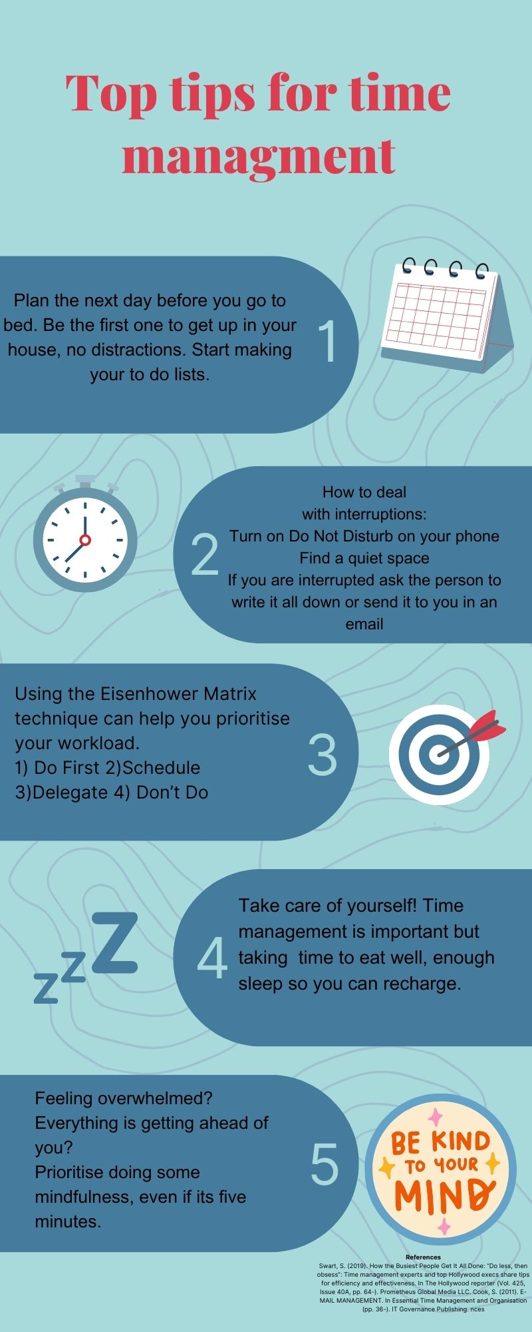
Task Two - Infographic
Task three: Essay Plan

Essay Title
Describe and discuss the psychological, social and physical benefits of owning a pet.

Research needed.

Need to look at the positives and negatives of psychological/social and physical effects.

Look at different countries' perspectives, age perspectives, and whether socioeconomic factors play a part.

Introduction
What are pets?
In developed nations, pet ownership is common within families. Both physical and psychological health benefits may result from owning a pet during childhood adolescence and retirement. However, it is difficult to determine whether these benefits are due to pet ownership directly or to factors linked to both pet ownership and health.
Socio-demographic factors
Physical factors
Biological Factors
Cultural perspectives on animals as pets
Main Body
- The PLAYCE PAWS intervention study - two intervention groups or a 'usual care' control group. The first intervention group will receive SMS messages over 4 weeks to encourage and prompt parents to undertake dog walking and dog play with their child. The second intervention group will receive the same text messages, plus a dog pedometer and personalised 'dog steps' diary for their child to complete.
- Questionnaires from Switzerland – findings of ageing population
- The Avon Longitudinal Study of Parents and Children (ALSPAC)
- Mood scales study
- Results often raising uncertainty as to whether pet ownership is advisable on health grounds - British Medical Journal
- Epidemiological Studies of older adults and human-animal interaction

Conclusion

Conflicting findings
How these studies are measured – questionnaires over long periods.
Differences in men and women, not concluded.
Once you reach a certain age, were the medical conditions taken into consideration in the experiment? If participants develop dementia, can they feedback accurately, for example?
Overall consensus is that pet ownership has a positive influence on psychological and social elements of people's lives.
British Medical Journal – has positive elements without health but can significantly impact on physical health.

Library Search Screenshot

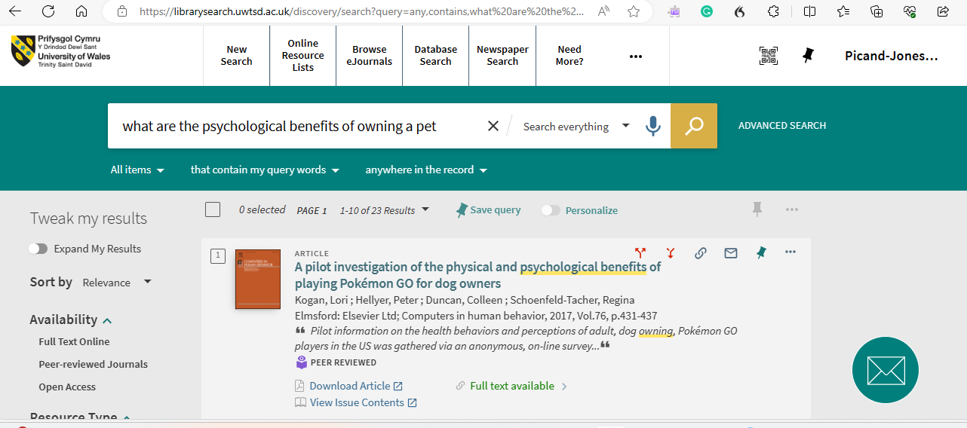

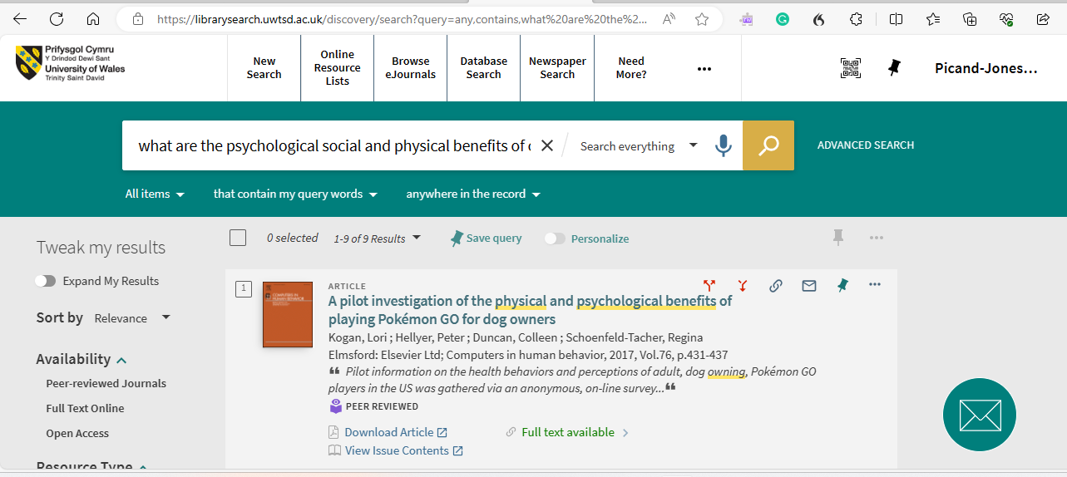

Summary of Searches
I picked the searches with specific texts relating to the question.
I looked at different books for each specific heading. For example, ‘health benefits’
I looked at texts that had looked at all three and I looked for books that had positive and negative findings for a balanced essay.

References
Reference for Article summary

Wetherell.M(2022, September 14) The bear necessities of stress. British Psychological Society. https://www.bps.org.uk/psychologist/bear-necessities-stress

References for essay plan
Ng, M., Wenden, E., Lester, L., Westgarth, C., & Christian, H. (2021). A study protocol for a randomised controlled trial to evaluate the effectiveness of a dog-facilitated physical activity minimal intervention on young children’s physical activity, health and development: the PLAYCE PAWS trial. BMC Public Health, 21(1), 51–51. https://doi.org/10.1186/s12889-020-10034-7

Purewal, R., Christley, R., Kordas, K., Joinson, C., Meints, K., Gee, N., & Westgarth, C. (2019). Socio-demographic factors associated with pet ownership amongst adolescents from a UK birth cohort. BMC Veterinary Research, 15(1), 334–15. https://doi.org/10.1186/s12917-019-2063-x

Meier, C., & Maurer, J. (2022). Buddy or burden? Patterns, perceptions, and experiences of pet ownership among older adults in Switzerland. European Journal of Ageing, 19(4), 1201–1212. https://doi.org/10.1007/s10433-022-00696-0

McNicholas, J., Gilbey, A., Rennie, A., Ahmedzai, S., Dono, J.-A., & Ormerod, E. (2005). Pet ownership and human health: a brief review of evidence and issues. BMJ, 331(7527), 1252–1254. https://doi.org/10.1136/bmj.331.7527.1252

Thorpe, R. J., & Kelley, J. A. (2019). Epidemiological Panel Studies of Older Adults: New Frontiers in the Research on Human- Animal Interaction. Anthrozoös, 32(2), 209–220. https://doi.org/10.1080/08927936.2019.1569904

Time Management
https://web-p-ebscohost-com.ezproxy.uwtsd.ac.uk/ehost/pdfviewer/pdfviewer?vid=0&sid=cb37339f-abdc-4e80-8b7f-c6e4b4575ffc%40redis

Swart, S. (2019). How the Busiest People Get It All Done: “Do less, then obsess”: Time management experts and top Hollywood execs share tips for efficiency and effectiveness. In The Hollywood reporter (Vol. 425, Issue 40A, pp. 64-). Prometheus Global Media LLC.

Cook, S. (2011). E-MAIL MANAGEMENT. In Essential Time Management and Organisation (pp. 36-). IT Governance Publishing.

