


Network Management

WC February 4, 2013

Faculty of Applied Design and Engineering
School of Applied Computing
Mount Pleasant Campus
Swansea
SA1 6ED

- INTRODUCTION AND OBJECTIVES OF THE Exercises
In the lecture, you learnt about IP address management, which is an essential factor in successfully operating a network. Apply your understanding and knowledge from what you learnt in the lecture about the topic by doing the following excercises:

Use your lecture notes and/or the Internet to answer the questions. Do not use online subnetting calculator for the IP addressing exercises.

Task 1

- Why is IP address management important?

- What are the IP address ranges for:
  - Host address
  - Multicast address
  - Experimental addresses

- List the private IP address blocks

- List 3 sets of public IP addresses

- List class A-E IP address ranges

- Differentiate between static and dynamic addressing.

- Why do we need IP network coordination centres for each region/continent?

- Why do we need translation (NAT) between Private & Public Addresses?

- What are the advantages and disadvantages of NAT?

Task 2

IP Address Exercises

Exercise 1

What does this address stand for? (i.e. class, mask)
204.155.2.128/26

Answer:

Exercise 2

Determine whether device A and device B are in the same subnet:

Device A: 172.16.17.30/20 Device B: 172.16.28.15/20

Answer: (Yes/No. Please give reasons.)

Exercise 3

A company has a C class network address 204.15.5.0.
If using subnet mask 255.255.255.224, please answer:

(1) How many subnets can it have?

(2) Name the range for each subnet

Subnetwork Address | Host Address Range
Exercise 4

Again for the same company with Class C network address 204.15.5.0/24.
If you need to deploy a network as shown in the figure,

(1) What subnet mask will you use?

(2) How many hosts are allowed per subnet?

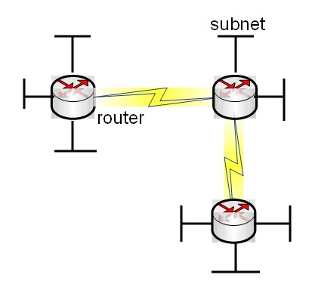

Exercise 5

A company has 450 LAN users. It has been allocated 2 class C IP network addresses. The company would like to add a new department to accommodate extra 100 LAN users. Discuss the possibilities.

Exercise 6

Determine whether device A and device B are in the same subnet:

Device A: 172.16.31.30/20 Device B: 172.16.32.15/20

Answer: (Yes/No. Please give reasons.)

Exercise 7

A company has a B class network address 172.15.0.0
If using subnet mask 255.255.192.0, please answer:

(1) How many subnets can it have?

(2) How many hosts can be accommodated within each subnet?

(2) Name the range for each subnet

Subnetwork Address | Host Address Range

Exercise 8

A host has this IP address, 172.15.65.3 /20. Please calculate its subnet address:

Exercise 9

A company has a network address 172.15.0.0
If using subnet mask 255.255.224.0, please answer:

(1) How many subnets can it have?

(2) How many hosts can be accommodated within each subnet?

(2) Name the range for each subnet

Subnetwork Address | Host Address Range
Subnetwork Address | Start Address | End Address

