Contents
Getting Familiar with Microsoft Access for Windows 2
Getting Started 2
Understanding Security 3
The Navigation Pane 4
The Microsoft Office Button 5
The Quick Access Toolbar 5
The Title Bar 5
The Ribbon 6
Access Objects 6
Change Views 8
Close a Database and Exit Access 8

Getting Familiar with Microsoft Access for Windows
Microsoft Access is a database software package. A database is an organized collection of records. Telephone and address books are examples of paper databases. With Access, you can create a computerized database. For example, you can use Access to organize the students who attend a school, the courses they take, and the instructors who teach them. After you create an Access database, you can search it, manipulate it, and extract information from it. This lesson introduces you to Access windows and teaches you how to create a database.

Getting Started
You use windows to interact with Access. To begin, start Access 2007. You screen will look similar to the one shown here.
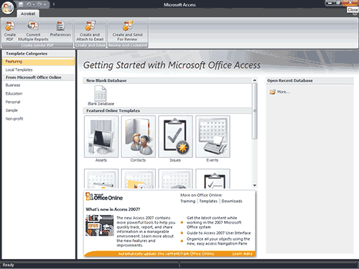
Northwind is a sample database you can download from the Moodle website. I will use the Northwind database to introduce you to Access windows.

To open Northwind:
- Click the Microsoft Office button. A menu appears.
- Click Open. The Open dialog box appears.
- Locate the Northwind database.
- Click the Open button. Access opens the Northwind database.

Understanding Security
It is possible for an Access database to contain malicious code, such as a computer virus. Access has security settings that disable code and display a security warning when you open a database. If you know a database is trustworthy, you can perform the following steps to enable it. You may need to enable the Northwind database.

To enable a database:
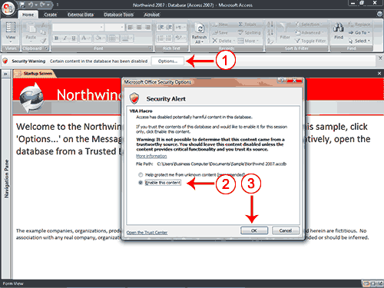
- Click the Options button. The Microsoft Office Security Options dialog box appears.
- Click Enable This Content.
- Click OK. Access enables the content. If you are enabling the Northwind database, the Login dialog box appears.
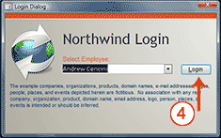
- Click Login. Access opens the Northwind database.
If you know a database is safe, you can store it in a trusted location. Databases stored in trusted locations do not require you to enable security.

The Navigation Pane
The Access window used in this example has been set up to make it easier to explain. This section shows you how to set up your window so that it matches the example. If you are not already logged in to Northwind, click the Login button.
An Access database consists of the following objects: tables, queries, forms, reports, macros, and modules. The Navigation pane displays the objects in a database.

To manipulate the Navigation pane:
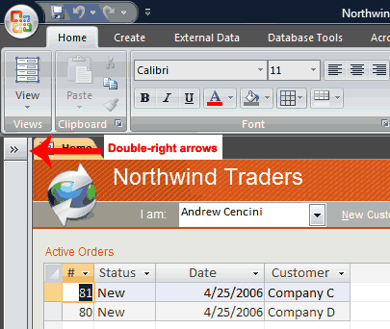
- Click the double right-arrows to open it. The arrows change to double left-arrows .
- Click the double left-arrows to close it. The arrows change to double right-arrows .
In this example, the objects are organized by type, which is not the default setting. You may want to organize the objects in your database by type also. You can use the down-arrow on the top of the Navigation pane to change the manner in which objects are organized.

To organize objects by type:
- Click the All Access Objects button on the Navigation pane. A menu appears.
- Click Object Type. Access displays the objects in the database by type.
The Access window with the Northwind database open is shown here.
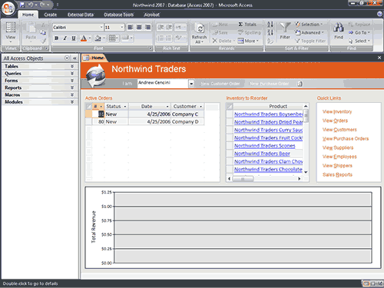


The Microsoft Office Button
In the upper-left corner of the Access window is the Microsoft Office button. When you click the button, a menu appears. You can use the menu to create a new file, open an existing file, save a file, and perform many other tasks.

The Quick Access Toolbar
Next to the Microsoft Office button is the Quick Access toolbar. The Quick Access toolbar provides you with access to commands you frequently use. By default, Save, Undo, and Redo appear on the Quick Access toolbar. You use Save to save an object, Undo to roll back an action you have taken, and Redo to reapply an action you have rolled back.

The Title Bar
The Title bar is located at the top in the centre of the Access window. The Title bar displays the name of the database on which you are currently working.

The Ribbon
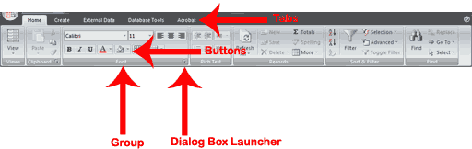
You use commands to tell Access what to do. In Access, you use the Ribbon to issue commands. The Ribbon is located near the top of the Access window, below the Quick Access toolbar. At the top of the Ribbon are several tabs; clicking a tab displays related command groups. Within each group are related command buttons. You click buttons to issue commands or to access menus and dialog boxes. You may also find a dialog box launcher in the bottom-right corner of a group. When you click the dialog box launcher , a dialog box makes additional commands available.

Access Objects

To view or hide the objects on the Navigation pane:
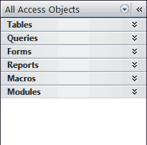
- You click the double down-arrows to view objects. The double down-arrows change to double up-arrows .
- You click the double up-arrows to hide objects. The double up-arrows change to double down-arrows .
As stated earlier, the Navigation pane stores the objects in your database: tables, queries, forms, reports, macros, and modules. Objects always display with an icon to the right. The icon tells you the object type: table, query, form, report, macro, and module.
Objects
Tables | In Access, data is stored in tables. A table is a set of columns and rows, with each column referred to as a field. Each value in a field represents a single type of data. Each row of a table is referred to as a record.
Queries | You use queries to retrieve specific data from your database and to answer questions about your data. For example, you can use a query to find the names of the employees in your database who live in a particular state.
Forms | Forms give you the ability to choose the format and arrangement of fields. You can use a form to enter, edit, and display data.
Reports | Reports organize or summarize your data so you can print it or view it onscreen. You often use reports when you want to analyze your data or present your data to others.
Macros | Macros give you the ability to automate tasks. You can use a macro to add functionality to a form, report, or control.
Modules | Like macros, modules give you the ability to automate tasks and add functionality to a form, report, or control. Macros are created by choosing from a list of macro actions, whereas modules are written in Visual Basic for Applications.

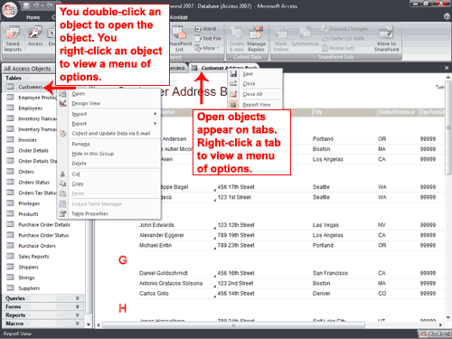
You double-click an object to open the object. You right-click an object to view a menu of options. You can use the menu to do such things as open objects, rename objects, and delete objects.
Objects that are open appear on tabs. Right-click a tab to view a menu of options you can perform, such as save the object, close the object, or change the view.

Change Views
A view is a way of looking at an object. For example, in Access, data is stored in tables. Two of the possible ways you can view a table are Datasheet view and Design view. You can see the data contained in a table in Datasheet view. You can see the design of a table in Design view. When you open an object, buttons appear in the lower-right corner of the Access window. You can use the View button on the Home tab to change views, or you can click the proper button in the lower-right corner of the window.

Close a Database and Exit Access
This completes the introduction to Access using the Northwind database. The following describes how you close a database and exit Access.

To close a database:
- Click the Microsoft Office button. A menu appears.
- Click Close Database. Access closes the database.

To exit Access:
- Click the Microsoft Office button. A menu appears.
- Click Exit Access. You exit Access.

