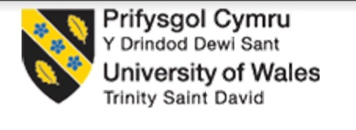

Programme: Master of Business Administration

Module: Human Capital Management
Module code: LCMB7025
Assignment No.1
Student ID: 2541192
Student Name: Vahora Saniyaben Sirajbhai
Lecturer Name: Gladius Kulothungan Eno Maycock
Word count: ≈2500
Last Submission Date: 17 July, 2026

Table of Contents
Introduction 3
TASK A: Socialisation, Identity and Business Activism 3
1. Evaluating Traditional Onboarding and Strategic Organisational Socialisation 3
2. Structured Socialisation Framework for Helios Urban Mobility 5
3. Developing Organisational Citizens through Identity, Ethics and Business Activism 5
TASK B: Job Design 7
1. Innovative Job Design Strategy for Helios Urban Mobility 8
2. Stimulating Intrinsic Motivation and Supporting Innovation 10
TASK C: Reflective Report (Gibbs' Reflective Cycle) 11
Conclusion 13

Introduction
Helios Urban Mobility has experienced rapid growth but now faces challenges related to ineffective employee socialisation, declining engagement, and the retention of high-potential graduates. These issues need a strategic human capital architecture that enables an alignment of people practice with organisational goals. This report suggests combined solutions to socialisation, job design, and development of professional capabilities to help the organisation to renovate its strategies and ongoing performance.

TASK A: Socialisation, Identity and Business Activism

1. Evaluating Traditional Onboarding and Strategic Organisational Socialisation
Strategic organisational socialisation is essential to Helios Urban Mobility (HUM) instead of traditional onboarding. Mainly as employee engagement rates and high graduate turnover rates suggest that new hires are not assimilating well into the organisation. Onboarding in traditional onboarding is based mainly on administration and compliance training and role clarification over the first employment period (Mitschelen and Kauffeld, 2025). Despite making operations ready, these activities do not often promote organisational commitment, integration of cultures and retention in the long term. Structured onboarding enhances retention of new hires by 82% (Allen, 2021). This is which shows that administrative induction is not sufficient on its own, as employees have to be constantly integrated.
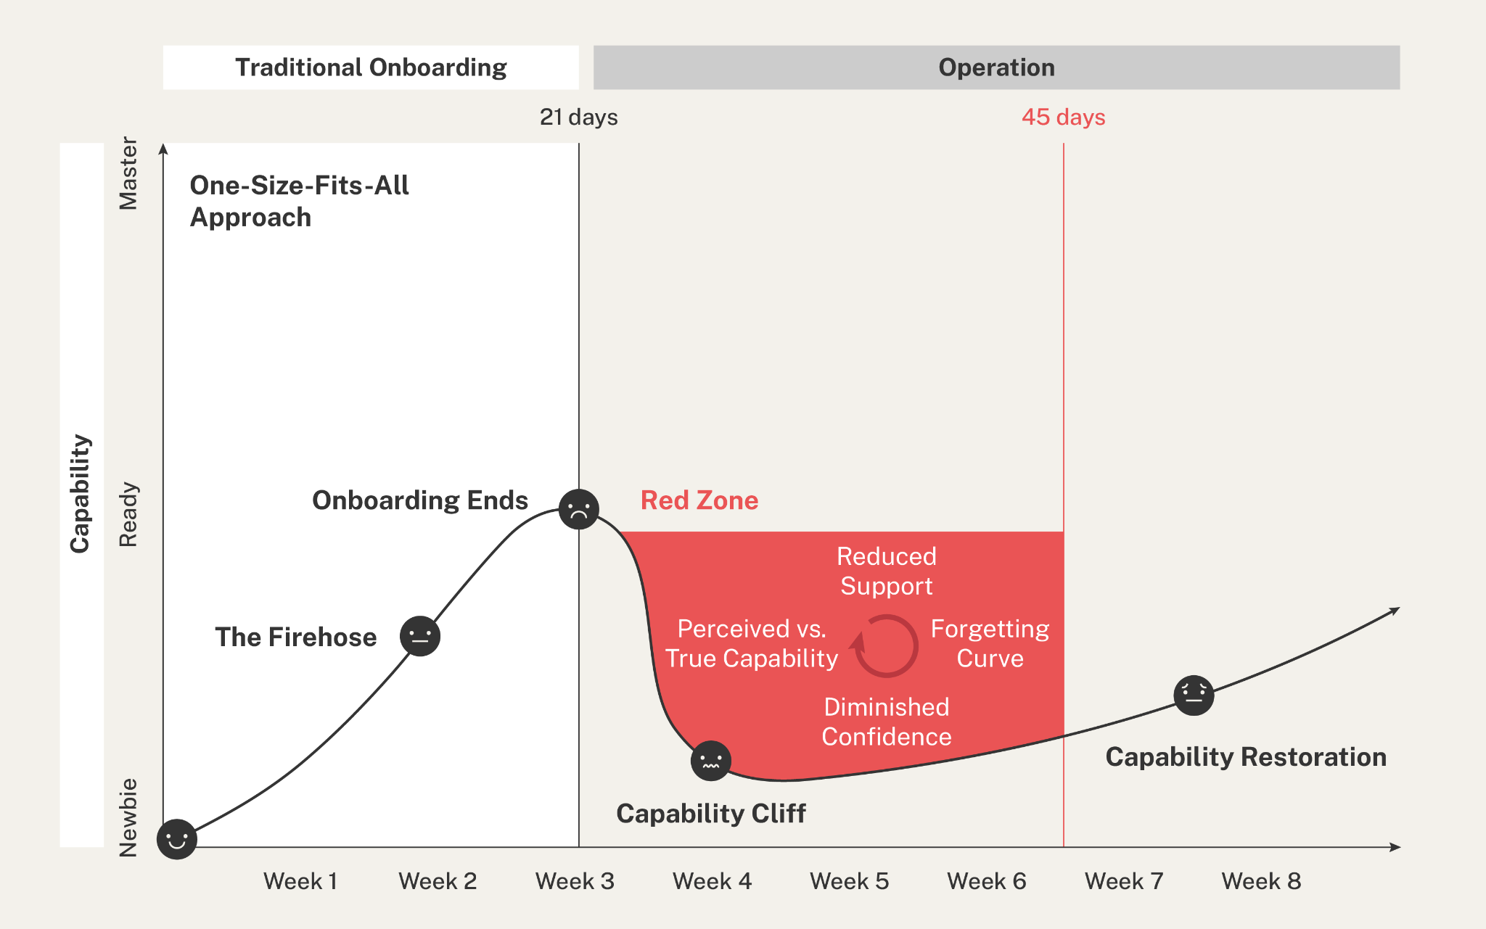
Figure 1: Traditional Onboarding
Source: (CapabilityGroup, 2026)
Strategic organisational socialisation helps take a long-term view of the organisation that organises organisational values, behavioural expectations, and relationships. It mainly refers to the process that a new entrant is expected to experience throughout the first year of employment (CapabilityGroup, 2026). The theory of organisational socialisation by Van Maanen and Schein suggests that institutionalised strategies such as formal mentoring, collective learning and sequential development help in this case (Thomas and Silvester, 2026). Mainly with the uncertainty of newcomers and produces uniform organisational experiences. In the case of Helios, the practices would standardise integration between its London, Berlin and Singapore offices. As well as boost collaboration between the offices in mobility endeavours that were based on AI. Nonetheless, integration of individualised mentoring and institutionalised programmes is an indicator of individualised strategies in which specialists can use their skills in a non-rigid manner. According to Harter (2022), organisations that are engaged have 23% more profitability, which explains the importance of a long-term socialisation strategy. Such a moderate system upholds both organisational coherence and professional independence.
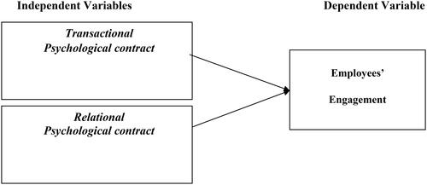
Figure 2: Psychological Contract Theory
Source: (Wonda et al., 2024)
Similarly, the Psychological Contract Theory underlines that employees establish unspoken expectations when it comes to career development, organisational support and fairness (Ngobeni et al., 2022). Exceeding these expectations by a clear career ladder, active feedback and management mentorship boosts confidence and motivation, and failing to meet these expectations drives turnover motivation. Employees who get regular career coaching are 2.7 times more likely to be committed (Crist, 2024). Therefore, strategic socialisation will be essential to reduce the number of graduate Helios losing to competitors and create committed organisational citizens.

2. Structured Socialisation Framework for Helios Urban Mobility

Pre-boarding
Helios should begin socialisation immediately after contract acceptance through an AI-enabled onboarding portal introducing organisational values, responsible AI practices, sustainability goals and city-specific cultural guidance for London, Berlin or Singapore. Appointing a technical mentor and peer buddy to each new person before his or her initial working day would set up early social networks. Alongside alleviate uncertainty and reinforce the psychological contract by showing commitment of the organisation (Fantineli et al., 2023). However, organisations that engage in effective pre-boarding enhance the retention of new hires in order to promote early engagement strategies.

First 90 Days
Within their initial 90 days, staff members will undergo engineered cross-functional rotations in engineering, analytics, sustainability and client engagement as a way to learn the integrated mobility ecosystem of Helios. Performance, wellbeing and capability development in the form of weekly coaching and AI-different learning pathways should be monitored (García-Madurga et al., 2024). Behaviour to collaborate across international teams should be upheld. Recurrent feedback facilitates faster readjustment and facilitates organisational engagement. Employees who are involved in continuous learning in the workplace are less prone to leave their organisation, and this step is central to minimising graduate turnover (Shiri et al., 2023).

Year One
During the first year, the staff members will need to be engaged in laboratories of innovation, foreign project placements, and quarterly career evaluations on a skills-based internal talent marketplace. These experiences promote leadership growth, internal mobility and enhanced organisational identification, as well as aligning personal development with strategic goals of Helios. According to Thomas and Silvester (2026), employees who receive regular development opportunities are 80% more engaged. Hence, constant socialisation should be considered based on the first onboarding.

3. Developing Organisational Citizens through Identity, Ethics and Business Activism

Organisational Identification
Helios needs to develop organisational identification by regularly conveying its mission of providing sustainable AI-based urban mobility solutions that make people value them. Storytelling by leadership, cross-regional working, recognition programmes and forums where people can engage in innovative thinking would allow staff in London and Berlin as well as Singapore to identify how their personal values fit in with the mission of Helios.
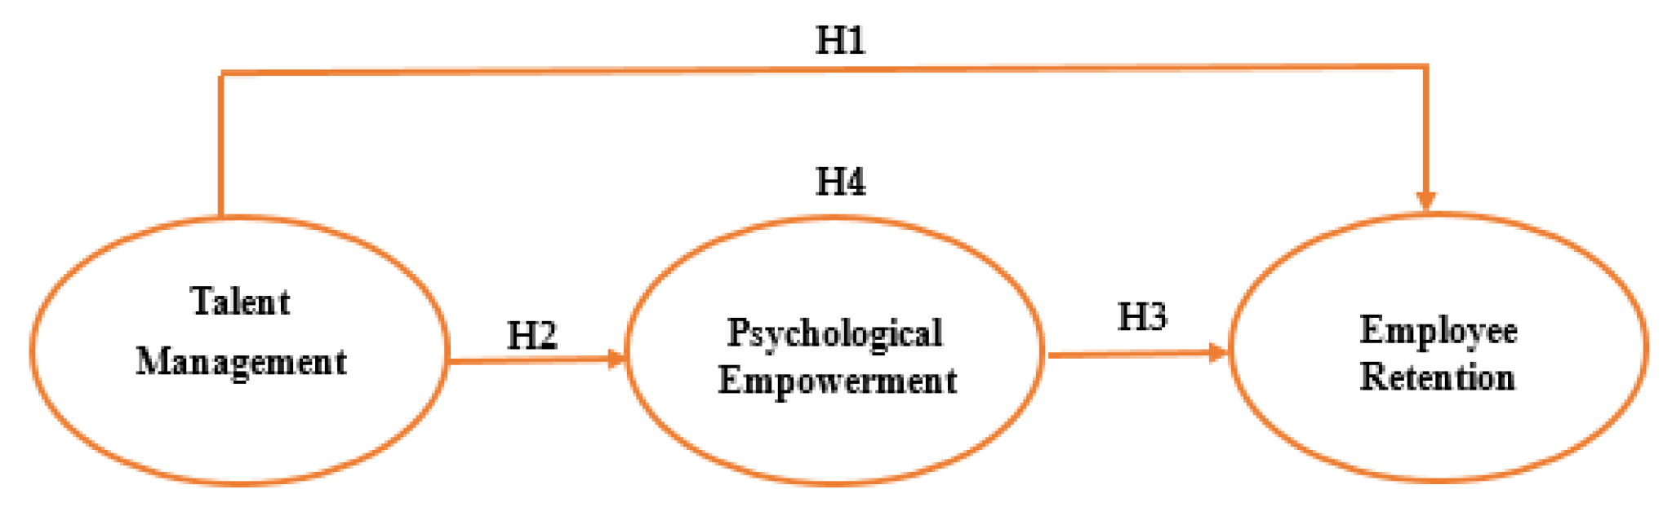
Figure 3: Employee Retention
Source: (Dalila et al., 2025)
According to Dalila et al. (2025), the retention of employees in purpose-driven organisations has been found to increase. Thus emphasising the importance of aligning the identity of the organisation and the identity of the employee with the purpose of the organisation. High identification helps to instil a feeling of organisational achievement in the employees (Shiri et al., 2023). Hence, making them feel that it is their achievement, thus making them more committed and preventing turnover.

Ethical Professionalism
Ethical professionalism should be embedded through mandatory responsible AI training, ESG education, ethical decision-making frameworks and transparent reporting mechanisms (Lee et al., 2025). With the emergence of technologies, as Helios focuses on the overall welfare of the citizens and their infrastructure, its workers need to think more about being accountable, fair and responsible in their technology. Employees expect organisations to be ethically led, as it is crucial to incorporate ethics into the operating practice (Lee et al., 2025). By incorporating ethical behaviour into the performance appraisal and the expectations of the leaders, an organisational culture in which ethical decision-making becomes the norm is strengthened.

Business Activist Mindset
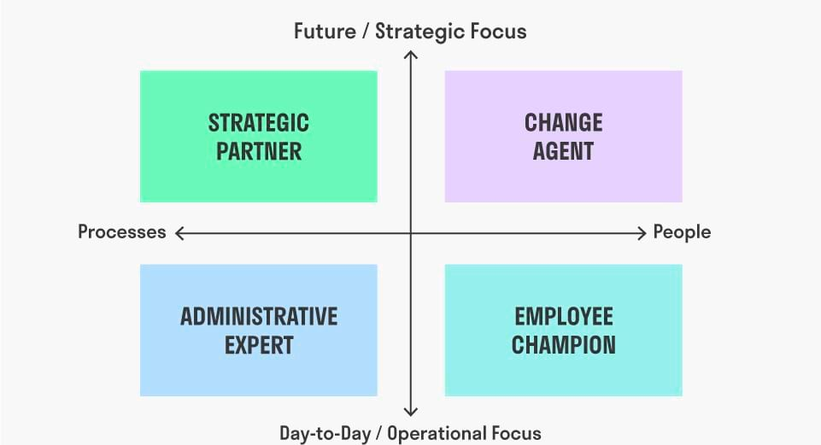
Figure 4: Ulrich’s HR Roles
Source: (Weijers, 2025)
Helios ought to establish a business activist culture by motivating its staff to make contributions strategically and not just do operational functions. The evolution of Ulrich’s HR Business Partner positions employees as change agents leading the innovation process, and the paradigm of stakeholder capitalism further encourages the development of value-generating activities. Mainly to governments, communities, customers and shareholders in addition to financial performance. Engaging employees in sustainability projects, AI governance and collaboration with cities would increase organisational citizenship (Caputo et al., 2023). Employees want CEOs to take leadership in social problems, facilitating the creation of business activists who are eager to act.

TASK B: Job Design

1. Innovative Job Design Strategy for Helios Urban Mobility
Helios Urban Mobility (HUM) needs a new job design approach to solve the problem of employee engagement dropping, ramp-up taking longer, and graduate turnover being high. Being an AI-enabled smart mobility organisation, HUM must incorporate the Job Characteristics Model, Job Crafting Theory and a skills-based architecture to develop flexible, collaborative and future-oriented jobs across the organisation that facilitate greater motivation, innovation and performance in the organisation.

Applying the Job Characteristics Model
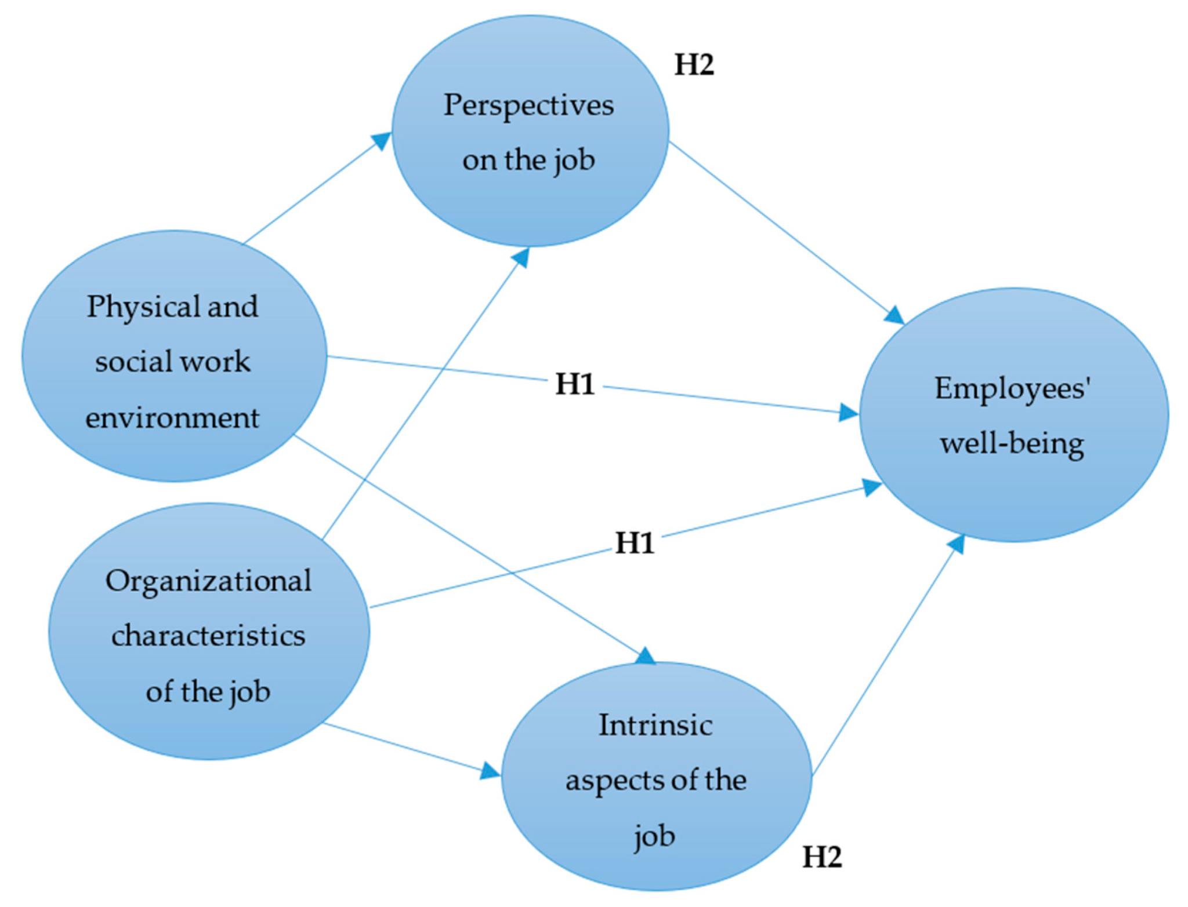
Figure 5: Job Characteristics Model
Source: (Dumitriu et al., 2025)
The Job Characteristics Model suggests that five fundamental job characteristics enhance intrinsic motivation through the reinforcement of meaningfulness, sense of responsibility and knowledge of outcomes (Zhao et al., 2024). The model is useful since it attributes job design directly to employee satisfaction and performance as well as employee motivation. It, however, presumes the employees do not account for the fast-changing capability demands of technology-intensive organisations (Dumitriu et al., 2025). Therefore, Helios must follow the model, but make it more flexible with diverse learning opportunities and collaborative practices that include alternative career growth and the expert knowledge of the specific field. This portfolio-based approach allows motivational job enrichment but still with the flexibility needed in the fast-changing AI industry.

Skill Variety, Task Identity and Task Significance
Helios should enhance skill variety by enabling AI engineers, software developers and infrastructure analysts to participate in multidisciplinary projects involving mobility technology, sustainability analytics and customer engagement. Movement of employees through the phases of projects enhances both technical and interpersonal skills and avoids monotony (Govindaras et al., 2023). Besides, reinforcing task value through showing how AI-powered transport systems enhance the sustainability of urban areas, traffic flow and safety will ensure that employees feel valuable to the organisation and its clients.

Autonomy and Feedback
Greater autonomy should be embedded by enabling employees to decide on project methodologies, choose suitable tools of innovation and control the aspects of hybrid working without becoming responsible through having agreed objectives. At the same time, annual performance reviews ought to be substituted with a series of monthly coaching sessions, a performance dashboard that will utilise AI assistance, and peer reviews with colleagues in the foreign offices. It is recommended that regular developmental feedback will help employees understand where they are lacking in capabilities (Johnson et al., 2022). Also enable the employee to adjust smoothly to an ever-changing project environment and constantly improve performance as well as build trust between managers and employees.

Integrating Job Crafting Theory
According to Job Crafting Theory, employees are supposed to take the initiative to make changes in their jobs in order to suit the job with their interests and strengths as well as their career desires (Kardas, 2023). It is also in contrast to the conventional job design that is top-down; it gives employees the ability to make meaningful work experiences which boost ownership, flexibility and involvement. Nonetheless, too much job crafting can lead to a lack of role clarity and coordination when organisational delimitation is not well specified (Johnson et al., 2022). As such, Helios needs to adopt formal job crafting through managerial guidance and articulate performance expectations which would create the balance between flexibility and organisational goals.
Employees should engage to participate in task crafting contributing to sustainability innovation projects, AI ethics efforts and smart-city research outside of their official roles. The relational crafting must foster cooperation between London, Berlin and Singapore engineers, data scientists and customer success teams, enhancing knowledge sharing and innovations. The cognitive crafting must assist the employees to see their work as contributing to sustainable urban mobility and not just creating software.

Developing a Skills-Based Architecture and Internal Talent Marketplace
In order to supplement enriched job design, Helios needs to have a skills-based architecture with an AI-based internal talent marketplace. The organisation should not distribute employees on predetermined job titles; instead, it should determine technical, analytical and leadership talent and distribute the talent on organisational priorities. The innovation projects, international assignments and emerging business opportunities within the competencies of employees could be accessed in the process of developing their new competencies. Future skill gaps would also be detected in the marketplace, assisting in ad hoc planning of the workforce and focusing learning investments. Organisations that focus on internal mobility are more likely to keep employees in the organisation as compared to organisations with low levels of career movement (Jooss et al., 2023). Thus proven that a skills-based architecture will enhance workforce nimbleness, employee retention and the long-term competitive power of Helios.

2. Stimulating Intrinsic Motivation and Supporting Innovation
The suggested job design approach enhances relative intrinsic motivation by providing employees with meaningful and development-focused work that satisfies their psychological needs and enhances organisational innovation. With the help of the Job Characteristics Model, employees feel more skill variety, task relevance, autonomy and feedback, which makes them feel purposeful, more responsible, and more accomplished (Zhao et al., 2024). Formal job crafting also allows employees to do what they do best and pursue career goals, creating a sense of ownership, involvement and longevity. In the meantime, skills-based architecture offers understandable career opportunities and internal mobility chances, promoting lifelong learning and career development. Gallup (2024) argues that intrinsically motivated workforces cost organisations in terms of profits, as highly engaged employees are 20% more profitable than disengaged employees.
Collaboration, both at multidisciplinary and international levels, enhances innovation as it allows employees to combine engineering, analytics and sustainability knowledge to help create AI-enabled mobility solutions. The digital marketplace within talent internalisation enables the sharing of knowledge by ensuring that employees are linked to projects of innovation according to their capabilities and not job titles. Constant feedback, AI-based learning, and exposure to a variety of projects promote experimentation, flexibility and creativity in solving problems (García-Madurga et al., 2024). In turn, this hybrid job design approach can help Helios Urban Mobility to enhance employee engagement, speed up innovation and competitiveness of the organisation in the long-term.

TASK C: Reflective Report (Gibbs' Reflective Cycle)
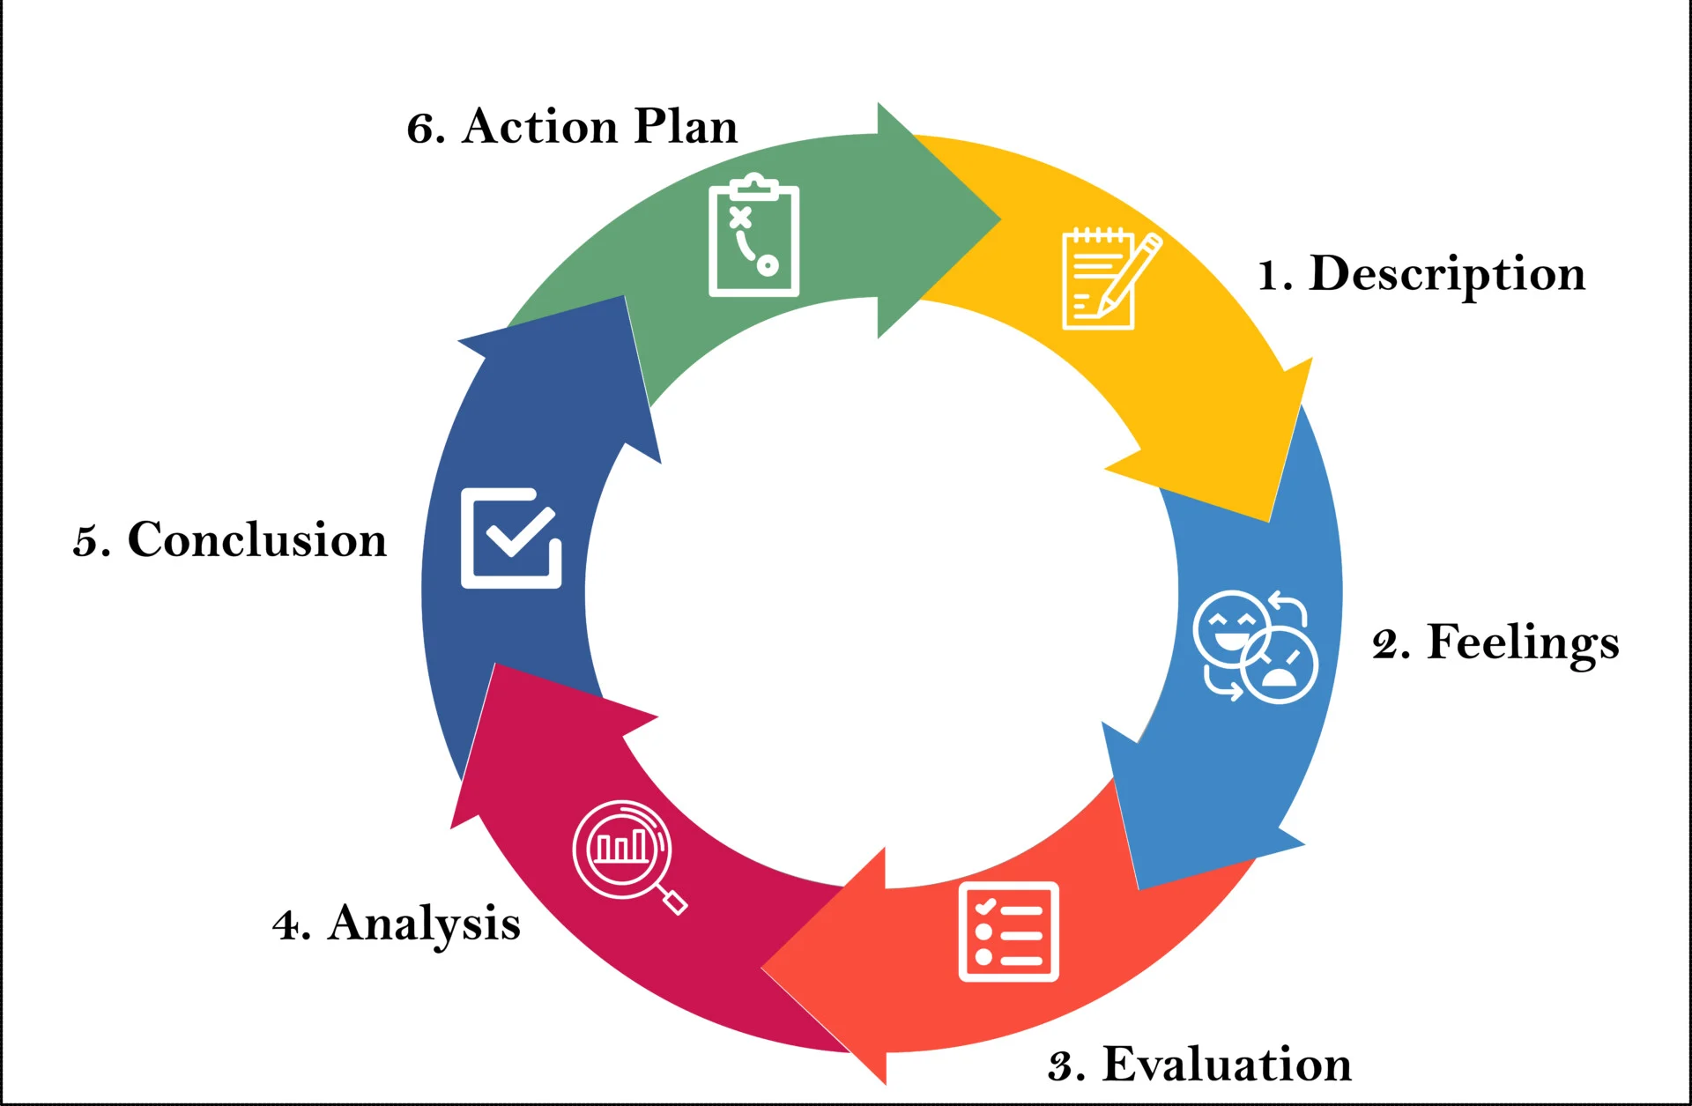
Figure 6: Gibbs' Reflective Cycle
Source: (McLeod, 2025)
Description
This module increased my level of understanding of how artificial intelligence (AI) can assist strategic human resource management through better workforce planning, recruitment, talent management and organisational decision-making. It has shown that although AI reinforces evidence-based HR practices, human judgement is crucial in dealing with ethical problems, employee wellbeing and organisational culture (Rodgers et al., 2022).
Feelings
Before studying this module, AI was seen by me primarily as a technology that would make the staff more efficient by automating most HR activities. Nevertheless, I currently recognise that over-reliance on AI can create bias in algorithms, lower empathy and ignore contextual variables for employees. This transformation has made me more certain about my responsible usage of AI and more aware of the value of having critical thought and professional judgement (Rodgers et al., 2022).
Evaluation
AI is incredibly powerful as it can provide analysis of workforce data and point to skill gaps and assist in applying strategic workforce planning more effectively than conventional approaches (Muhammad et al., 2025). However, AI-based recommendations can be based on biased data, and they might not take into account organisational culture and personal situations. Hence, only use of AI will not be able to ensure fairness, transparency, and ethical decision-making in human resource management.
Analysis
I will apply AI as a decision-support tool and not a decision-maker in my future career. AI will help me in examining the trends in recruitment, forecasting the growth and development of the workforce, and also examining the development opportunities of every employee, but all recommendations will be carefully evaluated before implementation. To make balanced decisions, I will keep in mind the organisational goals, the specifications of the stakeholders, ethical standards and contextual data in mind. By integrating both analytical knowledge and human judgment, I will be able to make responsible, fair and strategic HR decisions and reduce the risks of automation.
Conclusion
These reflections have strengthened the idea that instead of substituting professional judgement, AI should augment it. To make strategic human resource decisions, the ability of AI to reason ethically, show empathy and understand the context is highly demanded in conjunction with critical thinking.
Action Plan
To enhance my employability in future, I will enhance my data literacy by taking data analytics and data visualisation courses in HR. To become a skilled AI augmenter in HR, I will apply AI-augmented HR technologies in practice and abide by responsible AI guidelines. Leadership training will enhance my skills in strategic influencing, as well as communication and stakeholder engagement training (Leal Filho et al., 2025). Lastly, I will also become more aware of international mobility by reading about international employment regulations, cross-cultural management and global workforce patterns to equip myself to work in strategic HR positions in multinational organisations.

Conclusion
In the context of Helios Urban Mobility, creating an integrated human capital architecture will make it possible to foster the commitment of employees, enhance engagement, and innovativeness. Socialisation through strategic guidelines, driving job design, and ethical application of AI in human resource decision-making are all useful in promoting human resource renewal in the long term. Such suggestions will help create a strong, passionate workforce that can produce the strategic and competitive long-term goals of the organisation.
References
Allen (2021). EMPLOYEE ONBOARDING:A PROCESS FOR THE FUTURE OF WORK. [online] Available at: https://www.allencomm.com/wp-content/uploads/2021/10/eBook_DevelopingOnboardingModernWorkplace.pdf. [Accessed 6 July 2026].
CapabilityGroup (2026). The real impact of a well-designed onboarding programme. [online] Capability Group. Available at: https://www.capabilitygroup.co/latest/the-real-impact-of-a-well-designed-onboarding-programme [Accessed 6 July 2026].
Caputo, F., Magliocca, P., Canestrino, R. and Rescigno, E. (2023). Rethinking the Role of Technology for Citizens’ Engagement and Sustainable Development in Smart Cities. Sustainability, [online] 15(13), p.10400.
Crist, C. (2024). Although coaching is a top priority, leaders say they lack relevant skills. [online] HR Dive. Available at: https://www.hrdive.com/news/HR-leaders-need-coaching-skills/721475/. [Accessed 6 July 2026].
Dalila, Gumashivili, M. and Kanokon, K. (2025). The Role of Talent Management in Enhancing Employee Retention: Mediating the Influence of Psychological Empowerment. Sustainability, 17(7), pp.3277–3277.
Dumitriu, S., George, B.C., Vărzaru, Anca Antoaneta, Al-Floarei, Andreea Teodora, Maria, S.N., Popescu, F.L. and Băloi, I.-C. (2025). The Role of the Workplace Environment in Shaping Employees’ Well-Being. Sustainability, [online] 17(6), p.2613. Available at:
Fantinelli, S., Galanti, T., Guidetti, G., Conserva, F., Giffi, V., Cortini, M. and Di Fiore, T. (2023). Psychological Contracts and Organizational Commitment: The Positive Impact of Relational Contracts on Call Center Operators. Administrative Sciences, [online] 13(4), p.112.
Gallup (2025). State of the Global Workplace Report. [online] Gallup. Available at: https://www.gallup.com/workplace/349484/state-of-the-global-workplace.aspx [Accessed 6 July 2026].
García-Madurga, M.-Á., Gil-Lacruz, A.-I., Saz-Gil, I. and Gil-Lacruz, M. (2024). The Role of Artificial Intelligence in Improving Workplace Well-Being: A Systematic Review. Businesses, [online] 4(3), pp.389–410.
Govindaras, B., Wern, T.S., Kaur, S., Haslin, I.A. and Ramasamy, R.K. (2023). Sustainable Environment to Prevent Burnout and Attrition in Project Management. Sustainability, [online] 15(3), p.2364.
Harter, J. (2022). Employee Engagement vs. Employee Satisfaction and Organizational Culture. [online] Gallup. Available at: https://www.gallup.com/workplace/236366/right-culture-not-employee-satisfaction.aspx. [Accessed 6 July 2026].
Johnson, D.A., Johnson, C.M. and Dave, P. (2022). Performance Feedback in Organizations: Understanding the Functions, Forms, and Important Features. Journal of Organizational Behavior Management, [online] 43(1), pp.1–26.
Jooss, S., Collings, D.G., McMackin, J. and Dickmann, M. (2023). A skills‐matching perspective on talent management: Developing strategic agility. Human Resource Management, [online] 63(1), pp.141–157.
Kardas, J.S. (2023). Job Crafting Competences and the Levels of Self-Organization, Job Satisfaction and Job Redesign in a Mature Organization. Sustainability, 15(3), p.2253.
Leal Filho, W., Sigahi, T.F.A.C., Anholon, R., Rebelatto, B.G., Schmidt-Ross, I., Hensel-Börner, S., Franco, D., Treacy, T. and Brandli, L.L. (2025). Promoting sustainable development via stakeholder engagement in higher education. Environmental Sciences Europe, 37(1).
Lee, S.U., Perera, H., Liu, Y., Xia, B., Lu, Q., Zhu, L., Cairns, J. and Nottage, M. (2025). Integrating ESG and AI: A comprehensive responsible AI assessment framework. AI and Ethics, 4(3).
McLain, D. and Nelson, B. (2022). How Fast Feedback Fuels Performance. [online] Gallup.com. Available at: https://www.gallup.com/workplace/357764/fast-feedback-fuels-performance.aspx. [Accessed 6 July 2026].
McLeod, S. (2025). Gibbs Reflective Cycle. [online] Simply Psychology. Available at: https://www.simplypsychology.org/gibbs-reflective-cycle.html [Accessed 6 July 2026].
Mitschelen, A. and Kauffeld, S. (2025). Workplace learning during organizational onboarding: Integrating formal, informal, and self-regulated workplace learning. Frontiers in Organizational Psychology, [online] 3(3).
Muhammad Rizwan Saqab, Syed, D., Muhammad Ala-Ud-Din and Naveed, M. (2025). THE IMPACT OF ARTIFICIAL INTELLIGENCE ON HR DECISION - MAKING: OPPORTUNITIES, CHALLENGES AND ETHICAL CONSIDERATION. Policy Journal of Social Science Review, [online] 3(12), pp.39–53.
Ngobeni, D.A., Saurombe, M.D. and Joseph, R.M. (2022). The influence of the psychological contract on employee engagement in a South African bank. Frontiers in Psychology, [online] 13(3).
Rodgers, W., Murray, J.M., Stefanidis, A., Degbey, W.Y. and Tarba, S.Y. (2022). An Artificial Intelligence Algorithmic Approach to Ethical decision-making in Human Resource Management Processes. Human Resource Management Review, 33(1), pp.1–19.
Shiri, R., El-Metwally, A., Sallinen, M., Pöyry, M., Härmä, M. and Toppinen-Tanner, S. (2023). The role of continuing professional training or development in maintaining current employment: A systematic review. Healthcare, [online] 11(21), pp.1–17.
Thomas, H.C. and Silvester, J. (2026). Navigating vulnerability in elite organizational socialization: Insights on new politicians” use of reputational behaviors. [online] Human relations . Available at: https://journals.sagepub.com/doi/abs/10.1177/00187267261447841.
Weijers, L. (2025). Ulrich model of HR Roles: The Basics - Toolshero. [online] Toolshero. Available at: https://www.toolshero.com/human-resources/ulrich-model-of-hr-roles/ [Accessed 6 July 2026].
Wonda, T.A., Engidaw, A.E., Ning, J., Kebad, M.A. and Belay, N.A. (2024). Does psychological contract fulfilment determine employees’ work engagement? Empirical evidence from government sector employees. Cogent Business & Management, 11(1).
Zhao, S., Ping, J., Zhu, H., Ji, W., Wang, Y. and Wang, Y. (2024). Job characteristics model-based study of the intrinsic motivations for primary care practitioners. Chinese General Practice Journal, 1(1), pp.3–10.

