Student Name: Florentina Barbulescu
Student number:2324276
Digital skills for Personal Development and Business Growth
BMSW4008
Lecturer Philippa Fitzgerald
Evidence of Learning (E-Portfolio)
Flo's Coffee Shop
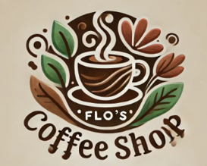

Table of Contents
1 Task 1 3
1.1 Questionnaire Analysis 3
2 Task 2 7
2.1 Segmentation 7
2.2 Mission Statement of Company 9
2.3 SEO 10
2.4 Webpages Designed 11
2.5 Marketing Materials Created 13
3 Task 3 15
3.1 Projection of Finances of a Coffee Business over a Three-Month Period 15
3.2 Importance of Excel in the Digital Era 16
4 Task 4 18
4.1 Video Advertising Chosen Brand 18
5 References 21
6 Appendix 24
6.1 Questionnaire 24
6.2 Questionnaire Analysis 26

Task 1

Questionnaire Analysis
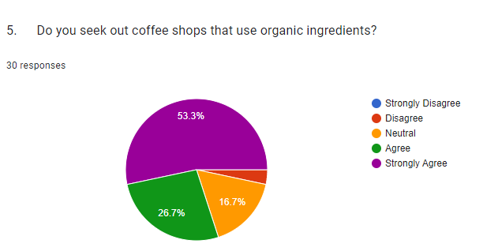
The question asked whether people go looking for coffee shops which use organic raw materials. The responses show that 80% of the respondents strongly agree that they prefer health-conscious as well as environmentally friendly options. The responses of participant’s shows a rising consumer awareness as well as quality of food and beverages. In the coffee market, a key considerable factor is the necessity of organic food, with more and more individuals learning about the benefits of using organic food for cultivation (Lee and Bateman, 2021). First, organic coffee is naturally usually chemical-free or it contains very less levels of synthetic chemical substances including pesticides and fertilizers than standard commercial coffee available in the markets. Such preference shows that Flo’s Coffee Shop should be able to maintain a good number of gourmet coffee consumers by sourcing for organic coffee beans and serving organic foods. Organic foods in Flo’s menu will attract more of the health-conscious market because of the goodness that is associated with natural food ingredients. Further on, the transparency of the information concerning the supply chain of the ingredients can really strengthen the focus of the shop on quality (Dionysis et al., 2022). Such certifications, along with procurement of organic produces from local farms, can help the business to establish itself in this niche market as the leaders of the organic coffee trade that also cares for consumers’ health.
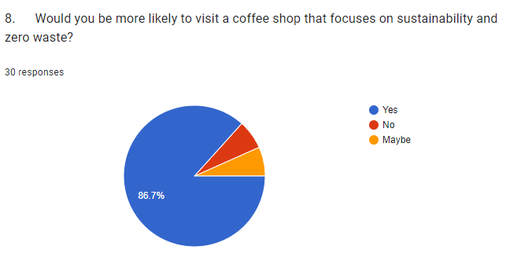
Another question aimed at finding out the respondents’ interest in a coffee shop that sees sustainability and no waste as important causes. 80 % of the respondents stated they prefer such establishments, proving once again that people are becoming increasingly environmentally friendly. Such a high index of coincidence indicates that clients are not only informed about sustainable concerns but are also looking for companies that are sustainable in their operations (Katt and Meixner, 2020). This finding is consistent with an emerging extensive societal culture of post-consumption consumption, also referred to as sustainable consumption since the consumer’s consideration for the environmental impact of an item is a critical factor when making a purchase. The primary consumer motivation, sustainable consumption has become a norm that influences consumer’s choices on where to spend their money. Hence, Flo’s Coffee Shop can maximize on this trend and obtain a lot of clients with attitudes towards the adoption of zero-waste strategy. Consequently, the key action should be a well-elaborated sustainability program, which Flo’s should create; utilizing bio-degradable packing, providing discounts for the customers who use their own cups/containers, the establishment of the composting point for coffee residues. Furthermore, customers can be identified by Flo’s through explanations of its sustainable activities through social account posts (Czarniecka-Skubina et al., 2021). If Flo’s intensively communicate and advertise its non-generation of waste, customers will be attracted by such a company policy.
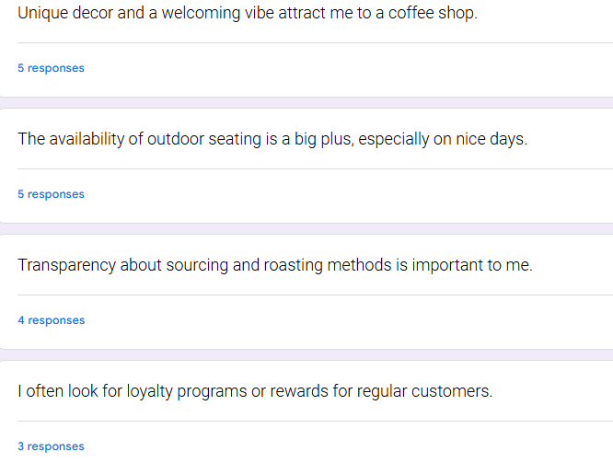
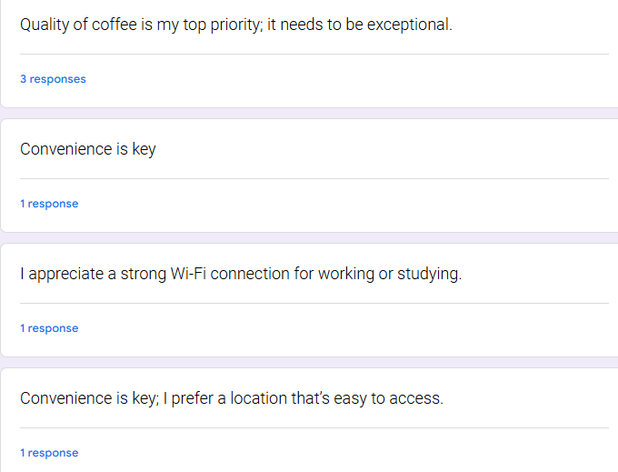
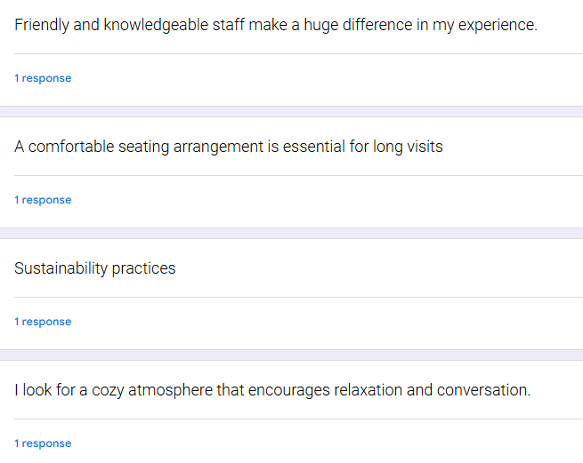
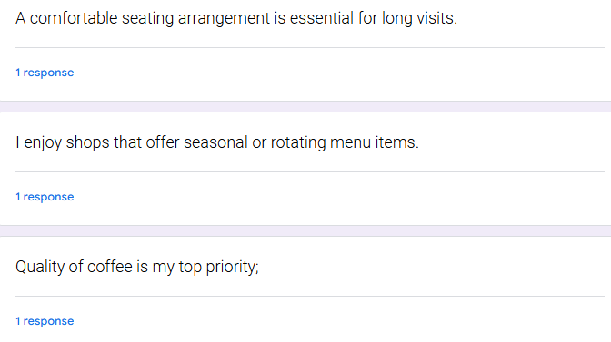
From the above graph, it is analyzed that most customers prefer comfort and original design when choosing coffee shop. It indicates that comfort and original design play a major role in choosing the place to drink coffee. Furthermore, customers’ outdoor seating are preferred, especially during the warmer weather of the day, as they can get to enjoy their coffee while in the fresh air, and thus is definitely a plus. Customers are also particular about transparency with several of the respondents arguing that understanding sourcing and roasting of coffee makes them more attached. The criterion of quality is unaltered; customers often stress that it is the flavor and quality of the beverages especially coffee that are unchangeable because that is what customers are consuming. Participants pointed out to Good Wi-Fi connection meaning that frequent coffee shop patrons seek productive work or study environments in addition to leisure.
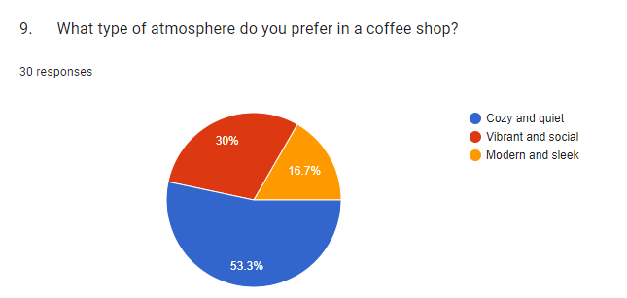
The question concerned which atmosphere the customers would like to have in a coffee shop, and 53.3% of respondents said that they prefer to have a comfortable and calm atmosphere. This insight mean that many people look for a place to loaf and chitchat, as opposed to the relatively energetic environment of coffee houses. The fact that the older consumer's majority preferred a small and quiet space showed that comfort is key and that the older generation at least would prefer a place that will make one feel welcome to relax, work, or catch up with friends and family. This trend is significant when understanding post pandemic behaviors, as many people seek places where they can find comfort from the stress and noise of everyday life (Singh and Alok, 2022; Birkenberg et al., 2021). Flo’s ‘Coffee Shop should make sure that the interior design is as welcoming so as to ensure that people spending long hours are encouraged. Success in creating a relaxing environment for a couple depends on factors like comfortable chairs, warm lighting as well as calming decoration. Also, the availability of the quite zone for clients and suitable environment make visitors conduct business or studies without interruptions. Various features such as lots of power outlets and free Wi-Fi can also be provided in order to fully satisfy the expectations of those, who might want to spend time in the space for effective studying or job purposes (Florek and Gazda, 2021).

Task 2

2.1 Segmentation
Segmentation | Evaluation
Demographic | - Based on the responses, the primary demographic can be young adults aged 18-35, likely to be students or young professionals with disposable income.  - This group is often interested in unique coffee experiences and health-conscious options.
Psychographic | - The data shows a strong preference for trying new and unique coffee flavors, along with a significant interest in vegan and gluten-free options.  - Additionally, the desire for sustainable packaging and zero waste practices indicates an environmentally conscious mindset among customers.
Behavioral | - The data reveals that many customers prefer in-person ordering but are open to online pre-orders and delivery options.  - There is also a notable interest in loyalty programs and discounts, indicating that promotions can drive repeat business.
Geographic | - While specific geographic data can require additional research, initial findings suggest targeting urban areas with a high concentration of young adults, such as college towns or city centers where foot traffic is high and coffee culture is thriving.

By utilizing these segmentation insights, Flo's Coffee Shop can craft targeted marketing strategies that cater to each identified segment. Marketing can include outstanding advertising through social networks, contacting with universities, organizing promotions for young adult audience. One way to gain this segment is through presenting varied coffee types, and other specialty products. The formulations of Flo’s can build a brand story around sustainability and health aspects. A blog about the souring of organic ingredients and social media status of how the company is promoting the culture of avoiding wastage will capture the attention of the environmentally friendly customers (Hajibaba et al., 2020). Such items as edible cups which are still new in the market can also add more precious in appeal.
Optimizing the parameters has the potential to affect the experience customers have when ordering (Cortez et al., 2021; Zhou et al., 2020). There are different strategies, such as the introduction of an easy-to-use Web interface for ordering food and a well-developed system of the customer loyalty. Promotion of getting several numbers of similar products or ordering before a given date can also encourage customers to be loyal (Yadegaridehkordi et al., 2021; Kovács et al., 2022. The coffee shop should be well situated in areas where young professionals and student often spend most of their time. Furthermore, campaigns like events, partnerships with companies of interest in the spatial area of interest are also helpful in targeting the geographic market with the product.
Targeting
The coffee shop identifies a clearly defined section of the market that it will commit its resources to meet the needs of effectively. When it comes to targeting for Flo’s Coffee Shop, the primary target market includes the individualized young adults 18 to 35 years in their consumptions of coffee services with a niche on sustainability. This group is rather indicative to the healthy eating and chooses organic products in preference, vegan food and products with minimized quantity of gluten. From the above analysis, it is analyses that by ensuring that Flo’s associates their coffee shop with their preferred products, they will be in a position to develop a captivating brand that suits these clients. Marketing communications can also focus awareness on the development of new and different products such as new coffees blend and coffee cups that are edible with health and environmentally sensitive features.
Flo’s can approach this demographic through social media experimenting with stars and community events to make the news about the brand spread. Through the development of the active web community, the coffee shop can enhance its popularity and generate oral references (Haverila et al., 2020; Abdulhafedh, 2021). Another major marketing segment comprises people who are eager to choose products that are environmentally friendly. Such an approach will help to attract this niche segment of customers as Flo’s will be able to offer them a number of sustainability strategies completing with the upgrades; for instance, carrying out zero-waste measures, using environmentally friendly packaging.

2.2 Mission Statement of Company
The key mission of Flo’s Coffee Shop is to offer a perfect cup of coffee and ambience to complement our coffee. Flo’s have sustained a founding principle of purchasing beans from fairly paid producers and providing a comfortable and welcoming environment where one can both find solace and get things done. If customers need a silent cup of coffee or a place to organize a meeting with friends, Flo’s will do everything to ensure guests have the best experience.

2.3 SEO
The findings from the survey shows that majority of individuals prioritize those coffee shops which focused on healthy and organic ingredients. Along with it, due to the rising demand of sustainability, people prefer eco-friendly coffee shops (Husin et al., 2022). These findings help Flo’s Coffee Shop in more focusing on natural and eco-friendly features in their SEO techniques. Such strategies are helpful for individuals who are go for these options. Flo’s Coffee Shop need to integrate a blog part in their website by engaging customers. Relevant topics related to this blog sections can be discovered through questionnaire.
By incorporating multiple keywords, Flo’s Coffee Shop can optimize their website (Poturak et al., 2022). Another strategy Flo’s Coffee Shop need to follow is to post on regular basis in order to stay connected with customers by providing current updates. The keywords must be present in the Meta title, Meta description as well as inside the website content. This is an effective technique for search engine optimization (Chaffey and Smith, 2022). In order to appeal local consumers, Flo’s Coffee Shop should optimize their Google My Business Profile that help this business to appear in local map search results. This strategy simplifies the process for nearby consumers to locate us.
Flo’s Coffee Shop should focus on enhancing their customer experience. For improving customer experience, it is important that website should be easily accessible and quick and easy to direct. This strategy benefits Flo’s Coffee Shop in improving their ranking and optimizing marketing material (Sobrepeña, n.d). This thing can increase the individual interest who visited this website. Moreover, Flo’s Coffee Shop utilized various coding methods so that their content can be appeared in several searches. In order to optimize marketing material, social media platforms can play a significant role. Flo’s Coffee Shop can post on social media platforms related to their sustainable actions. Such practices include compostable wrappings and giving discounts to consumers. Such kind of posts on website leads to increase traffic as well as enhancing ranking (Wibisono, 2020).
In addition, Flo’s Coffee Shop can provide incentives to consumers who prefer eco-friendly options by implementing a loyalty program. These strategies help Flo’s Coffee Shop in optimizing their marketing material. Such tactics also useful in retaining customer interests who prefer eco-friendly choices. It also helps in appealing those consumers who prioritize more natural and organic ingredients in their diet. This can be done through creating link from blogs related to sustainability and health (Zhou et al., 2020). By following all these tactics, Flo’s Coffee Shop will become one of the popular coffee shops in providing organic and healthy coffee.

2.4 Webpages Designed
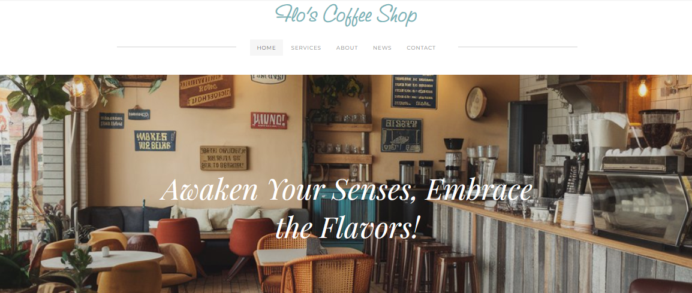

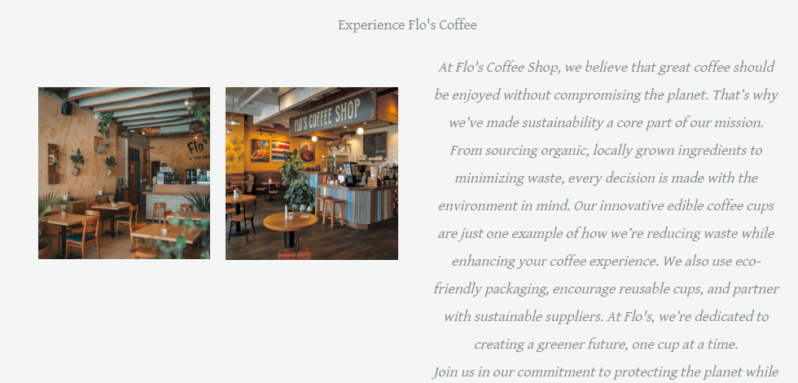
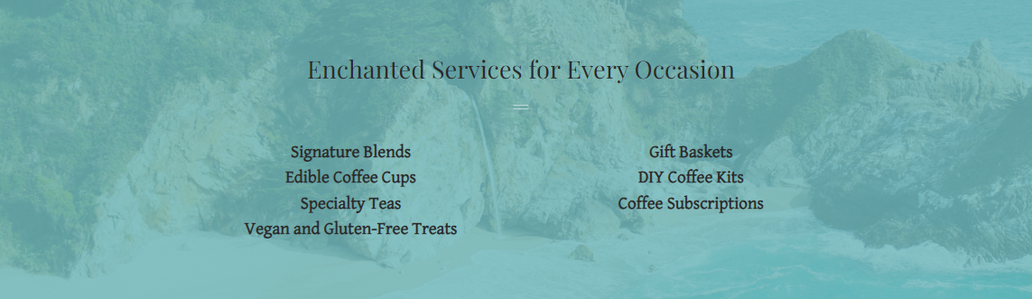
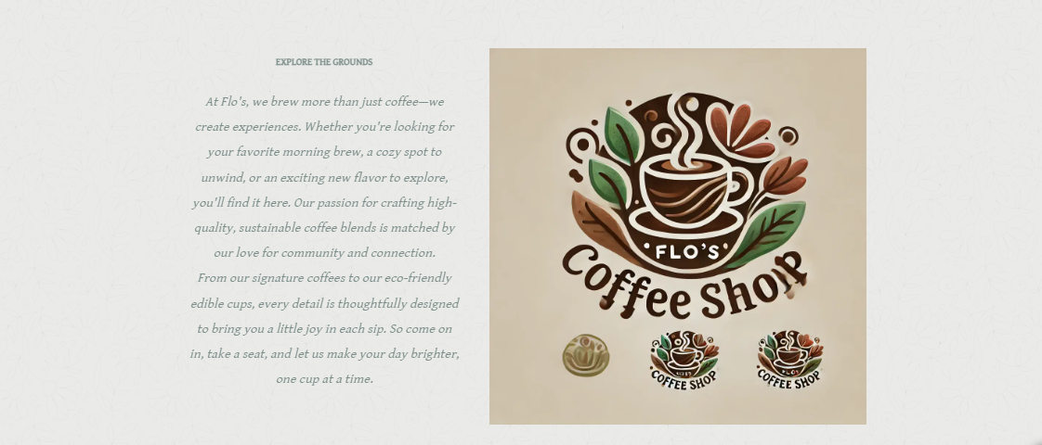
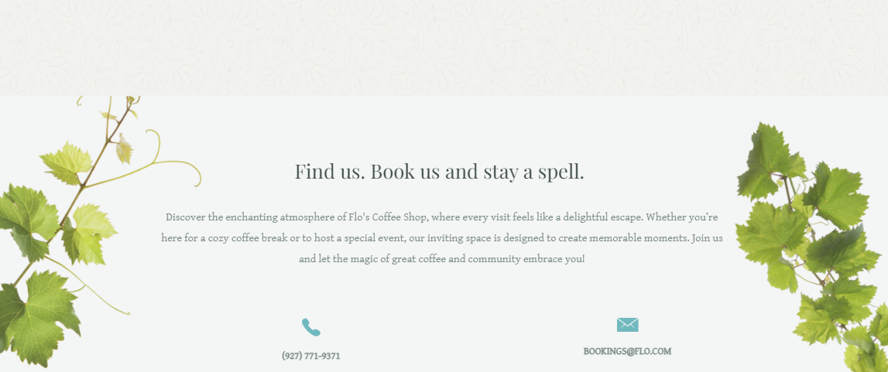
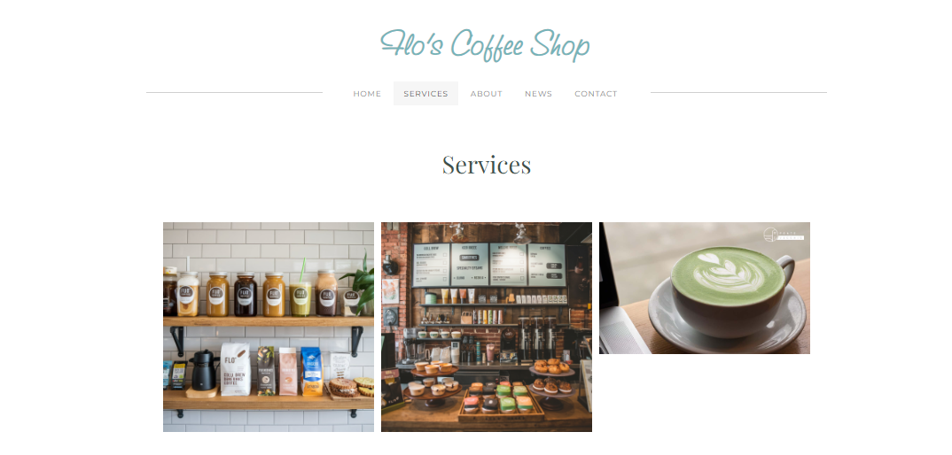
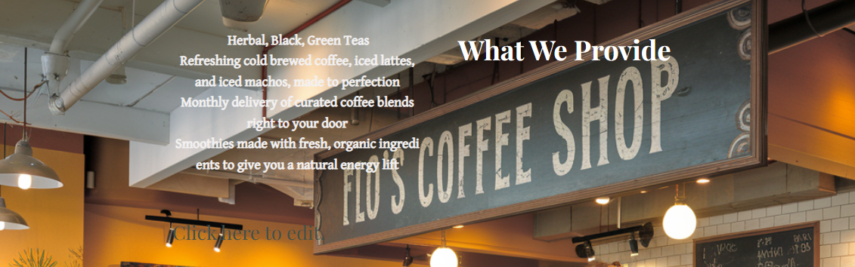

2.5 Marketing Materials Created
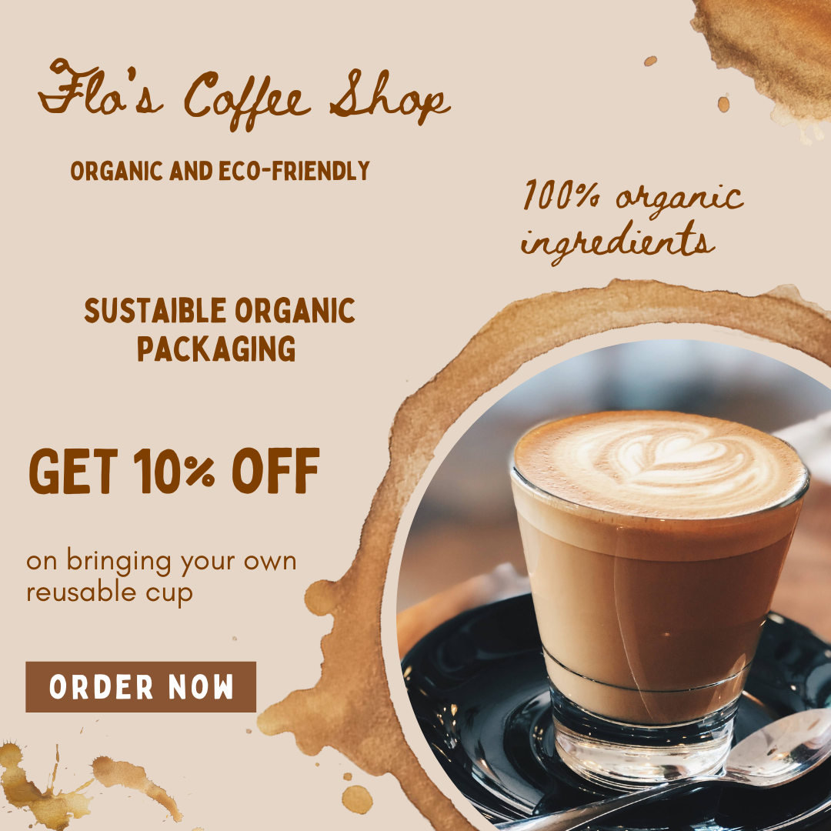
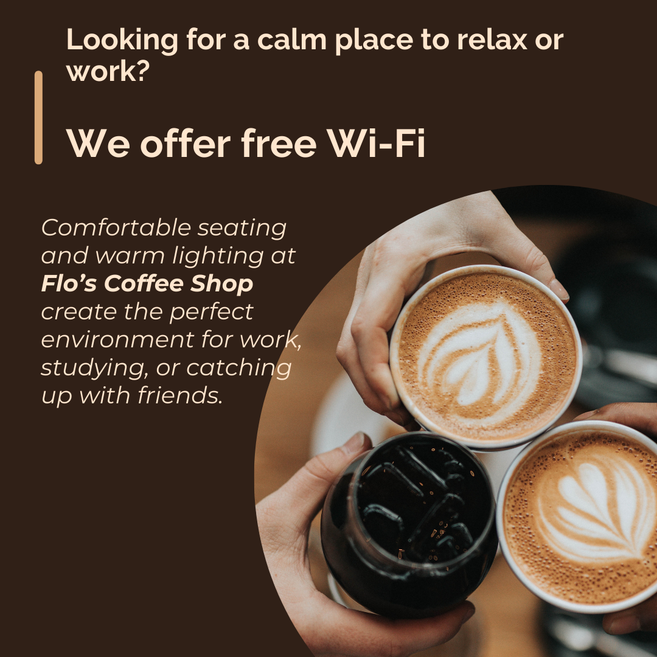

Task 3

3.1 Projection of Finances of a Coffee Business over a Three-Month Period
Category | Jan | Feb | March
Sales Revenue | £ 10,000 | £ 12,000 | £ 15,000
Other Income | £ 500 | £ 700 | £ 600
Total Income | £ 10,500 | £ 12,700 | £ 15,600
Raw Materials | £ 4,000 | £ 4,500 | £ 5,000
Marketing | £ 1,500 | £ 1,800 | £ 2,000
Salaries | £ 2,500 | £ 2,700 | £ 2,900
Utilities | £ 600 | £ 650 | £ 700
Misc. Expenses | £ 400 | £ 450 | £ 500
Total Expenses | £ 9,000 | £ 10,100 | £ 11,100
Profit/Loss | £ 1,500 | £ 2,600 | £ 4,500
Category | Jan | Feb | March
Total Income | £ 10,500 | £ 12,700 | £ 15,600
Total Expenses | £ 9,000 | £ 10,100 | £ 11,100
Profit/Loss | £ 1,500 | £ 2,600 | £ 4,500

3.2 Importance of Excel in the Digital Era
In today’s age and context, enterprises are flooded with large amounts of data from different source such as sale transactions, customer feedbacks, market survey, business processes and others. At the same time, trying to derive advantage from this data, the need for the tools for efficient storing, processing, and visualizing this data emerges constantly. From these tools, Microsoft Excel emerges as the critical instrument in the operation of organizations of all scales. Excel is an application for performing calculations on data (Aqlan et al., 2020). Companies oftentimes gather massive quantities of data, and using Excel ultimately offers a uniform way of organizing data in a way that is easily searchable. A workbook can contain multiple sheets where they can organize their data into different segments in the same workbook they can monitor their financial records, customer records, project schedules, and other stock in the same workbook. Users are able to input data systematically via the grid format displayed in Excel, which organizes information more systematically for retrieval (Islam, 2020). The fact that tables, filters, and sorting features are also available contribute to efficient data management to guarantee that companies can easily locate useful information. Data processing is a key feature today; it is necessary to have a tool that would ensure proper data management that would contribute to business performance improvements (Adigwe et al., 2023).
The basic analysis tool is probably one of the biggest strong suits of Excel. Businesses are also able to carry out capitalized calculations, the comparisons and the findings through Excel functions and formulae. Apart from simple calculations, the application accommodates all basic arithmetic, statistical studies, and complex operations that involve functions like a VLOOKUP, INDEX, and MATCH and even pivot tables (Stofkova et al., 2022). Since these tools help slice the big data into consumable chunks, businesses benefit from them, especially when making decisions based on facts. Furthermore, the Charts and Graphs menu gives Excel users a variety of ways they can use to display data in forms that are easy to understand. This capability is critical since stakeholders in a business organization usually require an understanding of the information conveyed within a short span of time. Data visualization enables one to draw attention to changing patterns, risk and opportunity, similarities and differences, patterns and trends that may be least conspicuous in numbers (Sanchez-Lizarraga et al., 2020). Excel allows for easy generation of such pictures, which will in turn help the team and its management to more easily understand vast amounts of information at once. In business organization particularly, financial management remains an essential component. Accounts and financial modelling have always used excel for financial forecasting, budgeting and analysis. Businesses can prepare budget documents and set up further programs for outlining expenditures and probable income with precision with the help of Excel’s plans and reasons. The use of what-if analysis empowers businesses to know the likely consequences of certain actions like a change of price, costing methods, or selling approaches among others (Yoshikuni et al., 2023). For example, by means of Excel, a company can assess how different advertising and promos affect the sales revenue and, therefore, decide where to invest.
In addition, Excel enhances the link between other financial equipment and software that can be used in import of exported data to ensure that the data contained therein is well updated. With the evolution of complex financial environments, the skills required in the interpretation and prediction of the company’s financial performance in Excel cannot be overlooked important in the sustenance of companies (Pauliková et al., 2021). The use of collaboration is especially important in the digital world of business. Excel is quite friendly when it comes to collaboration because it lets multiple people work on a single spreadsheet at once more so now that cloud-based services such as Microsoft 365 and SharePoint have come into the picture. Many organizations use the share functionalities feature of excel where teams are permitted to share current files, record changes and even add feedback in real time. Moreover, the Office Excel supports different formats of data as well as every user may not have the same tools in the computer or device. Such flexibility enables conferencing solutions to make sure that every

member of the business and every department can communicate and work together regardless of what tools they can be using (Stofkova et al., 2022). With a continued rise in work from home situations the interaction in a project using Excel will become valuable for keeping a team connected and for advancing projects.
Furthermore, most people know that Excel of an independent utility, but in fact, it can be synchronized with a number of other business applications or programs. In this context, a large number of organizations apply the Customer Relationship Management (CRM), Enterprise Resource Planning (ERP) and data analysis tools. Excel can be used to transfer data from one system to the other or export data from one system to another (Adigwe et al., 2023). For instance, the sales data from the CRM system can be exported to excel to make further analysis in performance metrics, customers behavioral assessment, and the potential growth required for the business. Additionally, Excel integrated well with other programming languages such as Python and R to extend the functions of Excel and is an all-in-one application for data analysts in most organizations out there. Practical concerns are, in fact, paramount for many companies with a special emphasis on small and growing midsized businesses. Excel have a relatively low cost of entry compared to other tools for data analysis or business intelligence tools many organizations find it cheap to use to manage big data.

Task 4

Video Advertising Chosen Brand


https://youtube.com/@flobarbulescu?si=ilJf-CIS94KH0UrF

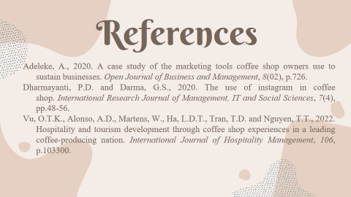

5 References
Abdulhafedh, A., 2021. Incorporating k-means, hierarchical clustering and pca in customer segmentation. Journal of City and Development, 3(1), pp.12-30.
Adeleke, A., 2020. A case study of the marketing tools coffee shop owners uses to sustain businesses. Open Journal of Business and Management, 8(02), p.726.
Adigwe, C.S., Abalaka, A.I., Olaniyi, O.O., Adebiyi, O.O. and Oladoyinbo, T.O., 2023. Critical analysis of innovative leadership through effective data analytics: Exploring trends in business analysis, finance, marketing, and information technology. Asian Journal of Economics, Business and Accounting, 23(22), pp.460-479.
Aqlan, F., Nwokeji, J.C. and Shamsan, A., 2020. Teaching an introductory data analytics course using microsoft access® and excel®. In 2020 IEEE Frontiers in Education Conference (FIE) (pp. 1-10).
Birkenberg, A., Narjes, M.E., Weinmann, B. and Birner, R., 2021. The potential of carbon neutral labeling to engage coffee consumers in climate change mitigation. Journal of Cleaner Production, 278, p.123621.
Chaffey, D. and Smith, P.R., 2022. Digital marketing excellence: planning, optimizing and integrating online marketing. Routledge.
Cortez, R.M., Clarke, A.H. and Freytag, P.V., 2021. B2B market segmentation: A systematic review and research agenda. Journal of Business Research, 126, pp.415-428.
Czarniecka-Skubina, E., Pielak, M., Sałek, P., Korzeniowska-Ginter, R. and Owczarek, T., 2021. Consumer choices and habits related to coffee consumption by poles. International Journal of environmental research and Public Health, 18(8), p.3948.
Dharmayanti, P.D. and Darma, G.S., 2020. The use of instagram in coffee shop. International Research Journal of Management, IT and Social Sciences, 7(4), pp.48-56.
Dionysis, S., Chesney, T. and McAuley, D., 2022. Examining the influential factors of consumer purchase intentions for blockchain traceable coffee using the theory of planned behaviour. British Food Journal, 124(12), pp.4304-4322.
Florek, M. and Gazda, J., 2021. Traditional food products—Between place marketing, economic importance and sustainable development. Sustainability, 13(3), p.1277.
Hajibaba, H., Grün, B. and Dolnicar, S., 2020. Improving the stability of market segmentation analysis. International Journal of Contemporary Hospitality Management, 32(4), pp.1393-1411.
Haverila, M., McLaughlin, C., Haverila, K.C. and Arora, M., 2020. Beyond lurking and posting: segmenting the members of a brand community on the basis of engagement, attitudes and identification. Journal of product & brand management, 30(3), pp.449-466.
Husin, S.N., Edastama, P. and Tambunan, A., 2022. Digital Marketing Strategy using White Hat SEO Techniques. International Journal of Cyber and IT Service Management, 2(2), pp.171-179.
Islam, M., 2020. Data analysis: types, process, methods, techniques and tools. International Journal on Data Science and Technology, 6(1), pp.10-15.
Katt, F. and Meixner, O., 2020. A systematic review of drivers influencing consumer willingness to pay for organic food. Trends in Food Science & Technology, 100, pp.374-388.
Kovács, I., Balázsné Lendvai, M. and Beke, J., 2022. The importance of food attributes and motivational factors for purchasing local food products: Segmentation of young local food consumers in Hungary. Sustainability, 14(6), p.3224.
Lee, Y. and Bateman, A., 2021. The competitiveness of fair trade and organic versus conventional coffee based on consumer panel data. Ecological Economics, 184, p.106986.
Pauliková, A., Lestyánszka Škůrková, K., Kopilčáková, L., Zhelyazkova-Stoyanova, A. and Kirechev, D., 2021. Innovative approaches to model visualization for integrated management systems. Sustainability, 13(16), p.8812.
Poturak, M., Keco, D. and Tutnic, E., 2022. Influence of search engine optimization (SEO) on business performance: Case study of private university in Sarajevo. International Journal of Research in Business and Social Science (2147-4478), 11(4), pp.59-68.
Sanchez-Lizarraga, M.A., Limon-Romero, J., Tlapa, D., Baez-Lopez, Y., Puente, C., Puerta-Sierra, L. and Ontiveros, S., 2020. ISO 9001 standard: Developing and validating a survey instrument. IEEE Access, 8, pp.190677-190688.
Singh, S. and Alok, S., 2022. Drivers of repurchase intention of organic food in India: Role of perceived consumer social responsibility, price, value, and quality. Journal of International Food & Agribusiness Marketing, 34(3), pp.246-268.
Sobrepeña, J.E.G., Ragas, R.D. and Sotomayor, C.K.R., Digital Marketing Strategies Used by Competing Coffee Shops in Candelaria, Quezon: Perspective of Employees. The Research Probe, 3(2), pp.62-73.
Stofkova, J., Krejnus, M., Stofkova, K.R., Malega, P. and Binasova, V., 2022. Use of the analytic hierarchy process and selected methods in the managerial decision-making process in the context of sustainable development. Sustainability, 14(18), p.11546.
Vu, O.T.K., Alonso, A.D., Martens, W., Ha, L.D.T., Tran, T.D. and Nguyen, T.T., 2022. Hospitality and tourism development through coffee shop experiences in a leading coffee-producing nation. International Journal of Hospitality Management, 106, p.103300.
Wibisono, D., 2020. Marketing Strategy of Madilog Coffee Shop using Influencers through Instagram Social Media. J. Ad’ministrare, 7(1), p.191.
Yadegaridehkordi, E., Nilashi, M., Nasir, M.H.N.B.M., Momtazi, S., Samad, S., Supriyanto, E. and Ghabban, F., 2021. Customer’s segmentation in eco-friendly hotels using multi-criteria and machine learning techniques. Technology in Society, 65, p.101528.
Yoshikuni, A.C., Dwivedi, R., Zhou, D. and Wamba, S.F., 2023. Big data and business analytics enabled innovation and dynamic capabilities in organizations: Developing and validating scale. International Journal of Information Management Data Insights, 3(2), p.100206.
Zhou, J., Zhai, L. and Pantelous, A.A., 2020. Market segmentation using high-dimensional sparse consumer’s data. Expert Systems with Applications, 145, p.113136.

6 Appendix

6.1 Questionnaire
- Do you prefer trying new and unique coffee flavors?
- Strongly Disagree
- Disagree
- Neutral
- Agree
- Strongly Agree
- Do you like it when coffee shops offer vegan or gluten-free options?
- Strongly Disagree
- Disagree
- Neutral
- Agree
- Strongly Agree
- Do you support coffee shops that use sustainable packaging?
- Strongly Disagree
- Disagree
- Neutral
- Agree
- Strongly Agree
- What is your preferred size of coffee drink?
- Small
- Medium
- Large
- Extra large
- Do you seek out coffee shops that use organic ingredients?
- Strongly Disagree
- Disagree
- Neutral
- Agree
- Strongly Agree
- What is the most important factor for you when choosing a coffee shop?
- Quality of coffee
- Ambiance
- Sustainability practices
- Customer service
- What do you think of the concept of edible coffee cups?
- Very innovative
- Interesting
- Not appealing
- Would you be more likely to visit a coffee shop that focuses on sustainability and zero waste?
- Yes
- No
- Maybe
- What type of atmosphere do you prefer in a coffee shop?
- Cozy and quiet
- Vibrant and social
- Modern and sleek
- Outdoor seating
- What is your preferred method of ordering coffee?
- In-person
- Online pre-order
- Delivery
- What factors do you consider most important when choosing a coffee shop, and why?

6.2 Questionnaire Analysis


