Assessment 2 Community Engagement

Table of Contents
Introduction 3
Body 3
Difference and comparison between both projects 3
Difference between both organisation on their community approaches 4
Reflection on British Red Cross’s workings and differences with others 4
Role of effective communication, stakeholder’s participation and inclusion in community engagement programme 4
Way of doing research for the programme 5
Community mapping 5
Impact of Social media platforms 5
Overall impact analysis 6
Evaluation and justification of best practices 6
Conclusions & recommendations 7
References 9

Part B: Reflection Essay:

Introduction:
Different non-profitable organizations across the globe are involved in several events or projects in order to serve the society and to serve the people. Similarly, one of the most popular non-profitable organizations in the UK is British Red Cross. This is one of the oldest non-profitable organizations. This organization is planning to support sportspeople who are willing to make their career in the field of sports but lacking in terms of financial conditions and lack of resources. For those sport persons or willing to be the sportspersons the British Red Cross is all set to organise an event for the inauguration of the fund-raising ceremony. After this inauguration, one can go to the respective website of the organization and donate their part as per their capabilities (Wall, 2018). Undoubtedly, this is a recommendable work that the British Red Cross is doing. In order to make this project successful, the organization is looking for communication with their respective stakeholders about the planning and how this project can be implemented. Apart from that, for any charitable organization, the major drivers of the organization are the people of the society. The organization is appealing to the people of the society to move forward for this cause and donate as per the convenience to make this project a grand success.

Body:

Difference and comparison between both projects:
The organizations like Charity Aid Foundation and British Red cross both decided to help the people who are willing in sport but do not have the financial backups, the organizations will help them through several activities. Charity Aid Foundation UK helped the sportspeople who want to take part in the Paralympics event in different sport categories. This organization supports all those physically disabled persons who want to take part in any sports event in the ParaOlympics, Whereas, The British Red Cross is an organization which helps all the underprivileged people who want to take part in the sports and achieve some certain level in the sports but do not have that required financial support, the British Red Cross is there to help them.
Both of the organizations are implementing a community engagement approach as both the organizations are promoting the sports to the needed people who have the potential.

Difference between both organisation on their community approaches:
Both the organizations work for the betterment of the society. However, British Red Cross is a slightly older and renowned organization in the field of charity with a large number of people who donate and help the organization to raise funds for their work. Since British Red Cross already has a large number of members, it could be easier to promote the events (Scholz et al., 2018). Through any social media platform, they can reach a large number of audiences along with their existing members and to the potential members of the organization for their particular cause.
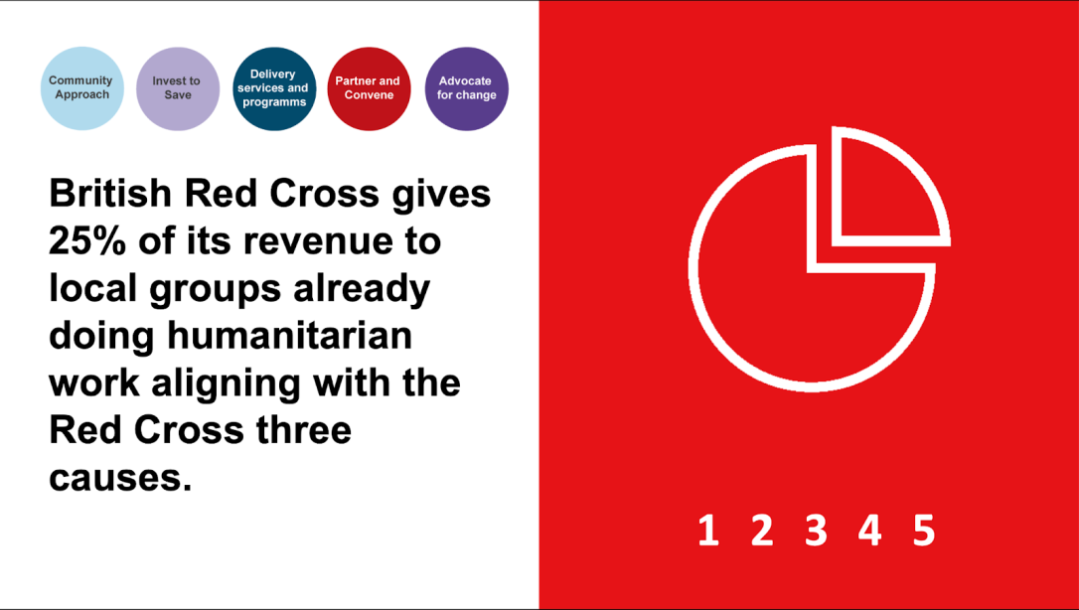
Image 1: Community Engagemnt of British Red Cross
(Source: Scholz et al., 2018)

Reflection on British Red Cross’s workings and differences with others:
British Red Cross is one of the most renowned and oldest serving non-profitable trustees who helped the organization in many ways over the years and continues to do so for the betterment of mankind. British Red Cross is involved in several activities from doing charity to many more for the society. Since British Red Cross is a popular organization across the globe, many people across the globe are associated with this organization to contribute more funds so that British Red Cross can serve more for the people and do better work for the people of the society (Atkinson, 2017). Other organizations which come popular in order to do charity or in the fund-raising programs of them building trust to the people’s mind is one of the most difficult tasks. For the fund-raising events British Red Cross is looking to organize a fundraising event in order to help the potential sportsperson who do not have the facility and through these fund-raising events, the fund-raising project will officially start. After that people can contribute their part at any time in virtual mode.
British Red Cross is different in many ways compared to others. Because:
- British Red Cross is a popular non-profitable organization. Thus, they have a large number of members across the globe who regularly donate for the organization to do social cause. This makes Red Cross organization a different compared to others.
- British Red Cross is different than other organizations in many ways. They have that expertise regarding doing those work for several years. Thus, implementation of those work would be easier for them. Hence, it can be said that British Red Cross will be able to do this work in an efficient way.

Role of effective communication, stakeholder’s participation and inclusion in community engagement program:
In any community engagement program, the participation of all the parties along with having effective communication between each other is important. In order to make the event or the project a successful one, all the stakeholders of the organization should take part and give their valuable feedback. To do such charitable work and make those kinds of projects successful, British Red Cross has to take part in the community engagement programme and have to make people aware about the projects along with the benefits of their projects (Mytton et al., 2017). Having a clear idea about the project among the public helps to raise funds as people will willingly donate money for a good cause.

Way of doing research for the programme:
British Red Cross organisation conducted various secondary research methods to be aware of the lack of recreational facilities in the United Kingdom. They also had recruited some field agents to verify the condition of sports in families with lower incomes in the United Kingdom. This primary research helped the British Red Cross organisation to gather information about those children and adults who are enthusiastic about different sports but they don't have proper facilities and funds to carry on with passion. British Red Cross organisation conducted another set of secondary research to find out the actual amount and facilities needed to give all of them a push towards success (Olson and Brennan, 2017). These researches helped the organisation to create the event successfully and also helped the needy sports persons.

Community mapping:
Community mapping is a kind of information gathering program that helps the organisation to find out the needy person and possible sources of funding from society. The British Red Cross is a medium which used to conduct this kind of fundraising and events to help the needy person without any discrimination and purely based on talents. So the organisation had to find out those who are really talented in sports and needed some funds and facilities to go forward (Barry et al., 2018). That is why community mapping was necessary for the British Red Cross. Another part of community mapping is to find out who can give resources voluntarily for this noble cause of recreational activities. This will help the organisation to find out sources of funding that can come from various parts of the world.

Impact of Social media platforms:
Social media platforms are the most powerful tool in spreading awareness about fundraising and the event. In this Covid-19 crisis, physical fundraising is not possible in any scenario, and that is why the British Red Cross organised online fundraising which will directly go for the help of various needy meritorious sportspersons. Social media platforms of the British Red cross have shared the information contained with reasons for fundraising, ways of fundraising, payment methods and how those funds can help the organisation to provide financial care to the sportspersons. Millions of social media users have already shared those posts related to the event and billions of users can view those posts worldwide (Steinmetz et al., 2021). That helps the organisation procure resources for better results of the event. The Internet is the most powerful weapon to spread any news and information about something good in society. British Red Cross is using that power to engage more and people of the community to conduct that event.

Overall impact analysis:
Sports are recreational ability that can keep any person fit and free from diseases. Fitness is the most precious wealth which any person needs to procure for a better future. But there are many families and persons, who are not, bothered about fitness and mental health issues. This is not a proper way of living and the British Red Cross organisation is trying to remove that mentality from the people with lower incomes (Martinez et al., 2018). Successful completion of the fundraising event will assure solutions to malnutrition issues and fitness issues of a part of the United Kingdom population. Many meritorious sportspersons are there in the society but no one notices because of this lack of resources. Recreational activities are reducing as the members of the society are getting busy with their jobs and businesses, no one is thinking about the recreational aspects. British Red Cross is trying to fix things for proper evaluation of recreational activities and sports awareness.

Evaluation and justification of best practices:
Best practices for fundraising events cannot be anyone's approach or two. There can be several ways by which social welfare can be done by any organisation or any individual. The way of British Red Cross organisation helps needy and meritorious sportspersons is nothing new, but effective (O’Neill, 2020). Via online sources and social media platforms, the fundraising options can be spread to the world which is a very effective way of gathering funds. The one-day sports event organised by the British Red Cross, is the perfect way of evaluating the merits of those sportspersons who are not able to procure costly proteins and food supplements. These ways of doing social welfare are fully justified also as unused resources and funds can be utilised to create a better future and opportunities for the nation.
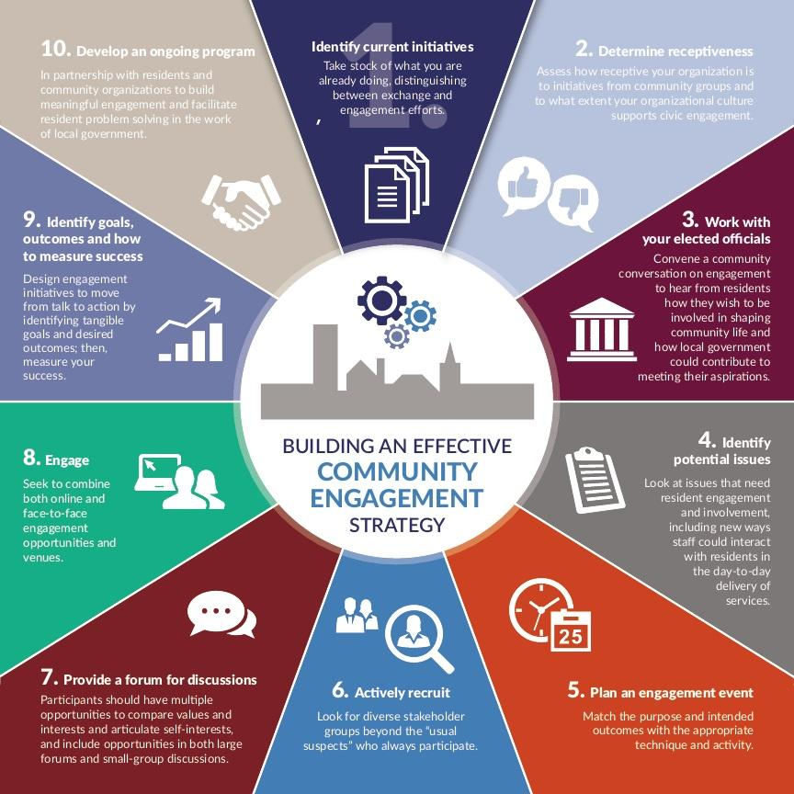
Image 2: Community Engagement
(Source: O’Neill, 2020)

Conclusions & Recommendations:
There are few recommendations which can be made in favour of the British Red cross-organisation to make the events more fruitful and successful.
Recommendations:
- The organisation should conduct more primary research in constructing the community map, as there can be many persons who deserve to be there in the list of beneficiaries.
- The organisation should allow referral systems by which the beneficiary circle can grow more to accumulate a large number of the country's population (O’Neill, 2020).
- The organisation should conduct this fundraising with maximum transparency possible. Fundraising is one kind of handling public funds without any assured benefits. That is why the organisation should look into the transparency and no corruption policy for making the event successful.
- The organisation should not think about their profits at any point in time, as they are working for the social welfare purpose only. So there is no way to get any profits from the public funds.
- The British Red Cross should recruit more field agents who can give a piece of proper knowledge about the social condition and needs of the society so that this type of event can be organised often for overall social welfare (Corbett and Lydon, 2018).
In this reflective assessment, the program or event of fundraising to eliminate the lack of recreational activities are analysed which is done by British Red Cross society. The comparison is also done with a similar kind of program done by The Charity Aid Foundation. Differences between their approaches are also discussed here to get the point of view from both organisations. The role of effective communication and stakeholder's participation is also elaborated here for better understanding. Community mapping, the importance of social media are discussed for getting a better view of social welfare issues. To conclude it can be said that both the organisations are doing their level best for encouraging various community challenges which can bring a better future tomorrow for the next generations.

References
Journals
Atkinson, M.L., 2017. Northern Voices of the Great War: Personal Perspectives and Narratives from Northern British Columbians. Northern Review, (44), pp.355-370.
Barry, M.M., Clarke, A.M., Morreale, S.E. and Field, C.A., 2018. A review of the evidence on the effects of community-based programs on young people’s social and emotional skills development. Adolescent Research Review, 3(1), pp.13-27.
Corbett, J. And Lydon, M., 2018. 5. Community-Based Mapping: A Tool For Transformation. In Learning and Teaching Community-Based Research (pp. 113-134). University of Toronto Press.
Martinez, L.S., Carolan, K., O’Donnell, A., Diaz, Y. And Freeman, E.R., 2018. Community engagement in patient-centered outcomes research: Benefits, barriers, and measurement. Journal of clinical and translational science, 2(6), pp.371-376.
Mytton, J., Booker, M., Bowen, L., Davies, B. and Baxter, H., 2017. The role of first aid education to support people attending urgent care services.
O’Neill, M., 2020. Increasing community engagement in collective impact approaches to advance social change. Community Development, 51(1), pp.17-35.
Olson, B. And Brennan, M., 2017. From community engagement to community emergence: The holistic program design approach. The International Journal of Research on Service-Learning and Community Engagement, 5(1).
Scholz, S., Knight, P., Eckle, M., Marx, S. and Zipf, A., 2018. Volunteered geographic information for disaster risk reduction—the missing maps approach and its potential within the red cross and red crescent movement. Remote Sensing, 10(8), p.1239.
Steinmetz, C., Rahmat, H., Marshall, N., Bishop, K., Thompson, S., Park, M., Corkery, L. And Tietz, C., 2021. Liking, Tweeting and Posting: An Analysis of Community Engagement through Social Media Platforms. Urban Policy and Research, 39(1), pp.85-105.
Wall, A., 2018. A qualitative exploration of reflective practice groups in British Red Cross services (Doctoral dissertation, University of East London).
Wukich, C. and Khemka, A., 2017. Social media adoption, message content, and reach: an examination of Red Cross and Red Crescent national societies. International journal of emergency management, 13(2), pp.89-116.

