An Investigation on the effects of multi-layer charge liners on EFP formation and performance

Research Proposal
Samuel Page

Contents
Figures 3
Tables 3
Abbreviations 3
1. Introduction 4
2. Background to the Proposed Research 5
3. Aims & Objectives 7
4. Experimental Design 8
4.1. Outline of Experimental Procedure 8
4.1.1. Independent Variables 8
4.1.2. Dependent Variables 8
4.1.3. Control Variables 8
4.2. Data Collection 8
4.3. Data Evaluation 9
4.4. Risks & Limitations 9
4.4.1. Risks 9
4.4.2. Limitations 9
4.5. Ethical Issues 9
5. Resources & Planning 10
5.1. Resources Required 10
5.1.1. Physical Resources 10
5.1.2. Human Resources 10
5.1.3. Other Resources 10
6. References 11
7. Bibliography 12
Annex A 13

Figures
Figure 1 - Diagram of a dual-layer liner for Shaped Charges
Figure 2 - Tandem EFP Formation, Simulation, and Imagery

Tables
Table 1 - Gantt Chart

Abbreviations
SC – Shaped Charge
EFP – Explosively Formed Projectile
COTEC – Cranfield Ordnance Test and Evaluation Centre
ERA – Explosively Reactive Armour
AT – Anti-Tank
AS – Anti-Structure
DLSC – Dual-layer Shaped Charge
APV – Armoured Personnel Vehicle
PE4 – Demolition Plastic Explosive 4
TBC – To be confirmed
CD – Cone Diameters
XO – X-ray Operator
RPS – Radiation Protection Supervisor
Cu – Copper
UWTSD – University of Wales Trinity Saint David
TCO – Trials Conducting Officer

Introduction
Previously, research has been carried out on the use of dual layered SC liners to either enhance penetration or to enhance behind armour effects [1]. An example has been provided in Figure 1. Extensive research has been conducted on SCs, however, there is a limited amount of research on dual liner EFP warheads. EFPs can be used for a wide range of applications so to fill a gap in knowledge, this research will begin to form an understanding of the effect these multi-layer liners have on EFP formation and performance. It is believed that the penetration ability will be enhanced, however, this research should inform an understanding of the effect and limitations to this technology.

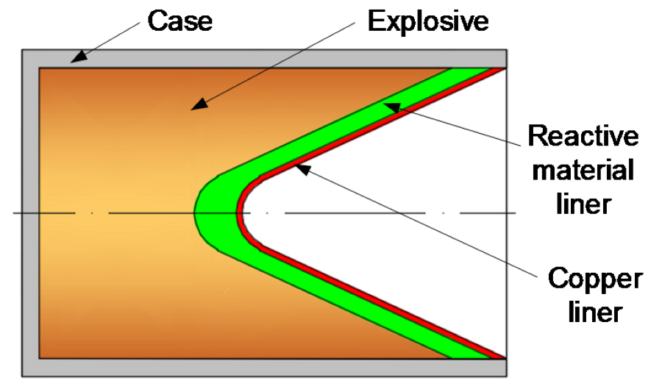
Figure 1 - Diagram of a dual-layer liner for Shaped Charges [2]

Background to the Proposed Research

With the increasing number of concrete structures and the up armouring of combat vehicles with defences such as ERA, there has been a focus on improving the penetration performance of AT and AS munitions such as SCs and EFPs [3]. There have been many approaches to SCs such as the addition of multi-layered liners with a sintered reactive secondary layer on an outer non-reactive copper liner [4]. Another way of trying to enhance the penetration performance of SCs was to develop a DLSC. This has a co-axial high velocity of detonation explosive encasing a low velocity of detonation explosive overdriving the detonation due to interference of the shock waves [5]. Replication was difficult however, due to the particulation of the SC jet [5]. Due to the relative scarcity of warheads utilising EFPs, little research has been put into how multiple layered liners might affect the EFP formation and penetration. EFP warheads have been used to great effect on structures and APVs in conflicts such as Iraq [6]. EFPs also exhibit much greater stability and penetrative ability over much greater standoffs than SCs [6].

Some limited simulation works using AUTODYN-3D and LS-DYNA have been carried out to simulate the potential effects of having layered liners on EFPs and have shown the potential for a tandem penetrator arrangement to form with the front EFP travelling at greater speeds to the EFP following behind [3]. With limited experimental work having been carried out and poor imagery of the EFP, it can be difficult to understand why this velocity difference exists. This is shown in Figure 2.
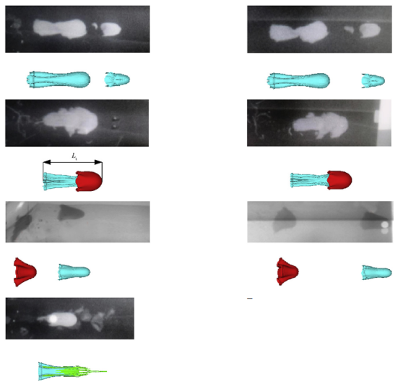
Figure 2 - Tandem EFP Formation, Simulation, and Imagery [7]
Theoretically, formation and separation occur in four stages, the impact phase, propulsion phase, slide phase and free-flight phase [7]. The axial and radial impacts are most likely to have an influence on the formation of the EFPs before they separate [7]. This research will seek to support these claims along with the bigger picture whilst capturing better imagery of the EFPs using flash x-ray to analyse the in-flight stability and formation. Figure 2 shows that the in-flight stability looks to be irregular. Comparisons will be made between the conventional and multi-layer liners. Should there be unanswered questions arising from this research, more work will be required to investigate these.

Aims & Objectives

Aims:
- To investigate the relationship between layering charge liners and the ability to form a coherent EFP.
- To investigate the relationship between having layered charge liners and the damage ability of the resulting EFP (penetration depth and crater size).

Objectives:
- To obtain flash x-ray images of the resulting EFP’s produced from both conventional and multi-layer EFP liners,
- To evaluate the depth of penetration that can be achieved by multi-layer EFP liners into a known target when compared to conventional EFP liners,
- To evaluate the crater diameter created from impact into a known target by multi-layer EFP liners when compared to conventional EFP liners,
- To critically analyse the data sets to contrast and compare the efficiency of conventional and multi-layer EFP liners and to quantify the improvement in performance of multi-layer EFP liners (if any).

Experimental Design
A comparative approach will be employed for this research.

Outline of Experimental Procedure
- A steel target of size TBD will be positioned in line with the EFP warhead location,
- The empty charge cases (30mm calibre), complete with EFP liners will be weighed and this noted,
- Charge cases will be hand stemmed with PE4, the top sealed, labelled with liner material type and number,
- Stemmed charges will be weighed providing an explosive charge weight,
- These stemmed charges will be radiographed.
- Three initial firings will be conducted as a baseline using conventional single layer Cu EFP liners over a standoff TBC CD
- Three further firings will be conducted on warheads using double layer copper liners.
- Three further firings will be conducted on warheads constructed of two liners of dissimilar materials,
- 3 final firings will be completed with liner materials reversed.

Independent Variables
- EFP liner construction

Dependent Variables
- Depth of Penetration
- Crater size

Control Variables
- Explosive Type (PE4)
- Mass of explosive
- Volume of Explosive
- Standoff
- Target Material
- Charge Diameter
- Charge Length
- Distance between liner layers
- Means of initiation
- Firing Circuit
- Detonator position and orientation

Data Collection
- Pulsed x-ray
- Flash x-ray
- High Speed Footage
- Crater diameter
- Depth of penetration
- Any recoverable fragments

Data Evaluation
- High Speed Video will be used to obtain EFP velocity.
- The depth of penetration will be analysed and averaged out for each series of EFPs.

Risks & Limitations

Risks
- Health and Safety – There is the potential for significant physical harm to the investigator as the risks of handling explosives and explosive devices occur along with the use of x-ray.
- Data loss – Data may be lost through targeted attack or during data transfer.
- Human error leading to data loss

Limitations
- Hand stemming PE4 charges.
- Limitation on liner materials to be used.

Ethical Issues
This research is ethically low risk.

Resources & Planning

Resources Required

Physical Resources
- 12 no. Charge Cases
- PE4
- 21 no. EFP liners
- 4 no. steel targets

Human Resources
- XO (5 days)
- TCO (5 days)
- Senior Instrumentation Technician (5 days)
- Range Support (5 days)

Other Resources
- Range hire (5 days)
- X-ray equipment (5 days)
- High Speed Camera (5 days)
- Velocity Foils (24 no.)
A Gantt chart is provided in Table 1 in Annex A

References

[1] | W.-j. Dong, X.-W. Cheng, S.-K. Li, Q.-H. Zou and W.-Q. Guo, “Penetration Performance of W/Cu double-layer shaped charge liners,” Rare Metals, vol. 35, no. 1, pp. 184 - 191, 2016.
[2] | H. Wang, H. Guo, B. Geng, Q. Yu and Y. Zheng, “Application of PTFE/Al Reactive Materials for Double-Layered iner Shaped Charge,” Materials, vol. 12, no. 17, 2019.
[3] | F. Zhang, C. Zhao, W. Feng, C. Ji, S. Lin and X. Wang, “Numerical simulation study on collinear EFP from warhead with double layer liners penetrating into target,” Vibroengineering PROCEDIA, vol. 39, no. 1, pp. 133 - 138, 2021.
[4] | H. Zhang, Y.-f. Zheng, Q.-b. Yu, C. Ge, C.-h. Su and H.-f. Wang, “Penetration and internal blast behaviour of reactive liner enhanced shaped charge against concrete space,” Defence Technology, vol. 18, no. 6, pp. 952 - 962, 2022.
[5] | S. Jang, K. Yoo, H. Lim, H.-J. Choi, J. Park and K. Lee, “Experimental and Numerical study on jet properties and penetration of double-layered shaped charge,” Journal of Mechanical Science and Technology, vol. 34, no. 1, 202.
[6] | D. Dawe, “Behind Armour Effects of EFPs,” Cranfield University, Shrivenham, 2008.
[7] | H.-b. Ma, Y.-f. Zheng, H.-f. Wang, C. Ge and C.-h. Su, “Formation and impact-induced separation of tandem EFPs,” Defence Technology, vol. 16, no. 1, pp. 668-677, 2020.

Bibliography

[1] | W.-j. Dong, X.-W. Cheng, S.-K. Li, Q.-H. Zou and W.-Q. Guo, “Penetration Performance of W/Cu double-layer shaped charge liners,” Rare Metals, vol. 35, no. 1, pp. 184 - 191, 2016.
[2] | H. Wang, H. Guo, B. Geng, Q. Yu and Y. Zheng, “Application of PTFE/Al Reactive Materials for Double-Layered iner Shaped Charge,” Materials, vol. 12, no. 17, 2019.
[3] | F. Zhang, C. Zhao, W. Feng, C. Ji, S. Lin and X. Wang, “Numerical simulation study on collinear EFP from warhead with double layer liners penetrating into target,” Vibroengineering PROCEDIA, vol. 39, no. 1, pp. 133 - 138, 2021.
[4] | H. Zhang, Y.-f. Zheng, Q.-b. Yu, C. Ge, C.-h. Su and H.-f. Wang, “Penetration and internal blast behaviour of reactive liner enhanced shaped charge against concrete space,” Defence Technology, vol. 18, no. 6, pp. 952 - 962, 2022.
[5] | S. Jang, K. Yoo, H. Lim, H.-J. Choi, J. Park and K. Lee, “Experimental and Numerical study on jet properties and penetration of double-layered shaped charge,” Journal of Mechanical Science and Technology, vol. 34, no. 1, 202.
[6] | D. Dawe, “Behind Armour Effects of EFPs,” Cranfield University, Shrivenham, 2008.
[7] | H.-b. Ma, Y.-f. Zheng, H.-f. Wang, C. Ge and C.-h. Su, “Formation and impact-induced separation of tandem EFPs,” Defence Technology, vol. 16, no. 1, pp. 668-677, 2020.
[8] | J. Yin, J. Chen, Y. Han, C. Dou and J. Yi, “Numerical simulation on forming of triple-layer tandem EFP,” in 30th International Symposium on Ballistics, Long Beach, CA, 2017.
[9] | S. Lin, C. Zhao, F. Zhang, C. Ji, L. Zheng and M. Zhong, “Effect of material characteristics of explosive on formation of collinear explosively formed proectile from warhead with double layer liners,” Vibroengineering PROCEDIA, vol. 40, no. 1, pp. 107 - 112, 2022.

Annex A
Table 1 - Gantt Chart
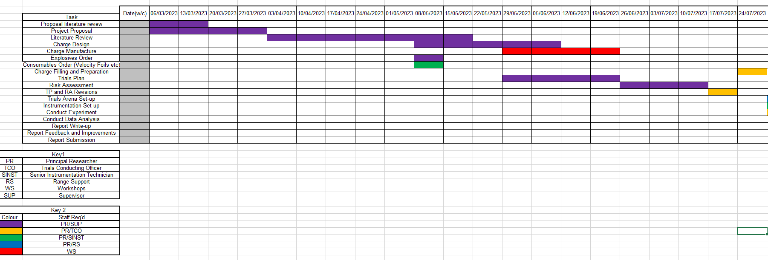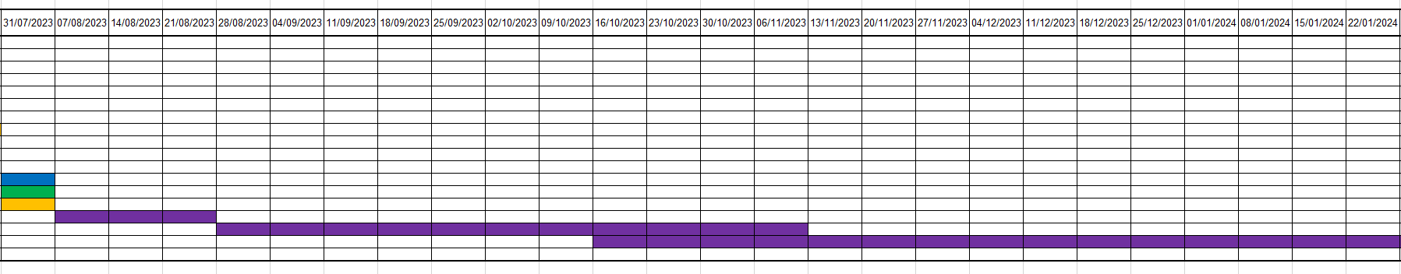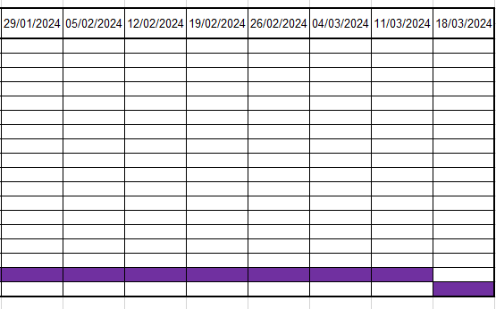

This research will also provide COTEC with the ability to conduct future research projects and will assist with the commissioning of a new digital x-ray imaging system.
Labelled on charge.
Using XR200 Pulsed X-ray
No other changes to be made.
Materials TBC
E.g., Liner 1 becomes liner 2. Before each firing, the target plate will be adjusted to present an undamaged surface.
To identify any voids in the main filling
This will be used to provide a detailed image of the EFP formation to see if it is coherent and to identify any separation within the EFP. High Speed Video Cameras could be used, however, the flash from the detonation and the detonation products may mask this.
EFP Velocity
This will be averaged over three measurements for all EFP’s and be compared to the conventional EFP with the results being presented as a percentage.
This will be presented as a percentage compared to the conventional EFP.
Should further effects be seen, deviations from this plan may be necessary.
All tasks will be operated in accordance with the COTEC range orders and procedures along with there being a 1-man risk when handling explosives. All personnel will be certified as competent, and all XO’s will be in overall control of the x-ray equipment in accordance with the ionising radiation local rules and will be authorised as competent to use the relevant pieces of equipment through the RPS.
Data will be backed up to the cloud, an external hard drive and stored solely on Cranfield University IT as well as Company Network Drives with restricted access. At no point will UWTSD IT be used to store or analyse data.
All personnel will be adequately trained in the operation of all instrumentation. Immediately before the firings take place, all instrumentation status’ will be checked to ensure it is ready to capture.
will always give a less homogeneous explosive filling than melt-cast, however, due to limitations on the capabilities of the test site, a melt-cast explosive filling isn’t practicable.
Where this is identified, an alternative material will be used where reasonably practicable.
No live subjects will be used human or otherwise, and no personal or sensitive data will be collected or processed.
3 no. single liner Cu, 3 no. double liner Cu, 3 no. double liner material TBC, 3 no. double liner material TBC in opposite order
1kg Total NEQ
15 no. Cu, 6 no. TBC
size TBC

