University of Wales Trinity St. David
School of Engineering

Identifying Major Accident hazards in a manufacturing process
Using Human Factors.

Bryony Stanfield
2008682
BEng (Hons) Manufacturing systems Engineering

Major Project
ACMA 6013

2023

Declaration

‘This thesis is the result of the author’s original research. It has been composed by the author and has not been previously submitted for examination which has led to the award of a degree.’


Signed: (Author)

Date: 18/05/2023

Non Disclosure Agreement
NDA UWT160523NDA - Between BAE SYSTEMS and University of Wales Trinity St David

Acknowledgements

• Kelvin Lake, Dissertation supervisor, for creative insights into the document creation and help guiding me through my dissertation.
• Arnaud Marotin for the support during the some of the more difficult times of my educational journey so far.
• Greg Owen and Arnaud Marotin for the support getting things back on track and putting up with my stress.
• Andrew Thorn for his expertise and guidance relating to manufacturing and processes.
• Helen Mansfield, for the knowledge and insight to Human Factors from her years of experience work for the Health and Safety Executive.
• Jason Davies, Head of SHE at BAE, for allowing me to create this report on the facility.
• Emma Davies and Holly Edwards for getting the NDA prepared and signed for this report.

Abstract.

This report demonstrates how the application of Human Factors can be used by Industry to identify potential Major Accident Hazards in the workplace. This is demonstrated by using a Human Factors Analysis, which highlights the potential failures that could arise during manufacturing. The document examines the reasons for this analysis, how it was to be conducted and how it was implemented.
The analysis used in this project is a process which looks at various types of interaction from visual, verbal and theoretical techniques. This is to help the human factors engineer gather as much information as possible to ensure that the analysis can be as thorough as possible capturing all the key elements in the process.
To verify the human failure analysis process outlined in the document, the report analysis will be put into practice to demonstrate the outcomes of the human failure analysis process. The report will also provide evidence of the human failure analysis systems robustness and how going forward the human factors team will apply this to the legacy processes onsite.
Incorporating results from the research conducted and data from the human failure analysis demonstrated the importance of gathering information from all parties and considering multiple key aspects of the work, equipment and personal factors.
Using the human failure analysis as a tool enabled the engineer to identify several improvements to the manufacturing process that would be used to mitigate against major accidents, these included recommendations to improve the human machine interface, safety declarations, identification of waste material routes/paths and safety critical equipment call-backs. These improvements would have been easily missed without the structured investigation that the tool dictates, and therefore was proven valuable and applicable for use on all legacy equipment on site.

Contents
Declaration 2
Acknowledgements 3
Abstract. 4
List of Figures 7
Abbreviations 8
Definitions 10
1. Introduction 12
2. Aims and objectives of the project. 16
Aim 16
Methodology 17
Thesis layout 19
3. Timing plan 20
4. Research 22
What is Human factors? 22
Swiss cheese model 24
Human factors in Medical sector 28
Human factors in passenger trains 30
5. Human Factors Analysis Process 32
Safety Critical Screening Process 32
Hierarchical Task Analysis 42
Walk through, Talk through 43
Operator workshop 45
Recommendations 46
Human Factors Analysis Report 46
6. Human Factors Analysis implemented 47
Screening the Explosive Material Disposal Area, Trays and Hearth 47
Hierarchical Task Analysis 49
Walk Through/Talk Through 50
Operator workshop 51
Operator responses 52
Recommendations 55
Site-wide Recommendations 55
Safety-systems & Barriers 55
Organisational Culture 55
Equipment 55
Site-wide actions 55
Process Specific Recommendations 56
Equipment 56
Safety systems & barriers 56
Supervision 56
Procedures/Checklists 56
Process specific actions 56
Human Factors Analysis Report 57
7. Discussion and conclusions. 58
8. Recommended further work. 59
9. Reference 60
10. Appendix 64
Appendix A – Screening question results 64
Appendix B – Complete Human factors analysis report 66

List of Figures
Figure 1 BAE Systems Land UK 14
Figure 2 Explosive Material Disposal Area 14
Figure 3 Gantt chart 20
Figure 4 Ergonomics and Human factors Chart (Ergonomics.org.uk, 2023) 22
Figure 5 Swiss cheese model (OHSA Occupational Health Services Australia, n.d.) 24
Figure 6 X-Ray identification markers (guest author, 2016) 29
Figure 7 AWS Magnet (Pandrol, n.d.) 30
Figure 8 TPWS Grid (Elmar Eye, 2005) 31
Figure 9 Hierarchical Task Analysis Level 1 49
Figure 10 Hierarchical Task Analysis Level 2 49
Figure 11 Hierarchical Task Analysis Level 3 49

Table 1 Swiss cheese causes 23
Table 2 Dirty Dozen 12 errors 25
Table 3 Supporting Documentation 31
Table 4 Screening question 34
Table 5 Q2 Quantity explanation 35
Table 6 Q3 level of separation explanation 35
Table 7 Q4 Significance of consequence if material is sensitised explanation 36
Table 8 Q5 Number of additional personnel in the area explanation 36
Table 9 Q6 Extent to which design could introduce human failures which could lead to a MAH explanation 37
Table 10 Q7 Immediacy of Consequence explanation 38
Table 11 Q8 Is there a likelihood of correction of human error explanation 38
Table 12 Q9 Type Classification of the potential error Explanation 39
Table 13 Q10 Does the process step require the defeating of safety critical protection devices explanation 39
Table 14 Q11 May safety critical protection devices be defeated through violation, error or lapse explanation 40
Table 15 Screening Criticality score 1 46
Table 16 Screening Criticality score 1.2 47
Table 17 Walk through, Talk through notes 49
Table 18 Hierarchical Task Analysis Revisit 1.1 52
Table 19 Hierarchical Task Analysis Revisit 1.2 53
Table 20 Site-wide actions 54
Table 21 Process specific actions 55
Table 22 Final Screening Criticality score 57

Abbreviations
ALARP - As Low As Reasonably Practicable
BoS - Basis of Safety
CMS - Competency Management System
COMAH - Control of Major Accident Hazards
COSHH - Control of Substances Hazardous to Health
EDAM - Engineering Delegated Authority Manufacturing
EHDS - Explosive Hazard Data Sheet
EMDA - Explosive Material Disposal Area
HF - Human Factors
HFA - Human Failure Analysis
HFE - Human Factors Engineer
HFRM - Human Factors Risk Manager
HH - High Hazards
HRA - Human Reliability Associates
HTA - Hierarchical Task Analysis
ME - Manufacturing Engineers
MI - Manufacturing Instructions
MAH - Major Accident Hazard
MSDS - Material Safety Data Sheet
PF - Process Flow
PFMEA - Process Failure Modes and Effects Analysis
PIF - Performance Influencing Factor
SHE - Safety, Health and Environment
SME - Subject Matter Expert
SOP - Standard Operating Procedure

Definitions

Hierarchical Task Analysis | - | A systematic way of decomposing a goal (i.e. process step) into the necessary tasks and sub-tasks required to achieve that goal. The analysis includes ‘plans’ which specify the order in which tasks and sub-tasks are carried out and any ‘pre-conditions’ for achieving the goal
Hierarchy of Control | - | A system used in industry to eliminate or reduce exposure to risk in the workplace
Human Failure Analysis | - | A systematic method for the identification and evaluation of the possible human errors that may be made during a process
Major Accident | - | An occurrence such as a major emission, fire or explosion resulting from uncontrolled developments in the course of the operation of any establishment to which COMAH Regulations apply, and leading to serious danger to human health or the environment (whether immediate or delayed) inside or outside the establishment, and involving one or more dangerous substances COMAH Regulations
Major Accident Hazard | - | Concerns the potential for a major accident
Major Accident Scenario | - | Addresses the circumstances that could lead to a major accident happening
Performance Influencing Factors | - | Characteristics of the job, the individual and the organisation that influence human performance
Process | - | The sequence of activities that produce a finished product. Many processes make up a product; each process will produce a sub-assembly and include a distinct set of steps
Step | - | A specific activity within a process e.g. breakdown of rejected product. Each step represents a distinct activity within a Standard Operating Procedure (SOP) or has a separate SOP associated with it
Task | - | A piece of work which an operator or technician is required to carry out in support of the steps within a process. Tasks can be broken down into progressively smaller units or sub-tasks

- Introduction

For BAE Systems to comply with Control of major accident hazards regulations (COMAH), there are several key safety points that BAE needs to meet. In order to maintain BAE’s Compliance with the COMAH Regulations, there are specialised individuals and process analytics that are deployed throughout the sites operational areas to ensure that all systems are safe and are compliant to the regulations. The area of focus for this report is, how Major Accident Hazards (MAH) are identified using Human Factors analysis.
This report details how to cover a manufacturing process using Human Factors analysis techniques to understand and identify potential Major Accident Hazards. Human Factors is the study of a human/individuals characteristics which could influence behaviours in a way that could potentially affect health and safety and create a dangerous environment for the person involved and/or bystanders. The whole aim of this project as a human factors engineer is to identify any MAH and rectify the issues by adapting equipment and the processes involved around the operator working in the manufacturing environment and capabilities of the person, rather than try to adapt the operator to the process, equipment, or environment.
The Control of Major Accident Hazards Regulations 2015 (COMAH) states that ‘The purpose of the COMAH Regulations is to prevent major accidents involving dangerous substances and limit the consequences to people and the environment of any accidents which do occur.’ (Crown, 2015)

‘COMAH applies mainly to the chemical industry, but also to some storage activities, explosives and nuclear sites, and other industries where threshold quantities of dangerous substances identified in the Regulations are kept or used.’ (Hid, 2003). Where in this case BAE Systems are an explosives site with a large amount of inventory, this makes BAE sit within the Top tier operators, this means that BAE are required to have a Major Accident Prevention Policy (MAPP), which must be included either as a separate document coupled with the safety report, or included as part of the safety report. The MAPP is a general statement of intent, and outlines company policy on the prevention of MAH’s with regards to prevention on site.

All top tier operators are required to produce a safety report to submit to the COMAH Competent Authority (CA). The reasons for the safety report is to show that the correct arrangements have been put in place for the control of major accident hazards on site and to eliminate the consequences to humans and the environment if a MAH was to occur.

Background to BAE Systems
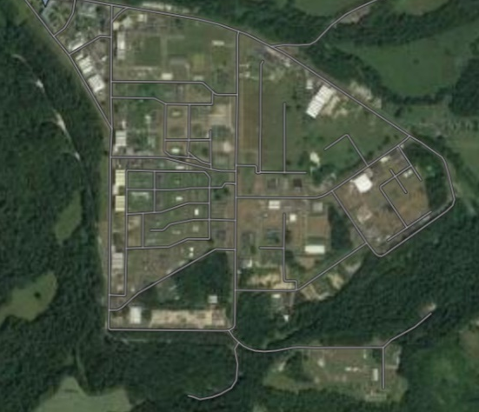
BAE Systems Glascoed facility is located in Monmouthshire, between Pontypool and the town of Usk. As seen in figure 1, the original factory was part of the British Government, when the Government planned to re-arm its military forces ready for World War 2. It was first known as the Royal Ordnance Factories (ROF's) contributing arms and ammunition to the war effort, which then changed to British aerospace and as it is today, BAE Systems Land UK.

Figure 1 BAE Systems Land UK
The report author is a Human factors support engineer. Previously they have worked alone based at Glascoed, but as of the past 3 months there have been new members added to the team to help with the sheer workload. Everyone is given their own work package to complete individually but with other members of the team around them it allows the engineers to gather more knowledge on a topic that may not be so familiar with themselves.
With regards to the report, all this work was completed alone unless needing senior permission from the High Hazard team manager.
As part of this report, the area that the author will be looking at in BAE Systems is the waste disposal area. This area processes some of the explosive waste that is generated on site. As can be seen from Figure 2, this shows a bird’s eye view of the area that is used to dispose of any waste. This area is called the EMDA, Explosive material disposal area. any waste. This area is called the EMDA, Explosive material disposal area.
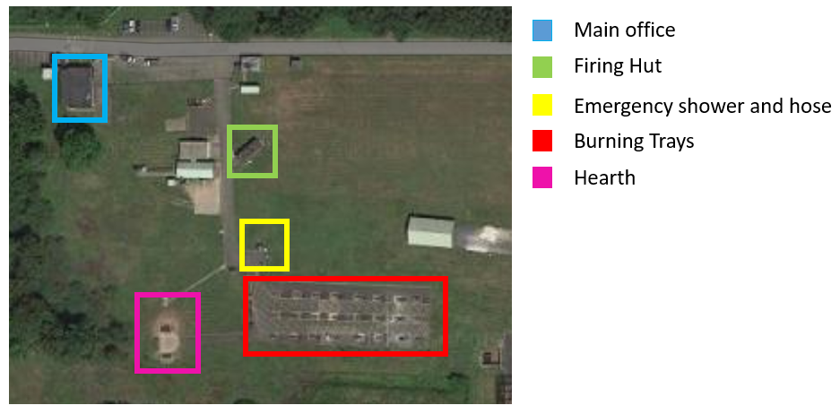

Figure 2 Explosive Material Disposal Area

Background to Human factors engineering

A human factors engineer is expected to conform to the following

- Reviews supporting documentation and familiarises self with process
- Undertakes HTA including walk-through/talk-through with operatives and maintenance personnel
- Inputs HTA into HFRM tool prior to running HFA workshops
- Identifies stakeholders for HFA and liaises with supervisors regarding access
- Sets up HFA workshop(s) with operators/technicians, and other relevant stakeholders associated with the process such as ME
- Briefs workshop participants on the HFA process
- Runs HFA workshop(s) using HFRM tool until all operator and maintenance tasks within process step(s) have been analysed
- Discusses outputs with stakeholders and agree recommendations
- Drafts HFA Report
- Liaises with EDAM and/or Process SME regarding recommendations and provides HF guidance during implementation
- Debriefs stakeholders e.g. operators, technicians, MEs on the recommendations and actions arising from the HFA

2. Aims and objectives of the project.

Aim

The aim of this work is to create a robust Human factors analysis process to ensure that Major accident hazards are identified and recommendations are put in place to make the process a safer environment for both operators and by standers. To test the Analysis, the process will be put into practice by analysing the EMDA Burning ground trays and hearth process.
The recommendations are based around two different types of recommendation, site wide and process specific, details below.

- Site wide recommendation
- Safety-systems and Barriers
- Organisational culture
- Equipment
- Process specific recommendations
- Equipment
- Safety systems and barriers
- Supervision
- Procedures/Check list

Why the business wants this project completed
The project is to identify MAH on processes which have been deemed safety critical by the HFE. This is a result of the business being a top tier COMAH site. Every 5 years the company must present a report to the HSE ensuring that the business is complying with COMAH regulation and adhering to any actions put against the company.

Objectives

This report has the following objectives

- Create a robust system to ensure that all aspects of the process are captured and any MAH are identifiable.
  - SCPS
  - WTTT
  - HTA
  - Operator workshop
  - Recommendations
  - HFA

- Implement the system to capture and potential MAH and highlight any safety critical tasks.
  - Assess the EMDA trays and hearth using the HFA process
  - Identify any recommendations for the EMDA process

Methodology

To fulfil the company needs/objectives highlighted above in 1, this report aims to follow the process detailed below to identify and recommend as itemised.
The first steps of the process are to cover a screening session with the relevant parties such as Manufacturing engineers, safety engineers and so on. This screening session will identify the SCT (safety critical task) in the process and will highlight that there needs to be a Human factors analysis undertaken.
The second step is the Walk-through, Talk-through. The walk-through, talk-through consists of the human factors engineer and the manufacturing engineer walking through the process as they give the HFE a running commentary. This step is where the engineer is able to overview the process, paying close attention to the SCT highlighted in the screening process.
The third step is the compile all of the information gathered into a HTA (Human Task analysis). This is where the HFE collates all the information and creates an analysis tree. This holds the task/step in the process and then highlights things such as, the error, consequence, influencing factors & recommendations.
Forth step is to conduct a workshop with the operators. This workshop is to get an understanding from the operator’s point of view whether or not they feel that the process is run safely, whether there are any steps that could be improved and if they are suffering any pressures and/or fatigue. This is where a lot of useful and important findings arise, due to the operators day-to-day interactions with individuals and equipment.

Fifth step is to create a recommendation session with the relevant stake holders. In this session the HFE will discuss the current process under review and highlight any recommendations from a HF perspective. This also allows the HFE to highlight any areas where they believe Lean activities could take place in order to make the workplace safer and potentially save time and money.
Once the recommendations session is complete and the relevant parties have agreed/disagreed to the action, these recommendations are then added to the OSHENS action tracker system and are given a time frame to be completed in.

Thesis layout

Section 2 – Aims and Objectives
Section 2 of the report introduces the aim and objectives of this dissertation. It highlights all the key aspects that the human factors engineer must comply with to ensure the work being carried out is to standard and capturing all relevant information for the analysis.

Section 3 – Time planning
Section 3 of the report shows the Gantt chart that was used to ensure that the Project was on plan to target or if there were any issues this would be logged and highlighted in the Gantt chart.

Section 4 – Research and Literature
Section 4 of the report contains research highlighting the importance of human factors in an engineering environment, and highlights just how important such simple features can make the biggest changes by giving wide engineering perspectives. This helps to give the report in the munitions sector a better chance of implement and receiving the buy in from other engineers in the manufacturing industry at BAE SYSTEMS.

Section 5 – Human Factors Analysis process
Section 5 of the report identifies all the sections which need to be hit to ensure that the human factors engineer has captured all the relevant information to create a successful HFA. The report also captures all Safety critical tasks as well as any MAH that could potentially occur.

Section 6 – Human factors analysis implemented
Section 6 of the report, the HFE will put into practice all the HFA structure highlighted in section 5. The HFE will produce a HFA on a process that is a live process running at BAE systems. The process that the analysis will be applied to is an explosives disposal area that destroys any waste or reject material.

Section 7 - Discussion and conclusions
Section 7 of the report confirms the findings and actions and any recommendations the HFE feels that need attention and any that need addressing.

Section 8 – Recommended further work
Section 8 contains the future work suggested as a result of this report.

Timing plan

Below details the Time frame which the project is to be completed by and breaks down each section to show the flow of the process and also time taken to complete each individual task.
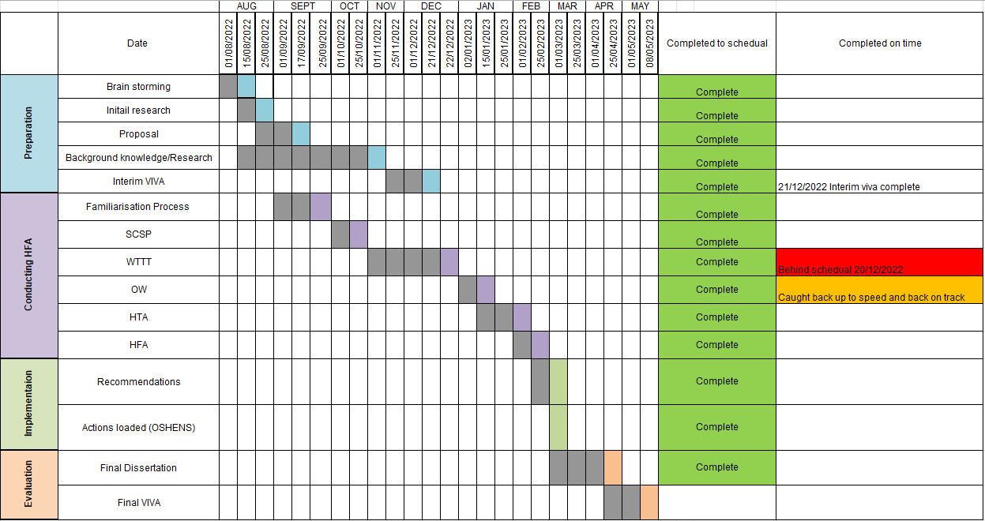
Figure 3 Gantt chart
The Gantt chart shown In Figure 3 is a time keeping tool that was used to keep track of the project through its process to ensure that the project was running on time and if not, highlight if the project is running late and if so why, was it an engineering issue? Personal safety issue? and so on. As highlighted in section ‘Conducting HFA’ there were two tasks that caused the project to fall slightly behind, the main issue was a personal safety issue stopping the WTTT being conducted on time and therefore pushing the operator workshop back. The cause was that the emergency water supply froze due to sub-zero temperatures overnight. This caused the process not to have any emergency water, things such as hose pipes and also emergency showers. Due to this, if the process was to run they would be running out of compliance and also have no emergency response to some incidents occurring.
Preparation
The preparation for the project covers the ideas which the report author considers, research of the topic, the proposal which the author had to submit to get the go ahead to continue with the topic covered in this dissertation and the interim viva which will give a brief overview of my dissertation.
Conducting HFA
This section ‘conducting HFA’ is the biggest section of work, this covers the whole Implementation of the Human factors analysis. Which is detailed in this report.
Implementation
The implementation stage will consider all recommendations being applied to the process and the agreed recommendations of the process being formalized by added to OSHENS, a reporting system used by BAE systems.
Evaluation
The evaluation section of this report will cover the finalisation of this report along with the Final Viva which will be presented to capture the findings of this report ‘Identifying Major Accident hazards in a manufacturing process Using Human Factors’.

Research

Human factors are the key elements of this report, below is an outline as to what HF is. This gives an outline as to why it was chosen as a method by which to conduct analysis on human interaction with processes on site.

What is Human factors?
Human Factors is defined by HSE as "Environmental, organisational and job factors, and human and individual characteristics, which influence behaviour at work in a way which can affect health and safety"
(Health and Safety Executive, 2019)
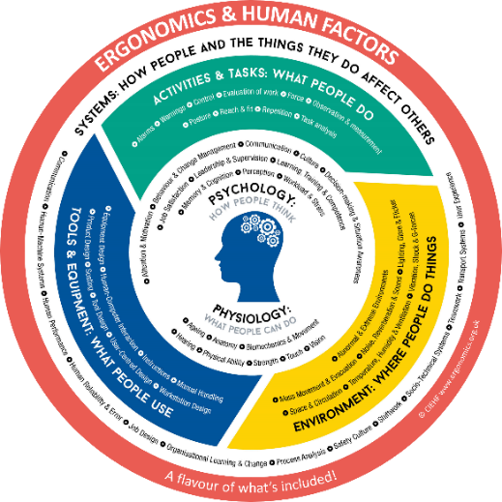
Figure 4 Ergonomics and Human factors Chart (Ergonomics.org.uk, 2023)
The three aspects which can be seen in figure 4 that make up the definition of HF must be considered in this report.
- The Individual – The skills and competencies of the individual, their attitude, perception of risk, and their personality. These characteristics have the ability to greatly affect behaviour whether working alone or with others. Certain characteristics cannot be changed, however some can be altered and improved.
- The Organisation - This can include but is not limited to, work cultures, shift patterns/rosters, hierarchal communication, physical resources (tools, machines, documentation) and management. These factors are sometimes not considered when designing processes or positions, but can greatly influence the work ethics, effectiveness and behaviour of all personnel.

- The Job – The environment or workstation, amount of work, task nature, the coherence of controls, displays and interfaces and the responsibility of the personnel. All of these considerations must be taken into account when designing a process or role and developed around the ergonomics of the individual. This includes the strengths, limitations (both mental and physical) and abilities of the person. When considering the mental limitations, these include, attention, decision making and perception.
The role of Human Factors assessment will not be as effective if only considering one of these aspects and characteristics at a time. HF is most effective when considering all of these aspects, and how they interrelate. When all of the factors are looked at together and how they all correspond, then HF analysis can be at its most effective. Deployment of effective HF analysis will aid risk control and help to improve safety management systems

Swiss cheese model

The Swiss cheese model is a guide which is set to help many engineers but in this case Human factors engineers to identify the root cause and help create a stronger safety culture across industries. The idea of the Swiss cheese model is to help industries understand that if in each layer of cheese one hole lines up through all this could potentially result in a non-favoured event. This is where Human factors engineering assess the situations/processes and try to prevent/mitigate the risk.
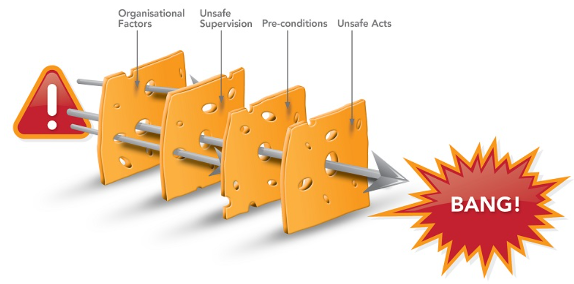
Figure 5 Swiss cheese model (OHSA Occupational Health Services Australia, n.d.)

In Figure 5, The Swiss cheese model there are usually four sections that are considering before the potential harmful event could occur.

- Organisational influences
- Supervisory factors
- Preconditions
- Unsafe acts

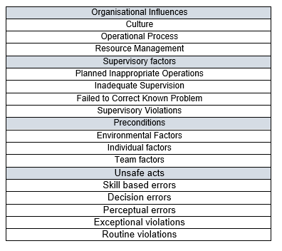
These four categories shown in table 1 are then broken down to highlight issues that occur under that umbrella.

Table 1 Swiss cheese causes
Human factor in Aviation sector

Human Factors in aviation plays a critical role. Learning from past failures, human factors helps to find the wrong answer before finding the right. There are two tools which are used to train pilots and help them understand how human factors comes in to the aviation sector. These two tools are PAVE and Dirty Dozen.
PAVE is a check list that is used to check for the risk factors, which is the building blocks of Human Factors. But within the aviation industry there is one more factor that needs to be accounted for in addition to the three fundamentals, which is the external pressures.
The four areas are

- Pilot
- Aircraft
- Environment
- External factors

The pilots will use this tool to help identify risks and in turn this tool should help them mitigate them.

- The Pilot is seen to be the greatest risk in flying the aircraft. There are many factors that could cause the pilot to initiate a problem or create a risky situation. As stated in the dirty dozen list below. There is a safety declaration check list that the pilots use before flight to sure they are in tip top condition to fly the aircraft. This check list is called the ‘I’M SAFE’ check list. The ‘I’M SAFE’ check list looks at the key points, Illness, Medication, Stress, Alcohol, Fatigue, Emotional Health.

- The aircraft is the next thing to look at, this would account for the tool, the tool which the pilot using to conduct their job. Is the aircraft suitable for the job? Is it performing correctly? Is it due a service or due maintenance? Are the fuel levels correct? Any questions like this are things that should be considered when thinking of the aircraft as the tool.

- The environment is the aircrafts environment this includes things such as weather conditions, visibility, air traffic. Weather conditions are predictable but are constantly changing meaning that the pilot needs to be trained to a high standard reading and understanding weather systems, it is also important that they know how to avoid situations such as turbulence.

- The external pressures is the environment that could be affecting the Pilot themselves. Could be that their line manager or boss is pressurising them to work over their hours to get the job complete, not enough rest between flights or rushed flight scheduling. As trivial as these points may seem this can cause a huge amount of stress on the pilot and will then affect their performance and decision making.

The PAVE check list is an example which is used in the aviation industry to help pilot and their team ensure that they are fit to fly and are ready for any situation which may occur. Working in hand with the PAVE check, Pilots are taught the various danger patterns which could occur in any one of the four discussed above.

HF training in Aviation is taught by helping workers identify the dangerous patterns which occur calling them the ‘Dirty Dozen’.
The ‘Dirty Dozen’ highlights twelve different causes that could potentially initiate a failure. This is mainly focused on Aviation but is a very useful list to think about when conducting a human failure analysis in any industry.

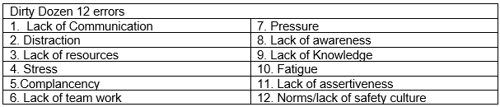
Table 2 Dirty Dozen 12 errors
The twelve errors highlighted in table 2 are the errors that can cause humans to make mistakes, this is not the extensive list, but this list helps workers in the aviation industry to narrow down reasons why the errors may occur in the first place. Over recent years this list has become a common tool within the aviation sector reaching the likes of air traffic control and workers on the ground.

Human factors in the aviation industry really highlights that training and safety declarations are a key factor to ensuring the safety of the pilots and the team controlling and maintaining the aircraft. This helps the employees understand that humans are prone to errors, but these can be mitigated by implementing the methods detailed above.

Much like the factory in this report, it is highly important that operators, engineers and senior management understand the importance of the safety culture and the importance of safety steps being implemented and adhered to during all processes on site.

Human factors in Medical sector

Identification markers

Implementing human factors into health care is all about improving and developing medical practices by taking into consideration the effects of the work environment, individual and team ethics, machinery and equipment, the application of skills and knowledge for medical application and attitudes within the organisation and these effects on individuals. Quality and reliable healthcare is the embodiment of the NHS. It has been developed to be accessible to all, meaning that should be without charge at the point it is needed. It should be effective for the patient, safe and should be a positive experience overall.
Implementing such a quality driven healthcare system can cause individuals, teams and organisations to be put under pressure. This creates issues for employees, making difficult decisions can intensify situations, meaning that their decision making can be impaired. Any kind of impact on their decision making can cause poor performance, impact quality and cause errors and complications.

An example of human factors implementation in a radiation department is the identification of patient’s images. The tool that is used to help the X-Ray staff complete their job to a high standard is by using Lead X-Ray markers also known as Pb markers. These markers are used to produce accurate and clear X-Ray images as shown in Figure 6.
The purpose of Pb markers is to ensure that the correct body part is being x-rayed and to ensure the clarity of the image. For example markers such as ‘LEFT’ or ‘RIGHT’ will be used to identify which side of the body has been x-rayed. These markers will be clearly identified on the image and will help prevent any mistakes or confusion when coming to view the image with a doctor and will give the doctor piece of mind that the image is clear due to the lead idents being seen on the image.
As in many jobs, ensuring that the correct product has been identified can be crucial. As with health care, identifying the incorrect body part could result in the patient receiving a procedure which was not necessary.
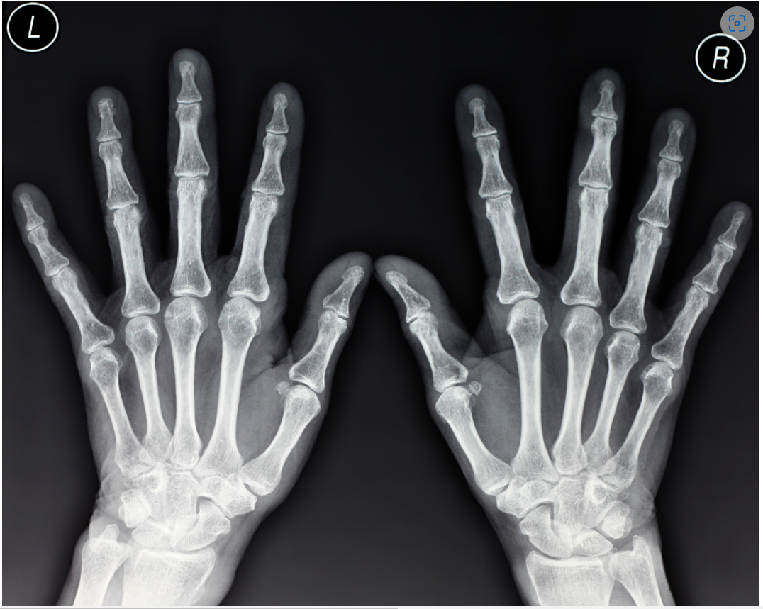
Figure 6 X-Ray identification markers (guest author, 2016)
Human factors in healthcare helps to prevent mistakes due to lack of information or misjudged decisions, ensuring the wellbeing of patients in care and assisting healthcare professionals during difficult scenarios.
The importance of correct labelling in healthcare is directly comparable to the need for optimum labelling for materials and instructions on the processes detailed in this report.

Human factors in passenger trains

A great example of implemented safety controls can be found on the railway. Much like an operator running a machine, or in the sorting of a process, it is important that the individual remains ‘engaged’ with the task that they are performing. Warning systems have been present on the railway since the late 1800’s, they were crude, but for the time, effective.
For example, if a train was approaching a signal showing ‘Red’, a lever would be deployed on the side of the track that would interact with the steam engine, alerting the driver who would then acknowledge this alert.
Things have moved on since then, and technology has allowed companies to not only add multiple layers of safety, but also to condense these systems into a compact, versatile information panel.
One of the most simple safety features inside all UK Train cabs, is the ‘dead-man’s pedal.’ This pedal acts much like the engine cut-out on the seat of a sit-on lawn mower, so when pressure is released from the pedal, the system will enter a safety cut-out, bringing the train to a stop through a combination of braking and throttle release.
Other Fail-Safe features include;
AWS – Automatic Warning System, Figure 7, This consists of a permanent magnet and an electromagnet mounted to the track. When a signal shows Red, the electro-magnet is not energised, meaning that when the train passes over it, the magnetic field is detected, and a horn sounded to the driver via the In-Cab HMI. The driver then acknowledges this Horn by pressing a button on the panel. If a Green signal is lit with the train approaching, the electro-magnet is energised, which ‘supresses’ (weakens/cancels out) the permanent magnet. This weaker signal is detected again by the passing train, and the In-Cab HMI sounds a Bell, the driver also acknowledges this alarm, but proceeds at normal line speed. Failure to acknowledge either of the alarms will apply the brakes on the train, bringing it to a stop.
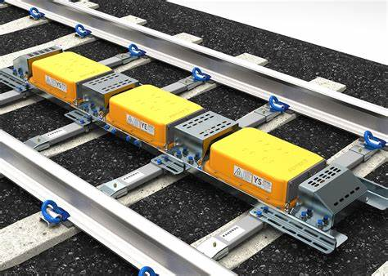
Figure 7 AWS Magnet (Pandrol, n.d.)

TPWS – Train Protection Warning System. An advancement on the AWS, TPWS does not replace AWS, but works alongside it. TPWS grids shown in Figure 8, project a frequency up towards the underneath of the train. This is detected by the TPWS Receiver on-board and relayed to the Drivers HMI. TPWS is ONLY energised/active when a signal is showing a Red light, and there are two types of TPWS in use in the UK, these are:
TSS – Train Stop System. The TSS is placed directly in line with a signal. When energised, if a train passes the TSS, it will apply the brakes permanently. It can only be released through a collaboration between the Train Driver and the Signaller.
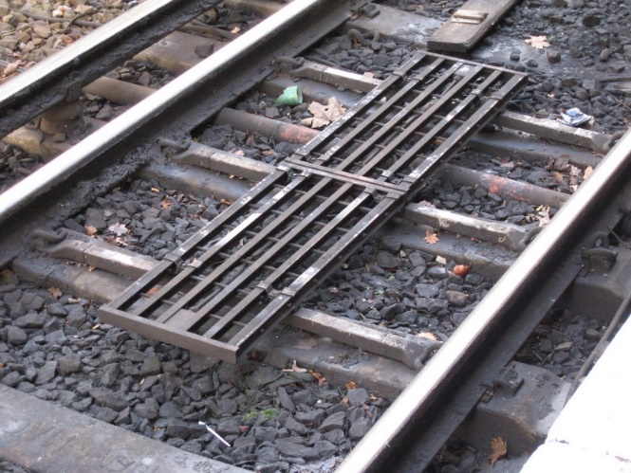
Figure 8 TPWS Grid (Elmar Eye, 2005)

OSS – Over Speed System. The OSS works exactly like an average speed camera on the motorway and the train timed between these points. If the HMI detects that the train is moving too quickly, it will apply the brakes for around 30-60seconds to lower the speed. TPWS is also Fail-Safe, ignoring alarms will bring the train to a stop.
Finally, there are very simple safety interaction alarms that require the driver to press a sequence of buttons and lights in order to prove consciousness when moving. This is especially useful on long sections of high-speed rail, where there could be sustained periods of inactivity due to low numbers of signals between stations.
Human factors in the rail industry show that HMI prompts and alarms are key features to ensuring the safety of drivers, passengers and infrastructure.
Much like the HMI integrated into the machines and processes detailed in this report, interactions are vital to ensuring the operator remains vigilant whilst the process is running.

5. Human Factors Analysis Process

Safety Critical Screening Process

The screening process has been developed to enable the business to comply with COMAH Regulations 2015.
The requirements for the process are two-fold: firstly, to help the business determine the safety-critical steps within its processes and secondly, to facilitate the prioritisation of these steps for further analysis, enabling the business to target its HF resources on these steps in its HFA delivery plan.

Identify HFA Required
The process for identifying and prioritising safety-critical process steps across the business states that Safety-critical process steps of operational and maintenance activities where any human action or inaction could initiate or fail to control or mitigate a Major Accident Hazard (MAH) must have a HFA conducted, as defined in COMAH Regulations 2015.

The outputs from this screening process shall identify and prioritise those process steps where Human Failure Analyses (HFAs) are required to support the business in its provision of a Basis of Safety (BoS) Certificate of Manufacture.

Review Process and Supporting Documentation
Once allocated a process on which to undertake the HFA, the Human Factors Engineer shall familiarise themselves with the process, including a site visit if required. The HFE shall liaise with the EDAM and/or Process SME to arrange access to the relevant operations and/or maintenance stakeholders and supporting documentation, Table 3.
This documentation to be reviewed will include:
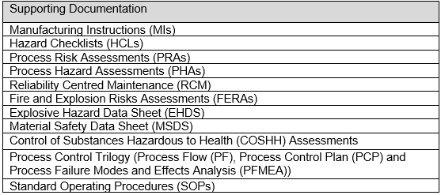
Table 3 Supporting Documentation
These documents, together, should provide enough information for a thorough task breakdown and should also contain information on potential human failures and consequences of these failures.

Preparation for Screening Workshop

Having identified a process to be screened, the HFE shall arrange a screening workshop(s) with appropriate stakeholders. For the screening of operational activities, personnel present should include the Manufacturing engineer/Technical Authority (TA) for the screening of process activities.
Prior to attendance at the workshop, the HFE should review supporting documentation (including process flows, SOPs, Process Risk Assessments, Process Hazard Assessments, Reliability Centred Maintenance, SAP Task Lists, Fire and Explosion Risks Assessments, Explosive Hazard Data Sheets, Material Safety Data Sheets and Process Control Trilogy) to familiarise themselves with the process and product/component produced.

What is the screening tool?

The screening tool is in the form of an excel spreadsheet and includes a series of diagnostic questions designed to assess the extent to which a process step could lead, or contribute, to a MAH. The reason that the excel spreadsheet was chosen to complete this task was the ability to include macros into the sheet. This allows the form to be more user friendly and helps the HFE calculate the process with its integrated ‘HFA required’ and ‘Criticality score’.

These questions assess a number of factors to determine the safety-criticality of a process step including:

• Type and amount of hazardous material
(Including energetics, non-energetics and articles)
• Level of separation between the operator and the process step
• Opportunity for the sensitisation of energetics/articles
• Number of operators involved, both directly or indirectly
• Impact of human failure
• Potential for the defeating of safety-critical protection devices.

What level of detail does the tool assess at?

The tool assesses at the process step level as defined in the SOPs; this gives enough detail to give granularity across the sites and processes, whilst not having to assess individual actions at this stage. Tasks and sub-tasks are assessed when a process step has been identified as requiring a HFA.

What are the outputs from the tool?

The screening tool provides two main outputs:

- The primary output from the tool is a list of process steps which have been deemed to be safety-critical and therefore require further investigation via a HFA.
- The secondary output from the tool is a prioritized list, ordered by criticality score, of all process steps for an area/building or a whole site. This list will include both process steps that do or do not require a HFA. The criticality score will be generated before and after the recommendations have been implemented and this will be the authors measurable of the project.

Screen process

Screening tool is a high-level questionnaire type activity based in excel which breaks down a SOP into process steps. Definition of process step is ‘a specific activity within the process’. Typically each step has a SOP associated with it (Glascoed old SOP system) or is a distinct section within a SOP (Glascoed SOP Manual & Radway Green)

Originally, HSE referred the business to Energy Institute Guidance on Safety Critical Task Analysis and suggested the customisation of HSE ‘OTO 5 questions’ approach to an explosives industry setting. However, when this approach was trialled with manufacturing engineers it received negative feedback. Their concerns were that it was too simplistic and subjective and failed to address the behaviour and quantity of hazardous materials.
As a result, a ‘process flow’ approach to the question set was developed with inputs from Manufacturing Engineers, Explosives Scientists, Chemical Engineers and Maintenance Engineers. This approach covers the same factors as the ‘OTO 5 questions’ but with more specific linking to data in risk assessments and is facilitated by a screening tool.

Each process step has the same set of 11 questions asked of it as seen in table 4. There are an additional 3 questions before question 1 which determine the appropriate starting point in the question set. The starting point is dependent on the presence of hazardous materials, the potential to sensitize a hazardous material, and whether or not the process step is for protection purposes or not. The descriptions of all 11 questions can be found below, Q1 to start and table 5 through to table 14 covering the remaining questions.

The 11 questions cover:

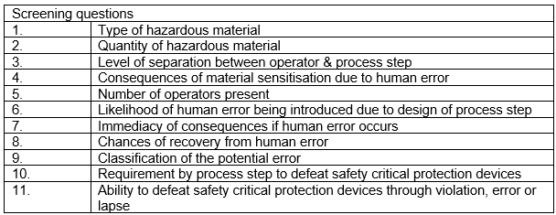
Table 4 Screening question

Explanation of screening questions
Q1 - What kind of hazardous materials are involved, either revealed or un-revealed?
The HFE first needs to determine if hazardous materials are involved in the process step. The HFE should pay particular attention to the possibility of hazardous materials being present when they should not be. For example, omissions in cleaning at the end of operations may result in some energetic material remaining in a machine or tool which the Maintenance Engineer/Fitter may not be aware of. This could create conditions for an initiating event. An example of this could be where operators clean down the equipment as part of their usual working practices yet due to the design or nature of that equipment hazardous materials may remain. Crevices, ports and seams could gather material quickly over a short period of time. Covers/guarding may need to be removed as part of inspection tasks or further cleaning. Where processes require an LEV, it may require duct inspection or filter replacement. Until the task is carried out it is not known if hazardous materials are involved.
Once it has been established that hazardous materials are involved in the process step, there are three options to choose from within question 1 in order to obtain a risk score for that material. Hazardous materials for the purposes of the tool have been classified as either:
• Energetic Materials
• Non Energetic Materials
• Articles (finished product)

Q2 - What quantity of substance is involved?
Once a material behaviour score is assigned, the quantity of that material present in the process step is assessed by question 2.
The quantity value is split into three options based on the extent of injuries possible with the amount of material being assessed if a MAH scenario developed.
Quantity is intentionally non weight specific in order for the assessment to accommodate highly energetic materials where only a small amount may result in multiple fatalities (which would be classed as bulk) as well as less (or non) energetic materials/articles where the same weight of material would have very little effect if initiated (classed as small).
Responses to this question should also consider the process layout as this will affect the classification of the quantity.
Quantity
Small
Medium
Bulk

Table 5 Q2 Quantity explanation

Q3 - What is the level of separation between the operator and the process step?

Question 3 considers the level of separation between the operator and the material(s) in question. The layout of the process area and the level of guarding present should be considered in this question.
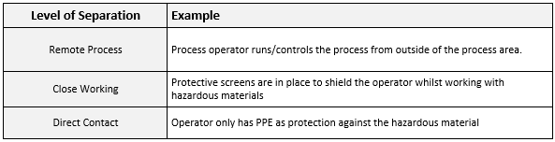
Table 6 Q3 level of separation explanation

Q4 - How significant are the consequences if the process step sensitises the material involved through human error?

Question 4 looks the possibility of material sensitisation through human error in the process step. In this circumstance, human error could include, but is not limited to; incorrectly following the SOP, using incorrect tools or adding/using incorrect materials/chemicals to the hazardous materials.
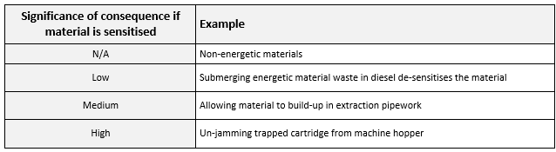
Table 7 Q4 Significance of consequence if material is sensitised explanation

Q5 – How many other operators are working on or around the process?

Question 5 addresses other personnel in the affected area should there be an event, be it ignition, initiation or release of gas etc. Due to this, the building layout and workstation layout must be considered when answering. When considering additional personnel, operators, supervisors, engineering and maintenance staff and other regular attendees to the process should be included.
The options for number of additional personnel in the area have been chosen to fit with the definitions in the COMAH regulations.

Number of additional personnel in the area | Description
0 | Process is remote for all personnel
0 | Only process operator in the affected area, no additional people
1 – 4 | 1 to 4 additional people in the affected area
5 or more | 5 or more additional people in the affected area
Table 8 Q5 Number of additional personnel in the area explanation

Q6 - To what extent could the design of the process step lead to the introduction of human failures which could have high hazard consequences?

Question 6 investigates the possibility for human failure to introduce high hazard consequences leading, or contributing, to a MAH.
In order to score a negligible result, it should be highly unlikely that a process step could lead, or contribute, to a COMAH event due to human error. These process steps either could not lead to a MAH or have had specific development to design human error out of the process. There should not be a credible failure path to a potential initiation/ignition or release event.
Those steps that score medium will be those that have a good process design, clear SOPs and work area that is well laid-out.
The medium score differs from the negligible score in that there may be a failure path to an initiation/ignition or release event.
A high likelihood result may be selected for a process step if the SOPs were in poor condition and did not provide clear and concise guidance through the process. If reports indicate the use of known work-arounds, poorly designed work areas or the use of legacy equipment which is incompatible with new equipment and processes then a high likelihood result may also be selected.

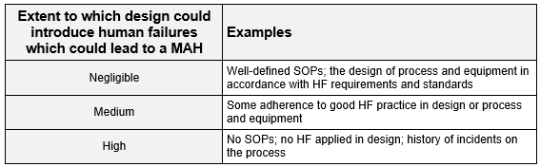
Table 9 Q6 Extent to which design could introduce human failures which could lead to a MAH explanation

Q7 - How immediate are the consequences?

Question 7 looks to the immediacy of the outcome should the operator make an error. Three options are available for this question. A latent consequence is scored lower than an immediate consequence due to the former having the potential to be corrected for in later process steps.

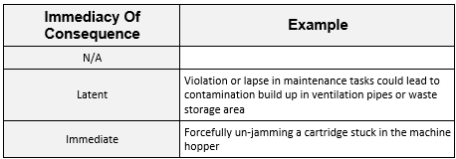
Table 10 Q7 Immediacy of Consequence explanation

Q8 - Are errors likely to be corrected in a following step?

Question 8 is a direct follow on from question 7 in that they may be considered a working pair. This question assesses the possibility to recover from an error made before a major accident occurs.
Where there is a latent consequence to an error there are two potential outcomes; either there is a following step that has the potential to identify and correct the error, or there is no possible or programmed method of catching the error.
Where an error consequence is deemed immediate in question 7 it is expected that the answer to question 8 will be ‘No’.

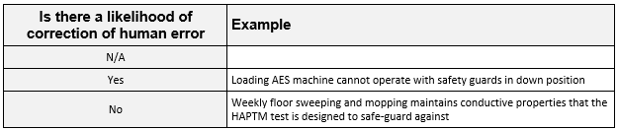
Table 11 Q8 Is there a likelihood of correction of human error explanation

Q9 - What is the type classification of the potential error?

This questions determines what the potential error could lead to. There are four classifications possible:

- Human error is either insignificant to the process or the process is not safety critical in any way
- Human error could cause a failure in a recovery system or impact emergency action, however there is no failure route in the process to a MAH
- Human error could directly or indirectly sensitise an energetic material over time and take further time to create an initiating event
- Human error could cause an initiating event immediately.

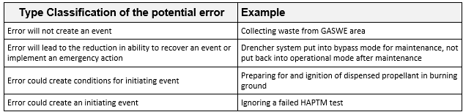
Table 12 Q9 Type Classification of the potential error Explanation

Q10 - Does the process step require the defeating of safety critical protection devices?

Question 10 focuses on if the operator is required to remove/disable safety-critical protection devices in order to complete the process step as described in the SOP. If the removal of safety critical protection devices is required in the process step, this will significantly increase the criticality score and automatically trigger the requirement for a HFA.

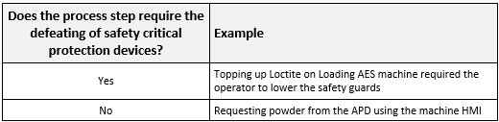
Table 13 Q10 Does the process step require the defeating of safety critical protection devices explanation

Q11 - May safety critical protection devices be defeated through violation, error or lapse?

Question 11 is a follow on from question 10, but rather than asking if the process step requires defeating safety critical protection devices, it asks if an operator could defeat safety critical protection devices by a violation or lapse. This could include incorrectly following the SOP or not correctly putting the safety critical protection device back in place after have removed it.

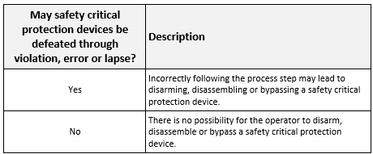
Table 14 Q11 May safety critical protection devices be defeated through violation, error or lapse explanation

Review of Screening Outputs

Based on the outputs of the screening process, the HH HF Specialist shall incorporate all process steps that have been identified as safety-critical into the HFA Delivery plan for the site, taking into account risk prioritisation scores and manufacturing schedules.
If the results from the screening process, or adherence to the process and use of the screening tool itself, raise any issues, the HF Discipline Lead should be informed who will action any required refinements to the process and/or tool.
Responses to the questions can be found in Appendix A.

Hierarchical Task Analysis

Using the supporting documentation, the HFE should undertake a HTA to logically deconstruct the process steps into individual tasks and sub-tasks. The HFRM tool shall be used to facilitate this deconstruction, helping the HFE to detail who does what, when and in what sequence.
Existing documentation should provide a thorough breakdown of tasks for each process step being analysed, and be used to develop an initial HTA in the HFRM tool. The HTA should deconstruct the process step(s) into a graphical, tree-like representation of the overall goal, tasks and fundamental subtasks, and sort them into the order in which they are performed/carried out.
‘Pre-conditions’ should also be specified; these are the conditions that must exist before the process step can be completed/ For example, required equipment or checks completed. ‘Plans’ must also be defined; these reflect the actual sequence in which the task and sub-tasks should be performed, and any conditions that could determine the order in which operations are carried out. For example, ‘Do in Sequence’ means the sub-tasks should be done one after another.
At this stage, the HFE can also provide and initial indication of what the consequences of human failure could be by linking individual tasks to potential MAHs, product quality, product safety, process safety and personal safety issues, based on data held in risk assessments.
The HFE should carefully consider the selection of the words used in the task description as these are used by the tool to identify activity types. A default set of keywords are provided in the software however these can be updated to reflect the specific requirements of the process being analysed. Guidance on how to do this are included within the tool’s help facility.

Walk through, Talk through

The Walk through, Talk through (WTTT) is an important part of the process analysis. It allows the Engineer overseeing the process to gain a visual on the actions performed by Operators, and seeing how it relates to the work instructions.
In order to begin the WTTT, the Engineer has a copy of the notes and information gathered during the screening process. This information allows the engineer to reference how the process is being performed, relative to the work instructions (SOP, Safe Operating Procedure). This information, coupled with direct involvement with the Operator regarding each step taken in the process, allows the Engineer to scrutinise any potential risks that could occur to the Operator(s). The Engineer will mostly remain invisible to the workflow of the Operator, but will ask for clarification from the Operator where necessary. It is important not to interfere too much with the Operators procedure, as it creates an unnatural environment that could lead to either mistakes, or give an unrealistic overview of the process. The WTTT is a helpful tool in outlining gaps and errors in the SOP, therefore allowing the HF Engineer to come up with recommendations that will help to mitigate MAH.

Once a preliminary HTA has been developed, this should be verified by ‘walking’ and ‘talking’ through the process step with operators, technicians or maintenance fitters, and manufacturing engineers, depending on the type of activity being analysed. This is best achieved by walking through the process step on site, asking the operator/technician to provide a commentary on what is being done, why it is being done, and the key factors influencing their decision making, etc.
The primary aim of these sessions is to enable the HFE to confirm whether procedures are an accurate reflection of how things are really done (i.e. ‘work-as-done’ rather than ‘work-as-imagined’), as well as helping them to develop a more detailed understanding of the tasks. These sessions also provide a valuable initial insight into where there is potential for human failure and the factors that can influence performance during the process step. Operators, technicians and maintainers will have a good understanding of current working conditions and the safety measures already in place.
It is important that the HFE creates an open and confidential atmosphere during these sessions so that those consulted are comfortable talking about where they may not have followed procedures, or where they have made a mistake. The HFE should be positive when someone hints that a task is difficult, or can go wrong, asking probing questions where necessary/appropriate.
- Building a good relationship with operators/maintainers is key; to facilitate this, the HFE should provide a briefing at the start of session and include the following points:
- An explanation of the role of HF in the business and in particular, how it contributes to process safety and protecting the workforce
- The independence of the analysis
- The value in contributors saying how things can, and have, gone wrong
- There is no come-back; it should be stressed that the outputs will not be attributed to individuals
- Comments and conversations will be de-personalised/anonymous, so it is not about how someone has ‘failed’ but how the system can be defeated, or has failed to support them doing their work

As well as using the results from these sessions to update the HTA, the HFE should immediately report any deviations to the process lead and SME from the SOPs to ensure appropriate and timely revisions can be made. If, at any point, the HFE considers deviations from the SOP to have safety-critical implications, they should contact the process SME or lead to ensure that the process is stopped immediately and record this in OSHENS.
The data gathered during these sessions should be used to start to populate the analysis of human errors in the HFRM tool, prior to running workshops.

Operator workshop

Through the process SME, the HFE should organise HFA workshop(s) with individual(s) who have a detailed understanding of the process step e.g. operators, maintainers of varying levels of experience, as well as individual(s) who understand the implications of failure, for example, a manufacturing or process engineer. Experience to date has also indicated that operators/technicians will talk more freely about potential errors and factors affecting their performance if supervisory roles are not present during workshops.
The aim of the workshop(s) is to obtain a balanced insight into potential human failures in the process step(s), the consequences, performance influencing factors and potential additional control measures.
The HFA can be developed in the tool as the workshop progresses. In some situations, it is beneficial for two HFEs to run the workshops, for example, if a process step is complex or a HFE is new to the business. This would enable one HFE to facilitate the workshop and the second HFE to support the sessions by inputting data into the tool and taking notes.
The HFRM tool facilitates structured discussions in these workshops, using the data gathered in the WTTT sessions as a basis. Again it is important to create an open and honest atmosphere and the points identified should be included in the briefing at the outset of a workshop.

Recommendations

All recommendations arising from the HFA should be documented in a draft HFA Report which should be forwarded to the Process SME for consideration. A meeting should be held with the Process SME to discuss and agree the recommendations. If there are any issues regarding implementation, the PAT should be consulted for an appropriate resolution. All agreed recommendations should be uploaded to OSHENS as actions for more detailed consideration, taking into account costs and benefits, and ALARP. Actions will be tracked through the normal OSHENS reporting system. A debriefing session should be held with operators/technicians who participated in the HFA to keep them informed of recommendations and what actions are being taken.

Human Factors Analysis Report
All HFAs shall be documented in a HFA Report in accordance with format and instructions outlined in the report template, A complete HFA can be found in appendix B. HFA Reports should be stored on Team centre where they will be reviewed by the HH HF Specialist with final approval from the HF Discipline Lead.

6. Human Factors Analysis implemented

Screening the Explosive Material Disposal Area, Trays and Hearth

Area Background
The EMDA is a disposal area for waste or rejected energetic material produced at the site. BAE systems has this disposal area separate from all other processes onsite. There are a variety of different ways of disposing of the energetics but the ones focused on in this report is the largest quantity of disposal at one time.

From completing the screening, table 15 and 16 shows the outcomes of the screening process of the EMDA trays and hearth. In Table 1 there are two examples where the criticality score has either been given a score of ‘0’ highlighting HFA action as N/A and another has a criticality score of 39 but does not require a HFA, as the materials are contained safely during this step.

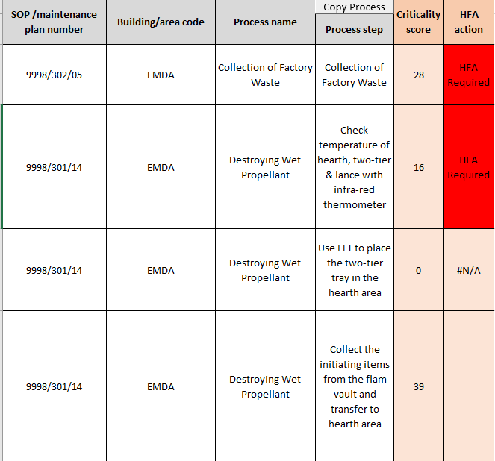
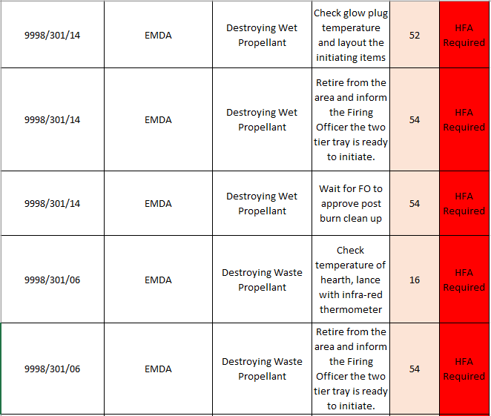
Table 15 Screening Criticality score 1
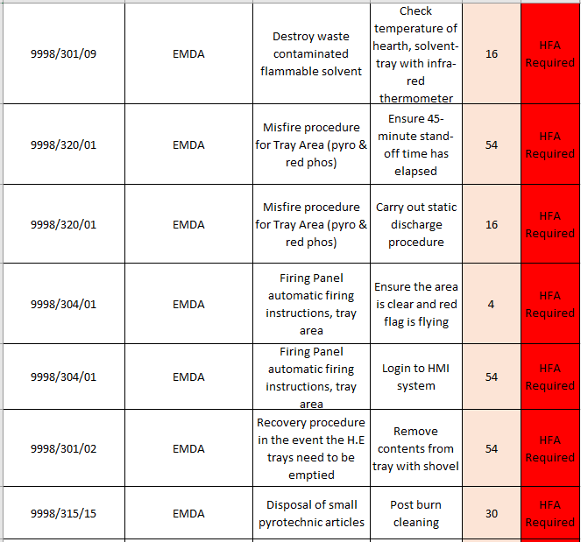
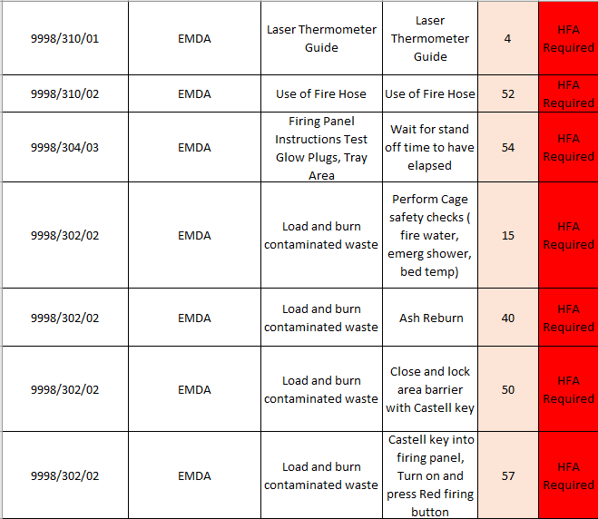
Table 16 Screening Criticality score 1.2

After conducting the screening process, the points highlighted ‘HFA Required’ allows the HFE to narrow down the search and concentrate on the highlighted, while also taking into consideration what else is going on around the process and what other issues could arise without being highlighted in the screening process. If an issue in the process step has not been highlighted ‘HFA required’ then this is where the WTTT will allow for the process step to be highlighted if missed by the screening.

Hierarchical Task Analysis

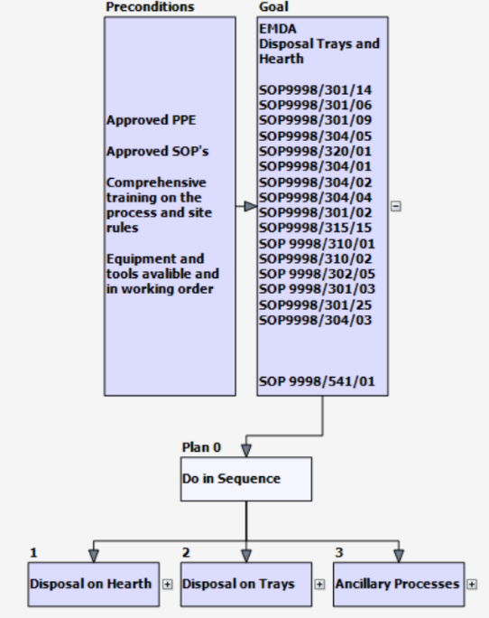
Level 1, of the HTA. This shows the preconditions of the process, the SOP numbers that are used to complete the process and highlights the process main activities. Figure 9.

For levels 2 and 3 Figures 10 and 11, this is where more depth is added to the process step, digging into each individual step allows the HFE to gather more information on the specific step if need be.
Figure 9 Hierarchical Task Analysis Level 1

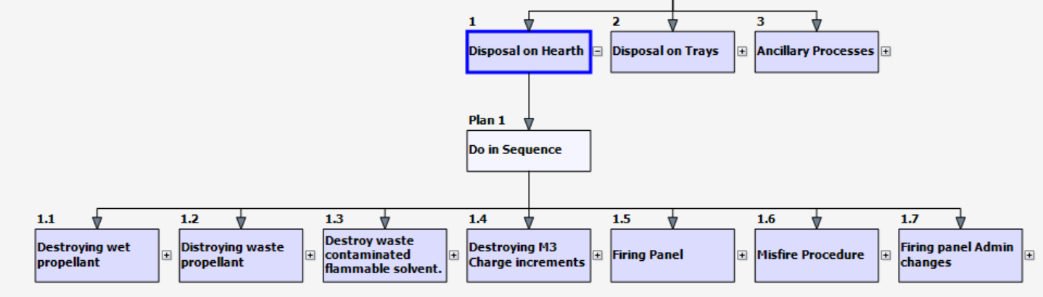
Figure 10 Hierarchical Task Analysis Level 2

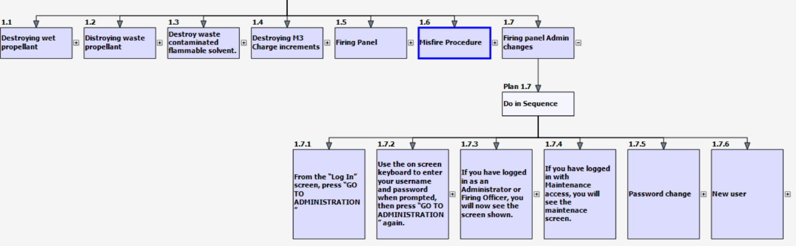
Figure 11 Hierarchical Task Analysis Level 3

Walk Through/Talk Through

During the WTTT the author used a notebook to write down anything they saw which they thought were a potential risk or a MAH. This is the process step which allows the HFE walk through the process with the operators following the SOP as they do day in, day out.
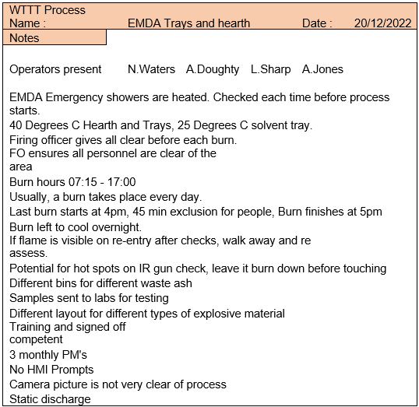
Table 17 Walk through, Talk through notes

Here in table 17 are notes gathered durring the WTTT. The WTTT consists of the HFE following the Operators carrying out the task to the SOP and taking any note which could potentially be an issue or even points which the HFE did not fully understand at the time and will use this as a topic of conversation in the Operator workshop. From table 13 there were a few things that were pulled up as being a contributer to a MAH, Things such as the IR temperature guns for example. If the IR temperature guns are not within calibration this could lead to a MAH as the temperature of the trays that the operators are processing on could be above the materials ignitiating temperature.

Operator workshop

When entering an operator workshop, it is important that there has been some prep work done going into the meeting, gathering information which the HFE thinks would be valuable to the result. Below in Email 1 shows two emails that were constructed ready for the workshop. Generating a template that resembles this email means that, when conducting the workshop Operators can be taken through each question, in this case one for Operator 1 (Liam) and a separate set of questions for Operator 2 (Marc), doing this allows the meeting to be transparent to the operators that these are the question and we will go through these together so that there is also a digital trace of the information.

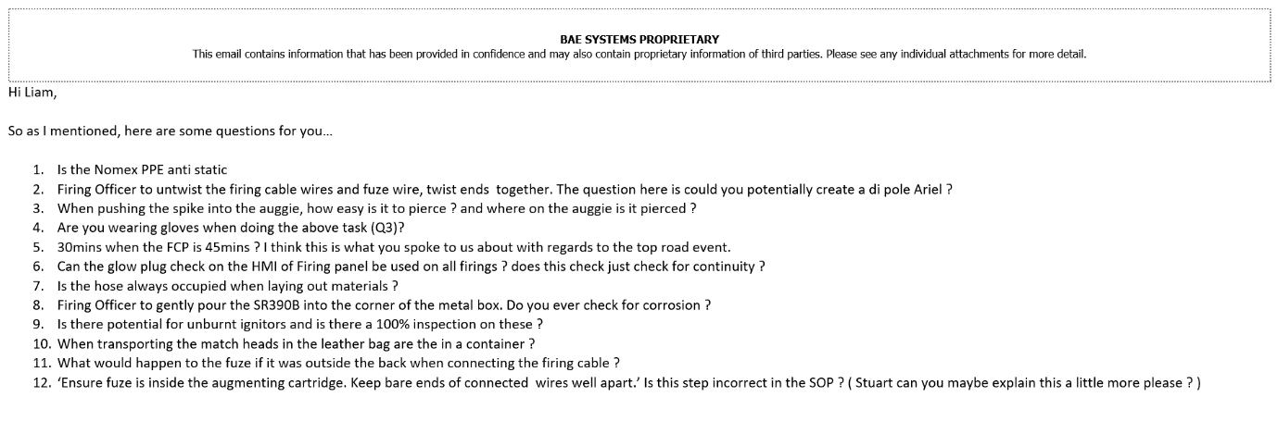
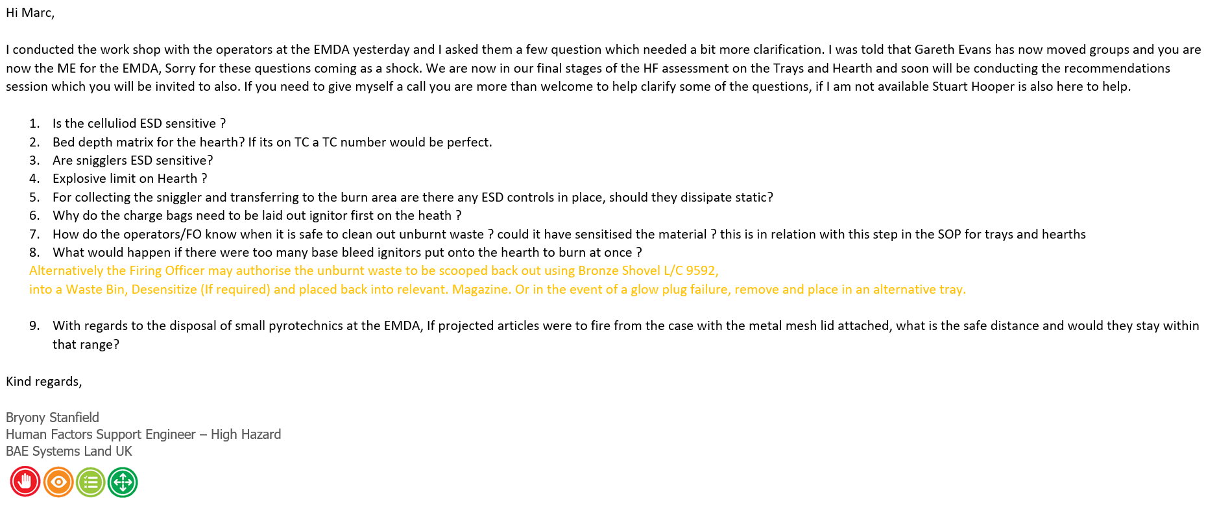
Email 1 Operator workshop preparation
Once these questions were completed, they were sent across to the two employees to complete. The findings will then be input into the HTA and to conclude the recommendations.

Operator responses

From the Response of Operator 1, Email 2, this gives the HFE a greater understanding of some of the technical reason why things are done the way they are to ensure that the process is safe and that the correct precautions are in place for the operators to conduct the process activities.

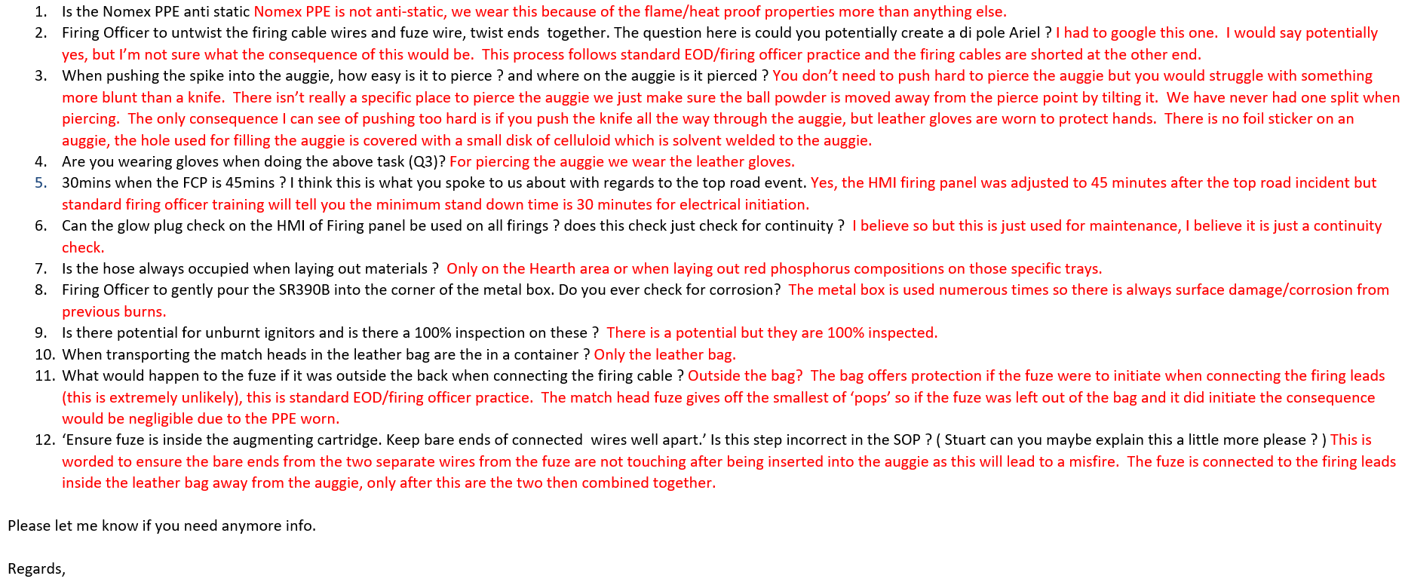
Email 2 Operator 1 response

The Response of Operator 2, Email 3, gives the HFE a greater understanding of some of the technical processing conditions such as licence limits to ensure that the process is safe and that the correct precautions, paperwork and licences are in place.

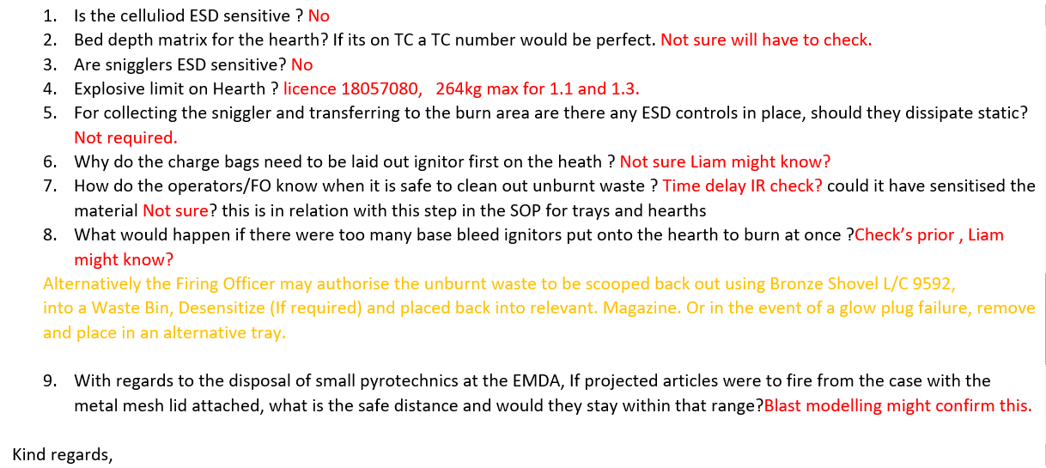
Email 3 Operator 2 response
Hierarchical Task Analysis revisit

By revisiting the HTA the HFE can now add any valuable information to the Process steps as mentioned in the first HFA section. This allows all information to be gathered and provide for each process step, as this document is a live working document up until the final submission of the report. This revisit covers things such as, Error description, Error Type, Consequence type, Performance influencing factors and any improvements, as shown in table 18 and table 19.

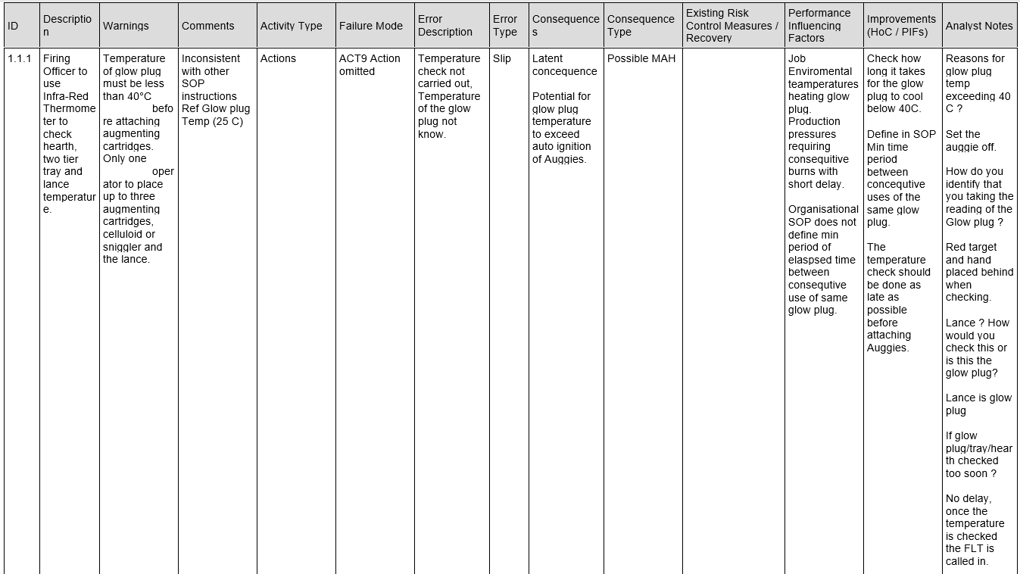
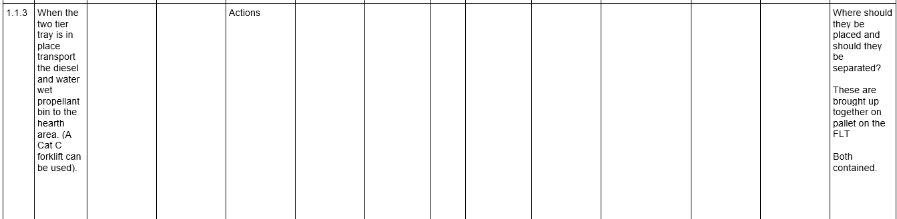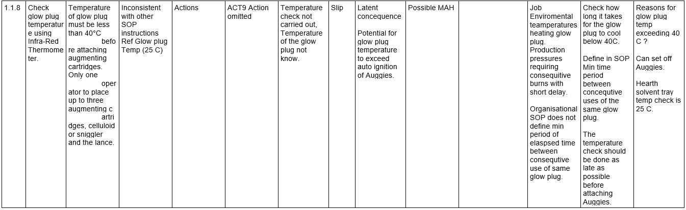
Table 18 Hierarchical Task Analysis Revisit 1.1
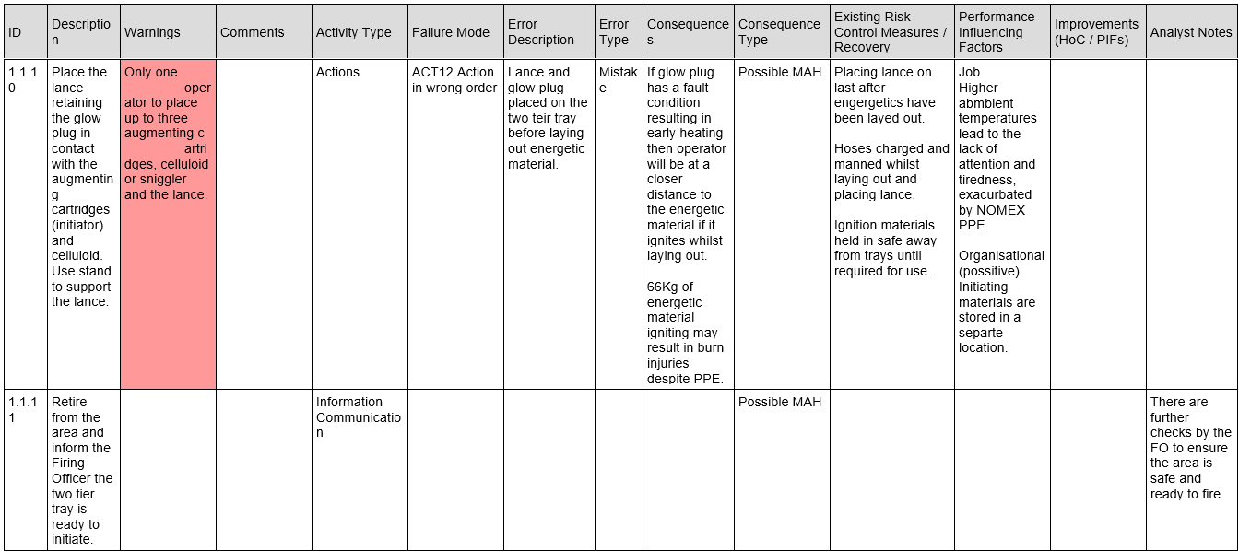
Table 19 Hierarchical Task Analysis Revisit 1.2

Recommendations

All the recommendations that are stated below are all long-term changes, these changes must be made to the process which has been assessed by the HFE in readiness for the completion of the HFA report. The recommendations session is a sit down, face to face meeting with the relevant stake holders to go through the recommendations and whether they agree or disagree with these recommendations and if so, a reason as to why? As the processes on site are so varied it is hard to blanket the recommendations. Below are the recommendations that were put forward in the meeting and classified into site-wide points which can be blanketed on site and also Process specific recommendations which need to be altered on the process which has been assessed. After the Recommendations session has taken place, this is where agreed recommendations are loaded to the safety logging software, OSHENS. The actions listed in table 20 and table 21 are added to the system with a timescale for them to be completed by.

Site-wide Recommendations

Safety-systems & Barriers
- Spare keys to be held in safe place with approval to take and be used. This will then allow full traceability of the keys.

Organisational Culture
- Ensure that when describing how to do a task it is detailed on how to do so, not just stating ‘carefully’.
- Clear description of roles and responsibilities (accountability) and organisational hierarchy available to all employees.

Equipment
- All Equipment involved with SCT should be on a call back register for calibration.

Site-wide actions

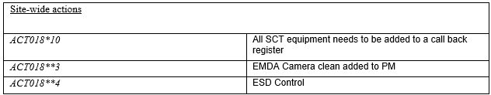
Table 20 Site-wide actions

Process Specific Recommendations

Equipment
- Apply colour matching to the floor markings and ash bins.
- IR temperature guns to be put onto a calibration call back register.
- New Camera system for checking the area before re-entering (IR Capable)

Safety systems & barriers
- Shrike (Ignition device) to be kept in a safe place at all times, when in use and not in use.

Supervision
- Ensure that SOP is being followed when conducting the tasks.
- Ensure that operators have been trained to the SOP.

Procedures/Checklists
- Signs to prompt FO that they have the shrike on them when carrying out the task.
- Floor marking to ensure there is consistency when taking temperature checks.
- Directions/Reference to which SOP needs to be used when moving onto another Step.
- Signs to make sure to the operator knows exactly what temperature they are checking for.
- Define terms that are used in the SOP, for example ‘Carefully’, ‘Safe distance’.
- Make steps in SOP’s more precise and where possible add photographs for guidance.

Process specific actions

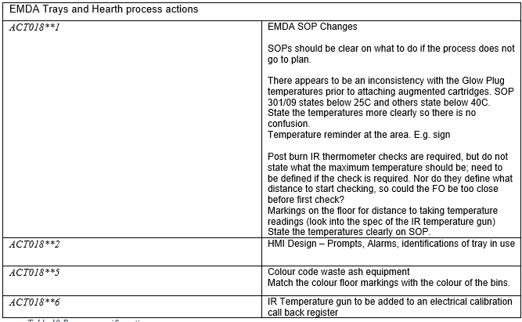
Table 21 Process specific actions

Human Factors Analysis Report

The HFA report which can be found in appendix B is the final report document that is subject to approval by senior engineers. Once the report has been approved this is then loaded to Team Centre and sent to stake holders for approval, to then be sent on to HSE as part of the COMAH report submission.

7. Discussion and conclusions.

Below the author has reassessed the process using the screening tool to use as their measurable to ensure that the work completed has had a positive impact on the process and shows the adherence to the COMAH regulations.
Table 22 shows the new criticality score from the recommendations that were implemented to the process, this is what was used as the measurable, to show the improvement of conducting an HFA. As you can see the majority still have a criticality score against them but now are not highlighted as a ‘HFA Req’.
This tool allows the HFE to indicate whether implementing those changes have improved the process or not.
The objective of this project was to create a robust system that could identify any MAH. Using the tools detailed within this project, from WTTT, Workshops, HFAs and others, the author believes these tools will continue to help make the workplace safer and ensuring the longevity of the processes.
The Project resulted in the recommendations being implemented in the process at the EMDA of the Glascoed site and the HFA process will be adopted by BAE Land UK, which the original aims and objectives wanted to achieve.
Some of the major outcomes from this project have been, implementing call backs to safety critical devices, Colour coding which ensures that the operators are using the correct waste streams and correct explosive on the trays prepared for that material and implementing safe designs on the HMI. Although these changes may seem minimal, if every error was to line up this would cause a devastating accident across site, this refers back to the ‘Swiss cheese model’.
Table 22 Final Screening Criticality score

8. Recommended further work.

- Have consistency of boss/lead. – During the last 12 months, the senior engineer of the report author has been absent due to illness. This has meant that they have been conducting the full COMAH/HFA Reporting process on their own, from beginning to end, for several manufacturing processes. They have been able to cope well with this added pressure, but from an analytical point of view, they have only been able to assess the processes through their own eyes, implementing the HFA criteria using the knowledge gained in the short period as a HFE. It would be helpful to the author going forward to be able to have consistent feedback and guidance through a process alongside their Senior HFE. Their depth of knowledge would hopefully highlight any other potential improvements in the process, as well as imparting key learning outcomes, helping them grow as a HFE.

- Repeat the process to make sure findings are consistent across shifts – With the WTTT, in the EMDA Section, HFEs run through the process with whomever is running the process on that day/shift. Ideally the process is being run straight from the SOP with no deviation or work around. In reality, there would be deviation between personnel, and by only seeing the process through with one operator, the HFE might not see a potentially hazardous practice being undertaken by another employee. Going forward, it would be helpful to see the process several times with different shifts/personnel to capture any additional risks or deviations that might be occurring in the process.

9. Reference

- Aero Corner. (2021). The Human Factors in Aviation. [online] Available at: https://aerocorner.com/blog/human-factors-in-aviation/#:~:text=A%20classic%20example%20is%20how%20the%20landing%20gear
- CIEHF (n.d.). Going global. [online] ergonomics.org.uk. Available at: https://ergonomics.org.uk/resource/going-global.html
- Crown (2015). UK Government Web Archive. [online] webarchive.nationalarchives.gov.uk. Available at: http://webarchive.nationalarchives.gov.uk/20080814090418/hse.gov.uk/comah
- Elmar Eye (2005). TPWS grid. [online] Flickr. Available at: https://flickr.com/photos/seadipper/81137114
- GRAEBER, C. (n.d.). The Role of Human Factors in Improving Aviation Safety - Text Only. [online] www.boeing.com. Available at: https://www.boeing.com/commercial/aeromagazine/aero_08/human_textonly.html.
- guest author (2016). The Importance Of Radiopaque Markers In Digital X-Ray. [online] Universal Medical Inc. Blog. Available at: https://blog.universalmedicalinc.com/the-importance-of-radiopaque-markers-in-digital-x-ray/.
- H, H. (2003). UK Government Web Archive. [online] webarchive.nationalarchives.gov.uk. Available at: http://webarchive.nationalarchives.gov.uk/20080814090418/hse.gov.uk/comah
- Health and Safety Executive (2019). Human factors/ergonomics – Introduction to human factors. [online] Hse.gov.uk. Available at: https://www.hse.gov.uk/humanfactors/introduction.htm.
- National Quality Board (2013). Human Factors in Healthcare A Concordat from the National Quality Board. [online] NHS ENGLAND, NHS England, p.3. Available at: https://www.england.nhs.uk/wp-content/uploads/2013/11/nqb-hum-fact-concord.pdf.
- Skybrary (2021). The Human Factors ‘Dirty Dozen’. [online] SKYbrary Aviation Safety. Available at: https://skybrary.aero/articles/human-factors-dirty-dozen.
- USF Health Online. (2021). Human Factors in Healthcare. [online] Available at: https://www.usfhealthonline.com/resources/health-informatics/human-factors-in-healthcare/.
- Wiegmann, D.A., J. Wood, L., N. Cohen, T. and Shappell, S.A. (2021). Understanding the ‘Swiss Cheese Model’ and Its Application to Patient Safety. Journal of Patient Safety, Publish Ahead of Print(2). doi:https://doi.org/10.1097/pts.0000000000000810.
- www.hpog.org. (n.d.). WTTT Technique › HPOG Human Performance Oil & Gas. [online] Available at: https://www.hpog.org/resource-centre/wttt/
- Ergonomics.org.uk. (2023). Ergonomics and human factors. Available at: https://ergonomics.org.uk/static/c739f21a-4acc-41ce-a5cf14e25af01b43/0ffd7018-1646-4344-a0d2d6563dd8a552/CIEHF-Ergonomics-Circular-Graphic.png

- Carayon, P. (2017). Handbook of Human Factors and Ergonomics in Health Care and Patient Safety. Crc Pr I Llc.

- Dr Chris Baber, Jenkins, D.P., Walker, G.H., Rafferty, L.A., Salmon, P.M. and Stanton, N.A. (2013). Human Factors Methods. Ashgate Publishing, Ltd

- Drury, C.G. (2008). Human Factors in Industrial Systems: 40 Years On. Human Factors: The Journal of the Human Factors and Ergonomics Society, 50(3), pp.368–374. doi:https://doi.org/10.1518/001872008x312189.

- Gavriel Salvendy (2012). Handbook of human factors and ergonomics. Hoboken, N.J.: John Wiley.

- Great Britain. Health And Safety Executive, Great Britain. Environment Agency and Scottish Environment Protection Agency (2006). A guide to the Control of Major Accident Hazards Regulations 1999 (as amended) : guidance on regulations. Sudbury: Hse Books.
- guest author (2016). The Importance Of Radiopaque Markers In Digital X-Ray. [online] Universal Medical Inc. Blog. Available at: https://blog.universalmedicalinc.com/the-importance-of-radiopaque-markers-in-digital-x-ray/.

- Health and Safety Executive (2019). Human factors/ergonomics – Introduction to human factors. [online] Hse.gov.uk. Available at: https://www.hse.gov.uk/humanfactors/introduction.htm.

- Karwowski, W. and Gavriel Salvendy (2010). Advances in Human Factors, Ergonomics, and Safety in Manufacturing and Service Industries. CRC Press.

- Miller, J.M. and Rockwell, T.H. (1972). The Use of Human Subjects in Human Factors Research. Human Factors: The Journal of the Human Factors and Ergonomics Society, 14(1), pp.35–40. doi:https://doi.org/10.1177/001872087201400107.

- OHSA Occupational Health Services Australia. (n.d.). OHSA ICAM Lead Incident Investigation Course - Reasons Swiss Cheese Model. [online] Available at: https://www.ohsa.com.au/course/icam-training-lead-incident-investigation/ohsa-icam-lead-incident-investigation-course-reasons-swiss-cheese-model/

- Pandrol. (n.d.). AWS Automatic Warning System Rail Track Magnets. [online] Available at: https://www.pandrol.com/product/aws-magnets-series-2/

- Thomas G.C. Griffin, Young, M.S. and Stanton, N.A. (2015). Human Factors Models for Aviation Accident Analysis and Prevention. Ashgate Publishing, Ltd.

- Wickens, C.D. (2014). Effort in Human Factors Performance and Decision Making. Human Factors: The Journal of the Human Factors and Ergonomics Society, 56(8), pp.1329–1336. doi:https://doi.org/10.1177/0018720814558419.

- Wiegmann, D.A. and Shappell, S.A. (2017). A Human Error Approach to Aviation Accident Analysis. Routledge.

10. Appendix

Appendix A – Screening question results
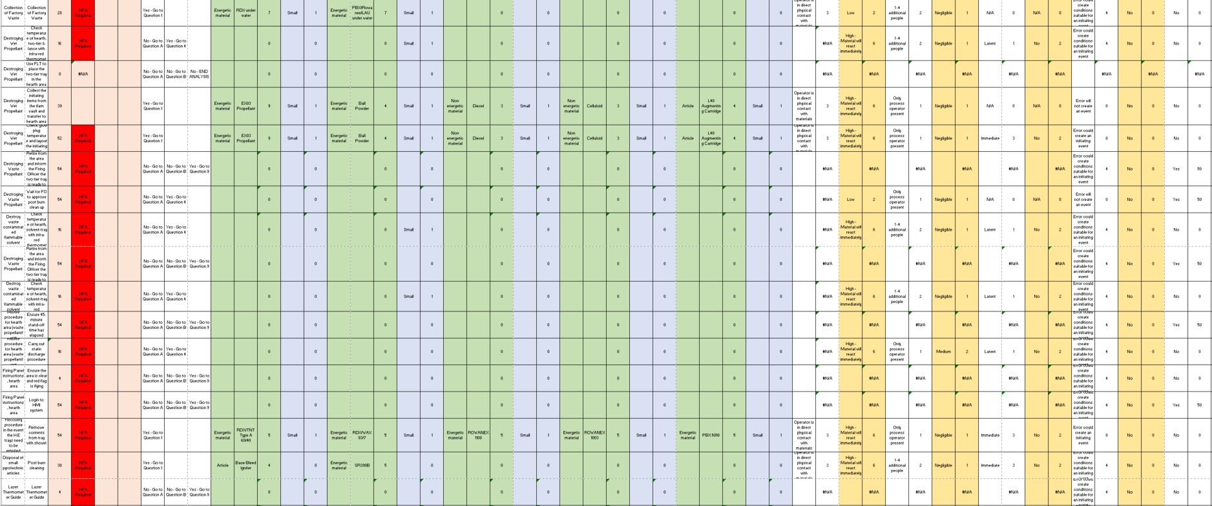
In section 5, Safety critical screening process was discussed and the explanation of the screening questions were documented, Here below are the results of the 11 screening questions which were asked during the screening process and are discussed in section 6, screening.
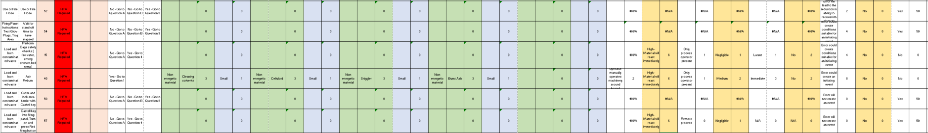

Appendix B – Complete Human factors analysis report

In section 6, Human failure analysis Implemented, the final piece of work is the HFA Report, here below is the complete report. This report was produced by the author of this dissertation for BAE System.

HUMAN FACTORS ANALYSIS
EMDA
Trays and Hearth

Analysis Title: | HFA for EMDA Trays and Hearth Glascoed
Analyst(s) | Bryony Stanfield, HF Engineer
Approach: | HFA in accordance the Human Factors Risk Manager (HFRM) tool.  Technical activities included:  - Review of supporting documentation  - Development of HTA using HFRM tool  - Walk/talk through of process with Manufacturing Engineer  - HFA workshop with operators  - Development of HFA  - Reporting  - Uploading of recommendations to OSHENS
Safety-critical process steps | Steps identified in accordance with HF screening process:  - Infra-red thermometer checks  - Laying out initiating items  - Collecting initiating items  - FO Approval for clean out  - Opening and laying out of ignitors  - Check for visible signs of flame, smoke or heat  - Re-entering the areas after the burn has finished  - Firing Officer to untwist the firing cable wires and fuse wire, twist ends together  - Static discharge procedure  - Piercing the Augmenting cartridge for misfire procedure  - Pouring out of SR390B  - Securing the area and retire to firing hut  - Securing the area and retire to 11A30  - Firing cable length  - Waste from Trays or Hearth into waste ash bins
Summary Role(s) | The Trays and hearth burning process is typically completed Monday – Thursday 07:15 – 17:00 but only 1 burn  can be running at one time, either the Trays or Hearth. The Trays can be burnt a few times a day whereas the  hearth is usually just one burn a day. There is one Firing officer and usually two operator’s process is running.  The Firing officer is responsible for checking that appropriate PPE is available before commencing, that the  Pre-startup conditions are correct and that all safety precautions are followed, including using the correct tools  and materials, throughout the process. To end the process the operators will complete and clean down of the  equipment and remove waste materials from the trays and hearth and then move them onto the correct process  for the waste to enter the designated waste stream.  Manufacturing Engineer is involved in write-up of SOP’s and other supporting documentation related to running  of the process. They are also responsible for continuous improvement projects, safety improvements, cost and  efficiency improvements and liaising with the technical and design authorities for the process.
Frequency | Operation Monday – Thursday on long days 07:15 – 17:00, Trays and Hearths are clean at the end of every shift.  Occasionally the process may be running during Fridays/weekend too depending on schedules.
Duration | Long Days Pattern  Mon – Thurs  07:15 – 17:00
Documents used during analysis | - SOP9998/301/14  - SOP9998/301/06  - SOP9998/301/09  - SOP9998/304/05  - SOP9998/320/01  - SOP9998/304/01  - SOP9998/304/02  - SOP9998/304/04  - SOP9998/301/02  - SOP9998/315/15  - SOP 9998/310/01  - SOP9998/310/02  - SOP 9998/302/05  - SOP 9998/301/03  - SOP9998/301/25  - SOP9998/304/03
Principal MAHs | - SOP’s not detailing the full extent of the task  - SOP not directing the operators in where/how the task should be carried out  - SOP’s giving too much ambiguity  - Inconsistency in taking IR temperature readings  - Shrike not being carried with the FO when critical task is carried out  - Potential of not clearly seeing the area is safe to re-enter by the camera system  - Lack of Camera Maintenance  - Potential for Static discharge when carrying out tasks in the trays/hearth area  - Potential for incorrect ash waste entering the wrong ash bin  - Potential for out of calibration IR Temperature guns to be used

Primary Recommendations (categorised according to Performance Influencing Factors)  Actions  ACT018**1  ACT018**2  ACT018**5  ACT018**6  ACT018*10  ACT018**3  ACT018**4 | Site-wide Recommendations  Safety-systems & Barriers  - Spare keys to be held in safe place with approval to take and be used. This will then allow full traceability  of the keys  Organisational Culture  - Ensure that when describing how to do a task it is detailed on how to do so, not just stating ‘carefully’  - Clear description of roles and responsibilities (accountability) and organisational hierarchy available to all  employees  Equipment  - All Equipment involved with SCT should be on a call back register for calibration  Process Specific Recommendations  Equipment  - Apply colour matching to the floor markings and ash bins  - IR temperature guns to be put onto a calibration call back register  - Static discharge when carrying out activities to be made more robust, ESD control  - Camera cleaning to be added to PM List  - New Camera system for checking the area before re-entering (IR Capable)  Safety systems & barriers  - Shrike to be kept in a safe place at all times, when in use and not in use  Supervision  - Ensure that SOP is being followed when conducting the tasks  - Ensure that operators have been trained to the SOP.  Procedures/Checklists  SOP changes. These SOP changes need to be considered through all SOPs.  - Signs to prompt FO that they have the shrike on them when carrying out the task.  - Floor marking to ensure there is consistency when taking temperature checks.  - Directions/Reference to which SOP needs to be used when moving onto another Step.  - Signs to make sure to the operator knows exactly what temperature he is checking for.  - Define terms that are used in the SOP, for example ‘Carefully’, ‘Safe distance’.  - Make steps in SOP’s more precise and where possible add photographs for guidance.  EMDA SOP Changes  SOPs should be clear on what to do if the process does not go to plan.  There appears to be an inconsistency with the Glow Plug temperatures prior to attaching augmented cartridges. SOP 301/09 states below  25C and others state below 40C.  State the temperatures more clearly so there is no confusion.  Temperature reminder at the area. E.g. sign  Post burn IR thermometer checks are required, but do not state what the maximum temperature should be; need to be defined if the  check is required. Nor do they define what distance to start checking, so could the FO be too close before first check?  Markings on the floor for distance to taking temperature readings (look into the spec of the IR temperature gun)  State the temperatures clearly on SOP.  HMI Design – Prompts, Alarms, identifications of tray in use  Colour code waste ash equipment  Match the colour floor markings with the colour of the bins.  IR Temperature gun to be added to an electrical calibration call back register.  All SCT equipment needs to be added to a call back register.  EMDA Camera clean added to PM  ESD Control

