University of Wales Trinity Saint David
School of Engineering

Significance and Properties of Coatings

Lee Stewart 1700860
Automotive Engineering

24/01/2022
Mechanisms of Material Failure
ACEA7010

Contents
Figure List 3
1.0. Introduction 4
2.0. Mechanisms of Component Failure 5
2.1. Cavitation 5
2.2. Corrosion 6
2.3. Fouling & Microbiological Corrosion 7
2.4. Accidental Contact with Floating Objects or Seabed 8
3.0. Potential Options for Component Protection 9
3.1. Material Coatings 10
3.2. Metallic Coatings 10
3.2.1. Nickel Aluminium Bronze 10
3.3. Ceramic Coatings 11
4.0. Adhesion methods 13
4.1. Physical Vapour Deposition 13
4.2. Thermal Spraying 14
5.0. Conclusion 15
References 16

Figure List
Figure 1: Image depicting the damage that can be caused to a marine propeller by cavitation. 6

Figure 2: Image illustrating how electrolytic corrosion occurs. (Jamborowicz, 2020) 7

Figure 3: Image depicting an extreme example of how electrolysis can erode a marine propeller. (Watson Marine Engineering, 2021) 7

Figure 4: Image showing an example of a biologically fouled propeller. (D'Antonio, 2014) 8

Figure 5: Image illustrating the damage that can be caused to a propeller when striking a floating object or the seabed. 9

Figure 6: Image showing sacrificial anodes being used to protect the propellers of a marine vehicle from corrosion. (BoatU.S, 2022) 10

Figure 7: Image illustrating the surface finish on a Nickel Aluminium Bronze coated propeller. (VicProp, 2022) 11

Figure 8: The Galvanic series at 10 Degrees Celcius in seawater. (Richardson, 2016) 12

Figure 9: Image of a propeller with a ceramic coating. ( Ferton Marine, 2019) 13

Figure 10: Image illustrating how the PVD process works. (E. Zalnezhad, 2014) 14

Figure 11: Image illustrating the thermal spraying process. (Poeton, 2019) 15

Introduction
Coating a material with another material has become a staple within the engineering and automotive industries. This is due to the ability coatings have to improve the properties of certain materials. Coatings can have many benefits on materials, such as increasing the corrosion resistance of a material, increasing the hardness or toughness of a material, altering the thermal properties of a material for specific applications, and increasing a materials resistance to fracture or creep. It can be seen from this, coating a material with another can allow engineers to alter the properties of a component to better suit certain applications and allow for an extended operating life of said component. This can be seen in many areas within the engineering sector, a common example of this would be applying a Diamond Like Carbon (DLC) coatings on pistons for use in an internal combustion engine. This is swiftly becoming common practice as it allows for better control of the thermal properties and friction coefficient of the component which is obviously of paramount importance for its specific application. (Funsho Olaitan Kolawole, 2020)
The idea of coating objects to protect them from their environment has been around d for centuries. This dates back as far as 600 BC when the ancient Greeks developed techniques to protect their important documents and paintings using oils or varnishes. Paints have also been developed for centuries with the process to produce them becoming easier and more affordable as time went on. This allowed machines used during the industrial revolution to be coated with paint to aid in the resistance of corrosion and environmental damage. As technology progressed through the twentieth century, coatings became more sophisticated and allowed engineers to create components with exceptional material properties to suit many applications which would have been impossible previously. (Cox, 2022)
This report will focus on the coatings applied to propellers used for marine applications and investigate their purpose. As well as this, the theoretical implications of applying such a coating to the component will be examined to help identify any defects or problems within the process.

2.0. Mechanisms of Component Failure
Propellers used in marine applications are exposed to an extremely harsh environment and subjected to some of the toughest conditions known for a metallic material. This environment can create a multitude of problems which could reduce the lifespan and performance of the propeller.

2.1. Cavitation
Cavitation is the phenomenon of vapour bubbles occurring within a liquid in areas of low pressure where the liquid has been accelerated to a high velocity. These vapour bubbles then further expand as the pressure is further reduced by the motion of the liquid and then collapse when they reach areas of higher pressure. The growth and collapse of these cavities within the liquid can cause extreme pressures that can cause pitting on the surfaces of the material in contact with the cavitating liquid. (Tikkanen, 2021)
Damage due to cavitation is typically dependent on the pressure distribution caused by the propeller and the wake flow of the liquid, but the damage is normally found to be localised to the tip and rear of the propeller blade. (AkzoNobel, 2021)
Cavitation is undesirable for a number of reasons, the first being when the vapour bubbles collapse in the high-pressure areas and impact the propeller, it can cause a large vibration through the hull of the vehicle which can also result in issues such as excessive noise. As well as this, the cavitating liquid causes the flow pattern of the liquid due to the action of the propeller to be compromised, which decreases the propeller’s propulsion efficiency, which in turn would result in the maximum speed of the vehicle to be reduced. Finally, as aforementioned, the cavitating liquid can cause pitting on the surface of the propeller when the vapour bubbles collapse in the higher-pressure areas of the wake near the tip and rear of the blades. This can be extremely detrimental to the lifespan of the propeller as the areas where pitting occurs normally sees an accelerated rate of erosion due to the corrosive environment in which the propeller must operate. (EMAC, 2008) It should be noted that as well as a material coating, cavitation can be reduced by an improved design which reduces the pressure differentials seen in the propellers wake. This however could negatively affect the propulsion efficiency of the propeller as a whole as they are normally designed for optimal performance.
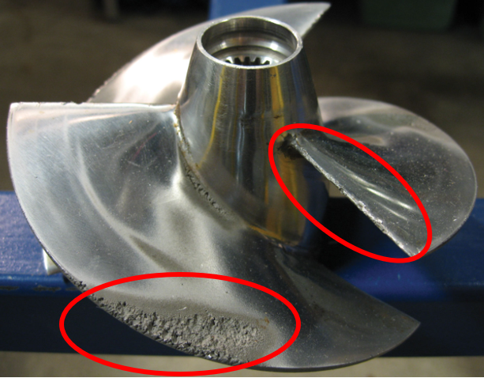
Figure 1: Image depicting the damage that can be caused to a marine propeller by cavitation.

2.2. Corrosion
Corrosion is the natural process of a refined metal converting to a more stable form, such as its oxide when in contact with an electrolyte such as water and oxygen. This process results in the deterioration of the material and will eventually lead to component failure if not addressed. (TWI, The Welding Institute, 2022) There are various ways in which corrosion of metallic materials is caused, such as oxidation, chemical corrosion, and electrolytic corrosion. Oxidation is caused by the material reacting with the oxygen in the atmosphere and developing an oxide layer on its surface which can weaken the materials properties and lead to corrosion of the material. It should be noted that some materials, such as stainless steel, can respond positively to an oxide layer forming on its surface and result in the material having an increased resistance to corrosion. Chemical corrosion is caused by the material reacting with other elements in the atmosphere such as nitrogen, sulphur, carbon, and chlorine. This adverse reaction results in a gradual destruction of the materials surface and could eventually lead to reduced component performance or even failure. (Corrosionpedia, 2019) Electrolytic corrosion is caused by a metal material being in contact with contaminated water. This contaminated water becomes an electrolyte and helps create a potential difference across the material’s surface, and therefore an electric current is formed. Due to the flow of electricity across the surface of the material, anodic and cathodic sites are formed. Electrons then begin to move from the anode to the cathode which causes corrosion (normally in the form of pitting) across the anodic site. (CorrosionPedia, 2018)
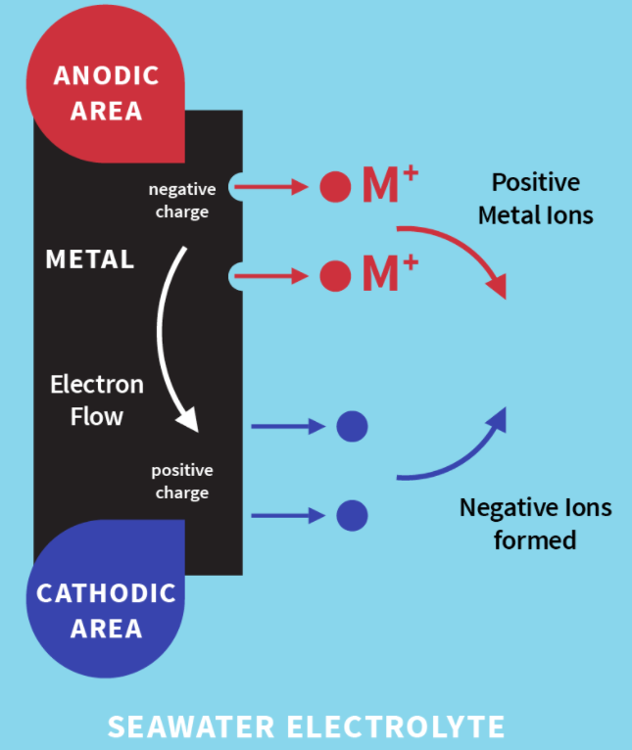
Figure 2: Image illustrating how electrolytic corrosion occurs. (Jamborowicz, 2020)
Due to the aqueous operating environment of a marine propeller, the erosion of the material is normally found to be due to electrolytic corrosion. This is because the oxygen needed for the metal to react and oxidise is relatively scarce in its typical working environment. This phenomenon can create multiple anodic and cathodic sites across the propeller which allows the charged ions to flow with relative freedom through the electrolyte, in this case sea water, into the cathodic sites and create multiple anodic areas in which erosion could occur. Corrosion of this type can be devastating to the performance, operation, and lifespan of marine propellers. This is evident from research as multiple reports have stated that erosion due to electrolysis can render a brand-new propeller useless within weeks or even days. (Smith, 2021)
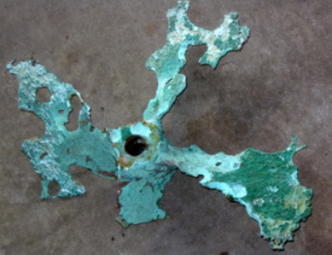
Figure 3: Image depicting an extreme example of how electrolysis can erode a marine propeller. (Watson Marine Engineering, 2021)

2.3. Fouling & Microbiological Corrosion
Fouling is the phenomenon of marine growth in the forms of algae, barnacles, and tubeworms settling on submerged metallic surfaces. This can be extremely detrimental to the overall performance of the propeller with studies showing that just 3 months of defacement due to biological fouling can reduce the efficiency of the propeller by more than 10%. This drop in efficiency can have dramatic effects on the overall performance of the vehicle with the top speed being reduced by up to 20% and an increase in energy consumption of around 40%. The build up of biological organisms on the propeller blades can also lead to a noise, vibration, and harshness issues due to the surface of the propeller no longer being smooth and of optimal shape. As well as this, the microbiological organisms can feed on the material if no other food source is available. This will eventually lead to erosion of the material and eventually, the adverse effects aforementioned. (EMAC, 2008)
The build-up of microbiological organisms which lead to microbiological corrosion is especially prevalent in stagnant water. This is due to the PH level in stagnant water dropping and creating an acidic environment which then liberates Hydrogen Sulphide. This Hydrogen Sulphide rich environment then helps accelerate the growth of bacteria and microbes which are then able to feed on the material. With a mixture of an acidic environment and biological organisms feeding on the material, erosion in this scenario is often seen at an accelerated rate. (Kilgallon, 1998)
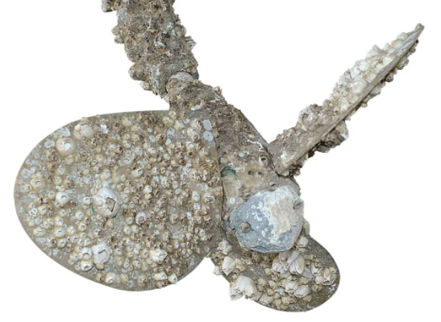
Figure 4: Image showing an example of a biologically fouled propeller. (D'Antonio, 2014)

2.4. Accidental Contact with Floating Objects or Seabed
As well as corrosion, a propeller on a sea going vehicle can be damaged by accidently striking a floating object or the seabed. When this occurs it can cause serious damage to the rotating propeller if not entirely destroy it and render it completely useless.
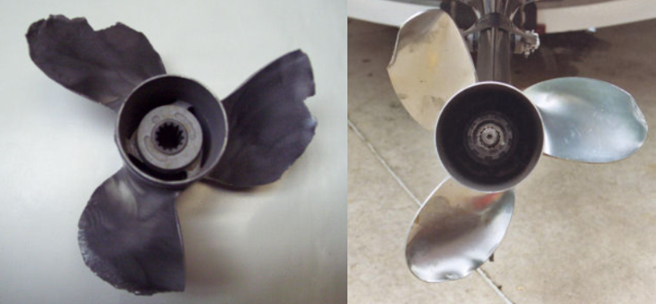
Figure 5: Image illustrating the damage that can be caused to a propeller when striking a floating object or the seabed.
As these accidental impacts can not always be avoided, it is good practice to acquire a propeller constructed from a material that has suitable properties to withstand such an impact. This however can not always be achieved as metallics with such properties can be extremely expensive and difficult to manufacture. To achieve the properties required for such a propeller, a material coating is normally applied to it in order to increase the toughness and impact resistance of the component.

3.0. Potential Options for Component Protection
To protect the propeller and ensure the intended longevity of the component, there are various ways of minimising the likelihood of corrosion or damage due to its operating environment. To achieve a greater resistance to corrosion there are 5 main areas in which to explore. The first being a change of environment in where the component would be more passive to the electrochemical process. This is normally achieved by adding anodic or cathodic inhibitors such as nitrates to the electrolyte in order to change the direction of the potential difference by altering the PH levels in the electrolyte. (C.Monticelli, 2018) Although this is an effective solution and would likely increase the corrosion resistance of the component, this could not be accomplished in the scenario of a propeller on a marine vehicle, as the environment is which the component is likely to operate is sea or river water. Another option would be to change the design of the component to reduce the pressure differentials across the component and subsequently minimise the damage seen due to cavitation. This however is an unlikely option in this scenario as the design of a propeller for a marine vehicle is normally designed to maximise hydrodynamic performance and efficiency. (Lixun Hou, 2019) As propellers for marine application are usually constructed from aluminium, resistance to corrosion and environmental damage caused from operational environment such as cavitation, could also be achieved by changing the material of the component to a harder more passive material such as stainless steel or titanium. This however can prove to be extremely expensive, as creating a component with the complex geometry of a propeller, from a metal such as titanium, can be an exceptionally difficult, time-consuming and therefore expensive process. (John Foltz, 2013) As well this, the corrosion resistance of the component could be increased by providing galvanic protection with sacrificial metallic anodes. This works by placing sacrificial metallic anodes with a greater potential difference in the galvanic series than the component, in close proximity to the part which needs protection, with zinc or magnesium being the usual option for such anodes. This then attracts the electrical current and therefore the corrosion which would have been focused on the component. (J.A.Richardson, 2010) This is a viable option for propeller protection and is sometimes used within the maritime industry, as shown below in Figure 6. However, due to the anodes being “sacrificial”, they would need to be inspected and replaced at regular intervals which could lead to unnecessary expense.
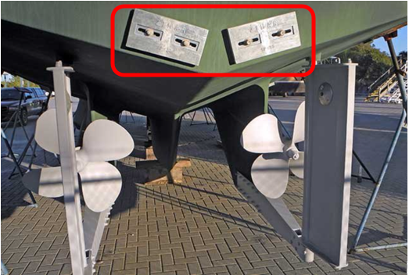
Figure 6: Image showing sacrificial anodes being used to protect the propellers of a marine vehicle from corrosion. (BoatU.S, 2022)
As previously stated, protection from damage or corrosion can come in many forms, but due to the impracticality of implementing the majority of the aforementioned methods, the most likely form of corrosion prevention and impact protection to be implemented is a material coating of some kind.

3.1. Material Coatings
A material coating can come in various forms with the choice of which normally dependent on the material properties required for the component’s application and environment. In the case of a propeller for use on marine vehicles, the desired result from a coating would be, an increased resistance to the electrochemical process leading to corrosion, an increased resistance to cavitation damage, a greater resistance to fouling from marine life or microbiological bacteria, and a greater resilience to accidental impact with floating objects or the seabed. It is clear from this that a coating for a propeller used in marine applications would need to increase the hardness and toughness of the component, without increasing the brittleness or effecting the performance, as well as increasing the component’s resistance to corrosion and microbiological fouling.

3.2. Metallic Coatings
Metallic coatings are a form of coating in which the component is coated in another metal or a selection of metals depending on the desired properties.

3.2.1. Nickel Aluminium Bronze
Nickel Aluminium Bronze coatings are relatively common in the maritime industry as they have excellent corrosion resistance due to the material’s ability to form an impressive self-repairing oxide layer in environments with very low oxygen, such as seawater. This means if the coating is scratched or minorly damaged from impact with a floating object, the oxide layer will reform and continue to protect the component. As well as this, Nickel Aluminium bronze has a good resistance to flow and stress corrosion cracking which leads to an impressive resilience to damage due to cavitation. A coating of this type will also create a good level of resistance to microbiological fouling due to the copper present within the alloy. This is because copper is known to be poisonous to most forms of marine life and will likely impede biological organisms from adhering and colonising on the surface of the component. (Richardson, 2016) Also, this type of coating provides a consistent rich gold surface finish which can be aesthetically pleasing and desirable.
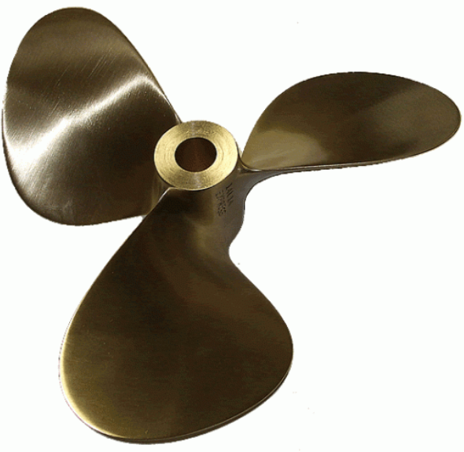
Figure 7: Image illustrating the surface finish on a Nickel Aluminium Bronze coated propeller. (VicProp, 2022)
Although the Nickel Aluminium Bronze alloy provides good protection against corrosion, long term exposure to water contaminated with sulphides can cause an issue and reduce the overall corrosion resistance of the material. Also, as the substrate is likely to be aluminium , if the coating gets significantly damaged in some way and it is not able to repair itself, the propeller itself would be subject to galvanic corrosion.
This is due to the substrate having a greater potential in the galvanic series, and due to the exposed area of substrate material, there would be a development of anodic and cathodic sites to drive the corrosion. This is shown below in Figure 8. However, if the propeller had cathodic protection nearby, these corrosive effects could be reduced.
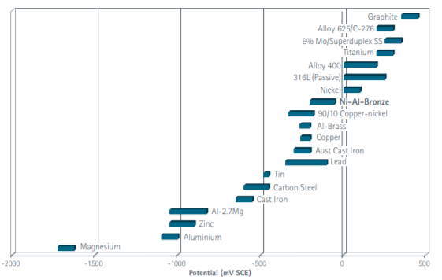
Figure 8: The Galvanic series at 10 Degrees Celcius in seawater. (Richardson, 2016)
As well as increasing the resistance to corrosion, a Nickel Aluminium Bronze coating will provide added impact toughness and greater resistance to fatigue or creep. This is due to the high strength and low ductility of the alloy. It should also be noted at this stage, that to maximise the hardness and yield strength of the alloy and receive maximum performance from the component, the propeller should be subjected to a heat treatment process. Coating a propeller with a Nickel Aluminium Bronze alloy would also aid in noise, vibration, hardness (NVH) issues sometimes associated with maritime vehicles. This is because the material has a high damping rate (twice that of steel). This means that there will be a significant reduction in the noise emitted from the propeller during its operation. Because of this, Nickel Aluminium Bronze alloy propellers are often used on military submarines. Due to the benefits of this material coupled with the relatively few draw backs of its use, Nickel Aluminium Bronze has become the leading alloy coating for components used in marine applications. (Richardson, 2016)

3.3. Ceramic Coatings
Ceramics are an impressive material that is used widely within the engineering industry due to its extraordinary material properties. Ceramics are compiled from metallic or non-metallic compounds, either oxides, non-oxides, or a mixture of the two, which have been formed into a desired shape and then heated to high temperatures to be hardened. Ceramics are generally extremely hard with excellent resistance to corrosion. However, such as most materials with a such a high degree of hardness, ceramics are usually extremely brittle. (Science Learning Hub (SLH,NZ), 2010)
As ceramics have progressed into the advanced material they are today, it has become fundamental to many industries, i.e. the aerospace, mechatronics, and maritime industry. Ceramics such as silicon nitrate, silicon carbide or alumina-zirconia are often used to coat existing components to improve their material properties according to their application. This can also be the case for components such as propellers used on marine vehicles such as speed boats or yachts. (R.H.Jones, 2013)
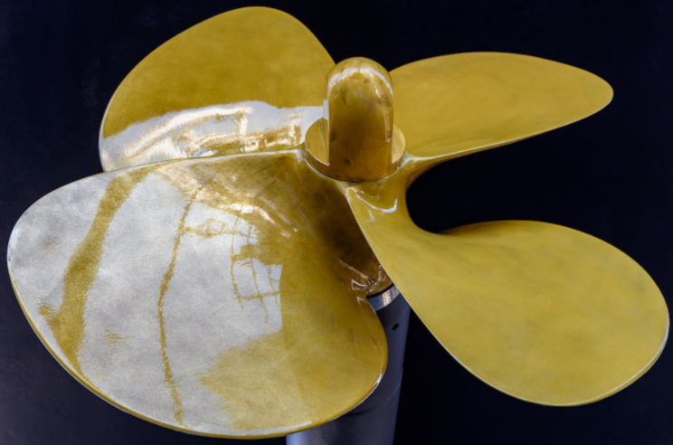
Figure 9: Image of a propeller with a ceramic coating. ( Ferton Marine, 2019)
Due to the hardness of ceramic coatings, they provide an excellent barrier to prevent cavitation damage. However, due to the brittleness of the material, it provides poor protection against accidental impact with floating objects or the seabed, with an impact of this kind likely leading to heavy damage. The excellent corrosion resistance present with ceramic coatings, comes from their chemical stability and high level of electrical insulation in comparison to metallic materials. Ceramics are often passivated against the electro-chemical corrosion process by adding specific compounds to the mixture during the forming process. (Umicore, 2016) As well as this ceramic coatings on propellers offer excellent performance benefits in regards to its hydrophobic properties and drag reduction. This is due to the smooth and shiny surface finish present when a ceramic coating is applied, which in turn, reduces the friction coefficient between the water and the component which leads to a high level of hydrodynamic efficiency. Also, due to the ease in altering the surface functionalisation of ceramic coatings, they can also offer an impressive resistance to biological fouling. (Dongmian Zang, 2020)
Due to the impressive material properties seen in modern ceramics, ceramic coatings on metallic components used in maritime applications have become much more popular and widespread.

4.0. Adhesion methods
As the performance of a coating is dependent on how well it has adhered to the substrate, having some control over the adhesion process is essential. Controlling the thickness and evenness of coating adhesion across the component is of paramount importance, as the thickness of the coating directly effects its properties. If the coating was to be applied to the substrate in an uncontrolled manner, the thickness of the coating could differ throughout the component leading to undesired properties and even a reduction in component performance. There are various methods in which the adhesion of the coating can be controlled with varying rates of success. This section of the report will focus on the typical methods commonly used to coat propellers with the metallic and ceramic coatings aforementioned.

4.1. Physical Vapour Deposition
Physical Vapour Deposition (PVD) is the process of applying a thin film of metal, alloys, or ceramic onto a clean substrate (without dirt or oxide layer) by physically depositing ions, molecules, or atoms upon it. This is achieved by either thermal evaporation where the material is heated by various means until a vapour is formed and condenses onto the substrate to form a coating, or spluttering, which is the process of generating electronic plasma between the substrate and the coating material to cause a reaction between the two materials. Physical Vapour Deposition can also be achieved through a process named ion plating which is a mixture of thermal evaporation and spluttering processes.
For the PVD coating process to be successful, the component for coating should be heated to around 200-400 degrees and placed in a controlled atmosphere with lower than atmospheric pressure (around 0.5 N/m²). The timing of the coating process can vary dependent on the thickness of coating required. This timing of which is carefully determined based upon previously coated components. It should be noted, that although this does bring about a slight control in coating thickness, due to the coating method being a line of sight process, creating an even coat on complex geometry such as propellers can be difficult. (The Welding Institute, TWI, 2022) Another pit fall of this process is that it is a complex process with a relatively large expense and a fairly low output. (A.S.H.Makhlouf, 2011) This method of material coating is often used to coat propellers used in marine applications. This style of coating can also be applied to components which have slight damage from previous work. However, due to the process only being able to apply relatively thin film coats, it is unlikely that the coating would be levelled across the component and the damage may still be visible.
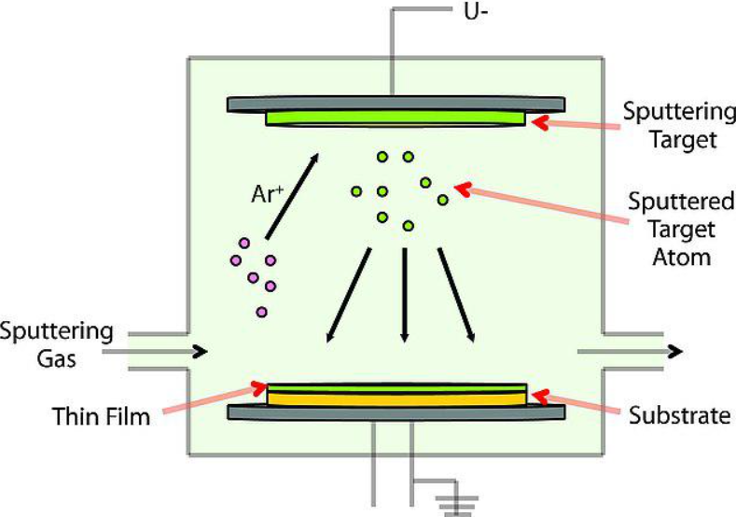
Figure 10: Image illustrating how the PVD process works. (E. Zalnezhad, 2014)

4.2. Thermal Spraying
Thermal spraying, also known as metal spray coating, is the process of applying a metallic or ceramic coating to a substrate by depositing finely divided molten metallic or non-metallic materials by means of a spray. This is achieved by heating the coating material until it is molten or semi molten by various means and sprayed onto the substrate using a spray gun. The great benefit to this process is, it allows thick coating to be applied with high deposition to most materials. As the spray is mechanically bonded to the substrate rather than metallurgically, materials that would normally react with one another are able to be used. (CorrosionPedia, 2019) Although the coating method is a line of sight process, the thickness of the coating can be controlled relatively well as the process can be mechanised. The thermal spraying method can be applied to most materials with previous work and due to the thickness of the coating which can be applied, the coating would be able to be levelled across the component and subsequently hide any previous damage. To prepare a substrate for thermal spraying, the component must be cleaned and worked until the surface roughness is suitable for maximum adhesion. (The Welding Institute, TWI, 2022) This coating technique is an excellent method in which to coat propellers for marine application with a metallic alloy such as Nickel Aluminium Bronze and is therefore extensively used throughout the maritime industry. The expense of the process is heavily dependent on the material used for coating with each wire or metallic powder having heavily varied costs. (Poeton, 2019)
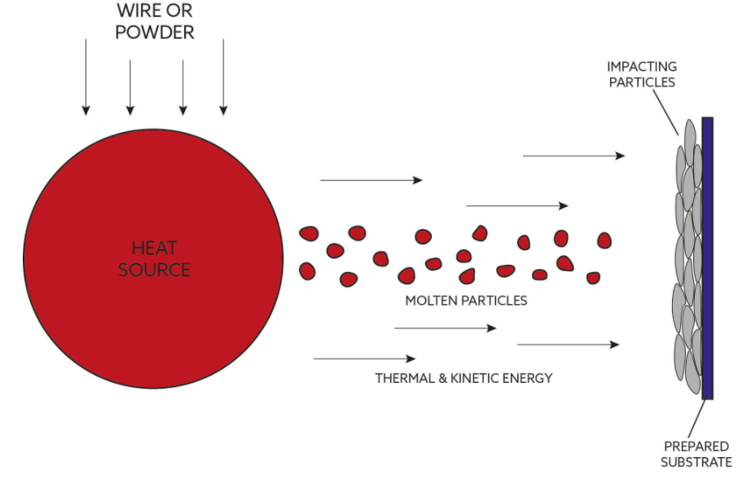
Figure 11: Image illustrating the thermal spraying process. (Poeton, 2019)

5.0. Conclusion
It is evident from research that the development of material coatings has progressed massively in recent years regarding their application control and adhesion to substrates. This has allowed many fields within the engineering industry to apply coatings to components to increase their performance as well as their longevity. This field is constantly developing with new coating methods and alloy types being experimented with to further enhance the coating processes and subsequently enhance the properties commonly used within industry. It has been shown that material coatings can have many benefits and can be tailored depending on the application of the component receiving the coating. These benefits include, corrosion resistance, impact protection, reduced friction, abrasion resistance, resistance to microbiological fouling, and even a desirable aesthetic appearance.
This report has focused on the possible damage that could occur to a propeller due to its operating environment, and the potential benefits to applying a material coating to such a component. It was found that the most likely coating to be applied to a propeller for use in maritime applications, would be a ceramic coating or a Nickel Aluminium Bronze alloy coating. It was found that coatings of this type can provide the component with the protection against its environment as intended with relatively few draw backs to the process. As the coating process is constantly being developed, the processes of applying coating will continue to become more efficient and more widespread throughout industry. This will allow the coatings themselves to continue to improve and provide components with impressive material properties to further aid in their performance as well as increase their longevity.

References
Ferton Marine, 2019. Specialised Yatch Paint. [Online]
Available at: https://www.fertonmarine.com/paintservices.php
[Accessed 19 January 2022].
A.S.H.Makhlouf, 2011. Current and advanced coating technologies for industrial applications. In: Nanocoatings and Ultra-Thin Films. Munich, Germany: Woodhead Publishing, pp. 3-23.
AkzoNobel, 2021. Propeller performance and coatings. [Online]
Available at: https://www.international-marine.com/blog/propeller-performance-and-coatings
[Accessed 4 January 2022].
BoatU.S, 2022. Boat Corrosion Protection with Anodes. [Online]
Available at: https://www.boatus.com/expert-advice/expert-advice-archive/2017/february/boat-corrosion-protection-with-anodes
[Accessed 13 January 2022].
C.Monticelli, 2018. Corrosion Inhibitors. Encyclopedia of Interfacial Chemistry, Surface Science and Electrochemistry, Volume 6, pp. 164-171.
CorrosionPedia, 2018. Electrolytic Corrosion. [Online]
Available at: https://www.corrosionpedia.com/definition/1321/electrolytic-corrosion
[Accessed 8 January 2022].
Corrosionpedia, 2019. Chemical Corrosion. [Online]
Available at: https://www.corrosionpedia.com/definition/6394/chemical-corrosion
[Accessed 6 January 2022].
CorrosionPedia, 2019. Metal Spray Coating. [Online]
Available at: https://www.corrosionpedia.com/definition/5681/metal-spray-coating
[Accessed 21 January 2022].
Cox, K., 2022. Historical Background of Paint and Coatings, Oxford, Ohio, USA: Miami University.
D'Antonio, S., 2014. Run Free, Running Gear. [Online]
Available at: https://www.cruisingworld.com/how/run-free-running-gear/
[Accessed 8 January 2022].
Dongmian Zang, X. X., 2020. Ceramics Coated Metallic Materials: Methods, Properties and Applications. London: IntechOpen Limited.
E. Zalnezhad, A. S., 2014. Fuzzy modeling to predict the adhesion strength of TiN ceramic thin film coating on aerospace AL7075-T6 alloy. In: Recent Advances in Structural Integrity Analysis - Proceedings of the International Congress. Malaya, Malaysia: Woodhead Publishing, pp. 239-244.
EMAC, A. M. A. C., 2008. Coating technology for ship propeller, Shenzhen, China: EMAC GROUP LIMITED.
Funsho Olaitan Kolawole, S. K. K. L. B. V. A. F. O. M. A. R. a. A. P. T., 2020. Diamond-Like Carbon (DLC) Coatings for Automobile Applications, London: IntechOpen Limited.
J.A.Richardson, 2010. Materials Science and Materials Engineering. 4 ed. Durham, UK: Elsevier.
Jamborowicz, M., 2020. The boater's guide to corrosion. [Online]
Available at: https://blog.side-power.com/en/the-boaters-guide-to-corrosion
[Accessed 7 January 2022].
John Foltz, G. D. A. M. C. T., 2013. Development of Complex Shapes Made by Titanium Extrusion. Bellevue, WA, USA, AeroMat.
Kilgallon, M. R. &. P., 1998. A Review of the Effects of Sulphate Reducing Bacteria in the Marine Environment on the Corrosion Fatigue and Hydrogen Embrittlement of High Strength Steels., Cranfield, UK: Health & Safety Executive.
Lixun Hou, A. H., 2019. Theoretical investigation about the hydrodynamic performance of propeller in oblique flow. International Journal of Naval Architecture and Ocean Engineering, 11(1), pp. 119-130.
Poeton, 2019. Thermal Spray Design Guide. [Online]
Available at: https://www.poeton.co.uk/knowledge-hub/thermal-spray-design-guide/
[Accessed 21 January 2022].
R.H.Jones, M. F., 2013. An Introduction to Microstructures and Processing. In: Engineering Materials 2. Cambridge, UK: Elsevier Ltd, pp. 313-325.
Richardson, I., 2016. Guide to Nickel Aluminium Bronze, s.l.: Copper Development Association.
Science Learning Hub (SLH,NZ), 2010. What are Ceramics. [Online]
Available at: https://www.sciencelearn.org.nz/resources/1769-what-are-ceramics
[Accessed 19 January 2022].
Smith, S., 2021. Electrolytic Corrosion. [Online]
Available at: https://fabdock.com/fab-dock-benefits/electrolytic-corrosion-or-how-come-my-prop-dissolved/
[Accessed 7 January 2022].
The Welding Institute, TWI, 2022. WHAT IS PHYSICAL VAPOUR DEPOSITION (PVD)?. [Online]
Available at: https://www.twi-global.com/technical-knowledge/faqs/faq-what-is-physical-vapour-deposition-pvd
[Accessed 22 January 2022].
The Welding Institute, TWI, 2022. What is Thermal Spraying. [Online]
Available at: https://www.twi-global.com/technical-knowledge/faqs/faq-what-is-thermal-spraying
[Accessed 22 January 2022].
Tikkanen, A., 2021. Matter & Energy. [Online]
Available at: https://www.britannica.com/science/cavitation
[Accessed 4 January 2022].
TWI, The Welding Institute, 2022. WHAT IS CORROSION? - DEFINITION AND PREVENTION. [Online]
Available at: https://www.twi-global.com/technical-knowledge/faqs/what-is-corrosion
[Accessed 6 January 2022].
Umicore, 2016. Corrosion Resistant Ceramics. [Online]
Available at: https://www.umicore-ceramics.com/za/corrosion-resistant-ceramics
[Accessed 20 January 2022].
VicProp, 2022. EXPRESS NICKEL ALUMINUM BRONZE. [Online]
Available at: https://www.vicprop.com/express_12ni_vp
[Accessed 16 January 2022].
Watson Marine Engineering, 2021. Projects. [Online]
Available at: http://www.watsonmarine.com.au/projects/
[Accessed 7 January 2021].

