WHAT DOES THE STUDY OF NEANDERTHAL BURIALS TELL US ABOUT THE AFTERLIFE?
Evan Davies

Death, Burial and the Afterlife HPHP4002
Thomas Humphreys
University of Wales Trinity Saint David
March 13, 2024

There will be a discussion on the study of Neanderthal burials, looking at Shanidar cave and Sunghir, as well as less known ones. Using these archaeological discoveries, there will be an indepth discussion on the different “burials” made by Neanderthals, and what they can tell us about their cultures and views on the afterlife. During the Middle Palaeolithic and Mid-Upper Palaeolithic, the Neanderthals may have practiced many “human-like” practices, such as possible art and recording information, and most importantly burials, which will be discussed in this essay. To be more specific, ritualistic burials, inferring that the death and burial of a Neanderthal in a community would be treated similiarly to how Homo Sapiens (Modern Humans) buried their dead. The first case study that will be looked at in this paper will be from the article written by Christ, O. Hunt and more, named “Shanidar et ses fleur? Reflections on the palynology of the Neanderthal ‘Flower Burial’ hypothesis.” Looking into this article to see the probability on whether it was an intentional burial, or whether it was an accidental death. Which is Solecki’s argument for most Neanderthal “burials”. Solecki will be mentioned often in this essay, to give more perspectives and arguments in the discussion.
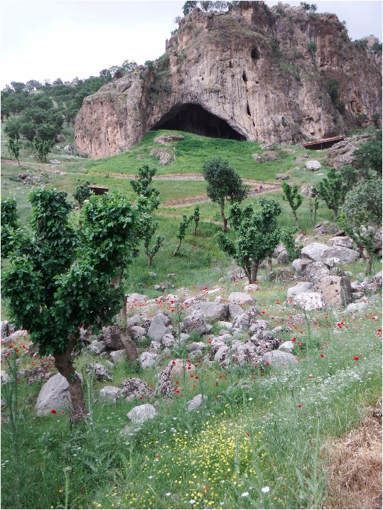
The remains of the first case study was found within Shanidar Cave, Iraq Kurdistan region (see fig 1) (Hunt, 2023). Groups of pollen where found alongside the skeleton known as Shanidar 4 (Hunt, 2023). This suggests that the burial that had taken place included the use of flowers, which is a very “human-like” thing to do (Hunt, 2023). The hypothesis for the burial including flowers came from Arlette Leroi-Gourhan in 1975 says Hunt. Which was also develpoed by Ralph Solecki. When the pollen clutches were discovered under Shanidar 4, Willem van Zeist assisted as he was a pollen analyst (Hunt, 2023). Despite a significant amount of support with the theory that flowers were intentionally placed at the burial, Chase, Dibble and Sommer have all argued against this (Hunt, 2023). Suggesting that it was done by small rodents burrowing rather than the original theory (Hunt, 2023). There is a suggestion that the flowers were invited into the cave by burrowing rodents named jirds, their scientific name is Meriones persicus (Sommer, 1999). Jirds are also known to be found in Shanidar cave (Tilby et al, 2022). There are other theories that go against Leroi-Gourhan for different reasons. What does the theory that the Neanderthals buried Shanidar 4 with flowers tell us about their views on the afterlife? Inferring that the pollen are flowers brought in by other Neanderthals during the burial, suggests that the culture of Neanderthals may have viewed flowers in a ritualistic context. However, this could not be the case, and instead the flowers could have been used just to pay respects. Such as Modern Humans do today in North America and Europe. In terms of the afterlife aspect of the potential burial practices. The Neanderthals of Shanidar may have believed that giving flowers may help them with achieving peace in the afterlife, as in a modern context flowers are seen as beautiful and peacful. Although, using a modern example of how flowers are percieved limits creativity on how the Neanderthals of Shanidar thought. The flowers do not suggest anything specifc, and leave many interpretations open. But, the theory that suggest that the Neanderthals of Shanidar went out of their way to add flowers to the burial infers that it must have meaning, as it would otherwise waste valuable energy.
Fig. 1. Wild flowers at Shanidar Cave (Hunt, 2023).
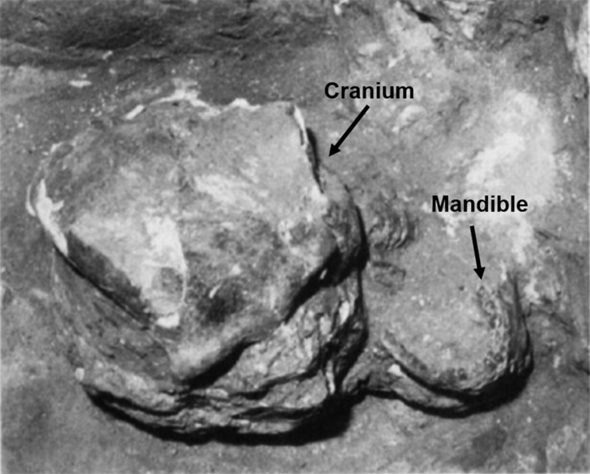
In order ot give skeletal evidence in the mortuary behaviour of Neanderthals. One must look at the placement of said skeletons. For example, in Shanidar cave. The reexamaniation of Shanidar 1 shows that the placement of the skull and mandible seems to look unnatural (see fig 2) (Pomeroy et al, 2020). This suggests that the Neanderthal named Shanidar 1 must have been intentionally placed in Shanidar Cave. Pomeroy and more continue to look more deeply into some of Solecki’s work. Analysing the bone breakage of some Neanderthal bones. The reason why the breakage of bones is being analysed in this study, is because bone breaks differently depending on its state (Pomeroy et al, 2020). Solecki often uses the idea that most of the Neanderthal remains that can fall under the catergory of a “burial” are rockfall deaths. However, looking at other factors rather than skeletal evidence, the sedementary and stratigraphic aspects can be looked into for mortuary activity.
Fig. 2. Cranium and Mandible of Shanidar 1 (Pomeroy et al, 2020).
In the levant during the Middle Palaeolithic, Homo Sapiens (Anatomically Modern Humans) and Neanderthals co-inhabited the region (Been, 2017). Some Neanderthal remains have been discovered to be associated with flint artefacts (Been, 2017). These flint artefacts could have been accidentally placed in the site. However, viewing the placement of the flint artefacts as intentionally placed. It can infer a plethora of hypotheses about Neanderthals and how they view the afterlife and their burial practices. Looking at the last paragraph. Where there was a discussion on Shanidar 4 and the flower burial. This can give “evidence” to an extent on object being intentionally placed. Using one of the idea used above. The flint artefacts may have been added to the burial for ritualistic, ceremonial, and respect reasons. This might infer that the Neanderthal view on the afterlife is perhaps materialistic. Such as many Human cultures today, where they would take the valuables into the afterlife. There is a common belief that the Neanderthals would practice rituals, this also suggests that they did have an idea on an afterlife (Gargett, 1989). There have been stone cysts containing the skulls of bears in Drachenloch, and there are also broken bones that do suggest a practice of cannibalism amognst Neanderthals (Gargett, 1989). These could have been practices used to ensure a peaceful afterlife
In 1908 at La Chapelle-aux-Saints, there was a fairly complete skeleton of a Neanderthal (Gargett, 1989). One of the reasons why La Chapelle-aux-Saints can be viewed as a burial is due to the size of the cave itself (Gargett, 1989). The size of the case would cause it to be too uncomfortable to live in with multiple Neanderthals. The possible age of the Neanderthal found at La Chapelle-aux-Saints must have been elderly (Gargett, 1989). If the Neanderthal was elderly, this gives some more evidence that they were carried by other family members into the small den/cave and buried there after death or before.
During the Mid-Upper Palaeolithic Neanderthal named today Sunghir 1, which was an older adult male (Trinkaus, 2010). It is by far one of the most elaborate burials known from Neanderthals due to the assemblage, which consisted of thousands of mammoth ivory beads and body ornaments (see fig 3) (Trinkaus, 2010). The body ornaments found were red ochre, arms bands, and pendants (see fig 3) (Trinkaus, 2010). The position of Sunghir 1 is also incredibly thought provoking. His hands are crossing covering his pelvis, and his legs and feet are fully extented (see fig 3) (Trinkaus, 2010). How Sunghir 1 met his death was violent, and may have possibly died from human weaponry (Trinkaus, 2010). There is a piercing blow across his cranial ninth rib, which would have caused him to get a penumothorax (Trinkaus, 2010). This would have caused Sunghir 1 to die weeks later after the incident, and not instantly (Trinkaus, 2010). To give more context to the cause of death of Sunghir 1, there will be 2 theories looked into. Firstly, this could have been a ritual killing, which might give an idea on why there were so many mammoth ivory beads and body ornaments (Trinkaus, 2010). Secondly, it may have been a hunting accident, caused by a spear that was thrown and aimed poorly the target (Trinkaus, 2010). These two theories are the most probable, in comparison to the others that were in the paper. What does all the information provided so far infer about how Neanderthals viewed the afterlife? Firstly, the context can be looked into. If the ritual theory of Sunhir 1’s death is to be the most probable out of the two, then this could suggest a religious or mythological ideology that they may have had. Since Homo Sapiens have been committing ritualisitic sacrficies since the beginning and this is usually due to homage to a higher power. If the theory for accidental death due to a hunting accident is correct. Then this shows that the Neanderthals of Sunghir had compasion, and cared for one another. As the effort that must have been put into the burial would have wasted energy on the group. This act of grieving for the death of a fellow family member or friend may infer that the view on afterlife was tranquil and accepting. Perhaps, all of the material that was added into the burial of Sunghir 1 was so that they can take it with them to the afterlife, such as the way other Ancient Humans did it.
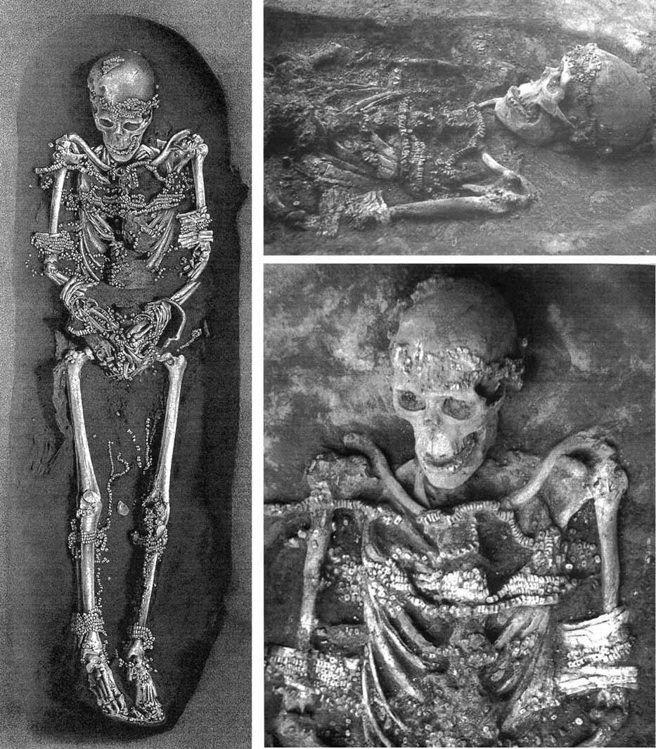

Figure 3, Burial of Sunghir 1 covered in mammoth ivory beads and body ornaments (Trinkaus, 2010).
In the image above are photographs of Sunghir 1. The image shows all of the mammoth ivory beads and the body ornaments that were found with the skeleton on Sunghir 1. The photograph also shows the position of the skeleton which was used to prove the theory of the burial of Sunghir 1. The photographs were found in Trinkaus’ paper on Sunghir 1.
To conclude. The examples used of Neanderthal burial practices for the discussion, help a conclusion to arise on the Neanderthals views of the afterlife. To clarify, the ideologies the Neanderthals may have had on the afterlife would have mostly varied from region to region, simiarly to how modern humans are today. However, analysing and studying the burial practices of both Shanidar 4 and Sunghir 1, have helped an understanding of what those specific areas’ ideology could have been on the afterlife. Firstly, looking at both of them, there is a idea of a materialistic style of burial. Shanidar 4 being found with pollen clumps indicating the existence of flowers at the burial provide partial evidence for this (Hunt, 2023). But, the most concrete evidence for materialistic burials come from the excavation of Sunghir 1, being covered in mammoth ivory beads and body ornaments of different kinds show this almost clearly (Trinkaus, 2010). Using the idea of a materialistic burial, this could infer that they viewed death as a payment perhaps were one must take belongings with them, or that it was a sign of respect towards those who passed away. Focusing more on Sunghir 1, the idea that Sunghir 1 was sacrificed brings much curiostiy to the ideas of afterlife (Trinkaus, 2010). As if this is the case did the Neanderthals have a religion or a diety they respected? Despite these theories and “evidence” to help the narrative that Neanderthal burials were a thing. One must also look into Ralph Solecki’s works that argue against it. Especially in regards to Shanidar 4’s burial. Solcki looks at the evidence of the flowers in Shanidar 4’s assemblage to be introduced by jirds, which are a type of burrowing animal. Despite the “evidence” of Neanderthal burials and the potentials of their views on the afterlife. There is no 100% fact that they even did this or thought like this. Therefore, one must be cautious when creating these to not be too confident in their decisions.

Reference List:
Been, E. (2017). "The first Neanderthal remains from an open-air Middle Palaeolithic site in the Levant.", Scientific Reports (Nature Publisher Group), vol. 7, pp. 1-8. Available at: https://www.proquest.com/scholarly-journals/first-neanderthal-remains-open-air- middle/docview/1955537791/se-2?accountid=130472. (Accessed: 09 March 2024).
Gargett, R.H. et al. (1989). “Grave Shortcomings: The Evidence for Neandertal Burial [and Comments and Reply].” Current Anthropology, [online] 30(2), pp.157–190. Available at: https://www.jstor.org/stable/2743544. (Accessed: 08 March 2024).
Hunt, C., Pomeroy, E., Reynolds, T., Tilby, E. and Barker, G. (2023). “Shanidar et ses fleurs? Reflections on the palynology of the Neanderthal ‘Flower Burial’ hypothesis.” Journal of Archaeological Science, 159, pp.105822–105822. Available at: doi:https://doi.org/10.1016/j.jas.2023.105822. (Accessed: 10 March 2024).
Pomeroy, E. (2020). “Issues of theory and method in the analysis of Paleolithic mortuary behavior: A view from Shanidar Cave.” Evolutionary Anthropology: Issues, News, and Reviews, 29(5), pp.263–279. Available at: doi:https://doi.org/10.1002/evan.21854. (Accessed: 8 March 2024).
Sommer, J.D. (1999). ”The Shanidar IV “Flower Burial”: a Re-evaluation of Neanderthal Burial Ritual.” Cambridge Archaeological Journal, 9(1), pp. Available at: 127–129. doi:10.1017/S0959774300015249. (Accessed: 06 March 2024).
Tilby, E., Miracle, P. and Barker, G. (2022). “The Microvertebrates of Shanidar Cave: Preliminary Taphonomic Findings”. Quaternary, 5(1), p.4. Available at: doi:https://doi.org/10.3390/quat5010004. (Accessed: 06 March 2024).
Trinkaus, E. and Buzhilova, A.P. (2010). The death and burial of sunghir 1. International Journal of Osteoarchaeology, 22(6), pp.655–666. doi:https://doi.org/10.1002/oa.1227. (Accessed: 06 March 2024).

