What does it mean to commemorate?
Discuss how and if memorials can create personal meaning in public spaces.
Jordan Mahoney (1704622)
Advertising and Brand Design (BA)
Word Count: 1,692
Sarah Tombs & Louis Burston

Contextual studies

Jordan Mahoney (1704622)

Advertising and Brand Design

Question 3: What does it mean to commemorate? How do memorials create personal meaning in a public place?

Commemoration deriving from the l16th century Latin term commeorat- ‘brought to remembrance’ is often referred to as a memorial or remembrance commemoration. These are often of war and battles and there are many events that took place in the past that are overseen and not account for when it comes to commemoration. Often because of the cause of war and death, many commemorations take place in the light of victory and success. Creating a meaning for a town or place where they have gained recognition or exposure in said event. Such things as funerals and birthdays are once again a commemoration, the funeral – commemorating one’s life whether it may be saddened or enlightened, and then the birthday, commemorating the birthday remembering years before that specific day to the day they were born, showing pictures and videos of the past.

Research concludes that there are many happenings of the past which have been documented and commemorated at the time, but there is no sign of annual remembrance. These monuments currently stand to be lessons to the here and now, showing and telling us not to commit the same tragedies that have been committed before.

Commemorations may be viewed as a sorrowful ceremony, but yet we must learn from the lessons they teach; They stand not only as a figure of remembrance but also lessons in each of their own. Showing not to commit the same war crimes, showing not to practice certain fields, to respect one another and appreciate our being.

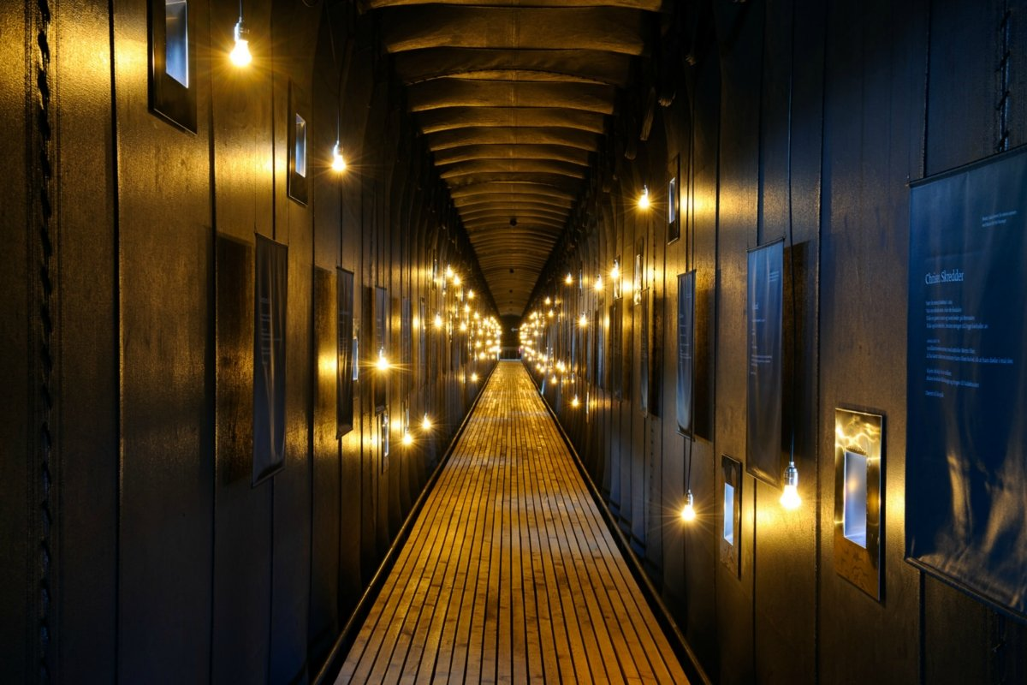
(1) Witches Memorial – Steilneset (c) Bjarne Riesto/www.riesto.no

The witches memorial steilneset is a huge monument dedicated to the thousands of individuals who were thrown into the water and tried to see if they were who they said they were. If the individuals were to float, then they would be considered a witch. These practices were undertaken through Europe during the 15th century, with these ceremonies taking place in places as close as Scotland.

The 125ft long corridor shows the affect that the 15th century witch hunt is also a commemoration of sorts; had on the people of the villages and fishing towns. Until modern day, proving the concept to be false there was a high number of believers in the reasoning for the monument. This public space, atop of the mountains in Scotland, is now primarily the ideas and concepts of which the monument stands for, before this a place of high beauty; still above the clouds only with the monument standing wide and tall to craft the present into not condoning the practices of the 15th century; thus, it being a lesson this is quite interesting as written papers by the late James I and Sir Isaac Newton reads:

(2) Witchcraft, a perceived facility to summon evil spirits and demons to do harm to others – James I, Sir Isaac Newton (www.Parliament.uk)

According to the Parliament website it is still illegal for a person to commit such a time to this day. The practices of witchcraft were banished at the time and yet we still stand to believe this to be a myth, the governments of today still recognize it as a threat, making it a crime to practice such things.
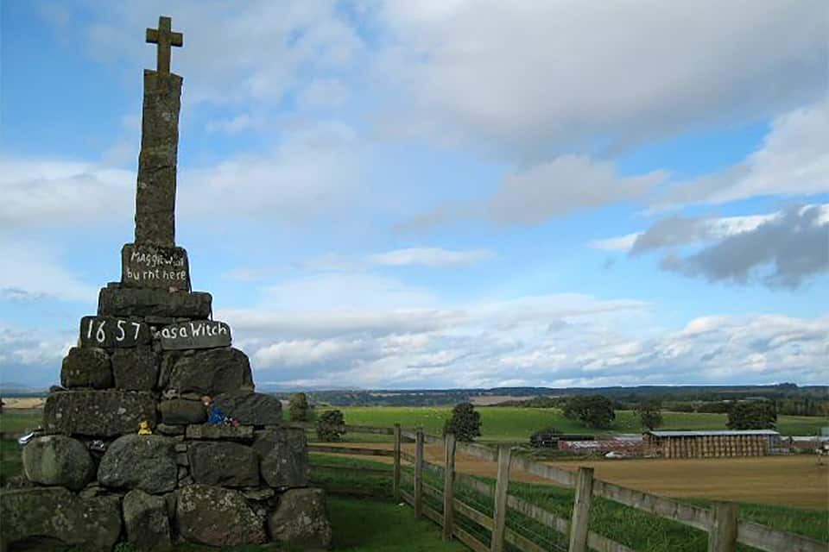
Lis Burke / Wikimedia Commons; (3) 2017 Article (inews.co.uk)

This monument, commemorating an individual by the name of Maggie Wall was found rather than built after an event. No documentation was recorded of such woman, and the village of the time refuses to believe that; the named; existed at all. Causing speculation and mystery throughout the whole country, people began paying tribute to the monument, leaving little gifts such as pennies, tea light candles, and soft plush toys.

Standing tall above a pile of rocks, not only did it change the meaning of the location, but also changed the perception of the minds in the generations to come. Questioning the tragic movement of the practices in the 15th century and the lessons that it teaches today.

With monuments getting raised all around the world for various reasons such as mail boys, wars, witched and presidents. They have all meaning to someone somewhere, but yet this does not mean that it attracts to everyone within that community or public space, as documented by James A Percoco;

(4) “We have monuments everywhere, and anytime a monument is created, whether it’s in a small community or the grand stage in Washington, DC, there’s almost invariably problems with it” – James A Percoco, Monuments as thought objects (teachinghistory.org)

Along with that statement shows that some monuments are not there for the majority, a monument may be placed by mistake, or out of hate. Creating statues of those who craft our world but yet the craft itself teaching a lesson. This lesson would not have to be taught if we had not committed the mistake in the beginning.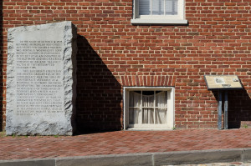
(6) Two Heyward Shepherds memorials: HP, WV

There’ve been times when the monument was boarded up because the park service didn’t want anybody to see it and there have been times when it’s been out for the public to see – James Percoco.

From reading an article at Teachinghistory.org James Percoco states that some monuments are hidden from the public at the location’s discretion, this shows that some parks and public places chose whether or not the public can see the monument, this raises the question as of why?

One incident was the John Brown raids in West Virginia, 1859. The raids were intended to seize all the weapons from one of the biggest caches of the south and supply them to the slaves, with plans for them to begin on the hills and make their way down, freeing all the slaves in the process.
Heyward Shepherd wasn’t well known of, but he was a free black man which was killed by John Browns raiders: The monument itself was erected by the United Daughters of the Confederacy and the Sons of Confederate Veterans and the monument itself has been protested for its position in Harpers Ferry.

People of West Virginia find that the monument itself commemorates slavery and gives the opposition credit for the happenings of the time; the time of abolition. It has been said that the markers themselves represent two very different interpretations of shepherd’s death which were the result of him being gunned down.

(7) “Chief among them was allowing a train to continue through the Ferry on its way to Washington DC, where conductors would alert the federal government to send troops. As that train came into town, Heyward Shepherd tried to warn them, and he was shot by Brown’s men.” – Andrew L, 2016 (contested history at Harpers Ferry, Gravesofnote.com)
For Heyward Shephard death was the beginning of other happenings during this time, ironically the raids themselves was to free the slaves and start an insurrection, and the first kill was a free black man. In the same article by Andrew L, he states that the memorial is filled with racial assumptions and that the monument is rather paternalistic.

This statement is also backed by James Percoco, in monuments as thought objects he states:

(8) “It’s a great ironic tale. Raiders come in ostensibly to liberate the slaves, lead a slave insurrection, and the man they first shoot is a free black “– James A. Percoco

Monuments themselves stand to represent one moment in time; one event. How we interpret that event is different to everyone, creating different meanings in everyone’s mind. In conclusion, the creator of the monument might have been focused on portraying the offense to be the victim, telling the course of history but from a different perspective, the perspective of the ones who lost.

In conclusion, monuments stand to portray messages and information on previous happenings and events, yet history is nothing, but things written in my books and it is often written by the successor rather than the fallen. The way these are viewed in the 21st century is varied, with everyone having their own form of thinking and interpreting.

May not understanding the events that took place and the reasoning behind it, but the curators of the monuments are placing certain happenings in the minds of today; reshaping the past to what they believe is the outcome, rather than the truth.

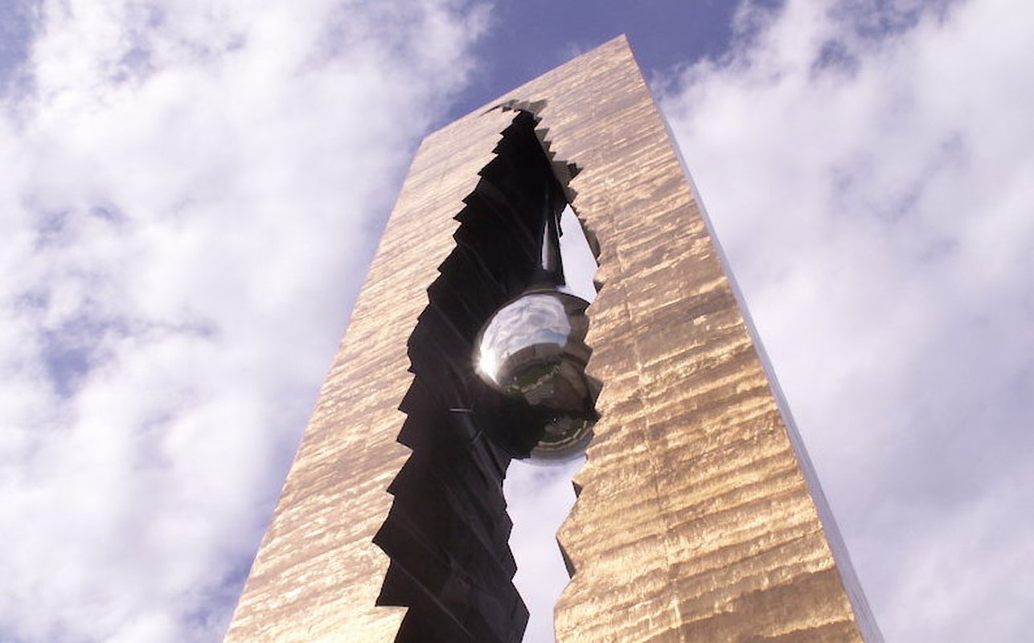
(8) 9/11 Teardrop Monument Flickr/Jackie

Some monuments are rejected when created, the aesthetic values of the creations may not appeal to the city where it has been planned to be placed.

Some of the issues surrounding misplaced monuments lay in the USA, Following the devasting event that occurred on September the 11th, 2001. Russian creators decided to craft a 10-story tall monument, commemorating those who lost their lives and their families in the fall of the world trade centre buildings. Initially the monument was going to be placed in Jersey City, but it was rejected. A local artist by the name of Leon Yost told the New York Times:

“It’s insensitive, it’s heavy-handed, it’s simplistic, it’s a cliché. Other than that, what’s not to like?”

This statement is one that is backed by many, thinking of it as more of an eyesore than a commemorative piece, allegedly the creators accounted for 40 more people to have passed away during the event, which is one of the reasons of it being heavily contested.
The majority on the other hand, believe the monument to be a perfect contribution to the city after one of the countries darkest days.

This shows that the reasoning behind monuments isn’t always understood, and any two people could look at it and have different opinions. They don’t always tell us the correct things or commemorate the right things. They can cause disruption in public places and in people’s thoughts, bringing back good memories or the ones that they wanted to forget; a monument is a physical representation of one’s vague memories; which does not necessarily account for everyone’s memories who lived through the same experiences. Often created by the victors, whether that victory was considered beneficial or negative.

Monuments to this day stand tall and cast shadows over the world, but are they there simply because one wants them there? Or do they actually mean something?

Reference List:
- Witches Memorial Bjarne Riesto (www.riesto.no)
- Article posted on Parliament UK, Sir Isaac Newton, James I (www.Parliament.uk)
- Article by Gillian McDonald: 2017 (https://inews.co.uk/inews-lifestyle/travel/witch-grave-maggie-wall-scotland/)
- James A Percoco, unknown, Monuments as thought objects (teachinghistory.org)

- James A Percoco, unknown, Monuments as thought objects (teachinghistory.org)

- Article published by Andrew L, (2016) https://gravesofnote.wordpress.com/2016/08/24/who-was-heyward-shepherd-contested-history-at-harpers-ferry/

- Andrew L, 2016, contested history at Harpers Ferry (Gravesofnote.com)

- The 9/11 “Teardrop Memorial” A Controversial History, 2017 (https://untappedcities.com/2017/06/30/the-911-teardrop-memorial-in-bayonne-new-jersey-a-controversial-history/)

