
Course: Inclusive Education
Module: Celebrating Language and Culture - Belonging to Wales

Contents
Rationale 2-4
Overview of activities 4-7
Evaluation 7-8
Appendices 9-12
References 13-14

In any community in which the original native language co-exists with the dominant language of the state, the issue of language in education is almost certain to be contentious matter. (Davies, 2014, p.123)
From an historical point of view the teaching of Welsh in schools has frequently been a fractious subject. An abstract taken from Welsh historian Owen M Edwards portrays the grim reality for many Welsh children attending school in the “late nineteenth century” (Owens, 1996, p.4). A pupil daring to speak his native tongue in class would have a “heavy wooden block put around his or her’s neck” (Owen M Edwards, 1933, p.4). Referred to as the Welsh not, this was then worn until another pupil communicated in Welsh. They would then have to wear it. (Owen M Edwards, 1933, p.4) quotes,
My school days which should have been full of the wonders of living and learning were the most bitter days of my life. I hated school, books and even knowledge itself. Further stating, to school I owe nothing but my story (Ibid).
From a modern-day perspective, over “420 primary schools currently deliver Welsh-medium education to almost 67,000 learners across Wales” (Welsh Government, 2017, p.8). Policies such as the Curriculum Cymreig have “helped pupils to understand and celebrate the distinctive quality of living and learning in Wales” (Welsh Government, 2003, p.4). Whilst further allowing the learner to “identify their own sense of Welshness and a heightened sense of belonging to their local community and country” (Ibid). Furthermore, “the Future Generations Act (Wales) 2015” (Welsh Government, 2017, p.6.) requires specific bodies including the Welsh Government “to work towards the seven well-being goals” (Ibid). One of which is a “Wales of vibrant culture and thriving Welsh language” (Ibid). Whilst further ensuring the system for planning Welsh medium education provision a statutory foundation. “The 2050 Welsh strategy” (Welsh Government, 2019, p.3) further aims to entrench “positive language use practices supported by formal and informal opportunities to use Welsh socially” (Ibid). Furthermore, each educational establishment “regardless of their linguistic ability” (Welsh Government, 2019, p.5) should encourage all pupils to adopt positive outlooks.
The “New Curriculum for Wales Successful Futures” (Welsh Government, 2019, p.1), to be introduced in 2022, will see the Welsh language come under one of the six areas of “learning and experience” (Ibid). Focusing on “Language, Literacy and Communication” (Ibid), whilst concentrating on the essential features of “human communication” (Ibid). Furthermore, allowing the fostering of learning across the whole curriculum and pupils to expand one’s knowledge in Welsh, English and international languages as well as literature.
A report conducted by Donaldson found that numerous improvements and ambitions have been recognised by the Welsh Government to “ improve the existing Welsh Curriculum for Wales” (Donaldson, 2015, p.11), an example being, the “Task and Finnish reports” (Ibid). Commissioned by the Welsh Government the report was sought to cover issues such as, the “role the Welsh language and culture play in the secondary curriculum” (Ibid).
Developments have further included, the introduction of the “foundation phase and the development of a Welsh Baccalaureate Qualification at key stage 4 and beyond” (Ibid). Despite these amendments, Donaldson has concluded there are several “issues both practically and fundamentally” (Ibid). An example being, the “1988 curriculum” was constructed in a society where we were yet to see the advancement of “the World Wide Web, technology and globalisation” (Donaldson, 2015, p.12) that now have a significant bearing in the way one lives there life today. Furthermore, a study reviewed by the (OECD) found a high percentage of Welsh pupils are significantly behind regarding there “performance in education”. Thus, a change in “current assessment and evaluation arrangements are needed” (Donaldson, 2015, p.11) regarding the role the Welsh language plays in modern day education. Donaldson states, the language should “remain compulsory up to the age of 16” (Donaldson, 2015, p.17), a fresh outlook on the way Welsh is taught in regard to “communication particularly oral communication and understanding” (Ibid). Furthermore, strengthening the value the language may have on the “cognitive benefits of bilingualism” (Ibid) and its importance in allowing pupils to gain a good comprehension of “the cultural life of Wales in the past and present” (Ibid).
Having said this, (Nation Cymru, 2020, p.1) state that the aim towards bilingual education in English-medium primary schools is “unlikely to make Welsh thrive towards the ambitious Cymraeg 2050 aim of 50 percent of English-medium pupils describing themselves as Welsh speakers when they leave school”. Further stating, “the New Curriculum for Wales on its own offers limited hope for improvement” (Ibid). Reasons for this include, a limited number of teachers that specialise in the Welsh language as a “second subject” (Ibid), the new Curriculum has not achieved the “roadmap and compass” (Ibid) educators were eager for. Furthermore, the Welsh language may be regarded with less precedence’s, due to the fact that the subject will now come under an area of “learning and experience” which includes, “international Languages, Literature and Communication “of which (Cymru Nation, 2020, p.1) state “will diffuse and diminish the Welsh language”.
From a personnel perspective, this essay will include an analysis and reflection of three Welsh activities, to take place at an English-medium primary school. Allocated in Wales, the school is a pioneer school, of which is currently following the “New Curriculum for Wales 2022” (Welsh Government, 2020, p.1). School A’s Polisi Cymraeg Ail Iaith states the “teaching of Welsh should be enjoyable, relevant and enriching” (School A, 2018, p.1). Furthermore, the school aims to develop the pupils existing understanding of the Welsh language, “enabling them to use it as a means of communication” (Ibid). Bilingual policy includes, “the regular use of incidental Welsh to be used” (Ibid) in situations such as morning registration. An example being, Flying Start will use simple Welsh phrases such as, bore da, yma, and diolch (See Appendix 1). Whilst the teachers and support staff in Year 6 will engage with more advanced Welsh phrases such as, oes rhywun yn absennol? Or rydch chi wedi bod? Additionally, (School A, 2019, p.1) has established a Criw Cymraeg, giving the pupils an opportunity to enhance “the Welsh ethos within the school”.
According to the Welsh Government, educational establishments should endeavour to develop in every pupil a comprehension of the “cultural identity unique to Wales and a sense of cultural and personnel identity respectful towards others” (Welsh Government, 2015, p.5). Under the area of learning and experience: Cymraeg/Language, Literacy and Communication, the first activity for pupils in year 6 will be to create a text map (See Appendix 2). Titled Dyma Fi Llafar – personal profile, this will prepare the pupils for the second activity, which will then be to perform an oracy presentation. Prior to the activities beginning, pupils were asked to choose a partner of their choice. For a clear understanding and expectation of the activity the success criteria was explained to the pupils (See Appendix 3). An example being, can you identify key words and phrases for your oracy presentation. Furthermore, can you create a text map to aid your oracy presentation. The what matters statement was further communicated to the pupils, which in this instance is “learning about identity and culture through languages which prepare us to become citizens of Wales and the world” (Welsh Government, 2019, p.2). A discussion was then undertaken with the class, to find out any prior knowledge they may have on text maps. Furthermore, an example of a text map was then drawn on the whiteboard and key Welsh words were discussed along with visual images they could use for their map. A range of wagolls were further used to scaffold the activity (See Appendix 4).
The (Welsh Government, 2015, p.15) state “at key stage 2 pupils should be given the opportunity to write for a variety of purposes” including formats such as, “stories, scripts and reports” (Ibid). Whilst further allowing the pupil to develop their accuracy “by using verb forms, forming negative sentences, prepositions and mutations” (Ibid). Following on from activity one the pupils were instructed to complete a Welsh writing activity based around the theme of dyma fi (See Appendix 5). Again, this comes under the what matters statement of “learning about identity and culture through languages enables us to become citizens of Wales and the world” (Ibid). The text map from the previous activity was used to help scaffold the activity. Whilst further helping to extend their use of the Welsh language and relay this into sentences.
Clear and precise communication through spoken language is an important life skill. Furthermore, pupils should be given the opportunity to present their written dialogue in a variety of ways including the use of ict. For the last activity pupils were asked to orally present their written piece from activity two and record it with the use of an iPad (See Appendix 6). Prior to this the pupils were given the opportunity to practice their presentations working with partners. After their presentation was completed the pupils were then asked to upload their work using an app called seesaw. To help scaffold the activity wagolls were further used (See Appendix 7).
On reflection, I feel the Welsh activities were a success. Prior to each activity beginning the teacher engaged the pupils with a group discussion. Activating prior knowledge is considered to play an imperative role in “influencing learning and student achievement” (Hailikarl, Katajavuori and Lindblom-Ylanne, 2008). The extent and value of prior knowledge unequivocally influence both “knowledge acquisition and the capacity to apply higher order cognitive problem-solving” (Ibid). Piaget’s theory underpins this concept, believing “children are viewed as active and powerful participants in the learning process” (Gray and Macblain, 2012, p.64). Describing the child as “a lone scientist” (Gray and Macblain, 2012, p.44), Piaget believed “knowledge is constructed by the knower based on mental activity” (Ibid). Whilst further believing that children produce understanding and meaning from an “interaction between their experience and their ideas” (Ibid).
To create the Welsh text map pupils were asked to work in pairs. Piaget believed collaborative engagement between peers “enriches the child’s communication skills and fosters intellectual development” (Gray and Macblain, 2012, p.62). Piaget further believed; peers gain a deeper understanding into the task through collective educational experiences. Whilst, a more capable peer can verbalize what is expected of the pupil in a simpler way (Gray and Macblain, 2012). This type of interaction was observed in activity one. A pupil with an additional learning need (ALN) showed signs of anxiety and frustration when the task was being explained. The pupil who was paired up with him showed an empathetic understanding and calmly explained the task in a simpler context. Almost immediately the child’s anxiety levels lowered, and the pupil engaged with the activity. Vygotsky and Bruner further endorsed the role collaboration has on the learner. Although, unlike Piaget, the role of the teacher plays an instrumental part in the “development of the child’s thinking and learning” (Gray and Macblain, 2012, p.60). Piaget believed teachers are simply facilitators of learning.
One of the main challenges for pupil’s learning another language is the vast array of new vocabulary. A text map is an effective way to help pupils internalize and memorize the information needed to progress. “Words are abstract and can be rather difficult for learners to remember” (Kouyoumdjian, 2012, p.1). Whereas, visual imagery proves an effective tool in retaining the information. Studies suggest, “visual learning makes complete sense when you consider our brain is mainly an image processor and not a word processor” (Ibid). Whilst theorist “Allan Pavio’s dual coding theory (DCT)” (Bates, 2019, p.78) suggests “combining verbal and visual material will increase the probability that words will activate corresponding images and vice versa” (Ibid). Although, some critics suggest Pavio’s theory does not allow for the prospect of “cognition being mediated by something other than words or images” (Bates, 2019, p.79). This activity enabled the pupils to embed single extracts of information into a greater context. Thus, recognising their relationships with other pieces. (Estyn, 2017, p.2) suggests for best practice educational establishments have a “legal obligation to teach Welsh to all pupils including pupils with an additional learning need (ALN)”. Furthermore, “a living language: a language for living” (Ibid) recognises the choice learners with (ALN) to obtain “provision in the language of their choice as set out in the revised SEN Code of Practice for Wales” (Ibid). The (UNCRC) further state, every child has a right to an education regardless of “ethnicity, gender, religion, language and ability” (UNICEF, 2020, p.1). The text map was particularly enjoyed by the pupils with an (ALN). The concrete images helped the pupils make connections and add meaning to them.
As suggested by the Donaldson report, “digital competence is increasingly fundamental to learning and life” (Donaldson, 2015, p.40). For pupils to become “knowledgeable in oracy, reading and writing” (Welsh Government, 2015, p.5) pupils should be given the opportunity to “explore, plan and develop their ideas” (Ibid). Using the written piece of work pupils were asked to work in pairs and practice their oracy presentation. This deliberate form of practice differs from the rote learning, which involves the “repetition of times tables and spellings” (Gray and Macblain, 2012, p.43). The behaviourist approach tends to facilitate learning by “testing the pupil’s memory with facts such as alphabet, colour, spelling and multiplication” (Gray and Macblain, 2012, p.44). Piaget deemed this as detrimental to the child’s learning process. Stating, “it merely encouraged the repetition of meaningless strings and circus tricks” (Ibid). Piaget preferred “discovery learning through practical activities” (Ibid). Believing the child to be “a lone scientist who generates his or hers sense of the world” (Ibid).
Although the pupils enjoyed this activity, several pupils felt anxious when they had to present the welsh text onto an iPad. This is understandable considering pupils have been unable to attend school for six months during lockdown. Along with the well-being of the pupils, a report from (Ofsted, 2020, p.1) states “children of all ages and backgrounds have lost some basic skills and learning as a result”. Providing secure and safe environments with plenty of reassurance and praise is paramount to the pupil’s success. Carl rogers believed “for a person to grow, they need an environment that provides acceptance, positive regard and empathy” (McLeod, 2014, p.1). Furthermore, as a visual learning school, based on “Carol Dweck’s theory of learner motivation” (Bates, 2019, p.144), the growth mindset is very much part of the school’s ethos. Dweck believes, pupils who have a growth mindset are “motivated by inner desires to improve rather than by external stimuli” (Ibid). The pupils applying their skills in the oracy presentation were praised for their effort rather than the result. An example being, ‘You have put in so much effort for this presentation’ as opposed to ‘wow you’re a natural’.
On reflection I feel the activities were a success. Although to add an extra dimension, games could have scaffolded the activities further. Games such as Taflwch y dis are a fun way for the pupils to practice their use of incidental Welsh (See Appendix 8). This is very much a feature of the Siarter Iaith framework, whom state, opportunities should be provided “which encourage the use of informal language amongst users” (Welsh Government, 2019, p.4). Furthermore, I felt the staff could have engaged more with the Welsh language. Bandura’s “social learning theory” (Macleod, 2016, p.1) suggests, children learn through “observation, imitation and modelling” (Ibid).
Research suggests, for a child to be successful in bilingual acquisition, several factors are acquired. Chomsky believed that all children are “genetically pre-programmed to acquire language” (Whitehead, 2010, p.12). Although, Bruner felt Chomsky “correctly identified the child’s capacity to understand the intricacies of languages grammatical structure” (Wyse and Jones, 2010, p.28). Bruner felt the “Language Acquisition Device cold not function without the aid given by an adult” (Ibid). The National Literacy Trust (2010, quoted in Gross, 2013, p.17) suggest, “adults who take the lead from children have more positive effect on language”. The micro systems between the child, parent and carer can play an imperative role in the acquisition of language. Bronfenbrenner (1994, quoted in Gross, 2013, p.17) states,
In order to develop normally, a child requires progressively more complex joint activity with one or more adults who have an irrational emotional relationship with the child. Somebody’s got to be crazy about that kid. That’s number one. First, last and always.
Research suggests, “Children learning two languages develop language in the same way as using one” (Gross, 2013, p.19-20). Furthermore, children need “a secure foundation in one language if they are to learn a second one with ease” (Ibid). Schools play an imperative role in nurturing the Welsh language. (School A, p.1) believes:
In the importance of Welsh as a living language. Adopting a whole school ethos using everyday Welsh and by giving Welsh a prominent role plays an important part in the fostering of positive attitudes towards the language and to the culture of Wales.

Appendices
Appendix 1
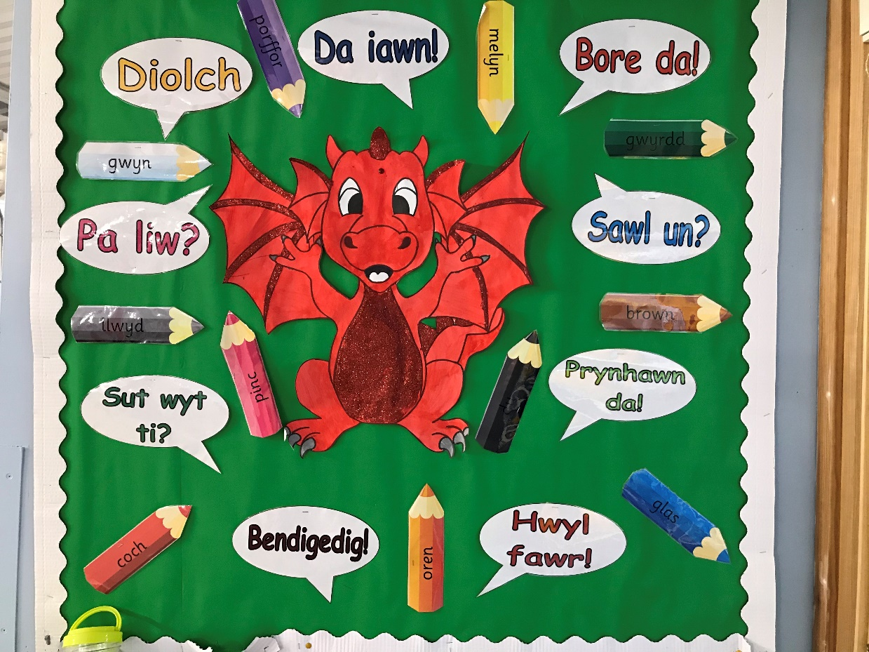
Appendix 2
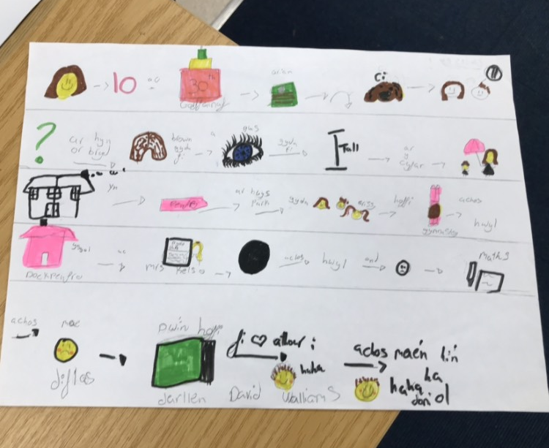
Appendix 3
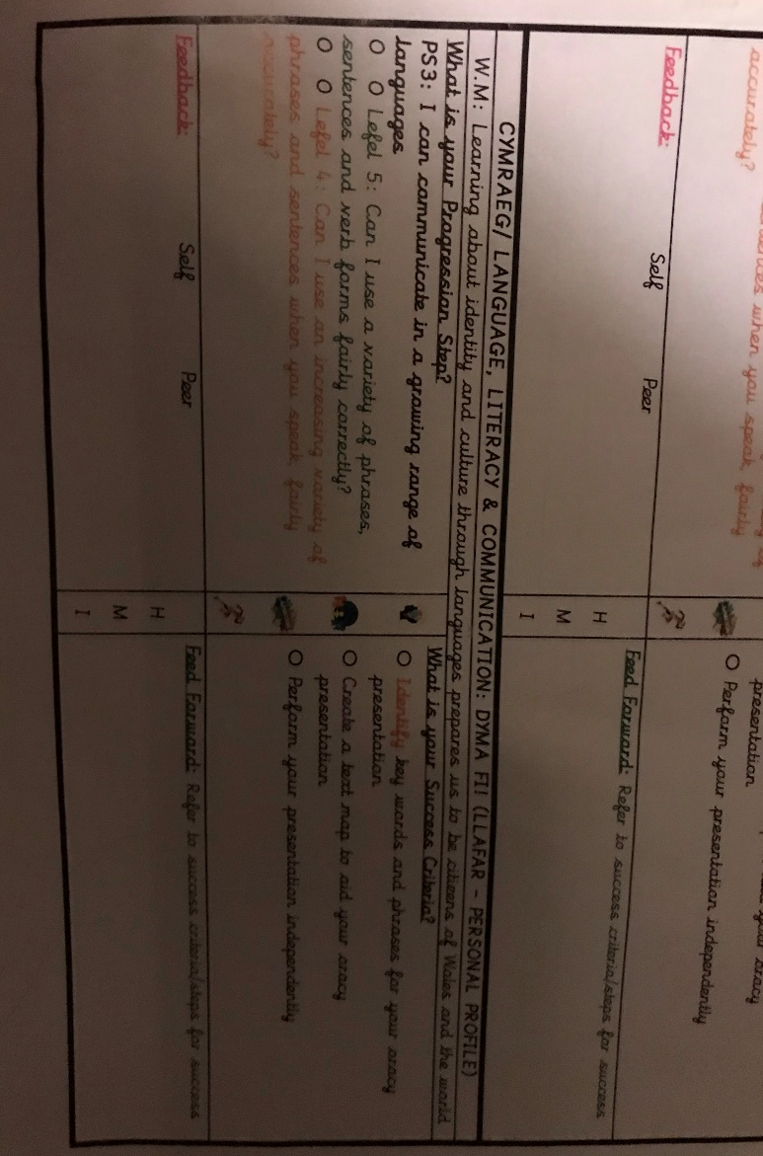
Appendix 4
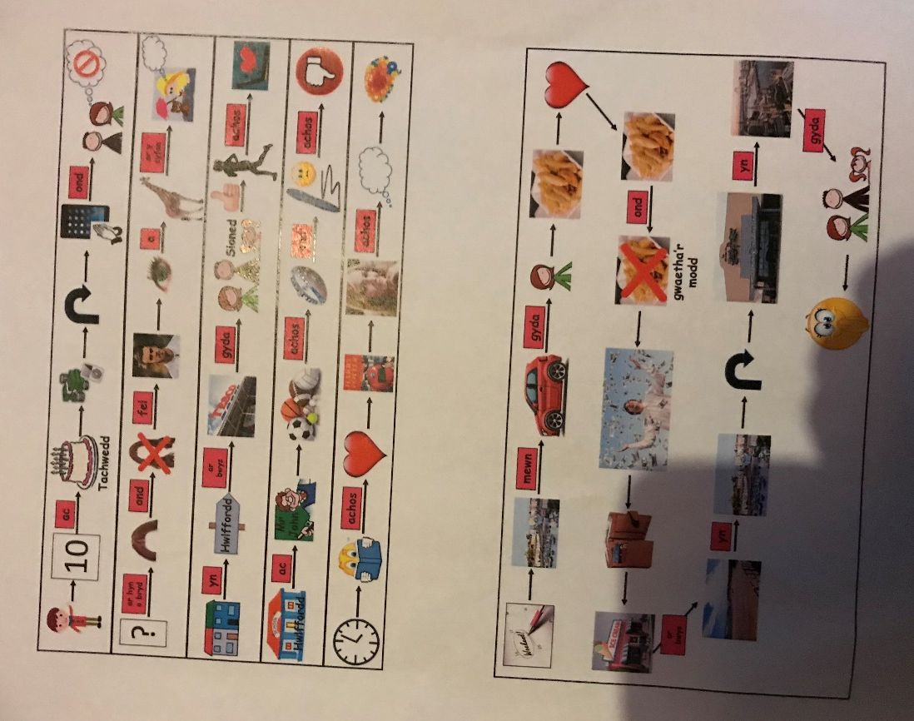

Appendix 5
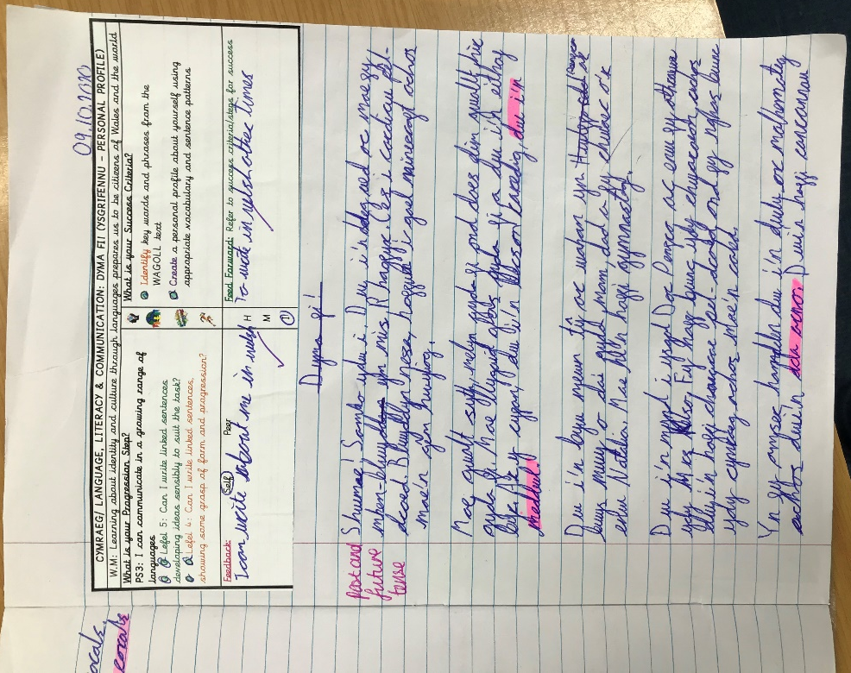
Appendix 6
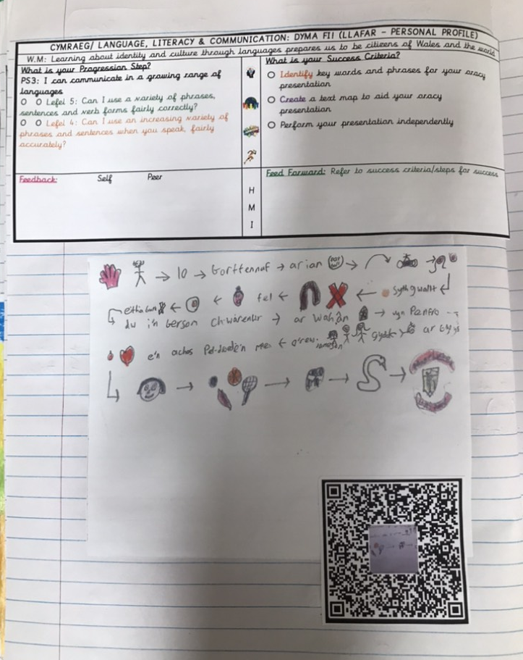
Appendix 7
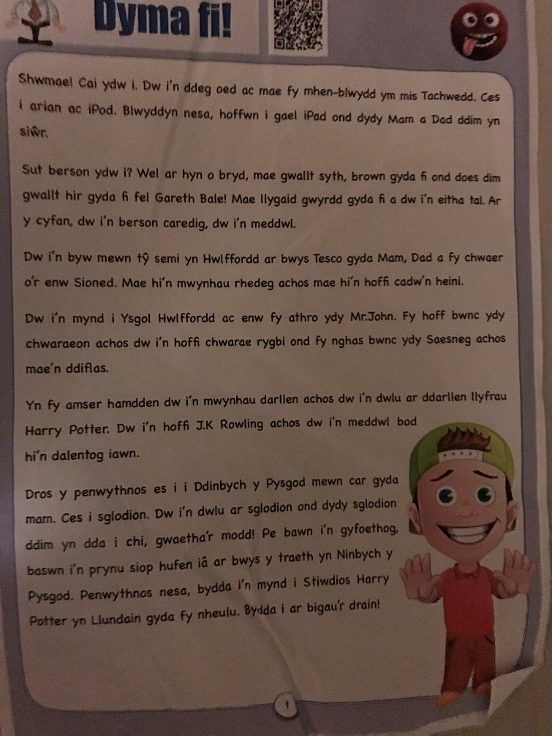
Appendix 8
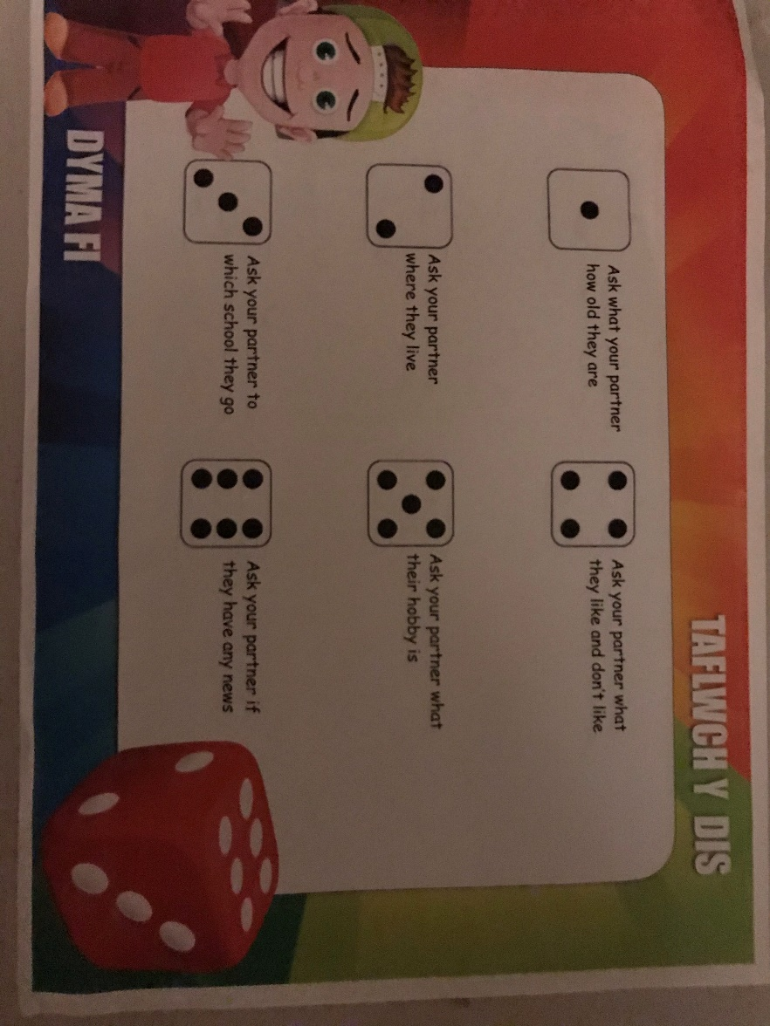

Reference List
Bates, B., 2019. Learning Theories Simplified. 2nd ed. London: Sage. Whitehead, M., 2020. Language And Literacy In The Early Years 0-7. 4th ed. London: Sage, p.40-79.
Davies, J., 2014. The Welsh Language A History. 1st ed. Cardiff: University of Wales Press, p.123.
Dera.ioe.ac.uk. 2015. Successful Futures. [online] Available at: <https://dera.ioe.ac.uk/22165/2/150225-successful-futures-en_Redacted.pdf> [Accessed 2 November 2020], p.4-50.
Elfed- Owens, P., 1996. The Implementation Of The National Curriculum On Wales. [online] Core.ac.uk. Available at: <https://core.ac.uk/download/pdf/33678746.pdf> [Accessed 15 November 2020], p.4.
Estyn, 2017. Supplementary Guidance: Welsh. Cardiff: Estyn, p.2.
GOV.UK. 2020. Ofsted: Children Hardest Hit By COVID-19 Pandemic Are Regressing In Basic Skills And Learning. [online] Available at: <https://www.gov.uk/government/news/ofsted-children-hardest-hit-by-covid-19-pandemic-are-regressing-in-basic-skills-and-learning> [Accessed 1 November 2020], p.1.
Gov.wales. 2015. Curriculum For Wales. [online] Available at: <https://gov.wales/sites/default/files/publications/2018-02/foundation-phase-framework-revised-2015.pdf> [Accessed 10 November 2020], p.5.
Gov.wales. 2017. Cymraeg 2050 A Million Welsh Speakers. [online] Available at: <https://gov.wales/sites/default/files/publications/2018-12/cymraeg-2050-welsh-language-strategy.pdf> [Accessed 12 November 2020], p.6.
GOV.WALES. 2020. Moving Towards A New Curriculum For Wales | GOV.WALES. [online] Available at: <https://gov.wales/moving-towards-new-curriculum-wales> [Accessed 15 November 2020]., p.1.Gov. wales. 2017, p.1.
Welsh In Education Action Plan 2017-2021. [online] Available at: <https://gov.wales/sites/default/files/publications/2018-02/welsh-in-education-action-plan-2017%E2%80%9321.pdf> [Accessed 4 November 2020], p.8.
Gray, C. and MacBlain, S., 2012. Learning Theories In Childhood. 1st ed. London: SAGE, p.20-120.
Gross, J., 2013. Time To Talk. 1st ed. Oxon: Rouledge, p.17-20.
Haililcarl, T., Katajavuori, N. and Lindblom- Ylanne, S., 2008. The Relevance Of Prior Knowledge In Learning And Instructional Design. [online] ncbi.nlm.nih.gov/pmc/articles/PMC2630138/. Available at: <https://www.ncbi.nlm.nih.gov/pmc/articles/PMC2630138/> [Accessed 13 November 2020], p.1.
Hwb.gov.wales.2019. Curriculum For Wales- Hwb. [online] Available at: https://hwb.gov.wales/curriculum-for-wales [Accessed 19 October 2020], p.1.
Hwb.gov.wales. 2019. Draft Statutory Guidance Area Of Learning And Experience. [online] Available at: <https://hwb.gov.wales/storage/4373f5ea-f77e-4b10-a20f-4b06eb02f6a0/draft-statutory-guidance-languages-literacy-and-communication.pdf> [Accessed 9 November 2020], p.2.
Hwb.gov.wales. 2019. Siarter Iaith Framework Initial Guidance For Schools. [online] Available at: <https://hwb.gov.wales/api/storage/3b73bf7c-640d-4c34-855d-9586b0b30c80/siarter-iaith-framework.pdf> [Accessed 11 November 2020], p.4.
Hwb.gov.wales.2019. Siarter Iaith Framework: Initial Wasacre.org.uk. 2003. Developing The Curriculum Cymreig. [online] Available at: <http://www.wasacre.org.uk/publications/wag/E-developingthecurriculumcymreig.pdf> [Accessed 11 November 2020], p.4.
Hwb.gov.wales. 2015. Welsh Second Language In The Welsh Curriculum For Wales. [online] Available at: <https://hwb.gov.wales/api/storage/535c1f8f-5b2f-4243-a232-e669a3ec6a0b/welsh-second-language-in-the-national-curriculum.pdf> [Accessed 11 November 2020], p.15.
2020 Image 1-8.
Kouyoumdjian, H., 2012. Learning Through Visuals. [online] Psychology Today. Available at: <https://www.psychologytoday.com/gb/blog/get-psyched/201207/learning-through-visuals> [Accessed 14 November 2020], p.1.
Mcleod, S., 2016. Albert Bandura | Social Learning Theory | Simply Psychology. [online] Simplypsychology.org. Available at: <https://www.simplypsychology.org/bandura.html> [Accessed 12 November 2020], p.1.
McLeod, S., 2014. Carl Rogers. [online] Simplypsychology.org. Available at: <https://www.simplypsychology.org/carl-rogers.html> [Accessed 30 October 2020], p.1.
Nation.Cymru. 2020. How We Can Get Serious About Teaching Welsh In Our English Medium Schools. [online] Available at: <https://nation.cymru/opinion/how-we-can-get-serious-about-teaching-welsh-in-our-english-medium-schools/> [Accessed 2 November 2020], p.1.
Sticker, L., 2020. Licensed Ripped Torn Metal Rip Design With Welsh Dragon Wales | Etsy. [online] Etsy. Available at: <https://www.etsy.com/ie/listing/675184417/licensed-ripped-torn-metal-rip-design> [Accessed 15 November 2020].
Thomas, N., 2014. Mental Imagery > Dual Coding And Common Coding Theories Of Memory (Stanford Encyclopedia Of Philosophy). [online] Plato.stanford.edu. Available at: <https://plato.stanford.edu/entries/mental-imagery/theories-memory.html> [Accessed 14 November 2020], p.1.
Unicef UK. 2020. UN Convention On The Rights Of The Child (UNCRC) - Unicef UK. [online] Available at: <https://www.unicef.org.uk/what-we-do/un-convention-child-rights/> [Accessed 14 November 2020], p.1.
Whitehead, M., 2020. Language And Literacy In The Early Years 0-7. 4th ed. London: Sage, p.12.
Wyse, D. and Jones, R., 2001. Teaching English Language And Literacy. 1st ed. London: RoutledgeFalmer, p.28.

